Design and Evaluation of Wireless Sensor Networks (April 2019)
Jasitharan Kugathasan, Student Number: P151435, Computer Networks and Cyber Security; Module: Wireless Network and Simulations, Lecturer: Simon Downes
Abstract— This report consists of research about modulation technique used in wireless communication. The research on Binary Phase Shift Keying (BPSK), Quadrature Phase Shift Keying (QPSK) and Quadrature Amplitude Modulation (QAM). Using one of the modulation techniques of BPSK, QPSK or QAM, the modulation technique is simulated using MATLAB Simulation software. The 2nd part of the report is implementation of smart farm using wireless sensor network with selected BPSK, QPSK or QAM modulation technique. This smart farm is implementation simulated using NetSim simulation software.

Introduction
The communication technology without cables are wireless communication. These communications can take place wireless to computer, network equipment’s, and etc. Wireless communications are performed using frequency radio waves. Modulation is core to all wireless communications. In wireless communication there are two types of transmission, analog and digital transmission. Techonology advancement uses digital transmission. Amplitude Modulation (AM) and Frequency Modulation (FM) are analog type modulation. Development in modulation is focused to compress data as much as possible in less amount of spectrum. [1] [2]

The report is researched and summarized on digital modulation techniques. This research paper consists Binary Phase Shift Keying (BPSK), Quadrature Phase Shift Keying (QPSK) and Quadrature Amplitude Modulation (QAM). Functions of modulations, Computer Network Simulation concept and principles, advantages and disadvantage of modulation and implementation sample of modulations. The chosen modulation technique is simulated using simulation software at MAC and physical layer.

The task 2 in this report to build the smart farms using wireless sensor network with simulation software. The smart farm simulated using chosen modulation technique. Analyzing the level of noise affecting the channel, Bit error rate (BER) against signal-to-noise ratio (SNR). The smart farm sensor to be implemented Livestock Sensors, Soil Sensors and self-driving machineries controlled remotely. These sensor networks are linked to the backbone of the network for user to remotely manage and monitor the network. This simulated implementation provide research about network performance.

What is Modulation?
The modulation is wireless communication, which convert electrical data to electromagnetic waveform for transmission of data. [3] There are two type of modulation in wireless communications which is analog modulation and digital modulation. Analog modulation is categorized into three types of modulation Amplitude Modulation (AM), Frequency Modulation (FM) and Phase Modulation (PM). The digital is transmission of binary data. Digital modulation is categorized as Single Carrier Modulation and Multicarrier Modulation.

Single Carrier Modulation
- Amplitude Shift Keying (ASK)
- Frequency Shift Keying (FSK)
- Phase Shift Keying (PSK)
- Orthogonal Amplitude Modulation (QAM)

Multicarrier Modulation
- Orthogonal Frequency Division Multiplexing (OFDM) [4]

Need of the modulation is, communication range is increased, make multiple digital or analog signal combined in one signal, in other words multiplexing, avoiding interference or mixer of signals and Avoid high antenna.

Modulation Process
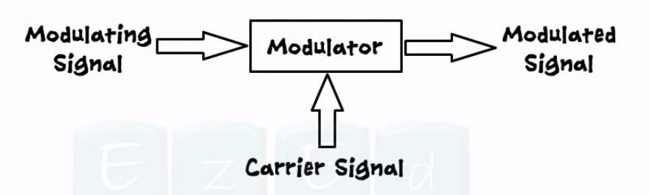
Figure 1: Modulation Process [5]
The modulation process is processing of the signal. Three steps of signal modulation, Modulating signal, Carrier Signal and modulated signal. The modulating signal is the original data to be transmitted, in other words baseband signal. Modulating signal should under go process of Carrier Signal and Modulated Signal. Carrier Signal has no information carried but it is high frequency signal which got amplitude, frequency and phase. This carrier signal empty high frequency signal which carries modulating signal. Modulated signal is the process of combining both modulating signal and carrier signal which is ready for transmission. [6]

The encoding techniques used in modulation for below reason.
- Digital data, digital signal:
This encoding technique is expensive than digital to analog modulation equipment’s and it is expensive but less complicated.
- Analog data, digital signal:
Uses switching and digital transmission of new technology.
- Digital data, analog signal:
Some of the transmission media only broadcast analog signals for example unguided media.
- Analog data, analog signal:
Analog data is in the form of electrical, it can be transmitted easily without any complication for example AM radio. [7]

Analog Modulation

The analog modulation is process of sending analog signal. Analog signal has low baseband frequency signal. Higher frequency is need to effective way of transmission. The analog signal can be processed easily.

Amplitude Modulation (AM)
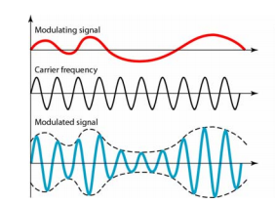
Figure 2:Amplitude Modulation
The Amplitude Modulation is process that keep changing it amplitude of the high frequency carrier signal. In Amplitude modulation phase and frequency constant and amplitude changes. Amplitude modulation is simplest modulation technique used in wireless communication. The advantages of Amplitude modulation are Low in bandwidth, Amplitude Modulation wave can travel long distance. Amplitude transmitter are less complicated and Detection in Amplitude Modulation receiver is easy. The disadvantages of Amplitude Modulation are wastage in power, Amplitude Modulation Get harmed by noise and Amplitude Modulation needs larger bandwidth.

Frequency Modulation (FM)
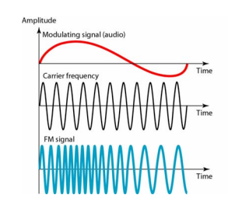
Figure 3: Frequency Modulation
The Frequency Modulation is the analog method of signal processing. Frequency Modulation is process of instantly differing frequency of carrier signal correspondingly with instantaneous amplitude of message signal. Frequency Modulation used in FM radio broadcast. Frequency Modulation does not get affect by any channel noise. With same amount of transmitted power frequency modulation can cover larger area and the transmitted power remains constant. The disadvantage of Frequency modulation is Bandwidth used in very large amount and Frequency Modulation transmitter and receiver are very complicated.

Phase Modulation (PM)
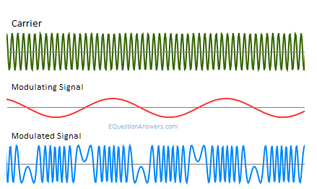
Figure 4: Phase Modulation
Phase Modulation (PM) is the process of transmitting signal. Phase Modulation instantly differ phase of carrier signal. The Phase Modulation is combined principal of angle modulation and frequency modulation. In the Phase Modulation amplitude and frequency carrier signal is maintained in balance. The advantages of Phase modulation are simple compared to Frequency Modulation, using telephone system Phase modulation permits high speed communication in computer, the speed rate can be detected when transmitting signal without any interruption and noise disturbance is reduced in Phase Modulation. The disadvantages of Phase Modulation are Frequency multiplier needed to increase the PM index, for phase difference between them there two signals needed, and Phase modulation phase ambiguity reaches if exceeded in index pi radian modulation. The Phase modulation is beneficial in radio waves transmission. The phase modulation is used in GSM in wireless technology, Television that receives satellite signals and in Wi-Fi. [8] [9] [10] [11] [12]

Digital Modulation
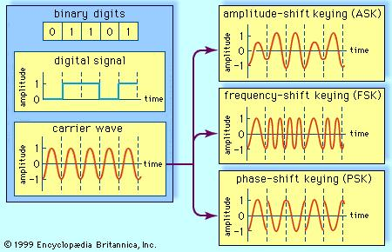
Figure 5:Digital Modulation [13]
Digital Modulation is converting digital signal such as series of 0 and 1 binary digits as wave form for wireless communication. The Digital Modulation are categorized Amplitude Shift Keying (ASK), Frequency Shift Keying (FSK) and Phase Shift Keying (PSK). [13] Compare to analog modulation and digital modulation, the system capacity increased and it is more efficient modulation. The digital modulation requires low power and security improved in digital modulation such as encryption.

Advantages of Digital Communication:
- Compare to analog transmission digital transmission is cheaper and simpler.
- Digital communication is capable of multiplexing which allows data, audio and video transmitted over same channel.
- In digital communication encryption is used, it will only allow the receiver to receive the transmitted signal.
- In long distance communication repeater to repeater does not accumulated by noise due to channel encoding.
- In digital transmission the signal in environment does not get affected by noise much it tolerates large amount of noise interference.
- Channel coding is used in digital communication to detect errors.
- Data processing for example data compression, image processing and digital signal processing are adaptive in digital communication.

Disadvantages of digital Communication:
- Synchronization is needed in digital communication.
- In digital communication larger bandwidth is need due to analog to digital conversion and high in data rate. [14]

Amplitude Shift Keying (ASK)
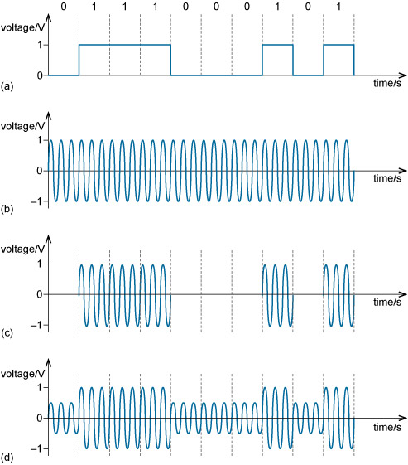
Figure 6: Amplitude Shift Keying (ASK)

Amplitude Shift Keying method, only the amplitude of the carrier signal is changed in modulation with ON and OFF keying (OOK). Depending on the input signal 1 or 0 binary digits the carrier wave is transmitted. If binary digit is 1, the carrier wave transmitted else binary digit is 0, nothing is transmitted. [15]

Frequency Shift Keying (FSK)

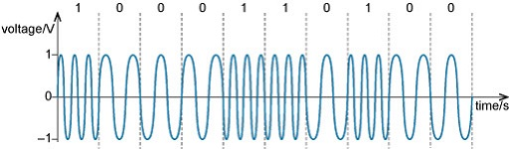
Figure 7:Frequency Shift Keying (FSK) [16]
Frequency Shift Keying method, only the frequency of the carrier signal is changed. Frequency Shift Keying modulated output is high in frequency for binary digit 1 and low frequency for binary digit 0. The Binary digits One’s and Zero’s are called mark and space frequency. [17]

Phase Shift Keying (PSK)

Phase Shift Keying method, only the phase of the carrier signal is changed by deferring the sine and cosine input. Phase Shift Keying is used is Bio-Metric, Wireless LAN’s, RFID, Bluetooth and contactless operation. The Phase Shift Keying is two types Binary Phase Shift Keying (BPSK) and Quadrature Phase Shift Keying (QPSK) [18]

Binary Phase Shift Keying (BPSK)

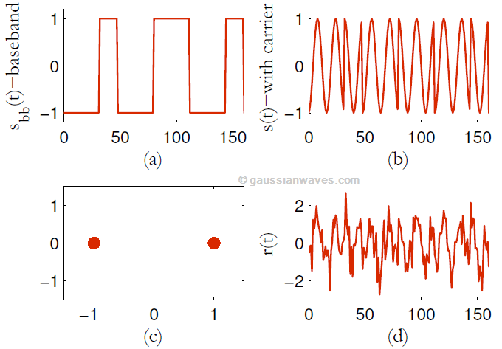
Figure 8:BPSK Signal
Binary Phase Shift Keying (BPSK) modulation is two phase schemes. The binary digits are represented in by two different Phase. When the carrier signal is binary digit One’s the wave angle is 0 degree and when binary digit zero’s the wave angle is 180 degree. In digital modulation there are set of basic function orthogonal to each other. [19]

Advantages of BPSK:
- The wave of the BPSK can travel long transmitted from base station.
- Demodulator of BPSK required to make only two decision to recover the binary information’s and BPSK receiver is simple.
- BPSK uses less power to transmit the carrier.

Disadvantages of BPSK:
- The data rate is bits/seconds. one single analog carrier is required to carry one bit.
- Bandwidth is not efficient in BPSK. [20]

Quadrature Phase Shift Keying (QPSK)

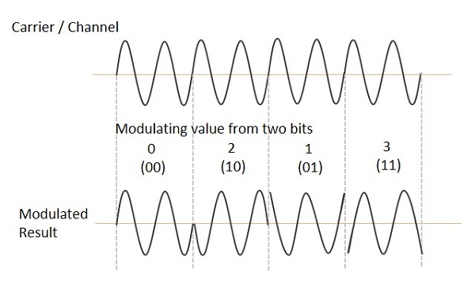
Figure 9: QPSK Signal

Quadrature Phase Shift Keying (QPSK) is Double Side Band Suppressed (DSBSC) which can send two bits at a single carrier. Instead converting series of binary digits, it converts them in to pair of binary bits. [21]

Advantages of QPSK:
- The bandwidth is double efficient compared to BPSK.
Disadvantages of QPSK:
- QPSK receiver is complicated than BPSK because QPSK transmit two bit per symbol. The receiver needs to recover the received information in four state.
- QPSK technique is not power efficient.
- Need an equalizer because of multipath interference. [22]

Quadrature Amplitude Modulation (QAM)
Quadrature Amplitude Modulation is combination of AM signal into a single channel. QAM uses two carrier with same frequency but different in phase. In mathematical representation one wave is represented as sine and another wave represented as cosine. [23] QAM can be modulated in both analog and digital.

Advantages of QAM:
- Using Amplitude and Phase variation, the transmission efficiency is increased in QAM
Disadvantages of QAM:
- QAM is easily harmed by noise.
- Linear amplifier is required. Linear amplifier is less efficient and use more power. [24]

QPSK Simulation

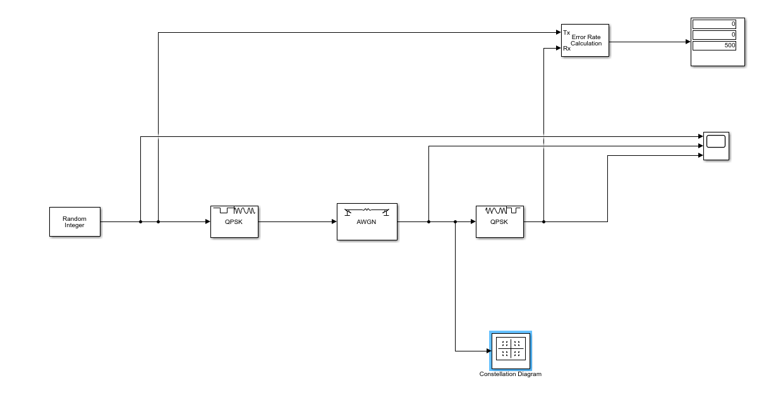
Figure 10: QPSK Simulation

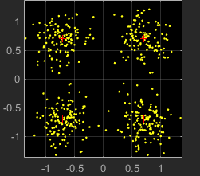
Figure 11: QPSK Constellation

The QPSK modulation and demodulation is done using Simulink software. In this modulation and demodulation, Random Integer Block which generates random integers. Random Integer Block Parameters are set. Set size is 4, sample time is 1 and sample frame is 1 or according to constellation, the sample frame is set to 500.
QPSK Modulator Phase offset is set to pi/4, input type is integer and constellation ordering is gray. QPSK modulator is connected to AWGN which is noise channel. The AWGN channel mode is set to Signal to Noise Ratio 10 dB and initial speed is 20.
The AWGN channel is connected to demodulator, where the waveform is converted back to digital output. The demodulator output type is set to integer, constellation ordering is set to gray and phase offset is set to pi/4. The error display, constellation and scope are connected to visualize the output.
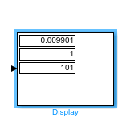
Figure 12: Error Rate
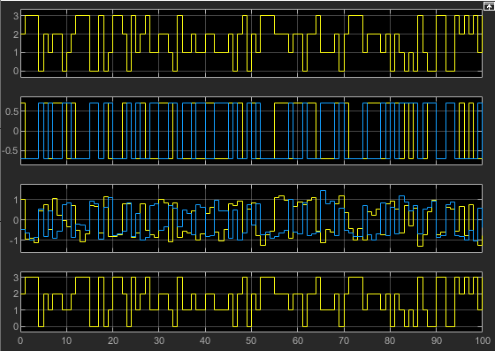
Figure 13: QPSK modulated And Demodulated Signals
The figure: 13, shows modulated and demodulated signal. The first scope shows the integer generated, the second scope shows the QPSK modulated signal, the third scope shows the QPSK modulated signal is affected by 10dB noise ratio and the fourth scope shows the QPSK demodulated signal.

Smart Farm NetSim Simulation

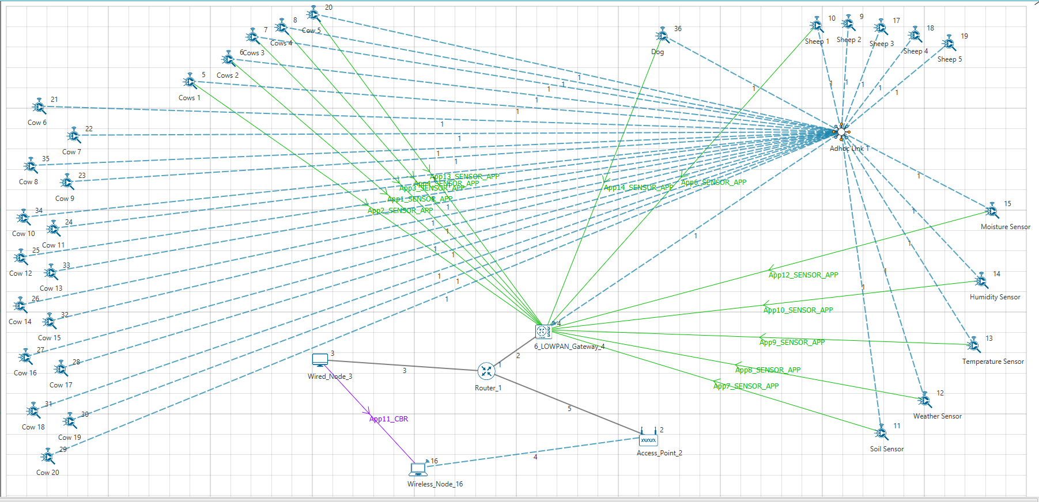
Figure 14: Smart Farm Simulation

The smart farm monitors 20 cows, 5 sheep’s, 1 dog, moisture, humidity, temperature, weather and soil. These are simulated using NetSim simulation software. For analysis purpose in simulation software, out of 36 sensors only 13 sensors created with application to test. The application 1 – 5 is configured with random walk velocity 1 m/s, application 6 is configured with random walk 10 m/s.

Comparison between TCP and UDP, Routing protocol AODV.

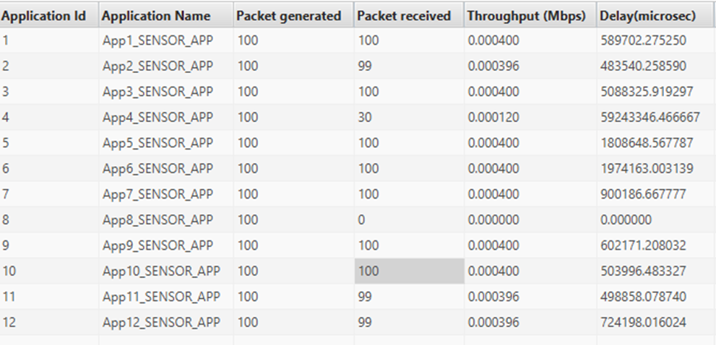
Figure 15: TCP
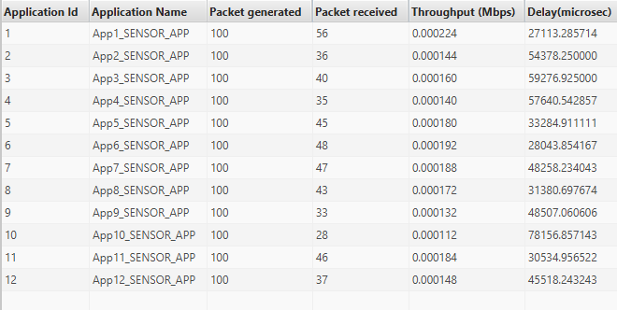
Figure 16: UDP
The distance is set to similar as TCP and UDP. The packets received in TCP is higher than the UDP, but the delay is long in TCP compared to UDP. The throughput is higher TCP. The more analysis going to be done with TCP, because received packets and through is considered in this case. The TCP and UDP test results are done with no path loss channel.

TCP and UDP Channel Path Loss, Fading, and Shadowing, AODV Routing protocol

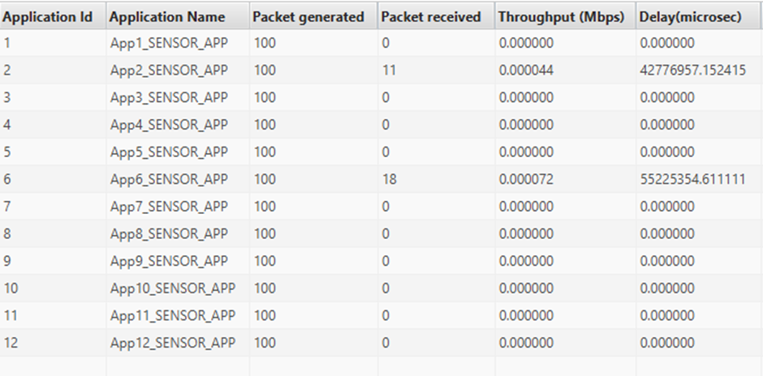
Figure 17: TCP Path Loss

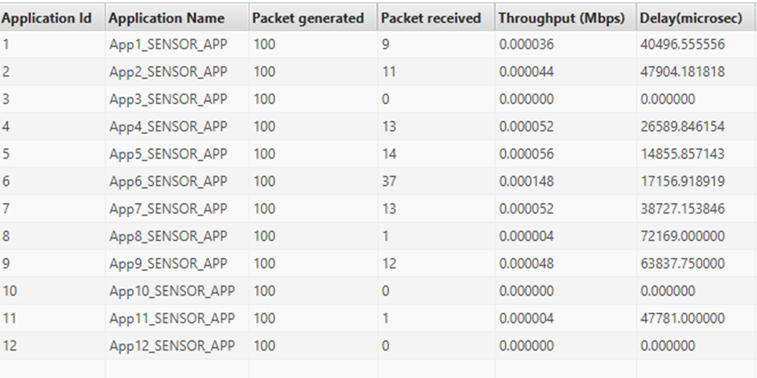
Figure 18: UDP Path Loss

Comparing channel path loss with TCP and UDP. Senor configured with UDP received more packets compared to TCP. Most of the sensor in TCP didn’t receive the packets to the destination.

TCP AODV vs RPL routing protocol

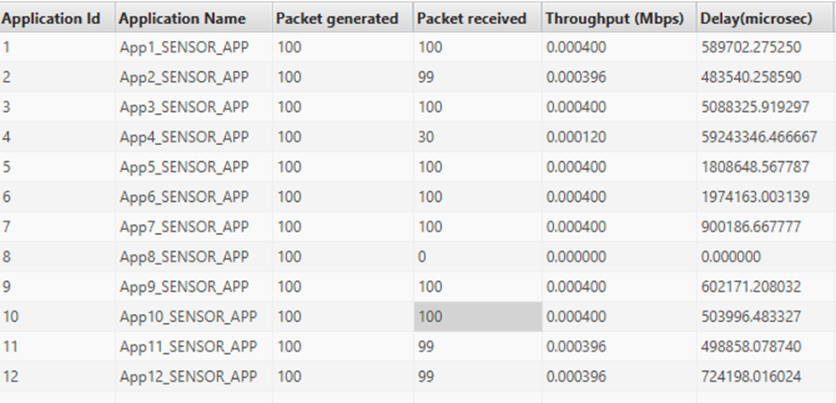
Figure 19: TCP with AODV Protocol

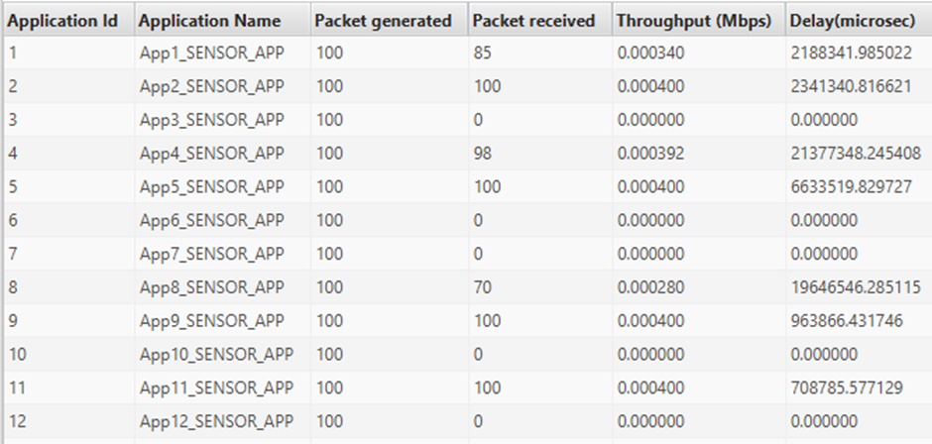
Figure 20: TCP with RPL Protocol

Comparing with AODV vs RPL protocol, the AODV protocol received more packets in each sensor. The Application moving in 10 m/s didn’t receive any packets in RPL protocol. These are compared in channel no path loss.

TCP with AODV protocol, analysis with different application

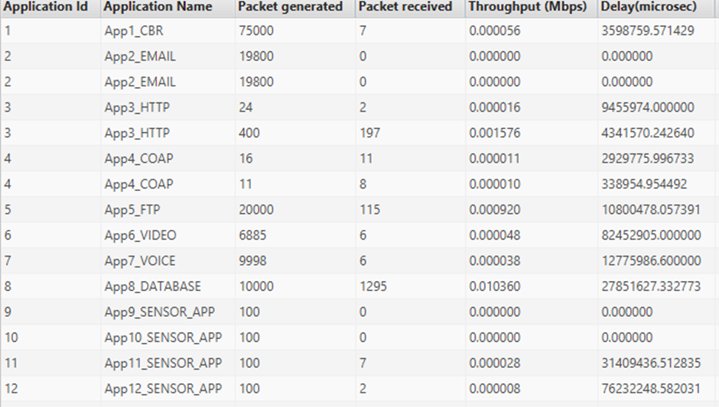
Figure 21: TCP and AODV with different applications

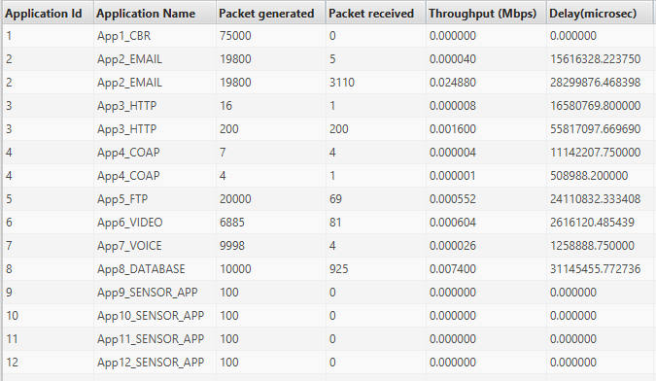
Figure 22: TCP and RPL with different applications

Application No | Application Type
Application 1 | CBR
Application 2 | EMAIL
Application 3 | HTTP
Application 4 | COAP
Application 5 | FTP
Application 6 | Video
Application 7 | Voice
Application 8 | Database
Application 9 | SENSOR_APP
Application 10 | SENSOR_APP
Application 11 | SENSOR_APP
Application 12 | SENSOR_APP
Table 1: Type of Applications
Some of the sensor in RPL received more packets than AODC protocol. The HTTP application in RPL routing received the full packets to destination. All the sensor is set to distance 50 to 100 meters.

Conclusion
This report contains information about ASK, FSK, PSK and QAM. There are many different types of modulation techniques used in wireless communication which is not written in this report. The QPSK modulation technique is chosen to do Smart farm simulation because QPSK modulation technique is most widely used, high bandwidth efficiency, video conference and used in satellite communication, wireless, and cellular. The information carried in QPSK is twice, compared to PSK or BPSK. The smart farm simulation in NetSim, compared with different application and protocols to visualize the performance, bandwidth, delay, throughput and received packets.

Tables and Figures
Figure 1: Modulation Process [5] 2
Figure 2:Amplitude Modulation 2
Figure 3: Frequency Modulation 3
Figure 4: Phase Modulation 3
Figure 5:Digital Modulation [12] 3
Figure 6: Amplitude Shift Keying (ASK) 4
Figure 7:Frequency Shift Keying (FSK) [16] 4
Figure 8:BPSK Signal 4
Figure 9: QPSK Signal 5
Figure 10: QPSK Simulation 5
Figure 11: QPSK Constellation 5
Figure 12: Error Rate 6
Figure 13: QPSK modulated And Demodulated Signals 6
Figure 14: Smart Farm Simulation 6
Figure 15: TCP 6
Figure 16: UDP 6
Figure 17: TCP Path Loss 7
Figure 18: UDP Path Loss 7
Figure 19: TCP with AODV Protocol 7
Figure 20: TCP with RPL Protocol 7
Figure 21: TCP and AODV with different applications 8
Figure 22: TCP and RPL with different applications 8

Table 1: Type of Applications 8

References

[1] | L. Frenzel, "Understanding Modern Digital Modulation Techniques," 23 01 2012. [Online]. Available: https://www.electronicdesign.com/communications/understanding-modern-digital-modulation-techniques. [Accessed 10 04 2019].
[2] | cisco, "Wireless Fundamentals: Modulation," cisco, [Online]. Available: https://documentation.meraki.com/MR/WiFi_Basics_and_Best_Practices/Wireless_Fundamentals%3A_Modulation. [Accessed 10 04 2019].
[3] | M. Rouse, "modulation," [Online]. Available: https://searchnetworking.techtarget.com/definition/modulation. [Accessed 11 04 2019].
[4] | "Modulation Methods," [Online]. Available: https://www.rohm.com/electronics-basics/wireless/modulation-methods. [Accessed 11 04 2019].
[5] | E. Channel, "Modulation Techniques," 30 09 2017. [Online]. Available: https://www.youtube.com/watch?v=beFoCZ7oMyY. [Accessed 11 04 2019].
[6] | "Analog Communication - Modulation," tutorialspoint, [Online]. Available: https://www.tutorialspoint.com/analog_communication/analog_communication_modulation.htm. [Accessed 11 04 2019].
[7] | D. Tipper, "Digital Modulation," [Online]. Available: http://www.pitt.edu/~dtipper/DM.pdf. [Accessed 12 04 2019].
[8] | tutorialspoint, "Analog Communication - Modulation," [Online]. Available: https://www.tutorialspoint.com/analog_communication/analog_communication_modulation.htm. [Accessed 12 04 2019].
[9] | n. vlajic, "eecs.yorku," 2010. [Online]. Available: https://www.eecs.yorku.ca/course_archive/2010-11/F/3213/CSE3213_08_AnalogModulation_F2010.pdf. [Accessed 12 04 2019].
[10] | equestionanswers, "equestionanswers," [Online]. Available: http://www.equestionanswers.com/notes/modulation-analog-digital.php. [Accessed 12 04 2019].
[11] | elprocus, "What is Phase Modulation: Advantages, Disadvantages, and Applications," [Online]. Available: https://www.elprocus.com/what-is-phase-modulation-advantages-disadvantages-and-applications/. [Accessed 12 04 2019].
[12] | allaboutcircuits, "Phase Modulation: Theory, Time Domain, Frequency Domain," [Online]. Available: https://www.allaboutcircuits.com/textbook/radio-frequency-analysis-design/radio-frequency-modulation/phase-modulation-theory-time-domain-frequency-domain/. [Accessed 12 04 2019].
[13] | britannica, "Digital signal modulation," [Online]. Available: https://www.britannica.com/technology/digital-signal-modulation. [Accessed 12 04 2019].
[14] | SASMITA, "Write the Advantages and Disadvantages of a Digital Communication System," 29 10 2017. [Online]. Available: https://electronicspost.com/write-the-advantages-and-disadvantages-of-a-digital-communication-system/. [Accessed 12 04 2019].
[15] | openlearn, "Amplitude-shift keying (ASK)," [Online]. Available: https://www.open.edu/openlearn/science-maths-technology/exploring-communications-technology/content-section-1.4. [Accessed 12 04 2019].
[16] | openlearn, "Frequency-shift keying (FSK)," [Online]. Available: https://www.open.edu/openlearn/science-maths-technology/exploring-communications-technology/content-section-1.5. [Accessed 12 04 2019].
[17] | tutorialspoint, "Frequency Shift Keying," [Online]. Available: https://www.tutorialspoint.com/digital_communication/digital_communication_frequency_shift_keying.htm. [Accessed 12 04 2019].
[18] | tutorialspoint, "Digital Communication - Phase Shift Keying," [Online]. Available: https://www.tutorialspoint.com/digital_communication/digital_communication_phase_shift_keying.htm.
[19] | Mathuranathan, "Binary Phase Shift Keying (BPSK) – modulation and Demodulation," 8 04 2010. [Online]. Available: https://www.gaussianwaves.com/2010/04/bpsk-modulation-and-demodulation-2/. [Accessed 12 04 2019].
[20] | rfwireless-world, "Advantages of BPSK | Disadvantages of BPSK," [Online]. Available: http://www.rfwireless-world.com/Terminology/Advantages-and-Disadvantages-of-BPSK.html.
[21] | tutorialspoint., "Quadrature Phase Shift Keying QPSK," [Online]. Available: https://www.tutorialspoint.com/digital_communication/digital_communication_quadrature_phase_shift_keying.htm. [Accessed 13 04 2019].
[22] | rfwireless, "Advantages of QPSK | Disadvantages of QPSK," [Online]. Available: http://www.rfwireless-world.com/Terminology/Advantages-and-Disadvantages-of-QPSK.html. [Accessed 13 04 2019].
[23] | M. Rouse, "QAM (quadrature amplitude modulation)," 09 2005. [Online]. Available: https://searchnetworking.techtarget.com/definition/QAM. [Accessed 13 4 2019].
[24] | R. A. Chaudhari, "Quadrature Amplitude Modulation," [Online]. Available: http://www.rutvijjoshi.co.in/index_files/Quadrature%20Amplitude%20Modulation11.pdf. [Accessed 13 04 2019].

