

University of Wales Trinity Saint David
School of Engineering

Alexandre Bierley
1901530
Bsc Motorsport Engineering Year1
23/03/2020
Module code: M4X02198

Contents:

List of figures: 2
Introduction: 3
Research: 4
Results: 6
Analysis: 12
Conclusion: 13
References: 14

List of figures:

Introduction:

Each Vehicle has its own design regarding the driver’s needs. A Formula 1 car’s purpose is to go as fast as possible around the track where a 4x4 is to be able to climb hills and get out of mud. The 4x4 will get out of the mud happily when the formula 1 has no chances. The formula 1 will fly on the track where the 4x4 will be slow and ineffective. They are simply designed to meet some specific requirements.
The following Technical report will look at how vehicle chassis and suspension design could affect a vehicle behaviour and will deeply explain how. It will start by defining what is vehicle ride comfort and handling all will explain what affects these vehicle characteristics. The report will also take a look at what affects vertical wheel load and will examine how it is affected by going through a series of real-life simulation using tables, formulas and graphs from Microsoft Excel.

Research:

What is ride comfort?
Ride comfort can be defined as how well a person feels in a vehicle while travelling in multiple scenarios. Different people will have different approaches of comfort but general opinion suggest that, the smoother the vehicle is, the more pleasant the ride will feel. The principal cause of discomfort in a vehicle is vibrations (International Ergonomics Conferences, 2004). Vibrations that human internal ear perceives may affect the overall feeling of a person. Generally, vibrations with a frequency between 1 Hz and 1.5 Hz. (Journal of Engineering Research and Application, 2019).
What factor affect ride comfort?
Ride comfort can get affected by diverse parameters such as suspension set-up, vehicle’s mass, vehicle’s design or tyre profile (Pankaj Vig (2016) What is ride quality & what affects it? ). The following technical report is orientated on the mechanical aspect of ride comfort, however, different noises such as exhaust sound, engine sound or the sound of tyres on road surface could also be a source of discomfort for the vehicle occupants.
How these factors affect ride comfort?
Suspension set-up makes a considerable impact on the ride comfort of a vehicle. Assuming that in this case, the suspension system is equipped with a damper unit and spring. The suspension system absorbs most shocks from road disturbances. More precisely, the spring absorbs the shock and the damper unit helps to reduce the natural oscillation effect caused by the shape the spring (Robert Q.Riley, 2020). The natural frequency of a suspension system is settled by the static deflection rate (capacity of a suspension system to compress regarding weight applied to it) (Bin Yu (2019)). Static defection rate has an impact on ride comfort of a vehicle. During the process, depending on the situation, the suspension system also creates high frequency vibrations that are reflected on the top strut mount of the suspension then on the structure of the vehicle. (Robert Q.Riley, 2020)
The mass of a vehicle has also an impact on ride comfort. In fact, it does not affect ride comfort directly but affects the natural frequency of the suspension system. If taking a completely factory car with suspension system designed for it, when additional mass like passengers or loading the car with luggage is applied to the vehicle, the natural frequency is reduced. It is due to the fact that the suspension system is preloaded and will deal less over-damping. As states Robert Q.Riley “Over-damping (above 100 percent) dramatically reduces ride quality” (Q.Riley, 2020).
Tyres is the only component that creates contact with road surface. The tyre profile has a significant impact on the ride comfort of a vehicle. Larger tyres will have greater side walls and a bigger contact patch than smaller ones. They have a better ability to absorb shocks as it will shape itself around road deformations. On the other hand, smaller tyres, due to the rigidity of their shape will have to climb the deformation which results in a less pleasant ride.
Vehicle wheelbase, wheel track and centre of gravity will also impact ride comfort. In fact, a car with a longer wheelbase tends to pitch less than a car with smaller wheelbase. Same theory for roll effect. A vehicle with a wider wheel track tends to deal less roll effect than a vehicle with a narrower wheel track. The Height of the vehicle directly affects the centre of gravity which impact roll effect as well. Higher vehicles will roll more during cornering than lower ones (Robert Q. Riley, 2020).

What is handling?
Handling could be defined as the ability of a vehicle to perform and react regarding the driver’s needs. Handling could also be evaluated while driving in different scenarios such as accelerating, braking or cornering (Policedriver.com, 2015).
What factor affects handling?
There are different factors that could affect handling such as weather conditions, the road surface condition. However, this report will focus on the mechanical aspects of what could affect a vehicle handling. The main factors that have an impact on a vehicle handling are suspension system design, tyres and aerodynamics (Cars direct, 2012).
How these factors affect handling?
The suspension system on a vehicle is designed to absorb shocks from road disturbances as seen previously. The true purpose behind absorbing road deformations is to try keeping maximum contact between the tyre and road surface in all conditions, at all times (Cars direct, 2012). Suspension systems are designed by manufacturers to fit specific requirements and abilities for a certain vehicle. Although, handling can be affected by how stiff or soft the manufacturer designed the system. On the other hand, a worn out, damaged or misaligned suspension components could result in a partial or even complete loss of control of the vehicle (Cars24, 2020). Here are some examples of factors that could affect handling: a worn-out damper unit, worn-out anti-roll bar bushes, a broken suspension spring, an incorrect suspension alignment, a bended suspension arm.
Tyre design also impacts vehicle handling. As seen previously, the choice for bigger tyres will allow a better ride comfort which is the case for most commercial vehicles. However, lower profile tyres will allow better performances. Low profile tyres tend to have smaller side walls which results in a tyre dealing less flexibility when cornering forces are applied to it.
Aerodynamics have a direct impact on stability of a vehicle at higher speed. Manufacturers design cars body shape in order to create downforce while minimising drag coefficient (Patrick E. George (2020) How Aerodynamics work). Downforce is the force that pushes the vehicle downwards at high speed. It contributes to vehicle overall stability and gives a better handling. Less or no downforce on a vehicle will give a less stable driving.
In order to apply the research and show the balance between comfort and handling, real life examples such as road vehicles, supercars and race vehicles are uses and compared. A common road vehicle, in its range of use, will need a proportional balance of handling and comfort. As it is used every day in every condition, it needs to be fairly comfortable but also needs to have a good handling for safety purpose. A road vehicle does not need to have great performances however it needs to be efficient and pleasant to drive.
Supercars on the other hand, have a slightly different range of use and will need to meet a different balance of comfort and handling than road vehicles. A supercar needs to show a better handling performance but also need to meet requirements in terms of comfort as it is a faster road vehicle and not a race vehicle.
Race vehicles are design for handling. In its range of use, a race vehicle does not need to meet comfort requirements but needs to have the best handling possible in ever situations.

Results:

To understanding how a suspension system behaves while the vehicle is experiencing G forces, a series graphs are created from real conditions scenarios using Microsoft Excel.
Base data about the vehicle details is given in order to complete a series of formulas. First step is to calculate static load for each corner. Next step is to calculate aero load with a given velocity (30m/s). The next step is to use formulas to complete the scenarios required. Graphs are plotted and discussed afterwards.
Here is the data base for the vehicle:

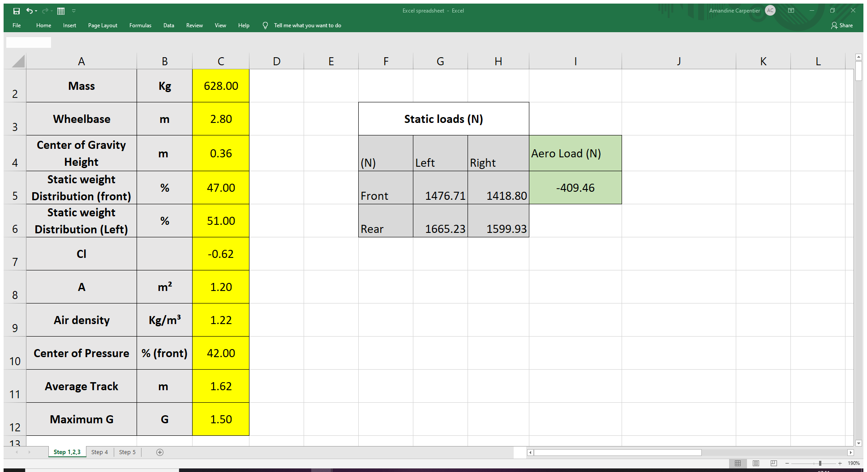
Figure 1 Vehicle base data and characteristics

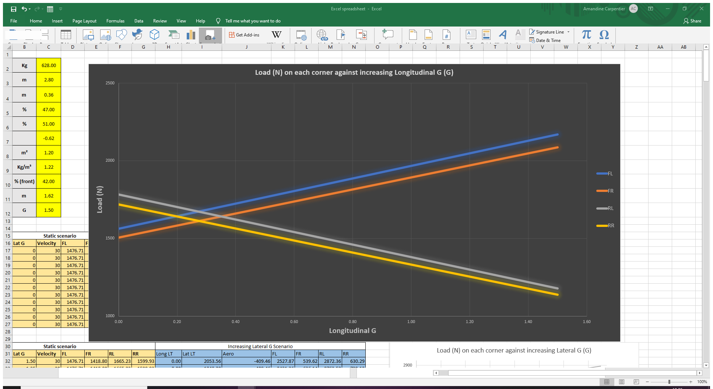
Figure 2: Load on each corner over increasing longitudinal G force
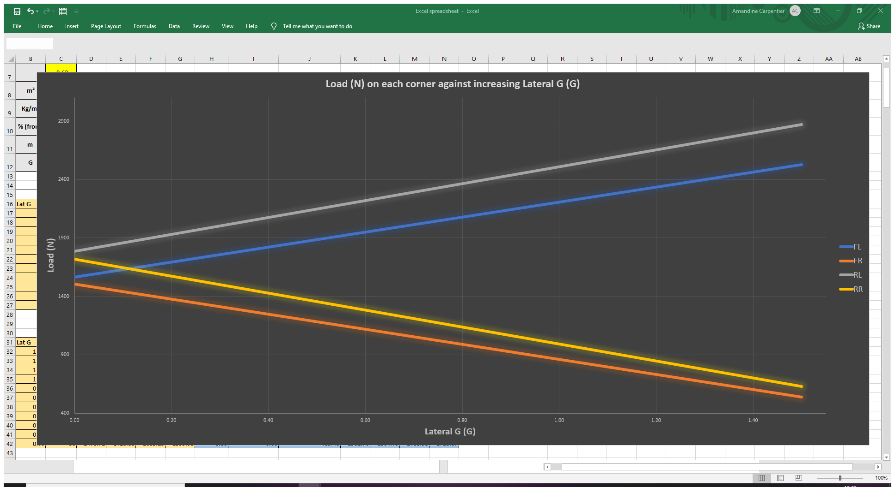
Figure 3: Load on each corner over increasing lateral G force
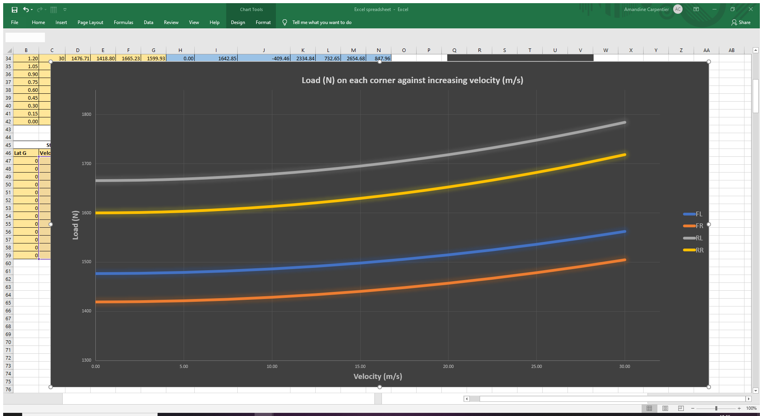
Figure 4: Load on each corner over increasing vehicle velocity
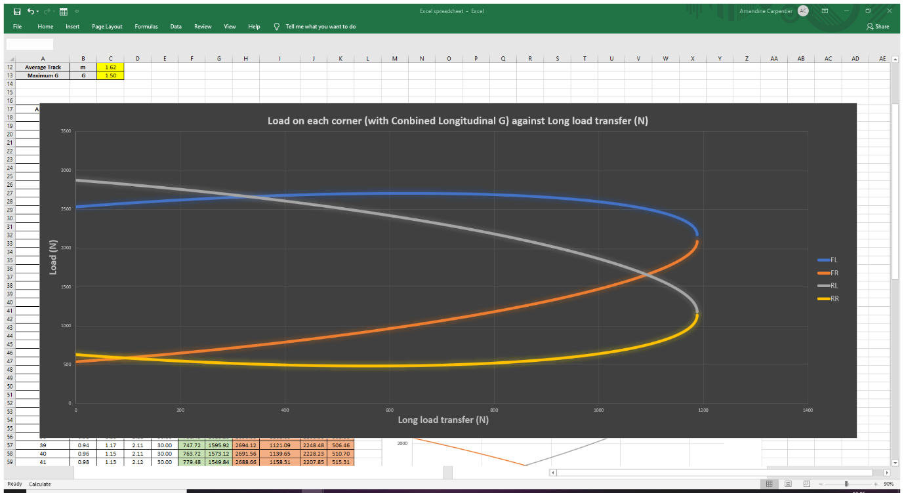
Figure 5: Load on each corner over combined longitudinal load transfer
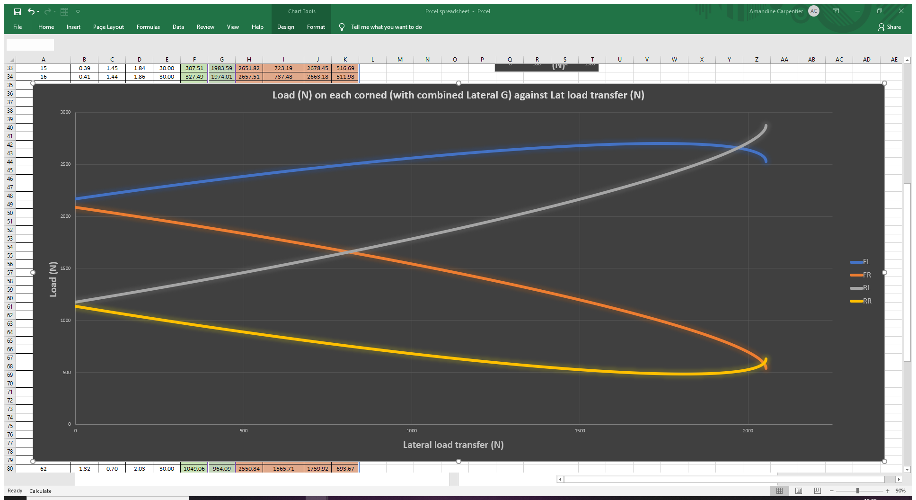
Figure 6: Load on each corner over combined lateral load transfer
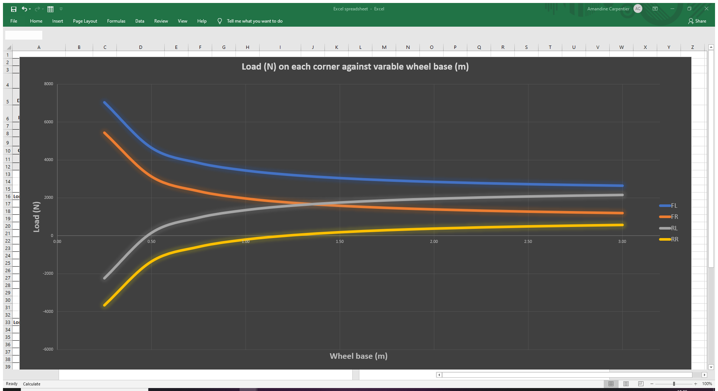
Figure 7: Load on each corner over varying wheel base
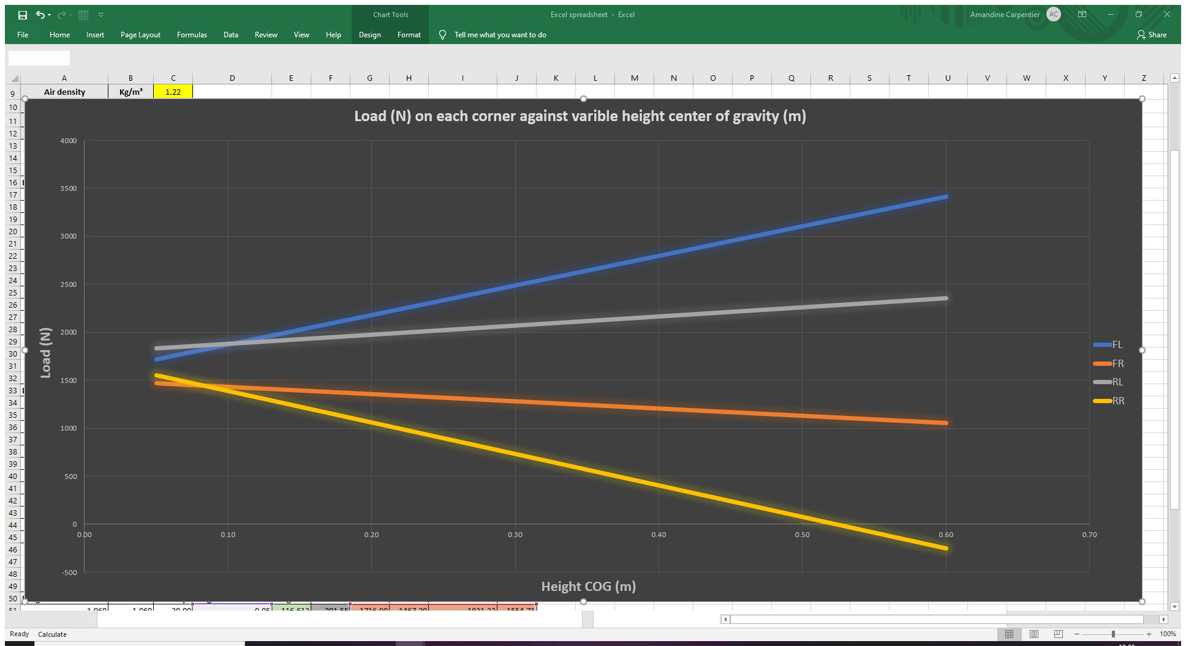
Figure 8: Load on each corner over varying wheel track
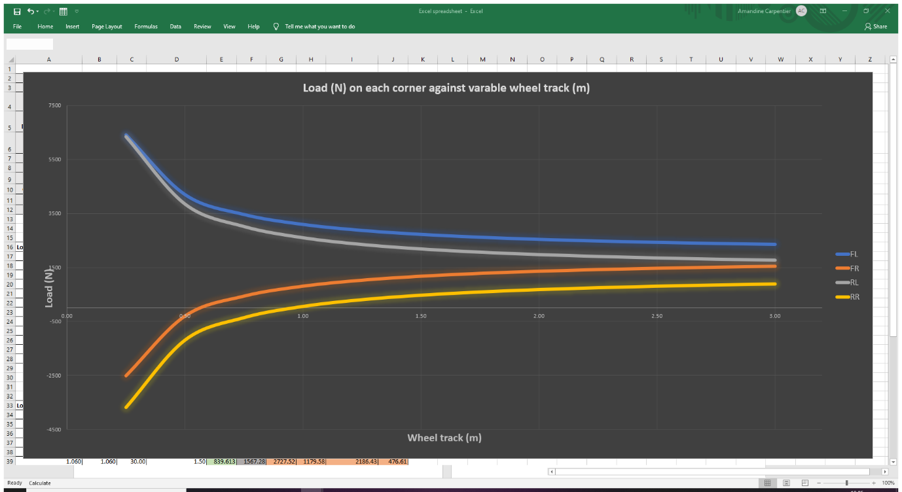
Figure 9: Load on each corner over varying Height COG

Analysis:

Basic Scenarios:
Figure n°2 shows the vertical load (N) on each corner over longitudinal load transfer (N). When simulating an increase of longitudinal G force from 0 to 1.5G at 30 m/s, the graph shows that vertical load transferred to the front of the vehicle is dramatically increasing. However, vertical load transfer at the rear is dramatically decreasing.
Figure n°3 shows the vertical load (N) on each corner over lateral load transfer (N). When simulating an increase of lateral G Force from 0 to 1.5G at 30 m/s velocity, the graph shows that the vertical load transfer on the Left corners of the vehicle is increasing when load on the right corners is decreasing.
Figure n°4 shows the vertical load (N) on each corner over velocity (m/s). When simulating an increase of velocity from 0 to 30m/s with no lateral or longitudinal G force, the graph shows that vertical load is gradually increasing in a parallel way.
Vertical load on corners is transferred regarding where the vehicle mass is transferred. While braking, most of the load is transferred to the front of the vehicle due to the pitch motion (figure 1). While going in a corner, load is transferred side to side in the opposite direction of the cornering direction due to roll motion (Figure n° 2).
While accelerating, aerodynamic load is applied on the vehicle resulting in an equally increasing vertical load on four corners due to the downforce effect (figure n°3).

Changes in chassis dimensions have serious impacts on vehicle behaviour as well as weight distribution. The load transfer is the main actor in vehicle handling as it affects the vertical load on each corner regarding of external forces applied to the vehicle.

Conclusion:

Chassis and suspension systems are designed by manufacturers according to purpose and use of every vehicle. A road vehicle will have different standards than a race vehicle (depends on driver requirements). Vehicle ride comfort and handling are indirectly linked as they are affected by the same components (tyres, spring, damper, chassis design). However, one could affect and limit the other one (comfort vs handling). Chassis design also affect the handling balance as it has an effect on pitch, roll and yaw which influences the repartition of vertical load on the wheels on the vehicle.

References:

- Robert Q.Riley Enterprises (2020) Automobile Ride, Handling, and Suspension Design and Implications for Low-Mass Vehicles.
Available at: https://rqriley.com/automobile-ride-handling-and-suspension-design-and-implications-for-low-mass-vehicles/
Accessed: 22/03/2020

- Pankaj Vig, AutoPortal (2016) What is ride quality and what affects it?
Available at: https://autoportal.com/articles/what-is-ride-quality-and-what-affects-it-9723.html
(Accessed: 22 March 2020).

- Kormuz & Osman, faculty of mechanical Engineering and Naval Architecture. (2004) Main ambient factors influencing passenger vehicle comfort

- Rajeev, (2019) Natural frequency, Ride Frequency and their influence in Suspension System Design. Bangalore: Department of Mechanical Engineering, JSS Academy of Technical Education.
- Bin Yu (2019) Investigation of the suspension design and ride comfort of an electric mini off-road vehicle. Available at: https://journals.sagepub.com/doi/full/10.1177/1687814018823351
(Accessed: 22 March 2020)

- Policedricer.com, (2015) The different between handling and cornering.
Available at: https://policedriver.com/the-difference-between-handling-and-cornering/
(Accessed! 22 March 2020)

- CarsDirect (2012) Factors that Affect Car Handling ( and How you can improve them)
Available at: https://www.carsdirect.com/car-safety/factors-that-affect-car-handling-and-how-you-can-improve-them
(Accessed: 22 March 2020)

- Cars24, (2020) ‘Factors Affecting your Car’s Handling’.
- Available at: https://www.cars24.com/blog/factors-affecting-car-handling/
(Accessed: 22 March 2020)

- Howstuffworks, P.E.G (2020) How Aerodynamics Work.
Available at: https://auto.howstuffworks.com/fuel-efficiency/fuel-economy/aerodynamics.htm
(Accessed: 22 March 2020)

