
Programme: BA Business Management
Module: Strategic Management and Sustainability
Module code: LCBB6004
Lecturer: Dr. Jaya Gopalkrishnan
Assignment Title: - Assessment 1 - Volkswagen UK
Student name: Aysidora Stavreva
Student ID: 2030536
Date: 26.08. 2024 City: London

Table of Contents
1. Introduction 3
2. Discussion 3
2.1 Company Background 3
2.2 Key Business Strategies 5
2.3 Resources and Capabilities of the Company 6
2.4 Overview of Automobile Industry and its Competitiveness 8
2.5 Environmental and Sustainability Framework 10
3. Conclusion 11
Reference: 12
Appendix: 14

Introduction
The focus of the assessment is to review the operations of Volkswagen which is engaged in the manufacture of automobiles and the company is known for its car designs and innovative products. The analysis will cover the key business strategies which the company has implemented over the last 5 years and such strategies will be analyzed with the help of different strategic models. Further the discussion will be showing the resources and capabilities of Volkswagen and show whether the same is consistent with their business strategies. Further the analysis would be presenting an insight into the UK Automobile Industry and how the business of Volkswagen competes in such an industry (Hassan 2019). In addition to this, the analysis would be showing how the business implements sustainability practices and environment-friendly approaches to stay competitive in the market. Further the analysis would conclude whether Volkswagen has been able to successfully implement its business strategies and whether approach outcome is gained from them or not.

Discussion
2.1 Company Background
The Volkswagen group is one of the leading automobile brands in the work and the company has its origin in Wolfsburg, Germany. The business manufactures automobiles and commercial vehicles and is the largest car manufacturer in Europe. The business has successfully expanded its operations as it has around 114 manufacturing facilities across 19 European Countries and 10 countries among Asia, Africa, North and South America. The group has bifurcated its operations into sectors like battery sector, Software Development center, Production site and innovation center. To show the presence of the company across the globe, a map is presented below marking all the sectors which the business maintains across nations.

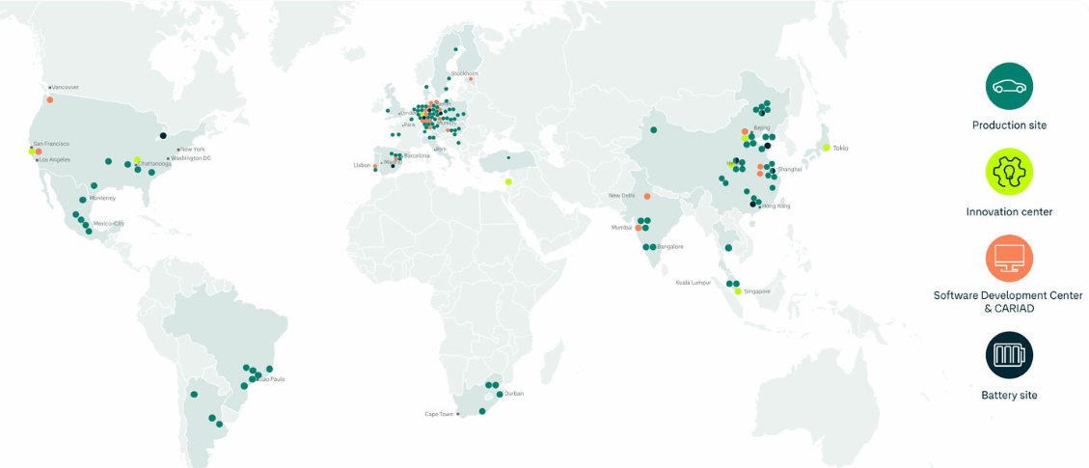
Source: (Volkswagen Group Sites 2024)
In addition to the above figure, some of the basic information regarding the company is shown below in table:
Parameters | Details
Number of employees | 684025 employees worldwide (Annual report 2023).
Company formation date and Age | 28th May 1937 and the company has operated for more than 87 years (Volkswagen Newsroom 2024).
Financial Situations | The business has achieved € 322 billion in 2023 worldwide in terms of sales.
Operating Markets | The business operates worldwide, as it has around 114 manufacturing facilities across 19 European Countries and 10 countries in Asia, Africa, North, and South America (Volkswagen Group Sites 2024).

2.2 Key Business Strategies
The automobile industry is changing rapidly due to the innovations taking place and due to emphasis on the environment & sustainability. The business of Volkswagen Group has always focused on innovative designs and products which can enhance the experience of the customers. As per a study conducted by Raj, Beck and Soliman (2019), German automobile makers always look to integrate innovation, efficiency and costs concepts in their strategies which has been a reason for the success of brands like BMW and Volkswagen (Raj, Beck and Soliman 2019). Some of the key business strategies which Volkswagen has implemented or going to implement, is explained below:
- Focus on Mechatronics and Scalable Systems Platforms: The management of Volkswagen has already realized that Electric vehicles are the future of the industry where clients are looking for innovative solutions and more features. The business is therefore focusing on the Scalable Systems Platform (SSP) where the business can create electric, digital and scalable vehicles for the clients across all its products (Volkswagen-group.com 2024). This shows that the business is following product differentiation strategy for its products as per Porter’s Generic strategies. As per Totlani (2023), Volkswagen has committed around €30 billion as investments for creating electric or hybrid version of vehicles and around 70 new models of such vehicles is expected to appear in the market by 2028.
- Emphasis of Software: The Group focuses immensely on the development of its own software and technology company CARIAD for the development of mobility solutions. The company has been developing the E3 1.2 platform which would assist in the harmonization of the hardware and software system of vehicles, and this is already being applied on Porsche and Audi. As per Totlani (2023), the Group is looking to redefine the company as a "software-driven mobility company”, with software development and new automated driving solutions (Totlani 2023). Considering the application of Ansoff Matrix, the business of Volkswagen is in the product development stage as improvements are being made to existing products and some new models are going to be introduced by 2028.
- Battery Improvements: The Group further recognizes that battery is an important component of the electric vehicle. Further the success of an e-vehicle is determined by the battery life and charging capacity and range. For this, the business of Volkswagen has entered strategic alliances with partners so that battery can be developed which are core to the success of the business. One objective here is to ensure that the battery developed is sustainable and recyclable. As per a study undertaken by Albertsen et al. (2021), Volkswagen and Daimler have formed an alliance over receiving battery cells and development of charging points for its electric vehicles.
- Sustainability: One of the core strategies for the business of Volkswagen Group is the policy of sustainability in their approach after the Diselgate scandal. The company has recalled its products and paid compensation for the same in the UK for the scandal and there were several litigations as well. For ensuring sustainability is achieved, zero emission policy is strictly followed for all the vehicles being developed (Volkswagen-group.com 2024). Further the business is also looking to transition to electric vehicles so that both sustainability and innovation can be achieved. In addition to this, the batteries which the company are development are recyclable, efficient and sustainable which promotes the strategy of the business.
The above analysis shows that the core areas where the strategies of the company is targeting are innovation, efficiency, costs and sustainability. As per the analysis done in the appendix, following Porter’s generic strategies, the business is differentiating its products by innovation, battery development, and better car design, and by following the Ansoff Matrix, the business is following product development for a better future of the company.

2.3 Resources and Capabilities of the Company
The business of Volkswagen is quite an established company in the automobile industry and the financial performance of the business has remained consistent over the years. In addition to this, the business has access to the networks of Europe and an employee strength of 684025 employees worldwide as of 2023. In terms of physical, monetary and human resources, the business has ample access to all three, which makes it easier for the company to focus on its strategies and ensure that success is achieved in business operations (Wappelhorst et al. 2020).
The SWOT framework, presented in the appendix section, appropriately shows that the business's strength is its brand name, and opportunities involve the new electric vehicles that are gaining customers' attention. The business is looking to develop a new range of electric vehicles by using its Scalable Systems Platform (SSP), efficient battery systems and software to enhance the experience of the users. As per Totlani (2023), the business of Volkswagen has achieved success in its operations through sales of nearly 50% pure electric (BEV) during the initial half of 2023. This shows that the management is utilizing its resources in an appropriate manner and generating revenue from its operations. This study further shows that the business has already invested around €30 billion in the development of software, electric vehicles and batteries. All these investments show that ample funds have been allocated and further there is a budget maintained if there is any shortage of funds (Volkswagen-group.com 2024).
By application of the VRIO framework, the unique features of Volkswagen are the software it utilizes for its cars and the battery, which are being developed as part of a strategic alliance. As per Kukkamalla, Bikfalvi and Arbussa (2021), collaborative partnerships in automobile industry have helped in development of unique capabilities within companies and a prime example is the case of Volkswagen where the business has benefitted significantly with the use of better battery and charging stations (Kukkamalla, Bikfalvi and Arbussa 2021). The VRIO framework explained in the appendix section also makes it clear that the software, battery and SSP which the business utilized are rare, not imitable and further are properly managed as well. Further as per a study undertaken by Cagáňová et al. (2019), intellectual capital is essential for an automobile industry and businesses like Volkswagen has some of the best minds working separately for its innovative departments.
One of the inherent objectives of the strategies defined above is expansion and competitive advantage through sustainability. The business of Volkswagen can establish more factories to boost production in areas of Europe and America, which would enhance the reach of the business. In terms of sustainability, the management has implemented a zero-tolerance policy towards carbon emissions and further ensured that materials are used which are environment friendly and recyclable. The sustainability framework for the company is developed in a manner such that it can repair the reputation affected due to Disealgate scandal.

2.4 Overview of Automobile Industry and its Competitiveness
The automobile Industry is very competitive in the UK market, as there are different established brands operating in the market. The automobile industry in the UK is an integral part of the economy, contributing around £ 93 billion in turnover from sales and around £ 47 billion in trade, which is 12% of the exports. A graph presented below shows the manufacturing volume of cars in UK:
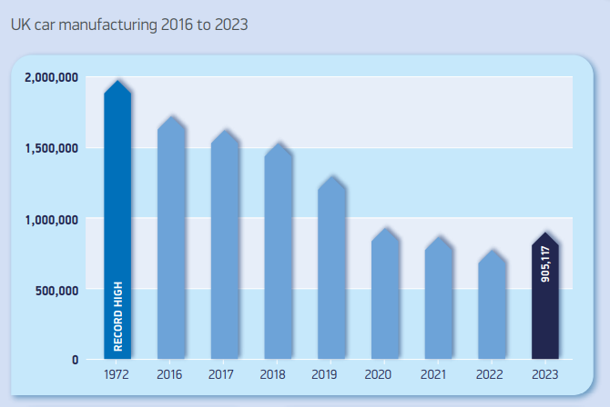
Source: (Smmt.co.uk 2023)

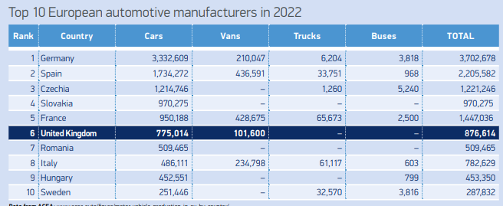
Source: (Smmt.co.uk 2023)
The above table further shows that the UK is in 6th place when it comes to automobile manufacture and distribution and this trend is expected to grow further in the coming years. Further, there are established brands in the market like Nissan, Landrover, Toyota, BMW and others and therefore the level of competition in the market is immense (Hlušková 2019). Considering the PESTLE analysis undertaken in the appendix section, the automobile industry in the UK is highly competitive with low political interventions (Smmt.co.uk 2023). The business of Volkswagen needs to integrate its electric vehicles with the software and look to differentiate their products from the competitors (Trintini et al 2021). The business of Volkswagen needs to develop a local network, and this can be done by setting up new factories in the UK region for electric vehicles and batteries. As per Lee et al. (2021), companies like Volkswagen and Hyundai need to develop local ecosystem and utilize local resources to successfully set up operations in the UK and face competition.
The appendix section also shows the use of Porter’s five forces model which provides insights that the bargaining power of the customers are high as there numerous substitutes available in the market. Further for the UK market, the business still needs to gain the trust of the people after the Disealgate scandal. There are businesses which have already established a loyal customer base in the market which further affects the growth chances for Volkswagen unless some new products are introduced by the company. As per a study undertaken by Skeete (2019), automakers in the UK face high competition mainly because all companies are trying to broaden their processes and add innovation to the same. This is another reason why new entrants are facing difficulties while entering the automobile industry in UK. The business strategies which Volkswagen follows incorporates innovation as one of the central features and with the resources the company has, innovation can be achieved with the new generation of electric vehicles which it will introduce by 2028.

2.5 Environmental and Sustainability Framework
Volkswagen understands its role in terms of environmental protection and integrating sustainable approaches in its operations. The company's vision has incorporated regenerate+, which focuses on taking responsibility for the business's actions and bringing about positive change in the operations. The Disealgate scandal has further made the company more vigilant against emissions and takes every initiate to control the emission in its vehicles (Che, Katayama and Lee 2020). The business is further committed to principles stated under the Paris agreement and looks to align the operations with the 1.5-degree target stated. One of the goals which the business is looking to implement is to achieve net carbon neutrality by 2050. In terms of energy consumption as well, the management has ensured that 100% of the energy for the electric plants comes from renewable sources of energy. For instance, one of the subsidiaries of Volkswagen has set up wind farms across Europe to ensure that electricity generation is done in an appropriate manner. The sustainability policies for Volkswagen further look to incorporate waste reduction which is achieved by recycling. The business at present capacity recycles around 25% of its resources which includes both plastic and metals.
The management of Volkswagen further recognizes that it has a responsibility towards biodiversity and therefore the business has set aside €25 million as biodiversity funds. This fund is maintained so that the business can undertake external projects, and this will be commencing from 2025. This shows that the business has incorporated a green strategy in its operations so that biodiversity can be protected. An instance can be given regarding the business’s commitment as it has a vision of a Zero Impact Factory that can coexist with biodiversity without any negative impacts of the same (Volkswagen-group.com 2024). The management has further taken steps to promote the local biodiversity of the country. All these initiatives show the commitment which business has towards the protection of the environment. Besides the environmental initiatives, the business also takes responsibility for its partners, suppliers, and society at large as part of their CSR initiatives. The company has decided to establish a sustainability impact fund worth 20 million Euros for ensuring that the needs of society are met. The initiative is said to commence in 2025, and further, it considers the safety of its employees as the top priority of the business. In an overall basis, it can be said that the business of Volkswagen is committed to the needs of the society and environment, and this is further expected to grow further in the coming years.

Conclusion
The above analysis shows the commitment of Volkswagen as a business that is looking for innovation for market leadership as well as maintaining sustainability. The analysis shows the main business strategies which the company has implemented in the last five years and the outcomes which they have already produced for the business. The analysis further shows the resources and capabilities which are available with the business and how the same aligns with the corporate strategies for the business. In addition to this, the analysis shows an overview of the UK automobile industry and how the business of Volkswagen is looking to develop competitive advantage in such a market. The analysis also gives an insight regarding the sustainability practices of the business and how the business is looking to pursue its sustainability objectives in future.

Reference
Albertsen, L., Richter, J.L., Peck, P., Dalhammar, C. and Plepys, A., 2021. Circular business models for electric vehicle lithium-ion batteries: An analysis of current practices of vehicle manufacturers and policies in the EU. Resources, conservation and recycling, 172, p.105658.
Annual report 2023 VW Annual Report 2023 Employees. Available at: https://annualreport2023.volkswagen-group.com/group-management-report/business-development/employees.html#:~:text=At%20the%20end%20of%20the,since%20the%20end%20of%202022. (Accessed: 20 August 2024).
Cagáňová, D., Hlásniková, P.R., Vraňaková, N. and Chlpeková, A., 2019. Intellectual capital as a key factor in the automotive industry. Mobile Networks and Applications, 24, pp.2024-2031.
Che, X., Katayama, H. and Lee, P., 2020. Willingness to pay for brand reputation: Lessons from the volkswagen diesel emissions scandal.
Hassan, A.S., 2019. Evaluating the marketing communication strategy of Volkswagen in post-crisis period: application of image repair theory. International Journal of Marketing Studies, 11(2), pp.87-101.
Hlušková, T., 2019. Competitiveness outlook of the automotive industry in the V4 countries. Studia Commercialia Bratislavensia, 12(41), pp.24-33.
Kukkamalla, P.K., Bikfalvi, A. and Arbussa, A., 2021. Collaborative partnerships in the automotive industry: key motives and resource integration strategy. International journal of business innovation and research, 24(4), pp.571-592.
Lee, J., Kim, J., Kim, J. and Choi, S., 2021. Why localization is necessary as a business strategy in emerging markets: The case comparison of Hyundai and Volkswagen. Journal of Open Innovation: Technology, Market, and Complexity, 7(3), p.190.
Raj, R., Beck, V. and Soliman, A., 2019. Utilization of value-based management in the strategic management of German automotive industry. Global Business Review, 20(4), pp.871-886.
Skeete, J.P., 2019. Concentration of power: A UK case study examining the dominance of incumbent automakers and suppliers in automotive sociotechnical transitions. Global Transitions, 1, pp.93-103.
Smmt.co.uk 2023 SMMT Motor Industry facts 2023. Available at: https://www.smmt.co.uk/wp-content/uploads/SMMT-Motor-Industry-Facts-May-2023.pdf (Accessed: 21 August 2024).
Totlani, R., 2023. How automotive firms can better adapt to the shift to electric vehicles. Innovative Research Thoughts, 9(5), pp.42-54.
Trintini, A.M.M., Amaral, M.G.D., Motta, G.D.S., Souza, M.C.M.D. and Rosa, J.A.A., 2021. Twenty years performance of Volkswagen’s Truck and Bus modular consortium. Gestão & Produção, 28, p.e4931.
Volkswagen Group Sites 2024 Volkswagen Group. Available at: https://www.volkswagen-group.com/en/volkswagen-group-sites-17481 (Accessed: 20 August 2024).
Volkswagen Newsroom 2024 Volkswagen Newsroom History. Available at: https://www.volkswagen-newsroom.com/en/history-3693 (Accessed: 20 August 2024).
Volkswagen-group.com 2024 Volkswagen Group. Strategy Available at: https://www.volkswagen-group.com/en/strategy-15955 (Accessed: 21 August 2024).
Volkswagen-group.com 2024 Volkswagen Group. Sustainability strategy Available at: https://www.volkswagen-group.com/en/sustainability-strategy-18157 (Accessed: 21 August 2024).
Wappelhorst, S., Hall, D., Nicholas, M. and Lutsey, N., 2020. Analyzing policies to grow the electric vehicle market in European cities. International Council on Clean Transportation.

Appendix
1. Porter’s Generic Strategies
The application of Porter’s generic strategy requires the business to select one strategy from the model which can be cost leadership, Differentiation strategy or a focused strategy for both. For automobile industry, the market changes are immense as there are lots of innovations. A Porter’s generic model is listed below for automobile industry:
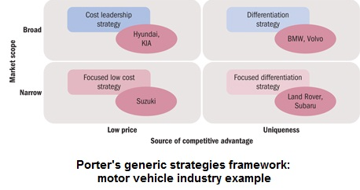
The above graph shows how different companies follow different approaches in terms of business strategies and this helps in generation of competitive advantage. In the case of Volkswagen Group, From the strategies of Volkswagen, it can be established clearly that the company is looking to make changes to its products only by changing mechatronics, battery and other aspects. This shows that the business is following an approach where it is utilizing product differentiation strategy from the model.
2. Ansoff Matrix:
The Ansoff Matrix is an effective tool which is used for the evaluation of the strategies which the business is implementing for the future. With the help of Ansoff matrix, an insight can be gained regarding the strategic approaches of the business. A graph showing Ansoff matrix is portrayed below:
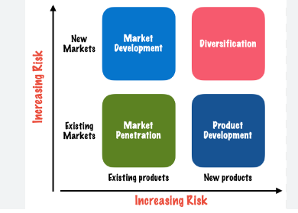
Regarding Volkswagen Group, the strategic approach of the business which are implemented a well as those which will be implemented suggests that the company is looking improve software, mechatronics, introduce numerous models of electric vehicles and improve the battery system as well. All these changes reflect major changes to the product, and they influence its performance as well. It can therefore be said that the business is at product development stage where the company is committed to make investments for a better future and competitive advantage. The business is using the same channels and network to introduce better products to the market.
3. SWOT Analysis
Parameters | Details
Strengths | - Brand Name of the company is successfully established in the market.  - Financial performance of the business has only improved over the years
Weaknesses | - Emission scandal and its related Lawsuits in the UK  - Diversification issues in terms of brands
Opportunities | - The new brand of electric vehicles being introduced in the market  - Expansion opportunity in other market like Asia, Africa, Middle east.
Threats | - The rising level of competition in the market from popular brands like Hyundai, Toyota and other premium cars  - Ongoing lawsuits in Europe

4. VRIO Analysis
VRIO analysis is undertaken to assess the strategy, process or product that is being developed and considers the approach of the business from the viewpoint of the following parameters:
Parameters | Details:
Value | A capability or resource is considered valuable if it helps generate competitive advantage and negates threats. For instance, Volkswagen's software and technology company, CARIAD, provides the company with a unique capability to develop software through a platform and integrate hardware and software systems together, which would help develop competitive advantage.
Rarity | The software systems and products designs are developed by Volkswagen independently and therefore the same are rare for the business and therefore effective in generating competitive advantage.
Imitability | Further it is to be noted that the software has their patents and copyrights which makes the difficult to imitate as per regulations.
Organization | In addition to this, Volkswagen has different centers to support innovations and software development and therefore appropriate skills and resources are available at the disposal of the company for further development.

5.PESTLE Analysis
Factors | Details
Political | The automobile industry in the UK is affected by the regulations and BREXIT which took place recently as trade is affected. One of the growing trends in Automobile industry is electric vehicles. The trade regulations are open for such vehicles between the UK and EU when it comes to batteries or any other materials, and this helps in the manufacturing of such materials. For businesses like Volkswagen, such access helps in setting up operations in the UK which are self-reliant. In addition to this, the tariff rates are also reduced to support operations and creations of new jobs
Economic | The economic factors are also favorable, even though there was high inflation and a dip in investment post-COVID-19. Businesses like Tata Group are investing £ 4 billion in setting up factories for electric batteries, while brands like BMW are investing around £ 600 billion in electric car manufacturing. The flow of funds is appropriate in the market, and even Volkswagen has invested 30 billion euros for the same purpose.
Social | The social factors incorporate the taste and preferences of the customers and brands which offer the best products are always preferred among the people.
Technological | The technological factors are at its peak in automobile industry as there is race on for perfecting the electric vehicles solution with proper battery life and capacity. The business of Volkswagen itself is working on software development for E³ Platform development and entered strategic alliance for battery development.
Legal | Legal factors play an important role as there are company regulations and registration requirements, along with third-party regulations, that need to be followed before commencing manufacturing and distribution operations.
Environmental | Lastly the environmental factors are also growing in importance due to climate changes concerns and therefore all companies are expected to produce vehicles which has minimum emissions.

- Porter’s Five Forces Analysis
- Bargaining Power of the Customers: The bargaining power of the customers is on the higher side as there are numerous options available in the market of UK and therefore product differentiation is important for developing competitive advantage. Players like Nissan, Toyota, BMW are always looking to innovate their product designs and therefore Volkswagen needs to work on its software for differentiation.
- Bargaining Power of Suppliers: The bargaining power of suppliers is on the lower side for Volkswagen as they maintain a list of suppliers and can import materials from other countries as well. The business further has strategic alliances with companies which also assist in procurement of materials whenever required.
- Threat of substitutes: The threat of substitutes is higher as there are similar products available in the market, including electric vehicles. The business of Volkswagen therefore follows a strategy to work on its software development and innovation so that product differentiation can be achieved.
- Threat of new entrants: The threat for new entrants in the market is not that high as the industry is an oligopoly which means that established players are dominating the market and there are several barriers to entry in the market which affects new entrants like availability of funds and bifurcated customer base.
- Industry Rivalry: The industry rivalry is also on the higher side due to extreme competition and all the brands are established with a loyal customer base. The products which are being offered are also not that much different.

