What makes a Great Leader?

This essay is about leadership styles and the author has used businessman Lord Alan Sugar and the author’s style as a case study. The author has selected Lord Alan Michael Sugar due to the fact that he is a prominent British business magnate and leader in the business industry. In addition to this, he is a media personality, political advisor, politician and author. Lord Sugar was born in Hackney hospital, London in 1947. Lord Sugar was brought up in a council estate; 16 Woolmer House in Upper Clapton Road in Clapton which is a district of east London in the London Borough of Hackney (Alan Sugar, 2010 p3). Furthermore, Lord Sugar’s mother worked in a clothing factory and his father worked as a tailor at numerous sweatshops in east London. Unfortunately, what his parent earned was not much. As a result, there was a lack of money however his parents made the most of the basic items they could afford and tried their utmost best to provide Lord Sugar and his siblings a good upbringing (Brennan, S 2010). Moreover, Lord Sugar attended Northwold Primary School. Upon finishing primary education, in 1958, he attended Joseph Priestly Secondary School (Alan Sugar, 2010 p5).

At the age of 17, Lord Sugar secured his first job as a salesman in a tape-recording company. At that company, he became the top salesman by selling, delivering products and collecting the money. Whilst working as a salesman, he realised that he could offer the same goods and services to customers albeit by himself in his own organisation. In an interview with Brian Rose on the London Real (2020), Lord Sugar asserted that he launched his businesses because he wanted to be self-sufficient and not depending on others. Lord Sugar also stated that he has always had a great interest in electronics which was also a factor that encouraged him to sell products for himself. To achieve this, in 1968, from his savings of £100 Lord Sugar purchased a minivan worth £60 to start his business which focused on electrical products. He also spent £8 on third party insurance for the vehicle and £42 on car aerials from a seller named Ronnie Marks. The car aerials were resold to customers for a profit. He named his electrical company ‘Amstrad’. Lord Sugar also mentioned that in 1967, the highest earners generated £20 a week however his target was to make at least £60 a week. 50 years later Lord Alan Sugar’s business ‘Amstrad’ was worth £1 billion however it was sold to Sky in 2007 (BBC, 2021). This shows that he applies Kurt Lewin’s autocratic leadership style. Additionally, Alan Sugar is the former chairman of Tottenham Hotspur Football Club. Currently, he is the owner of Amscreen which is the largest digital media organisation in the United Kingdom and property investment firm Amsprop (BBC, 2021). Lord Sugar has partaken in 15 series of BBC One’s the Apprentice in which he provides ambitious young businessmen and women the opportunity to compete in order to obtain an investment of £250,000 and work with Lord Sugar, this shows that he applies one of the five forms of power of French and Raven’s Power theory which is reward power. He views and tests the candidates who understand what business is and looks for the quality in people. For example, a fast learner, works hard and is ambitious to generate money. Lord Sugar motivates people by claiming that hard work will indisputably lead one to success therefore this results in people feeling inspired and impelled to achieve success. The impact Lord Sugar had on the winners of the Apprentice is that he guided them to their business success as a leader with his help and elevated their ability of business (London Real (2020). This shows that he utilises Vroom expectancy motivational theory and James Burns concepts of leadership style. (Lord Alan Sugar’s timeline is in the appendix p12).

What led Lord Sugar to success was that he comprehended the power of ownership. He concluded that one should be a leader who is self-motivated, possess the mental toughness to not cease making an effort to achieve one’s goals and committed to attain one’s business aims and objectives (Vials, L 2018). Due to Lord Sugar’s success and feats in business, former Prime Minister Gordan Brown awarded Lord Sugar his peerage. Subsequently, Lord Sugar was appointed as the Government’s enterprise tsar. What Lord Sugar has managed to achieve with The Apprentice made him ideally suitable to lead the campaign, as enterprise tsar, of driving people towards starting their own business (Live&Learn Consultancy ltd, 2020). In 2009, Alan Sugar was added into the House of Lords which made him a ‘Lord’ (London Real (2020).

Leadership

Leadership is with reference to influence individuals in such a way that they share similar or common aims and objectives, attitudes, values and work more effectively in order to achieve the visions of the organisation (Taleo Research p7 2010).

According to Skillsyouneed, (2021), leadership a characteristic of excellent leaders and gives them the ability and flexibility to adjust to changes in the situations required. Leadership skills are aimed to be brought about by an individual who is involved in dealing with people in a way to enthuse, build respect and motivate.

Importance of leadership style

Leadership style is important part of an organisation’s development. Organisations can not work efficiently without effective leadership. Leadership is also an important purpose for the management to increase the achievement and productivity of the organisation’s goals, it can help to maximise the efficiency of the organisation (Strengthscape limited, 2021).

An advantage and disadvantage of leadership

There is a plethora of advantages of a leadership. One advantage is that Rosser, J (2021) asserted on the article Success Steam that leadership can lead to an increase in productivity. To elucidate, when the correct leadership style is implemented it can result in the productivity of the employees to increase. Therefore, the employees will work together to achieve the shared aims of the organisation. However, despite the advantage there’s disadvantage to leadership. According to Hamel, G (2018), the disadvantage is that there could be a clash of personalities. To explain, the leader and the employee may not always agree and interact with each other properly. This is greatly avoidable due to the fact that the leader will operate in a workplace which includes people of different personalities. When a leader and employees have disagreements, it can result in disputes which can lessens productivity and consumes time. Undoubtedly, leaders must have people skills of the highest standard and must possess the ability to adjust their leadership styles in order to work well with the personalities of different employees.

Leadership styles

In the 1930’s, Kurt Lewin created leadership style framework. Kurt Lewin argued that there are three main leadership styles which are Autocratic, Democratic and Laissez-Faire (Mindtools, 2021).

Autocratic

Autocratic leadership is when a leader truly believes that one is highly intelligent in the workplace and has more knowledge compared to others. Autocratic leaders possess the ability to create all the decisions with little contribution from members of the team (Martinuzzi, B 2019).

An advantage and disadvantage of autocratic leadership style

Gaille, B of the article Brandongaille (2018) asserted that, there are many advantages of autocratic leadership style, one is that when there is an autocratic leader in the organisation it will save time and result in quick and fast decision making. To explain, there are less administration levels that are required to be informed of all decisions, when an autocratic leadership is present within the workplace. In addition, there is fewer feedback from several levels of management which are required to be processed. This is due to the fact that there is one leader and their role is to be in charge of all managements. This leads to time being saved and decisions are made swiftly as only one leader is assessing the advantages and disadvantages of the organisation. However, despite the advantage according to Cherry, K of the article verywellmind (2020), there are plethora of disadvantages of Autocratic leadership style one is that, when a person is known as an autocratic leader they are often viewed as by others as controlling, harsh and powerful. This can occasionally result in irritation to groups of people. To explain, groups of people might feel that they cannot speak up or cannot participate regarding something that needs to be done. This is a problem because it makes people think their skills, knowledge and contributions are not valuable therefore they feel as if they are ignored. This is highly common issue with autocratic leadership.

Democratic

Democratic leadership is one of the many leadership styles. In this leadership style, group members are more involved in the decision-making procedure. Members of the group are persuaded to share opinions and ideas however the final decision is retained by the group leader (Jakhar, S 2017).

Laissez-Faire
Laissez-Faire is a leadership style which is completely opposite to the leadership style of autocratic. Rather than one leader making most of the decisions for a team or group, organisation, Laissez-Faire leaders make a small number of decisions and permit their employees to select the correct solutions regarding the workplace. People with Laissez-Faire leadership style have these characterises (STU online, 2018).

Lord Alan sugar leadership style

Lord Alan Sugar’s leadership style according to Cotton, B (2018) is that he is known for autocratic leadership style. To elucidate, Lord Alan Sugar is owner of several organisations which are led by him. He develops ideas and leads employees to achieve the aim and objectives of the organisation in order for the organisation to succeed. As seen on the Apprentice programme his attitude can come as controlling which indicates that he is autocratic. Furthermore, Lord Alan Sugar being autocratic has led him to be a successful businessman. However, being too autocratic results in people who had worked for him disliking his character and quit his business. For example, 2010 Apprentice winner Stella English, she once admired Lord Alan Sugar for his achievements and success in the business industry (Macfarlane, J 2011). Stella English experienced significant autocratic behaviour from Lord Sugar and felt as a victim when she was working in his IT company ‘Viglen’ alongside Lord Sugar and his business partners. Stella English described Lord Alan as a rude businessman who has no interests in his employees and gives false hopes (BBC, 2013). Despite this, Lord Alan Sugar also has some of the characterises of democratic leadership style. To elaborate, Lord Alan Sugar takes the winners of the Apprentice business ideas and provides great support throughout their business career. Essentially, he takes in ideas and opinions of the winners and provides them with valuable and important information to guide them to success in the business. 8 out of 16 of Lord Alan Sugar’s Apprentice winners are still working with him. After taking the Apprentice winners ideas, Lord Alan Sugar makes the final decision for a business. This substantiates that Lord Alan Sugar has democratic leadership (BBC, 2019).

Management

Management styles is when a manager utilises one’s authority in the organisation and makes sure that the aims and objectives are attained. Management style refers to how a manager relates to and also manage with one’s subordinates, employees and group members. The essential components of leadership and management style are behaviours and attitudes (CMI, 2008).

Difference between Leadership and Management

According to Go2HR, (2021), the main dissimilarities between management and leadership is that managers have people that work for them in comparison to leaders who have people following them. Successful business owners are required to be an effective manager and powerful leader in order to have employees on board to lead them to their vision of accomplishment.

Motivation

Motivation is when one has passion regarding one’s activity which goes beyond status, money or power. When one is motivated one will strive to achieve goals with persistence and energy (Loeb, M and kindle, S 1999).

Vroom’s Expectancy Motivation theory

Vroom’s Expectancy theory of Motivation was developed in 1964 by Canadian professor of psychology Victor Vroom. Victor Vroom the theorist researched people’s motivation and established that it relies on three elements which are Expectancy, Instrumentality and Valence (Toolshero,2020).

Expectancy
Expectancy is when a person’s confidence is measured to achieve the results one expects. However, the measure is subjective as it is a measure of one’s belief in oneself (O’Reilly Media 2021). To explain, Lord Alan Sugar believes in himself and has high confidence in what he has achieved and what he intends to achieve.

Instrumentality
Instrumentality is when an employee believes that one’s leader or organisation will provide the rewards that were guaranteed by the leader or organisation (O’Reilly Media 2021). To explain, Lord Alan Sugar’s candidates of the Apprentice believe that they will receive guaranteed investment of £250,000 for their business if they win the competition.

Valence
Valence is when an employee has value to a given reward. The reward can be intrinsic which is essentially a sense of achievement or it can be extrinsic which can be promotion, money or paid time off work (O’Reilly Media 2021). To explain, Lord Alan Sugar awards an investment of £250,000 to the Apprentice winner.

Lord Alan’s techniques of Motivation

According to Vials, L (2018), Lord Alan Sugar has set up for young businessmen and women the Apprentice on BBC One, it is one of the most famous reality business shows which offers young businessmen and women an opportunity to win an investment of £250,000 and receive support from Lord Alan Sugar the successful businessman for more than 50 years for his businesses. Lord Alan Sugar demonstrates the Vroom motivation theory. This is done through motivational speaking, he discusses about the power of hard work and how working hard can lead to one to achieving one’s aims and objectives. This then leaves audiences feeling inspired and motivated. Lord Alan Sugar also believes in one must have confidence and passion in what they want to achieve. As a result, this demonstrates that Lord Alan Sugar applies Vroom’s Expectancy theory of Motivation in his business life.

An advantage and disadvantage of Vroom Expectancy theory of Motivation

There are many advantages of Vroom Expectancy theory, one is according to Tarver, E (2020) is that it is a fact that the achievement will lead to growth in performance which then leads to accomplishment of their desired result. However, there are numerous disadvantages one is, as asserted by Kohli, s (2020), is that the Vroom expectancy theory is not always accurate. To explain, performance, effort and value of the rewards are difficult to quantify which results in the theory being inaccurate.

Transformational theory

James Burns created the concept of Transformational leadership in 1978 which is a theory of a leadership styles that motivates, encourages and inspires workers to make and develop change which will assist in forming and growing the future desired outcome of the organisation (Simpson, S (2012).

The Transformational theory of leadership is based on four concepts. It appears that Lord Alan Sugar displays Transformational leadership style.

Inspirational Motivation- followers inspired and motivated (Inspiring)
To explain, Lord Alan inspires and motivates young businessmen and woman as they aspire to achieve great business success.

Idealised Influence- Role model, goal driven.
To elucidate, Lord Alan influences people to create businesses and partake in Apprentice program in order to enhance one’s business plan which will lead to developing successful business.

Individualised Consideration- truly concerned for the requirements of followers. People driven.
To elaborate, Lord Alan is people driven he motivates, engages and develops skills of young businessmen and woman to be successful for their business.

Intellectual stimulation- challenging followers to be creative and innovative (Innovating).
To explain, Lord Alan encourages young businessmen and woman with his help to innovate and create their business with an exceptional business plan.
(Educational-Business-Articles, 2021)

An advantage and disadvantage of the Transformational leadership

There are many advantages of the transformational leadership, according to Thompson, J (2019), one is that encourages confidence by means of more advantageous communication. To explain, transformational leaders are described as outstanding communicators. When an organisation faces a problem when communicating, they frequently conduct a transformational leader to fluently communicate clearly to remind employees what they need to do and when they need to do it and also moving employees from routine which is not necessary anymore in the organisation to a new routine. This results in an organisation to operate successfully to reach its goals. However, despite the advantage there are disadvantages. One disadvantage Miller, K (2021) asserted is that transformational leadership is not always effective. To explain, in a workplace the transformational leader might not work as an effective motivator which can result in the follower employees thinking the leader is at their level in the organisation rather than being on a higher and greater level which makes the follower employees rely on their own point of view in the workplace.

French and Raven’s five forms of Power theory

In 1959, John R.P. French and Bertram Raven organised and carried out a study of power. As a result of the study, French and Raven concluded that power is split into five distinct and separate forms such as legitimate, expert, coercive, referent and reward (Roven, B 2008). When the forms of power are utilised, it can influence one who has a dissimilar effect on outcomes and relationships. One form of power can be more advantageous compared to other forms of power (worldofworkproject, 2021).

Legitimate
This is what comes from a person’s belief which is formal right to make demands that expect others to follow and act in accordance.

Expert
This is based on the greatest level of knowledge and skills of a person.

Referent
This is the worthiness, perceived attractiveness of a person’s result and right to others respect.

Reward power
Reward power is when a person works well, and ones receives a reward for what they have undertaken or completed. For example, Lord Alan Sugar applies the reward power as he gives a reward to the winner of the Apprentice of £250,000 investment.

Coercive power
This comes from one’s belief that they can punish others regarding failure to act in accordance with what they are supposed to do (Mindtools, 2021). For example, Lord Alan Sugar applies the Coercive power to fire or dismiss his candidates at any time as when he identifies that they are not capable to do business or up to his standard.

An advantage and disadvantage of French and Raven power theory

There is plethora of advantages of French & Raven’s 5 power theory, one is as according to the article French & Raven (2021), is that there is reward power which increases the level of the reward. The bigger the award is the better it is. It can mediate and perceive oneself. The reward power relies on the ability to provide positive feedback and prevent negative responses and results. Although there is an advantage of the 5-power theory presents a many of disadvantages. One disadvantage in particular is that of the coercive power, Leiva, J (2017) asserted that it lowers job satisfaction. To elaborate, employees feel as they are being used and feel as they are being subjected to critical examination or analysis. If the employees does not operate their role or violate the rules which are set, they may get dismissed which can result in organisation losing elements of creativity and innovation.

Disadvantages of Lord Alan Sugar

Despite the success that Lord Alan Sugar has made, he has also had many disadvantages during his successful business journey. One disadvantage is that that he sold his first business Amstrad to Sky because it was not generating the expected amount of money (BBC 2021). Another disadvantage is that as the former chairman of Tottenham Hotspur Football Club he was too autocratic which led him to eventually selling his stake in that organisation because he did not comply with organisation’s partners’ decisions (BBC 2021). One other disadvantage was that while working with the 2010 winner of the Apprentice Stella English, he was criticised for being a rude businessman and not interested in his colleagues (Macfarlane, J 2011). Ultimately, this led to Lord Alan Sugar changing the reward of the Apprentice, in 2011, from a £100,000 salary job to an investment of £250,000 albeit he takes a 50% share in the winner’s business. Additionally, a disadvantage is that 8 out of 16 Apprentice winners are not working or collaborating with him (Rajani, D 2020).

My personal leadership styles and abilities

I have undertaken the Conceptualising leadership questionnaire and identified that I fall under the relationship emphasis. (Copy of the questionnaire is in the appendix, p13-15) Relationship emphasis is a type of leadership which focuses on building success for the result of long-lasting strong relationships with their staffs and job satisfaction, motivation and balance of work and life for them. Relationship emphasis believes that culture in the organisation is highly important and have intention about getting tasks to be completed. Relationship emphasis leaders focuses on supporting, motivating and developing their staffs. Furthermore, relationship emphasis leaders support teamwork and collaboration by communication being encouraged and developing positive relationships. This type of leader’s top priority is the welfare of employees therefore leaders exert effort and time into meeting the individual needs of the employees (Ferry, R 2021). To add, in the past, I demonstrated the relationship emphasis leadership style. To explain, I worked in Amazon as a problem solver on the weekend shift in which I supported, managed, motivated and encouraged a team of more than 20 employees. My role as a problem solver was to respond and assist with issues that employees had with their line of work. I resolved the problems that other employees encountered in which I handed back the problematic items that no longer has any issues in order for their tasks to be completed. As a relationship emphasis leader, I was required to have good teamwork skills, excellent communication with other employees and build strong relationships with them in order to make them feel satisfied and help them achieve the aims of their tasks. I put time and effort into helping employees with their problematic items which undoubtedly resulted in the productivity of the employees to increase and that developed the relationship between the team members and myself. This substantiates that I have displayed relationship emphasis leadership as I collaborated with employees. Indisputably, this has resulted in the employees continuing to work at the organisation.

Moreover, I also have undertaken the leadership style questionnaire to identify my leadership style. (Copy of the questionnaire is in the appendix, p16-17) The result shows that I fall under the democratic leadership style. The author Kurt Lewin asserted that Democratic leadership involves group members to make decisions, share opinions and ideas. This links with what I have applied in the past when working as a manager in my former workplace in a convenience store. As a democratic leader in the store, I had to make decisions however I had to take my colleagues ideas and opinions to make the ultimate decisions. To explain, one of my main responsibilities was to order the stock from suppliers albeit I had to listen to the views and opinions of colleagues regarding what products sell swiftly and are in high demand therefore when I make my final decision I take in the views of my colleagues and order products on the system and also acquire additional stock.

Despite having democratic leadership style in my former workplace, I display autocratic leadership style in my personal life at home and on social media. As Kurt Lewin’s theory of leadership mentioned that autocratic leadership is a management style. In autocratic leadership, the leader has full control of the decisions made taking only few inputs of group members. Autocratic leaders select their own decisions and choices based on their beliefs. To explain, this is similar to myself in my home life with my family. I make all the decisions of my household which include the welfare of my children, finances and management of my property. On social media, the content I create inspires and motivates my followers. To explain, I am a fashionable person as I have interest in luxury brands. I acquire luxury goods and then promote the products on social media sites. The result of the promotions is that a number of followers feel inspired by what I purchase and display. This influences my followers to purchase the goods for themselves. Essentially, I make my own choices based on my beliefs which results in people striving to follow. This also links with James Burns Transformational theory and businessman Lord Alan Sugar as he evidenced to inspire and motivate his followers to achieve the same or similar result as him.

Conclusion

In conclusion the researcher discussed Lord Alan Sugar’s past, achievements and the leadership styles he applies that is advantageous as it leads to the success of his organisations. The researcher defined and explained what the leadership theories are and also demonstrated how Lord Alan Sugar applies the theories and advantages and disadvantages of the theories. Additionally, the researcher undertook leadership questionnaire to find out one’s leadership style and explained how it was applied in the researcher’s workplace and personal life. It is essential for leaders to apply a leadership style due to the fact that it can be utilised to achieve the desired aims and outcomes of an organisation or a person.

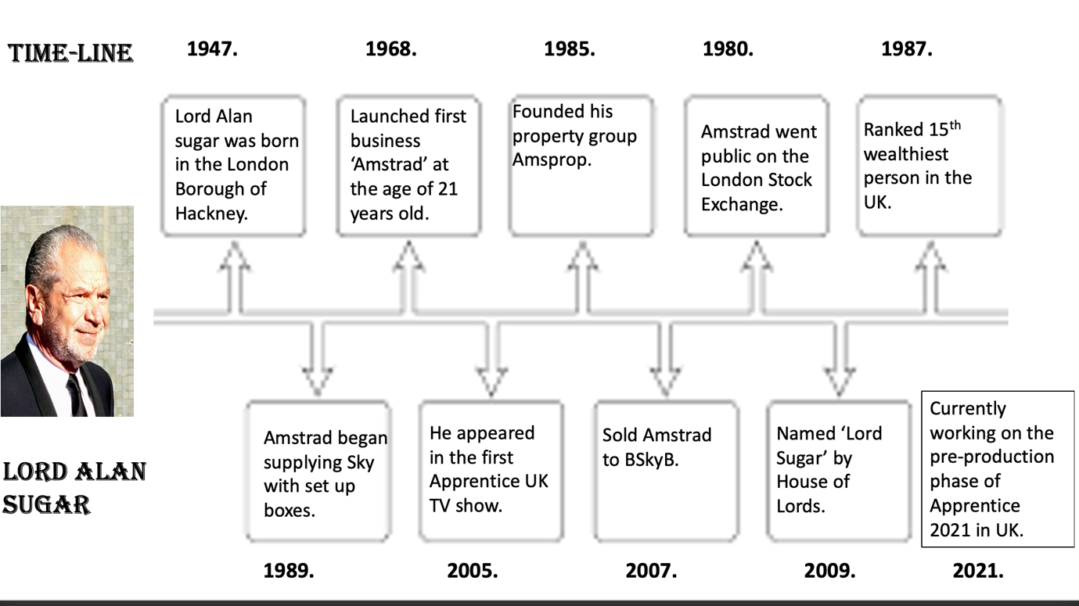
Appendix

Appendix

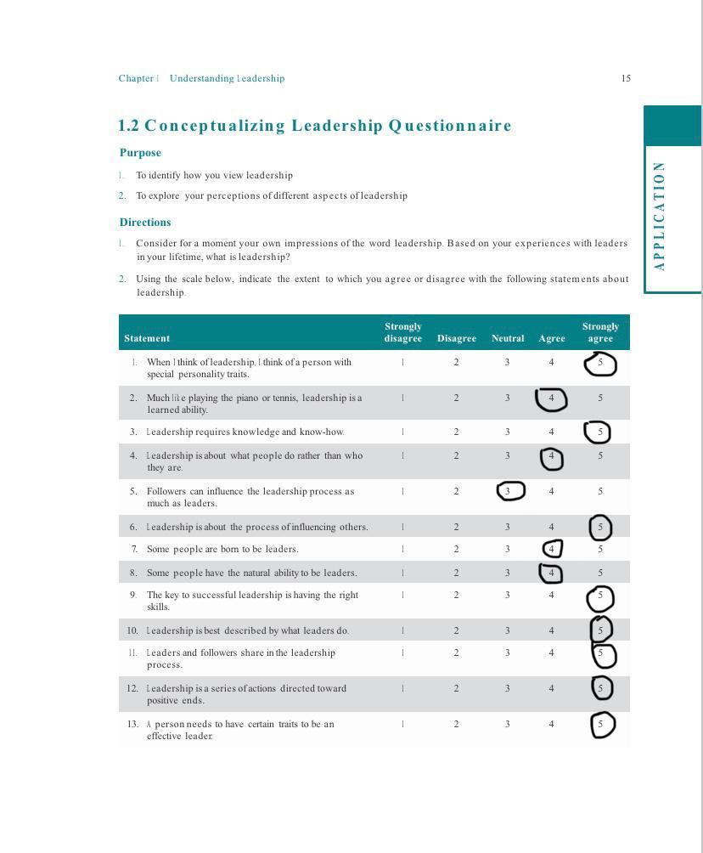

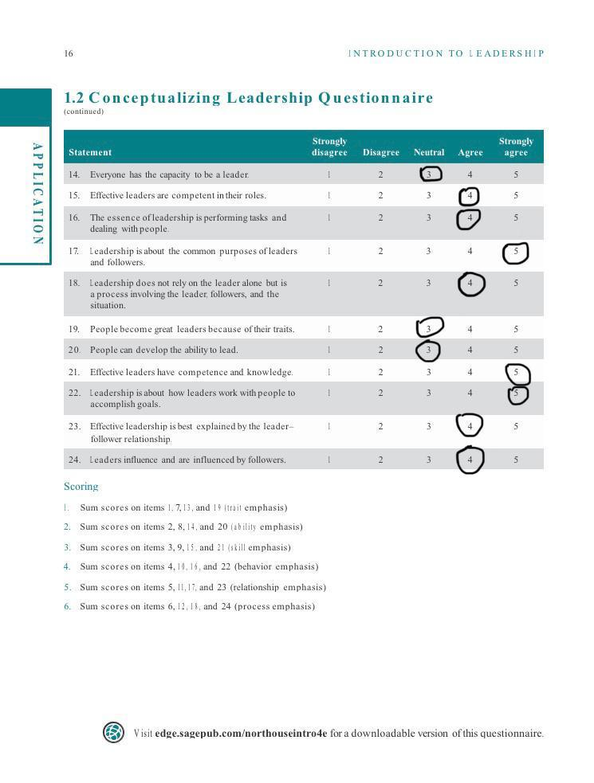

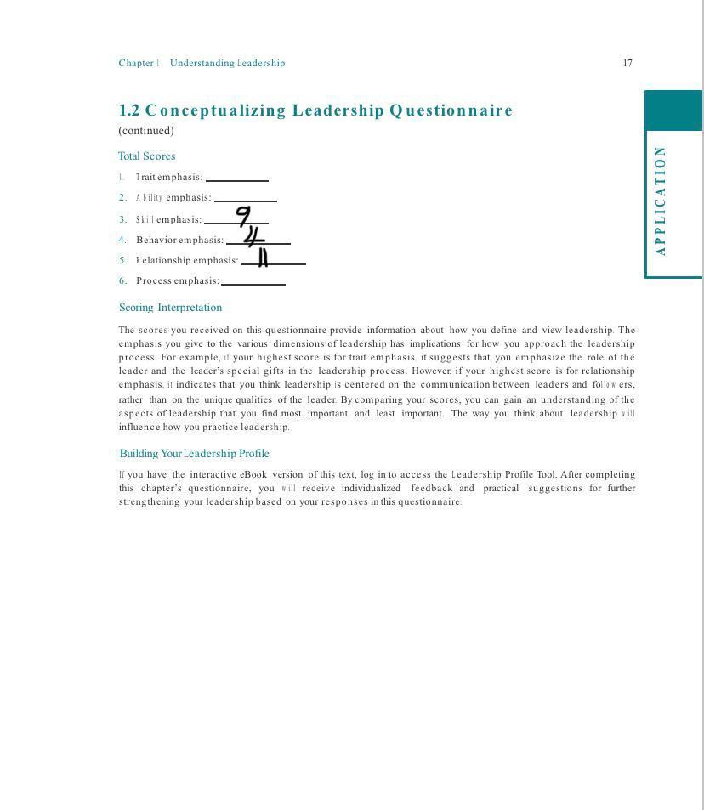

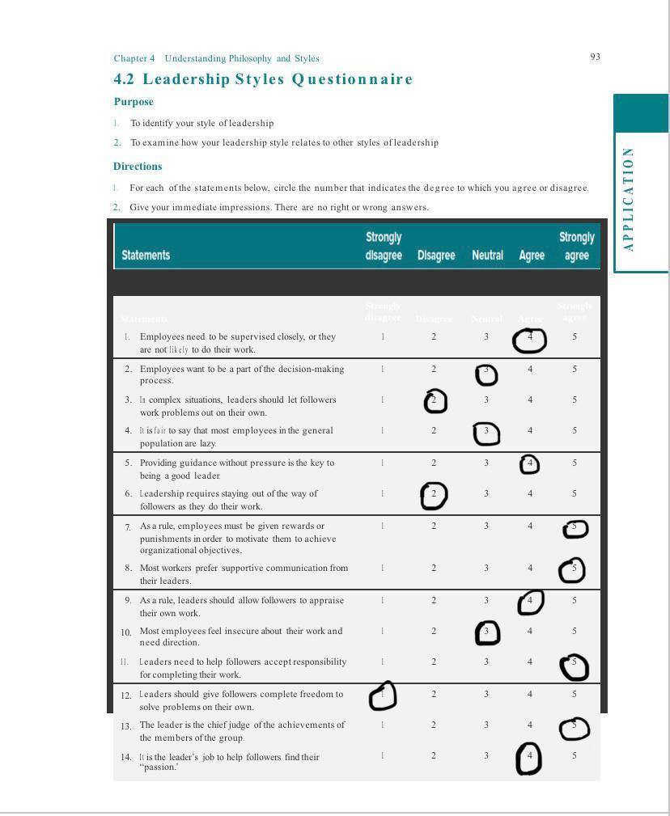

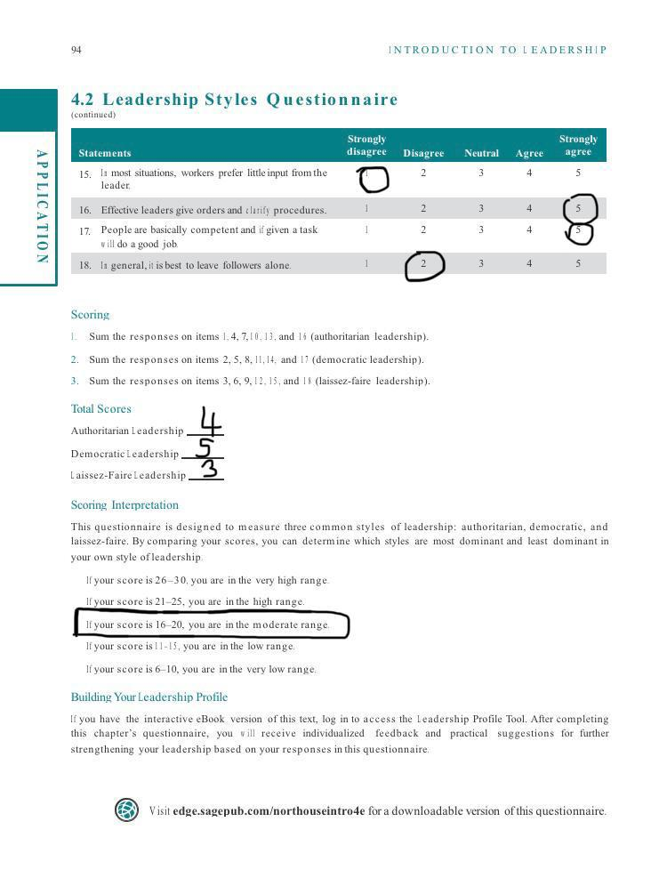

References:

Alan Sugar, (2010) Alan Sugar, what you see is what you get. London, Macmillan ltd
Martinuzzi, B (2019) The 7 most common leadership [Online] Available at: https://www.americanexpress.com/en-us/business/trends-and-insights/articles/the-7-most-common-leadership-styles-and-how-to-find-your-own/ (Accessed on 8th February 2021)

BBC (2021) The Apprentice [Online] Available at:
https://www.bbc.co.uk/programmes/profiles/3hDdWTFzsLy3lVCVtl0rxSg/lord-sugar (Accessed on 3rd February 2021)

BBC (2013) TV's The Apprentice winner Stella English 'overpaid lackey' [Online] Available at:
https://www.bbc.co.uk/news/uk-england-21673051 (Accessed on 26th February 2021)

BBC (2019) The Apprentice: where are the previous contestants now? [Online] Available at: https://www.bbc.co.uk/news/amp/entertainment-arts-50851313 (Accessed on 26th February 2021)

Brian for Mayor (2020) LORD ALAN SUGAR - We need to get everyone back to work: why my employees have returned to the office. London Real [Online] Available at: https://youtu.be/kdT9bSB9DPk (Accessed on 3rd February 2021)

Brennan, S (2010) The bitter side of Sugar |Daily Mail [Online] Available at: https://www.dailymail.co.uk/tvshowbiz/article-1316960/The-bitter-Sugar-How-Apprentice-tycoon-obsessed-height-lack-haunted-poisonous-relationship-parents.html (Accessed on 3rd February 2021)

Cotton, B (2018) LEADERS IN THE SPOTLIGHT: ALAN SUGAR| Business Leader [Online] Available at: https://www.businessleader.co.uk/leaders-spotlight-alan-sugar/42113/ (Accessed on 26th February 2021)

Cherry, K (2020) Autocratic Leadership, Key Characteristics, Strengths, and Weaknesses of Autocratic Leadership |Verywellmind [Online] Available at: https://www.verywellmind.com/what-is-autocratic-leadership-2795314 (Accessed on 3rd March 2021)

CIM, (2008) Understanding Management styles checklist [Online] Available at: https://www.managers.org.uk/~/media/Files/Campus%20CMI/Checklists%20First%20Management%20Role/Understanding%20management%20styles.ashx (Accessed on 8th February 2021

Educational-Business-Articles (2021) Transformational Leadership: Leading Change Through Growth and Empowerment [Online] Available at:
https://www.educational-business-articles.com/transformational-leadership/
(Accessed on 4th March 2021)

Ferry, R (2021) Task vs Relationship Leadership Styles [Online] Available at:
https://talenthub.rfc.ie/task-oriented-vs-relationship-oriented-leadership-styles/ (Accessed on 17th March 2021)

French and Raven (2021) French and Raven’s Source of Power [Online] Available at:

http://zimmer.csufresno.edu/~johnca/spch100/9-6-french.htm (Accessed on 8th March 2021)

Gaille, B (2018) 11 Autocratic Leadership Advantages and Disadvantages | BRANDONGAILLE.COM [Online] Available at: https://brandongaille.com/11-autocratic-leadership-advantages-and-disadvantages/ (Accessed on 3rd March 2021)

Rajani, D (2020) What does the Apprentice winner get? How Lord Sugar’s £250,000 investment prize money actually works Available at: https://inews.co.uk/culture/television/the-apprentice-winner-prize-money-investment-what-how-much-lord-sugar-2019-final-376223/amp (Accessed on 26th February 2021)

Go2HR (2021) Difference between Leadership and Management [Online] Available at: https://www.go2hr.ca/retention-engagement/understanding-the-differences-leadership-vs-management (Accessed on 17th February 2021)

Hamel, G (2018) what are the advantages & disadvantages in leadership in a company or business? [Online] Available at: https://smallbusiness.chron.com/advantages-disadvantages-leadership-company-business-35547.html (Accessed on 17th February 2021)

Jakhar, S (2017) Why and how democratic leadership style is one of the most effective management styles [Online] Available at: https://www.linkedin.com/pulse/why-how-democratic-leadership-style-one-most-effective-jakhar (Accessed on 25th February 2021)

Kohli, S (2021) Management Challenges [Online] Available at: https://supriyamanagementchallenges.weebly.com/expectancy-theory.html (Accessed on 8th March 2021)

Live and Learn Consultancy ltd, (2020) Why is Alan Sugar a successful entrepreneur [Online] Available at: https://www.liveandlearnconsultancy.co.uk/alan-sugars-business-tips/ (Accessed on 13th February 2021)

Loeb, M and kindle, S (1999) Chapter1: A Marshall’s baton in every soldier’s knapsack | Leadership for dummies. 1st edition. P.21, United States of America

leiva, J (2017) Coercive Power in the Workplace |Expert Program Management [Online] Available at: https://expertprogrammanagement.com/2017/07/coercive-power-in-the-workplace/ (Accessed on 8th March 2021)

Macfarlane, J (2011) 'I feel angry and used': 2010 Apprentice winner Stella English reveals why she quit Sugar's £100,000 job after just nine months| This is Money [Online] Available at: https://www.thisismoney.co.uk/money/celebritymoney/article-2047467/amp/2010-apprentice-winner-stella-English-quit-look-job-lord-sugar.html (Accessed on 26th February 2021)

Miller, K (2021) 10 Disadvantages of Transformational leaders |Future Of Working [Online] Available at: https://futureofworking.com/10-disadvantages-of-transformational-leader/ (Accessed on 4TH March 2021)

Mindtools (2021) French and Raven's Five Forms of Power
Understanding Where Power Comes from in the Workplace [Online] Available at:
https://www.mindtools.com/pages/article/newLDR_56.htm (Accessed on 9th March 2021)

Mindtools, (2021) Leadership Styles, Choosing the Right Approach for the Situation [Online] Available at: https://www.mindtools.com/pages/article/newLDR_84.htm (Accessed on 3rd March 2021)

O’Reilly media (2021) VROOM’S EXPECTANCY THEORY [Online] Available at:
https://www.oreilly.com/library/view/the-little-book/9780273785262/html/chapter-033.html (Accessed on 8th February 2021)

Rosser, J (2021) 7 Benefits of effective leadership for organisations [Online] Available at:
https://www.success-stream.co.uk/7-benefits-of-effective-leadership-for-organisations/ (Accessed on 17th February 2021)

Raven, B, H. (2008) The bases of power and the power/ Interaction model of Interpersonal Influence| The society for the psychological study of social issues. Vol 8, issue 1, p1. [Online] Available at: http://psyc604.stasson.org/Raven.pdf (Accessed on 16th February 2021)

Simpson, S (2012) The styles, models & Philosophy of leadership|3 leadership styles p9 Simpson, S & Bookboon.com [Online] Available at: https://www.sustainicum.at/files/projects/268/en/handouts/the-styles-models-philosophy-of-leadership.pdf (Accessed on 8th February 2021)

STU online, (2018) What is Laissez-Faire Leadership? How Autonomy Can Drive Success [Online] Available at: https://online.stu.edu/articles/education/what-is-laissezfaire-leadership.aspx (Accessed on 25th February 2021)

Skillsyouneed, (2021) Leadership skills [Online] Available at : https://www.skillsyouneed.com/leadership-skills.html (Accessed on 3rd March 2021)

Strengthscape limited, (2021) Importance of Leadership in Organizational Development [Online] Available at: https://strengthscape.com/importance-of-leadership-in-organizational-development/ (Accessed on 3rd March 2021)

Tarver, E (2020) Vroom’s Expectancy Theory of Motivation: Definition, Principles & Uses |Evantarver.com [Online] Available at: https://www.evantarver.com/expectancy-theory-of-motivation/ (Accessed on 8th March 2021)

Taleo Research white paper (2010) seven steps for effective leadership development p7 Taleo.com Taleo Corporation

Toolshero (2020) Vroom’s Expectancy Theory [Online] Available at:
https://www.toolshero.com/psychology/vrooms-expectancy-theory/ (Accessed on 8th February 2021)
Thompson, J (2019) Advantages and Disadvantages of Transformational Leadership |Small business, Chron [Online] Available at: https://smallbusiness.chron.com/advantages-disadvantages-transformational-leadership-20979.html (Accessed on 4th March 2021)

Vials, L (2018) Three Motivational Lessons That We Can All Learn From Lord Alan Sugar | The Motivational Speakers Agency [Online] Available at: https://motivationalspeakersagency.co.uk/news/three-motivational-lessons-that-we-can-all-learn-from-lord-alan-sugar (Accessed on 8th February 2021)

Worldofwork project, (2018) French and Raven’s Forms of Power: A Simple Summary
https://worldofwork.io/2019/08/french-and-ravens-forms-of-power/ (Accessed on 8th February 2021)
Bibliography
Famous People (2021) Alan Sugar Biography [Online] Available at:
https://www.thefamouspeople.com/profiles/alan-sugar-3669.php

The Sun (2021) BUSINESS AS USUAL Lord Sugar confirms The Apprentice will return this year and says the show is already in pre-production [Online] Available at:
https://www.thesun.co.uk/tv/14254500/lord-sugar-confirms-apprentice-return/amp/

The Sun (2019) SUGAR MAN How did Lord Alan Sugar make his money, why was The Apprentice boss in hospital and is he married? [Online] Available at:
https://www.thescottishsun.co.uk/tvandshowbiz/1617793/what-is-lord-sugars-net-worth-what-businesses-does-the-apprentice-boss-own-and-when-was-he-tottenham-chairman/amp/

American Express (2019) The 7 Most Common Leadership Styles (and How to Find Your Own) [Online] Available at:
https://www.americanexpress.com/en-us/business/trends-and-insights/articles/the-7-most-common-leadership-styles-and-how-to-find-your-own/

Tellymix (2019) The Apprentice winners: where are they now? [Online] Available at:
https://tellymix.co.uk/reality-tv/293427-apprentice-winners-where-now-2019.html?amp

