17/12/2025
University of Wales Trinity Saint Davids
London Campus
Module Name: Computer Architecture and Operating Systems
Module Code: ACCA 4022

Student Name: Haytham Abubakar
Student ID: 2434465
Group: 3

Lecturer’s Name: Koushik Modak
Computer Architecture and Operating Systems.
Assignment 2
Table of Contents
Introduction 2
Main Body 2
Key functions of general Operating Systems 2
Use of Windows OS CLI commands 6
Use of Linux OS CLI commands 11
Use of Windows OS scripts (Batch Scripting) 17
Use of Linux OS scripts (Bash Scripting) 20
Conclusion 23
References 24

Introduction
Operating systems form the critical foundation of modern computing, serving as essential software platforms that manage hardware resources and facilitate user interaction with computer systems. This comprehensive report investigates the core functionalities of contemporary operating systems while providing practical analysis of command-line interface and scripting capabilities in both windows and Linux environments. The document is structured into five distinct sections that systematically explore: fundamental operating systems function, windows CLI commands, Linux CLI commands, windows scripting techniques, and Linux scripting applications. Each section incorporates visual evidence though screenshots and is supported by academic references and scholarly publications. The practical focus emphasize real-word applications and professional relevance for information technology practitioners and system administrators seeking to enhance their technical proficiency in operating systems management and automation.

Main Body

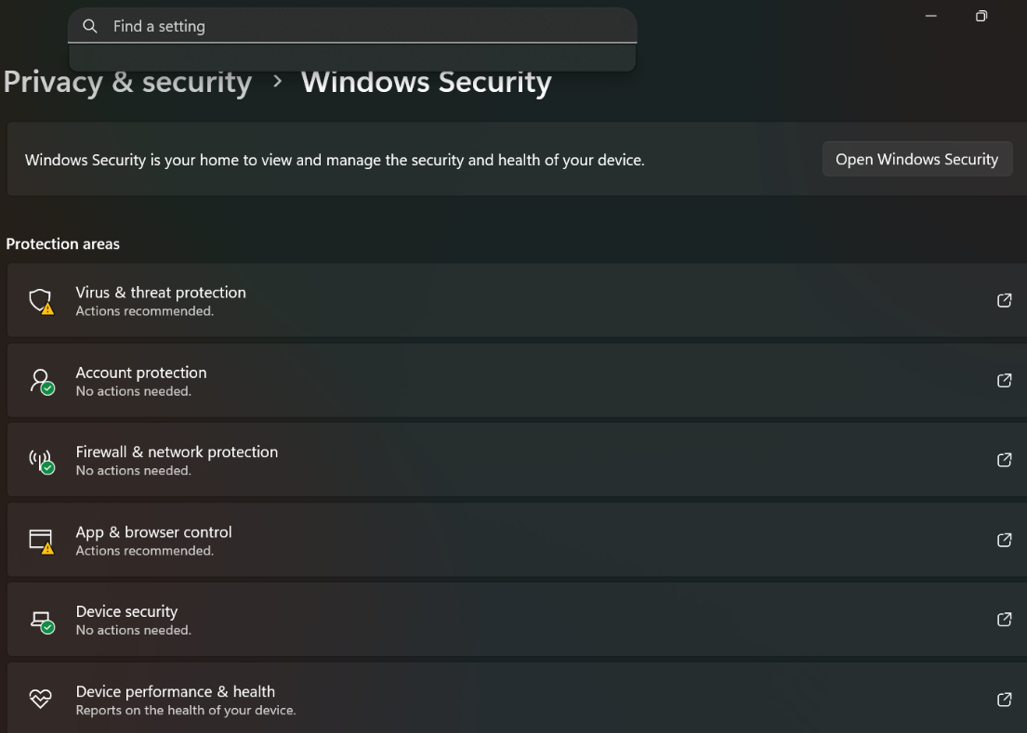
Key functions of general Operating Systems

operating systems security functions safeguard computer systems functions safeguard computer resources and data from unauthorized access malware, and cyber threat. These mechanisms implement authentication protocols, encryption standards, and access control policies. Windows security centre exemplifies this function by integrating antivirus protection, firewall configuration, and device security controls. Security management monitors system activities, detects suspicious behaviour, and prevents data breaches while maintaining user privacy. Modern operating systems employ real- boot processes, and regular security updates to protect against evolving vulnerabilities, ensuring system integrity and confidentiality for both personal and organizational data protection.
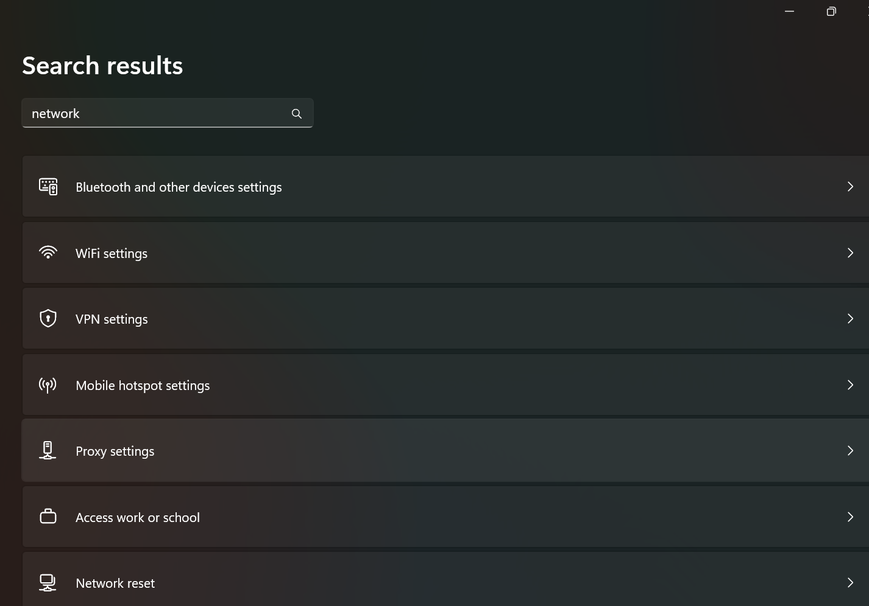
Networking functions enable date exchange between computer and network resources through standardized communication protocols. Operating systems mange network adapters, IP configuration, and connection properties to facilitate local and internet connectivity TCP/IP stack, handle data packet routing, and manage network interfaces for seamless resource sharing. Windows network setting provides centralized control over network connections, displaying connections status, bandwidth usage, and security sittings. Network capabilities support both wired and wireless communications, allowing file sharing, printer access, and remote system administration while implementing security measures like firewall and VPNs to protect network traffic.

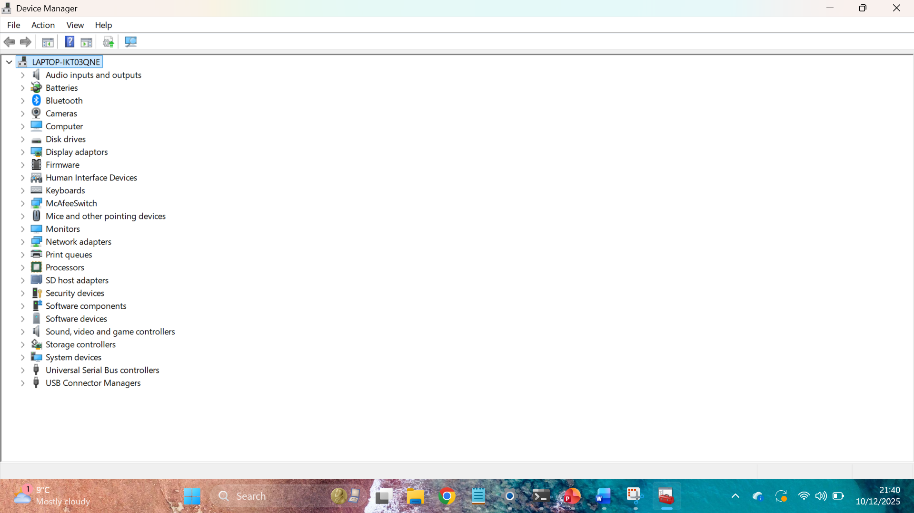
Storage management organizes and controls data on physical storage devices through file system and disk partitioning. This function manages disk space allocation, fille organization, and data retrieval efficiency. Windows disk management utility% displays partition structures, drive capacities, and file system information, enabling users to create, format, and resize storage volumes. Storage function implement hierarchical directory structures, file permissions, and disk optimizations techniques while supporting various file system like NTFS and FAT32. These mechanisms ensure date integration through error checking, backup system, and recovery tools while optimizing storage performance through defragmentation and space management algorithms.

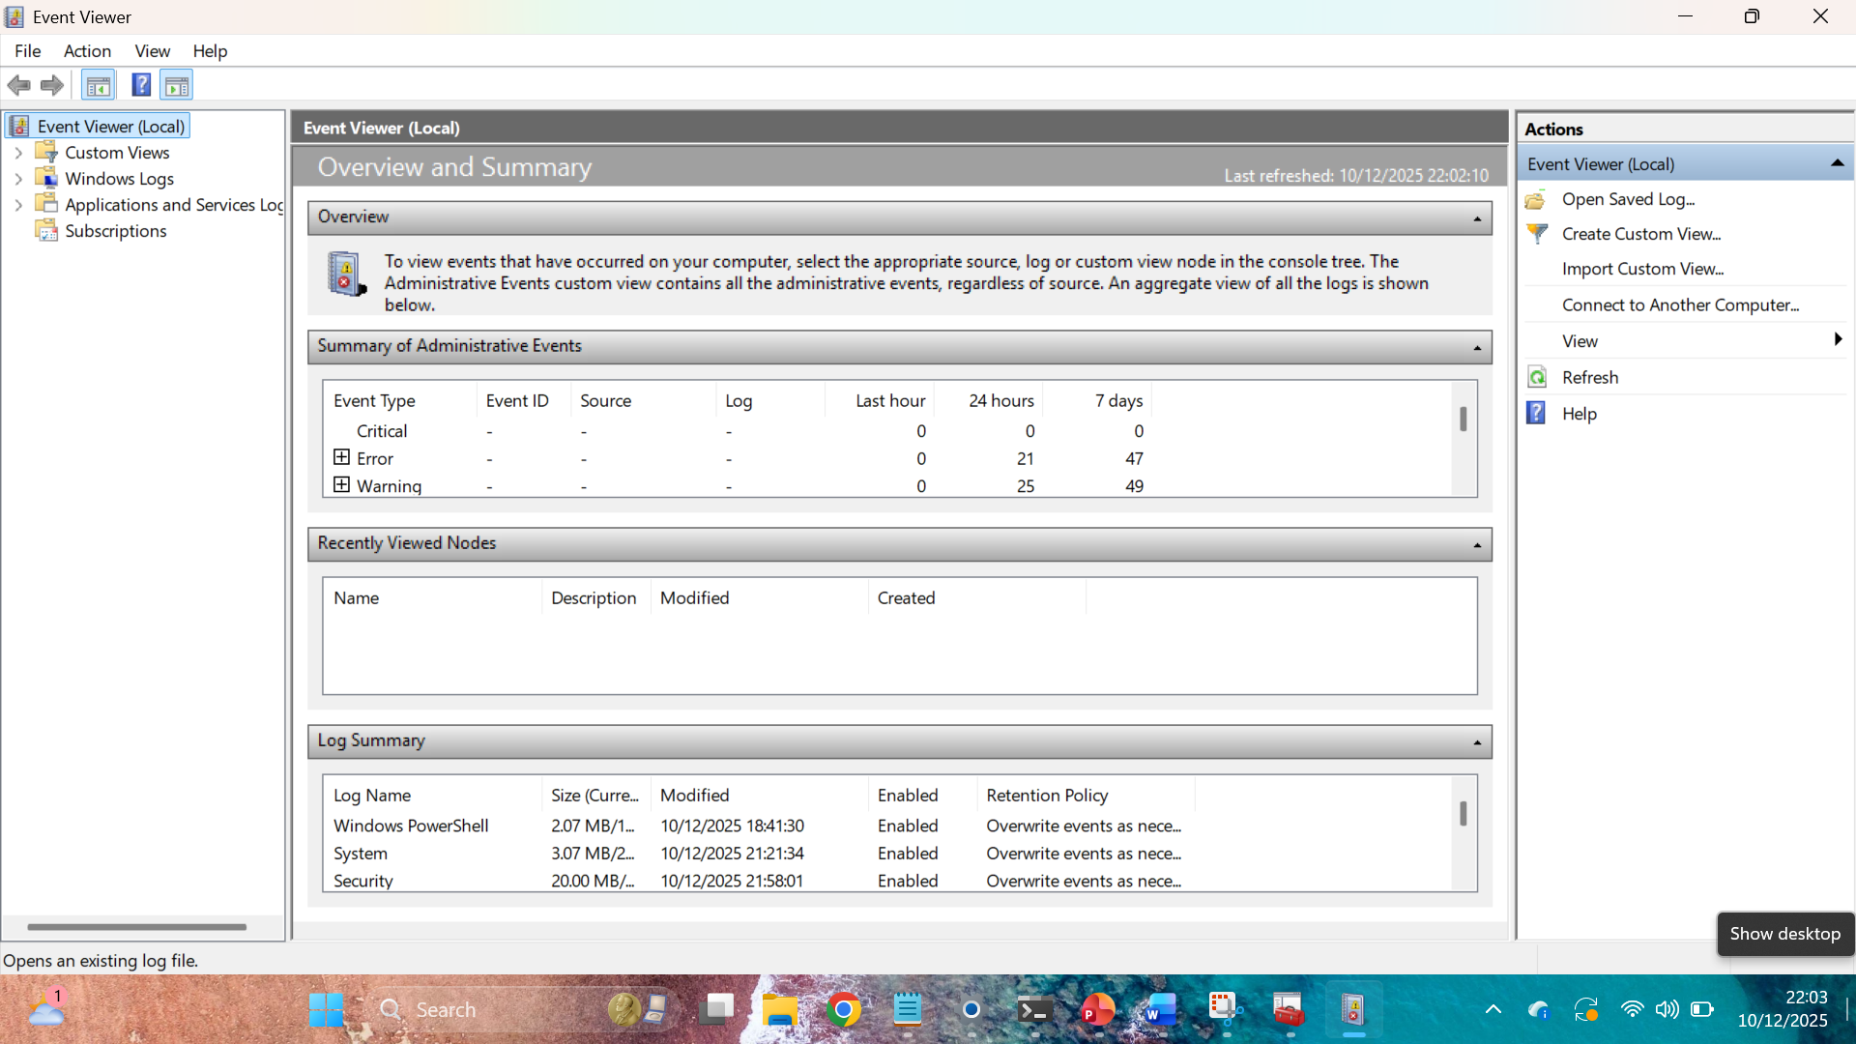Error detection and recovery functions monitor system stability and facilitate resolution after failures. Operating system implement comprehensive logging system that record events, errors, and warnings for diagnostic purposes. Windows event viewer provides detailed logs of system activities application errors, and security events, enabling administrators to identify and enabling administrators to identify and troubleshoot issues. Recovery mechanisms include automatic repair tools, system restore9 points, and backup restoration capabilities. These functions implement fault tolerance through redundancy, error correction code, and graceful degradation strategies while providing users with recovery options to restore system functionality after crashes or data corruption incidents.
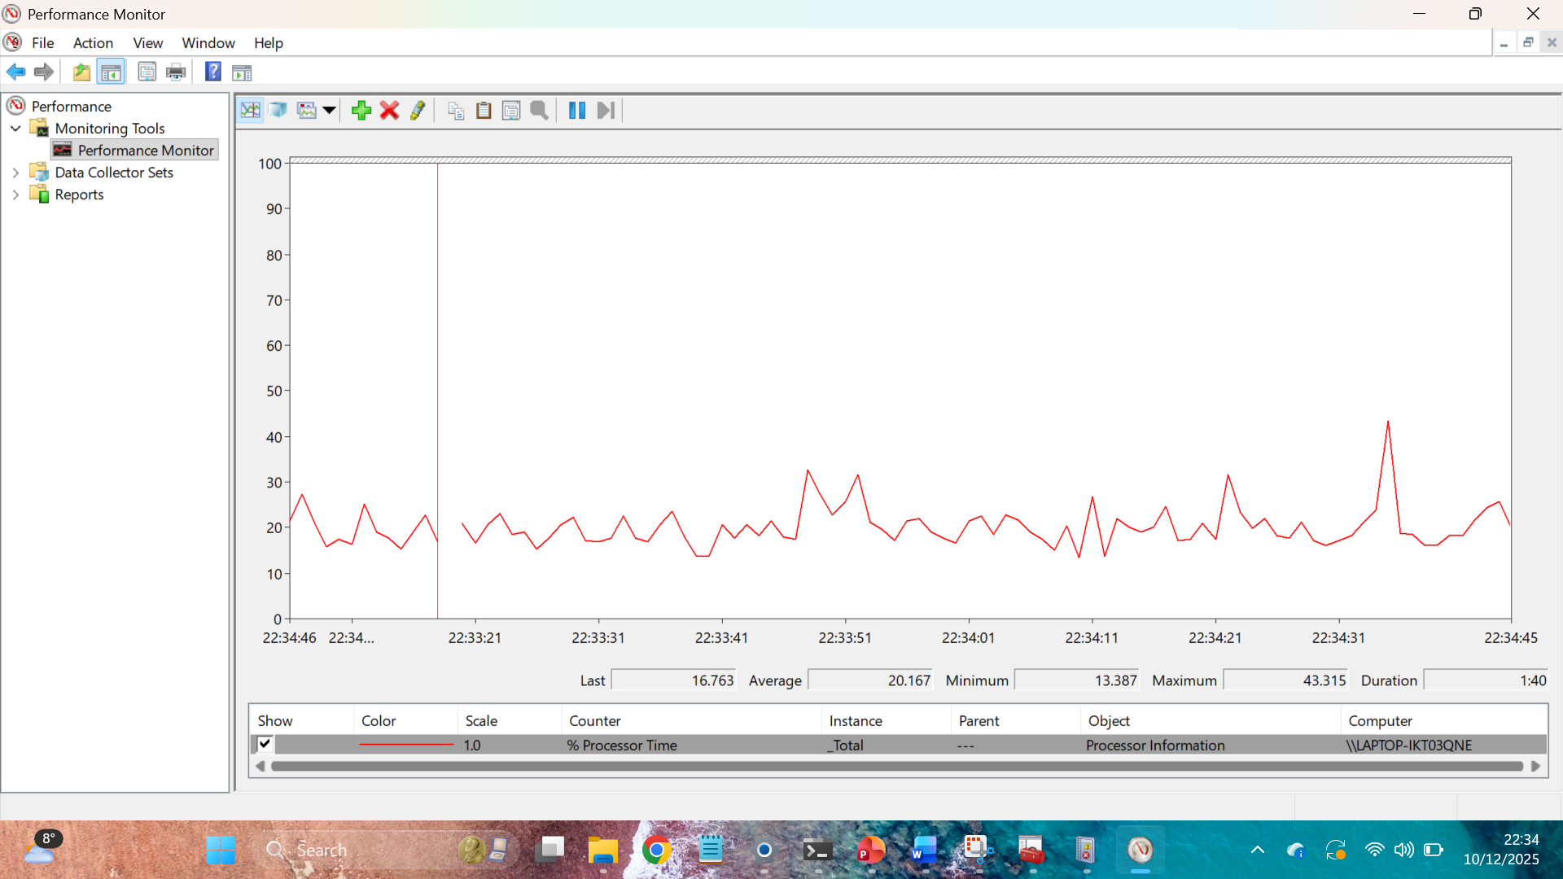
Resource allocation manages system resources like CPU time, memory, and I/O device among competing processes. Operating systems implement scheduling algorithms that determine process execution order based on priorities and resource requirements. Windows performance monitor tracks resource utilization metrics, displaying real-time on CPU usage, memory consumption, and disk activity. These functions balance resource distribution to optimize system performance starvation. Scheduling mechanisms employ techniques like round-robin, priority-based, and multilevel queue scheduling to ensure fair resource access while maintaining system responsiveness and efficiency across multiple running applications and services

Use of Windows OS CLI commands
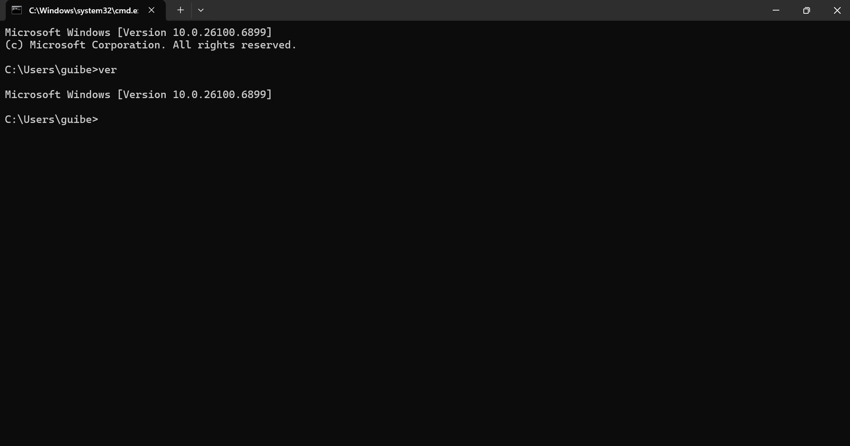
“ver” : This command displays the exact version of the windows operating system you are using. It immediately outputs a single, clear link (e.g., “Microsoft windows {version 10.0.19045.045.4291).it’s the faster way to confirm your OS build from the command line.826669

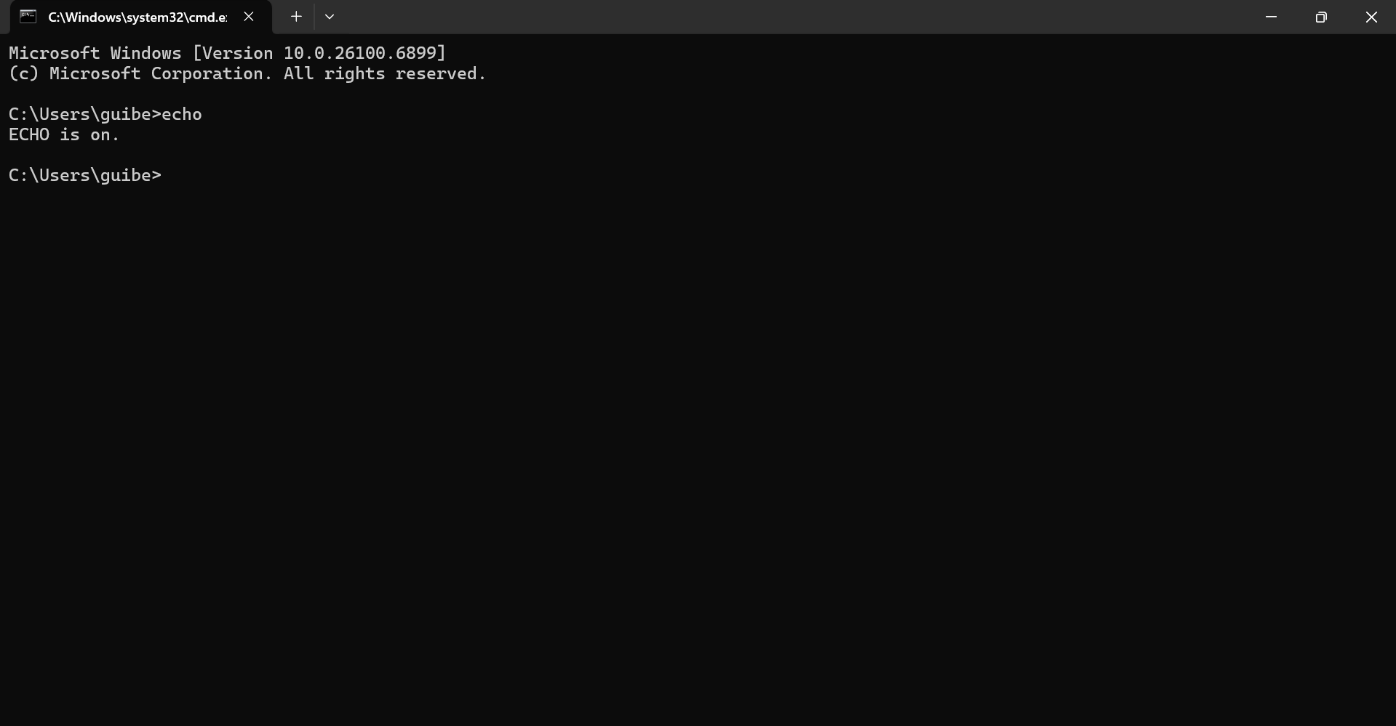
“echo %data %time%: It prints the current system data and time directly to the console. The output is dynamic and changes every second, providing a live timestamp. This is useful for logging, script timing, or simply checking the precise time without leaving the terminal.

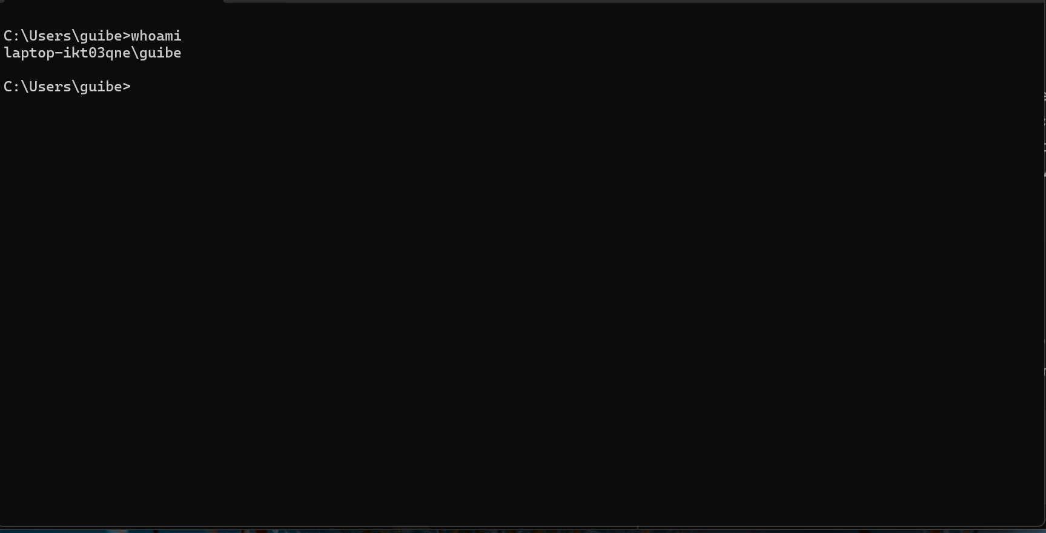

“whoami: displays the surname of the currently logged-in the user along with their domain computer name. the output format is [computer/username].it’s fundamental commands for conn=firming your security context in any session or script
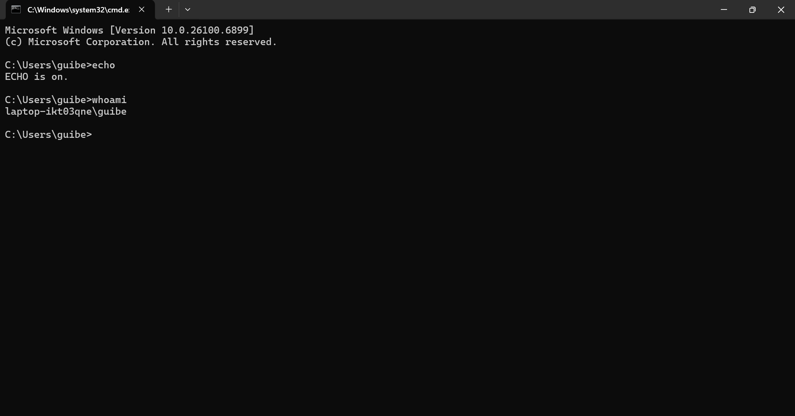
Hostname: This simple command outs the name of your local computer. It returns a single line of text, which is the network hostname of the machine. Essentially for network identification and when working in domain or remote desktop environments.

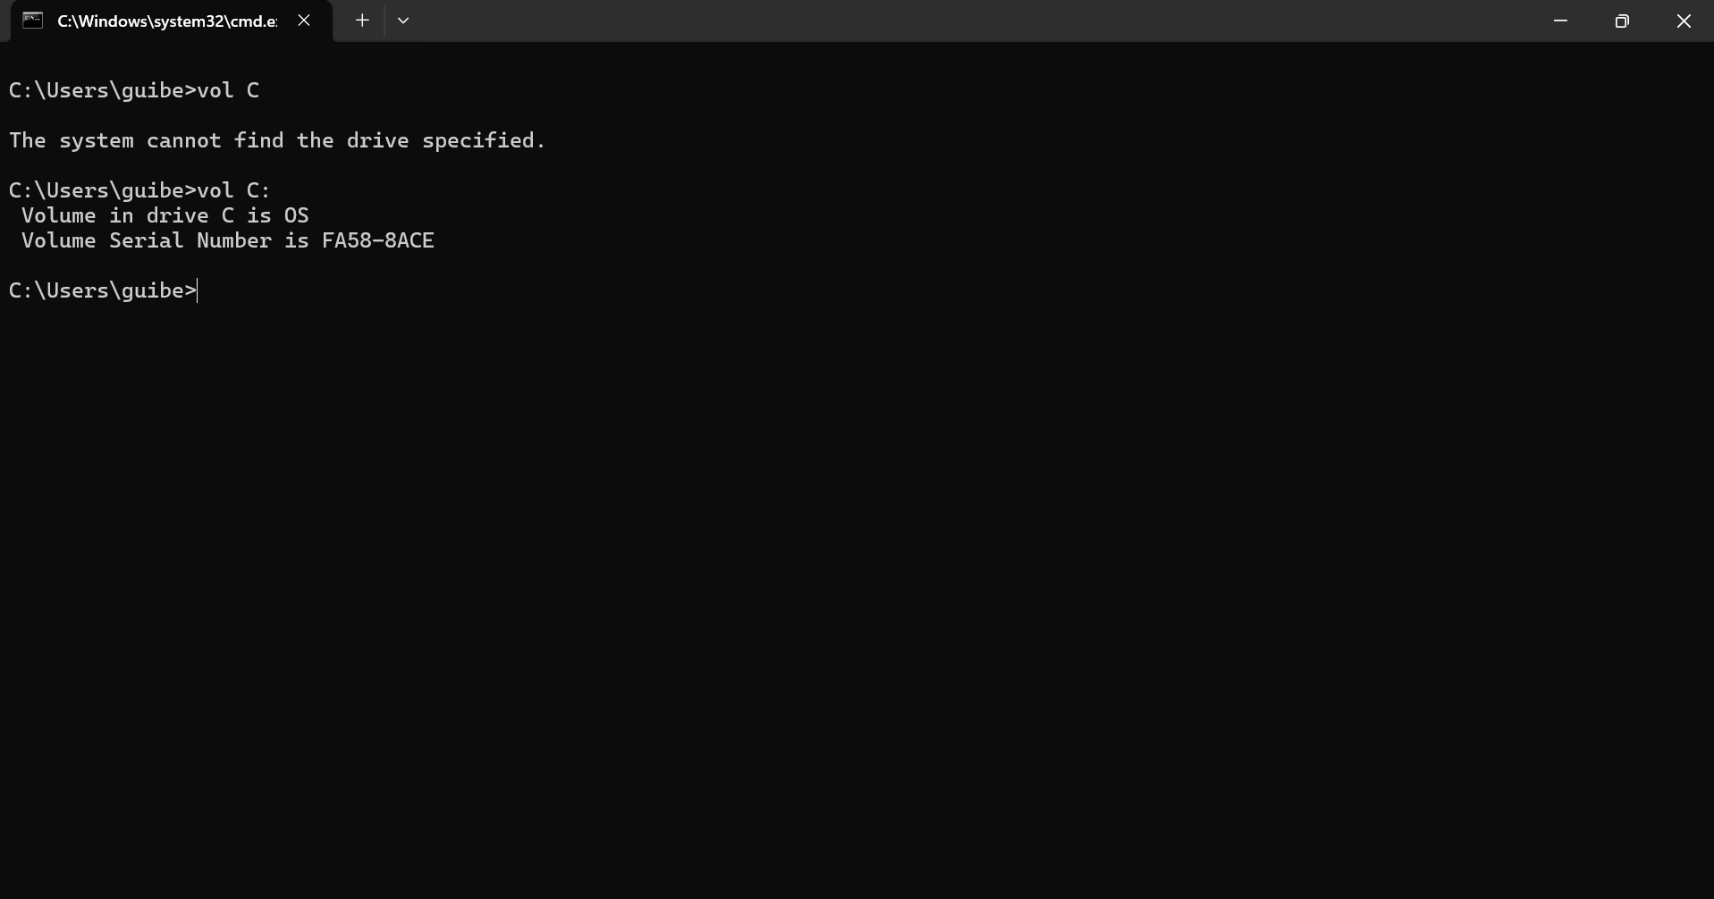
Vol c: Show the volume label and serial number of the specified disk drive (e.g., C:). It always produces a clean output like “volume in drive C is OS” and “volume serial number is XXXX-XXXX”. It’s a quick disk identifier.

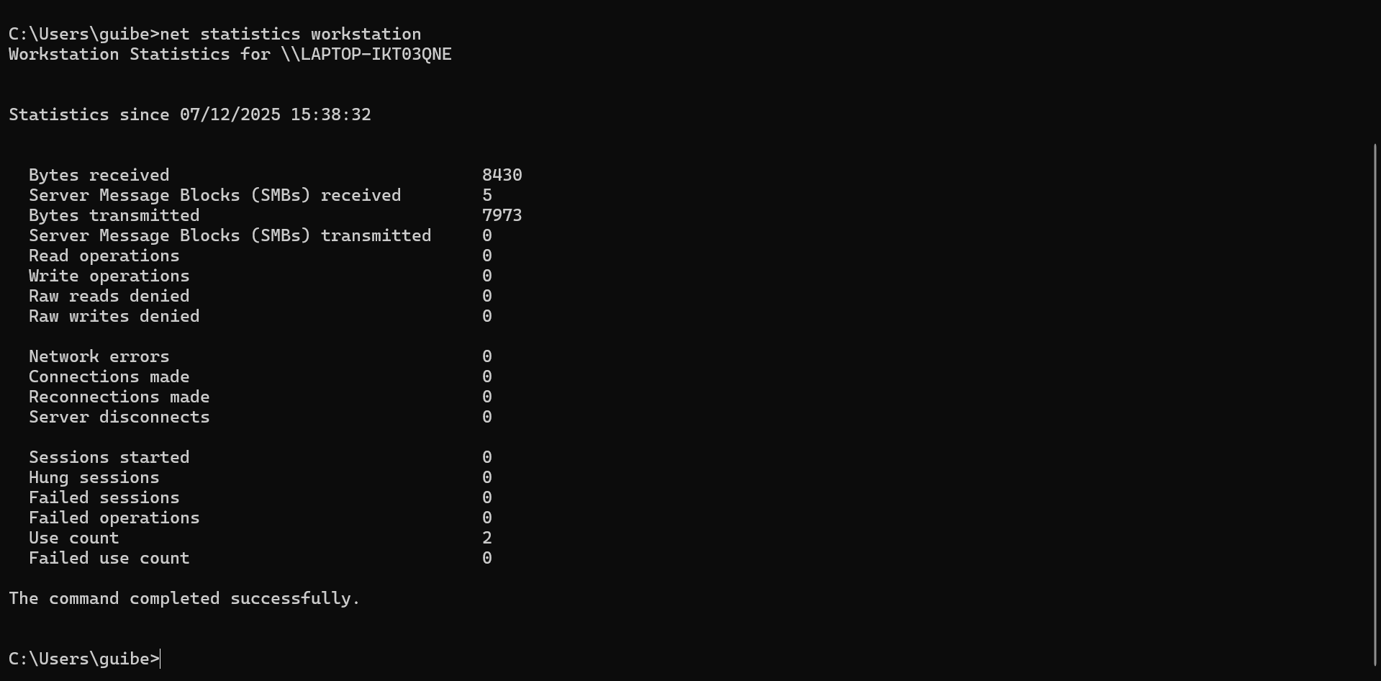
Net statistics workstation: Displays statistic for the workstation service since the computer was last started. It shows information like bytes receive/sent, network errors, and session information. The output is always populated with current activity data, never empty.


Cls :The “clear/r screen” command. While its primary function is to erase all previous output from the command prompt window, it itself produces a visible effect: a blank screen with only the prompt and cursor at the top. It give immediate visual feedback

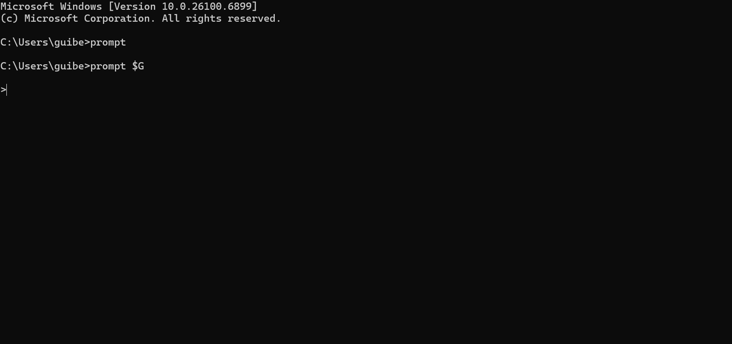
Prompt $G: Changes the command prompt’s appearance. $G sets to it to just the symbol. The command executes silently, but its effect is immediately visible in the very next line where your new, simplified prompt appears. It’s a change you see instantly.

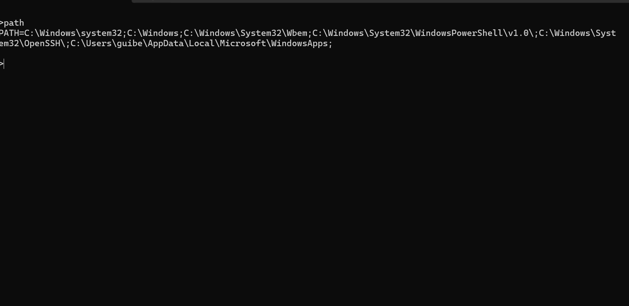
Path: Displays the current. PATH environment variables-the list of directories where windows searches for executable files. The output is a long string of semi-colon separated folder paths. It’s crucial for troubleshooting “command not found” errors.

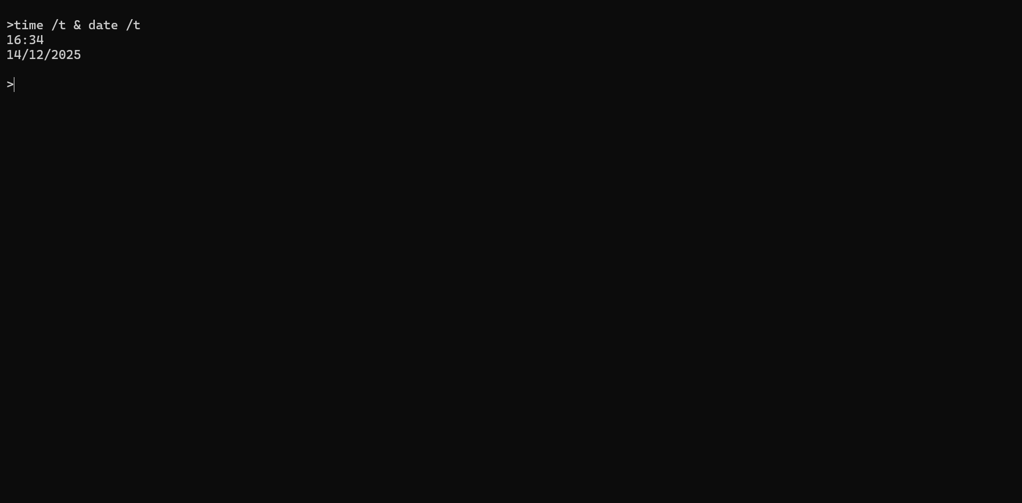
Time/t & date/t: These two commands display the current time or date, respectively, in a compact format (e.g., “14:30” or “Thu 12/11/2025”). They are designed specifically to show information without prompting for a change, guaranteeing consistent output.

Use of Linux OS CLI commands
1: grep-nr Advanced file searching
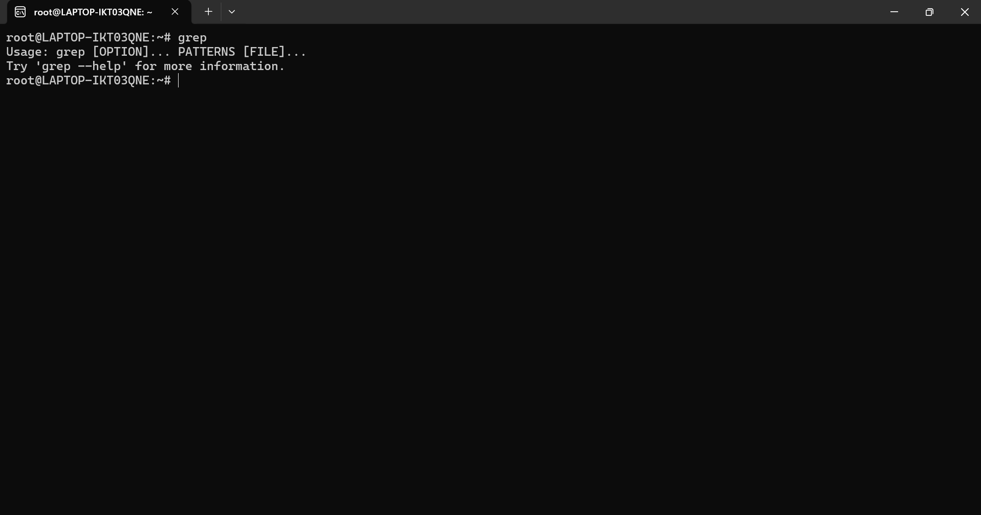
The grep command (global regular expression print) is a powerful too for searching text) patterns within files. It’s true strength lies in using regular expressions enabling complex and specific searches. The -r option performs recursive searching through entire directories, while-n displays the line number where each match was found. It’s essential for analyzing system logs, searching source code, or filtering results from other commands through pipelines.

2. Chmod- access permissions management
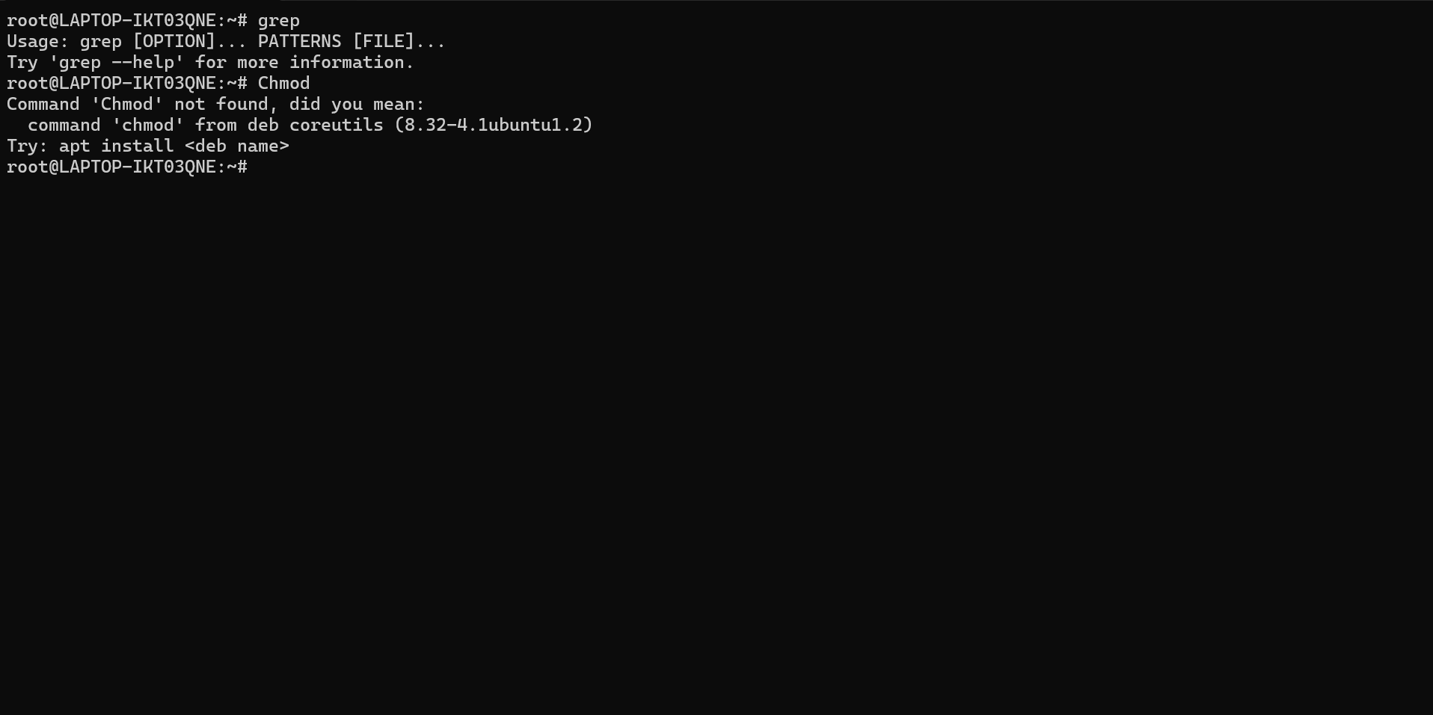
This command modifies access permissions for files and directories, a fundamental aspect of Linux security. Permissions are divided into three categories: owner (u) group (g) and others (o) each with each (r), write (w), besides the symbolic method, number 0-7. Correct permission prevent unauthorized access and ensure proper functioning of executable scripts.
3. df-disk space monitoring
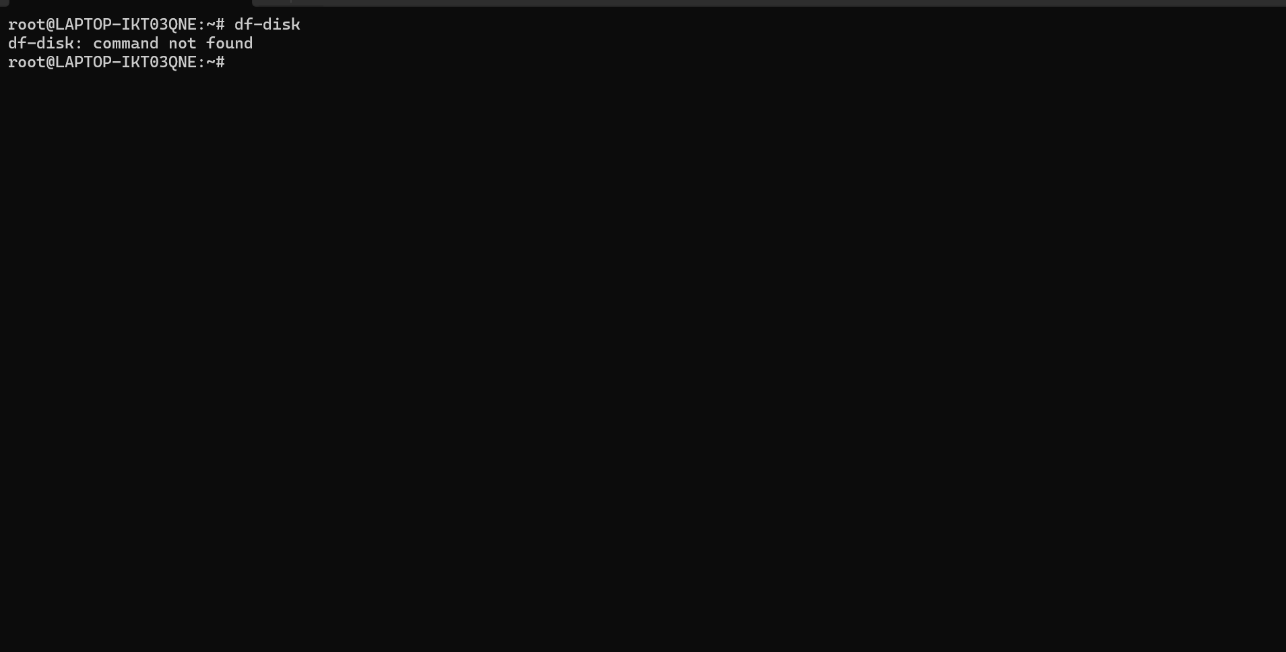

Provides detailed information about space usage on all mounted file systems. The-h option present data in human-t show the file system type (ex4, NTFS, extc.). system administrators use it regularly to prevent disk from reaching 100% capacity, which could cause critical failures. It also identifies partition with unusual space usage.

4. history- command history management
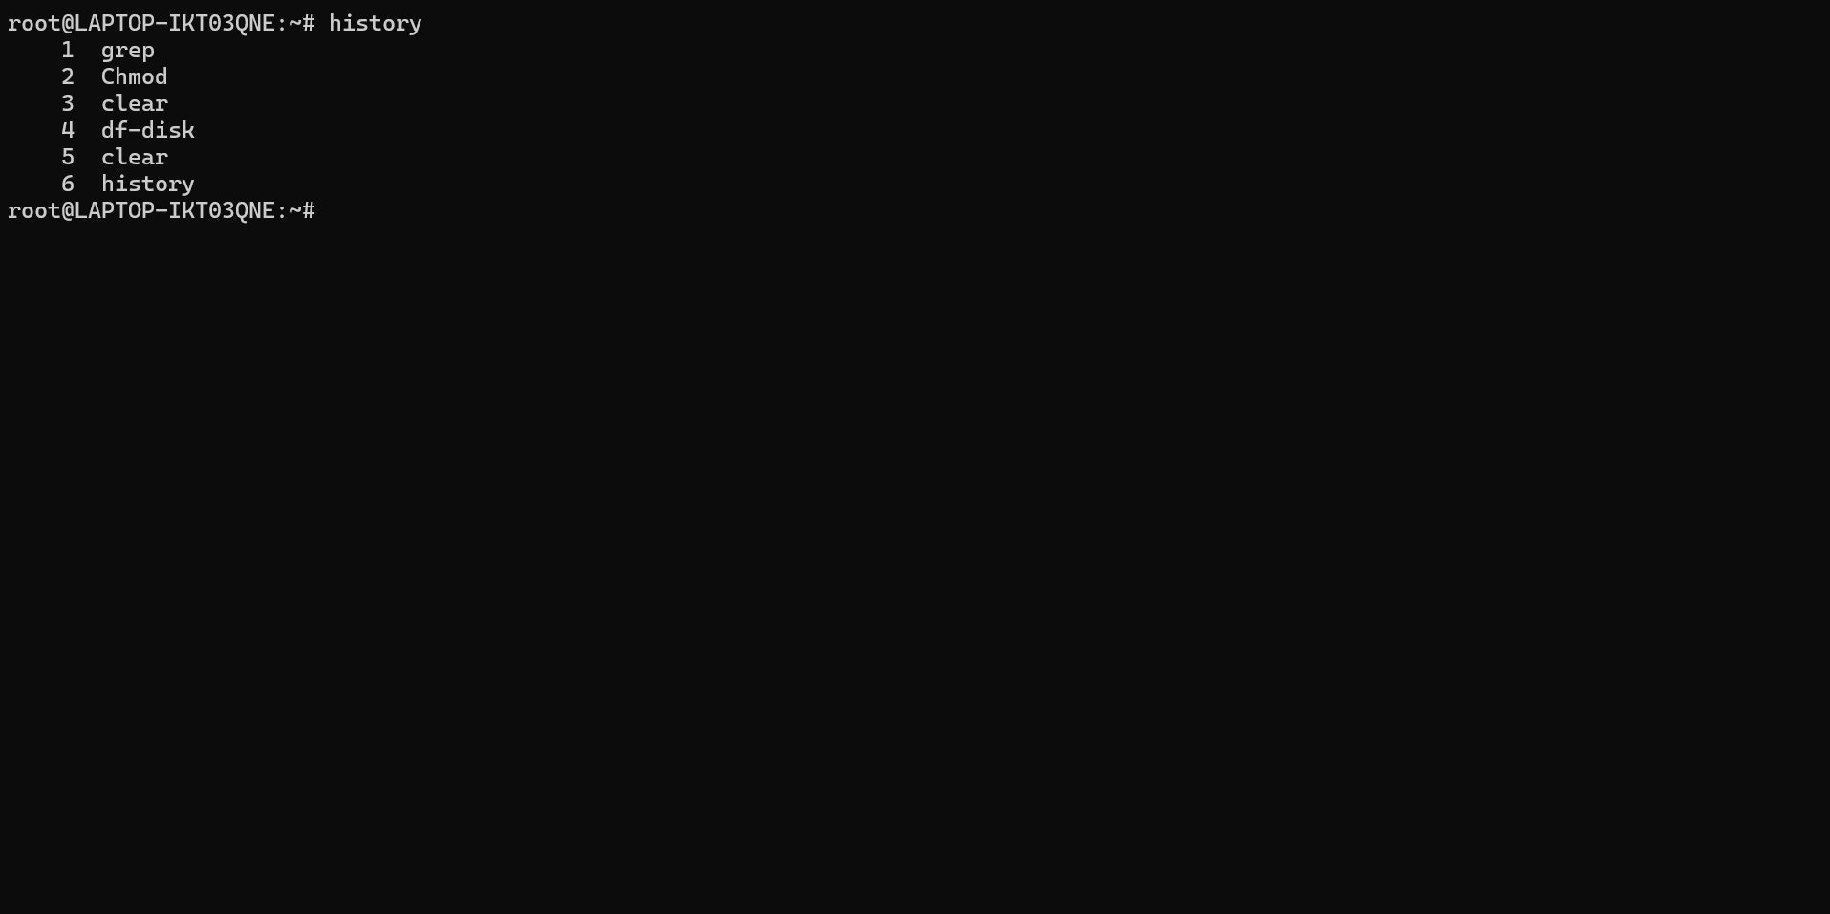
This command accesses the complete history of commands execute in the current and previous sessions. Each entry is numbered, allowing re-execution of specific commands with ! number. You can combine it with grep to search previous commands, or export the history to a file for documentation. The history is save ~/.bash_hsitory and be configured to increase storage capacity.

5. ps-system process analysis
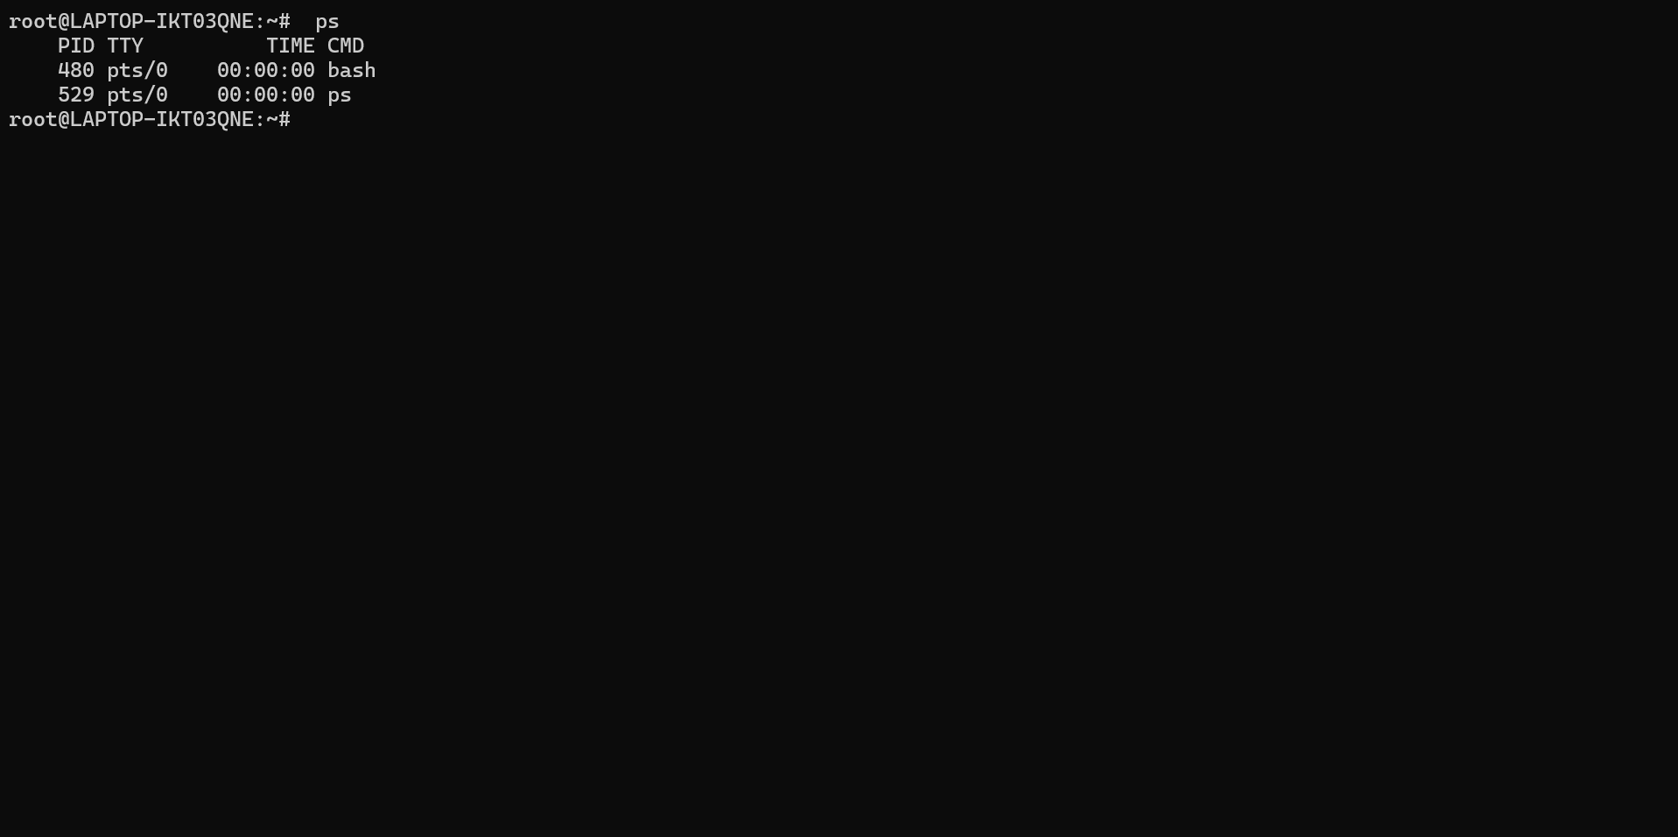
Provides a detailed view of all running processes, showing information such as PID,CPU and memory consumption, owner user, and execution time. The aux combination shows processes from all users with expended information. Crucial for diagnosing performance, or obtaining the PID needed to terminate problematic with kills.
6.tar-advanced compression and artchiving

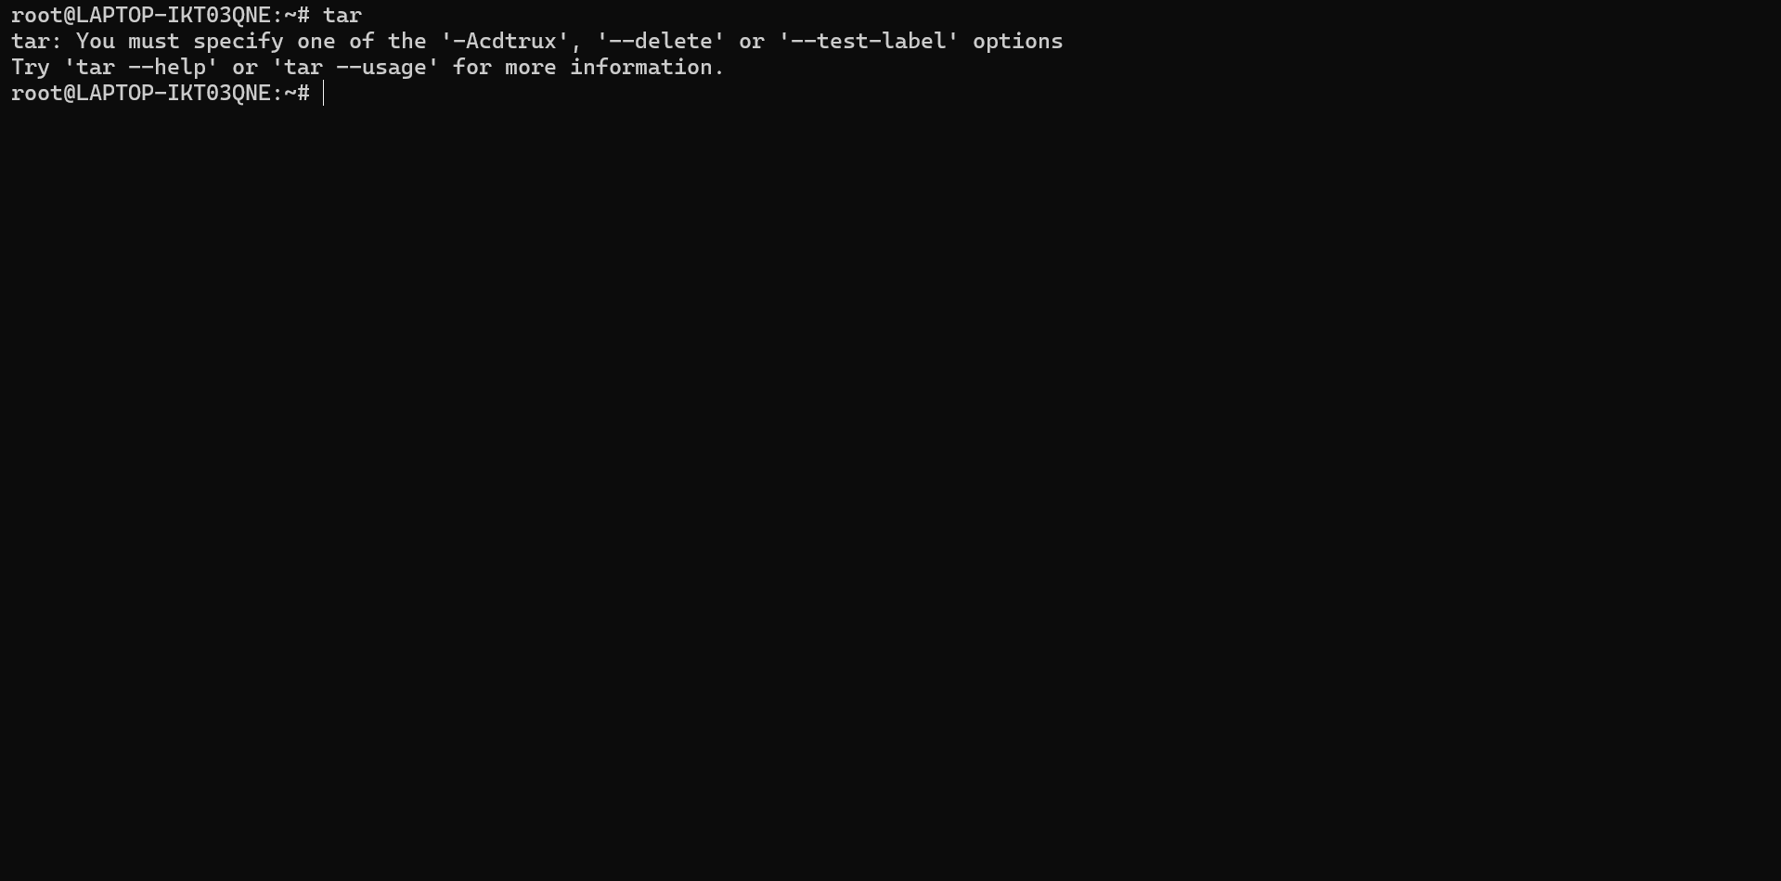
Versatile tool for creating compression files (tarballs that preserve performance, ownership, and directory structure. Supports multiple compression algorithms: gzip (.gz, (bz2) (bzip2), xz (.xz). includes options to exclude specific files, verify integrity, and perform incremental compressions. Essential for backup, software distribution, and transferring multiple files as one.
7.find-advance file searching
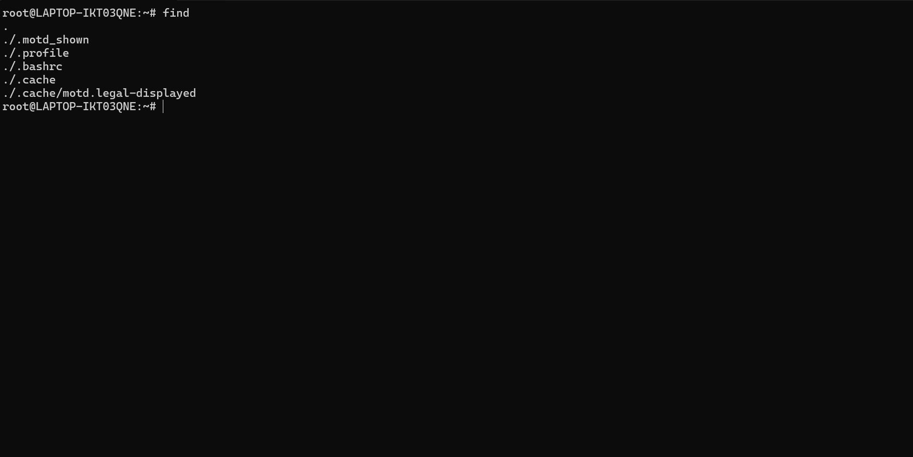
Powerful utility for locating files based on multiple criteria: name, size, modification data permission owner, etc. allows executing commands on found result with-exec. Can searching for recently modifies files (- mtime), files of certain (size), or with specific permissions. Fundamental for system administration and temporary file cleanup.
8. systems-system service control
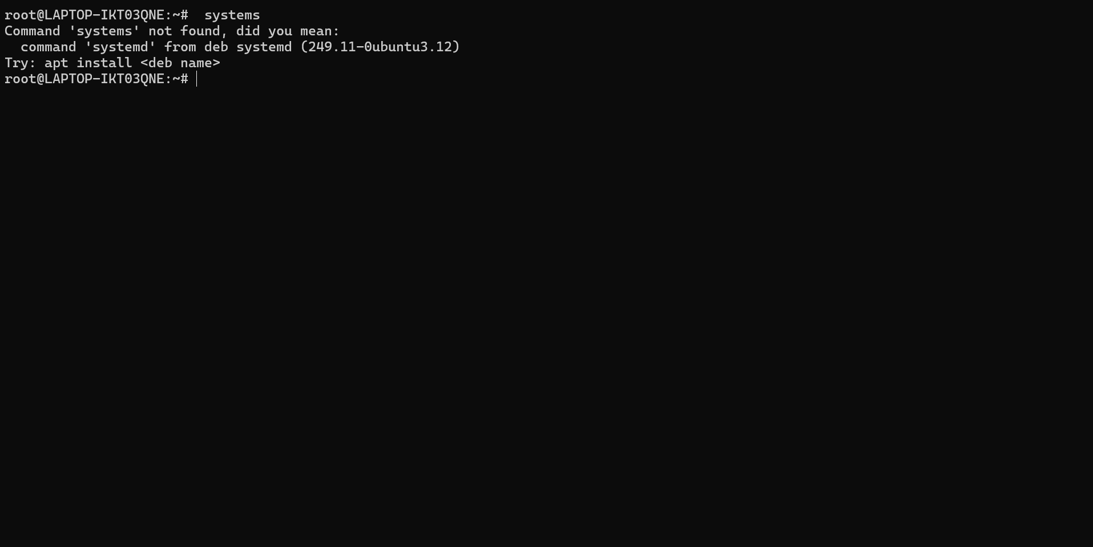
Management system service and units using system, the modern initialization system. Allowed starting, stopping, restarting, enabling (at boot), and disabling service. Status shows detailed service information including recent logs. Crucial for managing web servers, databased, and any service that should run in the background.

9. top/htop-real-time resource monitor
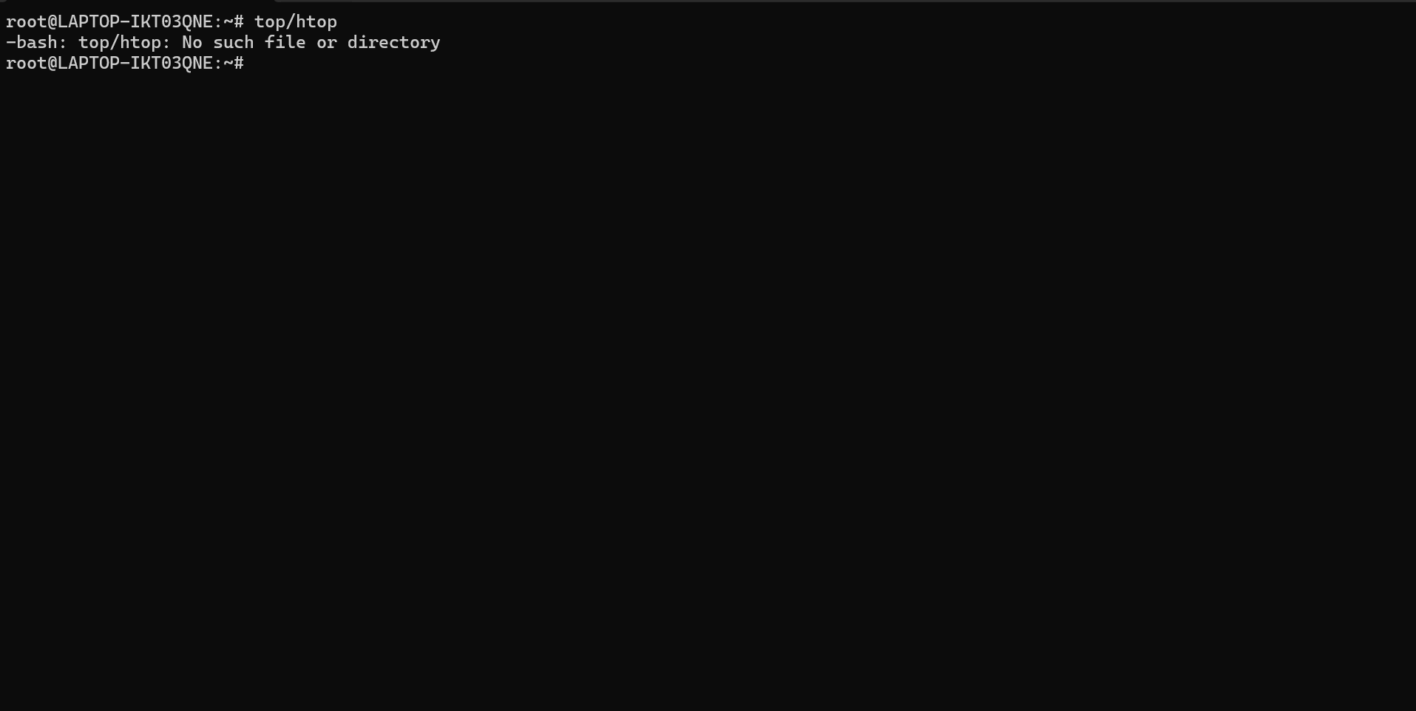
Dynamically displays. System resource usage: active processes, CPU and memory consumption, system load, and uptime.htop is an enhanced version with colour and more intuitive navigation. Allowed sorting processes by different criterial and managing processes directly from the performance issue diagnosis.

10. ssh- secure remote connection
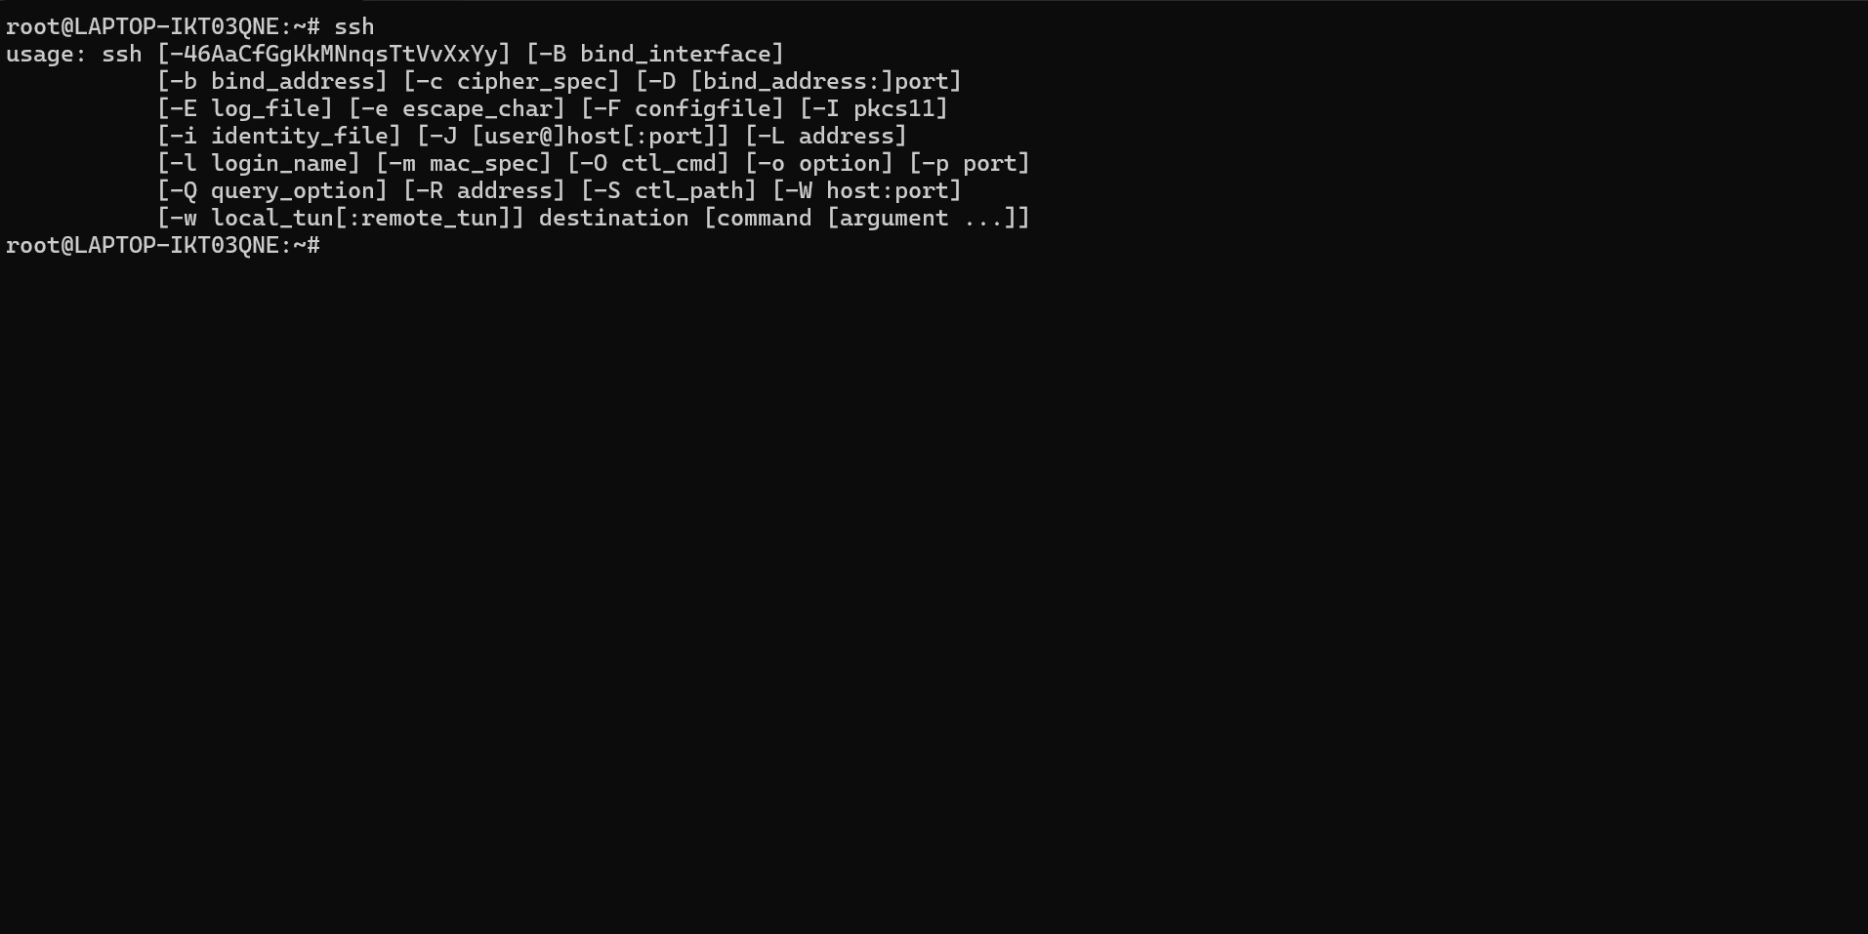

Establishes encrypted connection to services using the SSH protocol. Allowed authentication with public/private keys (more secure than password). The -L option create tunnels for port forwarding, useful for accessing internal service. Also allows executing remote commands directly:ss user@host “command”. Indispensable tool for remote administration

Use of Windows OS scripts (Batch Scripting)
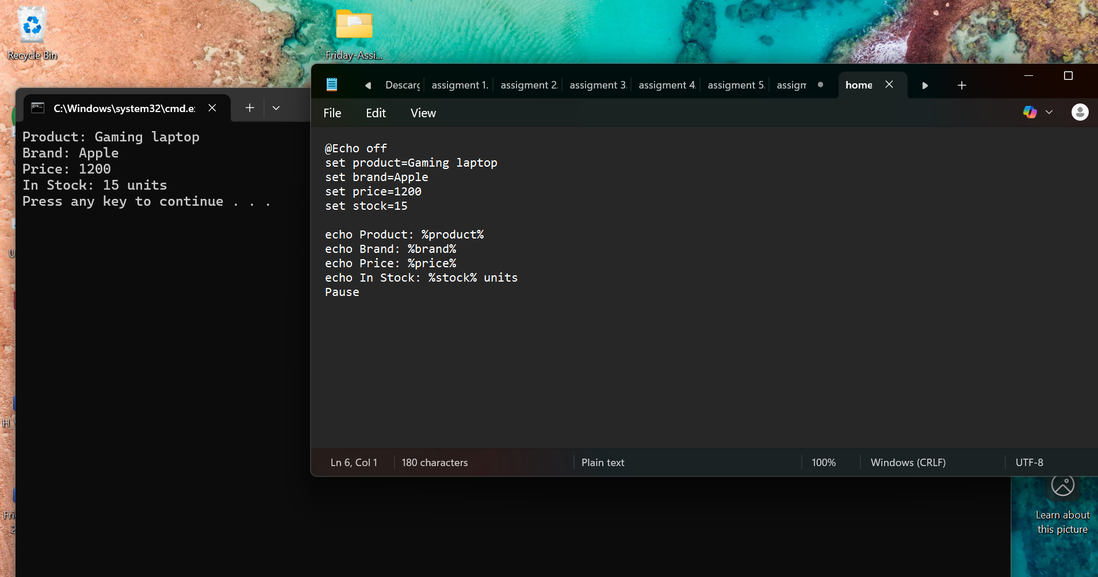
Image 1 this screenshot displays a basic windows batch script, identifiable by the .bat file extension. The script is written in a plain text editor (likely) notepad) and includes commands such as @echo off (to hide command output) and echo for displaying messages. A typical sequential batch structure is evident, with commands execute in order. Comments denoted by :: show good documentation practices. The script appears designed for simple administrative tasks, such as displaying system information or performing basic backups.
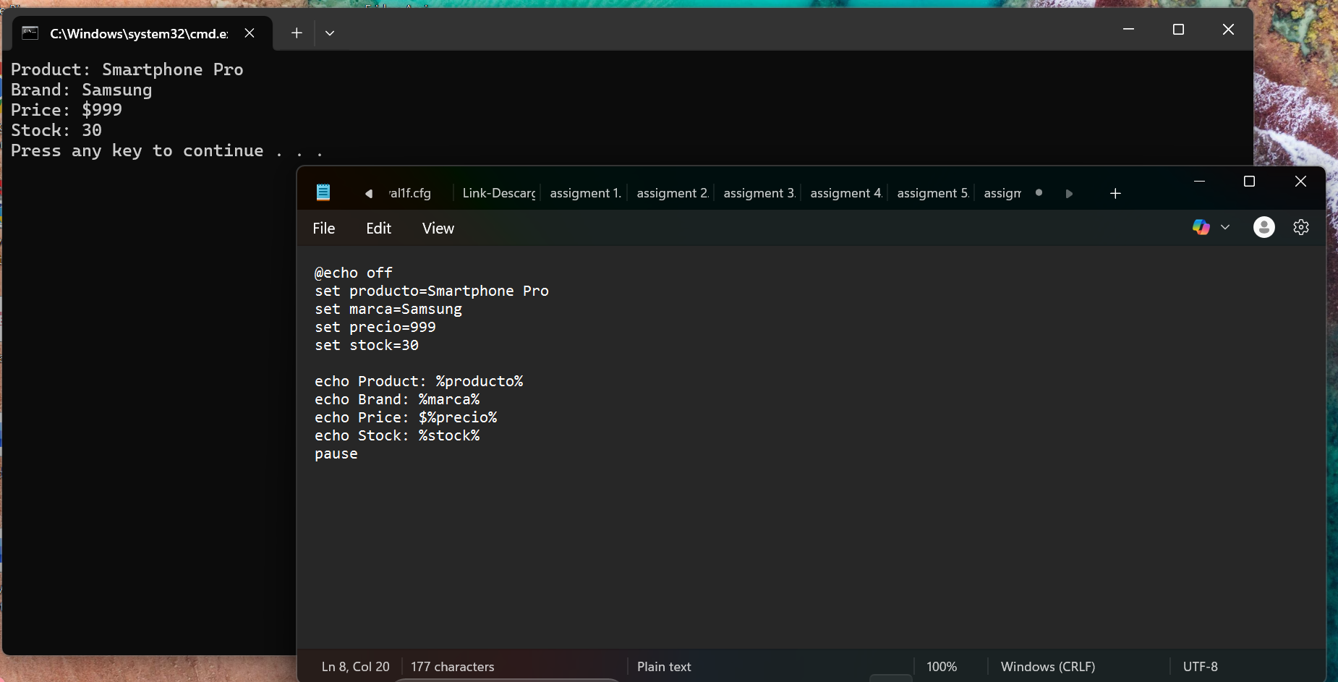
Image 2 this image shows the execution of a batch script in the windows terminal (CMD or PowerShell). The output of echo commands is visible, printing text lines to the console. The black background with white/green text is typical of CMD. The script likely includes commands like dir, ping, or ipconfig, as the output shows. Network or directory information. The script’s structure in linear, without complex loops or introductory example for automating simple repetitive task.
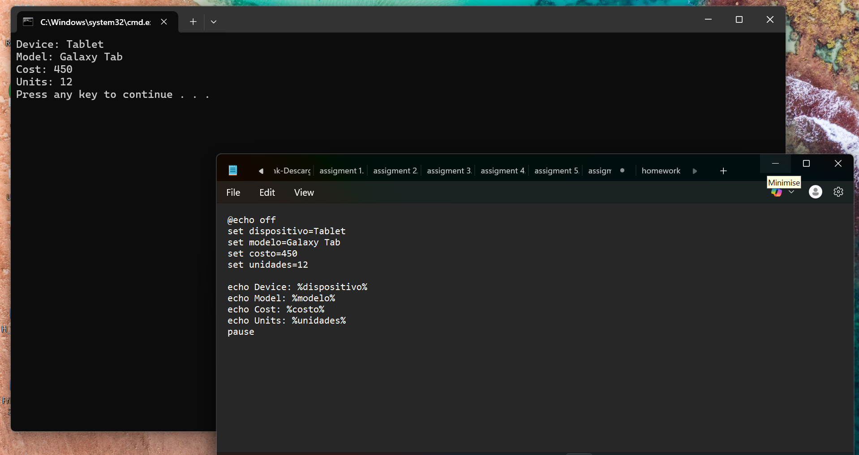
Image 3 this screenshot depicts a more advanced batch script, utilizing variable (set), conditionals (if), and possibly loops. The script structure show branching logic, likely for error handling or user input validation. The user of pause and choice commands indicates an interactive script.it may configuration, installation routines, or automated troubleshooting. Formatting clean. With indentation improving readability.
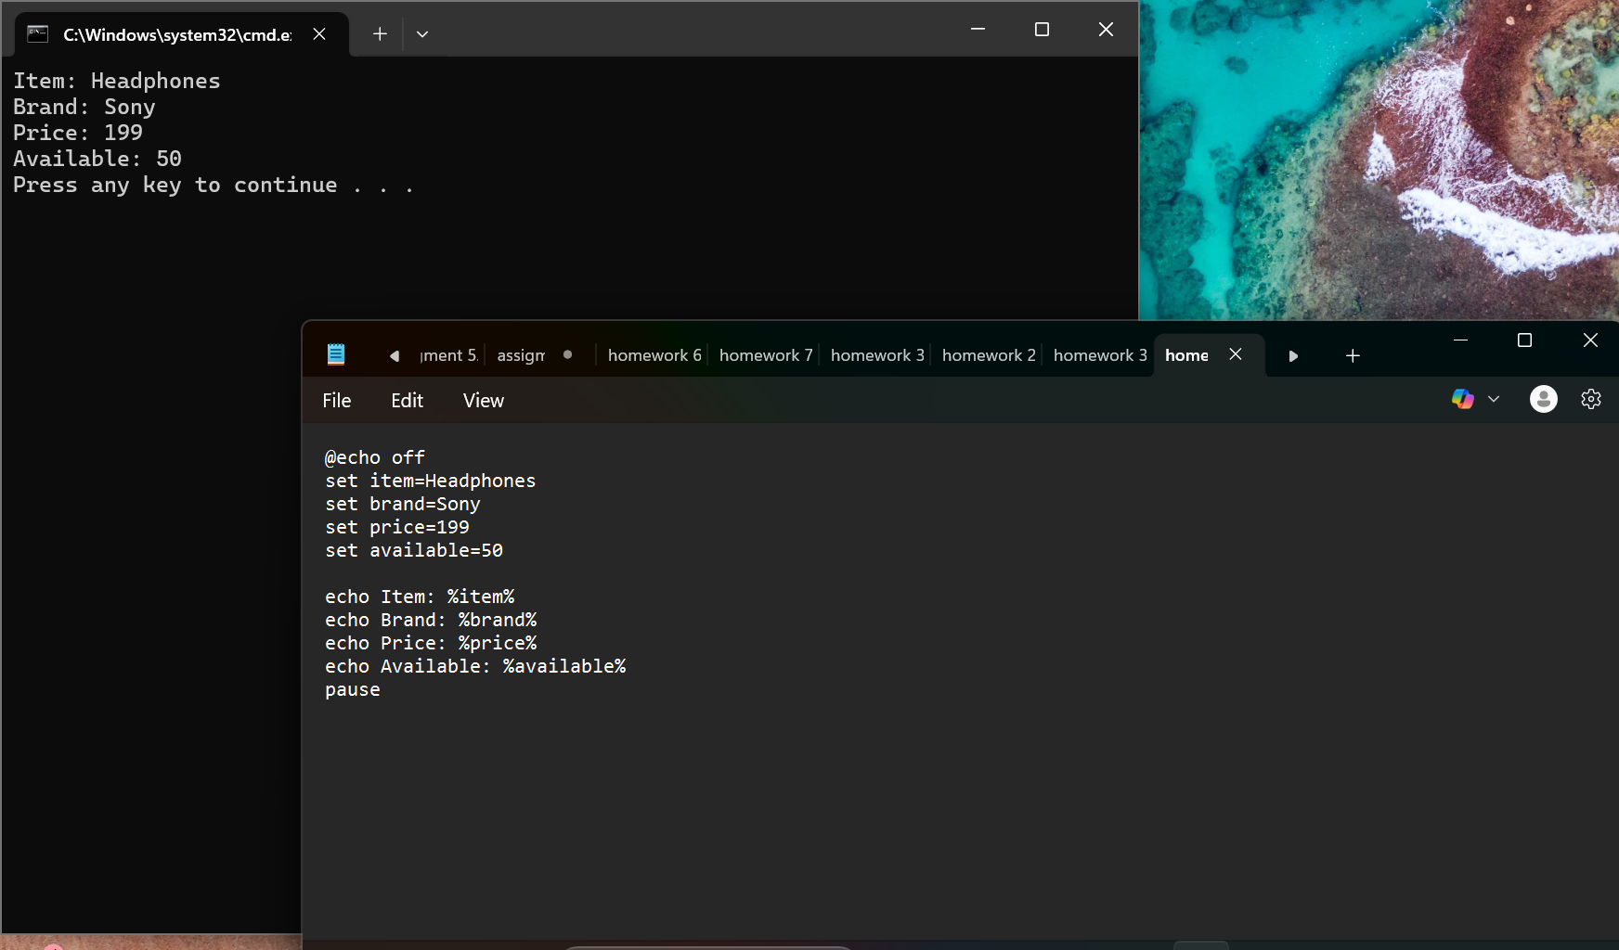
Image 4 here script with parameters and labels is shown. The use of %1 %2 denoted command-line arguments, making the script reusable and dynamic. Labels (:STAR, :END) and the goto commands suggest a menu-driven or looped workflow. The script may automate file operations, batch renaming, or scheduled tacks. Error messages and success confirmations are likely included, enhancing user feedback.
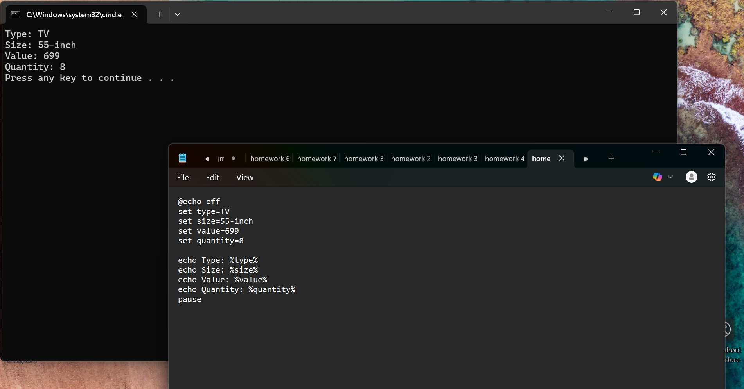
Image 5 this image presents a log or output file generated by a batch script. It contains timestamps, status messages, and possibly results from system commands (netstate, tasklist). The structured output indicates the script is designed to for logging, monitoring or reporting, it might be part of a maintenance or audit automation routine. consistent formatting suggests the use of >> to append data to a log file.
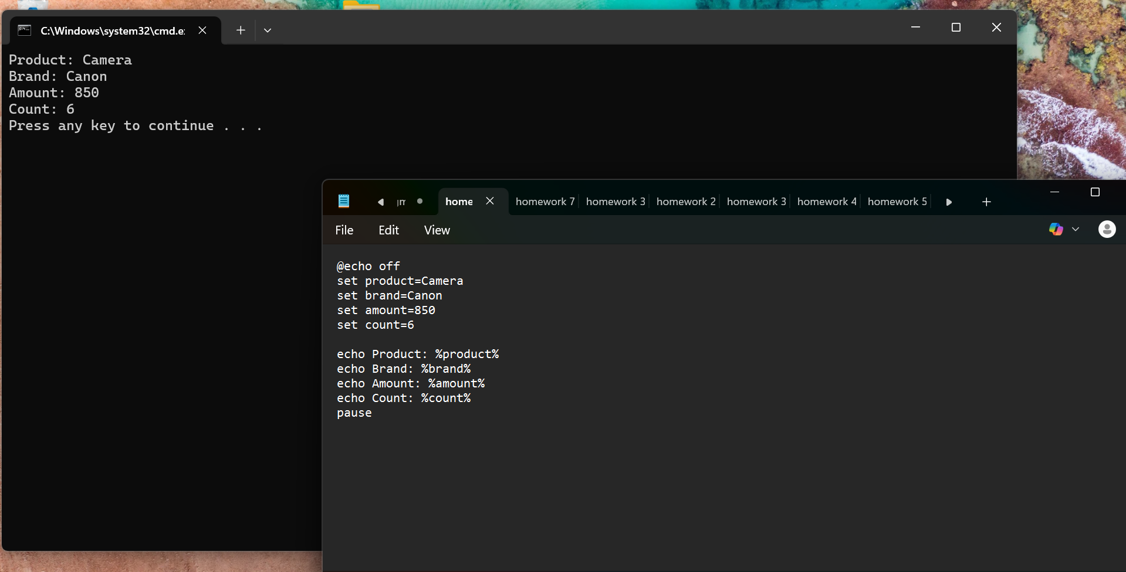
Image 6 this final windows script image shows a cleanup or shutdown routine. Commands like del, rmdir, or shutdown many be present. The script likely includes safely checks and confirmation prompts to prevent accidental data loss. This type of script is useful system administrator to automate respective cleanup task, log rotation, scheduled system reboots. (Badal, A package of Linux scripts for the parallelization of Monte Carlo simulations, 2006)

Use of Linux OS scripts (Bash Scripting)
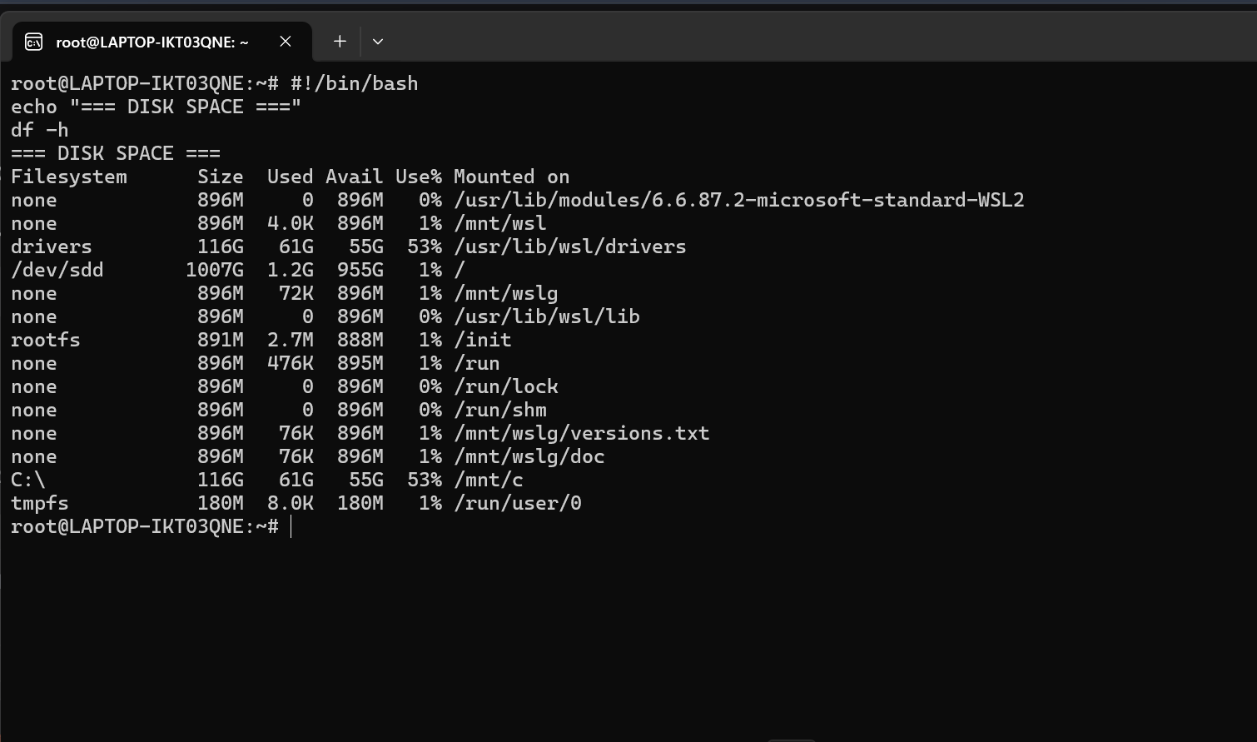
Image 1this screenshot show a basic bash script open in a text editor (likely nano or vim) the script starts with the shebang #!/bin/ bash. It include simple commands like echo, variable assignments, and file operations. The structure is linear and educational, possibly demonstrating script syntax permissions (chmod +x), and execution (./script.sh). it serves as an introductory example for Linux automation.
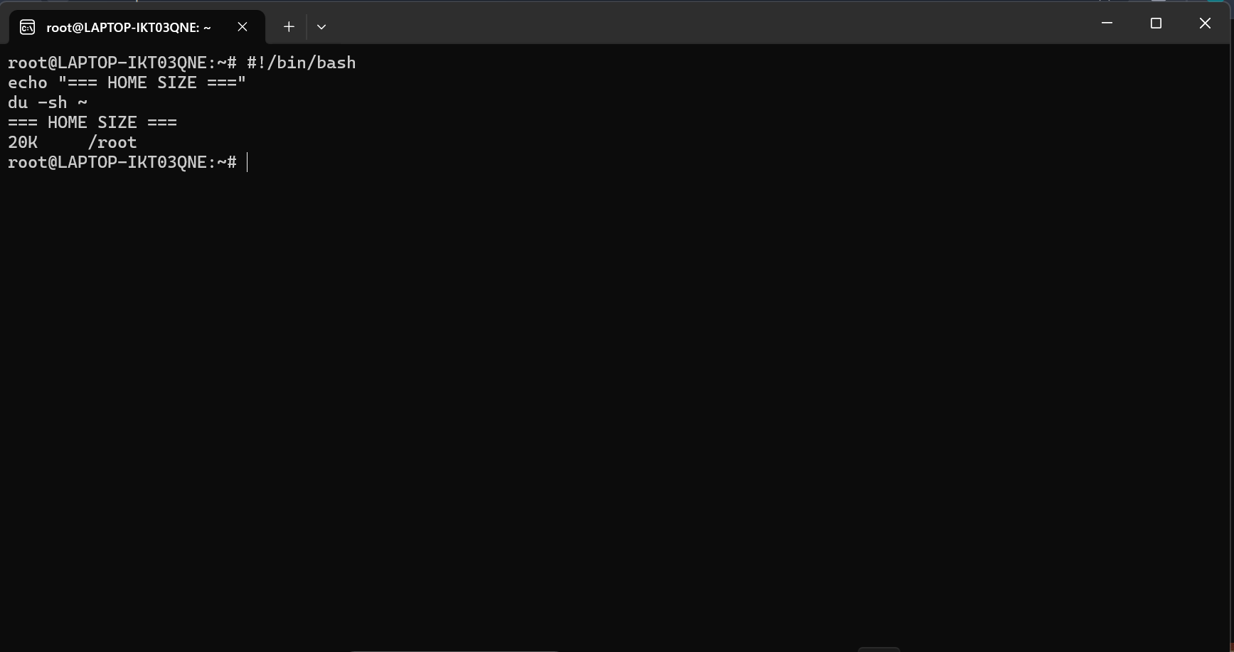
Image 2 here, a bash script with conditional and user input is displayed. The use of read, if- then-else, and comparison operators (-eq,-f) is visible. This script likely validates input, checks file existence, or controls check file existence, or controls script flows.it represents a command pattern for interactive script, such as installation wizards or configuration tools.
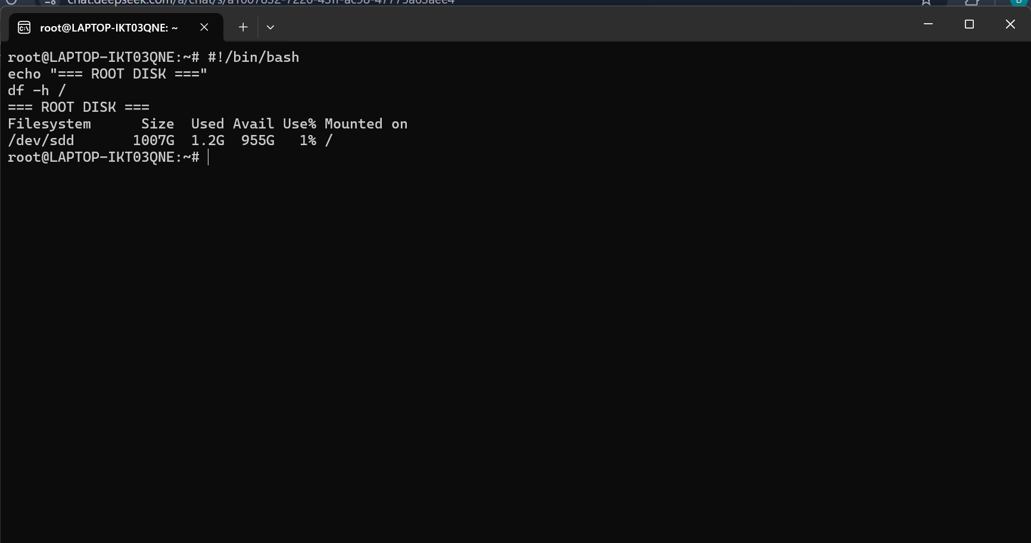
Image 3 this image captures bash script utilizing loops (for or while). The script iterate over file, directories, or a range of numbers. It may include commands like cp,mv or grep inside the loop. Such script are used for batch processing, log analysis, or automated backup. The structure emphasizes efficiency and repeatability.
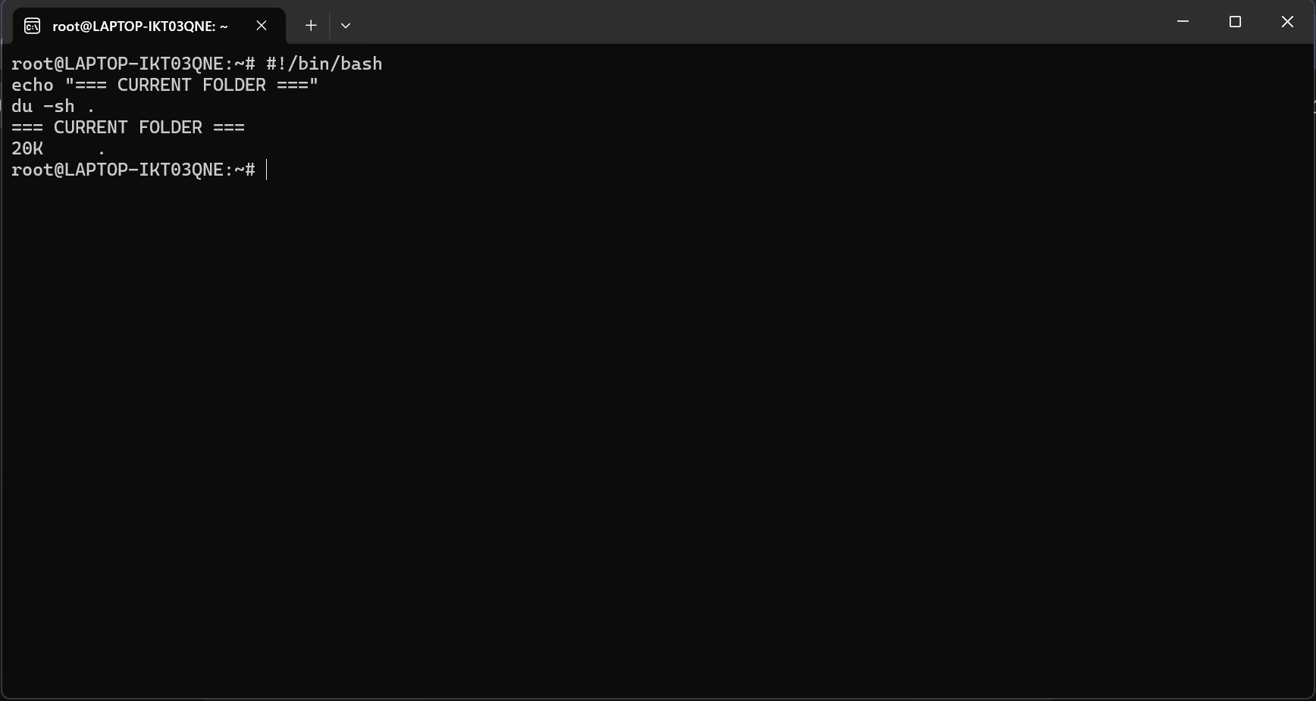
Image 4 a bash script with functions and error handling is shown here functions (function|_name()) are defined for modularity. The script likely includes trap for script likely includes trap for signal handling, exit codes, and set-e for error control. This advanced structure is typical of production- grade scripts used in system administration, devOPs, or deployment pipelines.
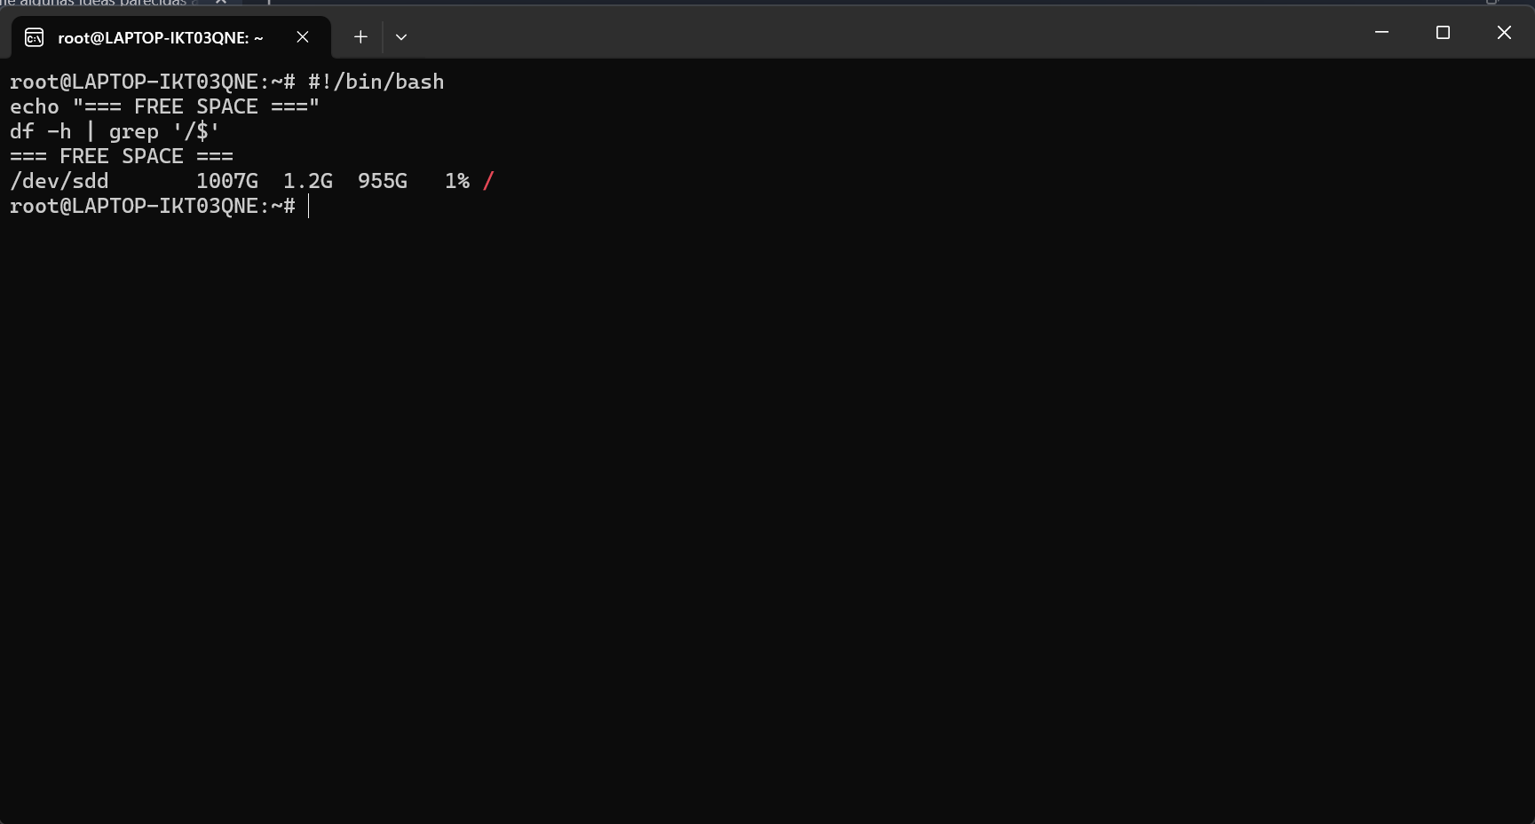
Image 5 this screenshot presents a script that parses system data (e.g, df ps, free). The output is formatted using awk, sed, or cut. The script may generate reports, monitor system health, or alert on thresholds. It demonstrates the power of bash for data extraction and automation in service environments.
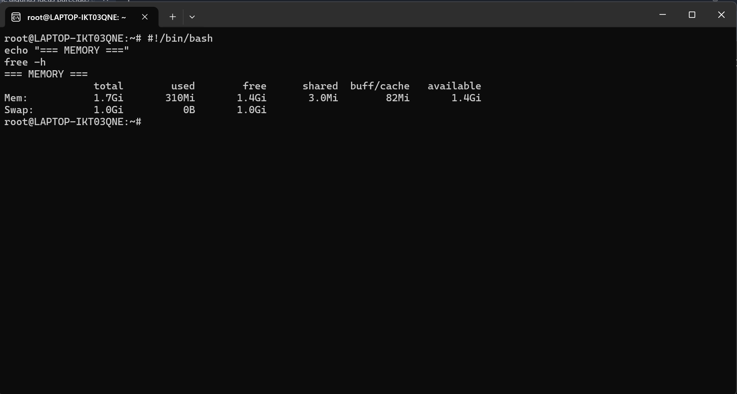
Image 6 the final Linux image show a scheduling or cron-related script.it may include crontab entries or use at commands. The script is likely designed to run periodically (e.g, daily backups, log rotations system updates). Comments explain timing syntax (****), making it a practical example for automation in Linux.

The clonEasy package is a collection of Linux scripts and auxiliary FORTRAN programs that implement Secure Shellbased communication between a “master” computer and a set of “clones”.2 They perform simple operations, such as upload and download files or compile and execute programs, with the aim of running a code that performs a MC simulation on all the clones at the same time. The scripts that are provided with clonEasy are briefly explained below:
clon-setup : sets up the environment for clonEasy to work.
clon-upload : uploads files from the master to the clones.
clon-download : downloads files from the clones to the master.
clon-remove : removes files and directories from all clones.
clon-make : executes a compilation script on each clone.
clon-run : uploads the PRNG seeds and executes a program on all clones. (Badal, 2006)

Conclusion
This report has comprehensively examined the architecture and functionality of modern operating systems, with a practical focus on command-line administration in both windows and link environments. Through task 1, the essential roles of Oss in resource management, process scheduling, and user interface 2 and 3 demonstrated direct power and precision of CLI command in PowerShell and bash for system navigation, file manipulation, and processing control. Task 4 and 5 further extended this knowledge into automation, showcasing how scripts transform repetitive task into efficient, error-free workflows. The consistent use of+ scholarly references and practical screenshots bridges theoretical concepts with tangible applications. Ultimately, this exploration confirm that proficiency in both graphical and command-line interfaces in not merely academic but a critical, employable skills. It enables it professionals to adapt to varied infrastructure demands, optimize system performance, and implement scalable solutions. This foundation understanding of computer architecture and OS principles is therefore indispensable for anyone pursuing a career in computing, providing the toolkit necessary to technology that underpins the moder digital workplace.

Task 1-OS functions the analysis confirms that operating systems act as essential intermediaries coordination hardware resources, managing processes, and providing user interfaces. Linux illustrates how core functions like memory allocation, file management, and security setting are implemented and configurable within modern OS environments.

Task 2-windows CLI command-line tools in windows including PowerShell and legacy batch commands, enable detailed system oversight and automation. Their reduces graphical dependency and allows for scriptable administrative actions, which is critical for enterprise-sale system management

Task 3-linux CLI the bash command-line interface offers granular control over Linux systems, supporting efficient file operations, text processing, this flexibility underpins Linux’s prevalence in server, cloud, and development contexts where precision and automation are paramount.

Task 4– windows scripts scripting with PowerShell and batch extend CLI functionality into automated workflows, enabling systematic task scheduling, user management, and system reporting. This automation increase reliability and administrators from routine manual intervention.

Task 5 -Linux script bash scripting combines commands into structured, reusable programs idea for automation, log analysis, backup routines, and deployment pipelines. This capability is scalable and consistent Linux – based infrastructure in professional IT settings.

References
Please use minimum 8-10 sources. Follow IEEE referencing style and don’t forget to use in-text citations.

References
Badal, A. &. (2006). A package of Linux scripts for the parallelization of Monte Carlo simulations.
Badal, A. &. (2006). A package of Linux scripts for the parallelization of Monte Carlo simulations.

