
Converting Research into Practice
(LCDB7010)
“Exploring the extent of digital technology (DT) on banking services: the case of meeting stakeholders' expectations.”

Ayushi kapatel
Student number: 2434235
DBA Level 7
Prof. Amare Desta

Abstract
This study examines the role of digital banking services in influencing customer satisfaction within the UK retail banking sector. The research precisely focuses on two key factors from the Technology Acceptance Model (TAM): perceived ease of use and perceived usefulness. The study seeks to analyse how these elements affect customers’ overall satisfaction with digital banking platforms.
A quantitative research approach was adopted, and primary data were collected through a structured questionnaire distributed via online platforms. A total of forty-five valid responses were obtained from digital banking users. The outcomes show that both perceived ease of use and perceived usefulness have a positive impact on customer satisfaction. Customers are more likely to feel satisfied when digital banking services are simple to use, efficient, and helpful in managing their financial activities.
The study concludes that improving the usability and functionality of digital banking applications can extensively enhance customer satisfaction and encourage continued usage. These findings offer useful insights for banks aiming to improve their digital service offerings.
Keywords: Digital Banking; Perceived Ease of Use; Perceived Usefulness; Customer Satisfaction; Technology Acceptance Model (TAM)

Table of Contents
Abstract 2
Part 1 5
1.1 Introduction 5
1.2 Background of the study 7
1.3 Problem statement 9
1.4 Research Aim 9
1.5 Objectives 9
1.6 Scope of the study 10
1.7 Primary research question 10
1.8 Literature review 11
1.8.1 Digital Banking Growth 11
1.8.2 Technology Acceptance Model 11
1.8.3 Perceived ease of use 11
1.8.4 Perceived usefulness 12
1.8.5 Customer satisfaction 12
1.8.6 Research Gap 12
1.9 Methodology 13
1.9.1 Research Philosophy (Positivism) 13
1.9.2 Ontology (Objectivism) 13
1.9.3 Epistemology (Positivist/ Empirical) 13
1.9.4 Axiology (Value-free / Neutral) 14
1.9.5 Research Design 14
1.9.6 Research Approach 14
1.9.7 Sampling Method 14
1.9.8 Data collection 15
1.9.9 Data Analysis Method 15
1.9.10 Ethical considerations 15
1.10 Data Analysis 16
1.10.1 Demographic information 16
1.10.2 Digital Banking usage 18
1.10.3 Screening 19
1.10.4 Perceived ease of use 20
1.10.5 Perceived usefulness 23
1.10.6 Customer Satisfaction 26
1.11 Findings 29
1.11.1 Perceived ease of use 29
1.11.2 Perceived usefulness 29
1.11.3 Customer satisfaction 29
1.12 Discussion 30
1.13 Conclusion 31
1.14 Recommendations 31
1.15 Limitations 32
1.16 References 33
1.17 Appendices 34
Part 2: Reflection of the Study 36
2.1 Introduction 36
2.2 Topic selection process 36
2.3 Literature review experience 37
2.4 Designing the Questionnaire 37
2.5 Data collection experience 37
2.6 Research Skills Developed. 38
2.7 Challenges and Solutions 38
2.8 Conclusion 39

Part 1

1.1 Introduction
In recent years, digital banking has faced rapid growth in the United Kingdom and globally. Customers are increasingly dependent on online and mobile banking platforms to conduct routine financial transactions, reducing the need to visit bank branches in person. Everyday banking activities such as fund transfers, bill payments, balance enquiries, and account management can now be completed through mobile applications and online systems. In response to this change, banking institutions have significantly invested in modern technologies to enhance service delivery and remain competitive in a digitally driven environment (Ghani et al., 2022).
As customer beliefs continue to evolve, there is a growing demand for banking services that are fast, convenient, and user-friendly. Customers expect digital platforms to provide seamless and efficient experiences. Therefore, understanding the factors influencing customer satisfaction in digital banking has become increasingly vital for financial institutions operating in the UK retail banking sector (Gibson et al., 2022).
Customers progressively expect digital banking applications to be simple, intuitive, and free from complicated procedures. Users prefer platforms that enable them to transfer money, check account balances, and pay bills quickly and efficiently. When digital banking systems are perceived as complicated or difficult to navigate, customers may experience frustration and dissatisfaction.
Conversely, when digital banking services are perceived as helpful, time-saving, and efficient, customers are more likely to feel steady and convinced of the service. The opinion that a digital banking platform enhances convenience and reduces effort can significantly influence overall customer satisfaction. Therefore, perceived ease of use and perceived usefulness are considered critical factors in understanding customer experiences within digital banking services (Pratama, 2024).
Perceived ease of use refers to the extent to which customers believe that digital banking use is simple to access and operate without obstacles. It reflects how easily users can navigate the platform and complete financial transactions with minimal effort. In addition, perceived usefulness relates to the degree to which customers consider that the digital banking application enhances their banking experience by improving efficiency and performance. These two factors are considered elementary determinants of customer satisfaction, as they influence how customers evaluate the overall quality and effectiveness of digital banking services (Davis, 1989).
Customer satisfaction is an essential priority for banking institutions. Satisfied customers are more likely to continue using digital banking services and maintain long-term relationships with their bank. In addition, satisfied customers often spread positive word-of-mouth, recommending the service to others. This can enhance customer acquisition, loyalty, and retention. Therefore, understanding the factors influencing customer satisfaction is essential for banks seeking to increase their competitive position in the UK retail banking sector.
This study seeks to examine the effect of perceived ease of use and perceived usefulness on customer satisfaction within the context of digital banking services in the United Kingdom. Particularly, it aims to explore how customers’ perceptions of simplicity, efficiency, and practical benefits influence their overall satisfaction with digital banking platforms. By investigating these relationships, the research intends to provide a clearer understanding of the key factors that contribute to customer satisfaction in the UK retail banking sector.

1.2 Background of the study
The banking sector is presently enduring a significant digital transformation, marked by an ongoing shift from traditional branch-based services to online and mobile banking platforms. In the United Kingdom, the use of physical bank branches has declined as customers increasingly rely on digital channels to manage their financial activities. This transformation accelerated following the COVID-19 pandemic, which reshaped consumer behaviour and promoted greater dependence on digital services. As a result, mobile banking usage has extended rapidly across different customer segments (Acosta-Prado et al., 2024).
Moreover, the growth of financial technology (fintech) firms has exaggerated competition within the retail banking sector, convincing traditional banks to enhance their digital offerings. While younger customers were early adopters of digital banking platforms, older customer groups have also increasingly adopted digital services, particularly due to the limitations and behavioural shifts allied with the pandemic. Thus, digital banking has become an essential element of contemporary financial service delivery in the UK.
From a technology acceptance evaluation, customers are more likely to adopt digital banking services when they perceive the system to be both useful and easy to use. When digital platforms are viewed as beneficial in improving efficiency and shortening financial transactions, customers develop a more positive outlook towards their continued use. Conversely, if a digital banking application is perceived as complex, confusing, or difficult to navigate, customers may resist adoption or reduce their engagement with the service (Londa et al., 2022).
Perceived ease of use and perceived usefulness are therefore measured as primary determinants in technology adoption research. These raises play a significant role in shaping customer experiences and influencing satisfaction with digital banking services.
Despite the extensive adoption of digital banking services, several challenges remain. Some customers continue to experience difficulties in navigating mobile banking applications, predominantly those who are less familiar with digital technologies. Older customers may face greater challenges compared to younger generations, who are more adapted to digital platforms and mobile applications.
In addition, concerns regarding security and data privacy can influence customer perceptions and potentially affect overall satisfaction. Technical issues such as system glitches, application errors, or poor interface design may further reduce user confidence and negatively affect the digital banking experience. These challenges highlight the importance of understanding the factors influencing customer satisfaction in the UK digital banking context (Martínez-Navalón et al., 2023).
Despite the rapid digital transformation within the UK retail banking sector, many banking associations primarily focus on technological advancement rather than customer perception and experience. While significant investments are made in developing advanced digital platforms, moderately less attention is given to understanding how customers evaluate these services in terms of usability and rational value.
Customer satisfaction remains a critical determinant of long-term digital service success; however, there is inadequate empirical research specifically examining the role of perceived ease of use and perceived usefulness in shaping customer satisfaction within the UK retail banking context. Therefore, further investigation is required to better understand how these factors influence customer experiences and satisfaction with digital banking services.

1.3 Problem statement
The rapid digital revolution of the UK retail banking sector has significantly transformed the way financial services are delivered and consumed. Banks have invested heavily in digital infrastructure, mobile applications, and online platforms to improve operational efficiency and customer accessibility. However, technological advancement alone does not guarantee customer satisfaction or long-term usage. While digital banking adoption continues to expand, customer experiences with these platforms vary considerably.
Many banks prioritise technological innovation and system functionality, yet insufficient attention is often given to how customers perceive and evaluate these digital services. If digital banking platforms are perceived as complicated, difficult to navigate, or lacking functional value, customer dissatisfaction may occur despite the availability of advanced features. In a highly competitive banking environment—particularly with the rise of fintech institutions—customer satisfaction has become a critical determinant of customer retention and continued usage intention.
Although prior studies have discovered digital banking adoption broadly, limited empirical research within the UK retail banking context specifically examines the combined influence of perceived ease of use and perceived usefulness on customer satisfaction. Understanding these relationships is necessary for banks seeking to enhance digital service quality and maintain a competitive advantage. Therefore, there is a clear need to examine how these key perceptual factors contribute to customer satisfaction in UK digital banking services.
This study is part of a broader examination of the role of digital technology in banking services and its competence to meet stakeholder expectations. In the context of this research, digital banking platforms signify the application of digital technology within the UK retail banking sector. Customers are considered key stakeholders, whose expectations are reflected via their perceptions and satisfaction levels.
The study specifically focuses on perceived ease of use and perceived usefulness as critical factors that shape customer experiences with digital banking services. These factors provide a realistic basis for evaluating how effectively digital technology meets customer expectations. Therefore, by examining customer satisfaction, this research contributes to understanding the extent to which digital banking services fulfil stakeholder expectations in a technology-driven banking environment.

1.4 Research Aim
This study aims to examine the impact of perceived ease of use and perceived usefulness on customer satisfaction with digital banking services in the UK retail banking sector and to address gaps identified in previous research on customer perceptions in the UK context.

1.5 Objectives
- To explore customers’ perceptions of digital banking technologies in terms of ease of use within the UK retail banking sector.
- To examine the extent to which digital banking technologies are perceived as useful in improving efficiency and saving time.
- To assess the overall level of customer satisfaction with digital banking services as an indicator of stakeholder expectations in the UK.
- To analyse the influence of perceived ease of use and perceived usefulness on customer satisfaction in digital banking services.
- To evaluate how digital technology in banking services contributes to meeting customer expectations within the UK retail banking sector.

1.6 Scope of the study
This study is geographically limited to the United Kingdom, with a restricted focus on the UK retail banking sector. It does not extend to international markets or other financial systems outside the UK context.
In terms of industry scale, the research focuses exclusively on digital banking services, including mobile banking applications and online banking platforms. Traditional branch-based banking services are eliminated from this study, as the focus is on digital service delivery channels.
The participant scope is inadequate for customers who actively use digital banking services. Bank employees, managers, and other internal stakeholders are not included in the sample population.
Regarding the conceptual scope, the study examines only three primary variables: perceived ease of use, perceived usefulness, and customer satisfaction. Other factors, such as trust, loyalty, perceived risk, security concerns, or artificial intelligence features, are beyond the boundaries of this research.
Finally, the study adopts a quantitative approach through a small-scale pilot survey involving forty-five respondents. The purpose is to examine the relationships between the selected variables within a controlled and manageable research framework.

1.7 Primary research question
How does digital technology in banking services influence stakeholders’ expectations, particularly in terms of perceived ease of use, perceived usefulness, and customer satisfaction in the UK retail banking sector?
Secondary research question
- How do customers perceive the ease of use of digital banking technologies in the UK retail banking sector?
- To what extent do customers perceive digital banking technologies as useful in enhancing their banking experience?
- What is the overall level of customer satisfaction with digital banking services in the UK?
- How do perceived ease of use and perceived usefulness contribute to meeting customer expectations in digital banking services?

1.8 Literature review

1.8.1 Digital Banking Growth
Digital banking has undergone substantial growth over the past decade, both universally and within the United Kingdom. The shift from traditional branch-based services to mobile and online banking platforms has been enhanced due to technological innovations and changing consumer behaviour (Acosta-Prado et al., 2024). Following the COVID-19 pandemic, digital adoption further expanded as customers depended more heavily on remote financial services.
Previous literature focuses on mobile banking adoption, which has been widely studied, with particular emphasis on user perceptions of technology and behavioural intentions (Shaikh and Karjaluoto, 2015). In the UK context, customer satisfaction with online banking services has become progressively important, particularly in a competitive environment where switching behaviour is shaped by digital service quality (Gibson, Ofori and Appiah, 2022). These progresses emphasise the need to critically examine the factors influencing customer perceptions and satisfaction in digital banking environments.

1.8.2 Technology Acceptance Model
The Technology Acceptance Model (TAM), developed by Davis (1989), provides a well-established theoretical framework for explaining user acceptance of modern technologies. The model suggests that perceived ease of use and perceived usefulness are the elementary causes of technology adoption. When users perceive a system as straightforward to use and valuable, they are more likely to accept and continue using it. TAM has been significantly applied in digital banking research to explain customer behaviour and satisfaction (Ghani et al., 2022). However, while TAM essentially explains technology adoption, its application to understanding customer satisfaction outcomes requires further, more realistic exploration, particularly within specific contexts such as the UK retail banking sector.
The Technology Acceptance Model was further continued through TAM2, which develops the original framework by including additional determinants of user acceptance, such as social influence and cognitive influential processes (Venkatesh et al., 2003). TAM2 provides a more comprehensive interpretation of how exterior factors, including subjective norms and perceived relevance, influence user behaviour in adopting technological systems.
In the context of digital banking, these added factors may play a significant role in shaping customer perceptions and usage behaviour. However, this study focuses principally on the core constructs of perceived ease of use and perceived usefulness, as they represent the most direct and noticeable determinants of customer satisfaction within digital banking services.

1.8.3 Perceived ease of use
Perceived ease of use refers to the extent to which an individual believes that using a system requires minimum effort (Davis, 1989). In digital banking perspectives, ease of use is correlated with user-friendly interface design, intuitive navigation, and efficient transaction processing. Empirical research has supported that perceived ease of use positively influences customer satisfaction in mobile banking environments (Londa, Worang and Arie, 2022). Furthermore, ease of use has been demonstrated to enhance user trust in digital banking applications, emphasising its importance in shaping customer evaluations (Martínez-Navalón, Fernández-Fernández and Alberto, 2023). This proposes that simplicity and usability are not only performance attributes but also key drivers of customer perception and confidence in digital banking services.

1.8.4 Perceived usefulness
Perceived usefulness refers to the degree to which an individual considers that using a system improves their performance or efficiency (Davis, 1989). In the context of digital banking, usefulness is demonstrated in the ability to save time, improve monetary management, and increase the efficiency of banking transactions. Empirical research implies that perceived usefulness has a significant positive influence on customer satisfaction and continued usage of digital banking services (Ghani et al., 2022). In addition, previous studies have highlighted that usefulness plays a key role in shaping user adoption and engagement with digital banking technologies (Alalwan et al., 2016).
Furthermore, when users perceive digital banking services as beneficial and value-adding, they are more likely to obtain positive evaluations and continue using these platforms. This suggests that perceived usefulness is not only a performing benefit but also a critical determinant of customer satisfaction and overall digital banking experience.

1.8.5 Customer satisfaction
Customer satisfaction is a fundamental cause of retention and long-term engagement in digital banking services. Satisfied customers are more likely to continue using digital platforms and less likely to switch to competing institutions (Gibson, Ofori and Appiah, 2022). Pratama (2024) further highlights that satisfaction substantially influences continued usage intention in digital banking environments. This relationship suggests that satisfaction not only considers past experiences but also shapes future behavioural intentions, making it a key outcome variable in digital banking research.

1.8.6 Research Gap
Although existing research has extensively investigated digital banking adoption elements (Acosta-Prado et al., 2024), comparatively fewer studies have focused specifically on customer satisfaction outcomes within the UK retail banking context. Many experimental investigations have been conducted in evolving economies or non-UK markets (Pratama, 2024; Londa, Worang and Arie, 2022), restricting contextual generalisability. Therefore, there is a clear need for empirical research that examines the relationship between perceived ease of use, perceived usefulness, and customer satisfaction within the UK retail banking sector. This study aims to address this gap by providing context-specific insights into customer perceptions and satisfaction.

1.9 Methodology

1.9.1 Research Philosophy (Positivism)
This study embraces a positivist research philosophy, as it is instructed in a quantitative approach and focuses on the collection of numerical data through a constructed questionnaire. The research aims to analyse the relationships between key variables, namely perceived ease of use, perceived usefulness, and customer satisfaction within the context of digital banking services. The study is informed by the Technology Acceptance Model (TAM) and its extension, TAM2, which provides a theoretical establishment for understanding user perceptions of technology. TAM2 expands the original model by incorporating additional factors, such as social impact and rational involved procedures, which further describe user behaviour and technology adoption.
A rationalist approach is applicable as the research takes to produce objective and considerable findings based on empirical data rather than subjective interpretations. The study does not involve an in-depth assessment of individual views, as would be the case in qualitative research, but instead depends on assessable data to recognise patterns and relationships. Therefore, the research supposes that existence can be objectively observed and measured, aligning with the principles of positivism and an empirical, quantitative research approach.

1.9.2 Ontology (Objectivism)
The ontological position of this study is grounded in objectivism, which assumes that reality exists separately from the researcher. In the context of this research, customer satisfaction in digital banking is considered a real and measurable phenomenon. The study assumes that individuals’ insights, such as perceived ease of use and perceived usefulness, can be objectively measured using structured scales within a questionnaire.
Furthermore, the data collected from respondents is observed as a reflection of their factual experiences and behaviours when using digital banking services. Therefore, the research adopts an objectivist outlook, where social phenomena are treated as observable and measurable entities, independent of the researcher’s personal influence.

1.9.3 Epistemology (Positivist/ Empirical)
The epistemological perspective of this study is aligned with positivism, where knowledge is acquired through the collection and analysis of empirical data. The research uses a constructed survey questionnaire, overseen through Google Forms, to gather quantitative data from respondents. Participants provide consistent responses, allowing for consistent measurement of key variables.
The collected data is examined using descriptive techniques, such as charts and patterns, to identify relationships between perceived ease of use, perceived usefulness, and customer satisfaction in digital banking. This approach ensures that knowledge is received from observable and measurable evidence rather than subjective interpretation. Therefore, the study adopts an empirical and quantitative epistemological position, dependable with positivist research principles.

1.9.4 Axiology (Value-free / Neutral)
The study adopts a value-neutral axiology, where the researcher tends towards objectivity and abates personal preference throughout the research process. No subjective views or subjective results are included in the data collection or analysis phases. The research relies on structured and standardised methods to ensure that findings are drawn objectively from the data.
In addition, ethical concerns are carefully followed. Participation in the survey is voluntary, and respondents are not influenced or forced to give specific answers. All responses are collected anonymously, ensuring privacy and confidentiality. This method ensures that the research is shown in an ethical, unbiased, and objective manner.

1.9.5 Research Design
This study adopts a quantitative research design to explore the relationships between perceived ease of use, perceived usefulness, and customer satisfaction within the context of digital banking services in the UK retail banking sector. A structured questionnaire will be retained as the primary data collection medium. The research is meant as a small-scale pilot study, aiming to gather pilot empirical evidence on the suggested relationships among the selected variables.
The quantitative approach allows the collection of numerical data from customer respondents, allowing for the identification of patterns and links between observations of digital banking services and overall satisfaction levels. This design is suitable as it supports objective measurement and eases the systematic analysis of relationships between variables in a structured manner.

1.9.6 Research Approach
This study follows a reasonable research approach, built on the Technology Acceptance Model (TAM) proposed by Davis (1989). The deductive approach begins with the creation of theoretical frameworks and uses them to guide empirical investigation. In this case, the study is constructed on existing theory and prior literature relating perceived ease of use, perceived usefulness, and customer satisfaction in digital banking environments.
By building upon TAM as the theoretical foundation, the research looks to examine whether the theoretical relationships identified in previous studies are observable within the UK retail banking context. Thus, the study moves from theory to data, using empirical evidence to discover the applicability of established constructs in a specific setting.

1.9.7 Sampling Method
This study retains a convenience sampling technique to recruit participants. Convenience sampling is right for small-scale pilot studies where respondents are selected based on availability and willingness to participate. The target population consists of customers who dynamically use digital banking services within the UK retail banking sector.
The study collected forty-five valid responses from participants. Respondents were chosen from easily available sources, including friends, family members, and known contacts who use digital banking applications. While this sampling method does not confirm full generalisability, it is considered suitable for examining pilot research aimed at generating preliminary insights into customer perceptions and satisfaction. This approach is appropriate for the current study as it allows for efficient data collection and supports the identification of primary patterns and relationships between key variables.

1.9.8 Data collection
Data for this study were collected from an online survey questionnaire created using Google Forms. The questionnaire will consist of structured questions designed to measure the key variables of the study, namely perceived ease of use, perceived usefulness, and customer satisfaction. Responses will be measured using a five-point Likert scale ranging from strongly disagree (1) to strongly agree (5), allowing the collection of quantitative data for analysis.
Participation in the survey will be completely voluntary, and respondents will be informed that their answers will remain anonymous. The use of an online survey platform allows for effective data collection from digitally active banking customers within the UK retail banking sector.

1.9.9 Data Analysis Method
The collected responses were examined using a descriptive statistical approach. The survey outcomes were introduced visually via charts and graphs, involving bar charts and pie charts, to identify designs and trends in respondent behaviour. The study focused on examining the division of responses across key variables, including perceived ease of use, perceived usefulness, and customer satisfaction.
Given the tentative nature of this pilot study and the small sample size, advanced statistical techniques were not applied. Instead, the use of descriptive analysis provided a clear method for identifying general models and supporting preliminary interpretation of relationships between variables.

1.9.10 Ethical considerations
Ethical considerations are necessary for this research study. Participation in the survey will be fully voluntary, and no individual will be required to respond. Participants will have the right to withdraw from the research at any stage without offering any justification. The questionnaire will not collect any personal or identifiable information, ensuring that all responses stay unspecified. The data gathered will be used only for academic purposes and will not be shared with third parties. Furthermore, the study poses no physical, psychological, or financial risk to participants. All collected data will be stored securely and accessed only by the researcher for analysis purposes.

1.10 Data Analysis
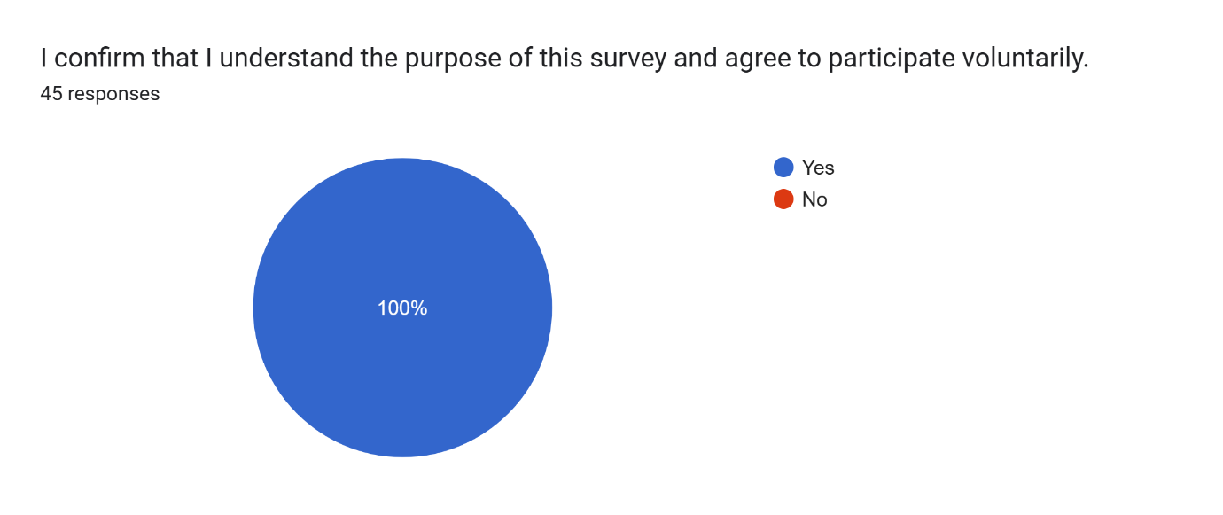

The findings indicate that all 45 respondents agreed to participate in the survey voluntarily. This confirms that participants were notified about the purpose of the study and understood that the data would be utilised for academic research. The results also reveal that ethical standards were maintained throughout the data collection process.

1.10.1 Demographic information
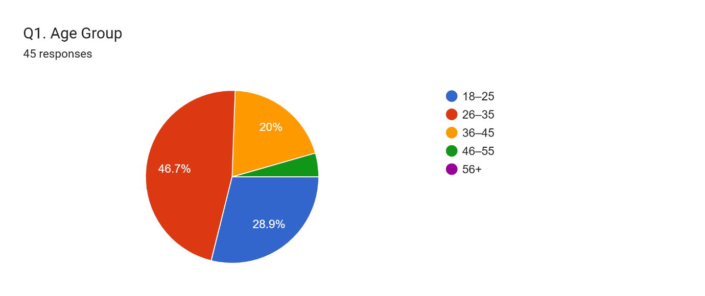

The division of respondents by age shows that the sample is predominantly composed of individuals within the 26–35 age group, representing 46.7% of the total participants. This is followed by those aged 18–25 (28.9%), indicating a strong version of younger users. Participants within the 36–45 age bracket account for 20% of the sample, while only a small proportion (4.4%) falls within the 46–55 category. Notably, no respondents were recorded in the 56 and above age group.
This pattern suggests that digital banking usage is more dominant among younger and middle-aged individuals, who are normally more familiar and comfortable with technology-based financial services. Therefore, the findings may primarily reflect the perceptions and experiences of digitally active age groups.

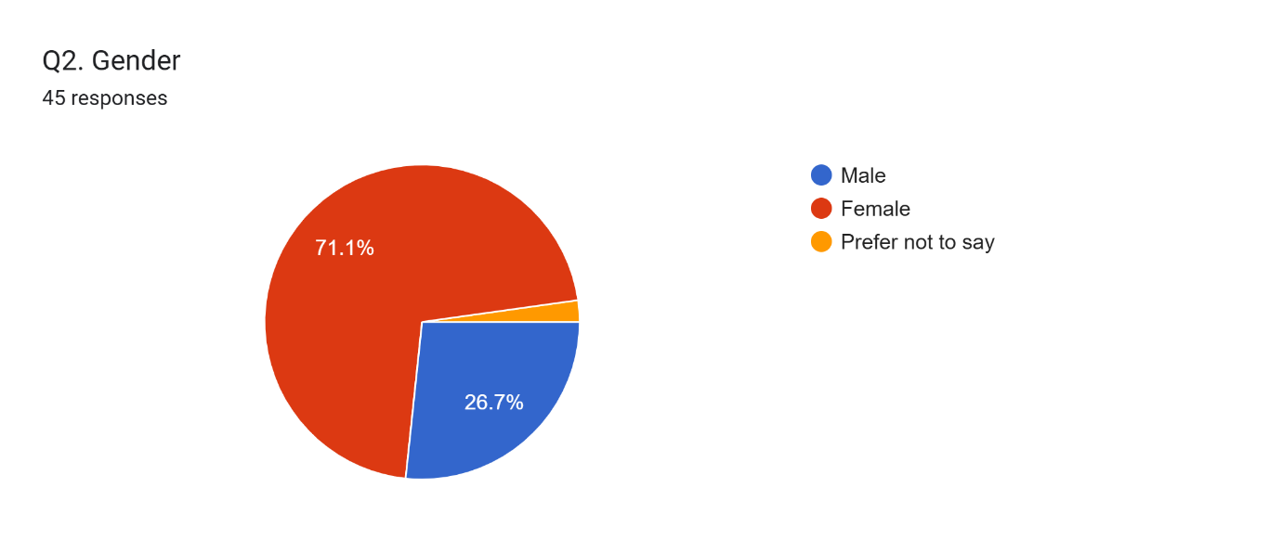

The gender allocation of respondents signifies that the sample is largely female, accounting for 71.1% of the total participants. Male respondents represent 26.7%, reflecting a moderately lower proportion. A small percentage of participants (2.2%) chose not to reveal their gender.
This distribution recommends that the findings of the study may be more strongly influenced by the perceptions of female users, which could have implications for interpreting overall customer perceptions of digital banking services.
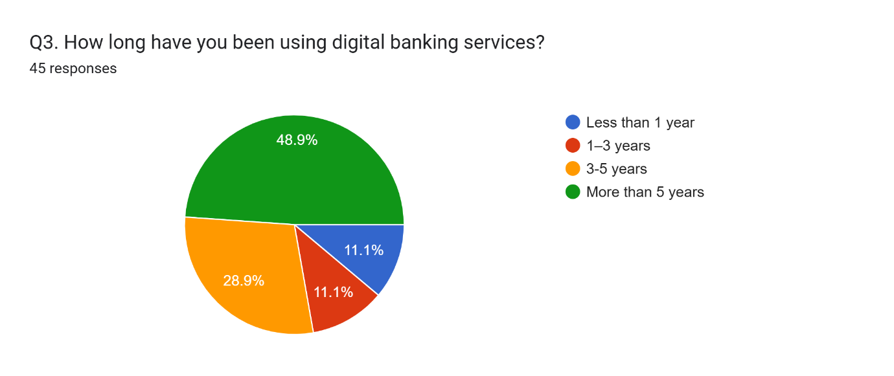
The period of digital banking usage among respondents shows that a substantial ratio of participants are experienced users. A majority (48.9%) have been using digital banking services for more than five years, indicating a major level of familiarity with these platforms. This is followed by 28.9% of respondents who have been using such services for 3–5 years. In contrast, minor and equal proportions (11.1% each) reported usage of less than one year and between 1 and 3 years.
This distribution indicates that most respondents possess experience with digital banking, which develops the dependability of their responses in assessing ease of use, usefulness, and overall satisfaction.

1.10.2 Digital Banking usage
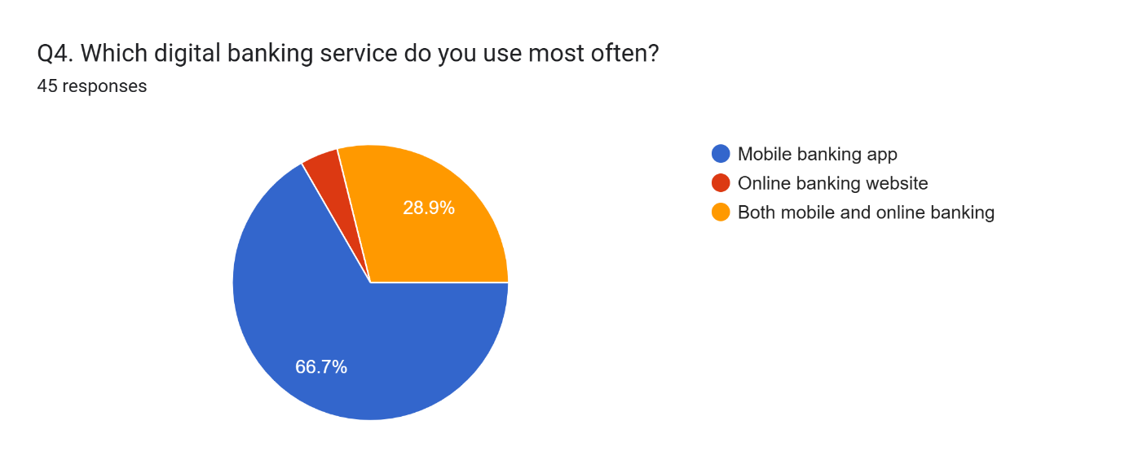
The distribution of digital banking usage channels indicates that mobile banking applications are the major platform among respondents. A clear majority (66.7%) informed primarily using mobile banking apps, while 28.9% indicated that they use both mobile and online banking services. In contrast, only a small proportion (4.4%) rely completely on online banking websites.
This data implies a strong user preference for mobile-based banking, due to its convenience, accessibility, and ease of use, highlighting the growing importance of mobile platforms in delivering digital banking services.
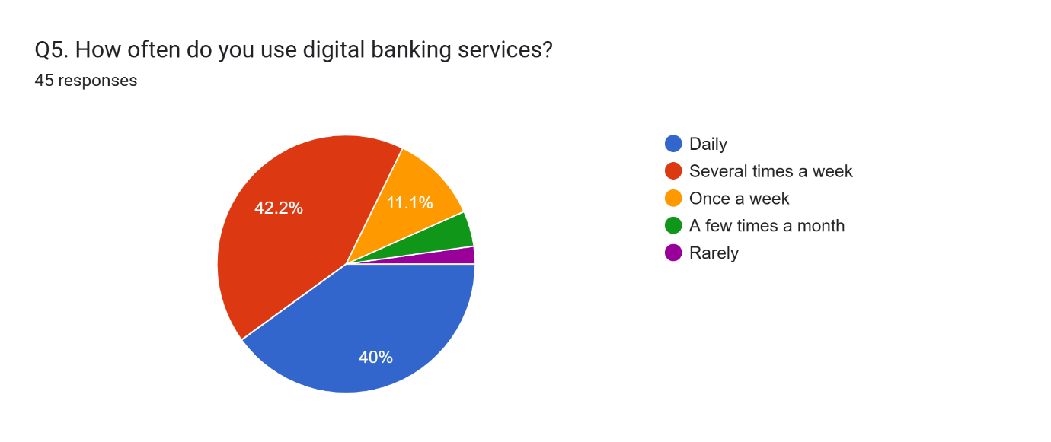
The frequency of digital banking usage reveals a superior level of engagement among respondents. Most participants reported using digital banking several times a week (42.2%), closely followed by those who access these services daily (40%). A smaller proportion indicated usage once a week (11.1%), while 4.4% reported using digital banking a few times a month. Only a nominal percentage (2.2%) said that they rarely use such services.
A clear trend is manifest, proving that digital banking has become an integral part of users’ daily financial activities. This indicates a strong level of user familiarity and comfort with digital banking systems, reflecting a positive perception of usability and convenience.
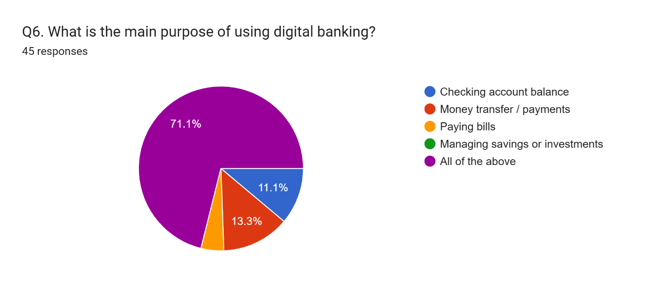
The distribution of usage purposes indicates that digital banking is used for an expansive range of financial activities. A substantial majority of respondents (71.1%) selected “all of the above,” showing that users rely on digital banking for multiple functions, embracing checking balances, making payments, and managing transactions. A minor proportion (13.3%) reported using digital banking primarily for money transfers and payments, while 11.1% indicated checking account balances as their main purpose. Only a minimal percentage (4.4%) found bill payments as their primary use.
This pattern highlights the multifunctional characteristics of digital banking services, suggesting that users perceive these platforms as comprehensive financial tools rather than being limited to a single purpose.
1.10.3 Screening 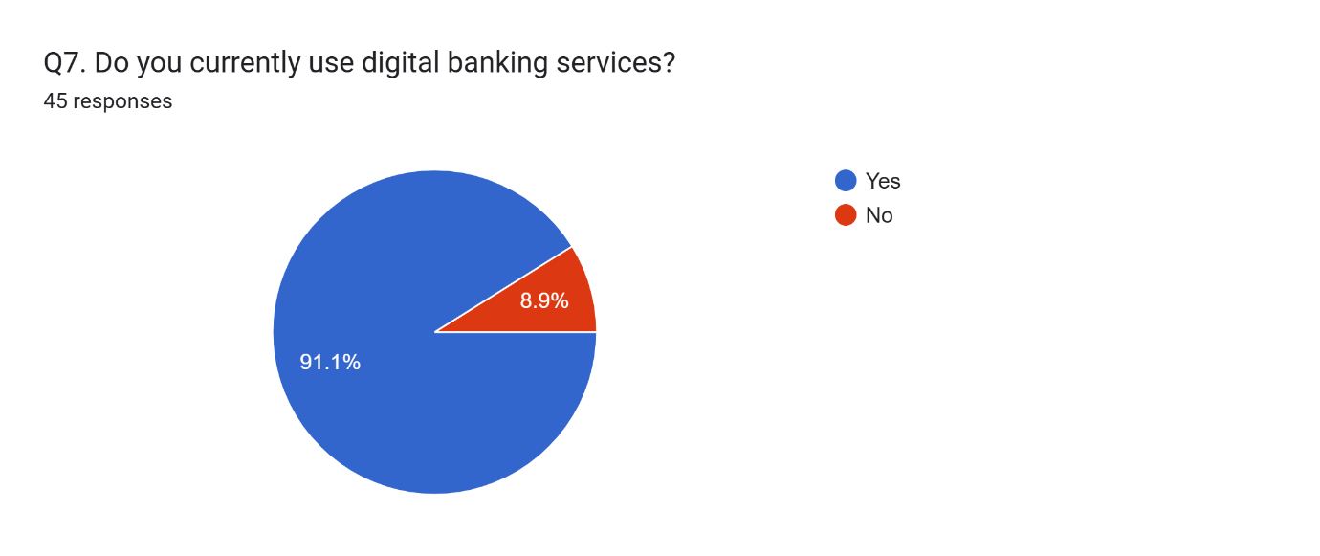
The reactions to the screening question reveal that many participants are active users of digital banking services. An outsize proportion of respondents (91.1%) confirmed that they currently use digital banking, while only a small minority (8.9%) reported that they do not.
This distribution confirms that the sample is highly relevant to the research objectives, as it consists of individuals with direct experience of digital banking. Consequently, the data collected provides a reliable basis for analysing customer perceptions, usability, and satisfaction.

1.10.4 Perceived ease of use

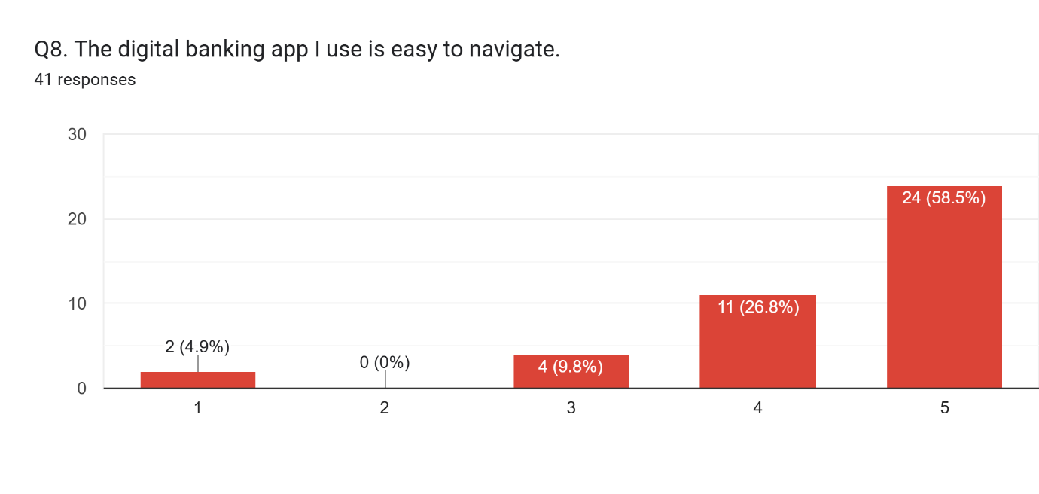
The responses involving to the ease of navigating digital banking applications indicate a highly positive user perception. A majority of respondents (58.5%) strongly agreed that the applications are easy to navigate, while a further 26.8% agreed. A smaller proportion (9.8%) stayed neutral, and especially, no respondents selected “disagree,” with only 4.9% strongly disagreeing.
This distribution suggests that digital banking platforms are generally perceived as user-friendly, highlighting the effectiveness of current interface design and navigation structures. It also reflects a strong level of perceived ease of use, which is a key determinant in shaping positive user experiences.
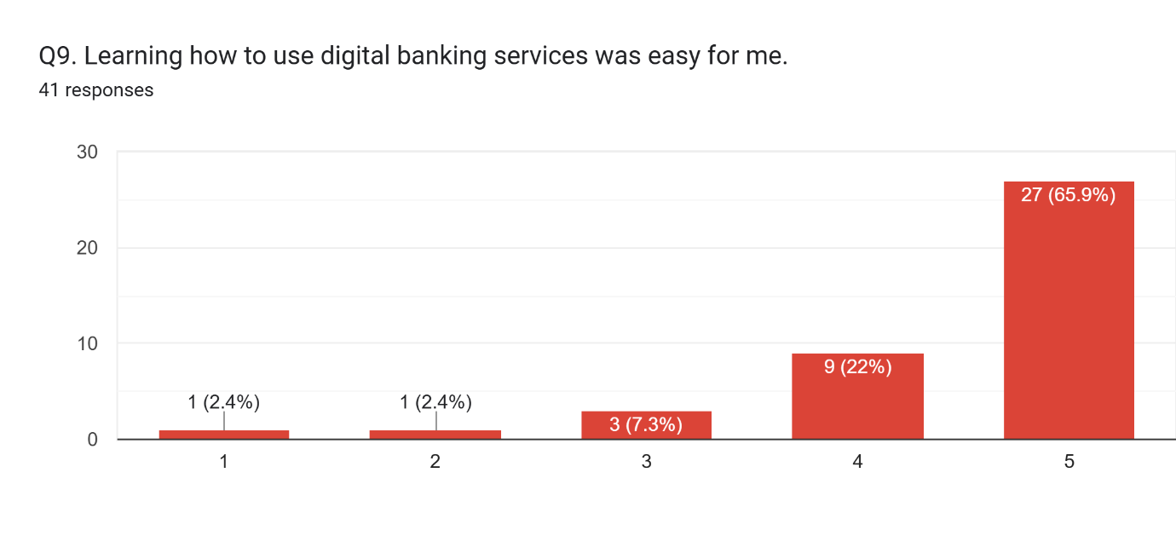
The responses regarding the ease of learning digital banking services indicate a strongly positive user perception. A substantial majority of participants (65.9%) strongly agreed that learning to use digital banking is easy, while a further 22% agreed. A smaller part (7.3%) remained neutral, and only the smallest percentage (2.4% each) indicated disagreement and strong disagreement.
This outline suggests that digital banking systems are generally intuitive and require limited effort to learn, underlining a high level of perceived ease of use. It also highlights the effectiveness of user interface design in supporting user adoption and reducing learning obstacles.
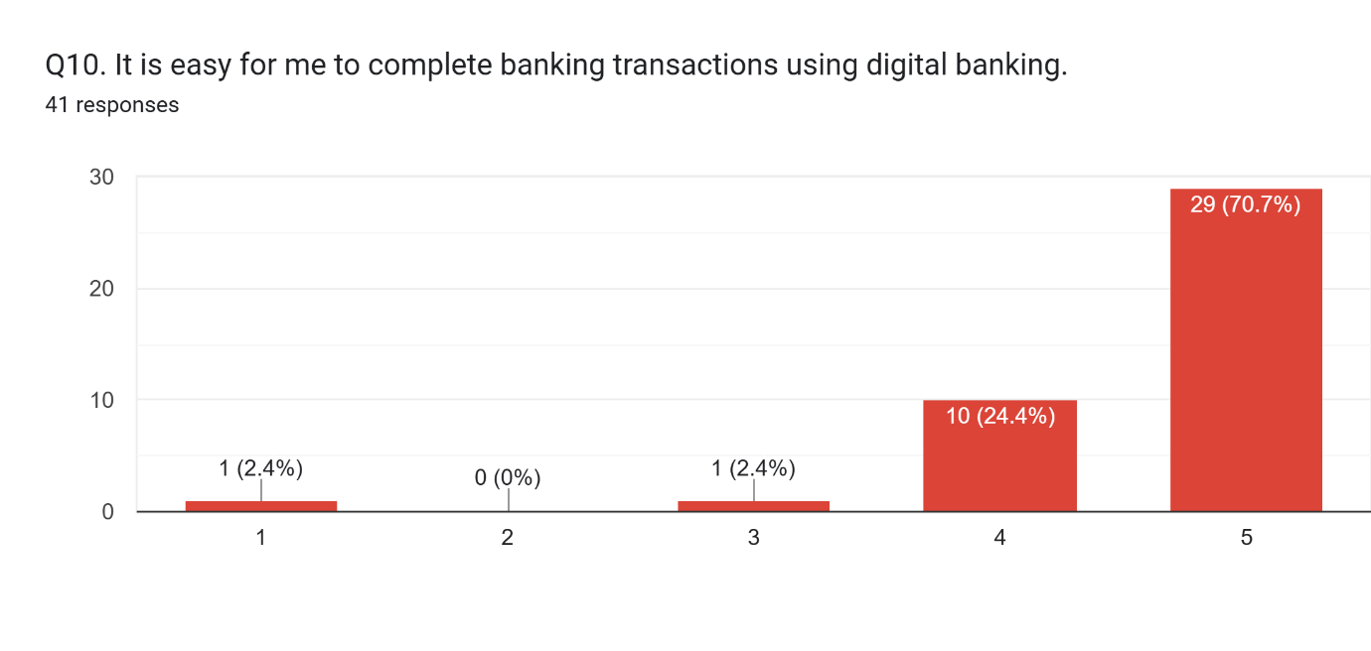
The responses regarding the ease of completing banking transactions indicate a highly positive perception among users. A substantial margin of participants (70.7%) strongly agreed that digital banking allows easy transaction completion, while a further 24.4% agreed. Only a small proportion (2.4%) stayed neutral, with no respondents selecting “disagree” and a minimal percentage (2.4%) strongly disagreeing.
This distribution emphasises the efficiency and practicality of digital banking services, indicating that users perceive these platforms as convenient tools for managing transactions. It also highlights the role of perceived ease of use in enhancing overall user satisfaction and encouraging continued usage.
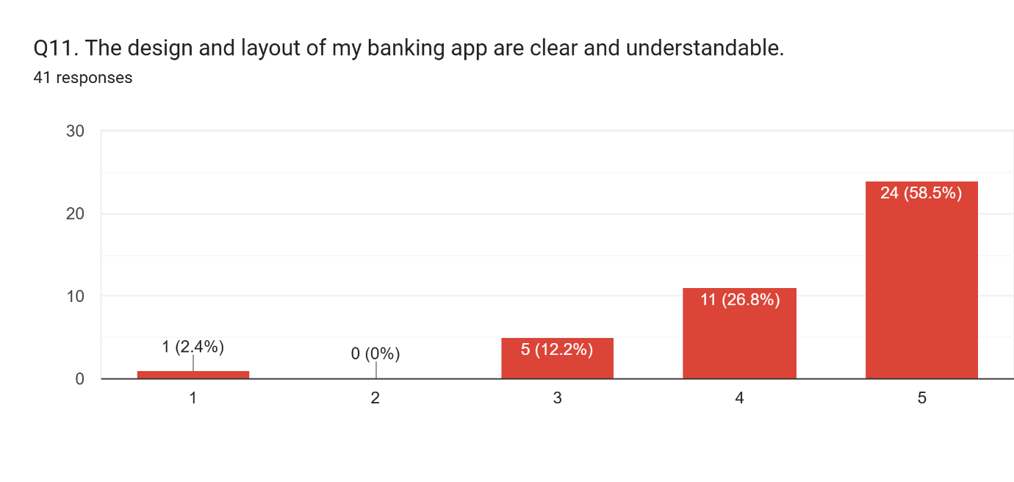
The responses relating to the clarity and comprehensibility of digital banking application design indicate a strong positive perception among users. Most participants (58.5%) strongly agreed that the design and layout are clear and easy to understand, while 26.8% stated agreement. A further 12.2% of respondents persisted neutral, with no participants selecting “disagree” and only a minimal proportion (approximately 2.4%) strongly disagreeing.
This distribution suggests that digital banking applications are perceived as well-structured and user-friendly, highlighting the importance of effective interface design in enhancing usability. It also highlights the role of clear and intuitive layouts in supporting positive user experiences and reducing complexity.
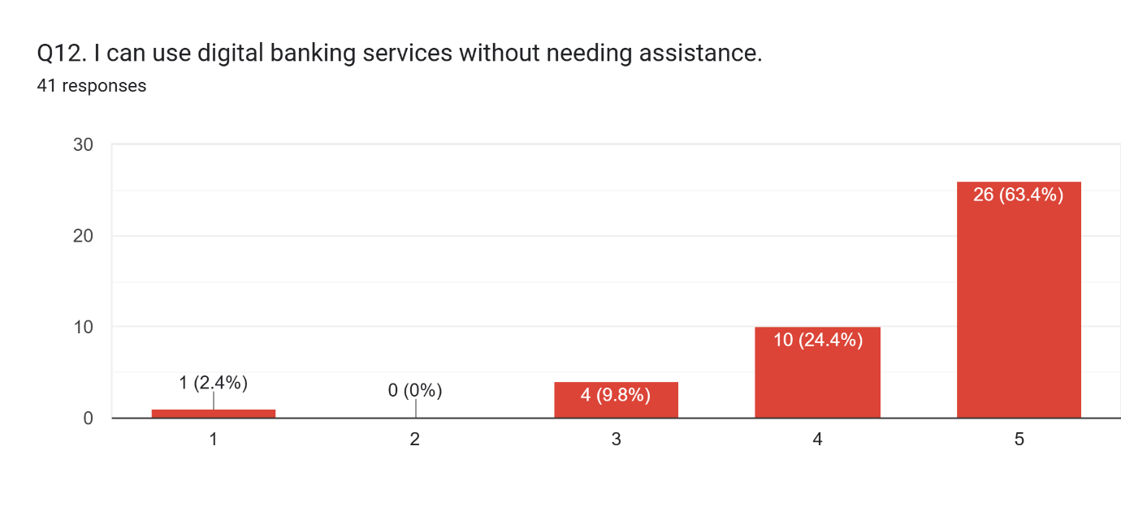
The findings related to users’ ability to use digital banking services individually demonstrate an important level of user confidence. Many respondents (63.4%) strongly agreed that they can use digital banking without assistance, while 24.4% expressed agreement. A further 9.8% remained neutral, with no respondents indicating disagreement and only a small proportion (2.4%) strongly disagreeing.
This pattern reveals a powerful sense of user self-efficacy, suggesting that digital banking platforms are sufficiently intuitive to be used without external support. It also underlines the effectiveness of system design in enabling independent usage, which is a key aspect of perceived ease of use.

1.10.5 Perceived usefulness
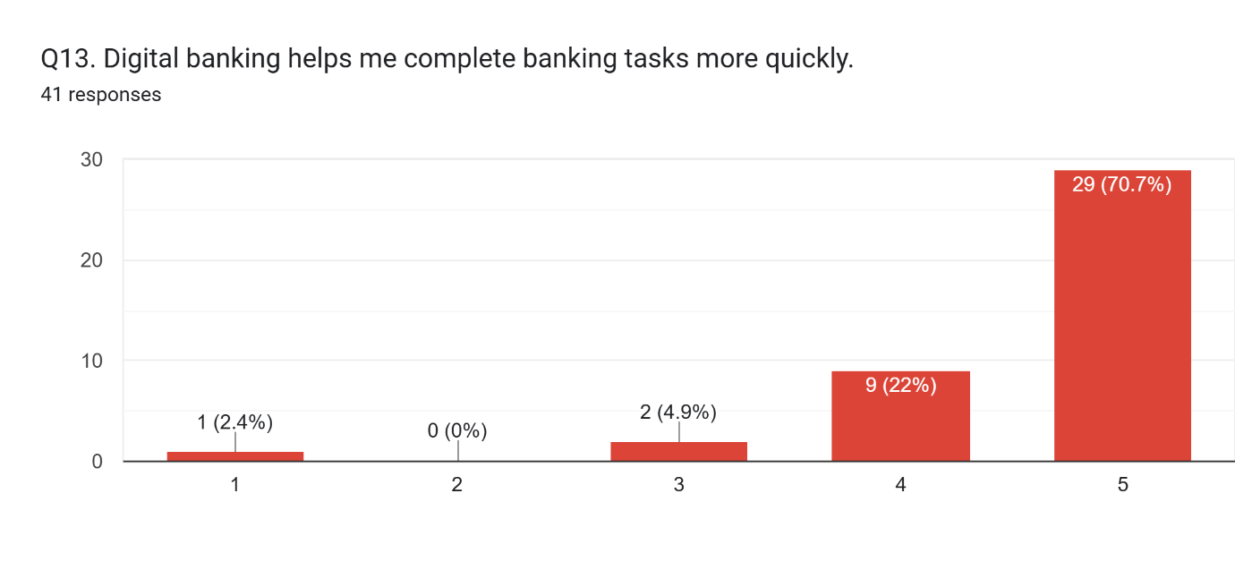
The responses regarding the efficiency of digital banking in completing tasks highlight a strong positive perception among users. A considerable majority of participants (70.7%) strongly agreed that digital banking enables immediate completion of financial activities, while 22% expressed agreement. A small proportion (4.9%) remained neutral, with no respondents indicating disagreement and only 2.4% strongly disagreeing.
This distribution underscores the perceived usefulness of digital banking, particularly in terms of time-saving and efficiency. It indicates that users value digital platforms for their capacity to streamline financial processes, which plays a crucial role in enhancing overall user satisfaction.
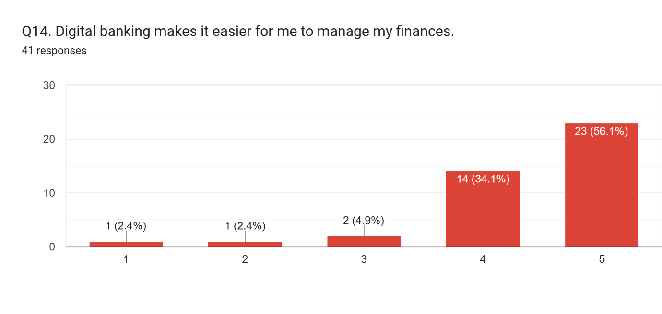
The responses relating to the role of digital banking in financial management indicate a predominantly positive user perception. A majority of participants (56.1%) strongly agreed that digital banking makes it easier to operate their finances, while a further 34.1% agreed. A small proportion of respondents (4.9%) remained neutral, whereas only minimal percentages (2.4% each) indicated disagreement and strong disagreement.
This pattern highlights the perceived usefulness of digital banking as an effective financial management tool. It suggests that users benefit from improved control, accessibility, and organisation of their financial activities, which contributes to enhanced user experience and overall satisfaction.
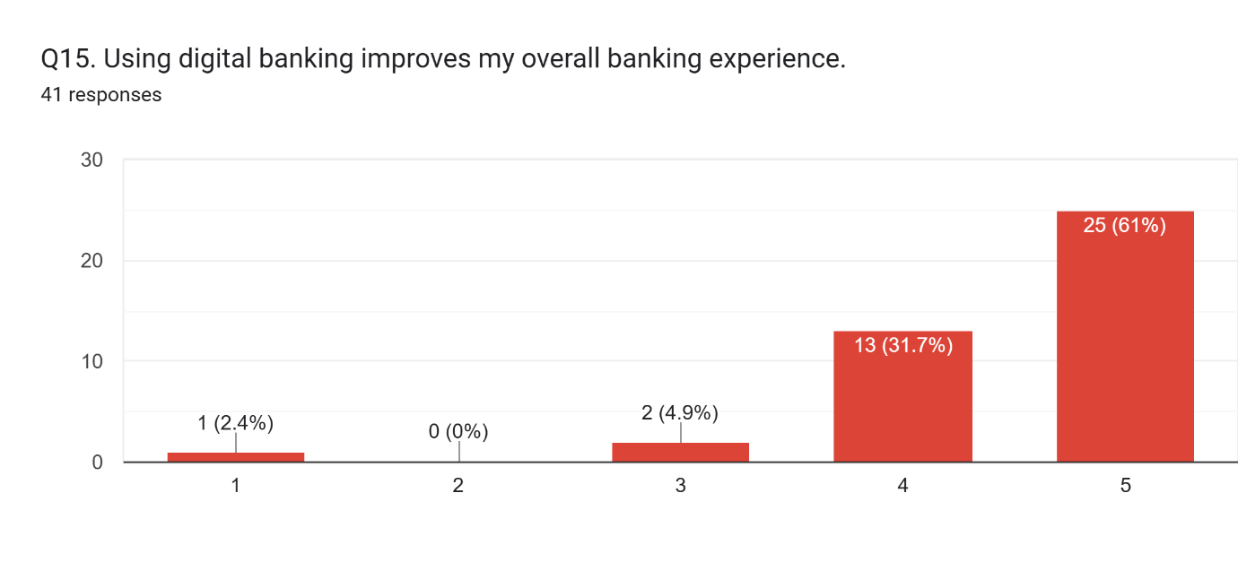
The findings concerning the impact of digital banking on overall user experience reveal a highly positive perception among respondents. A majority of participants (61%) strongly agreed that digital banking enhances their overall banking experience, while 31.7% expressed agreement. A smaller proportion (4.9%) remained neutral, with no respondents showing disagreement and only 2.4% strongly disagreeing.
This distribution indicates that digital banking contributes significantly to improving the overall customer experience. It reflects users’ gain of convenience, accessibility, and efficiency, which are key factors in defining positive perceptions and satisfaction with digital banking services.
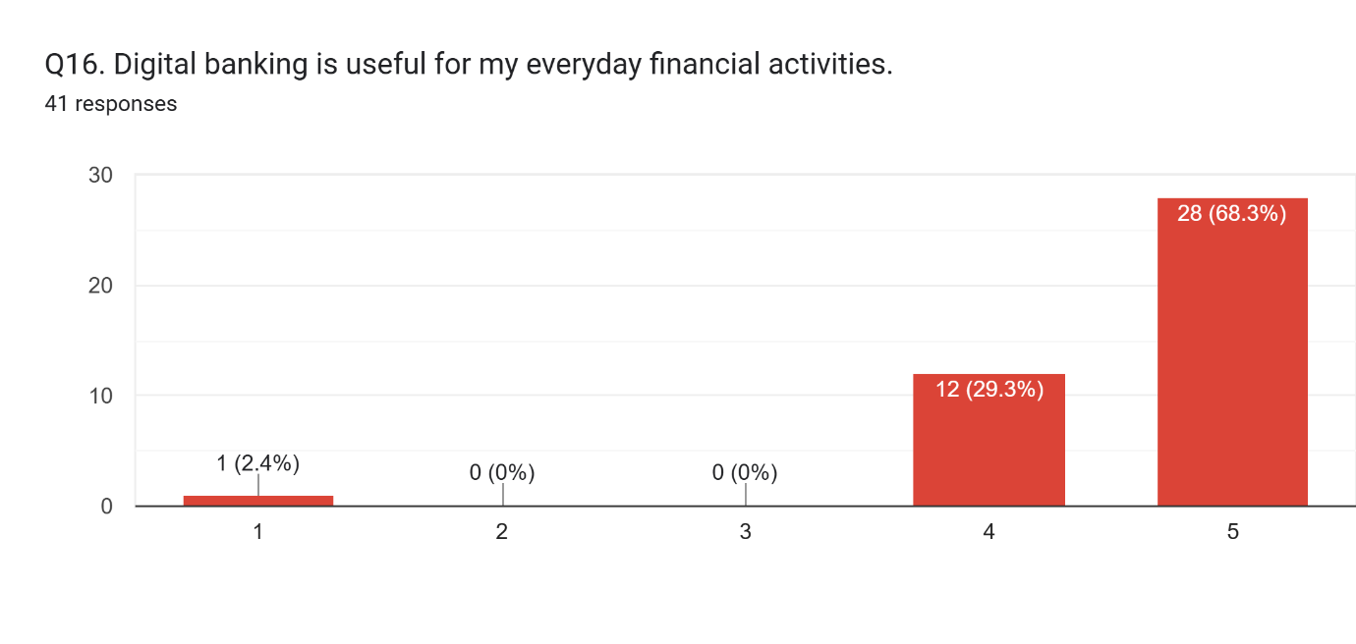
The responses regarding the usefulness of digital banking for everyday financial activities demonstrate a strong positive perception among users. A significant majority of participants (68.3%) strongly agreed that digital banking supports their daily financial tasks, while a further 29.3% agreed. Notably, no respondents selected “neutral” or “disagree,” and only a minimal proportion (2.4%) strongly disagreed.
This pattern emphasises the pivotal role of digital banking in regular financial management, suggesting that users depend profoundly on these platforms for their daily activities. It also reinforces the perceived usefulness of digital banking as a convenient and essential tool, contributing to higher levels of user satisfaction.
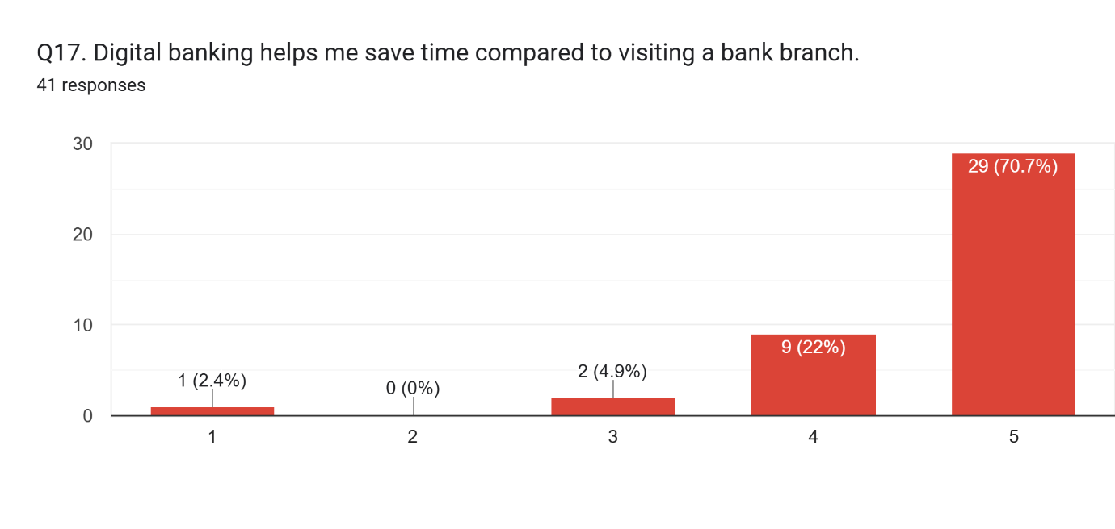
The findings relating to the time-saving benefits of digital banking indicate a highly beneficial perception among respondents. A substantial majority of participants (70.7%) strongly agreed that digital banking facilitates saving time compared to visiting a physical bank branch, while 22% expressed agreement. A small proportion (4.9%) remained neutral, with no respondents indicating disagreement and only 2.4% strongly disagreeing.
This distribution highlights the efficiency benefit of digital banking over traditional banking methods. It suggests that users value the ability to perform transactions fast and conveniently, reinforcing the importance of time efficiency as a key element of perceived usefulness and overall customer satisfaction.

1.10.6 Customer Satisfaction
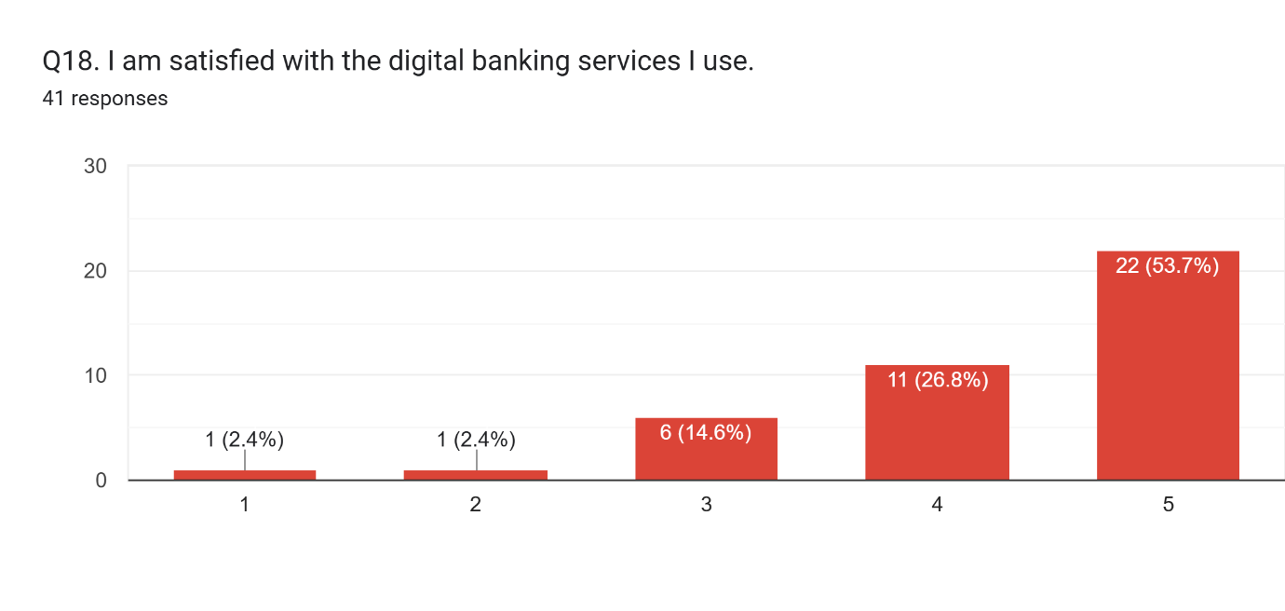
The responses relating to overall satisfaction with digital banking services indicate a predominantly positive perception among users. A majority of participants (53.7%) strongly agreed that they are satisfied with the digital banking services they use, while 26.8% expressed agreement. A further 14.6% remained neutral, with only a small proportion indicating dissatisfaction (2.4% each for “disagree” and “strongly disagree”).
This pattern suggests that digital banking services are commonly successful in meeting user expectations. It reflects a favourable evaluation of service quality, usability, and functionality, all of which contribute to enhanced customer satisfaction and continued usage intention.

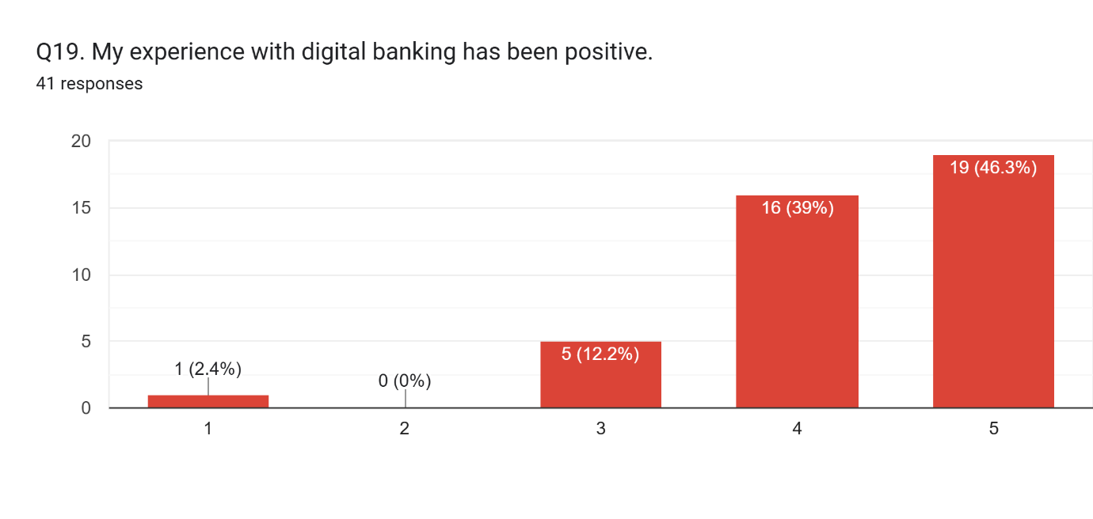
The findings related to users’ overall experience with digital banking disclose a highly positive perception among respondents. A significant proportion of participants (46.3%) strongly agreed that their experience had been positive, while a further 39% expressed agreement. A smaller percentage (12.2%) remained neutral, with no respondents indicating disagreement and only 2.4% strongly disagreeing.
This distribution reinforces the overall positive evaluation of digital banking services, suggesting that users are generally satisfied with their connections and involvement. It also highlights the effectiveness of digital platforms in presenting convenient, efficient, and user-oriented banking services, which contribute to favourable customer perceptions.
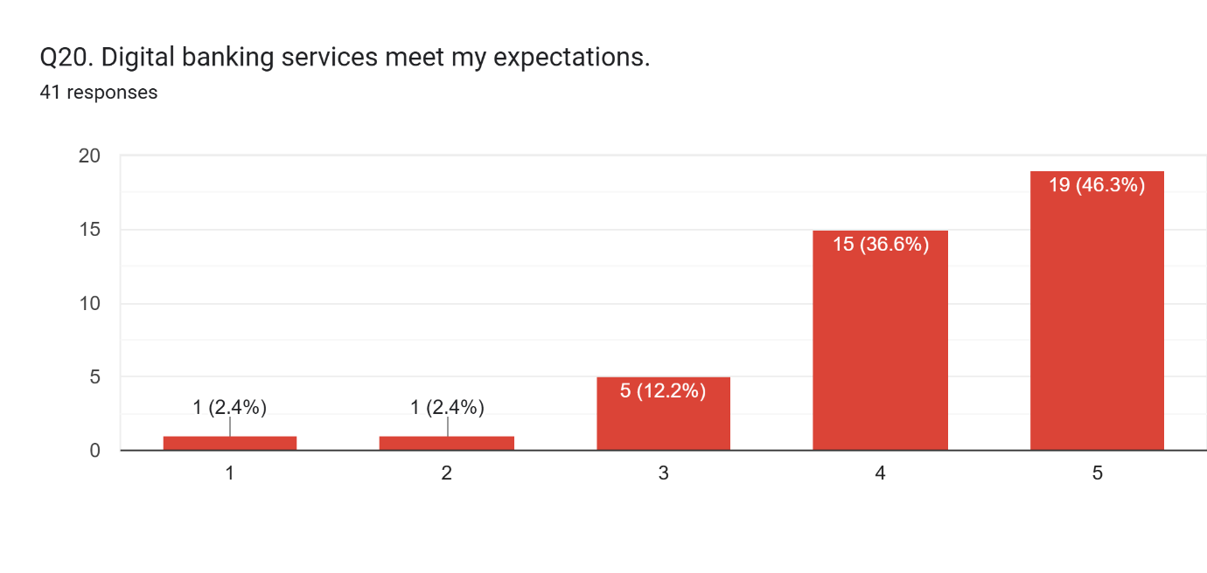
The responses concerning whether digital banking services meet user expectations indicate a predominantly positive evaluation among participants. A considerable proportion of respondents (46.3%) strongly agreed that digital banking meets their expectations, while a further 36.6% agreed. A smaller percentage (12.2%) remained neutral, with only nominal proportions (2.4% each) indicating disagreement and strong disagreement.
This distribution suggests that digital banking services are largely successful in aligning with user expectations. It highlights the capability of these platforms to deliver value in terms of usability, efficiency, and convenience, thereby contributing to overall customer satisfaction and reinforcing positive user perceptions.

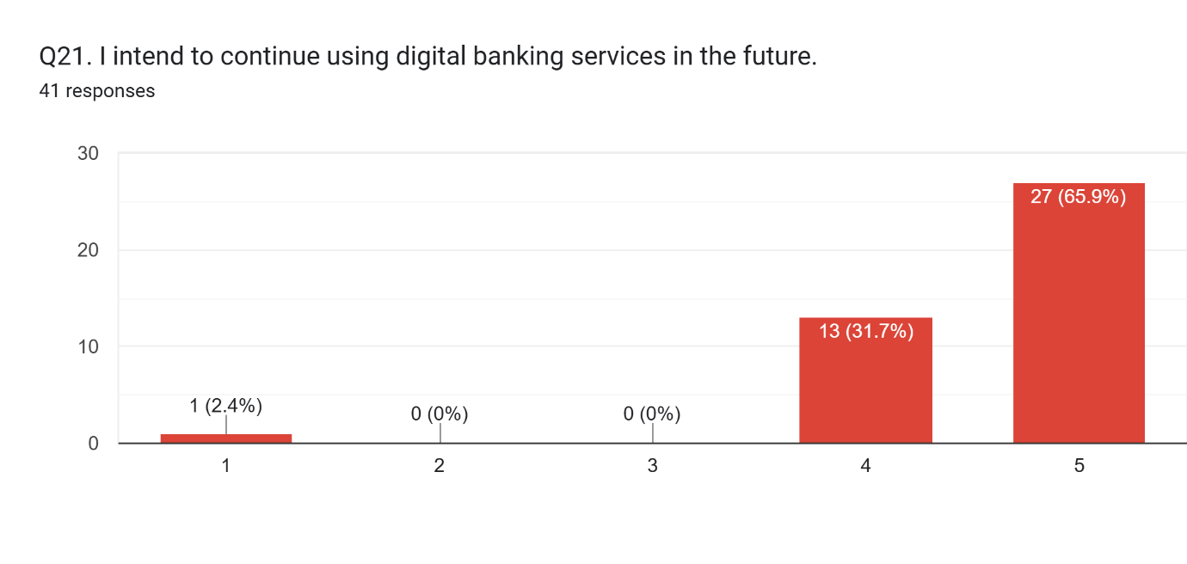
The responses regarding users’ intention to continue using digital banking services indicate a strong positive interactive outcome. A significant majority of respondents (65.9%) strongly agreed that they aim to continue using these services in the future, while 31.7% expressed agreement. Notably, no participants selected “neutral” or “disagree,” and only a minimal proportion (2.4%) strongly disagreed.
This pattern demonstrates a high level of continued usage intention, reflecting sustained satisfaction and acceptance of digital banking services. It also aligns with the Technology Acceptance Model (TAM), where positive perceptions of ease of use and usefulness contribute to favourable behavioural intentions and long-term adoption.

1.11 Findings
A total of forty-five respondents took part in this study. Data were collected through an online questionnaire distributed to digital banking users. All respondents confirmed that they currently use digital banking services, ensuring that the data collected was related and appropriate for assessment. This provided a reasonable basis for examining the relationships between perceived ease of use, perceived usefulness, and customer satisfaction.

1.11.1 Perceived ease of use
The findings discover a strong positive perception of ease of use among respondents. Many participants revealed that digital banking applications are easy to navigate and understand. A clear trend also emerged: users found it easy to learn to use digital banking services. In addition, most respondents reported that completing transactions through digital platforms is straightforward and effective. Furthermore, a considerable proportion of participants stated confidence in using digital banking independently, without requiring assistance. These results indicate that digital banking platforms are perceived as user-friendly and accessible.

1.11.2 Perceived usefulness
The results reveal that respondents widely perceive digital banking services as useful. A strong majority reported that digital banking enables faster completion of financial transactions paralleled to traditional banking methods. Participants also indicated that digital platforms support more valuable monetary management. While an exceedingly small number of respondents stated concerns about usefulness, the overall perception remained highly positive. Additionally, respondents emphasised that digital banking improves their overall banking experience and plays a significant role in everyday financial activities. The ability to save time by avoiding trips to the bank was also effectively recognised. These findings suggest that digital banking provides significant practical benefits to users.

1.11.3 Customer satisfaction
The findings indicate a noticeable level of customer satisfaction with digital banking services. Most respondents stated being satisfied with their current digital banking experience and illustrated it as positive. Furthermore, most participants agreed that digital banking services meet their expectations. A strong behavioural purpose to continue using digital banking was also seen among respondents. These results suggest that digital banking services are successful in delivering a satisfactory user experience and keeping customer engagement.
Overall, the findings of this study indicate that perceived ease of use and perceived usefulness have a strong positive impact on customer satisfaction. The results are associated with the Technology Acceptance Model (TAM) (Davis, 1989), suggesting that when digital banking services are perceived as easy to use and useful, customers are more likely to be satisfied and demonstrate continued usage intention.

1.12 Discussion
This study evaluated the influence of perceived ease of use and perceived usefulness on customer satisfaction within digital banking services. The findings specify that both aspects play a substantial role in forming customer satisfaction, emphasising the importance of user perception in assessing digital banking platforms. These outcomes reinforce the assumptions of the Technology Acceptance Model (Davis, 1989), suggesting that definite perceptions of usability and functionality contribute to beneficial user evaluations. In the context of increasing digital dependency, particularly following the COVID-19 pandemic, customers have elaborated higher expectations for convenience, efficiency, and accessibility. This shift helps clarify why ease of use and usefulness have become critical determinants of satisfaction in digital banking environments.
The findings suggest that perceived ease of use significantly contributes to customer satisfaction. When digital banking applications are modest to navigate and require minimal effort, users are more likely to engage with the platform confidently. This shows that usability is not only a technical element but also a key factor influencing user trust and overall experience. This finding is coherent with prior research highlighting the importance of ease of use in influencing user behaviour and engagement (Alalwan et al., 2016). In practice, numerous uses may further improve expertise, allowing users to interact with digital banking systems more efficiently. Therefore, ease of use can be viewed as a foundational element that supports both satisfaction and continued engagement.
Perceived usefulness has also developed as a strong determinant of customer satisfaction. The findings indicate that users place considerable value on the practical benefits offered by digital banking, principally in terms of time efficiency and convenience. The ability to perform transactions quickly and manage finances essentially enhances the perceived value of digital services. This is associated with previous research (Ghani et al., 2022), which emphasises the role of usefulness in shaping customer satisfaction and behavioural outcomes. In a fast-paced digital environment, customers prioritise services that improve efficiency and reduce effort, suggesting that usefulness is inherently linked to both functional performance and user expectations.
Customer satisfaction, as discovered in this study, plays a leading role in influencing continued usage intention. The findings indicate that positive user experiences lead to deeper behavioural intentions to continue using digital banking services. This is consistent with preceding research (Pratama, 2024), which underlines the relationship involving satisfaction and continued usage. Satisfaction reveals not only the accomplishment of expectations but also the overall evaluation of service quality. As a result, reassured users are more likely to maintain long-term relationships with digital banking platforms and demonstrate higher levels of engagement.
The findings of this study can also be taken in the context of broader digital transformation trends. The rising integration of digital technologies into everyday life has regularised the use of online banking services. In the UK, customers progressively choose fast, accessible, and convenient banking solutions, which further strengthens the role of digital platforms. The common adoption of digital banking following the pandemic has also enhanced user familiarity and confidence, contributing to higher satisfaction levels.
This study contributes to practice by providing actionable insights for banking institutions to enhance digital service design, usability, and functionality. Expanding interface simplicity and system effectiveness can directly influence customer satisfaction and help banks better meet advancing customer expectations in a competitive digital environment.
Overall, the results deliver dedicated support for the Technology Acceptance Model (Davis, 1989), confirming that perceived ease of use and perceived usefulness are key considerations influencing customer satisfaction and continued usage intention. The study emphasises that digital banking success is not solely dependent on technological advancement but also on how users perceive and experience these services.

1.13 Conclusion
This study aimed to assess the effect of perceived ease of use and perceived usefulness on customer satisfaction in the context of digital banking in the UK. A small pilot study was conducted using a questionnaire distributed to UK digital banking users through a convenience sampling approach. The outcomes disclose that both perceived ease of use and perceived usefulness have an optimistic impact on customer satisfaction. It was noted that when digital banking applications are easy to use, customer satisfaction increases, and likewise, when services are perceived as useful, they improve overall user experience. As a result, customers develop a cheerful outlook, increased trust, and confidence, which promotes continued usage of digital banking services. These findings support the Technology Acceptance Model (Davis, 1989), highlighting the importance of user perceptions in shaping behaviour and satisfaction. Therefore, banks must focus on improving ease of use and offering useful features to enhance customer satisfaction and experience.

1.14 Recommendations
Based on the findings, this study indicates that banks ought to focus on improving the ease of use of digital banking services by confirming simple interfaces, easy navigation, and a user-friendly design while lowering complications as much as possible. In addition, banks should improve the usefulness of their services by offering faster transactions, time-saving features, and increased financial tools to help customers manage their finances more efficiently. Furthermore, delivering effective customer support is essential, particularly for inexperienced users, through guidance, seminars, and approachable support systems. Trust and security also play a vital role; therefore, banks should consolidate security measures to develop customer trust and ensure data protection. Constant improvement is also important, including usual updates to applications, enhancement of user experience, and implementation of recent technologies. These behaviours can help improve customer satisfaction, increase usage, and serve a better overall customer experience.

1.15 Limitations
This study has respective limitations that should be measured. Primarily, the sample size is small, with only forty-five respondents, which might not entirely signify the wider population. In addition, the use of convenience sampling might introduce bias and limit the generalisability of the findings. The study is also constrained to the UK context; therefore, the results may vary in other countries. Data were collected through an online questionnaire, which limits the depth of responses and does not capture in-depth opinions compared to face-to-face methods. Furthermore, the study focuses only on perceived ease of use, perceived usefulness, and customer satisfaction, without considering other crucial factors such as trust, security, and service quality. As this is a pilot study, the findings are preliminary in nature. Therefore, future research should involve a larger sample size, include different regions, and consider additional variables to provide more comprehensive insights.

1.16 References
Davis, F.D., 1989. Perceived usefulness, perceived ease of use, and user acceptance of information technology. MIS Quarterly, 13(3), pp.319–340.
Ghani, E.K., Ali, M.M., Musa, M.N.R. and Omonov, A.A., 2022. The effect of perceived usefulness, reliability, and the COVID-19 pandemic on digital banking effectiveness: Analysis using the technology acceptance model. Sustainability, 14(18), p.11248.
Pratama, S.F., 2024. Analysing the determinants of user satisfaction and continuous usage intention for digital banking platforms: A structural equation modeling approach. Journal of Digital Market and Digital Currency, 1(3), pp.267–285.
Gibson, A., Ofori, F.N.K. and Appiah, K., 2022. Exploring young consumers' satisfaction with online and offline banking services: The motivation of switching between banks in the UK. Archives of Business Research, 10(6).
Aziz, K.A., Jabar, M.A., Abdullah, S. and Nor, R.N.H., 2022. Assessing factors influencing internet banking adoption using the Rasch model measurement. Bulletin of Electrical Engineering and Informatics, 11(4), pp.2313–2321.
Acosta-Prado, J.C., Rojas Rincón, J.S., Mejía Martínez, A.M. and Riveros Tarazona, A.R., 2024. Trends in the literature about the adoption of digital banking in emerging economies: A bibliometric analysis. Journal of Risk and Financial Management, 17(12), p.545.
Martínez-Navalón, J.G., Fernández-Fernández, M. and Alberto, F.P., 2023. Does privacy and ease of use influence user trust in digital banking applications in Spain and Portugal? International Entrepreneurship and Management Journal, 19(2), pp.781–803.
Londa, D.R., Worang, F.G. and Arie, F.V., 2022. The influence of perceived credibility, perceived ease of use, and perceived usefulness toward customer satisfaction in using BSGtouch. Jurnal EMBA: Jurnal Riset Ekonomi, Manajemen, Bisnis dan Akuntansi, 10(1), pp.123–132.
Venkatesh, V., Morris, M.G., Davis, G.B. and Davis, F.D., 2003. User acceptance of information technology: Toward a unified view. MIS Quarterly, 27(3), pp.425–478.
Alalwan, A.A., Dwivedi, Y.K., Rana, N.P. and Williams, M.D., 2016. Consumer adoption of mobile banking in Jordan: Examining the role of usefulness and ease of use. International Journal of Information Management, 36(5), pp.697–709.
Shaikh, A.A. and Karjaluoto, H., 2015. Mobile banking adoption: A literature review. Telematics and Informatics, 32(1), pp.129–142.

1.17 Appendices
Title:
Exploring the Extent of Digital Technology (DT) on Banking Services: The Case of Meeting Stakeholders' Expectations
Section 1: Participant Consent
- Do you agree to participate in this study?
☐ Yes
☐ No
Section 2: Demographic Information
- Age:
☐ 18–25
☐ 26–35
☐ 36–45
☐ 46–55
☐ 56+
- Gender:
☐ Male
☐ Female
☐ Prefer not to say
Section 3: Digital Banking Usage
- Do you currently use digital banking services?
☐ Yes
☐ No
- How long have you been using digital banking services?
☐ Less than 1 year
☐ 1–3 years
☐ 3–5 years
☐ More than 5 years?
- Which digital banking service do you use most often?
☐ Mobile banking application
☐ Online banking website
☐ Both?
- How often do you use digital banking services?
☐ Daily
☐ Several times a week
☐ Once a week
☐ A few times a month
☐ Rarely?
- What is your main purpose for using digital banking?
☐ Checking account balance
☐ Paying bills
☐ Money transfers and payments
☐ All of the above?
Section 4: Perceived Ease of Use
(Please indicate your level of agreement using the following scale:
1 = Strongly Disagree, 2 = Disagree, 3 = Neutral, 4 = Agree, 5 = Strongly Agree)
- Digital banking applications are easy to navigate.
- Learning to use digital banking services is easy.
- It is easy to complete banking transactions using digital banking.
- The design and layout of digital banking applications are clear and understandable.
- I can use digital banking services without assistance.
Section 5: Perceived Usefulness
(Please indicate your level of agreement using the following scale:
1 = Strongly Disagree, 2 = Disagree, 3 = Neutral, 4 = Agree, 5 = Strongly Agree)
- Digital banking helps me complete banking tasks more quickly.
- Digital banking makes it easier to manage my finances.
- Digital banking improves my overall banking experience.
- Digital banking is useful for my everyday financial activities.
- Digital banking helps me save time compared to visiting a bank branch.
Section 6: Customer Satisfaction
(Please indicate your level of agreement using the following scale:
1 = Strongly Disagree, 2 = Disagree, 3 = Neutral, 4 = Agree, 5 = Strongly Agree)
- I am satisfied with the digital banking services I use.
- My experience with digital banking has been positive.
- Digital banking services meet my expectations.
- I intend to continue using digital banking services in the future.

Part 2: Reflection of the Study

2.1 Introduction
This reflective section seeks to convert the findings of the research into practical applications within the real-world context of digital banking. The study focuses on the role of perceived ease of use and perceived usefulness in influencing customer satisfaction in the UK retail banking sector.
This section aims to indicate how these research findings can be applied by banks to improve their digital services. This is predominantly important in the contemporary environment, where customer expectations are constantly increasing, and the banking sector is experiencing rapid digital transformation.
In addition, research plays a considerable role in supporting organisational decision-making by proposing evidence-based insights. In the context of digital banking, understanding customer perceptions and behaviour is fundamental for designing effective and user-friendly services.
Furthermore, this section presents practical references to enhance customer experience, advance service efficiency, and support banks in developing more accessible, dependable, and effective digital platforms. By linking theoretical concepts with real-world applications, this part of the study highlights the importance of translating research into actionable strategies.

2.2 Topic selection process
The selection of digital banking as a research topic was influenced by its growing significance in the modern financial scene. Digital banking signifies a rapidly growing sector that reflects the future of global financial services, driven by continuous technological innovation. It is a dynamic and progressing field, offering a strong link between technology and everyday life, as digital banking services are now used by individuals for routine financial activities.
The choice of perceived ease of use (PEOU) and perceived usefulness (PU) was led by their strong theoretical foundation within the Technology Acceptance Model (TAM). These forms are widely recognised as key bases of technology adoption behaviour. They provide significant behavioural insights into why individuals accept or reject digital technologies. Additionally, these variables are measurable, which makes them suitable for quantitative analysis and allows for clear interpretation of user perceptions.
Furthermore, the topic was considered practical in conditions of data collection. Digital banking users are undoubtedly accessible, as they are already active online, which eases the distribution of surveys through digital platforms. The prominent level of user engagement with banking applications also ensures that respondents can provide informed and profound feedback. Moreover, the availability of extensive academic literature encourages the research process and enables effective benchmarking of findings.

2.3 Literature review experience
The literature review process offered valuable learning opportunities, with both positive and challenging portions. One of the easier aspects was accessing academic sources through digital databases such as Google Scholar and the university library, which allowed for fast identification of many related studies. Organising references and managing citations was also relatively straightforward with the use of reference management tools. Additionally, after reviewing respective core articles, it became easier to show key themes and recurring concepts within the field of digital banking. While a substantial number of sources were primarily reviewed, only the most relevant and high-quality studies were selected to maintain focus and coherence within the literature review.
However, several challenges were met during this process. Many academic articles had complex technical language and advanced statistical analysis, which made interpretation difficult at times. Another challenge was information overload, as the large volume of available literature made it difficult to narrow down the most relevant studies for inclusion. Furthermore, synthesising the literature proved to be one of the most demanding tasks, as it required combining ideas from different authors into a coherent argument rather than simply summarising individual studies. Finally, developing a critical perspective was challenging, particularly when trying to find gaps or limitations in well-established research.

2.4 Designing the Questionnaire
Designing the questionnaire involved balancing the technical ease of digital tools with the academic requirements for collecting valid and reliable data. One of the easier aspects was the use of Google Forms, which provided a user-friendly platform to design and distribute the survey efficiently. The use of Likert scales (five-point scale ranging from strongly agree to strongly disagree) was particularly helpful, as it allowed for consistent measurement of respondents’ beliefs. This structure also ensured the attachment of a neutral midpoint, reducing respondent exhaustion and improving response quality.
However, several challenges were encountered during the questionnaire design process. One of the main complications was ensuring that all questions were clearly worded and easy to understand, while avoiding complex terminology or double-barrelled questions. Maintaining consistency in scale formatting across all sections was also important to prevent confusion among respondents.
The key challenge was ensuring alignment between the questionnaire and the research aims. Each question needed to directly contribute to answering the core research aim. This required careful consideration, as any unrelated or unsure question could affect the quality and reliability of the collected data. Overall, the procedure helped develop a deeper understanding of how to design structured and effective research instruments.

2.5 Data collection experience
The data collection process was accomplished by obtaining forty-five responses through direct engagement with personal and professional networks. The survey link was allocated to friends, family members, and colleagues using social media platforms and direct messaging. This method proved to be effective, as it allowed for quick and convenient access to participants who were familiar with digital banking services.
This involvement highlighted the importance of clear communication, as respondents were more willing to take part when the purpose of the study was clearly explained. Additionally, follow-up reminders played a decisive role in achieving the desired number of responses, demonstrating the importance of persistence in the data collection process.
Overall, this stage of the research enhanced both communication and organisational skills, while also providing practical insight into how to effectively engage participants and manage survey-based data collection.

2.6 Research Skills Developed.
Throughout this research process, numerous core research skills were extensively developed. These include questionnaire design, data analysis, critical thinking, and participant engagement. Connecting in this study enabled the development of a more organised and structured approach to evaluating academic sources and explaining research findings.
Critical thinking skills were improved through the process of investigating literature and showing appropriate themes and research gaps. Additionally, practical experience in designing a questionnaire improved the ability to create clear, structured, and objective research instruments. The process of data collection and analysis further strengthened the ability to interpret numerical data and draw meaningful conclusions.
Overall, this experience contributed to both academic and practical skill development, providing a solid foundation for conducting future research at a doctoral level.

2.7 Challenges and Solutions
Through the research process, several challenges were encountered that required effective problem-solving and self-management. One of the primary hurdles was time management, as the workload initially felt overwhelming. This challenge was directed by adopting a structured approach, such as working in focused 25-minute intervals followed by short breaks, which improved productivity and task organisation.
Another challenge involved confusion about the technical requirements of the research task. This was operated by seeking clarification from peers and dedicating more time to assessing relevant academic guidelines and supporting materials.
In addition, there were moments where confidence decreased, particularly when facing research-related difficulties. This was overcome by reflecting on earlier progress and recognising the skills and knowledge already developed during the research journey.
Overall, these challenges contributed to personal and academic growth by supporting resilience, time management, and problem-solving abilities.

2.8 Conclusion
This reflective process has required valuable insights into the overall research journey, from topic selection to data collection and analysis. It has enhanced my understanding of how to conduct structured academic research and apply theoretical models in a practical context.
Throughout this process, I have developed important research skills, involving critical thinking, questionnaire design, data analysis, and effective communication. These skills have increased my confidence in handling research tasks and overcoming challenges independently.
Moreover, this experience has enabled me to pursue future doctoral-level work, particularly in the development of my DBA thesis. It has provided a determined foundation for conducting more advanced research, with a clearer understanding of research design, methodology, and practical application.
Overall, this reflection highlights both academic and personal growth, demonstrating readiness to undertake more complex and independent research in the future. This study contributes to practice by demonstrating how customer satisfaction can be used as a key indicator of how effectively digital banking services meet stakeholder expectations.

