
Applied Computing

Wales Institute of Science and Art (WISA)

Networks and Cybersecurity Essentials (ACCA4024)

Lab 7: Tools to check on Threats and Vulnerabilities



n.kaliyamurthy@uwtsd.ac.uk 1

Objectives
Using Packet Capturing tools and network monitoring tools.
Tasks
1. Use Nmap to scan 2.
Required Resources
- PC with Ubuntu 16.0.4 LTS installed in a VirtualBox or VMware virtual machine. (Alternatively, Any Linux Platform)
- Internet Connection to refer the outcomes o References: https://nmap.org/

Task 1
- Login as User Cisco.
- Go to Terminal and Type the following commands and examine o To do that we are using Nmap.
▪ Network Mapper, or Nmap, is an open source utility used for network discovery and security auditing. Administrators also use Nmap for monitoring hosts or managing service upgrade schedules. ▪ Nmap determines
        - what hosts are available on a network,
        - what services are running,
        - what operating systems are running, • What packet filters or firewalls are running?
o So, basically if you could get all the above details using Nmap, you could get few information which could be used later in performing attacks or mitigating attacks.

- Commands to execute o Step 1:
▪ nmap localhost
(This is a scan performed to get information about the services that are bound to the localhost)
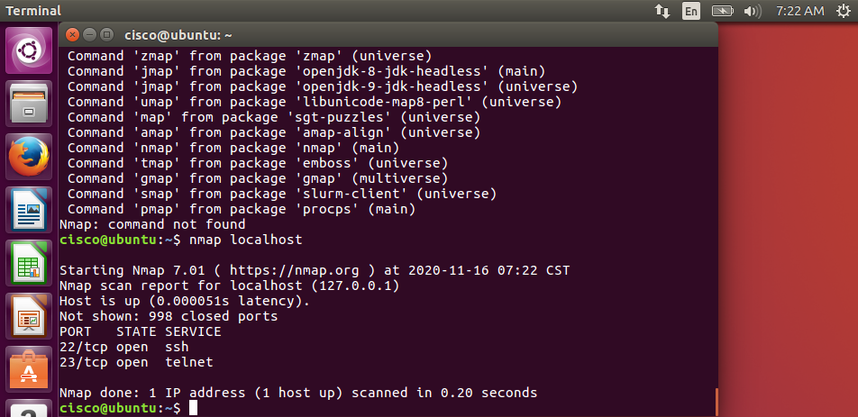

o Step 2:
▪ Replace the above command with your IP Address and other hosts (if connected/ else ignore) in your network to check the outcomes.
Type the command you used to find out your host IP Address
ifconfig
Type the command you used to scan after finding your host IP Address
Nmap ipaddress
Record the outcomes of the above command here
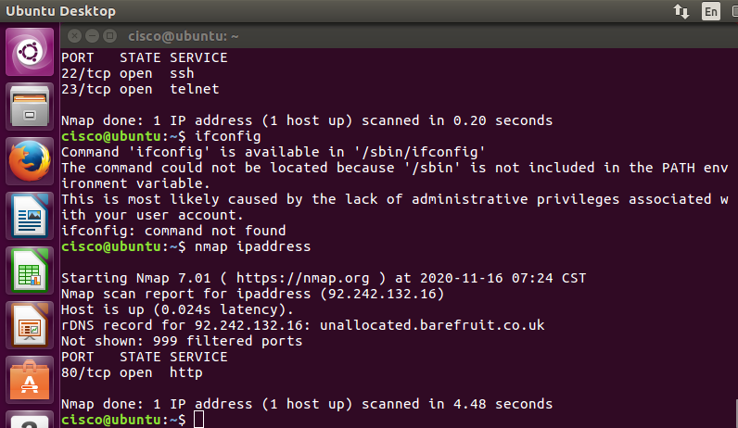
o Step 3: Analyse the outputs/outcomes from Step 1 and 2 and record your reflections. (Hint: Analyse what is the difference between local host and ip address of the host, If ports displayed are different, Why is it different? etc (not limited to the hints))
When using nmap local host it scans the local host which provides the ip address similar to the nmap ipaddress command. However, localhost command doesn’t show 998 closed ports, while nmap ipaddress doesn’t show 999 filtered ports. Port state service is also different, nmap localhost is using ssh and telnet, where as nmap ipaddress is using http.
The nmap local address was scanned in 0.20 seconds compared to that of 4.48 seconds of the nmap ipaddress scan, mainly due to it having to scan further afield.

- Step 4: Why is the nmap scan only scans the first 1000 ports? What will be the command to scan all the ports?
This is because by default, nmap only scans the most common 1,000 ports for each protocol. It is a limited scan to 1000 ports because it can take quite a while to scan a system for every single port.
Nmap –F ipaddress
Nmap –F localaddress

- Step 5: Scan the UDP Ports
    - nmap –sU localhost
(This is a scan performed to get information about the UDP ports and to execute this command you need root privileges. So, try)
    - sudo nmap –sU localhost
Record the outcomes of the above command here (Hint: what UDP ports could you find open through your scan)
For this command I received the below response with regards to UDP ports.
Not Shown: 997 closed ports
PORT STATE SERVICE
68/udp open!filtered dhcpc
631/udp open!filtered ipp
5353/udp open!filtered zeroconf

- Step 6: From the above outcomes select any ports which is open
▪ sudo nmap –p137 localhost
(Change the port number 137 to any port which you found as open in the previous step (5).)
Record the outcomes of the above command here (Hint: Is the port open or closed? Why? Also, record the use of –p command)
For this I used the command sudo nmap p-631 localhost
I received the below
PORT STATE SERVICE
631/tcp closed ipp

- Step 7: Try other port related commands and record its purpose.
    - sudo nmap –pportnumber host_ip
    - sudo nmap –pportnumber_startrange-portnumber_endrange host_ip
    - sudo nmap –pportnumber,portnumber host_ip
give the proper port number –p1-10 localhost
    - not limited to the above (Do a google search, refine your search and find out other port related commands, Hint:nmap.org)
Record the outcomes of the above commands here
Sudo nmap –p631 host_ip
RDNS record for 92.242.132.16 : unallocated.barefruit.co.uk
PORT STATE SERVICE
631/tcp filtered ipp
Sudo nmap –p631_startrange-p5353_endrange
Error #487: Your port specifications are illegal. Example of proper form: “-100,200-1024 , T:3000-4000,U:60000-“
Sudo nmap –p631,5353 127.0.0.1
PORT STATE SERVICE
631/tcp closed ipp
5353/tcp closed mdns

- Step 8: Detecting the version is a very important part of information gathering. Try to find out the version. ▪ nmap –sV localhost
Record the outcomes of the above commands here
This command also presents a VERSION too,
PORT STATE SERVICE VERSION
22/tcp open ssh OpenSSH 7.2p2 Ubuntu 4ubuntu1 (Ubuntu Linux; protocol 2.0)
23/tcp open telnet Linux telnetd
Service Info : OS: Linux; CPE: cpe:/o:linux_kernel

- Step 9: Try other commands to detect other versions and record its purpose.
      - Command to identify the Operating System version
Record the outcomes of the above commands here
Nmap –sV localhost
This provides me with the below information for the Operating system being used along with other information
OpenSSH 7.2p2 Ubuntu 4ubuntu1 (Ubuntu Linux; protocol 2.0)

      - Command to identify the Service Version
Record the outcomes of the above commands here
Nmap –sV localhost
This provides me with the below information for the service version being used along with other information
Service Info : OS: Linux; CPE: cpe:/o:linux_kernel

Learnings from tutorials so far:
Part 1 (Packet Tracer, Host Machines)
  - Build a home Network
  - Understand and configure IP Address
  - Use Ping/ Trace route Utility to check the connection status
  - Use ipconfig /all command to determine the MAC address of a Windows computer on an Ethernet network.
  - Analyze a MAC address to determine the manufacturer.
  - Analyze the Wired and Wireless Network connection.
  - Analyze Address Resolution Protocol (ARP).
  - Connect to a Wireless Router and configure the basic settings in a wireless router and add security features.
  - Use nslookup command to understand the url to ip conversion.
  - Configure basic connectivity settings in Intermediate devices (Switch/ Router).
  - Work with SBA Packet Tracer Files/ environment
  - Configure ftp, web, email, dns, ntp and aaa Servers Part 2
  - Set up a virtual lab environment
  - Troubleshooting the virtual lab environment
  - Working with virtual machines
  - Authentication, Authorization and Accounting
  - Threats and Vulnerabilities – Using NMAP

