Module Assignment Submission
Cover Page

Student Name: | Nadean Kennedy
Student Number: | 1815021
Module No: | BMSK 6003
Module Title: | Leading and Implementing Workplace Change.

Date submitted:
Time submitted:
Statement of Confirmation of Authenticity
By the act of making this submission, the student declares that this is the work of the student named above. Where materials have been used from other sources it has been properly acknowledged. If this statement is untrue, the student acknowledges that an assessment offence has been committed. Proven incidents of plagiarism, collusion or cheating can result in a learner being withdrawn from a
qualification.
Attention is drawn to the Plagiarism, Collusion and Cheating Policy and Unfair Practice policies of the University and ILM.
Permission for ILM to use this script
ILM uses learners’ submissions – on an anonymous basis – for assessment standardisation. By submitting, both the centre and the learner agree that ILM may use this script on condition that identifying information is removed. However, if you are unwilling to allow ILM to use this script, please refuse by ticking the box: □

Contents
Introduction 3
1. What are the current forces for change in Admiral Insurance Companies micro and macro environment? 3
2. How does the force for change impact the workplace culture and capability within Admiral Insurance? 5
3. How can organisational stakeholders be efficiently led through complex workplace change? 7
4. Conclusion 8
5. References 9
6. Appendix A 11
7. Appendix B 12
8. Appendix c 13
9. Appendix D 14

Introduction
This report is going to look at the current force of change for a chosen organisation. This will include looking at the micro and macro environments and its effects on an organisation. Considering changes such as technology advancements and culture shifts within the organisation as well as changes such as economic conditions, market trends and shifts in society. This report will also look at how the force of change impacts workplace culture and capability within a chosen organisation and how implementing change has to be planned and communicated affectively to ensure all stakeholders are on board with the changes.
What is change – Thompson, J. (2010) “Business changes occur when an organisation improves, restructures or transforms a major part of its operations, disrupting systems, people, and processes”.
What is workplace Culture? – CIPD (2023) “A positive workplace culture will allow employees to understand their organisation and feel that their voice matters in driving business towards a common purpose.

What are the current forces for change in Admiral Insurance Companies micro and macro environment?

The first part of this report will look at change within an organisation. When implementing any changes within an organisational setting or otherwise, it is important in the success of implementing change that there is a lot of planning that has gone into it. Communication is also vital with people that would be directly and indirectly by any changes made. It is important that all stakeholders are aware and also have a strategy in place to help with any resistance or negativity towards any future changes. Changes can come in all shapes and size from something that may be perceived as small, such as changing the drinks selection in the office vending machine, to a complete overhaul as to how the organisation is run.
Nordqvist, C. (2016) Defines organisational change as the process where the organisation may change things such as how the company operates, to its technology, the structure of the organisation and its strategies, as well as looking at what affect these changes will have on the organisation and its staffing. Organisational changes are usually as a result of and internal or external pressure. This is also known as Micro or Macro environments. Microenvironments affect the organisation directly and can have an immediate affect the organisation and how it is run. The microenvironment would include people such as employees, customers, suppliers, shareholders, media, suppliers. Were as a Macro environment are external factors such as the economy that can affect the workings, decision making, and business strategy for the organisation. Macro environments are continuously changing and influence the success of an organisation. The type of groups and organisation that would be included within the Macro environment would be the political and legal environments, economic, social and demographic environments, technology, as well as the ecology and physical environments.
Looking at Admira insurance company, they are a company that are continuously making changes and try to stay ahead of the curve when pricing their policies, to not only treat their customers fairly but to also stay competitive with other insurance providers. Looking first at the Macro environment changes that have had an impact on Admiral and the way that it conducts business, A number have factors have influenced how Admiral do business today. Admiral Insurance group was first established in 1991 with just Admiral, to now have Elephant, Diamand, Bell and Gladiator. As well as a number of international companies in Europe, and America. As well as expanding from not just selling car insurance, but van, home, pet and travel insurance. These additional ventures helped Admirals ability to stay competitive within the insurance industry for 30 years. Due to advances in technology Admiral was quick to join that trend a few years after becoming established. In 1995 Admiral launched its website, making it the first insurance company in the UK with an internet presence. In 2002 Admiral launched another side venture, that was Confused.com. Again, the was the UK’s first insurance aggregator launched. Within the insurance industry admiral insurance seem to stay one step ahead of the trend, which seems to have work mainly to an advantage as many other companies have followed their lead. There are many different aggregator sites available now such as compare the market, money supermarket etc. More recent macro environment changes that have an impact on not only admiral insurance, but the industry and other organisations worldwide was the Covid 19 epidemic. Not only business, but every aspect of life was affected by Covid 19 costing the treasury approximately £372 billion supporting the country through. Focusing on organisations and business, looking back at article regarding covid McGregor, H. (2021) mentions restaurants, clubs, pubs, live entertainment, and face to face conferencing being closed, meant the majority of the furlough claim were made by people within food and accommodation services with 34% of workers furloughed. Arts, entertainment and recreation at 29%.
The most recent Macro environmental change having an effect to the whole UK and the rest of the world, is the cost-of-living crisis. This is where the cost of things such as food, gas, electric and other fuels and many other products and services increase in price, more than the living wage. The impact of this is meaning people and families are struggling to live within the cost of inflation. BBC (2022) refers to the energy prices and how they have increased drastically due to the apparent cost of living crisis. When the cost of heating homes, transporting products and keeping organisations in production for example, that increase will then have an impact on the cost of said products and services. Thus, meaning the cost has to then be passed down to the consumer to allow the organisation to regain losses.
BBC (2023) is an article on how admiral insurance increased its insurance rates by a massive 20% in a response to inflation and repair costs. Admiral as an organisation decided to increase their prices early as an attempt to stay ahead of the trend and other competitors that will inevitably have to follow suit and increase their prices. All these increases are unfortunately passed on to the consumer. This did see admiral insurance loose customers by 7% according to the article but was a strategic move to be able to maintain profitable insurance contracts. Brignall, M. (2024) wrote an article for The Guardian newspaper January 2024, noting that the increase in the cost of car insurance in the industry is around 58%. Which in comparison to Admirals 20% increase in the previous year shows that the hit the company took by increasing their rates early has now benefited them and are still competitive within the insurance industry.
Taking a look now at the forces for change within the Micro environmental, because of the previous mentioned pressures stemming from covid 19, Admiral insurance have continued to offer remote working and what is known as hybrid working. It has been shown that staff are capable of producing the same level of work at home or in the office. Hybrid or remote working offers lot more flexibility for staff, meaning their work life balance s more aligned. Admiral Insurance company have also been one of many organisations that offer the real living wage to employees. This again due to the cost-of-living crisis can make a massive impact on individuals and families, but also as an organisation Admiral are insuring the wellbeing of their employees. Changing the work environment also means having adapt the technology used to communicate and complete tasks efficiently weather at home or in the office. Advancements in technology has reshaped the way organisations do business. Some companies operate solely online. It is important for organisations to adapt and innovate to stay competitive. Admiral have introduced the use of teams as an intricate way of communication to aid hybrid working. Enabling communication to stay affective, be able to assist homework int the same way as an office worker, and also keep a connection so as to ensure wellbeing. Admiral have also pride itself on ensuring the wellbeing of staff, and again with the cost-of-living crisis, can make the difference for an employee struggling. The include free fresh fruit daily, free eye testing, paid leave to attend health screening, independent financial advisors, free sanitary products and a team solely for the wellbeing and workplace support for employees.

How does the force for change impact the workplace culture and capability within Admiral Insurance?

Change will have an effect on workplace culture, depending on how the changes are implemented communicated, and accepted by staff within the organisation. If an organisation pro-actively manages change and prioritises maintaining a healthy culture during the change it is more likely that the implementation of change will be positive and accepted. The force for change within any organisation is just that, forced. But generally, within if an organisation is not making changes and keeping up with current trends, then they are in danger of being left behind and inevitably failing. There can be many different reasons an organisation is forced to change, such as political changes like taxes, rates, to climate control and global warming. How change is implemented within an organisation can have a major effect. Planning and strategies are imperative in them success of the change, how the staff and the organisation respond ton the change depends greatly on communication. Looking at Kurt Lewins change model, there are three main step to implementing change. Unfreeze, would be the first step in Lewins model. This is where the organisation would recognise the need for change, or maybe the need for change has been decided by factors outside of the companies control such as a macro environmental change such as cost increases or tax increases. This stage is also the organisation or department would want to communicate and encourage the replacement of old procedures and practices. There will always be a need for by in from all employees affected directly and indirectly of the new changes being implemented. This would also be the time to manage and understand and concerns and worries there may be. The second part if Lwin’s model is to plan and implement the change and providing employees with all the necessary tools an advice needed to support the changes. Again, making sure to listen to employees’ point of view and concerts, addressing them as soon as possible. The last stage of Lewins theory is ton refreeze. By this stage the change has been implemented and have become a normal for the staff and organisation. Monitoring the progress of the change is crucial to ensure the change is sustained and successful. The same process will be repeated for any future changes made within the organisation.
Moran, J., W, & Brightman, B., K. (2000) mention in even back in 2000 that the realisation that for the organisation to grow, change is necessary. Change is the only way of continu8ing to renew the organisations direction, structure and capabilities to stay relevant and provide products and services to meet the changing needs of internal and external customers. The article notes the importance of focusing on the people affected by the change than the change itself as managing change is managing people. There are four stages of change according to Moran and Brightman. Stage 1, understanding the current situation by seeing the bigger picture. It is important that the change is in context of what is happening within the environment and if changes in customer’s needs, what competitors are doing within the market. Are there any up coming technology changes or changes in the economy or government changes. This stage is also important to communicate plans and gauge the understanding from stakeholders directly and indirectly affected by the changes. As previously mentioned, change can have a positive or negative impact on the organisations culture depending on how the change is communicated. Feeling included within the decision can make a massive difference in making sure all members are on board and addressing any concerns good or bad. Stage 2 is to determine the desired state and develop a change plan. Many different methods of implementing the plan will be developed and communicated clearly for all to understand. It is important hat the plan is clear, and any concerns addressed. Stage 3 would be to enlist others and develop a critical mass. Meaning implementing change is not a solo project and calling on the knowledge of peers and colleges is crucial in the process of affective change. Stage 4, track and stabilise the results. Having specific targets and measurements help provide goals, which can increase motivation, and helping maintain the organisation culture. Tracking the progress for the change will allow all to see progress and helps keep individuals feeling less motivated, to see the progress being made.
The biggest change that affected the way work is conducted within Admiral insurance was he covid 19 pandemic. It meant not only having to adapt to working from home but also having to update technologies used to allow working from home to be successful. New ways of communicating had to be introduced, such as Microsoft teams, allowing staff members to still be able to communicate video chat. It was important for the company that its staff were still able to maintain contact for wellbeing and health issues as well as work due to the magnitude of the situation at the time. Having to deal with different personal circumstances was also magnified as some staff were isolating solo, had ill family members, lost loved ones etc. From a technology point of view, having to have all staff that can, work from home for what was along period of time, Admiral not only had to make sure that staff working from home had the necessary equipment needed to complete the requirements of their role to the same standards as working from the office, but also had to look at security risk due to dealing with personal data and bank information. All physical phones were removed, and all staff provided with laptops and monitors, desks, chairs, and any other equipment that may possibly be needed. A new authentication system was introduced as a security feature. A new way of taking payment was introduced, were as the customers need to input their payment details via their phone again to add data protection. The new way of working did have an impact on the culture of Admiral, as a company the wellbeing of staff is paramount and see its staff as a family. Socials and team nights out run regularly but during lockdown was not possible. Admiral however allowed staff to have Microsoft Teams parties, allocating time from normal duties. Voucher for places such as Starbucks were also sent to staff as good will gestures. Admiral have over 30 different groups and societies to join such as running clubs, choir, PRIDE network. It is part of the Admiral culture that staff feel included and that their wellbeing is important to the organisation. Casual dress is also part of the Admiral culture regardless of hierarchy to ensure comfort at work and ministry of fun which are companywide events, quizzes, bake sales etc. Moving on to current time, since the pandemic Admiral has maintained the option for staff to continue what is know as hybrid working. Giving staff the option to either working solely in the office or break up the time between working from home or office. The company like to encourage at least one office day so as to try and keep the culture of the company, allow staff to catch up and not feel isolated by solely working from home. It also gives management a chance to see staff face to face and maintain a good relationship. This new hybrid system does make it harder for department that work as teams to be able to come together as often as previously but it does give staff more flexibility. With the current cost of living crisis previously mention the hybrid working system also helps staff reduce transport costs. For those that do work in the office, will be provided free parking, reduced train tickets costs, and Admiral have subsidised the independent canteen meaning staff pay half price for food and drinks, also free fresh fruit is provided daily. All these benefits introduce to preserve Admirals culture of ensuring its staff wellbeing is as important as the business of the organisation if not more. Maintaining a strong culture helps the staff within the organisation navigate through changes positively as they trust in the organisation through the culture that it has built.

How can organisational stakeholders be efficiently led through complex workplace change?

Langtry, B. (2021) Defines a stakeholder as” groups or individuals who either are such that the firm's decisions to act, or decisions to not act, have been or will be to a significant extent causally responsible for their level of wellbeing, or else have some independently identifiable moral or legal claim on the firm which the firm's actions violate or respect”.
Refer to Appendix B, for list of potential stakeholders. It is well known that to implement any change within an organisation, it is important to communicate the changes as early as possible and include all stakeholders affected directly and indirectly within the organisation. Customers, employees, suppliers are generally the ones directly involved and affected by any changes made by an organisation. However, it is also important to involve other stakeholder such as investors, communities and government. Clear communication gives the stakeholders the opportunity to ask questions and share any concerns they may have about the changes. It also gives opportunity to provide feedback of the progress to stakeholders. Acknowledging concerns of stakeholders affected by the changes being implemented also shows transparency, and allows the organisation to give support, training and assistance if needed.
A change management plan is imperative to ensure not only that the changes are implemented affectively but helps for stakeholders to see plans and time scales allowing them to understand the changes and see progress.
Tang, D. (2016) Takes a look at Demings change cycle, plan do, check, act. The article lists a number of benefits of the Demings cycle including things such as planning, management of projects, continuous improvement to name a few. The initial stage is to identify the goal or purpose, who this change will be implemented by looking at different theories and putting a plan in action. By establishing expectations, deadlines and specification of the change will provide a clear guid for the stakeholders to follow and understand the change and how it will be implemented. The next stage is do, which will involve implementing the change, by this stage any concerns stakeholders may have had would have been addressed and hopefully eradicated. Step 3 is to check. This would be the stage in which to check the results of the change that has been implemented and compare it against the expectations set out earlier in the plan stage looking for any changes or improvements needed, similarly seeing expectations being met. The fourth stage is act. If the check stage shows the plan Implemented in the do stage has shown improvements that that will then become the new organisational standard in the future. If no improvements have been made, existing standards remain. If the check stage shows something different than what was expected in the plan stage, an opportunity to learn from previous implementation can be taken on broad. Demings is a continuous improvement cycle so would return back to the plan stage and the cycle repeats for future changes.
Enis Aldemir (2010) Looks at Kotter’s 8 steps to change management. Refer to appendix C. The first is create a sense of urgency. Communicating why change is urgent or necessary to all stakeholders involved. This helps generate buy in and motivation amongst stakeholders. Forming powerful coalition. Building a strong team of leaders and influencers is important to drive change. Are range of individuals need to be included at different levels within the organisation to champion the change and help gain support across the organisation. Create the vision of change. A clear goal and vision will give all involved a clear understanding and helps guide the change. It also shows purpose, direction and the benefit of the change to the stakeholders. Communicating the vision. As previously mentioned, effective communication is pivotal in ensuring all stakeholders are included were necessary and the vision is understood and hopefully embraced by all stakeholders. Empower action. Empowering the employees by providing resources, delegating responsibility giving a sense of empowerment and inclusion. Generate short term wins. This will help build moment and a sense of trust in the process and change. Consolidate gains and produce more change. Embracing gains and reinforcing new behaviour and practises allow changes to then become part of the culture and system of the organisation. Anchor new approaches in the culture. To ensure changes are sustained and become part of the organisations culture practises, values and behaviours need to be reinforced and aligned with current practises to prevent stakeholders reverting back to old practises.

Conclusion
This report has shown that if organisations are to sustain, they need to recognise change is a very important part of keeping a coming successful and allow it to be competitive and stay relevant. Continues changes keep organisations such as Admiral insurance, to stay relevant within the insurance industry. Implementing any change within an organisation can be tricky and will not be successful if there is a low level of communication and understanding of the change for all stakeholders, whether directly or indirectly affected. If an organisation change is not implemented with a lot of planning, is it more likely that staff will not trust or have buy in towards changes, it can affect moral and culture of an organisation if affective planning and communication are not achieved. Change can be predicted, but events within the Macro environment to for example such as government taxes, major events like covid or the cost-of-living crisis require organisation to not only react quick but affectively. Communication keeps appearing during the report as one of the most important steps of implementing changes. Changes impact employees moral and engagement, lack of communication can mean changes being preserved as negative, but if managed well change is positive for organisational growth. Change helps organisations stay relevant but can also encourage creativity and innovation. Change encourages organisations to think outside of the box and try to stay ahead of the trend. Involving stakeholders in changes made within an organisation builds a sense of unity and transparency. This then leads to more trust in the organisation and staff buying into the organisational cultures. This report has shown how important it is to be continuously change, to be able to meet customers expectations and for ever changes needs and requirements.

References

Admiral Insurance. (2024). Community & Culture. Admiral Jobs. https://www.admiraljobs.co.uk/community-culture
Admiral Group plc. (2013). Our milestones | Admiral Group Plc. Admiral Group Plc. https://admiralgroup.co.uk/who-we-are/our-milestones
Admiral Insurance. (2024). Health & Work life balance. Admiral Jobs. https://www.admiraljobs.co.uk/health-work-life-balance
BBC. (2022). What is the “cost of living” crisis? - CBBC Newsround. Www.bbc.co.uk. https://www.bbc.co.uk/newsround/62038311
BBC. (2023). Admiral car insurance loses thousands of customers. BBC News. https://www.bbc.co.uk/news/business-66521490
Brignall, M. (2024). Average car insurance cost in UK nears £1,000 after prices rise 58%. The Guardian. https://www.theguardian.com/money/2024/jan/16/average-car-insurance-cost-uk-prices-rise-inflation
CFI Team. (2023). Stakeholder. Corporate Finance Institute. https://corporatefinanceinstitute.com/resources/accounting/stakeholder/
CIPD. (2023). CIPD | Organisational Culture. CIPD. https://www.cipd.org/uk/views-and-insights/cipd-viewpoint/organisational-culture/
Enis Aldemir. (2010). Models and Tools of Change Management: Kotter’s 8 Steps Change Model. ResearchGate. https://www.researchgate.net/publication/338345322_Models_and_Tools_of_Change_Management_Kotter
Key Differences. (2015). Difference Between Micro and Macro Environment (with Comparison Chart). Key Differences. https://keydifferences.com/difference-between-micro-internal-and-macro-external-environment.html#:~:text=The%20following%20are%20the%20major%20difference%20between%20micro
Langtry, B. (2021). Stakeholders and the Moral Responsibilities of Business. Business Ethics Quarterly, 4(4), 431–443. https://doi.org/10.2307/3857342
McGregor, H. (2021). How COVID has affected UK businesses – and what happens after July 19. The Conversation. https://theconversation.com/how-covid-has-affected-uk-businesses-and-what-happens-after-july-19-164569
Moran, J., W, & Brightman, B., K. (2000). Leading organisational change. Journal of Workplace Learning, 12(2), 66–74.
Nordqvist, C. (2016). What is organizational change? Definition and... Market Business News; Market Business News. https://marketbusinessnews.com/financial-glossary/organizational-change-definition-meaning/
Science Direct. (2024). Kurt Lewin’s change model: A critical review of the role of leadership and employee involvement in organizational change. Uwtsd.ac.uk. https://www-sciencedirect-com.ezproxy.uwtsd.ac.uk/science/article/pii/S2444569X16300087?via%3Dihub
Tang, D. (2016). Continuous Improvement 101: The Deming Cycle (PDCA) | flevy.com/blog. Flevy.com. https://flevy.com/blog/continuous-improvement-101-the-deming-cycle-pdca/
Thompson, J. (2010). The Definition for a Business Change. Bizfluent. https://bizfluent.com/facts-7214659-definition-business-change.html

Appendix A

Kurt Lewin’s Change model.
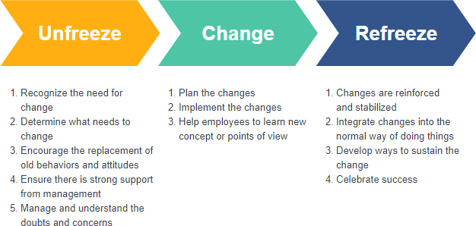

Appendix B

Stakeholders of an organisation. Sourced: Stakeholder - Learn About the Different Types of Stakeholders (corporatefinanceinstitute.com)
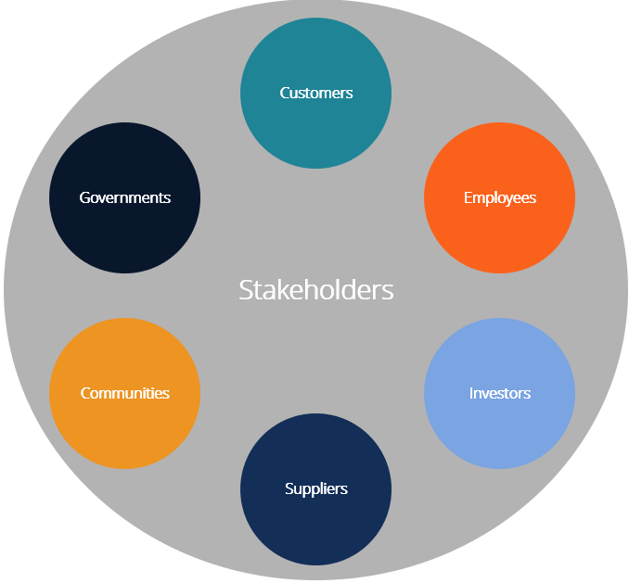

Appendix c
model.

3"
"
Table-1 Kotter’s eight step change model (Kotter 1995, 61; Kavanagh and Thite 2009, 185)
The first four stages focus on the practices associated with “generating/unfreezing” the
organization:
1. Establishing a sense of urgency
a. Examining market and competitive realities.
b. Identifying and discussing crises, potential crises, or major opportunities.
c. Providing evidence from outside the organization that change is necessary.

2. Forming a powerful guiding coalition
a. Assembling a group with enough power to lead the change effort.
b. Encouraging the group to work together as a team.
c. Attracting key change leaders by showing enthusiasm and commitment.

3. Creating a vision
a. Creating a vision to help direct the change effort.
b. Developing strategies for achieving that vision.

4. Communicating the vision
a. Using every vehicle possible to communicate the new vision and strategies.
b. Teaching new behaviours by the example of the guiding coalition
c. Building alignment and engagement through stories
d. Keeping communication simple and heartfelt.

The next three stages introduce many new practices, “consolidating/changing”:
5. Empowering others to act on the vision
a. Getting rid of obstacles to change.
b. Changing systems or structures that seriously undermine the vision.
c. Encouraging risk taking and non-traditional ideas, activities, and actions.

6. Planning for and creating short-term wins
a. Planning for visible performance improvements
b. Creating those improvements.
c. Recognizing and rewarding employees involved in the improvements.

7. Consolidating improvements and producing still more change
a. Using increased credibility to change systems, structures, and policies that do not fit.
the vision
b. Hiring, promoting, and developing employees who can implement the vision.
c. Reinvigorating the process with new projects, themes, and change agents.
Finally, the last stage is required to ground the changes in the corporate culture,
“anchoring/refreezing”, and make them stick:
8. Institutionalizing new approaches
a. Articulating the connections between the new behaviours and corporate success.
b. Developing the means to ensure leadership development and succession.
3
"
model.

3"
"
Table-1 Kotter’s eight step change model (Kotter 1995, 61; Kavanagh and Thite 2009, 185)
The first four stages focus on the practices associated with “generating/unfreezing” the
organization:
1. Establishing a sense of urgency
a. Examining market and competitive realities.
b. Identifying and discussing crises, potential crises, or major opportunities.
c. Providing evidence from outside the organization that change is necessary.

2. Forming a powerful guiding coalition
a. Assembling a group with enough power to lead the change effort.
b. Encouraging the group to work together as a team.
c. Attracting key change leaders by showing enthusiasm and commitment.

3. Creating a vision
a. Creating a vision to help direct the change effort.
b. Developing strategies for achieving that vision.

4. Communicating the vision
a. Using every vehicle possible to communicate the new vision and strategies.
b. Teaching new behaviours by the example of the guiding coalition
c. Building alignment and engagement through stories
d. Keeping communication simple and heartfelt.

The next three stages introduce many new practices, “consolidating/changing”:
5. Empowering others to act on the vision
a. Getting rid of obstacles to change.
b. Changing systems or structures that seriously undermine the vision.
c. Encouraging risk taking and non-traditional ideas, activities, and actions.

6. Planning for and creating short-term wins
a. Planning for visible performance improvements
b. Creating those improvements.
c. Recognizing and rewarding employees involved in the improvements.

7. Consolidating improvements and producing still more change
a. Using increased credibility to change systems, structures, and policies that do not fit.
the vision
b. Hiring, promoting, and developing employees who can implement the vision.
c. Reinvigorating the process with new projects, themes, and change agents.
Finally, the last stage is required to ground the changes in the corporate culture,
“anchoring/refreezing”, and make them stick:
8. Institutionalizing new approaches
a. Articulating the connections between the new behaviours and corporate success.
b. Developing the means to ensure leadership development and succession.
3
"
l.

3"
"
Table-1 Kotter’s eight step change model (Kotter 1995, 61; Kavanagh and Thite 2009, 185)
The first four stages focus on the practices associated with “generating/unfreezing” the
organization:
1. Establishing a sense of urgency
a. Examining market and competitive realities.
b. Identifying and discussing crises, potential crises, or major opportunities.
c. Providing evidence from outside the organization that change is necessary.

2. Forming a powerful guiding coalition
a. Assembling a group with enough power to lead the change effort.
b. Encouraging the group to work together as a team.
c. Attracting key change leaders by showing enthusiasm and commitment.

3. Creating a vision
a. Creating a vision to help direct the change effort.
b. Developing strategies for achieving that vision.

4. Communicating the vision
a. Using every vehicle possible to communicate the new vision and strategies.
b. Teaching new behaviours by the example of the guiding coalition
c. Building alignment and engagement through stories
d. Keeping communication simple and heartfelt.

The next three stages introduce many new practices, “consolidating/changing”:
5. Empowering others to act on the vision
a. Getting rid of obstacles to change.
b. Changing systems or structures that seriously undermine the vision.
c. Encouraging risk taking and non-traditional ideas, activities, and actions.

6. Planning for and creating short-term wins
a. Planning for visible performance improvements
b. Creating those improvements.
c. Recognizing and rewarding employees involved in the improvements.

7. Consolidating improvements and producing still more change
a. Using increased credibility to change systems, structures, and policies that do not fit.
the vision
b. Hiring, promoting, and developing employees who can implement the vision.
c. Reinvigorating the process with new projects, themes, and change agents.
Finally, the last stage is required to ground the changes in the corporate culture,
“anchoring/refreezing”, and make them stick:
8. Institutionalizing new approaches
a. Articulating the connections between the new behaviours and corporate success.
b. Developing the means to ensure leadership development and succession.
3

Sourced: Kotters-8-Step-Change-Model.png (1480×899) (getlucidity.com)

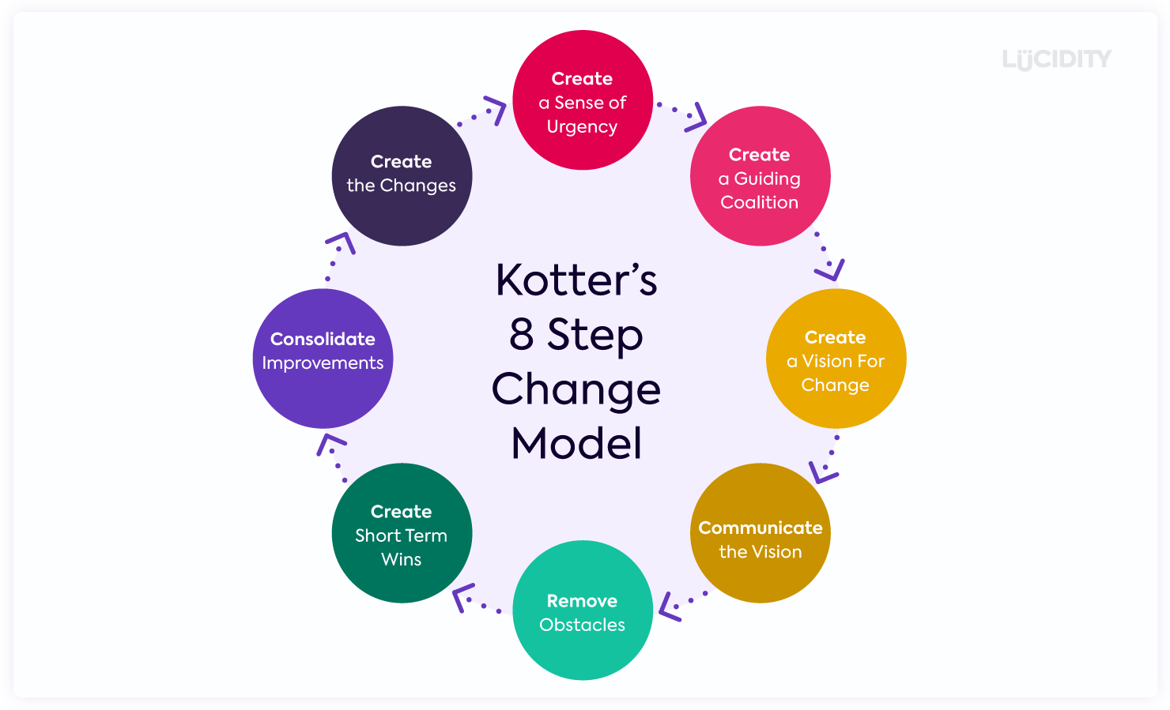

Appendix D

Deming Cycle: Sourced Continuous Improvement 101: The Deming Cycle (PDCA) | flevy.com/blog


