Personal Reflection Plan
Programme: Certificate Of Higher Education: Skills For The Workplace
Module: Professional Career Development
Reflective review
By Abdul Awal

University of South Wales
Trinity Saint David
Module Code: BMSK4005
Date: 08/11/2018

Student ID: 1806799

Contents
Introduction………………………………… 1
Importance of professional development for career success:…….1,2
SWOT Analysis …………………………………2,3
Smart Objectives……………………………3,4
Johari…………………………………………5
Kolb’s Learning Cycle……………………………6
Vark…………………………………………………6
Go Mad……………………………………………….7
Personal Development Plan………………………8
References…………………………………………9
Appendix ……………………………………….10,11

Introduction
The main aim of this report is to briefly talk about what I have learnt from this course and how it will benefit me in many different ways. By completing this course this will enhance my skills and knowledge. Skills that are necessary for the Workplace (which is a programme for self-improvement).
After completing Myers Biggs personality profiling test, my overall score was highest on an EXTROVERSION (E) charts. This indicates that I am socially outgoing, confident and talkative person who engages in seeking new opportunities.
Followed by a VARK questionnaire, I managed to score highest on the Category A (V’s) which is a visual learner. I find this course exciting as I learn new things academically. As my learning journey continues, I learn and seek new knowledge every time I attend the lectures.
As a mature student I try to stay behind after the class to get feedbacks from the lectures, of how I can improve on areas that did not go successfully. I am eager to acquire and develop on my knowledge. As a school student I wouldn’t have the confidence to ask the questions to my teacher’s. This is the advantage I took as a mature student. Also, I have found my self as an activist learner based on the results from the learning style questionnaire. Which all fits in my right frame of mind and adapt to the relevant course I am about to complete which I will be able to peruse the B.A degree.
Importance of professional development for career success:
In order to have a successful career, professional development is required. It can help informs of formal learning which consists of course works, training and apprenticeships. (opencollege.com,2018).
Professional development requires learning sills. Failing to develop ‘workplace’ skills has its consequences in career. I will be bale to develop skills which will have an effect on my academia as I will develop and grow as an individual. (Morgan, P. 2017, p.23)
I would like to reflect on what I did and move forward.
I will begin this report by doing a SWOT Analysis. This means the Strengths, Weaknesses, Opportunities and Threats. This is a type of self-awareness tool to enable me to understand where I’m currently at in my career and life.
- Strengths – flexibility, family, good customer communication skills from running a catering business
- Weaknesses – time management
- Opportunities-better career skills, new learning skills
- Threats – finding time to study

My main aim in this analysis is to remove any weaknesses and try turn them into a positive situation. An example is to prioritise my time in both my personal and professional life.

Smart Objectives
I believe that in order to gain and achieve something in life you will need dedication and passion. This particular course will enable me to attain many different opportunities in my career. After completing this course, I will have the advantage in my professional life. I will present this by; S M A R T Objectives

- Specific - to attain a certificate for a higher education
- Measurable – to focus on the lectures in all class assessments and keeping up to date with the assignments
- Achievable – after completing the course I would like to achieve a BA Honour Degree with the support of my family and the correct resources. Also, be the role model for my children.
- Realistic- enhance wider opportunities in my career.
- Time Bound- talk to my lectures and get their honest feedbacks
The SMART objectives lay out a development plan. For example Johari Window.
“A Johari window is a psychological tool created by Joseph Luft and Harry Ingham in 1955. It’s a simple and useful tool for understanding and training” (self awareness, 2013)

This particular tool introduces different personality of an individual.
Known to Self | Not Known to Self
Open self | Blind self
Enjoy communicating | Forgiving
Sociable | Optimistic
Love to learn new things | Wise
Highly energetic | Consistent
Hidden self | Unknown to Self
Stressed | Abilities
Disorganised | Potential
Enjoy going out | Change in different circumstances

In class, we have learned about paraphrasing. Paraphrasing is when we rephrase words and word from other who may be professional in their fields of knowledge such as publishers, book authors and journal authors. As we paraphrase, we have to give credit to the author. Referencing is important as it will avoid plagiarising the original authors work. This is because it will cause a serious offence within the academic industry.
Vark
Vark is a learning style with the inspire to achieve and the other was the Vark questionnaire which was completed through an online process. It is based on learning preference style as an individual and how we learn. I think I am a visual leaner, this is because I learn through seeing things such as diagrams or demonstrations. Also, I think I learn through oral learning as I prefer to be explained and clarified of what needs to be done. (very well, 2018)
Kolb (1984) developed the theory of experiential learning cycle. He said that adults develop natural preferences in terms of understanding information. The learning cycle is useful for allowing us to know there are stages of thinking when processing information. However, the learning cycle does not take into consideration of the feedback of others. (Thomas, et al, 2018)
Kolb’s learning cycle
- Experience- doing something
This first thing I have to do is get experience which would help my development also putting theory into practice.
- Reflect- think about what I did
When reflecting, I will have based it on my experience and see my strength and weaknesses.
- Conceptualise- make overview
I am sure I will learn many things in life especially in studies. I have to generalise and bring effectiveness in work.
- Plan- bearing inner conclusions
Lastly, I will have to plan so I am aware of what I will need to do. This will allow me to bring more motivation. and be more organised with work
From Kolb’s theory of the learning cycle, individuals can learn from experience and previous learning.

Go mad framework
Take actions and measure results:
Take all important measures for the action to gain better result

Personal responsibility
Responsibilities play an important part in the academic lifestyle and family life
Self belief
I believe I can put any goal in my head with motivation and self confident
Involve others
This includes support from families and lectures

Define goal
To complete this course and make a better career

Reason why
I am doing this course to get a qualification and future jobs as I am passionate

Plan priorities
Make time for studies and allow pritotise to be successful

Go mad is a coaching method and a framework for individuals development and improvement. Above is an example of how the go mad framework is laid out for skills needed in a workplace course. (Gilber A, 2001)

Personal plan development
Skills number | Objective | Action | Barriers and overcoming them | Support needed | How will I know when achieved
1 | Research and library | To get information | Family and full time job | Family support and lecturer support | When I get the right result
2 | IT skills | Using familiar software | Lack of knowledge  Learning | Teachers support and tips | Get feedback from lectures
3 | Gather information | Read suitable sources | Lack of understanding  Using sources | Library services  Textbooks | Feedback and reading

Conclusion
I am interested in learning more about this course and see the opportunities this course will provide in the business industry. As well as increasing my knowledge.

REFERNECE LIST

Morgan, P (2017) The business student’s guide to study and employability. SAGE Publications LTD: London
Open college (2018) What is professional development? Online. Available at: https://www.opencolleges.edu.au/careers/professional-development [accessed: 7/11/18.
Self awareness (2013) understanding the Johari window model online available at: http://www.selfawareness.org.uk/news/understanding-the-johari-window-model10 November (accessed: 6.11.180
Thomas L Brggs P Kerrigan and Hart A (2018) exploring digital emendation in support and personal reflection. International journal of human computer studies 110 pp. 53-62
Very well (2018) vark [online[ available at: https://www.verywellmind.com/vark-learning-styles-2795156 (accessed: 7.11.18)

(Appendix)
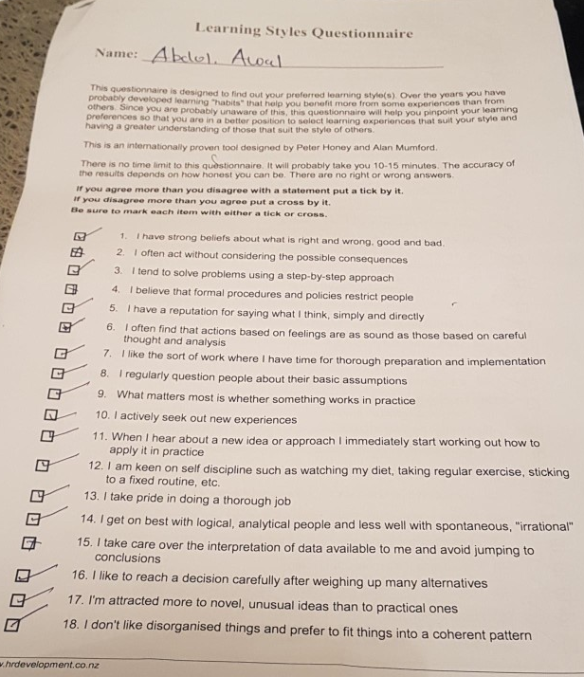

(Appendix)



