Silvia Settle
1708386
February 2021
ADVANCED SOftware development
Object Oriented programming
Module code: ACCB5011 Lecturer: Gordon Dickers

Table of Contents
Design of the OO Solution 2
Attributes, Methods, Relationships 4
Unit tests and Test Harness 10
User Guide 18
References and Bibliography 20

Project Description

The project aim was to design an object-oriented solution in C++ for a company’s car park. Task 1 involved the development of classes using aggregation and an implementation with class constructors. Task 2 involved the use of inheritance and a dynamic data structure.

Deliverables

Design of the OO Solution
For the initial design of the solution two diagrams were created: use-case and a more detailed UML class diagram. The purpose of the first was to provide an overview of the carpark project and to identify the entities from an abstract high-level view. This also helped with the detailing of the sequence of events from a user point of view (fig 1: Car park use case diagram).
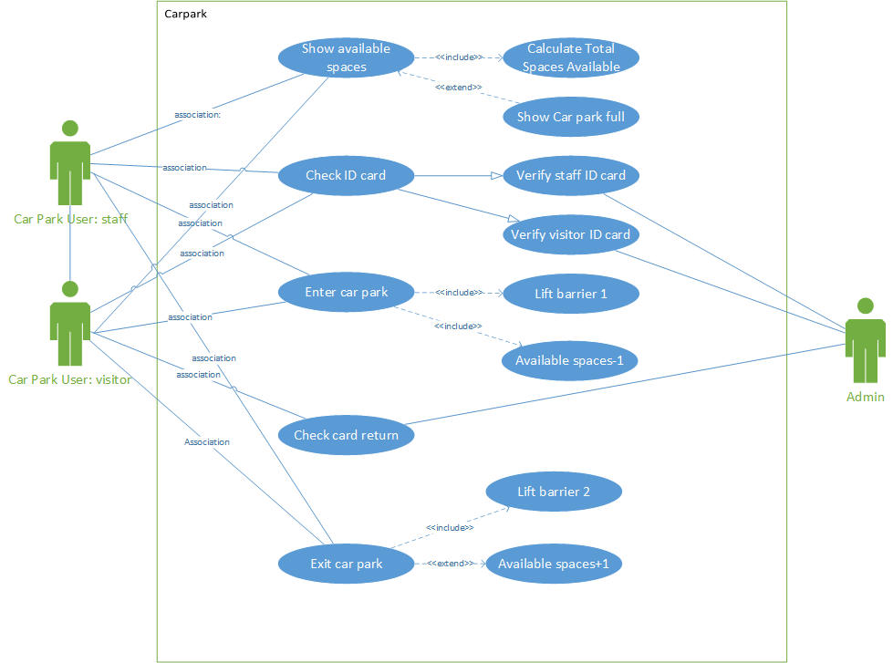
Figure 1: Car park use case diagram.

The second diagram was helpful during the developmental stages as it provided more detail in terms of the data members and member functions of each class, as well as the relationships between the classes. This design changed several times to reflect the changes made during the implementation stages. The one enclosed below is the latest one used, however, the solution is slightly different as the diagram was used more as a conceptual prompt rather than a definite blueprint (fig 2. Car park UML class diagram).
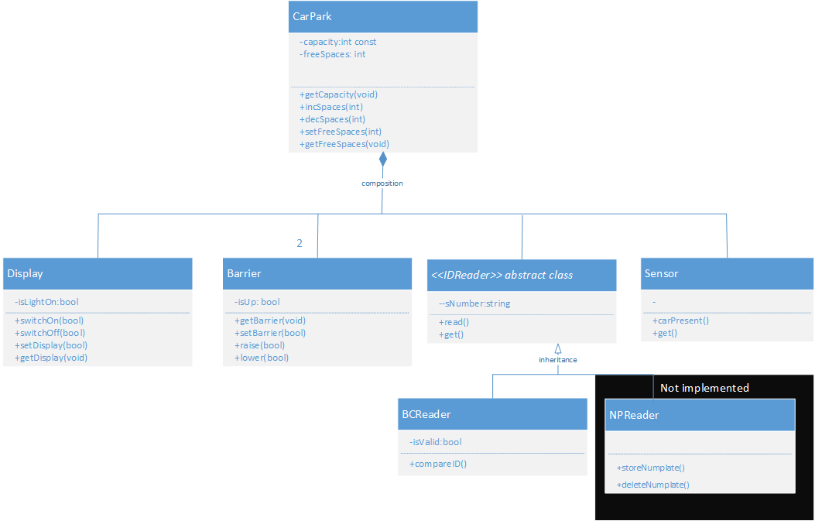
Figure 2: Car park UML class diagram.

Five classes were developed for the purpose of the project: cCarPark, cDIsplay, cBarrier, cReader and cSensor. Each class has a header file to hold the declaration of the class, the class members, and the member functions. The associated *.cpp file holds all the definitions for the member functions, as well as the constructors (see fig 3. Car park framework).
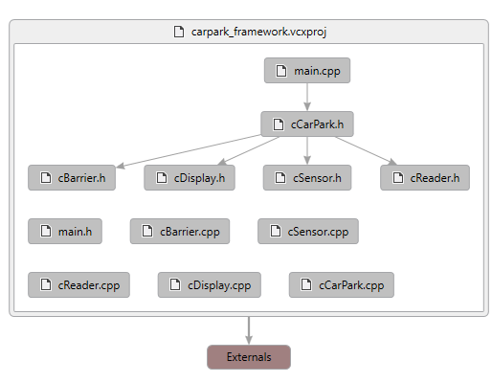

Attributes, Methods, Relationships
One of the benefits of object-oriented programming is the ability to create user-defined structures from the available elemental data types (Decker and Hershfield, 1993, p4.). This project used classes understood as a “collection of data, with operations that may be performed on the data” (Decker and Hershfield, 1993, p.8) that ultimately allowed object-oriented concepts such as abstraction, encapsulation, and code-reusability to be applied to the solution (Lafore, 2001, p.12). Instead of having a sequential structure typical for the procedural programming model, the car park was implemented using object-oriented programming that allows to explore a solution and model it on how objects interact in the real world (Lafore, 2001, p.14).
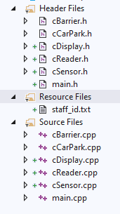 | This is an overall view of the classes in the car park solution.

cCarPark.h  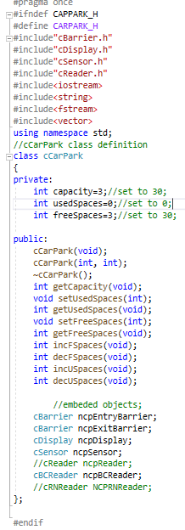 | The cCarPark header file includes the declarations of its data members (i.e. capacity, used spaces and free spaces stored in member variables of integer type), two constructors, a destructor and its member functions to access the data members. The latter are used to access the data members, which are kept private. The class also refers to all other classes it is composed of by including embedded objects such as ncpEntryBarrier, ncpDisplay, ncpBCReader, etc. At the top of the header file all references to other structures/classes are included as to allow access to the data and functions in those entities. The user-defined ones are enclosed in quotation marks.
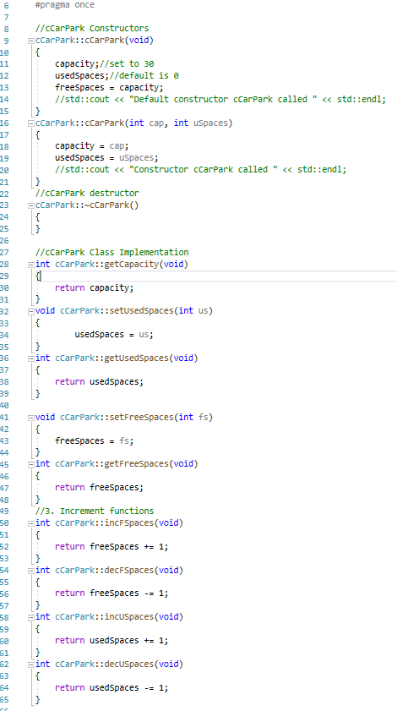 | The cCarPark.cpp file contains all the constructors and member functions. In addition to the default constructor, another one was created to allow capacity and used spaces for the car park to be set up.

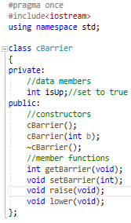
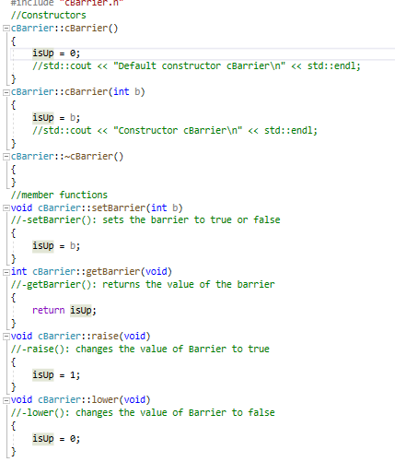 | cBarrier.h  Contains the default constructor in which isUp is set to 0 (to allow checking the current state of the barrier). In addition to the accessor and modifying functions to get and set the value of isUp, there are also two functions to raise and lower the barrier, which are similar to the basic modifying function to set the value of a Barrier isUp to 0.  Overall, the functionality of this class was not fully used as the number plate reader class was not implemented.

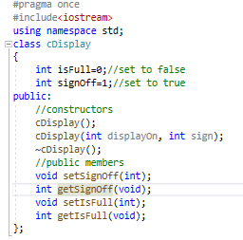 | The Display class has two data members: isFull set to 0 and signoff set to 1. Their accessor and modifier functions set and get equivalents were used for the control flow of the implementation in the main.cpp
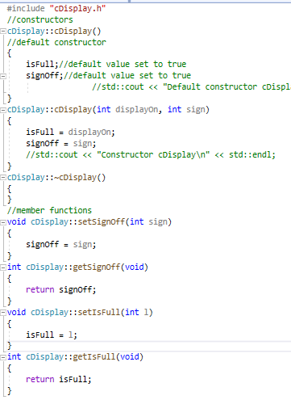 | cDisplay constructors, destructor and member functions.

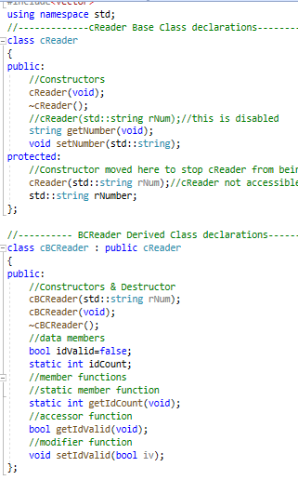 | This class was the most complex as after the cReader was developed, it was used as a base class for two derived classes – cBCReader (bar code reader) and cRNReader (registration number reader). Only one of these derived classes was implemented – the barcode reader to be used to scan the users ID cards upon entry of the car park.  The base class constructor was disable to make it an abstract class,, i.e. one that is not going to be instantiated for use within the program.
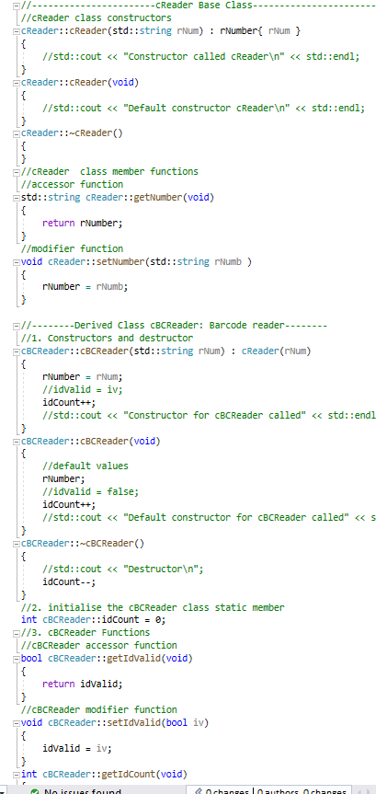 | The

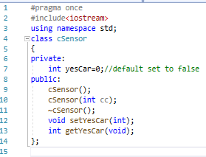 | The sensor class purpose is to tell the barrier/car park if a car has approached the barrier. It has a data member to check this condition, constructors, destructor and two member functions to access and modify the data member
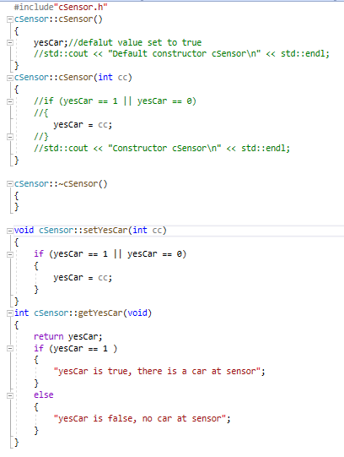

Unit tests and Test Harness
Test were performed during the implementation of the project – this included testing the constructors of each class and the relationship between the aggregate members of the car park. In addition, tests were performed to check the implementation of the solution in main and the logic of the execution flow.

Testing Constructors
After the build test in main that the classes are called
Test1.0
Default constructors | Expected outcome:
cCarPark | 1 car park, 2 barriers, one display, one cReader, one cBCReader(barcode), one sensor
cBarrier
cDisplay
cReader
cSensor
Result
as expected | 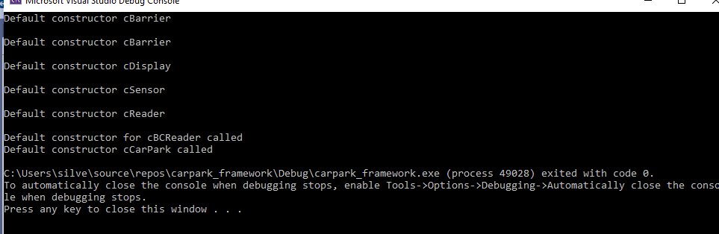

Test1.1
CarPark constructor and functions | default capacity should show as 30
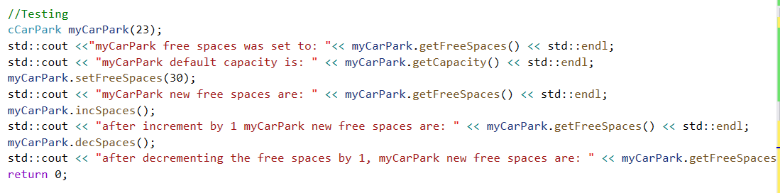
Result
Warning: increment function allows the capacity to exceed the allowed limit(30). To introduce a validation in the polling logic | 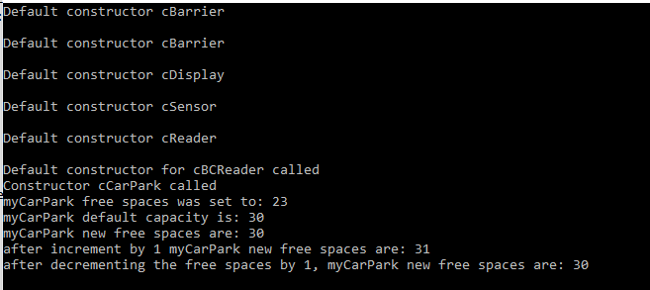

Test
cBarrier constructor and functions | 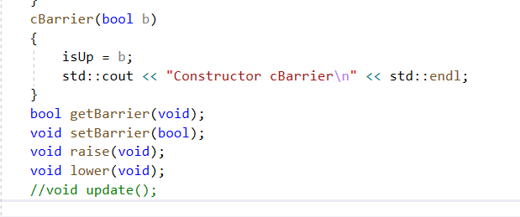
Result
as expected | 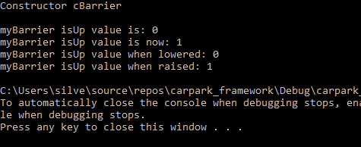

Test
Display | 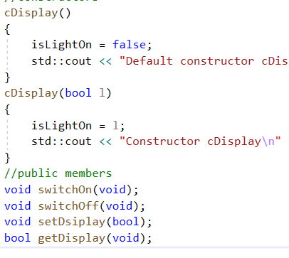
Result
spelling corrected on setDisplay(); | 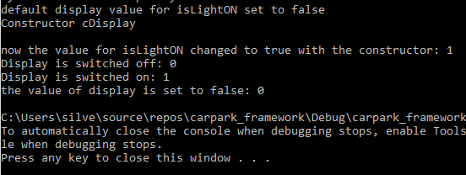

Reader | 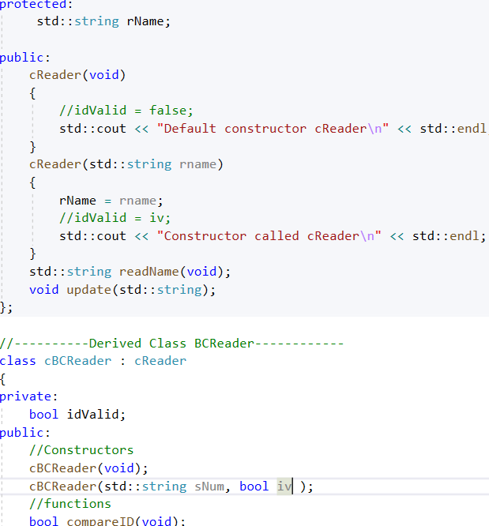
Result

Test
Sensor
Result
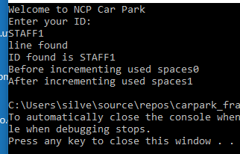

Testing Logic Implementation in Main.cpp

Testing the first loop – if the sign is off (and currently it is by default, it is set to 1 or true), the loop will run
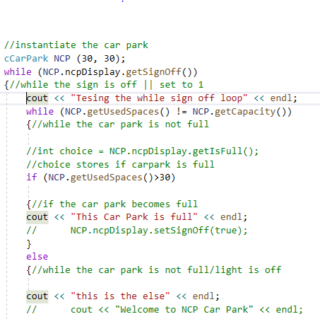 | 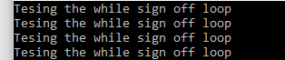
Testing the used spaces not the same as capacity – the second output should display
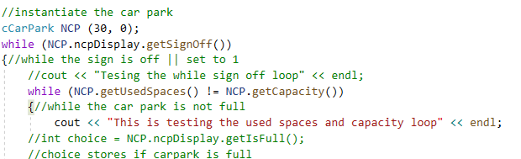 | 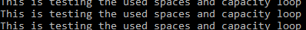
Testing if the first if condition is executed – I.e. the car park has become full
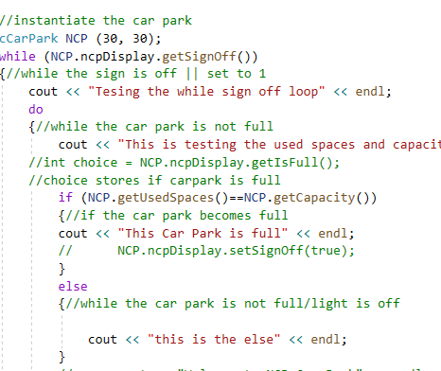 | 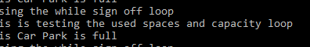

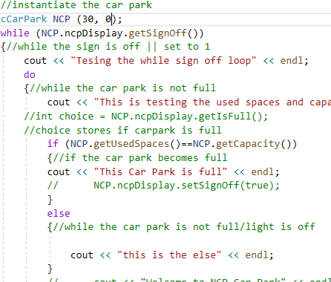
Checking that the IF block will display, exit to the main loop and terminate it | the car park has to be full and the sign has to be switched on //set to 0
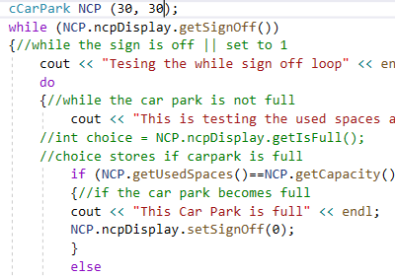 | 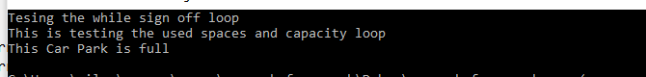

 | 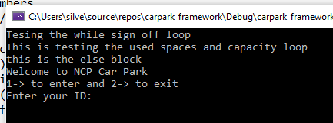
incrementing | 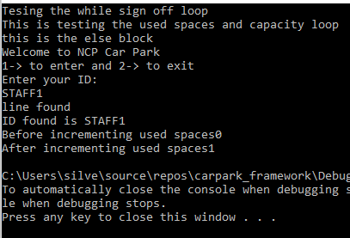

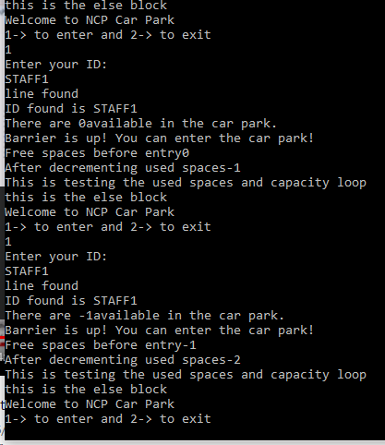

User Guide
To use the car park program you will need to run it from the main.cpp file. There are two things you need to set up:
- In the cCarPark.h set up your carpark capacity

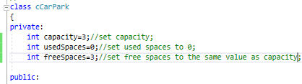

- In the attached staff_id.txt file ensure you update your staff IDs
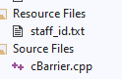

- When you run the program it will ask you if are entering or exiting the car park
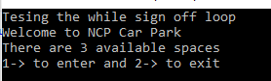
- If you chose 1, it will ask to enter your ID
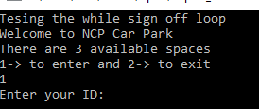
- It will check it against the list
If found, it will confirm, it will raise the barrier and it will automatically increment used spaces and decrement the free spaces.
- Once the spaces have been filled, a sign will appear to show that the car park is full and terminate the program
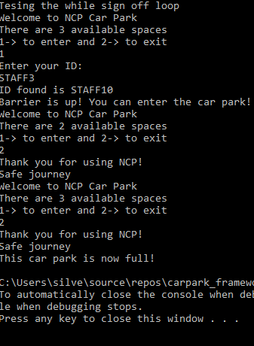

References and Bibliography

Decker R. and S. Hershfield, 1993, Working Classes. Data Structures and Algorithms Using C++, PWS Publishing Company
Lafore, R. (2001), Object Oriented Programming Using C++, Fourth Edition, SAMS

