The relationships between extreme sports, personality, mental toughness and stress.

Study Overview
This study will focus on assessing if there is a relationship between Mental Toughness, and personality traits within the participation of extreme sports and to establish if individuals that do participate within extreme sports score lower on the stress scale. To establish this, a partial component of the Mental Toughness Questionnaire-48 questionnaire (MTQ-48), referred to as the MTQ Lite, by Clough, Strycharczyk, and Perry, 2017(cited in the mental toughness report, 2018) will be used to measure an individual’s overall mental toughness, which only includes 10/48 questions within the scale. This will also discuss the 4cs Mental Toughness Model developed by Clough, Strycharczyk, and Perry, 2017(cited in the mental toughness report, 2018, Cabral and Cristfield, 1996), they suggest that if an individual’s have high self-belief that they are able to control their own destiny, they will overcome challenges, therefore will discuss Freud, (1923), personality theory, (The Ego and The Id). To measure personality traits the IPIP,50 item big five personality questionnaire, agreeableness, conscientiousness, extroversion, neuroticism and openness, Goldberg, (1992) will be used to establish if certain personality types that are said to be contributing factors to why some individuals are more inclined to take part in extreme sports and why others do not. To measure stress amongst participants, the Cohen, (1994) stress measurement scale will be used. This study will also investigate if Type A or Type B personalities are more or less likely to take part in extreme sports, this will be established by using the Glazer-Stress control lifestyle questionnaire. Sporting choice will be established before participants complete the questionnaires (See Appendix 6).
Exploration into edgework could be a possibility.
Rationale
For the purpose of this study extreme sports will be defined as any sport where an accident may result in a fatality. Brymer, (2011) defines such sport as ‘BASE (Buildings, Antennae, Space, Earth) jumping, extreme skiing, waterfall kayaking, big wave surfing, high-level mountaineering and climbing without ropes’. The Extreme Sports Company (no date) suggests that extreme sports characterised in the following categories, earth, water, air, snow and ice, therefore would include all the above mentioned by Brymer, (2011) but would also include Wing Suiting, High-lining, Hang Gliding, Paragliding, Snowboarding, Skiing, Ice Climbing, Snowmobiling, Snow Kiting, Monoskiing, Snowblading Surfing, Water-skiing, Body Boarding, Wakeboarding, Kitesurfing, Windsurfing, Cave diving, Flow boarding, Paddle surfing / Stand up paddle, Kayaking, Cliff Jumping, Coasteering, Scuba Diving, Knee Boarding, White Water Rafting, Skim Boarding, Jet Skiing, Flyboarding/Jet boarding Skateboarding, Longboarding, Mountain Boarding, Sandboarding, Drifting, BMX, Motocross, FMX, Aggressive Inline Skating, Mountain Biking, Caving, Slacklining, Abseiling, Rock Climbing, Free Climbing, Bouldering, Mountaineering, Parkour, Sand kiting, and Zorbing.
​
This study will establish if there is a difference in stress scores between individuals in the extreme sports, general sports and non-sports categories. Also, to establish if individual’s mental toughness scores are higher in the extreme sports category, followed by, general sports and the non-sports category scoring the lowest.
The study will also establish if personality plays a part on individual’s choice in which sport they choose to participate in.
By conducting this study, it will give an understanding of the part that personality plays in sports choice if participation within extreme sports aids with stress reduction and to establish if individuals in the extreme sports category are more mentally tough than those in general sport and non-sporting categories.
To establish differences in stress levels between groups, participants will be asked to complete and the Cohen, (1994) stress measurement scale was used. To establish personality traits between groups, participants will be asked to complete the big 5 personality questionnaire, and to establish if mental toughness varies within the three groups, the MTQ-Lite questionnaire will be used. To measure personality traits the IPIP,50 item big five personality questionnaire, agreeableness, conscientiousness, extroversion, neuroticism and openness, Goldberg, (1992)
Due to lack of research this study will also investigate if Personality type A or B are contributing factors to participation within extreme sports. This will be achieved by participants completing the Glazer- Stress control life style questionnaire, consisting of 20 questions
When questionnaires are returned those, who do not partake in extreme sports will be excluded from the analysis of Type A and B personalities as this research is only investigating type A and B personalities within participation of extreme sports only.
Within this study, it was thought best to use questionnaires and distribute them online. A total of 4 questionnaires will be used. As the investigation will involve approximately 300 participants this approach would be less time consuming than the qualitative approach. The benefits of quantitative data is that it is easier to analyse, the use of questionnaires is familiar to most individuals, the individual will not be influenced by the researcher in any way, it reduces bias and participants will be more comfortable in answering as they will be anonymous.

The aim of this study
The purpose of this study is to establish if findings would agree with Clough and Strycharcxyk, (2015) who suggest that individuals that are mentally tough can deal with pressures, stressors, and challenges. They therefore possess less levels of depression and anxiety, having a positive impact on wellbeing. Therefore, individuals that participate in extreme sports will score lower in stress. To establish this the Cohen, (1994) stress measurement scale will be used and to measure stress within the diverse groups.
Also, findings by Crust and Clough, (2011) suggests that individuals that participate in outdoor adventurous activities are more mentally tough. Mentally tough individuals are more inclined to be excited by challenge and therefore may be drawn to adventure, involving themselves in activities that are highly challenging.
Findings by Kajtna, Tusak, Baric, and Burnik, (2004) suggest that participation in extreme sports enhances mental and physical health, more so than general physical activity. Individuals with certain personality types participate in extreme sports, more so than those who participate in general sports and non-sporting individuals, suggesting that those in the extreme sports category will score higher in emotional stability, conscientiousness and extroversion than individuals participating in general sports, followed by non-sporting individuals scoring lowest.
Kajtna, Tusak, Baric, and Burnik, (2004) also suggest that individuals that participate in extreme sports are energetic, dynamic, brave, forceful, communicative, sociable, they are excited by events and are influential on others, therefore this could imply that extreme sporting individuals could potentially be type A personality other than type B.
This research will also discuss the following
Individuals that partake in extreme sports e.g. B.A.S.E. (Buildings, Antennae, Space, Earth) jumping, waterfall kayaking, extreme mountaineering big wave surfing, extreme skiing, and rope-free climbing with risk taking behaviour was thought to be the most common cause for individual’s participation, where some individuals are drawn to participating in unnecessary risks for adrenaline rush, Byrmer, (2009).
Byrmer, (2009) also suggest participation in extreme sports can aid to one releasing their deeply felt dreams. Individuals become more self-aware of their inner core, they gain deeper insights regarding their personal and interpersonal realms therefore, and participation within these types of sports is a contributing factor wellness and lifestyle enhancement.
Willig, (2008) suggest that that participation in adventurous physical activity can possibly be therapeutic and aid with psychological balance and wellbeing.
Self-efficacy theory, Bandura, (1997) individuals are more inclined to take risks if they possess enhanced feelings of self-efficacy and have the belief that they are capable of copping with the situation at hand.
Personality Theory, Eysenck (1916 - 1997) discussing Extroversion, Introversion, Neuroticism etc.

Hypothesis 1
Individuals in the extreme sports category will score highest in emotional stability, conscientiousness and extroversion. Those in the general sports category will score lower in emotional stability, conscientiousness and extroversion than those in the extreme sports category. Individuals in the non-sports category will score lowest in emotional stability, conscientiousness and extroversion.
Hypothesis 2
Individuals in the extreme sports category will score the highest in mental toughness. Followed by individuals in the general sports category, therefore, Individuals in the non-sports category will score lowest in mental toughness.
Hypothesis 3
Individuals in the extreme sports category will score lowest on the stress scale, followed by Individuals in the general sports category will score will score slightly higher, Individuals in the non-sports category will score the highest in the stress scale.
Hypothesis 4
Extreme sporting individuals will score higher in type A personality other than type B.

Methodology
Design
This study is an unrelated independent design, consisting of four Dependant Variables (DVS) which include: stress, personality, mental toughness, and personality type A/B. In relation to stress, personality, mental toughness there will be three Independent Variables (IVS), which include: no sport, sport and extreme sport Stress levels will consist of low, medium and high scoring categories, mental toughness will also consist of low, medium and high scoring categories, personality will consist of 5 personality traits, consisting of agreeableness, conscientiousness, extroversion, neuroticism and openness.
Type A and B personalities will also be considered in extreme sports individuals only, this will be established by using the Glaser- Stress control lifestyle questionnaire. Scoring will be on a scale of 1-7 measuring personality type A1, A2, AB, B2 and B1. Therefore, consisting of one dependant variable and 5 independent variables.

Participants
This study will include the minimum of 100 participants in each of the three categories, no sport, general sport and extreme sport, totalling to no less than 300. Within this investigation, gender and age will not be considered. Ethics was considered, and checks were carried out by answering the Ethics online questionnaire (appendix 2) abiding by the British Psychological Society, Codes of Conduct, (2018). Participants will be informed of the process and thanked for their participation. Participants will be recruited from Social Media sites.

Materials
The MTQ Lite questionnaire consisting of 10 Likert questions to establish mental toughness.
The stress questionnaire consisting of 10 Likert questions to establish stress levels between groups.
The Big Five personality questionnaire consisting of 50 Likert questions, enabling the researcher to establish personality traits.
The Glaser-Stress control life style questionnaire, consisting of 20 Likert questions to establish Type A and B personality.
A USB stick will be used to store data for research purposes and to protect participant’s confidentiality.
A consent form and debrief form was also issued at the time of participation.

Procedure
The study was an opportunity sample and a total of at least 300 participants (100 in each of the three sporting groups) over the age of 18 were asked to take part via internet promotion with use of a computer and the use of software via kwiksurvey. Participants were informed of the process and its importance and were then asked to complete a series of questionnaires, which include – The MTQ-Lite, which measured mental toughness between the three sporting groups, the Glazer- Stress control life style questionnaire, measured type a and b personality within extreme sports category only. To measure personality traits the IPIP,50 item big five personality questionnaire was used to measure agreeableness, conscientiousness, extroversion, neuroticism and openness, Goldberg, (1992) between the three sporting groups and the Cohen, (1994) stress measurement scale was used to measure differences in stress levels within the three sporting groups. A consent form and debrief form was also issued at the time of participation.

Ethics
Confidentiality, informed consent, and the right to withdraw has been considered, in line with the British Psychological Society Guidelines. Participants under the age of 18 will be excluded from the research. An ethics questionnaire was filled out to check that all considerations met the BPS guidelines.
A USB stick will be used to store data for research purposes and to protect participant’s confidentiality.

Results and analysis
This study will consist of 4 questionnaires; therefore, the analysis is purely quantitative. To analyse the data of both stress and mental toughness questionnaires a one-way Anova will be used to determine the means and standard deviations. To analyse the data of the big 5 personality scale, a multiple regression will be used to analyse the means and a post hoc- Bonferoni will be used to determine where the differences lie. To analyse Type and B personalities within extreme sports participants a one-tailed Independent Samples T test will be used.

Appendix 1
Informed consent
The purpose of this study will focus on assessing the differences in the relationships between Mental Toughness, and personality traits within the participation of sporting categories which include- no sport, general sport and extreme sport extreme and to establish if stress is higher or lower within the sports categories. To establish this, it will require the completion of questions that will determine differences within these factors. This study will also establish if extreme sporting individuals are type A or B personality and establish if stress varies within the sporting groups.
Mental Toughness is a personality trait which gives insight into how individuals respond to pressure, challenge, and stress, regardless of their conditions. The assessment and development of Mental Toughness has importance in all areas of life and is linked to positive behaviours, performance, and well-being. The MTQ Lite, is part of the MTQ-48, it is a very high-quality assessment and is used worldwide, especially with sporting multinationals. Usually individuals are charged a high fee for the assessment, therefore, this will be great cost-free opportunity to measure how mentally tough you are.
The total time to complete the study will be approximately 15 minutes. In terms of the benefits of completing the study; on request, individuals will be given an opportunity to obtain their unique feedback of the questionnaire report which will provide information on their Mental Toughness scores.
All questionnaire results will remain confidential, will not be shared with any other parties and your personal details will remain anonymous.
By completing this questionnaire, you are consenting to taking part within this research, you have the right to withdraw at any time, even after the questionnaires have been completed for research. If you have any queries, please email me at: 1601973@student.uwtsd.ac.uk
I would like to take this opportunity to thank you kindly for your participation.
Appendix 2
Ethics


Appendix 3
Stress Scale Questionnaire
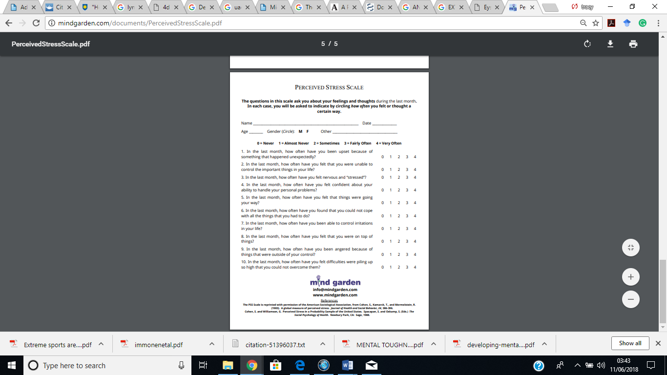

Appendix 4
Personality Questionnaire

Appendix 4
Personality questionnaire

Appendix 4
IPIP,50 item big five personality questionnaire
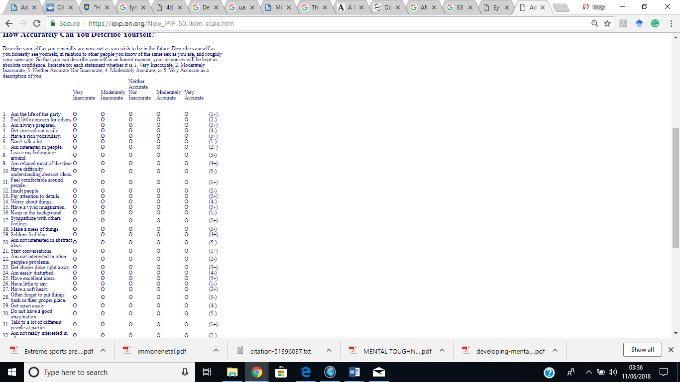

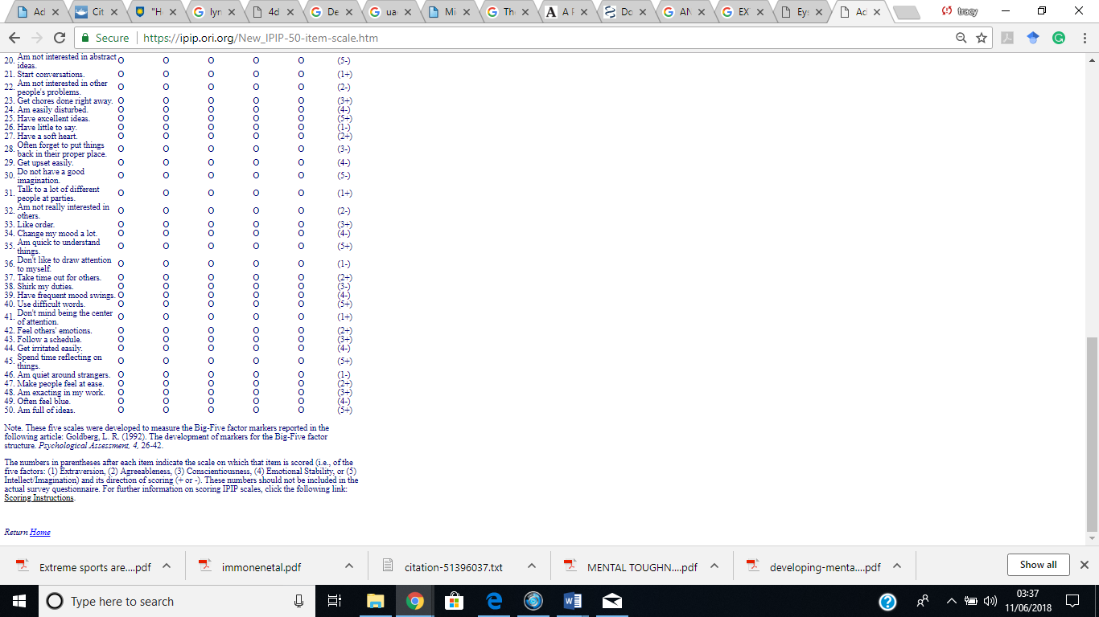

Appendix 5
MTQ- LITE, Mental toughness Questionnaire
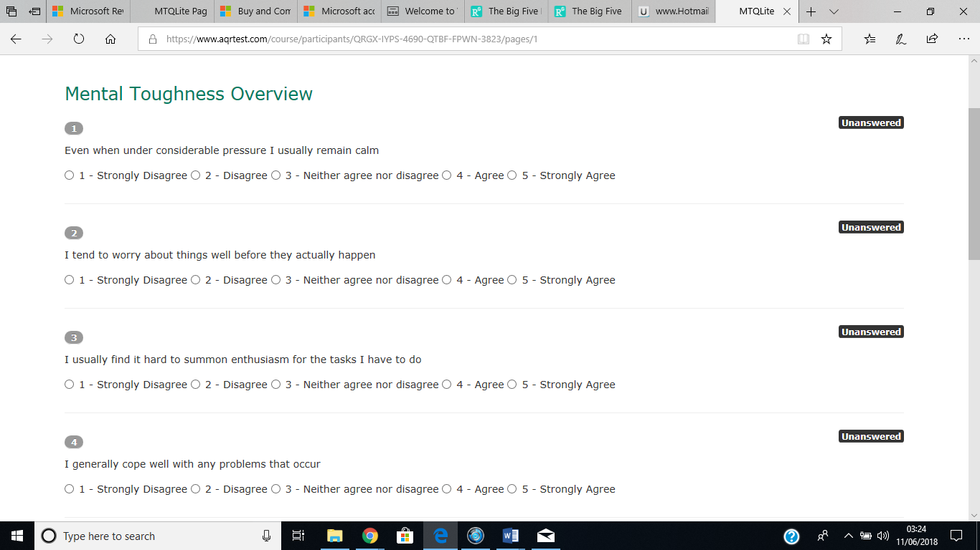

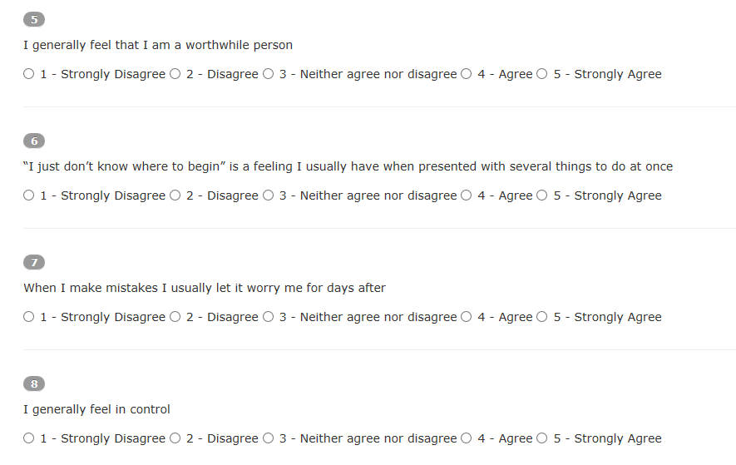

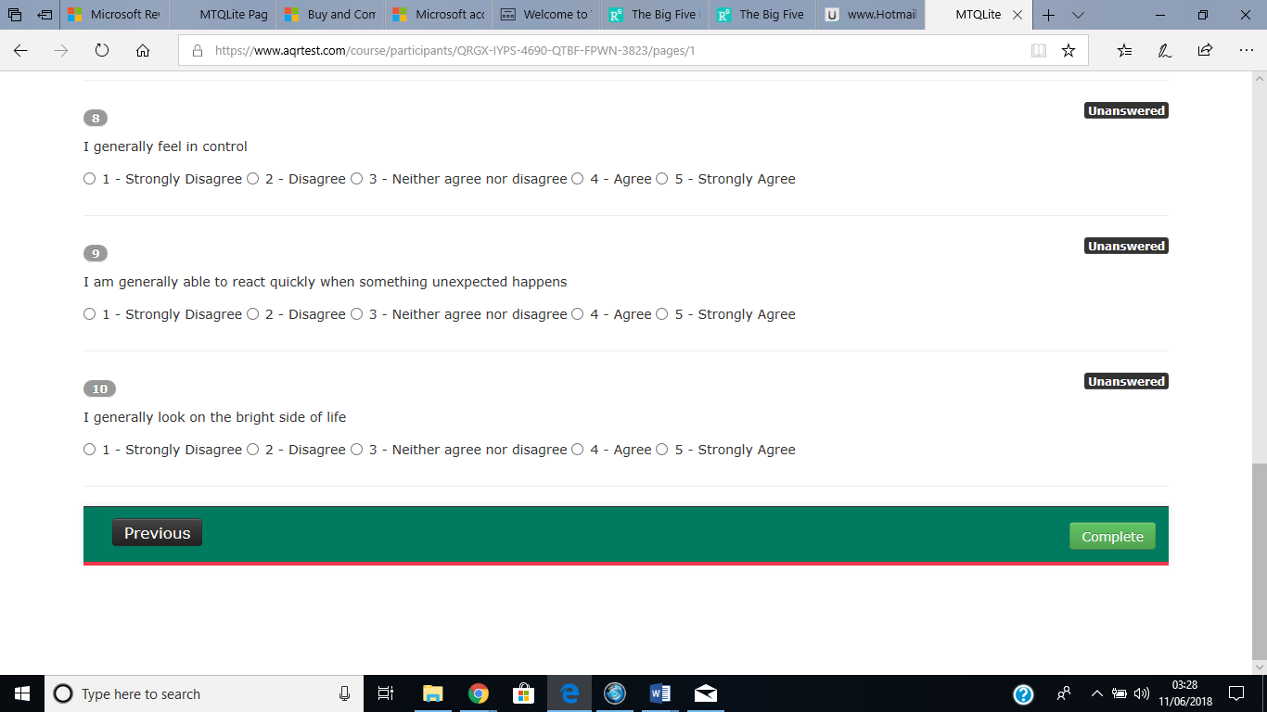

Appendix 6
Questions prior to the completion of questionnaires

Please tick which category applies to you.
I am over 18

I do participate in sport

I do not participate in sport

If you do participate in sport, please tick the sports category that applies to you

Extreme sport, consisting of the following- base jumping, sky diving, mountaineering, extreme skiing, waterfall kayaking, big wave surfing, high-level mountaineering, climbing without ropes bungee jumping, skateboarding, Parkour, bodyboarding, extreme pogo jumping, Wing Suiting, High-lining, Hang Gliding, Paragliding, Snowboarding, Skiing, Ice Climbing, Snowmobiling, Snow Kiting, Mono skiing, Snowblading Surfing, Water-skiing, Body Boarding, Wakeboarding, Kitesurfing, Windsurfing, Cave diving, Flow boarding, Paddle surfing / Stand up paddle, Kayaking, Cliff Jumping, Coasteering, Scuba Diving, Knee Boarding, White Water Rafting, Skim Boarding, Jet Skiing, Flyboarding/Jet boarding Skateboarding, Longboarding, Mountain Boarding, Sandboarding, Drifting, BMX, Motocross, FMX, Aggressive Inline Skating, Mountain Biking, Caving, Slacklining, Abseiling, Rock Climbing, Free Climbing, Bouldering, Mountaineering, Parkour, Sand kiting, and Zorbing.

Or
General sport, consisting of cricket, golf, football, hockey, darts, Netball, tennis, rugby, badminton, squash, swimming, ice skating etc

Appendix 7
Glazer Stress Control Lifestyle Questionnaire

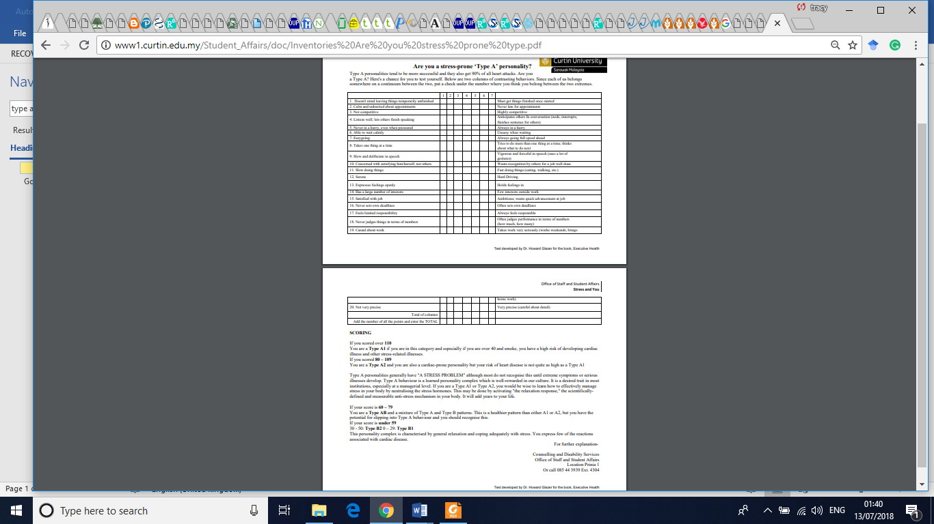

References
Bandura, A, (1997) Self-efficacy. In V. S. Ramachaudran (Ed.), Encyclopaedia of human behaviour (Vol. 4, pp. 71-81). New York: Academic Press. (Reprinted in H. Friedman [Ed.], Encyclopaedia of mental health. San Diego: Academic Press, 1998). Available at: https://www.uky.edu/~eushe2/Bandura/Bandura1994EHB.pdf
British Psychological society, (2018) code of ethics and conduct. Available at: http://www.bps.org.uk/sites/bps.org.uk/files/Policy%20-%20Files/BPS%20Code%20of%20Ethics%20and%20Conduct%20%282018%29.pdf
Byrmer, Eric G. (2009) The role of extreme sports in lifestyle enhancement and wellness. In: Proceedings of the 26th ACHPER International Conference. Available at:
Cabral, P and Cristfield, P, (1996) Motivation and Mental Toughness. Better Coaching, Better Sport. National Coaching Foundation.
Cohen, S, (1994) Perceived Stress Scale. Mind Garden. Available at: http://mindgarden.com/documents/PerceivedStressScale.pdf
Freud, S (1923) The Ego and The Id. Available at:
https://www.sigmundfreud.net/the-ego-and-the-id-pdf-ebook.jsp
Glazer, H, Stress Control Lifestyle Questionnaire. Available at: http://www1.curtin.edu.my/Student_Affairs/doc/Inventories%20Are%20you%20stress%20prone%20type.pdf
Goldberg, L, R (1992) personality. Available at: https://projects.ori.org/lrg/PDFs_papers/Goldberg.Big-Five-Markers-Psych.Assess.1992.pdf

Goldberg, L, R (1992), 50-item Sample Questionnaire. Available at: https://ipip.ori.org/New_IPIP-50-item-scale.htm
Kajtna, T, Tusak, M, Baric, R, and Burnik, S (2004) Personality In High Risk Sports Athletes. Available at: file:///E:/big%205%20personality%20link%20with%20type%20a%20and%20b.%20%20look%20at%20our%20assumption%20at%20end.pdf
Mental toughness report, (2018). Available at: file:///F:/studies%20for%20dissertation/MTQLite-Sample-Candidate-MT-Report.pdf
MTQ-LITE Questionnaire. Available at: https://www.aqrtest.com/course/participants/QRGX-IYPS-4690-QTBF-FPWN-3823/pages/1
The Extreme Sports Company (no date). Available at: https://www.extremesportscompany.com/list-of-extreme-sports
Willig, C, (2008) A Phenomenological Investigation of the Experience of Taking Part in ‘Extreme Sports. Journal of Health Psychology. Vol 13(5) 690–702. Available at: http://www.academia.edu/4769666/A_Phenomenological_Investigation_of_the_Experience_of_Taking_Part_in_Extreme_Sports.

