Postgraduate/Distance Learning
Assignment coversheet & feedback form

THIS SHEET MUST BE THE FIRST PAGE OF THE ASSIGNMENT YOU ARE SUBMITTING (DO NOT SEND AS A SEPARATE FILE)

For completion by the student:
Student Name: JOHN JAMES MURRAY

Student University Email: 2008616@student.uwtsd.ac.uk
Module code: HPCA7016  Module title:  Researching Contemporary Cosmologies | Student ID number:  2008616 |  |  | Educational support needs:  No
Assignment title: Research Project in Contemporary Cosmology

Assignment due date: May 14, 2021
This assignment is for the 1st 2nd X 3rd 4th 5th 6th module of the degree
I confirm that this is my original work and that I have adhered to the University policy on plagiarism.
Signed ……………………………………………………………
Email submission: If you are submitting this form via email, please tick this box X
(as a substitute for your signature) to confirm that you agree to the above declaration.
Assignment Mark
1st Marker’s Provisional mark
2nd Marker’s/Moderator’s provisional mark
External Examiner’s mark (if relevant)
Final Mark

NB. All marks are provisional until confirmed by the Final Examination Board.

For completion by Marker 1:
Comments:

Marker’s signature: |  |  | Date:
For completion by Marker 2/ Moderator:

Comments:

Marker’s Signature: |  | Date:
External Examiner’s comments (if relevant)

External Examiner’s Signature: |  | Date:

Research Project in Contemporary Cosmology
(Word Count = 5,222)
Introduction
Conjunctions involving the outer planets in general – and Great Conjunctions of Jupiter-Saturn or conjunctions of Saturn-Pluto in particular – have historically attracted attention both astronomically and astrologically. Much of the astronomical attraction with respect to any Great Conjunction of the two outermost naked-eye planets is its rarity – recurring on a synodic cycle of about 20 years. All other planetary conjunctions among the five visible planets of antiquity operate on much shorter time scales. In addition, the aesthetic of observing two quite contrasting but easily visible planets coming close together in the sky and then appearing to recede from one another for an extended period, and with cyclic regularity, is one of historical significance and the appeal continues today.
This essay presents initial results of a study set among professional and avocational astrologers. The research sought to examine astrological perspectives in terms of whether the conjunctions of Saturn-Pluto in January, 2020 and the Great Conjunction of Jupiter-Saturn in December, 2020 were defined in some way by – or possibly were redefined by – the present SARS-CoV-2 pandemic era of COVID-19 disease. The spring of 2021 provided for pre- and post-hoc examination of astrologers’ positions with respect to these celestial conjunction events and perceptions of their importance to the present global situation. Therefore, this essay relies exclusively on the testimony of present-day, actively practicing professional astrologers as its primary source.
The study adopted a qualitative, mixed-methods research design. Purposive sampling of the worldwide astrological community on six continents included both open and moderated social media groups, faculty within astrological academic institutions, and approaching directly diverse individuals who have an active and accessible online presence among modern astrologers. The wide range of sampling sought to differentiate between those who self-identify as serious avocational astrologers and those who are professional astrologers in practice. The latter constituted the target group for the study.
The findings of the research clustered around the two conjunction events in the following manner: 1) The Great Conjunction of Jupiter-Saturn was more notably framed by astrologers within its regularity as a planetary cycle which – when contextualized with its inauguration of the Air Signs sequence at 0 degrees Aquarius – was viewed primarily with optimism as the harbinger of a forthcoming period of constructive and fundamental change in the world; politically, societally, spiritually, and astrologically; 2) The long-period in orb conjunction of Saturn-Pluto was viewed with a deeply felt sense of pessimism and foreboding with severe and negative consequences for governance, political authority, and the disruption of the social order and economic systems.
Literature Review
The astrological significance of outer planet conjunctions as omens of pestilence, societal upheavals, the emergence of a great prophet, or political instabilities parallels the mechanistic, astronomical nature of these events as celestial wonders to the historical eyes. Jupiter-Saturn conjunctions in antiquity - and in post-1930 astrology outer planet conjunctions involving Pluto - have been considered as potent turning points in world affairs and even the inauguration of entirely new eras. For instance, Great Conjunctions of Jupiter-Saturn have been addressed among Arabic astrologers such as Abu Ma'shar (787-886 CE) and his contemporary - Sahl Ibn Bishr (ca. 786 – 845 CE) – and when occurring in combination with a conjunct Mars, a malefic, were deemed omens of pandemia (Ma'shar), or a great struggle which ‘will be in all of the lands, and it will happen many times….and it will intensify and the matter of the world will be difficult’ (Ibn Bishr). Ibn Bishr also warned that such outer planet alignments would render ‘infortunes’ in travel to various persons or to travel by sea. The Black Death of the mid-14th century coincided with such a triple conjunction of Mars-Jupiter-Saturn which occurred in Aquarius in 1345 CE. In March of 2020, Mars sequentially was conjunct Jupiter-Pluto-Saturn in that order – in tropical Capricorn. The most urgent reports issued by the World Health Organization regarding SARS-CoV-2 and the COVID-19 pandemic were released that month at the peak of the global first ‘wave’.
Continuing forward, the late medieval and early Renaissance literature among transitional astrologer / astronomers such as Roger Bacon (ca. 1219–1292 CE) who, as Nicholas Campion has argued, ‘pushed astrology into potentially dangerous realms’ by associating this event with Judaic history and more comprehensively as the arbiter of the rise and fall of all great currents of religious history. Campion further stated that Bacon’s apocalyptic astrology drew extensively on Abu Ma'shar’s contemporary, Masha’Allah, and the notion that Great Conjunctions as planetary cycles were an ‘astronomical pattern to socio-political and religious shifts which occurred every 240 years, and periodic conflagrations or catastrophes…[take] place every 960 years’. According to Anthony Aveni, the 1603 conjunction of Jupiter and Saturn was closely observed by Johannes Kepler (1571-1630 CE) and prompted Kepler to be among the first to back-calculate the event [to] the 7 BCE conjunction – not as the Star of Bethlehem – but as a herald of the coming of the Christ. One notable modern example of such ‘back dating’ is the Saturn-Pluto conjunction of 1914-15 as having been (retrospectively) aligned with, and interpreted within, a narrative of the ‘shadow side of ambition and abuses of power’ - the outbreak of hostilities leading to World War 1. The phenomenon of the Great Conjunction is also a feature of early dramatists such as Dante Alighieri (ca. 1265-1321 CE) and William Shakespeare (1564-1616 CE).
In the instance of Dante, and in contrast to the astrological accounts of 14th century catastrophes of Campion, Woody claimed that ‘all his genius’ (Dante’s tutto il mio ingegno) was attributable to the Great Conjunction of the year of his birth (in Gemini) and later ones coinciding with his prognostications – not of calamity, but of the ‘reformation of Christendom’. These historical accounts of Great Conjunctions – with few exceptions such as the nativity of Christ and the astrological musings of Dante – were rather pessimistic and foreboding, containing a negativity and severity of consequences for governance, political authority, and prospects of the disruption of the social order and turbulence within society’s systems. For instance, Margaret Aston’s account of the ‘astrological fracas of 1583’ pitted Richard Harvey and Thomas Heath as protagonists in a ‘play’ to determine whether the consequences for the world that year would be ‘heavy calamities, imprisonments, disturbances, tribulations, anguish and sorrow’ (Harvey) or ‘most happy, prosperous and benevolent….[and] not pretend or foresee any great matter worthy of writing, much less the alteration of kingdoms, the coming of Christ in judgement, or the consummation of the world’ (Heath). This is the epitome of the polarity of the Great Conjunction as blessing or curse.
The triple Great Conjunction of 7-6 BCE in tropical Pisces has been identified as a probable candidate for the “Star of Bethlehem” or possibly the herald of the Piscean Age as described in the work of Brady, Burke-Gaffney, and Molnar., , These authors consider such significant events, astrologically, as narratives of optimism, of potential, of expectation, of radical social movements, and the emergence of prophetic voices. There are contrarian modern voices, however. Among modern astrologers, particularly archetypal astrologers such as Richard Tarnas and Renn Butler (his student), many of the malefic, or ‘shadow qualities’ of the Jupiter-Saturn conjunction are still in evidence, with polarities such as the ‘positive sides of adversity and challenge…feelings of constriction and missed opportunities, a tendency for pessimism to outweigh optimism, [and] the possible negative results of too much prosperity or success’. For these authors, the pessimism of the historical attributes of Saturn conjunctions with Jupiter are carried forward to the other, modern outer planets. For instance, Saturn-Pluto conjunctions transmit with them ‘ominous forebodings and sense of danger, feelings of anxiety and fear, a dark and sinister atmosphere, [and] negative or threatening forces’. With modern Pluto returns occurring at 249-year intervals (recall the 240-year planetary cycle of Jupiter-Saturn), it brings forth the suggestion that astrological speculation about the significance of the Saturn-Pluto conjunction and the triple of Jupiter – Saturn - Pluto in 2020 would bear the negative hallmarks brought about by the ‘Plutonic’ archetype.,
Methodology
This research study combined the ordinariness of qualitative methodology with the extraordinariness of the present global times. With this in mind, the research adopted a mixed-methods research design in which ‘the investigator collects and analyses data, integrates the findings, and draws inferences from both approaches’ in accordance with Hennink, Hutter and Bailey, Tashakkori and Cresswell, and Cresswell. The study used purposive sampling to secure a representative cohort from among the professional astrological practice community. The strategy included approaching a diversity of individuals and their respective astrological systems or specializations, including: electional, mundane, archetypal, psychological, Hellenistic, esoteric, hermetic, and medieval systems. These (and other) disciplines were intended to constitute and identify the astrological typologies of the study’s eventual full participants. Therefore, the study confines itself to participant astrologers from among the Western astrological tradition. Participants were recruited from among those who belong to established astrological schools, associations, academia, and/or practice (or have practiced) in private consultation.
The study was conducted exclusively online and the questionnaire architecture was with QuestionPro™ online software (see Appendix ‘A’ for the instrument as distributed). Recruitment of participants included contacting the administrators of social media outlets to permit online hosting of the questionnaire. Participants were also recruited from directly contacting professional astrologers via their websites, blogs, newsletters, and their open social media sites. The entry-level participation once the questionnaire was ‘live’ was substantial (N = 831), which involved a consideration of participation in the study by reading the online consent form. Consent would comprise the source of the research (MA student of the University of Wales Trinity Saint David), the rationale and objectives for the study, who was best suited to participate, and the approximate time commitment. Of this number, about one-quarter provided consent and entered the study (N = 201) with 59.7% of these completing the 26-item questionnaire. Most of the 40.3% (N = 81) who dropped out did so at the points where the respondent was asked about their level of experience with astrological practice or whether they held a formal credential in astrological theory and practice. Since these were the points of bifurcation where respondents were re-directed in accordance with their answers, and was at the seventh item, it is unlikely that drop out was related to questionnaire fatigue.
Since the focus group of the research was determining a representative sampling of the astrological community of professional practitioners, a methodological difficulty arose since the respondents were anonymous, online, and voluntary. The difficulty is exacerbated by the small number of studies available which involve a randomized selection of a group of professional, practicing astrologers. To secure a defensible and reliable subset of professional astrological participants, criteria for inclusion in the final cohort was needed. The solution to the problem was devised from an adaptation of the analytics found in the doctoral thesis of Bernadette Brady. Details of this set of procedures are outlined in Appendix ‘D’.
The study design also included an interview protocol. There was significant interest in being a participant in a one-hour, semi-structured interview following completion of the questionnaire with thirty-two (55.17%) of the established cohort of professional astrologers (N = 58) demonstrating an interest in the interview process. The manner in which interviewees were selected into the final interview pool (N = 10) was based primarily on my assessment of satisfying at least two of these three criteria: 1) Identified as having a practice grounded in archetypal, psychological, or mundane astrology; 2) Holding a professional designation or recognized credential in astrological theory/practice, and/or; 3) Teaching and practical experience in astrology of >20 years. A sample interview protocol is available in Appendix ‘B’.
NVivo 10™ computer assisted qualitative data analysis software (CAQDAS) from QSR International was used to code the written ‘commentary’ responses within the questionnaire and the transcripts of ten (10) semi-structured interviews. This procedure determined the principal themes and critical incidents that emerged from the data collection. All responses were coded reflexively and iteratively until a reliability of at least 75% was obtained. Specifics of the coding as conducted can be examined in Appendix ‘C’.
There was one instance of an individual – an internationally cited, award-winning astrologer - who expressly did not wish to complete the questionnaire but contacted me directly for an interview, citing astrological theory and practice as “far too sacred a vocation to ever be reduced to the level of reductionist scientific inquiry”. That request – from a psychological/archetypal astrologer – was accepted. I was reminded in this instance of the researcher occupying the space which Guillemin and Gillam described as where ‘ethical tensions are part of the everyday practice of doing research’. The instance was one of an experience which would fit well into the two dimensions of Guillemin and Gillam when they refer to ‘procedural ethics’ (how the study is designed, constructed and implemented) and an ‘ethics in practice’ (what occurs on the ground at the site of the research).
Thoughts on Reflexivity
The researcher vignette just outlined was a reminder that all such qualitative studies invite some consideration and characterization of the insider/participant and the outsider/observer., In this research, the positionality to which I would be inclined to consider would be as follows: that of the interested outsider/observer, combining the lenses of a professional academician in the health sciences by background with my concurrent condition as a graduate student in cultural astronomy and astrology studies. In recent years, I have encountered the astrological community and its literature (post-2014) and so have only a nascent familiarity with that community but a continuing interest in the development of academic inquiry into the theory and practice of astrology. The professional life I have in research is strongly quantitative in orientation, and so I can identify certain disadvantages in constructing an online instrument which would adequately capture – with both depth and precision – the nuances of astrological thought and expression. A good example of this was the pilot phase vetting of the questionnaire prior to its deployment; my interests were primarily on its functionality, appearance, ease of use, and navigability. With no formal connections to, or affiliations with, any of the target group associations, social media groups, or personalities approached, there was a certain sense of being situated in a continuum of a two-dimensional space; of a unique data collection environment which was the traditional ‘procedural ethic’ (e.g., recruitment and deployment) together with the - at times - unexpected moments of an continuing ‘ethics in practice’ which became the emphasis within the interview processes.

Demographics
Prior to the presentation and discussion of the findings of the research, a brief characterization of the attributes of the cohort of professional astrologers will be offered in a series of charts. It is important to mention that this section of the treatment of the study does not involve itself in detailed correlational analyses grounded in the demographics. That treatment will occur elsewhere. The reader may find it useful, in one way or another, to situate themselves within the findings by virtue of what is presented here.
There occurred a critical point, early in the questionnaire, which produced a sudden withdrawal of the majority of those who left – the possession (or not) of a recognized astrological credential. Even among the professional astrologers, just under half (45.76 %) indicated that they did not possess a credential. Respondents were asked to identify an area of specialization in astrology which they possess and / or devote most of their professional time. Over 50% claimed an identity which was within either psychological astrology or archetypal astrology. It is recognized that this produces an internal bias effect on the manner in which outer planet conjunctions will be explained within the research, but aggregate responses were preferred. Figure 1 displays these areas of specialization:
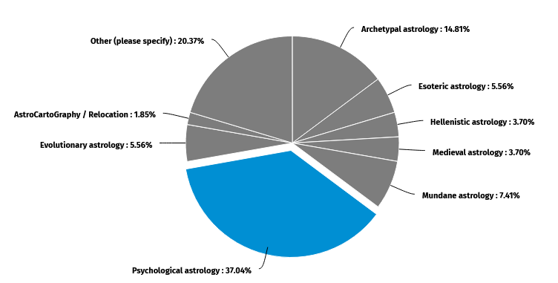
Figure 1: Areas of specialization within astrology (N = 54)
In terms of chronological age, the spread was within expectations of the general population given the largest groups clustered in the 40-49 and 50-59 years categories with mean age of 52 (Figure 2). Any respondent who selected < 18 years of age were immediately redirected in the questionnaire to a page declaring that ‘your age does not fit the criteria of the study’. This was an important ethical consideration.,
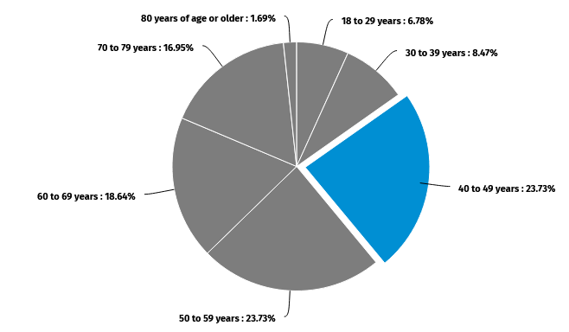
Figure 2: Age ranges of final cohort classified as professional astrologers (N=59)
The veteran nature of the professional astrologers was borne out in responses to years of active involvement in the study of astrology, the years of experience in professional practice, and teaching. It is notable that, among the entire group of respondents (N = 201), just 41.2% had teaching experience (N = 83) and of those, almost one-half had less than 5 years teaching astrology. In contrast, among the cohort of professional astrologers, 78.0% held teaching experience and more than half of them had been teaching astrology for more than ten years. Among the interviewees, all but one had been teaching astrology for more than twenty years. Figures 3, 4, and 5 summarize these levels of experience in study, practice, and teaching:
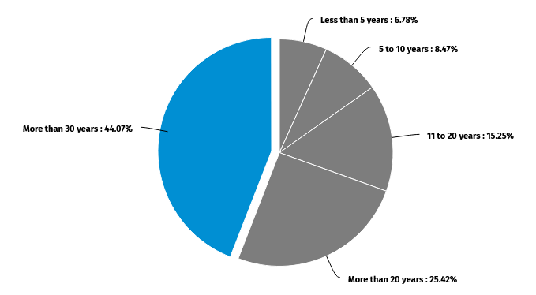
Figure 3: Years of collective study of astrology among professional astrologers (N = 59).
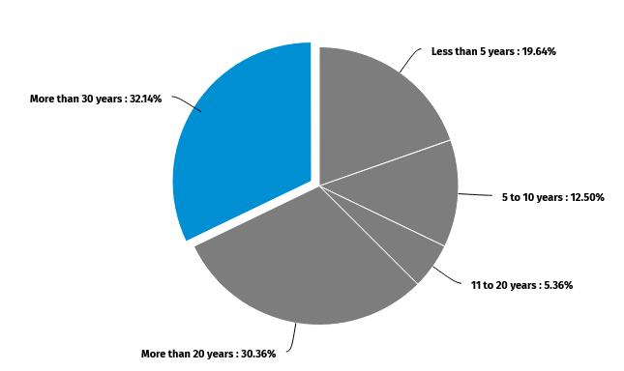
Figure 4: Years of experience in the practice of astrology (N = 56).

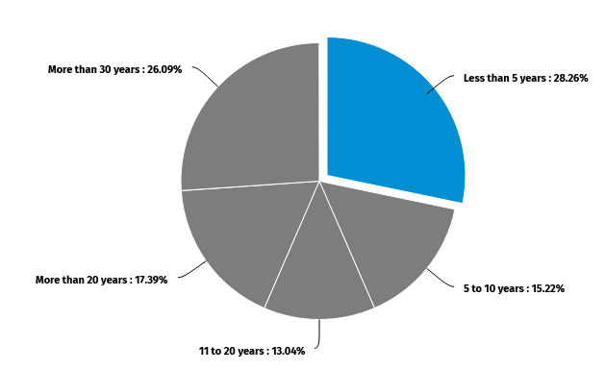
Figure 5: Teaching experience among professional astrologers (N = 46).
(421)
Findings and Discussion

The findings of this study will be grouped in two sections comprising four themes which emerged as dominant in the research results. The structure comprises the following categories in combination: 1) astronomically as the Saturn-Pluto conjunction (+/- Mars) and the Great Conjunction of Jupiter-Saturn (+/- Pluto) in 2020 in the context of the SARS-CoV-2 pandemic, and; 2) astrologically according to two meta-level, over-arching themes emerging from the primary-source data of questionnaire responses, the coding of the voluntary comments among respondents, and interview transcript anecdotes which relate to these events. Pragmatically, and with the 2020 calendar in mind, this organization allows for the examination of the perspectives of astrologers in terms of whether the conjunctions of Saturn-Pluto in January, 2020 and the Great Conjunction of Jupiter-Saturn in December, 2020 were defined in some way by – or possibly were redefined by – the present SARS-CoV-2 pandemic era of the global reach of COVID-19 disease.
Saturn-Pluto Conjunction
Theme – Governance and Rulership
Sub-themes - Political Authority, Control, Limitations of the Social Order and COVID-19

There existed much commentary from astrologers that this event in the early part of 2020 was something that would not be positive for the world, holding consequences for governance, political authority and the disruption of the global social order and its economic systems. In addition to this, a theme which connected the pandemic to anxiety, fear, grief, the processes of dying and death en masse were evident in the data. To background these claims, when asked about how long astrologers were ‘paying attention – astrologically – to the approaching Saturn-Pluto conjunction’, almost half of them stated that they had been doing so for as much as five years and even substantially longer (Figure 6).

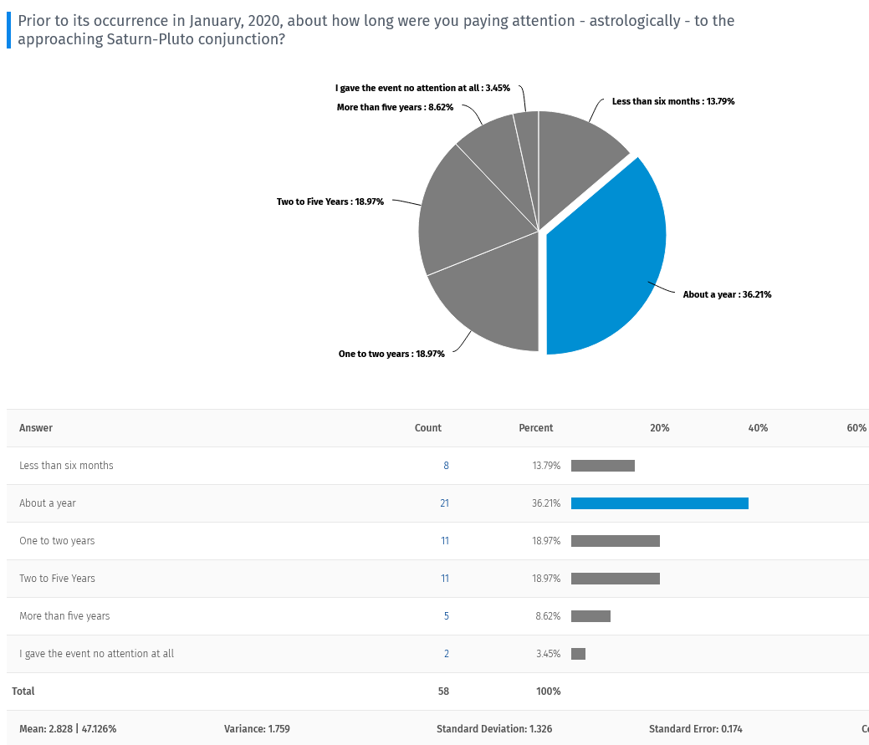
Figure 6: Astrologers' attention to the Saturn-Pluto conjunction of 2020.

Among those who had been preparing for this event for a number of years, one stated that:
Some astrologers were thinking about this conjunction for as much as a decade…and some of us were thinking of it way back since the early 1990s; reason being one of the big conjunctions of recent decades was the conjunction of Uranus and Neptune in 1993 which so happened to be in the very same degree as the upcoming Saturn-Pluto which also happens to be the Pluto return in the horoscope of America. Knowing that America was going to absolutely feature, and [also] knowing that because it was in Capricorn it was likely to be something quite literal and very restrictive of personal freedoms.
In terms of that ‘literal’ effect, an astrologer mentioned that, for them in the USA, ‘the ongoing restrictions and necessity for governments to bring in emergency powers to control their populations; which in democracies would have been unthinkable in “normal times was actually happening” while others commented that ‘I knew something major would happen causing upheaval in our structures and institutions’ and ‘the Saturn-Pluto connection brought about a governmental authoritarian model approach to handling the disease., From the archetypal astrological perspective, a respondent claimed that ‘the global pandemic, along with its restrictions on personal movement, on confinement, on hard choices, on the importance of personal responsibility in order to protect the collective; all of these tie into the Saturn-Pluto conjunction archetypal dynamics. The Saturn-Pluto ‘complex’, according to Tarnas, encourages – particularly in the instance of conjunction - an ‘empowerment of expressing itself through social and legal constraint…[an] intensified law-and-order impulse, [the] extreme intensification of air travel security, [and] the shadow of state control over the private lives and freedoms of citizens.’ The narrative echoes the centuries’-old positions held by Ibn Bishr and Richard Harvey, but involve the substitution of a modern planet (Pluto) for Jupiter which implies a raw intensification., ,
This narrative among astrologers aligns with the attitudes which they held, prima facie, about how they characterized their attitude towards a Saturn-Pluto conjunction and its meaning for the world. The general consensus or median position was that of pessimism but with a minority reporting that out of such negative and challenging circumstances, openings were made in people’s lives which can be interpreted as at least of neutral effect and possibly positive. The large proportion of astrologers indicating that they had no opinion on the event (29.31%) cannot be accounted for in the literature (see Figure 7 below):
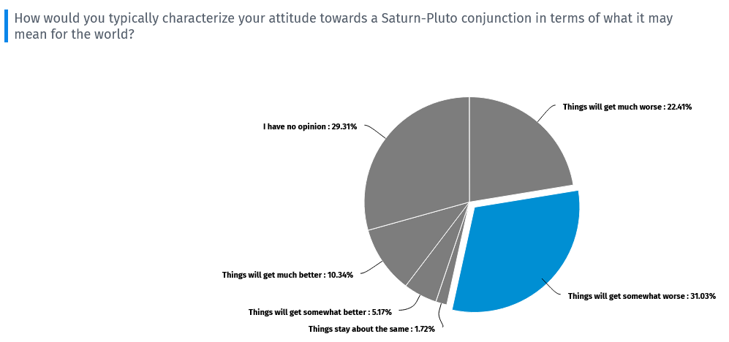
Figure 7: Astrologers attitudes with respect to a Saturn-Pluto conjunction.
The effect on astrologers’ characterization of the global COVID-19 pandemic was stark and unequivocal with respect to Saturn-Pluto once 2020 arrived. Over 80% of them indicated that, upon the emergence of the disease, they were compelled to consider this celestial event as having an astrological connection exclusively to COVID-19. Despite much speculation, virtually no astrologer in the study was willing to claim that the manifestation of the conjunction would take the form of a global health crisis involving so much fear, anxiety, grief, and death. Much of the commentary would be consistent with this view, as follows:
I was expecting something of global significance, involving some sort of breakdown and hardship. I was aware of the impact of previous conjunctions, which arguably also correlated with major shifts in society or widespread disease. However, I am concerned that much of the analysis was political and I would have liked to know more about truly global impacts. This is not in doubt with the pandemic, however.
It was unclear the actual expression of the Pluto Saturn conjunction, but in retrospect the energies as powerful, transformative and challenging as they were, would have needed to be as total as it’s been. Societal structures that reflect age old systems of the Age of Pisces and the dominance of the patriarchy with Pluto and Saturn joining to create change, it made sense that the events of COVID-19, the death toll (Pluto), the dark side of political, economic and other structures (Saturn) would be revealed. The inequalities, separation of humankind from nature, seeing the nature of human-made power with its destructiveness and rawness - all Pluto manifestations along with Saturn The waves of death associated with Mars joining the conjunction seemed to match the astrology with perfection – all out pandemic war.,
According to the recollections of one astrologer, the Saturn-Pluto conjunction was within a 10-degree orb from early January of 2019 to the end of January of 2021; exact on 12 January of 2020. At that time, the Global Coordination Mechanism for Research and Development held its first conference on the identification of the SARS-CoV-2 coronavirus on 10 January and the World Health Organization published its initial guidance documents on the management of epidemics to member countries on 21 January in the wake of the first COVID-19 disease deaths reported in Wuhan City, China. That same individual presciently noted the following recounting:
I researched the 1918 pandemic and found similar astrological signatures of Pluto conjunct Jupiter in Cancer. I prepared [for] panic and fear. The astrology was quite clear to me from the 1918-19 pandemic. Interestingly, then, it was the young that died. I thought this time - and the world events confirmed it - it was the old (50+) that died in mass numbers [because] Pluto (the main planet of epidemics) was in Capricorn, the sign of the senex. Astrological research made this clear to me. The handwriting was on the wall.
Prior to the discovery of Pluto, such a narrative of fear, pestilence, death and dying would have only been possible within the occurrence of Jupiter-Saturn conjunction and at one of the key positions in the trigonal system of Johannes Kepler., The Saturn of tradition, with its limits, restrictions, and harsh realities is viewed among modern astrologers as synergistically involved in the ‘magnification of death, the magnification of grief, a complete decay of the world’s structures, and the Plutonic archetype of a hunger for these which endures and is something that is here to stay’.

Great Conjunction of Jupiter-Saturn
Theme – Planetary Cycles
Sub-themes – Constructive Forms, Societal Transformation, Universal Effects and COVID-19
If the astrological significance of Saturn-Pluto conjunctions in the post-1930 human experience - pointedly demonstrated among the astrologers who participated in this research - have been considered as potent indicators of pestilence, societal upheavals, and the emergence of a great trial for the world, the manner in which Great Conjunctions were viewed is inconsistent with that traditional Western astrological tradition. Notably contrasting the lengthy preoccupation with what Saturn-Pluto would imply, and similar preoccupation among Medieval counterparts where Jupiter-Saturn are involved, the astrologers in this study spent far less time considering the implications of the 2020 Great Conjunction. However, they did recognize in large numbers that the ‘change in element’ from earth to air signs was consistent with traditional expectations of a real likelihood that a lengthy period of fundamental change was (or is about to) take place in the world. This is the ‘Heath’ argument articulated by Aston and speaks to the prominence of planetary cycles among astrologers.
When asked to recall their attitude about the 2020 Jupiter-Saturn conjunction, the vast majority of sampled astrologers (82.76%) viewed the event with ambivalence or optimism (Figure 8). Not only that, only a minority (16.95%) expressed any change in their position with the emergence of the COVID-19 pandemic. A complete contrast to their impressions of Saturn-Pluto even in the face of centuries of tradition and a conjunction event which – if one considers a 15-degree orb – paralleled the height of the pandemic throughout 2020 and well into the vaccination period ending in late May of 2021.
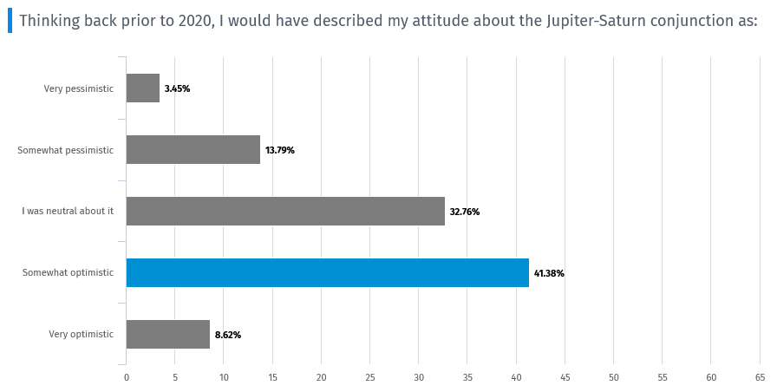
Figure 8: Astrologers’ perceptions of the implications of the Great Conjunction of 2020.

As one astrologer put it:
I don’t want to sound insensitive, but I feel the world was blessed by the ‘time out’ we received [and] I am grateful that people had the opportunity to slow down. Yes, I am aware it [the pandemic] has caused bankruptcies, divorces, more depression and of course many COVID-19 deaths; but on the other hand, our environment is cleaner, people have paid more attention to family and deeper issues, people are questioning the news and sources of information, and relying more on community rather than outside supports because we can no longer count on them. This is good.
This astrologer was speaking to the theme of ‘constructive forms’ and ‘societal transformation’ which also included beneficial outcomes such as a ‘change in the international rhetoric where wealth and what defines wealth is changing’. A number of astrologers who were interviewed readily acknowledged what can be termed the ‘traditional and historical significance of Great Conjunctions’ and this would include the possibility of challenging the current social constructs, but the 2020 event involving an elemental change into the air signs provided their best explanation of why they were more optimistic, more hopeful, and expected any changes in society to be both deep and lasting. As one described it metaphorically:
Much like the waves of a tsunami as compared to the waves of a windy Saturday morning - the deeper the wave, the slower and longer-lasting the impact. A tsunami wave starts at the ocean floor, at the tectonic plate boundary, and travels far across the ocean and deep into land. On the contrary, throw a pebble in the ocean, it may make a small ripple. The outer planets are like the tsunami, and we are accepting that the smallest pebble (Pluto) now makes the deepest impression. Jupiter-Saturn, for me, means centuries of beneficial times ahead.
Not all the rhetoric spoke to completely positive orientations to the Jupiter-Saturn event, and this was due primarily to the triple conjunction in late 2020 which included Pluto. The majority of those interviewed emphasized the uniqueness of this triple conjunction (+ Pluto), with comments such as ‘the inclusion of Pluto now completely masks any benefic effects of Jupiter, but instead expanding the power and harshness such that hard, societal lessons [are] to be learned, and structures are transformed unequivocally’, and ‘it is the final lessons to be learned as we move fully into the Age of Aquarius’.,
Conclusion
This paper presented initial results of a study set among astrologers in the world, and so embedded the ordinariness of research within the context of extraordinary times. The research explored the question of whether present-day practicing astrologers articulated specific astrological connections to the emergence of the SARS-CoV-2 coronavirus and subsequent COVID-19 worldwide pandemic to the 2020 conjunctions of Saturn-Pluto and the Great Conjunction of Jupiter-Saturn within a three-planet stellium which included Pluto. The unprecedented context, in modern times, of the worldwide reach of the pandemic provided an opportunity. An opportunity to access and assess present-day practicing astrologers’ views to determine if these events were viewed as omens, portents, indicators or symbols of significant world events and/or the advent of widespread socio-political change.
The research demonstrated that, prior to the COVID-19 disease pandemic, professional astrologers speculated about what was to be expected in 2020 with the kind and number of outer planet configurations involved. Quite apposite, vivid if not apocalyptic conceptions of the interrelationships among the outer planets, their periodicity, and conjunctions were found among the sample of astrologers. The astrologers’ characterization of the global COVID-19 pandemic was stark and unequivocal with respect to the Saturn-Pluto conjunction once 2020 arrived early in 2020, as the alignment had been in orb for about a year prior to the pronouncements of the World Health Organization. It is reasonable to conclude that, without the telescopic discovery of Pluto in 1930, modern astrologers would likely have maintained millennium-scale understandings of the links between Great Conjunctions and the advent of pestilence. By invoking the Saturn-Pluto complex in the context of the Plutonic archetype in recent decades, astrologers now possess a narrative with respect to very long-period world transits which diminishes the relative importance of the 20-year planetary cycles of Jupiter-Saturn. Newer, longer-term outer planet cycles have been grafted onto the periodic, cyclic eternal narrative of Kepler’s trigons and offer an archetypal astrological narrative which, one day, could seriously threaten the prominence of the traditional Great Conjunction of history. In the wake of its emergence and stubborn lingering in societies all over the world, the SARS-CoV-2 novel coronavirus appears to be on the threshold of becoming a benchmark in a ‘novel’ modern conjunction astrology.

References
Abu Ma'shar, De Magnis Coniunctionibus , ‘On Historical Astrology, The Book of Religions and Dynasties’, trans. by K. Yamamoto and Charles Burnett (Leiden, 2000).
Aston, Margaret, ‘The Fiery Trigon Conjunction: An Elizabethan Astrological Prediction’, ISIS, 61 (2) (1970): 159-187.
Aveni, Anthony F., ‘The Star of Bethlehem: Was it a Celestial Event, a Supernatural Phenomenon, or a Story Made Up by Matthew?, Archeology 51(6), Archeological Institute of America, November / December 1998, pp. 37. https://www.jstor.org/stable/41771453,[accessed February 17, 2021].
Bacon, Roger, Opus Majus, J.H. Bridges (ed.), (Oxford: Clarendon Press 1897 Vol. 1): pp. 263.
Bell, Judith, ‘Doing Your Research Project: A Guide for First-time Researchers in Education, Health and Social Science’ (4th ed.), (London, UK: Open University Press, 2005).
Brady, Bernadette, ‘The Star of Bethlehem and Luke’s Shepherds: an Exploration of the Astrological Features of the Two Nativity Stories, Ivan Sprajc and Peter Pehani (eds.). Ancient Cosmologies and Modern Prophets, (Proceedings of the 20th Conference of the European Society for Astronomy in Culture, Slovene Anthropological Society, Ljubljano, 2013): 443-456.
Burke-Gaffney SJ, W., ‘Kepler and the Star of Bethlehem’, Journal of the Royal Astronomical Society of Canada, 31 (1937): 417-425.
Butler, Renn, The Archetypal Universe: Astrological Patterns in Human Culture, Thought, Emotion and Dreams, (Bolton, ON Canada: CreateSpace), 368 pp.
Campion, Nicholas, A History of Western Astrology (Volume II): The Medieval and Modern Worlds, (London: Bloomsbury 2009), 371 pp.
Nicholas, Campion, ‘The Shock of the New: The Origin of the Age of Aquarius and the 2012 Phenomenon, Culture and Cosmos, 15 (1) (Lampeter: Sophia Centre Press 2011): 17-27.
Cresswell, John W., ‘Mapping the Field of Mixed Methods Research’, Journal of Mixed Methods Research, 3 (2) (April 2009).
Dykes, Benjamin N. (ed.), The Astrology of Sahl B. Bishr, Volume 1: Principles, Elections, Questions, Nativities, trans. by Benjamin N. Dykes (Minneapolis, MN: The Cazimi Press, 2019).

Emmerich, Nathan, ‘Reframing Research Ethics: Towards a Professional Ethics for the Social Sciences’, Sociological Research Online, 21(4) (2016), http://www.socresonline.org.uk/21/4/7.html [accessed March 27, 2021], pp. 1-14.
Etz, Donald V., ‘Conjunctions of Jupiter and Saturn’, Journal of the Royal Astronomical Society of Canada, 94 (2000): 174-178.

Hennink, Monique, Inge Hutter and Ajay Bailey. Qualitative Research Methods (2nd Ed.). (London: UK: SAGE, 2020).
Hunt, Jeffrey L., ‘2020: December 21: The Great Conjunction of Jupiter and Saturn’, When the Curves Line Up: Watching the Sun, Moon and Planets, https://whenthecurveslineup.com/2019/12/11/2020-december-21-the-great-conjunction-of-jupiter-and-saturn/ , [accessed February 20, 2021].

Kepler, Johannes. De stella nova in pede Serpentarii, De Trigono Igneo ac Initio de Primo Fignificatu Vocis Trigonis: Feu de Triangulatione Signorum, Ex officina Pauli Sessii, 1606. (Google Books) https://books.google.ca/books?id=Bk5RAAAAcAAJ&dq=Kepler+de+Stella+Nova&lr=&source=gbs_navlinks_s [accessed February 19, 2021].

Molnar, Michael R., The Star of Bethlehem: The Legacy of the Magi, Rutgers University Press (1999).

Oellers, Claudia and Eva Wegner, ‘A New Research Ethics for the Social Sciences?’, RatSWD Working Paper Series, 86, (2009).

Sinkovics, R. and Alfoldi, E.A. (2012). Progressive focusing and trustworthiness in qualitative research: The enabling role of computer-assisted qualitative data analysis software (CAQDAS). Management International Review, 52(6), 817-845. (DOI: 10.1007/s11575-012-0140-5).

Tashakkori, A. and J.W. Creswell, ‘The new era of mixed methods’, Journal of Mixed Methods Research, 1 (1) (2007).

Tarnas, Richard, Cosmos and Psyche: Intimations of a New World View, (New York, New York: Viking Penguin 2006).

Woody, Kennerly M., ‘Dante and the Doctrine of the Great Conjunctions, Dante Studies – Annual Report of the Dante Society, (95) (1977): 119-134.

World Health Organization, Novel Coronavirus (2019 nCo-V) Situation Reports – March 2020, https://www.who.int/emergencies/diseases/novel-coronavirus-2019/situation-reports . [accessed February 19, 2021].

List of Figures

Figure 1: Areas of specialization within astrology (N = 54) 7
Figure 2: Age ranges of final cohort classified as professional astrologers (N=59) 8
Figure 3: Years of collective study of astrology among professional astrologers (N = 59). 9
Figure 4: Years of experience in the practice of astrology (N = 56). 9
Figure 5: Teaching experience among professional astrologers (N = 46). 10
Figure 6: Astrologers' attention to the Saturn-Pluto conjunction of 2020. 11
Figure 7: Astrologers attitudes with respect to a Saturn-Pluto conjunction. 13
Figure 8: Astrologers’ perceptions of the implications of the Great Conjunction of 2020. 15

Appendix ‘A’
A Questionnaire: Astrologers’ Views on Outer Planet Conjunctions

Dear Colleague:

I am a graduate student enrolled in the MA in Cultural Astronomy and Astrology in the Institute of Education and Humanities, University of Wales Trinity Saint David (the "University") located in the UK. A core module of the program - Researching Contemporary Cosmologies - provides opportunity to conduct original research under an approved research ethics protocol. I invite you to complete this questionnaire so as to provide data to the inquiry project that I have developed.

What is the purpose of this questionnaire? I am seeking your input in terms of insights, opinions, and thoughts to be used as data to inform the question that is guiding the research. The orientation of the research question can be summarized as a "focus on the astrological significance, if any, of periodic conjunctions involving the outer planets".

To whom is this questionnaire directed? The target group for this questionnaire comprises currently practicing astrologers and/or those who have developed an interest in a particular discipline within astrology. Participants are not required to hold any professional or academic certification in an area of astrology.

How long will it take to complete? The questionnaire consists of 26 rapid response items and on occasion includes items providing opportunity to write freely to express yourself. The experiences of those who completed 'pilot phase' samples of the questionnaire reported that the average time to complete the questionnaire was approximately 20 minutes which was inclusive of written commentary.

Are my responses anonymous? Yes. The questionnaire platform does not collect IP addresses nor are you asked any questions which could identify you. Responses to the questionnaire are assigned random ID numbers automatically (e.g., ID12345678) and so you cannot be identified either by the researcher nor by the University or its members and students.

By what date should I respond to the questionnaire if I choose to participate? The projected closing date for receipt of questionnaire data is currently set at April 30, 2021 at 23:59 GMT (16:59 PM PDT, 19:59 PM EDT).

How will the results of the questionnaire be used? The data gathered from the questionnaire will be 'aggregated' in an anonymous manner and used solely for the purposes of developing understandings related to the research question and the writing up of the results of the research in the form of an academic paper.

Notice Regarding Collection, Use, and Disclosure of Personal Information by the University: The information collected in this questionnaire is governed under the authority of the University Ethics Committee by virtue of an Approved Ethical Approval Form via the Academic Office of the University.

If I have questions about this questionnaire? If you require technical assistance in completing the questionnaire or have questions about it, please contact: Dr. John Murray (principal investigator) via email to 2008616@student.uwtsd.ac.uk . The graduate student community of the MA in Cultural Astronomy and Astrology, Institute of Education and Humanities, University of Wales Trinity Saint David, thanks you in advance for your time given to the completion of this questionnaire. Your responses, opinions, feedback and written submissions are greatly appreciated and acknowledged.

By clicking "I Agree", and beginning this questionnaire, you are giving consent to the use of your data in the research study.

A Questionnaire for Astrologers - Section 1 - Demographics

To begin, some essential information about you is being collected. Some questions are voluntary. Those marked by an asterisk '*' are required.

1. Which of the following best describes you?
- I am a professional astrologer with an active practice in astrology.
- I am a professional astrologer attached to an academic institution.
- I am an individual who has interests in the practice of astrology but do not identify as a professional astrologer.
- I am an individual with an interest in astrology for personal reasons only.
- I prefer to identify this way (click):

2. Are you comfortable with continuing this questionnaire?
- Yes
- No
- I would prefer to be interviewed instead

3. If I were to identify an area of specialization in astrology that I have, and/or spend the most time in, it would be (please choose one):
- Archetypal astrology
- Electional / Judicial astrology
- Esoteric astrology
- Hellenistic astrology
- Hermetic astrology
- Medieval astrology
- Mundane astrology
- Psychological astrology
- Evolutionary astrology
- Horary
- Astrocartography / Relocation
- Other (please specify) __________

4. I hold a professional designation, diploma, certificate or similar credential in astrology.
- Yes
- No

5. I belong to this age range.
- <18
- 18 to 29 years
- 30 to 39 years
- 40 to 49 years
- 50 to 59 years
- 60 to 69 years
- 70 to 79 years
- 80 years of age or older

6. I have been actively involved in the study of astrology for this span of years:
- Less than 5 years
- 5 to 10 years
- 11 to 20 years
- More than 20 years
- More than 30 years

7. I have experience in the practice of astrology for this span of years:
- Less than 5 years
- 5 to 10 years
- 11 to 20 years
- More than 20 years
- More than 30 years
- I have never been in astrological practice

8. I have teaching experience in astrology for this span of years:
- Less than 5 years
- 5 to 10 years
- 11 to 20 years
- More than 20 years
- More than 30 years
- I have never taught astrology

9. I was born in this year (optional):
- 1947
- 1952 or 1953
- 1961
- 1980 or 1981
- 1988 or 1989
- 2000
- None Apply

A Questionnaire for Astrologers - Section 2 - Views on Astrology

10. Do you work in predictive astrology (i.e., transits, progressions, planet returns)?
- No
- Yes

11. Please select from these statements the one which best fits your understanding of predictive astrology. Predictive astrology to me is:

- Working with a person’s natal horoscope to seek insights into understanding their personality and/or psychological makeup.
- Applying a set of rules and/or procedures to the moment of an event in order to suggest a likely outcome of that event.
- Using my intuitive capabilities exclusively to divine future events.
- The application of mathematical/geometrical techniques (such as transits, progressions, returns) to a horoscope to suggest future events.

12. Please choose TWO (2) statements which best fit how you would understand unpleasant events occurring in the world from an astrological point of view:
- I look at a chart just to see what it was astrologically.
- I try to find out why it happened and what the planets had in store for the world.
- I look at the astrology of the event and then worry about the next time the same astrological alignment(s) are to take place.
- I look at the astrology with a view to helping others to be prepared to deal with a similar situation next time.
- I examine the planetary energies at the time of the event, in order to work with them on a more personal level in my life.
- I look at the astrology to identify specific information, which helps me to encourage others to take action in the future.

13. In five years’ time your natal chart will have a series of tightly-spaced once or twice in a lifetime transits produced by the outer planets. You would most likely:

- Not think too much about it because the events are too far away in time to reliably predict what the events may be.
- Take note of the transits but take no particular action because the actual timing is something you are not completely certain of.
- Take note of the transits and start to take action right away, in the hopes of having optimal outcomes when the time comes.
- Take note of the transits and worry about what will happen because you believe there is nothing you can do about the outcome(s).

A Questionnaire for Astrologers - Section 3 - The Astrology of the 21st Century

14. What is your opinion on the likelihood of astrology achieving a status in society which is deemed &#39;more mainstream&#39; in the next fifty years?
- Very unlikely
- Unlikely
- Neutral
- Likely
- Very likely

Using the sliders, indicate the amount of emphasis you place on outer planet transits and returns in your astrological work:

Personal Transits | ❏
World Transits | ❏
Planetary Returns | ❏
*Note: This item cannot be formatted as text

15. Please rank your perception of the following world transits of 2020 in terms of their significance as indicators of world-changing events given the aspect was a conjunction: Note: You have the option to rank 1, 2, or all three items from 1-3 with ‘3’ being more significant, and ‘1’ less significant.

- Saturn-Pluto __________
- Jupiter-Saturn __________
- Jupiter-Pluto __________

Would you be willing to offer a brief commentary on why you ranked the transits the way you did in the previous question?

16. Prior to its occurrence in January,2020, about how long were you paying attention - astrologically - to the approaching Saturn-Pluto conjunction?
- Less than six months
- About a year
- One to two years
- Two to Five Years
- More than five years
- I gave the event no attention at all

17. How would you typically characterize your attitude towards a Saturn-Pluto conjunction in terms of what it may mean for the world?
- Things will get much worse
- Things will get somewhat worse
- Things stay about the same
- Things will get somewhat better
- Things will get much better
- I have no opinion

18. With the emergence of the COVID-19 pandemic, did you feel compelled to consider an astrological connection to the Saturn-Pluto conjunction of January 2020?
- No
- Yes
- Not sure

Please take a few moments to describe what (if any) connections you did make astrologically between the Saturn-Pluto conjunction event and the emergence of the COVID-19 pandemic:

19. The Great Conjunction of Jupiter-Saturn was in orb for most of 2020 and was exact December, 2020. For approximately how long were you communicating with others - astrologically speaking - about this event prior to 2020?
- Less than six months
- About a year
- One to five years
- Five to ten years
- Since the previous one in the year 2000
- I did not communicate at all about this event

20. Great Conjunctions occur in the same element for roughly 400 years, then shift to another of the four elements. These are often referred to as Great Permutations. The 2020 Great Permutation shifted the cycle to the &#39;Air&#39; signs of Aquarius, Libra and Gemini for the next 4 centuries. Astrologically, what is the likelihood that the Great Conjunction of 2020 is consistent with a coming lengthy period of fundamental change in the world - politically, socially, spiritually, etc.?
- Very unlikely
- Unlikely
- No Opinion
- Likely
- Very likely

21. Thinking back prior to 2020, I would have described my attitude about the Jupiter-Saturn conjunction as:
- Very pessimistic
- Somewhat pessimistic
- I was neutral about it
- Somewhat optimistic
- Very optimistic

22. My astrological perspectives on the Great Conjunction in 2020 were changed upon the emergence of the COVID-19 pandemic that year:
- Disagree
- Agree
- Not sure

Please take a few moments to describe in what ways your position changed with the emergence of the COVID-19 pandemic:

23. Please respond to this statement: “The world’s astrologers had few specific ideas about what 2020 would bring to the world...but they have operationalized the COVID-19 pandemic in ways that directly connect it to the astrology of outer-planet conjunctions.”

- I disagree strongly
- I disagree somewhat
- I have no opinion
- I agree somewhat
- I agree strongly

Please offer a brief commentary on your response to the previous question (to clarify):

24. As an astrologer, do you have a position, opinion, or viewpoint on what can be called “The Age of Aquarius”?
- Yes
- No

Please describe briefly what you understand as "The Age of Aquarius" (e.g., what does the term mean or imply for you?; Is this a 'new age' that is about to happen?, etc.):

25. From your perspective as an astrologer, did the Great Conjunction of Jupiter-Saturn in Aquarius in 2020 act as an omen, a harbinger, sign, or symbol of the coming of the Aquarian Age?

- Not likely at all
- Likely not
- No opinion
- Likely so
- Very much so

Would you be willing to comment on your response to the previous question?

26. My level of familiarity with the connection between the Precession of the Equinoxes and the Age of Aquarius could be described as:
- Not at all familiar
- Slightly familiar
- Moderately familiar
- Very familiar
- Extremely familiar

Please consider writing a brief description of your understanding of the connection between the Precession of the Equinoxes and the Age of Aquarius:

27. The study is seeking to assemble a small subgroup of astrologers who wish to participate in a one-hour in-depth interview related to the content of this questionnaire. Do you have an interest in being interviewed?
- Yes
- No

28. I have indicated that I am interested in participating in an interview. Please enter your confidential email address in the space provided. If you prefer, the researcher can be contacted at this email address to set up a convenient time: 2008616@student.uwtsd.ac.uk

29. Would you be interested in receiving a copy of the study results once they are published?
- Yes
- No

You can send a copy of the study results to this email address:

Appendix ‘B’
Interview Questions Protocol – Researching Contemporary Cosmologies
Interviewer: John Murray
Inteviewee: ID42771263

Dear Participant:

This document outlines the parameters of the semi-structured interview. Following the completion of the online questionnaire, volunteer interviewees will be provided an opportunity to address in-depth their thinking about the astrology of conjunctions and other topics raised by the questionnaire. As there will be interviewees who will freely respond to deeper questioning without prompts, and others who will be more comfortable with some guiding prompts throughout the process, the researcher will look to be cued in this regard and make adjustments to the line of questioning with discretion. Interviewees will have access to the questions one- to two-weeks ahead of the scheduled interview. Here are the interview questions:

- Please speak to me, briefly, about how you came to become a practicing astrologer. This can include: the area(s) of astrology which are of interest to you, techniques you specialize in, the nature of your practice(s), and how you feel you have contributed to 20th - 21st-century astrology.
This question is intended to be open-ended, allowing the interviewee lots of space for conversation, gaining comfort with the interviewer, and seeing themselves in a researcher-practitioner relationship.
- Can you describe for me, from your current vantage point as an astrologer, what the future of astrology could (or should) look like over the coming decades?
- From your perspective, how should conjunction events involving only the outer planets be interpreted? On a personal level? On a collective, ‘generational’ level? Perhaps both in some way?
- There were a number of outer planet transits which occurred in the years leading up to 2020. The one most often discussed in the worldwide astrological community was Saturn conjunct Pluto which came into orb in early 2019 to become exact in January, 2020 and stay within orb throughout the remainder of last year. These Saturn-Pluto transits operate on a cycle of about 33 years. Many astrologers view this type of transit as one which involves two planets which express themselves quite differently.
From your recollections, did you attach any particular importance to this transit of Saturn-Pluto in 2020? If so, what do you recall as your impressions of what this transit would (or could) offer to the world?
- Great Conjunctions of Jupiter-Saturn occur in a synodic cycle of about 20 years. The December, 2020 event was widely publicized – even in the popular press – as a particularly rare example by virtue of how close the two planets would appear (6 arc-minutes separation) and that, for the first time in almost 800 years, the element cycle had a return to Aquarius. The event was also easily visible throughout the world.
How did you view this Great Conjunction, astrologically, in the years or months leading up to the event in December, 2020? Was your thinking about this conjunction influenced in any way by the inclusion of Pluto in the stellium and/or the emergence of the SARS-CoV-2 worldwide pandemic? Feel free to elaborate….
- Please respond to the following (hypothetical) statement and question: “The world's astrologers probably could not have precisely determined what 2020 would bring to the world, but they do know about the implications of big transits...and they have operationalized the COVID-19 pandemic in ways that directly connect it to the astrology of outer-planet conjunctions."
In your view, is this a fair assessment of the astrological community and its response to the emergence of the COVID-19 pandemic? Please elaborate….
- In December, 2009, the astrologer Erin Sullivan delivered a seminar at Royal Roads University in Vancouver, Canada. In that seminar, she provided the following description of the Age of Aquarius:
“Each of us, in our own unique way, contributes to the collective
unconscious. This collective leap has been gestating for about 500 years,
but now we are on the threshold of the astronomical closure of a 2,160-year
epoch – the Age of Pisces – and the earliest stages of the Age of Aquarius.
These are creative and critical times where epochal archetypal shifts carry
both the dark and the light.”

To what extent are you in agreement with Sullivan’s viewpoint on history, large-scale epochs in the human experience, and the possibility that we are now on the cusp of the ‘Aquarian Age’? Would you have an inclination to make connections to big astronomical cycles within a narrative of the astrological significance of such cycles?
- Do you have any other thoughts or considerations of outer planet conjunction astrology which you would like to speak to? Feel free to elaborate.

Thank-you for your participation in the interview process.

If questions arise about this interview protocol in advance, please contact me by e-mail at: 2008616@student.uwtsd.ac.uk or on IG: @john.j.murray

P.S. If you have certain specific points that you wish to raise in the interview, you have the freedom to do so. Note them here as marginalia for future reference.
Looking forward to our discussion and exchanges!

John Murray

Appendix ‘C’

Coding Procedures for Participant Responses
NVivo 10™ computer assisted qualitative data analysis software (CAQDAS) from QSR International was used to code the written ‘commentary’ responses within the questionnaire and the transcripts of the ten (10) semi-structured interviews. This procedure determined the principal themes and critical incidents that emerged from the data collection. All responses were coded reflexively and iteratively until a reliability of at least 75% was obtained. This coding was conducted in the following manner:
- Word frequency analyses were conducted for each questionnaire item which offered voluntary additional commentary (N = 59). This was ‘Coding Pass 1’.
- Word frequency analyses were conducted for each of the interview transcripts (N=10). This was ‘Coding Pass ‘.
- If a particular term, phrase, or word association appeared repeatedly in a word frequency analysis from one participant, it was noted and coded for as a “node” in NVivo 10™; in addition, if a term, phrase, or word association had close similarity among a number of participant responses, that too was noted and coded as a “classification node”; all keywords and terminologies directly associated with the question wording were automatically eliminated from word frequency analyses through filtering.
- These coded concepts, explanatory ideas, and phrases were considered as “emergent” point sources (i.e., nodes) in the data; each node was associated with a brief, written description within NVivo to maintain consistency in the coding; clusters of similar nodes were grouped into categorical nodes that would eventually describe the themes in the data.
- Any node categories containing a minimum of two sources (a “source” is an individual respondent) and two references (a “reference” is a codeable item as identified in (b) above) were then included in a ‘Coding Pass 3’ for re-coding; this third pass involved coding of individual responses across each item in Coding Pass 1 and Coding Pass 2. All coded responses were then collated into to a single text document which constituted the third and final pass.
- Any node references that reached a minimum of >75% coverage in terms of their emergence in the data across all three coding events (i.e., were observed to have coding in at least three of: (1) individual participant responses; (2) aggregated responses within the interview transcripts; (3) auto-coded responses from text analyses in NVivo 10™, and; (4) matrix coding NVivo 10™ using two or more similar concepts, explanatory ideas, or phrases (as outlined in (c) above).

The five coding procedures just described became the basis for identifying the themes in the data. The emergent themes are summarised in the following figures:
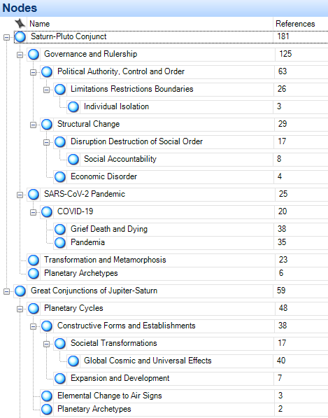
Figure C1: Themes related to the Saturn-Pluto conjunction and the SARS-CoV-2 pandemic.
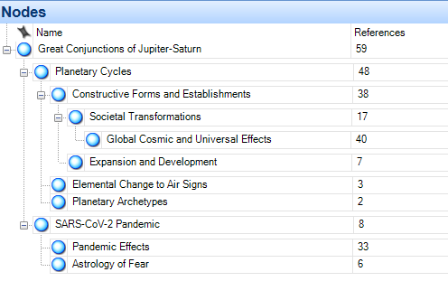
Figure C2: Themes related to the Jupiter-Saturn Great Conjunction and the SARS-CoV-2 pandemic.

Appendix ‘D’

Method of Professional Astrologer Identification as a Cohort

What follows are further details of the procedures used to identify – from among the participants who self-identified as professional astrologers (N = 77) – the final cohort (N=59) which constituted the basis for the study analysis and findings, as well as the interview pool from which the interviewees were selected (N=10).
In the questionnaire, I included a brief, four-item sequence of items which were modified from the survey distributed as a component of the doctoral work of Bernadette Brady, who conducted an examination of astrologers’ theoretical commitments to fate – particularly in relation to their application of determinism. Since the Saturn-Pluto and Jupiter-Saturn conjunctions of 2020 were simultaneously astronomical events and astrological transits, if a respondent indicated that they were actively involved in transit work with clients or in research, they were re-directed to this series of four items. Of those who responded to the question ‘Which of the following best describes you?’ (N = 187), N = 77 (41.17%) identified as a professional astrologer, and N = 110 (58.83%) indicated that they did not identify as professional but had an interest in the practices of astrology or involved themselves in astrology for personal reasons. The latter group was set aside and is not included in the data analysis (see findings section later) but will be discussed outside of this paper elsewhere. Of the group who did identify as professional, their responses to the four questionnaire items was checked for alignment with Brady’s items 2.1, 2.2, 2.3, and 2.7 associated with a theoretical, non-emotional ‘personal action in the face of believed determinism’. Close alignment (i.e., > 75% agreement) with a ‘compatibilist or rejection of universal determinism’ according to Brady delineated the final cohort of professional astrologers (N = 59) or 76.4% of those who had self-identified as professional astrologers. This method essentially reproduces a cohort of astrological professionals who share many of the characteristics of Brady’s cohort in 2008 and could be utilized for future intercomparison work.

Donald V. Etz, ‘Conjunctions of Jupiter and Saturn’, Journal of the Royal Astronomical Society of Canada, 94 (2000): 174-178.
Jeffrey L. Hunt, ‘2020: December 21: The Great Conjunction of Jupiter and Saturn’, When the Curves Line Up: Watching the Sun, Moon and Planets, https://whenthecurveslineup.com/2019/12/11/2020-december-21-the-great-conjunction-of-jupiter-and-saturn/ , [accessed February 20, 2021].
Benjamin N. Dykes (ed.), The Astrology of Sahl B. Bishr, Volume 1: Principles, Elections, Questions, Nativities, trans. by Benjamin N. Dykes (Minneapolis, MN: The Cazimi Press, 2019), p.245.
Benjamin N. Dykes (ed.), The Astrology of Sahl B. Bishr (On Choices), pp. 222-223.
Abu Ma'shar, De Magnis Coniunctionibus , ‘On Historical Astrology, The Book of Religions and Dynasties’, trans. by K. Yamamoto and Charles Burnett (Leiden, 2000). Cited in Nicholas Campion (2009), pp. 78.
World Health Organization, Novel Coronavirus (2019 nCo-V) Situation Reports – March 2020, https://www.who.int/emergencies/diseases/novel-coronavirus-2019/situation-reports . [accessed February 19, 2021].
Roger Bacon, Opus Majus, J.H. Bridges (ed.), (Oxford: Clarendon Press 1897 Vol. 1): pp. 263.
Nicholas Campion, A History of Western Astrology (Volume II): The Medieval and Modern Worlds, (London: Bloomsbury 2009): pp. 59.
Nicholas Campion, A History of Western Astrology (Volume II), pp. 60.
Anthony F. Aveni, ‘The Star of Bethlehem: Was it a Celestial Event, a Supernatural Phenomenon, or a Story Made Up by Matthew?, Archeology 51(6), Archeological Institute of America, November/December 1998, pp. 37. https://www.jstor.org/stable/41771453,[accessed February 17, 2021].
Richard Tarnas, Cosmos and Psyche: Intimations of a New World View, (New York, New York: Viking Penguin 2006): pp. 212.
Kennerly M. Woody, ‘Dante and the Doctrine of the Great Conjunctions, Dante Studies – Annual Report of the Dante Society, (95) (1977): 119-134.
Margaret Aston, ‘The Fiery Trigon Conjunction: An Elizabethan Astrological Prediction’, ISIS, 61 (2) (1970): 159-187.
Woody, ‘Dante and the Doctrine of the Great Conjunctions, pp. 127.
Margaret Aston, ‘The Fiery Trigon Conjunction: An Elizabethan Astrological Prediction’, pp. 169-170.
Bernadette Brady, ‘The Star of Bethlehem and Luke’s Shepherds: an Exploration of the Astrological Features of the Two Nativity Stories, Ivan Sprajc and Peter Pehani (eds.). Ancient Cosmologies and Modern Prophets, (Proceedings of the 20th Conference of the European Society for Astronomy in Culture, Slovene Anthropological Society, Ljubljano, 2013): 443-456.
W. Burke-Gaffney SJ, ‘Kepler and the Star of Bethlehem’, Journal of the Royal Astronomical Society of Canada, 31 (1937): 417-425.
Michael R. Molnar, The Star of Bethlehem: The Legacy of the Magi, Rutgers University Press (1999).
Renn Butler, The Archetypal Universe: Astrological Patterns in Human Culture, Thought, Emotion and Dreams, (Bolton, ON Canada: CreateSpace), pp. 164.
Renn Butler, The Archetypal Universe, pp. 195.
Renn Butler, The Archetypal Universe, pp. 339-341.
Richard Tarnas, Cosmos and Psyche: Intimations of a New World View, pp. 234-238.
Monique Hennink, Inge Hutter and Ajay Bailey, Qualitative Research Methods (2nd ed.), (London, UK: Sage Publications 2020), p. 42.
A. Tashakkori and J.W. Creswell, ‘The new era of mixed methods’, Journal of Mixed Methods Research, 1 (1) (2007): p. 4.
John W. Cresswell, ‘Mapping the Field of Mixed Methods Research’, Journal of Mixed Methods Research, 3 (2) (April 2009): p. 96.
Monique Hennink, Inge Hutter and Ajay Bailey, Qualitative Research Methods (2nd ed.), p. 92.
Bernadette Brady, ‘Theories of Fate Among Present-Day Astrologers’, Appendix 1 – Survey (unpublished doctoral thesis, University of Wales Trinity Saint David, 2012). pp. 301-321.
R. Sinkovics and E.A. Alfoldi, E.A., Progressive focusing and trustworthiness in qualitative research: The enabling role of computer-assisted qualitative data analysis software (CAQDAS). Management International Review, 52(6) (2012), pp. 817-845. (DOI: 10.1007/s11575-012-0140-5).
Interview ID40918001.
Marilys Guillemin and Lynn Gillam, ‘Ethics, Reflexivity, and “Ethically Important Moments” in Research’, Qualitative Inquiry, 10(2) (2004), p. 261. [hereafter, Guillemin and Gillam, Ethics, Reflexivity, and “Ethically Important Moments]
Guillemin and Gillam, Ethics, Reflexivity, and “Ethically Important Moments, p. 263-264.
Nathan Emmerich, ‘Reframing Research Ethics: Towards a Professional Ethics for the Social Sciences’, Sociological Research Online, 21(4) (2016), p.1.
Judith Bell, ‘Doing Your Research Project: A Guide for First-time Researchers in Education, Health and Social Science’ (4th ed.), Open University Press (2005): p. 51. [hereafter, Judith Bell, ‘Doing Your Research Project].
Guillemin and Gillam, Ethics, Reflexivity, and “Ethically Important Moments, p. 267.
Guillemin and Gillam, Ethics, Reflexivity, and “Ethically Important Moments, p. 263-264.
Claudia Oellers and Eva Wegner, ‘A New Research Ethics for the Social Sciences?’, RatSWD Working Paper Series, 86, (2009).
Emmerich, Nathan, ‘Reframing Research Ethics: Towards a Professional Ethics for the Social Sciences’, Sociological Research Online, 21(4) (2016), http://www.socresonline.org.uk/21/4/7.html [accessed March 27, 2021], pp. 1-14.
Interviewee ID40918001.
Interviewee ID40918001
Respondent comment ID41701321
Respondent comment ID41680618
Interviewee ID42372298
Interviewee ID41922574
Richard Tarnas, Cosmos and Psyche: Intimations of a New World View, pp. 228-229.
Margaret Aston, ‘The Fiery Trigon Conjunction: An Elizabethan Astrological Prediction’, pp. 169-170.
Benjamin N. Dykes (ed.), The Astrology of Sahl B. Bishr (On Choices), pp. 222-223.
Renn Butler, The Archetypal Universe: Astrological Patterns in Human Culture, Thought, Emotion and Dreams, (Bolton, ON Canada: CreateSpace), pp. 196.
Interviewee ID42510650
Interviewee ID42771263
Benjamin N. Dykes (ed.), The Astrology of Sahl B. Bishr, Volume 1: Principles, Elections, Questions, Nativities, trans. by Benjamin N. Dykes (Minneapolis, MN: The Cazimi Press, 2019), p.245.
Respondent commentary ID41724765.
World Health Organization, Novel Coronavirus (2019 nCo-V)Situation Report-1 21 January 2020, https://www.who.int/docs/default-source/coronaviruse/situation-reports/20200121-sitrep-1-2019-ncov.pdf?sfvrsn=20a99c10_4 [accessed February 19, 2021].
Respondent commentary ID41724765.
Anthony F. Aveni, ‘The Star of Bethlehem’, pp. 3
Margaret Aston, ‘The Fiery Trigon Conjunction: An Elizabethan Astrological Prediction’, pp. 176.
Interview ID40918071.
Margaret Aston, ‘The Fiery Trigon Conjunction: An Elizabethan Astrological Prediction’, pp. 169-170.
Interviewee ID41787963.
Respondent commentary ID41642586.
Interview ID41489820.
Participant commentary ID42771263.
Interview ID42372298.
Nicholas Campion, ‘Prophecy, Cosmology and the New Age Movement’, (2014), p. 47.
Johannes Kepler. De stella nova in pede Serpentarii, De Trigono Igneo ac Initio de Primo Fignificatu Vocis Trigonis: Feu de Triangulatione Signorum, Ex officina Pauli Sessii, 1606. (Google Books) https://books.google.ca/books?id=Bk5RAAAAcAAJ&dq=Kepler+de+Stella+Nova&lr=&source=gbs_navlinks_s [accessed February 19, 2021].
R. Sinkovics, R. and E.A. Alfoldi, Progressive focusing and trustworthiness in qualitative research: The enabling role of computer-assisted qualitative data analysis software (CAQDAS). Management International Review, 52(6), (2012). pp. 817-845. (DOI: 10.1007/s11575-012-0140-5).
Bernadette Brady, ‘Theories of Fate Among Present-Day Astrologers’, Appendix 1 – Survey (unpublished doctoral thesis, University of Wales Trinity Saint David, 2012). pp. 301-321.
Bernadette Brady, ‘Theories of Fate Among Present-Day Astrologers’, Appendix 1 – Survey, pp. 302-304, 316.

