DEFCON: EVERYBODY DIES
BY
SAMANTHA OSBORNE, LUKE MORGAN, LUKE REES, HAMZA QASIM

SECTION 3: MAIN CHARACTER(S)
& PLAYER CONTROLS

CHARACTER APPEARANCE
In terms of character appearance, the only real appearance for the ‘character’ that you choose, is the outline of your chosen country, the colour you have chosen and the country that you named yourself. There isn’t much character customization or detailing that goes into the gameplay system. It is a point and click war game that requires no sort of characterisation at all. For reference images/concept art, it is quite difficult to find any concept art of the game at all, but I am sure they used a map of the world as a reference.
You could possibly make up your own backstory for your chosen country/continent why you named it the way that you did or why you used your chosen colour.

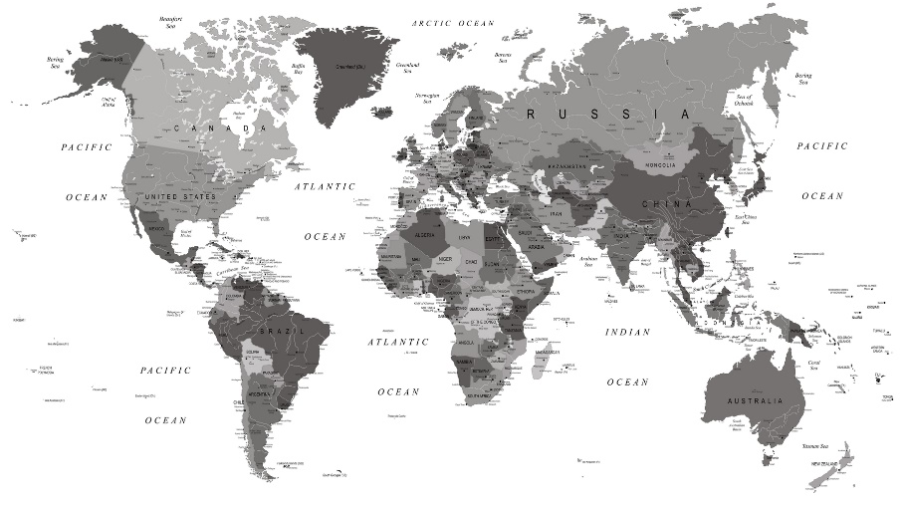

CHARACTER DOSSIER / DETAILS (Add/adjust categories as appropriate)
NAME: | NIL
GENDER: | NIL
SPECIES: | NIL
AGE: | NIL
FACTION: | NIL
KNOWN ASSOCIATES: | NIL
(Extra categories) | NIL
(Extra categories) | NIL

CHARACTER’S BACKSTORY
There is no character to have a backstory.

CHARACTER CONTROLS / PLAYER CONTROLS
Player controls is primarily point and click, with placing buildings and aiming where you want your units, or bombs to travel to. There are barely any hotkeys, so far, the only ones I have discovered is ‘Spacebar’ to quickly attend to the chat box. Whilst pressing ‘Shift’ on a group of carriers or submarines, you can change the order for all the submarines in that unit, from say ‘Passive Sonar mode’ to ‘MRBM Launch Mode’. This changes all the submarine units ordered in that group simultaneously to ‘MRBM Launch mode’.

You do have a choice within the gameplay whether you want to be against everyone or team up and join forces. Although halfway through the game, you do get that urge to team up with one of your enemies so you can take the highest scoring country down! You can form a pact or declare peace between two countries/continents and take the other countries/continents down! I found this particularly amusing and tried my best to team up with my fellow players when I found myself losing, even by the tiniest gap score between points. Although, you can also run a similar game mode called ‘Diplomacy’ where all the characters begin with a world-wide alliance. But that wouldn’t last long!

Gameplay is mainly keyboard and mouse. I couldn’t find any control options for a controller. But you can change keyboard layout options. This game is only available on PC as of right now. It was said that they are currently looking for developers to help create a mobile version of the game. The game can be acquired through the steam store. But the game is also now available to play in VR. That will make the game feel more immersive and emotional.
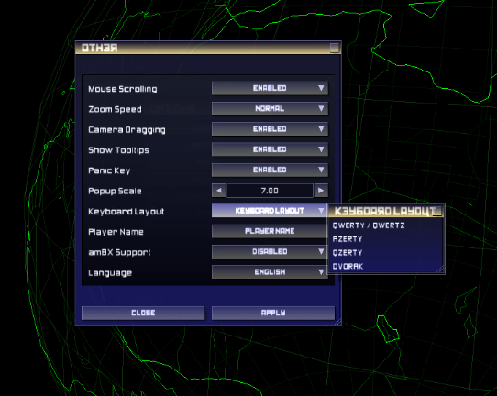

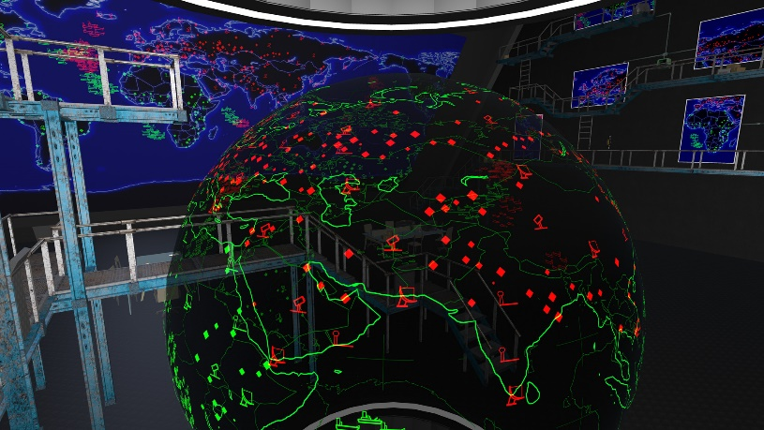

CONTRIBUTING TEAM MEMBER: | Samantha Osborne

SECTION 5: GAME WORLD

GAME WORLD
The game world is the entire world, essentially a flat map of the globe. It has a cold; nuclear world war type feels to the design with a neon aesthetic, which fits the gameplay rather well. It displays a map interface of your chosen country/continent. As the layout is quite dark, it almost gives off the impression of a dark void, like an eternity of doom that you cannot escape from, living the ever-lasting nuclear war repeatedly until every country/continent is destroyed apart from one.
It gives you the feel of a flight radar, watching the enemies’ planes come into your field of vision as you send a plane to scan the area. As you set a course for each nuke, fighter, or bomber plane, you can see the tracking of where the destination is set and where the device travelled from, which I found quite interesting, but also quite sad.
The game almost sets you into the seat of war itself, not only are you fighting for the highest position on the score board, but you are also trying to keep your own civilians and people alive, this did not sink in for me until a kill count of how many people were killed in a nuke/bomb, spread across my screen. Along with the slow, dramatic, and deep music, it adds a horror and sadness aspect to the gameplay.

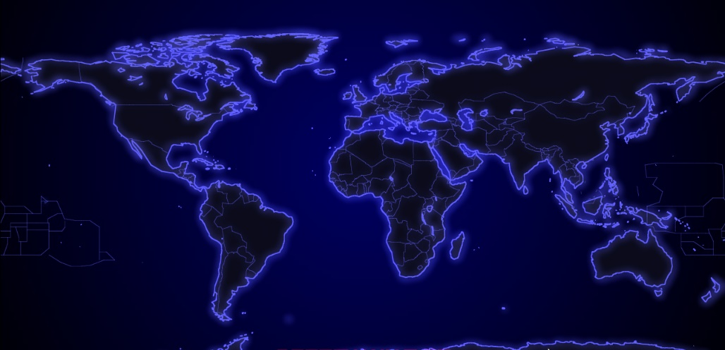

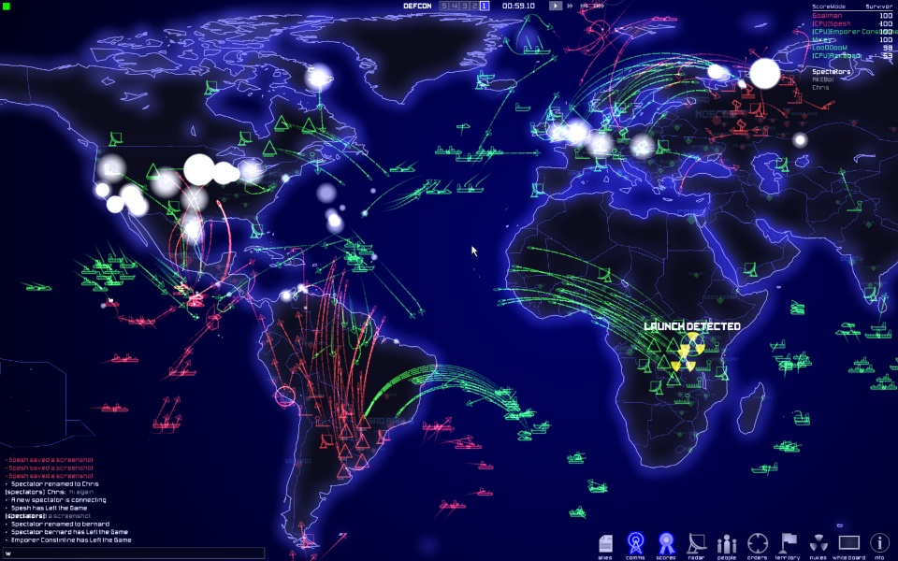

LOCATION DETAILS
NAME: | The Globe.
WHAT DOES IT LOOK LIKE? | It is a flat map of the globe with a dark background that contrasts with the neon colours surrounding the countries and any base/weapon that will be placed.
WHAT MOOD IS BEING INVOKED IN THIS LOCATION? | The environment is dark and cold. Almost like you are stuck in your own thoughts as you watch the world fight for dominance in the nuclear war filled world.
WHAT KIND OF MUSIC WILL BE USED FOR THIS LOCATION? | A deep, slow musical tune is used as the background music throughout the entire world. The music can also be quite quiet. It gives a horror and sadness feel to the gameplay, as it feels you are stuck in a horror movie. Except all you can do is fight to keep your country safe.
HOW ARE THE LOCATIONS CONNECTED IN THE GAME WORLD? | The countries are all connected by the oceans between.

(NOTE: Copy-paste the table in this section as necessary for each location you wish to feature.)

GAME FLOW
DEFCON 5
Set up stage.
First spawn in, placing down everything the player has. Countdown begins.

Last chance to set up, the start of being able to see enemy placed bases in radar.

DEFCON 4 Enemy Visibility. Last set up availability.

DEFCON 3
Battle Begins.
Units can begin to give heavy fire to the enemy.

Like DEFCON 3. Fighters, Bombers, and ships are sent out to give heavy fire for DEFCON 1 preparation.
DEFCON 2
Bombers, Fighters, Ships deployed.

DEFCON 1 Nuclear War.

Nuclear War begins. Nukes can now be deployed across enemy lines.

CONTRIBUTING TEAM MEMBER: | Samantha Osborne

SECTION 8: ENEMIES

LIST OF ENEMIES
In the matter of enemies, you are playing against either your friends, or a CPU that will appear straight away upon starting the game. Playing against a CPU is fun but being able to play against your friends makes the game even better.
Unless you start the gameplay with the alliance gameplay or form an alliance with one of your enemies, there will be enemies always surrounding you with nuclear warfare and heavy fire raining down into your country.
The player earns points for the number of kills and destruction caused against another enemy country. But you can also lose these points. If you get the enemy retaliating back, and causing bigger destruction points on your country, that can cause you to lose your points in return. You can tell when a plane or a nuke gets destroyed or reaches their destination, by a small white flash that appears where the plane/nuke would have been. But the plane would end up turning around and returning to base if flown to and bombed the destination successfully.
There is no boss character in the game. There is light attack range and scouting for the first few DEFCONs. But once you reach DEFCON 1, you are then able to expand upon sending nuclear warfare to your enemies and hope to cause the most destruction and win.

ENEMY DETAILS
NAME: | CPU/Your friend’s name.
WHAT DOES IT LOOK LIKE? | A country of your enemies’ selection. That country is also surrounded by the colour the enemy had chose before the match started.
ATTACKS: | Airstrikes that include Nukes, Bombs or Fighter planes that fly over to get rid of your radar, silos, nuclear stations, flight bases and even your units placed in the ocean.
WHEN WILL IT FEATURE IN THE GAME? | Heavy fire is constant, until the countdown reaches DEFCON 1 – where nuclear warfare will be added into the mix.
HOW DOES THE PLAYER DEFEAT IT? | By trying to hit their country/continent back twice as hard, whilst defending their own base.
WHAT DOES THE PLAYER EARN FOR DEFEATING THEM? | Points, earned through kills in cities and destruction of bases. Highest points win.

LIST OF BOSS CHARACTERS
There are no Boss characters.

BOSS CHARACTER DETAILS
NAME: | NIL
WHAT DOES IT LOOK LIKE? | NIL
ATTACKS: | NIL
WHEN WILL IT FEATURE IN THE GAME? | NIL
HOW DOES THE PLAYER DEFEAT IT? | NIL
WHAT DOES THE PLAYER EARN FOR DEFEATING THEM? | NIL

(NOTE: Copy-paste the tables in this section as necessary for each enemy / boss you wish to feature.)

CONTRIBUTING TEAM MEMBER: | Samantha Osborne

