Selection in C (1) – if/else statements (SOLUTIONS)

Work through the following exercises, deciding whether you need if/else or if/else if/else etc.

Don't forget to choose appropriate types for any variables involved (int, float, char) and test on the boundaries.

1. Write a program which tells you whether a number entered by the user is negative, positive or zero.

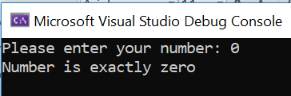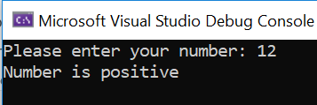

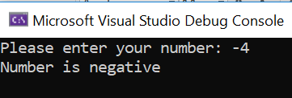

Solution:

#define _CRT_SECURE_NO_WARNINGS
#include <stdio.h>

void main()
{
int userNumber;
printf("Please enter your number: ");
scanf("%d", &userNumber);

if (userNumber > 0)
{
printf("Number is positive\n\n");
}
else if (userNumber < 0)
{
printf("Number is negative\n\n");
}
else
{
printf("Number is exactly zero\n\n");
}

}

2a. Write a program to allow the user to enter a whole number between 1 and 20. The program should tell the user whether the number they entered was 10 or more, or less than 10.

Sample output:

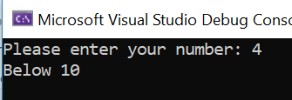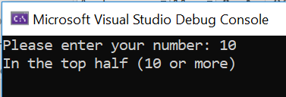

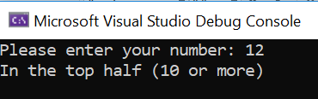

Solution:

#define _CRT_SECURE_NO_WARNINGS
#include <stdio.h>

void main()
{
int userNumber;
printf("Please enter your number: ");
scanf("%d", &userNumber);

if (userNumber >= 10)
{
printf("In the top half (10 or more)\n\n");
}
else
{
printf("Below 10\n\n");
}

}

2b. Extend your program above to tell the user if the number they entered was out of range.
Sample output:
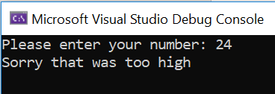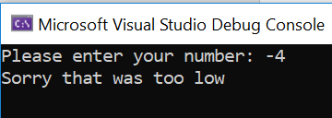
Solution:
#define _CRT_SECURE_NO_WARNINGS
#include <stdio.h>

void main()
{
int userNumber;
printf("Please enter your number: ");
scanf("%d", &userNumber);

if (userNumber > 20)
{
printf("Sorry that was too high\n\n");
}
else if (userNumber < 1)
{
printf("Sorry that was too low\n\n");
}
else if (userNumber >= 10)
{
printf("In the top half (10 or more)\n\n");
}
else
{
printf("Below 10\n\n");
}

}

3. Write a program to allow the user to enter 2 numbers. The program should tell the user
which is the larger number.

Sample output:

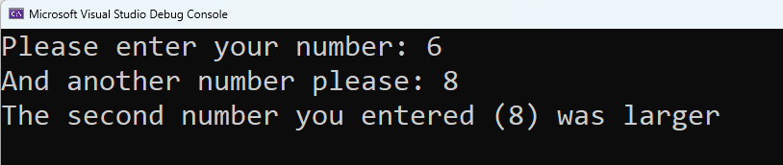

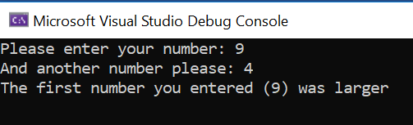

Solution:

#define _CRT_SECURE_NO_WARNINGS
#include <stdio.h>

void main()
{
int number1, number2;
printf("Please enter your number: ");
scanf("%d", &number1);

printf("And another number please: ");
scanf("%d", &number2);

if (number1 > number2)
{
printf("The first number you entered (%d) was larger\n\n", number1);
}
else if (number1 < number2)
{
printf("The second number you entered (%d) was larger\n\n", number2);
}
else
{
printf("The numbers are equal\n\n");
}

}

4. Ask the user to enter their favourite pizza topping. Pass comment on their choice (good and bad – note: lighthearted, have a fun with it! ) You should comment on at least 3 pizza toppings.

Remember that strings are a little tricky in C. You will need to use #include <string.h> and the strcmp() function.

Sample output:

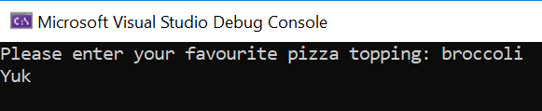

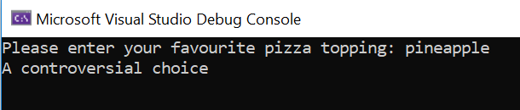

Solution: (or something similar to the following!)

#define _CRT_SECURE_NO_WARNINGS
#include <stdio.h>
#include <string.h>

void main()
{
char topping[20];
printf("Please enter your favourite pizza topping: ");
scanf("%s", &topping);

if (strcmp(topping, "broccoli") == 0)
{
printf("Yuk\n\n");
}
else if (strcmp(topping, "pineapple") == 0)
{
printf("A controversial choice\n\n");
}
else if (strcmp(topping, "potato")==0)
{
printf("A Japanese favourite\n\n");
}
else
{
printf("A nice normal choice\n\n");
}
}

Note, we might use to make lower case (sneak preview of the for loop):

#include <ctype.h>

for (int i = 0; i < strlen(topping); i++)
{
topping[i] = tolower(topping[i]);
}

