Academic and Employment Skills-Assignment new format BMSW 4001
Skill is the ability to do something well.

According to Doyle (2019), employability skills are core skills and traits required in any place of work. Those are general skills that make an individual desirable to a company. All employers know the skills that their employees need in order to expand their business and to make it successful (Doyle,2019).

Soft skills are the personal attributes, personality traits, inherent social cues, and communication abilities needed for success on the job. Soft skills characterize how a person interacts in his or her relationships with others.
My soft skills are that I am good at communicating with others , working with a team , punctual and I am good with deadlines.

Hard Skills Defined
Hard skills are part of the skill set that is required for a job. They include the expertise necessary for an individual to successfully do the job. They are job-specific and are typically listed in job postings and job descriptions.

My hard skills are mathematics and computing.
I am good with mathematics because since I was a child I always found the subject very interesting and it always attracted me. I was always curious to know how the subject was created, where do numbers come from. Mathematics is a subject that challenges you and makes people push for themselves.
My interest in computers started when I started having IT classes where I noticed that computing is not all about what we see but what we do. There are a lot of interesting things to learn about computing and even to get more recognition in the technology sector.

One of my strengths is that I am a good listener.During this teamwork i listened to my colleagues ideas before I could contribute my own options. Another strength that I have is teamwork as I work well with others, because there are more ideias , opinions and advice involved which is important in teamwork. According to Brainstorming theory having more than three people in the team it encourages everyone within the team to participate in the productive thinking process which it can guide to problem solving; it allows the individual to think outside the box. In this team there was a lot of encouragement and I was able to help my colleagues with developing a lot of solutions.
My goals for my strengths are to increase all the abilities I got and be most helpful.

My weaknesses are that I do not know how to handle my time because I like to do everything at the last minute and with pressure as is happening now with this work that I am doing now, I tried to change my way of being but I can not, I can only gain inspiration or ideas when a few days or even a deadline day.
Another weakness of mine I am not very good at writing or even talking but I speak more than I write and easier for me.
Another weakness is also when I am new in a place I will rarely talk to people and I hope they will talk to me but I have notion that this is bad for my career because communication is a very important thing and it helps us to interact with people.
My goals for my weaknesses are to improve so that in the future I do not make the same mistakes and avoid having any weaknesses and be ready for any task and organise well the time to do the tasks.

The threats that I may face when it comes to become more employable are that I procrastinate a lot so I tend to do things last minute and because of that I believe that I might have problems with it in the future and things might not go as I expect them to. Another threat I might face is the language barrier and with that I intend to read more books and practice exercises to improve my vocabulary and be prepared for the challenges ahead.
My goals are to be confident to talk to people and to not be afraid to make mistakes and show that I am ready to learn and to not have any barrier in my growth in the business area.

With my strengths I have the opportunity to work well other people in big companies and that I can take roles in leadership jobs
With my hard skills of design I have the opportunity to help my colleagues that are struggling and even elaborate ideas where we can all be successful in the workplace..
With my mathematics skills I have the opportunity to work in accounting jobs.
With my goals opportunities I hope improve my life for better in the way that all my work will be recognised, successful and increase my potential to achieve my goals

My personal Development Plan for my education is to have good grades and to improve my language in terms of speaking and writing and to improve my interaction within a group even though it is already a strength of mine.
My goal in terms of my career is when I finish university look for a job in my area and when I find the job in my area I will not be looking for a high position straight after as I would like to gain more experience.

The threat to accomplish my goals is my communication because English is not my first language but I am confident that I will get better with time and practise.
To develop my skills I will need to know more about the job and read books about the topics that I am studying.

My time management is really bad because I like to do everything at the last minute. I do not know how to organize my time correctly. Sometimes I do not know how I should start my work because sometimes I get some work I do not know how to do it because of the language.
What I learned from the videos in class was that we should start from the hard part because it takes longer than the easy part and they help you how we should organize our time .
I also learned how to plan my time to study , how I should prioritize and we should create one timetable to organize our time. When doing my work I need to focus on what is more important and urgent . Basically to manage our time better we should follow 3 steps they are record ,analise and change , so we should print and write one day from the time we wake up until the time that we go to sleep and then analyse how much time we waste with things that are important or not important so after that we should change and prioritize which ones are more important. So when talking about writing a to do list it means we should always start from the hardest thing and calculate how long it is going to take.
When working as a part of a team it was excellent because everyone was cooperating and we were working hard and helping each other .
About communication it was not difficult because all people from my team speak the same language and communication was easier and we can interact better and figure out the problems we needed to solve .

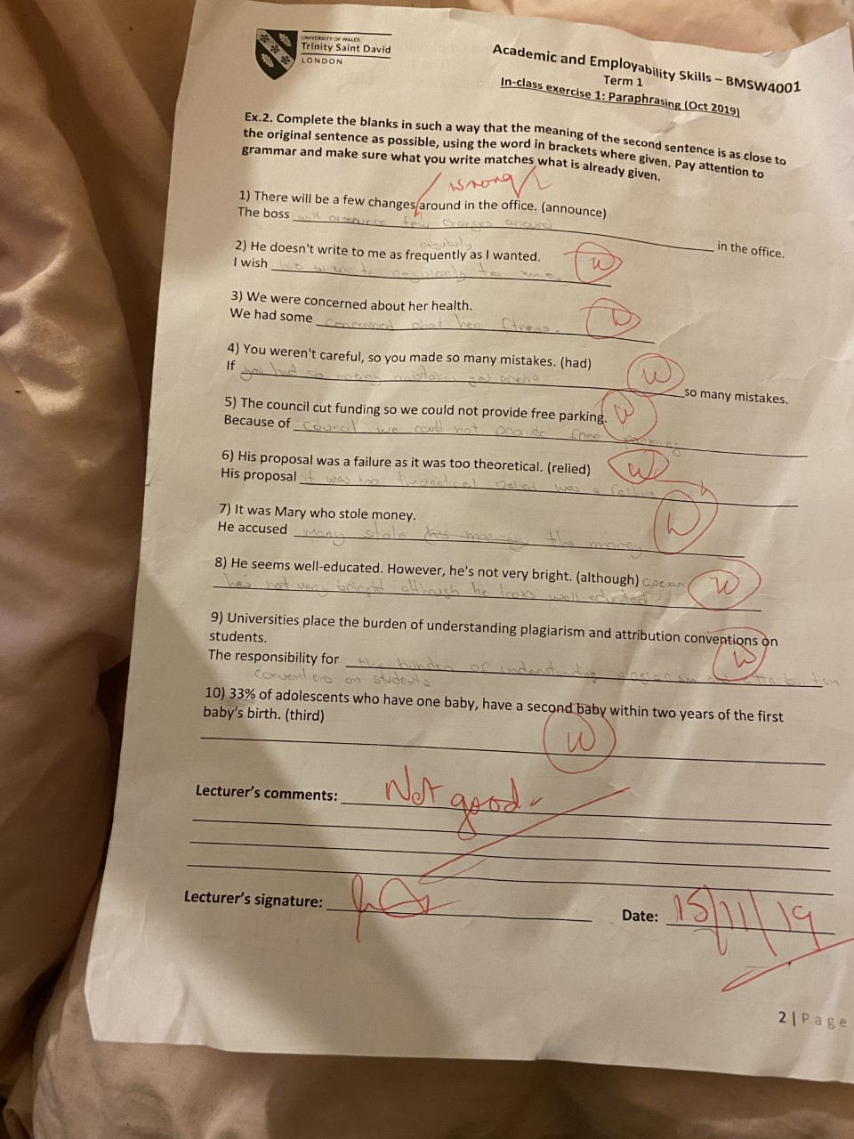

Even though my great was not good when I watched the video on moodle I learned that I have to read carefully, think, understand and check.
REFERENCE LIST
Important Employability skills for the workplace available at:
https://www.thebalancecareers.com/employability-skills-list-and-examples-4143571

What are soft skills available at:
https://www.thebalancecareers.com/what-are-soft-skills-2060852

The hard skills employers seek available at:
https://www.thebalancecareers.com/what-are-hard-skills-2060829

