Further Searching using forms

We have learned how to feed search data entered by the user from an HTML form through to a PHP query and return some results to the screen.
The database we have created has one table, people and looks something like this:

people


The code we used in class is shown below:
search.php
<html>
<head>

</head>
<body>
<form action="readdatabase.php" method="post">

Search: <input type="text" name="thesearch"><br><br>
<input type="submit">

Dacey
</form>
</body>
</html>

readdatabase.php
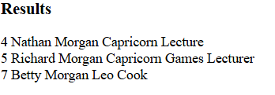
<?
include "conninfo.php";

$mySearch=$_POST["thesearch"];
Morgan

$query="SELECT * FROM people WHERE surname like '$mySearch'";

$result=mysqli_query($link,$query);
$nr=mysqli_num_rows($result);//how many rows were found?

if($nr==0)//none found
{
echo "Sorry, nothing found";
}
else //print out rows found
{

while($r=mysqli_fetch_array($result))
{
echo $r["id"]." ";
echo $r["firstname"]." ";
echo $r["surname"]." ";
echo $r["starsign"]." ";
echo $r["job"]."<br>";
}
}
?>

Exercises for searching

- Change your code that your search will work on ANY field (not just surname). For example, if I enter “Thomas” or “Leo” or “Kapilan” etc. the search should return results.

Example output:

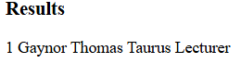
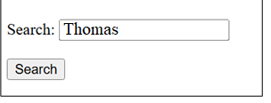

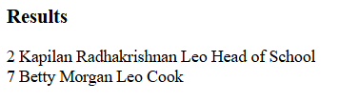



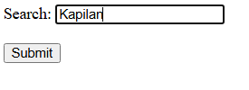

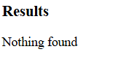
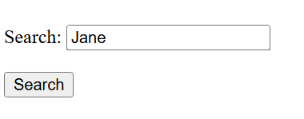

- Write a search so that you can search on both first name and surname.

- Write an exact match search (ie it will only find a match if both the exact first name and surname is entered)

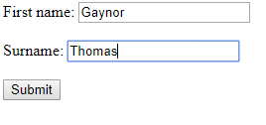

But not:

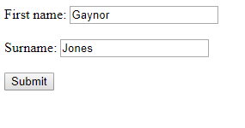

- Change your search so that it is less exact, and will match on either field:

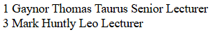

- Radio button search

Using a radio button, allow the user to select the field of their choice.

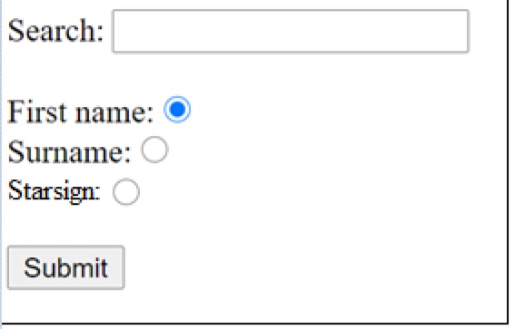

The code for your form might look something like this:

search3.php
<html>
<head>
</head>
<body>
<form action="dosearch3.php" method="post">

Search: <input type="text" name="search"><br><br>

First name: <input type="radio" name="fieldtype" value="fn" checked="checked"><br>
Surname: <input type="radio" name="fieldtype" value="sn"><br>
Starsign: <input type="radio" name="fieldtype" value="ss"><br><br>

<input type="submit">

</form>
</body>
</html>

Remember that each radio button in a group has the same name, but are differentiated by their values.

The output would look something like this:

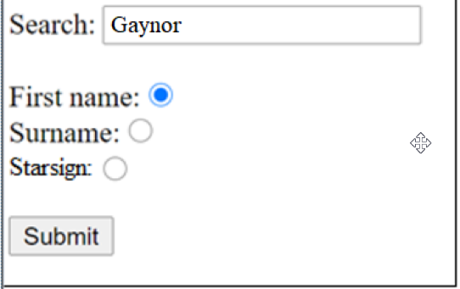

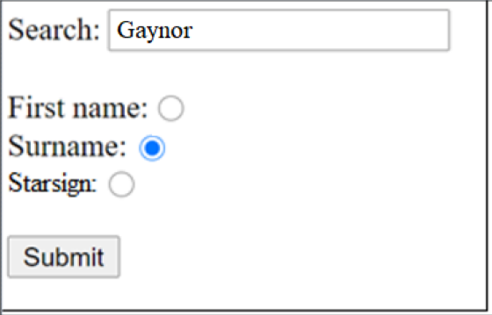

(ie nobody with the surname Gaynor)

Try to work out how to make this functional.

