

LOCATION: LONDON LEVEL 4 LEFEL 4

EXAMINATION PERIOD CYFNOD ARHOLIADAU MAY 2020 MAI 2020

MODULE CODE: ACCB4017
SOFTWARE DEVELOPMENT
TIME: 2.5 HOURS
ANSWER ALL QUESTION/S IN PART ONE
ANSWER ANY TWO QUESTIONS IN PART TWO

Equipment or materials required – Computers with Python installed

PART ONE ANSWER ALL QUESTIONS

1. a) What variable type would Python infer for the following values”

14.32 …. Float ( floating )

1234 …. Int (integer)

Bag …. str (text string)

-34.62 …. Float (floating )

-56 …. Int (integer)

[1 mark each - 5 marks total]

1 b) What errors are present in the following program to calculate the area of a triangle?

print("Enter the base) base = int(input() print("Enter height: "); height = input()
area=0.5*base*height
print(" The area of the triangle is : ",area)

CORRECT WAY for 1b.

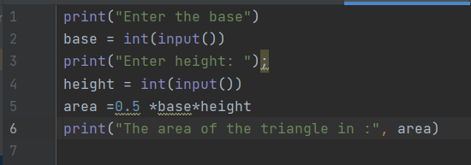
The errors is a :
- Missing bracket on line 2
- Missing variable type on line 4

[5 marks]

1 c) How many iterations do the following loops have?

- for i in range(24):
print(i) …………

RESULT:
1
2
3
4
5
6
7
8
9
10
11
12
13
14
15
16
17
18
19
20
21
22
23

- for i in range(1,10):
print(i)

RESULT:
1
2
3
4
5
6
7
8
9

[4 marks]

1. d) What is the value of the integer variable total after the following code is executed?

total=1 for x in range(8):
total=total+x if(x = = 4):
total=0 ………
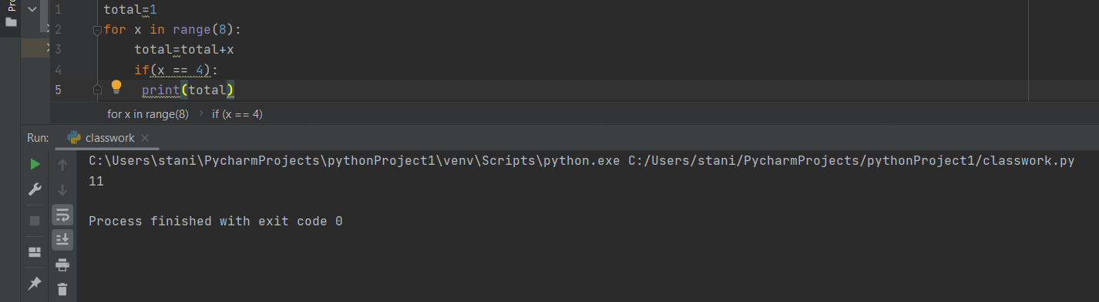

[4 marks]

1 e) Given the following program:

Temp=[23,24,25,29,40]

- Write the code you would use to print the value stored in the third element of the array on the screen

Temp=[23,24,25,29,40]
print (Temp[3])
...................................................................................................... [1 mark]

- Write the code you would use to add the first and last elements of the array

............................ .............................................................................. [1 mark]
[20 marks total for Question 1]

Part TWO (Answer any two)

1. Calculating the area of a circle

The area of a circle is calculated using the formula

𝐴𝑟𝑒𝑎=𝜋𝑟²

Task:
Write a program to calculate the volume using the above formula.

Allow the user to enter the measurement for r. You may set π as 3.142

[20 marks ]
print("Calculate area of circle (Area = Pi*radius^2")
radius = float(input("Enter radius:"))
area = 3.142 * (radius*radius)
print("Area is:" , area)
Enter radius:3.142
Area is: 31.018339287999996

2. Using List

Task:
Define a list called height and enter the following values.

height = [122,145,163,122,121,141,170,180]. Use the list functions available to do the following:
- Display the created list
- Append 190 to the list
- Display total number of elements in the list
- Sort the list in ascending order and display the modified list
- Display the list in reverse order.
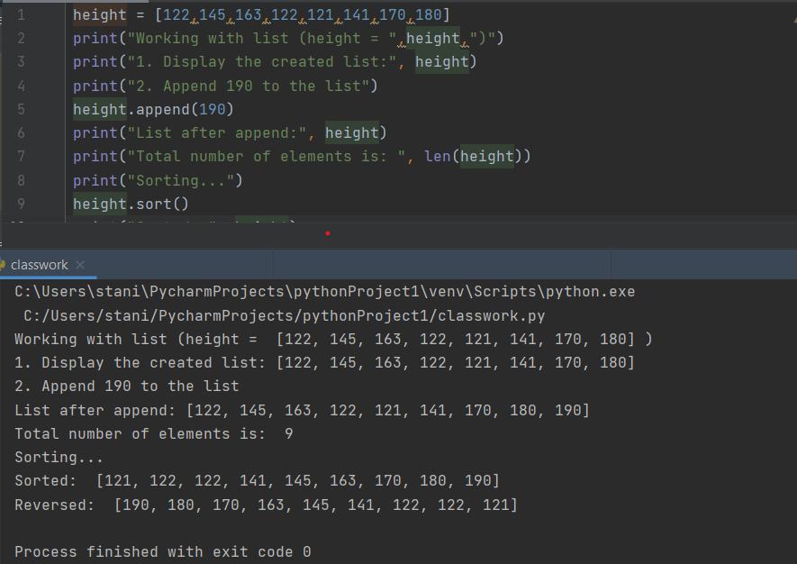

[20 marks ]

3. Using Turtle

Using Python with turtle, draw the following shape :
- A circle (filled with blue colour) (5 marks)

- A Regular Pentagon (15 marks)

3b)

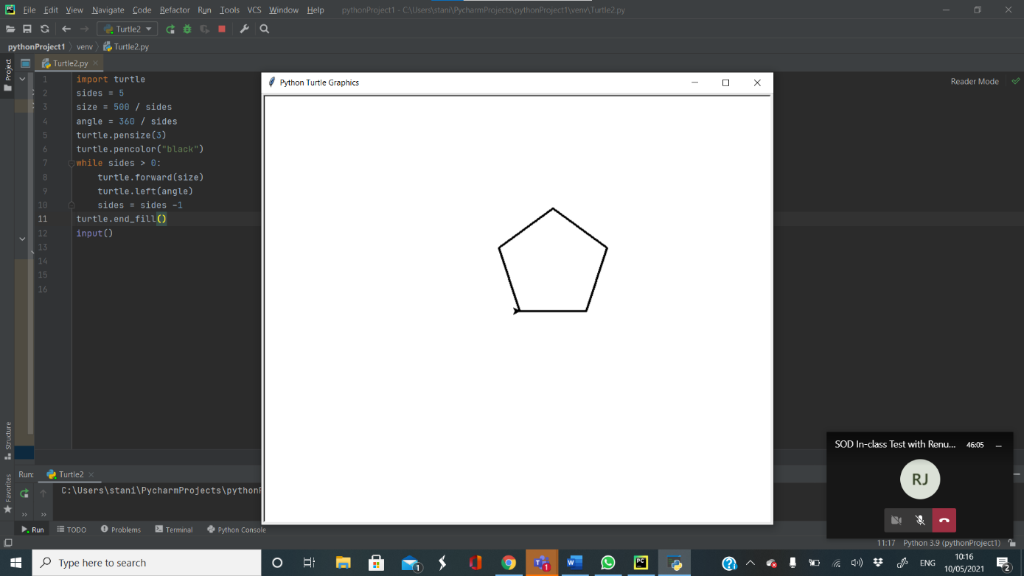[20 marks]
3a)
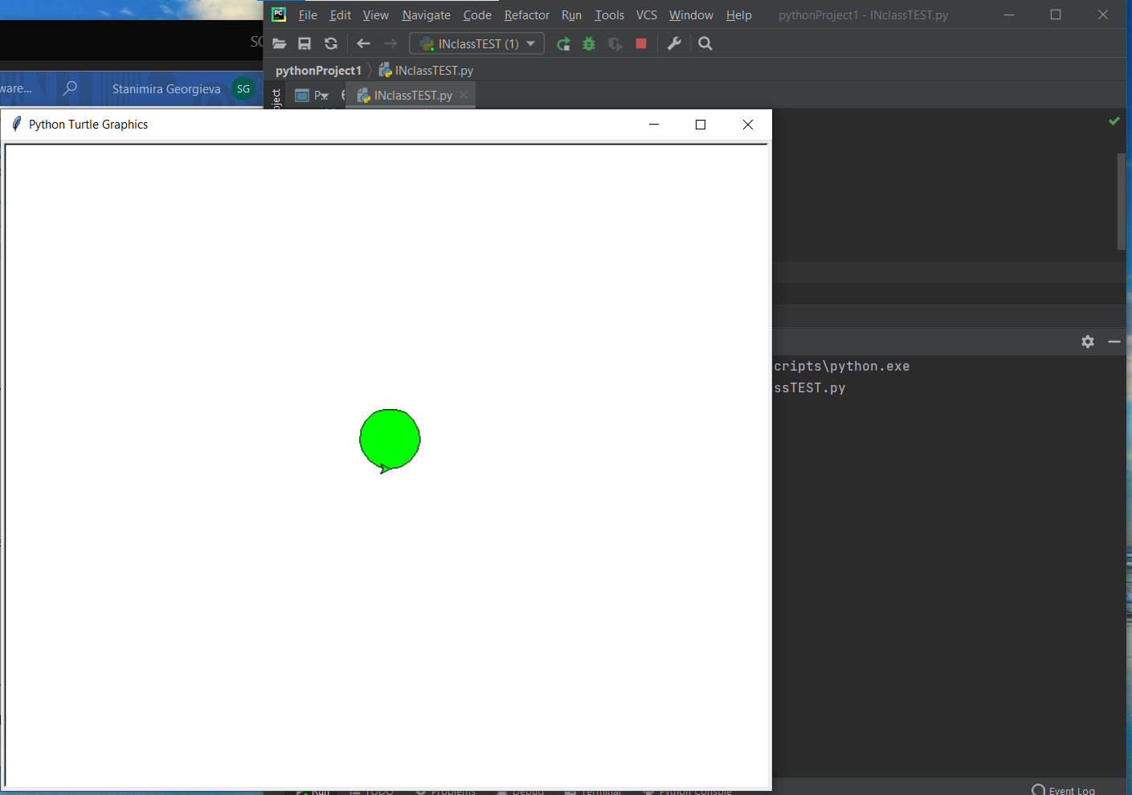

Diwedd/End

