Coexistent Perspectives (ADAA7000)

Tracing the River of Memory:explores collective and individual memory through the exploration of memory

Abstract
Tracing the River of Memory:explores collective and individual memory through the exploration of memory, focusing on the works of Yin Xiuzhen and Anselm Kiefer. The artists use different materials to create works of art that become mnemonics, guiding individual memories into the framework of collective memory. yin Xiuzhen creates works of art that utilise the elements of life, exploring fleeting memories in the context of Chinese society and preserving them in his own resonant way. In contrast, Anselm Kiefer explores historical memory, and it is significant that he constructs different memory scenarios to guide the public to face up to history and put collective memory back on the right track.
Drawing on sociology and philosophy, this paper explores the ways in which the two artists present the pursuit of memory, and how individual memory can be integrated into the framework of collective memory through art.

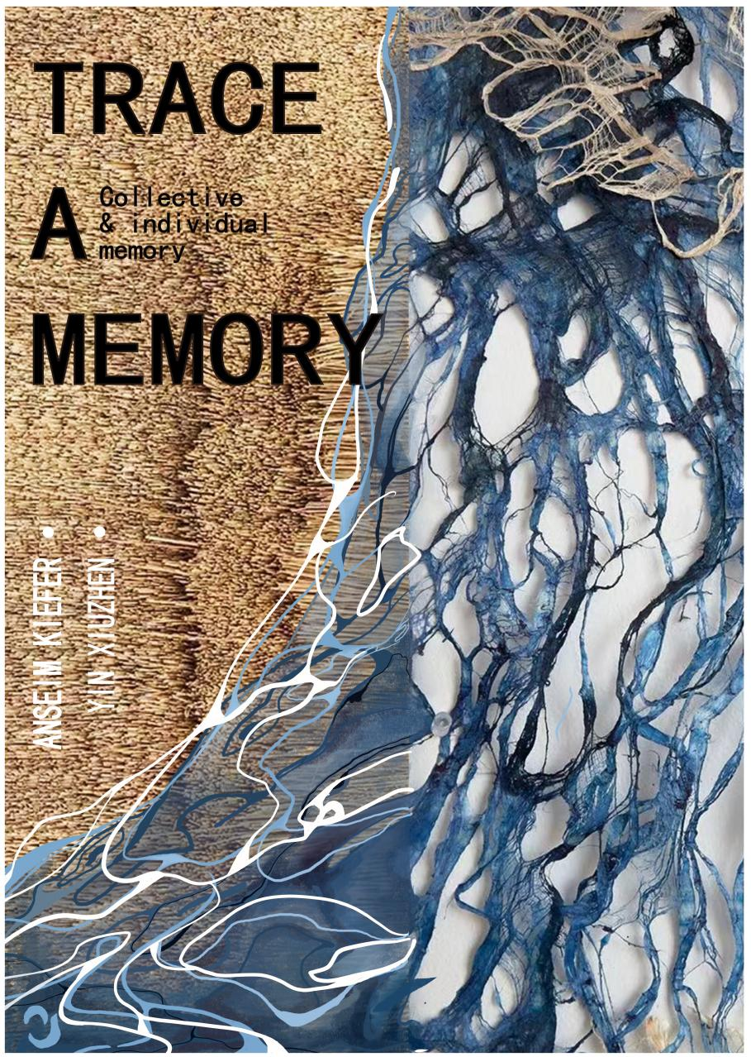

Introduction

This paper explores the work of artist Yin Xiuzhen and artist Anselm Kiefer. Both artists' work deals with the conception of retrospective memory and in it explores how personal and collective memory is created, communicated and perceived through artworks. In this essay, I will first explore the concept of personal and collective memory, and then go on to analyse how the work relates to memory, how collective and individual memory and the meanings presented are explored, based on the context of the two artists' lives, their methods of creation and use of materials.I will then analyse and compare the two artists' artworks through critical thinking.

Yin Xiuzhen is a leading female artist in China. She has her own way of exploring memory. She is good at observing life and using its elements to weave together past and present experiences, integrating the individual and the collective by collecting materials used by different people, and expressing the ever-changing society and the complex relationship between people in her personal perspective of memory through her art creations, which systematically triggers the viewer's memory.

During his career, Anselm Kiefer has been called "the poet of painting who grew up in the ruins of the Third Reich".He has a broad vision of his work and wants to redefine the development of German history and culture with his paintings. His paintings are always striking. He likes to use various materials: photographs, straw, lead, latex, etc. in his paintings. He always uses his own thoughts to reflect and feel. His series of Holocaust paintings are always shocking and provoke the public to think about the history of the Nazis.

Memory is a cognitive process in the brain, yet its perception, when transferred to the cultural level, becomes a complex topic: it can be reflexively reconstructed in philosophy, literature, psychology, sociology, etc., giving rise to a lot of discussion and research on it.

We can find a lot of terms about memory in the relevant literature, social memory, cultural memory ,collective memory and so on, which is enough to show the complexity and abstractness of the concept of "memory".As noted by Stefan Bednarek ,‘this terminological abundance may well underestimate the issue, but, on the other hand, it allows for a whole array of semantic distinctions. Although all these terms relate to one and the same area, they nevertheless differ in scope’.（Marta，2020）

The study of memory never stops. Marianne Gorka considers memory as a metaphor. In his view, memory can be compared to a dialogue with the past, an accumulation of past experiences, knowledge and present activities. And the dialogue has to remain present in every social group as long as you want to survive. (Golka 2009:23).
Many researchers, however, follow the French sociologist Maruice Halbwachs' claim about memory that it can only be formed in the process of socialisation. Although it is always the individual who "owns" memory, it is created collectively. This is why the term collective memory should not be interpreted as a metaphor, because although the group itself does not "own" memory, it determines the memory of its members. (J. Assmann, 2011, 22)

This is also the corresponding theory of "collective memory". The concept of "collective memory" was fully developed by the French sociologist Maruice Halbwachs in 1925, and it is something that is shared, passed on, and constructed together by people in a group. Distinguish it from individual memory. Since then, there have been a number of researchers of "collective memory", including：Maurice Halbwachs (1992) Paul Ricoeur (2004), , Krzysztof Pomian (2006),
Andrzej Szpociński (2006), Barbara Szacka (2006, 2012)，Jan Assmann (2008, 2009), and Jacek Nowak (2011).

Halbwachs argues that we are actually affected by current issues and social pressures regarding memory, so collective memory is essentially a reconstruction of the past based on the present.（Halbwachs,1992, ）He also think that We can understand every memory that occurs in an individual mind only when the memory is located in the corresponding group mind.(Halbwachs, 1992 )In other words, individual and collective memories support each other and influence each other.

In addition to Halbwachs, Paul Connerton's book How Society Remembers continues his discussion and extends the concept, as does Pierre Nora, who extends the vehicle of collective memory from a temporal and spatial dimension, defining memorable places as "fields of memory", and examining the contribution of place and space to collective memory.

This paper is an artistic enquiry based only on the foundational ideas of collective memory as presented by Maruice Halbwachs .

Yin Xiuzhen

Artist Yin Xiuzhen uses the materials she creates are common objects in life, and explores collective memory through these close-to-life elements as mnemonic symbols, starting from her personal experiences and memories, and using the conception of daily life, so that more people can trigger individual memories to trigger a collective exchange of memories through her works.

Yin Xiuzhen, a female artist, live in Beijing, China, who is especially good at art installations and sculpture. When she face the theme of memory, their artworks related to the theme of “memory” always have special affection that is unique to female artists. By focusing on the memory ,she created artworks to express her memory’s perspective and elicited thinking from a group to the point of reaching strong emotional resonance. In her artworks, she often use clothes as the fundamental materials to design or make something, which is her favorite material throughout her creating career.

This kind of recalls (Meret Oppenheim's) Fur Cutlery (1936), Oldenburg's flimsy whisks made of fabric, and Judy Chicago's The Dinner Party (1974) in that, having changed the context and use of the material itself, the original material attributes are withdrawn from it, and new meanings injected into it, producing an eerie effect of detachment, but one that invites reflection.However, Yin Xiuzhen's use of old clothes is different from theirs in that she focuses on the material properties of the clothes themselves. She transforms the use of the material to express the meaning of the texture of the material itself.

And she state ”The clothes like the second skin.” (‘SongDong &Yin Xiuzhen in Beijing’n.d.)For her, the worn clothes carry weight, which not only the piece of clothes, behind every different material quality and varies color were diverse experiences, aesthetic, values and so on. However, the changes of the clothes is also the microcosm of the whole social and even whole time on the move. She always observe the daily life ,analyse the instability of the life and memory along her thoughs.The reason she loves old clothes so much has a lot to do with her childhood memories, as her mother used to work in a garment factory, and she says she loved to watch her mum sewing and mending at work!But how can such a boring and draining job be consistently appealing to a young child at the age when she likes to play the most? I think it's the result of her memory reconstruction of the past, but I can't rule out the fact that she really loves the content of this work.

The one of the most famous artwork is Portable Cities, which were miniature sculptures of the city are made by sewing and repairing the old clothes of residents collected in each local area in the opened suitcases . Like Beijing ,Hangzhou, Shenzhen ,Hongkong, Paris. The classic landmark building of every city are all made of socks, clothes that she personally collect: The sewn socks act as a highway, the pleats of the skirt as ripples in the lake. Meanwhile, in order to give the full experience for the audience, she also played local background music in the suitcases.In the face of the urban landscape, the cold and hard concrete and steel bars, the green bricks and green tiles are transformed into soft clothes that have been close to the skin, using old clothes to show the warmth of the hometown and interpret the soul of the city.
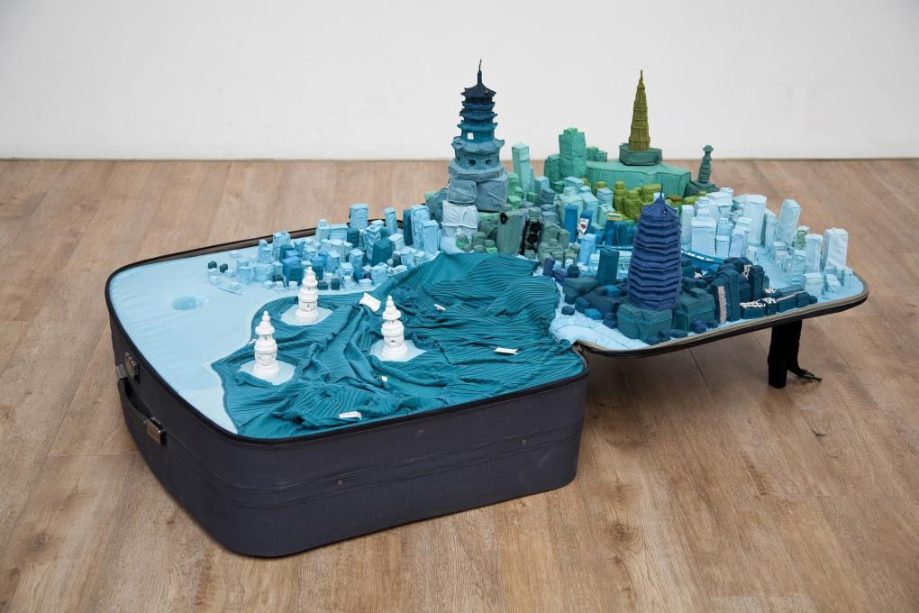
Figure 1.Yin Xiuzhen,Portable Cities,Hangzhou,2011
Retrieved from:https://www.pacegallery.com/artists/yin-xiuzhen/

The inspiration of the work come from the consignment department in the airport. As she walked through different airports, seeing a lot of people checking in suitcases, and each suitcase with a name on it, She felt that each suitcase felt like a home” Yin Xiuzhen said in a interview.（‘SongDong &Yin Xiuzhen in Beijing’n.d.）
With the accelerated development of the times, many people work in foreign countries, often on business trips, or travelling regularly, and have an unstable living situation, so it can be said that for them it is a time when everywhere feels like home, but the hometown is irreplaceable, and the memories of the hometown are everlasting, no matter when they are. Especially at that stage when Beijing began its urban renewal, the city's traditional neighbourhoods, the hutongs, were demolished to make way for high-rise buildings, and the city was littered with ruins. "The houses you see today will be gone tomorrow," she says.（‘SongDong &Yin Xiuzhen in Beijing’n.d.） With the rapid changes in the city, the process of remembering and storing memories was even more important to this emotional artist, and thus the series was born.As Yin suggests,‘people in our contemporary setting have moved from residing in a static environment to becoming souls in a constantly shifting transience ... [the] suitcase becomes the life support container of modern living’（SHENG,2014,393）

What’s more，the use of clothing is more in line with the same concept as suitcases, it is necessary to carry with you. When the city, clothing and suitcases combined together, but also with the sound of the city, it will be enough to evoke the wandering outside the uncertainty of the people for the hometown of longing, but also awakened us to the city and the memory of the times of deep insight.

From 2001 to now, this series of works is still being renewed as a way of preserving her memories of the different cities she has visited, and in the exhibition she uses the yellow weaving threads to construct a relational map to explain the relationship of these cities to her. The city as a public space becomes more beautiful and humanised. Her art practice is through suitcases and clothes, which are close to everyone's life memories and communicate directly with the audience's memories.On the other hand, this work also highlights the extraordinary nature of women's labour in those times through Yin Xiuzhen's repetitive and banal labour (often associated with housewives) with old clothes.

Apart from that most of her other works are also close to life, with a poetic sense of life.

Also using old clothes as materials, in the work "Can't Bear the Warmth of Life", she collected 1,000 scarves and put them together into a huge installation in the shape of a vortex, which is visually appealing and colourful. Scarves are meant to bring warmth. Wrapping the scarves together and warming each other is to bring together the warm memories of different individuals to form a warm current of memories. The personalised narrative is integrated into the public sphere of society, where people who don't know each other intertwine, creating a connection that transcends time and space. Silent scarves gather here to tell warm stories. By emphasising the concept of warmth to trigger the viewer's empathy, as if falling into a vortex of warm memories, people can't help but recall warm memories.

However, while there are a thousand Hamlets in a thousand people‘s eyes, there are also those who believe that Yin Xiuzhen's story is a reflection on the current Chinese social context of spoiling an only child. Too much pampering and warmth can easily make a child drown in a whirlpool of desire and attention, or in the enormous pressure of using love as an appearance of being unable to catch a break. The warmth and affection that should be there becomes "unbearable warmth". Individuals with different memories enter different frames to recall and relate.
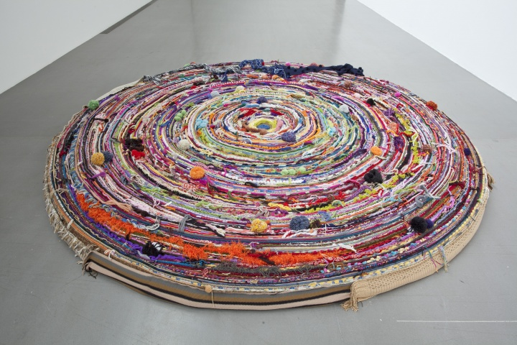
Figure 2.Life Unbearable Warmth.2018
Retrieved from:http://www.hiart.cn/feature/detail/4f5iuts.html

There is also her work "Transformation"which is also based on the background of urban change. For this work she used a material other than clothes - tiles. She was born, grew up, went to school, worked, got married, had children, and has a deep affection for old Beijing. However, the change of the city was unexpected and unstoppable, and she could only watch the neighbourhoods turn into ruins. Among these ruins, she collected 128 concrete roof tiles, which have traces of history and past experiences. She attached a photograph to each tile, documenting the changing character of the community, the vibrant moments of people labouring over it. For her, these materials are her old memories, locations that are rapidly disappearing and have a special meaning in her life. The process of transforming these tiles between her life with art work forms a time line that will have its own voice when the work is presented. This ritualistic means of presentation undoubtedly touches something for the audience, a triggered switch of memory. However, different people will have different thoughts and feelings about these works, and under the framework of a collective memory, there will be their own images and stories in their individual memories.
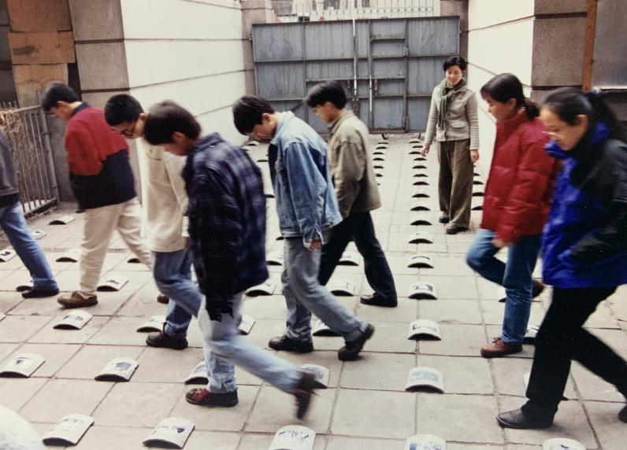
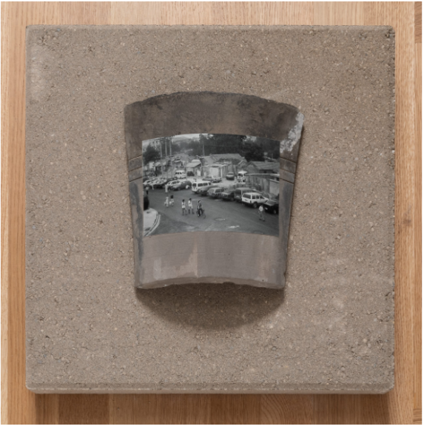
Picture 3&4，Yin Xiuzhen，Transformation，1997.
Retrieved from：https://theallureofmatter.org/artists/yin-xiuzhen/

Anselm Kiefer

Anselm Kiefer is a German artist with a long history of exploring memory, and Halbwachsiane has explored the idea that just as God needs us, memory needs other people, and that memory needs to be sustained by the collective and maintained by society and morality.(Halbwachsiane ,1992) Against this social backdrop, he has gone ahead to be the forerunner of the "others", using his artwork to explore the history and unambiguous collective memory, and to evoke the memory of the "others".

He was born in 1945, a special period for Germany, at the end of World War II. He grew up in ruins, and in the documentary Remeber the Future, he recounted that the ruins of his hometown were his playground during his childhood."I need nothing else I played with his brakes the joints of the top donation you know there was a mass of them i could play them.”（‘Anselm Kiefer：Remeber the future’n.d.）Yet Germany's post-war recovery process took an unexpected turn.“After Auschwitz, to write a poem is barbaric.”(Adorno,1983,34) Theodor Adorno's remark brought silence to Europe, especially Germany. Artists were following the abolition of the topic of atrocity wars and could only respond with abstract art to meanings that could not be expressed in the post-war ideology. Even in education there was ambiguity and attempts to cover it up, and collective memory began to deviate from the trajectory of history.“It's extraordinary now because Germany has been about the best place in the world to teach his children about the war and Holocaust and Nazis but even as late as the sixties it wasn’t the case something profound and horrible has gone wrong Germany is shrouded in silence and denial a kind of willed amnesia”(‘Anselm Kiefer：Remeber the future’n.d.) Simon Schama commented in the documentary. Being of their generation, he began to question the cover-up. He began a bold, reckless search for memory through art. In his early work Besetzungen(1969), he gave the Nazi salute at various European landmarks, on Nazi uniforms, and in his own studio. This is a book of black and white photographs and watercolors, and his form more like performance art to me. However, his behavior caused a great controversy that his publication in the publication in the《interfunktionen》in 1975 led to a boycott of the entire magazine.

However I believe that the Besetzungen project is not a way in which Anselm kiefer endorses or even deludes himself into reviving Nazism, it is simply a way in which he goes about trying to reproduce memory. In my explorations, I agree with the author Brailovsky that Anselm is presenting a work of art in the dramatic manner of Brecht, and that it is not Nazism that is being criticised, but rather the relationship between the masses and society in contemporary Germany. The work is divided by the semantic ambiguity of the title, but this ambiguity is only an attempt by Anselm kiefer to show the complex relationship between trauma, memory, and reproduction. In her inquiry, she analyses the term Bestaungen in many ways. The masses recoiled because the meaning of the word was most obviously means military occupation.But in psychoanalytic discourse Besetzung [cathexis, or investment of libidinal energy] is a key mechanism involved in the recording and reactivation of the memory-trace and in the formation of object relations through identification. In the case of mourning, the subject must gradually withdraw the cathected energy from the lost object and attach it to a new love object, or risk an extreme form of melancholic incorporation of the absent object in which all the energy is directed inward, precluding any further identification with anything in the outside world. And in this kind of work that reproduces memory, psychoanalysis seems even more relevant and important; in a theatrical sense, the word means the cast of a play.(Brailovsky,1997) So this is a work directed by Kiefer, he doesn't identify with the Nazis, he just compares himself to Brecht as an actor, immersed in the role, and that's when I realised what he said in an interview: "I don't identify with Nero or Hitler but I have to reenact a little bit of what they did in order to understand their madness! ".(‘Anselm Kiefer：Remeber the future’n.d.) Stepping out of the work, he is only consciously satirical, consciously evoking an escape from the collective memory of deviance
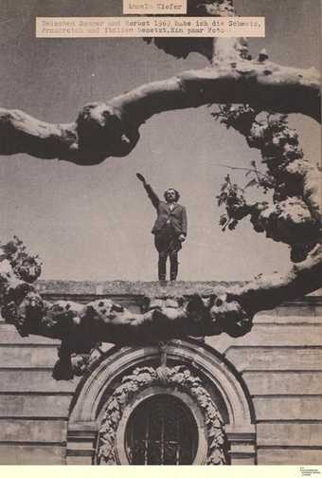
Figure 5.Anselm Kiefer,ocupation(Besetzungen),1969.
Retrieved from:https://www.tate.org.uk/research/in-focus/heroic-symbols-anselm-kiefer/difficult-reception-occupations

For the next ten years, he concentrated on this theme, but the form began to change, and he became obsessed with large-scale paintings, using the effect of stacking various materials to produce shocking effects.

He likes to use some of his poetry to trigger the memory images he constructs.

Kiefer stated: I think in images. Poems help me do this. They are like buoys in the sea. I swim to them, from one to the next; in between, without them, I am lost. They are the points amidst the infinite vastness at which something masses together out of interstellar dust, a bit of matter in the abyss of antimatter. Sometimes the rubble of things past coalesces into new words and associations. (Anselm Kiefer, “Acceptance Speech for the Peace Prize of the German Book Trad).

For example, influenced by the work of Romanian poet Paul Celan, the only surviving member of his family in a concentration camp during the Holocaust, he created the work Margarete (1981), which uses visualisations to portray two women, the blonde straw for Margarete's long, blonde hair, and the black, tangled lines for Shulamit's hair. Using lead and sand as the background, the grey tones seem to recount the dark and cold metaphorical resonance of the concentration camp period, the straw as the main material abstracted upwards to form a flame, the meaning of which is ambiguous, as if it possesses the power of life but the soil has already been burnt, as if to describe the tragic fate of these two women who were doomed to be harmed by the Holocaust, Margarete's graffiti is written in the centre of the painting, echoing the flame, as if to pray for them and their future. It is as if it is a prayer and a remembrance of the women.
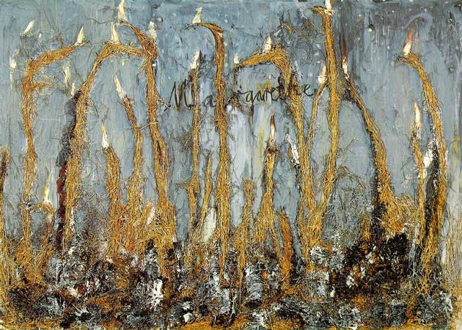
Figure 6.Margarete ,1981
Retrieved from:https://www.independent.co.uk/arts-entertainment/art/great-works/margarete-1981-by-anselm-kiefer-saatchi-collection-970630.html

The heaviness of Maikaifer flieg [Cockchafer Fly] is also expressed by the use of a large amount of paint, the top layer of which is a black paint of almost tar-like consistency, to depict the charred earth. Some of the tears in the ground and the smoke rising from the ground are a fitting representation of the aftermath of the war. The horizon line is so high that it seems to express the tragic fate that is hard to escape, and a children's song from Germany after the Second World War is written on it: Maikafer flieg, der Vater ist im Krieg, die Mutter ist in Pommerland, Pommerland ist abgebrannt... [Cockchafer Fly, Father ist abgebrannt]. Cockchafer Fly, Father is at war, Mother is in Pomerania, Pomerania is burnt up. Using an innocent children's song as the only text to express the tragic fate, the children will not pay attention to the deep meaning of the lyrics when they sing it, however, this kind of unconsciousness only pokes the fragile place in people's heart.

As for this work, Biro has another interpretation that goes beyond the surface expression. He compares the painting with Heidegger's philosophy, and argues that the painting utilises Heidegger's specific term "vision". Vision, in Heidegger's interpretation, is the difference between the heavens and the earth, between human beings and the gods, and the bringing of them together. Therefore, he believes that the horizon line is the horizon for the author of this painting, the boundary between heaven and earth, between flatness and depth, which defines the limit of the distance that human beings can see. It is like the distance that the masses of society see in history, forcing them once again to face up to the depth of historical memory.(RICH,2000)

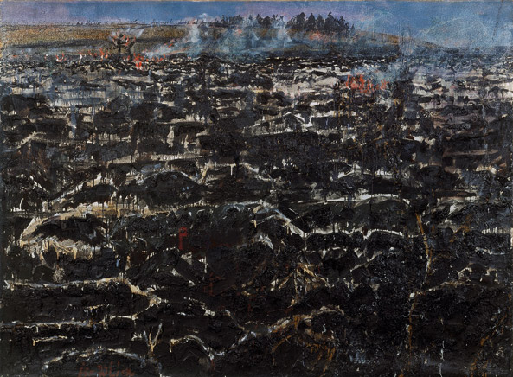
Figure 7. Maikaifer flieg [Cockchafer Fly]
Retrieved from:https://theircreations.wordpress.com/2016/03/01/anselm-kiefer/ak-cockchafer-fly-1974/

His series of paintings of his massacres become a realm of memories that are described as if they were taking us to the atrocities of the war, shocking and at the same time quickly capturing the memories of the masses. He creates a large number of these memories in order to trace the war he did not live through, to face history alone and to try to evoke a collective response.

Conclusion

Both artists explore memory through their works. Unlike Yin Xiuzhen, who has a precise memory, her search is gentle, and the memories she explores are warmer and more likely to resonate with the viewer, bringing the viewer's personal memories into the framework of a collective memory, allowing for the emergence of a memory system, as Halbwachs calls it, “which is a connection of the mind”.（Halbwachs，1992，p53）To search and explore the memories together, the viewer is allowed to reconstruct his own memories. This is an art creation that is closer to everyday life. However, the presentation of the work alone is a little bit monotonous, but it was already a surprising creation in those days.

Whereas Anselm Kiefer's exploration is more ferocious, he has no exact memory. He just expresses sadness and mourning with doubts and thoughts about the collective memory, and the memory of history he explores is also heavier. Halbwachs's theories have also explored the tendency to distort the past in the process of social reconstruction of the past, and that if no one preserves the memory of the society, then every individual will surely forget the facts in the following.（Halbwachs，1992，p52） Anslem Kiefer is the one who has the courage to keep the memory for the society, in Halbwachs‘words, "the individual relies on the framework of the social memory to recall the memories".（ Halbwachs，1992，p182） He constructs memories through his artworks and tries to lead the public into a real collective memory framework. Each of his works brings shock and reflection, and rises to the level of social history, which is of great significance to the society at that time.

At the same time, the way they are presented is also different. Compared with works that come into life, installation art is close to the eyes, touchable and even flavourful, which makes it easier to enter the viewer's heart and instantly arouse the viewer's memory search. This kind of historical theme works, such as Anselm Kiefer's paintings are even more thought-provoking, because his paintings are always slightly abstract, as if they are pregnant with emotions that are hidden and cannot be exploded. In particular, Anselm Kiefer is fond of using large-size visual presentation, and this kind of close-up flat effect seems to draw people into the scene, which is more likely to shock the mind.

However, at the same time, their works also have certain limitations, that is, the limitations of the cultural background, the home country, have the same experience of the viewer may have more feelings. But as an international art work, different people have different understandings and feelings, and there will be a better role of cultural exchange.

Bibilography
Anselm Kiefer: Collecting what is Broken. Works from the Chevirat Ha-Kelim (breaking of the Wessels) Cycle. 2022. Art inquiry, 24.
ADORNO, T.W., 1981. Cultural criticism and society.
ANFAM, D., 2014. Anselm Kiefer. Burlington magazine, 156(1341), pp. 831-832.
BIRO, M., 1998. Anselm Kiefer and the philosophy of Martin Heidegger. Cambridge: Cambridge University Press.
BRAILOVSKY, A., 1997. The Epic Tableau: Verfremdungseffekte in Anselm Kiefer's Varus. New German critique, 71(71), pp. 115-138.
CHENG, M., 2020. Metropolis Ecologies: Yin Xiuzhen’s Parallel Cities. Positions : East Asia cultures critique, 28(1), pp. 145-175.
GOLKA, M., 2009. Pamięć społeczna i jej implanty. Wydawnictwo Naukowe Scholar.
HALBWACHS, M. and COSER, L.A., 1992. On collective memory. Chicago: University of Chicago Press.
Maurice Halbwachs.On collective memory. 2002.Shanghai: Shanghai People's Publishing House
Maurice Halbwachs - The Collective Memory-Harper & Row Colophon Books .1980
RICH, S., 2000. Anselm Kiefer and the Philosophy of Martin Heidegger / Anselm Kiefer and Art after Auschwitz. New York: College Art Association, Inc.
SHENG, K.V., 2014. Yin Xiuzhen’s fabric cavities: fabricating ‘strange encounters. The sculpture journal, 23(3), pp. 393-402.
SHENG, V.K., 2021a. Yin Xiuzhen’s Portable Cities. Third text, 35(6), pp. 733-750.
SHENG, V.K., 2021b. Yin Xiuzhen's Portable Cities: 'Homemaking' via Domestic Preservation. Third text, 35(6), pp. 733-750.
WÓJCICKA, M. and ŁOZOWSKI, P., 2020. Collective memory and oral text. Bern: Peter Lang International Academic Publishing Group.

Webiste
1/5 Anselm Kiefer: Remembering the Future (2015). Available at: https://www.youtube.com/watch?v=FUQuhoqTKtg (Accessed: 14 December 2023).
Anselm Kiefer: “My paintings change" (2019). Available at: https://www.youtube.com/watch?v=HaWt0tuPErU (Accessed: 14 December 2023).
Song Dong & Yin Xiuzhen in ‘Beijing’ - Season 10 - ‘Art in the Twenty-First Century’ | Art21 (2023). Available at: https://www.youtube.com/watch?v=pX7DoQuOWng (Accessed: 14 December 2023).

