Networking and Operating System Services
Building, Deploying., Configuring and Managing a Virtualized Network for NOSS
Ethan Shellem-Prince ACCA5023 2109509

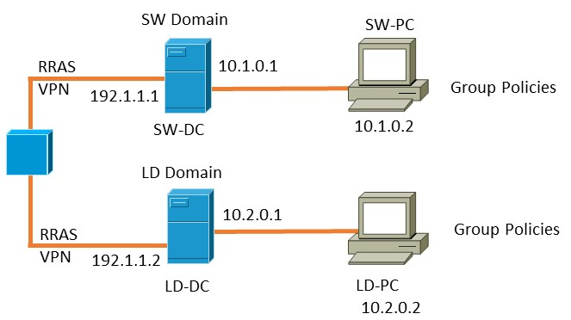

Table of Contents
Introduction 3
What is a Hypervisor? 3
Types of Hypervisors 4
Type 1 Hypervisor: 4
Type 2 Hypervisor: 4
Choice in Hypervisor 4
User Friendly Interface 4
Cost Effective 4
Compatibility 5
Community Support 5
Integration 5
Overall choice 5
Set up of the Topology 5
Downloading Oracle Virtual Box. 5
Specifications for Swansea 1 Server 6
IP Addressing 9
What is an IP Address 9
Routers and Switches 9
Structure and Format of IP Addresses 9
IPv4 and IPv6 9
Configuration of my Network and IP Addressing 12
PC1 12
PC2 12
London (Server 2) 12
Testing and Troubleshooting 14
References 20

Introduction
Virtualizing networks has become very important for optimizing resources and managing IT systems efficiently. This report documents the process of creating a virtualized network for NOSS, a multinational corporation with operations in Swansea and London.
This report explains research on hypervisors and justifies the reasoning behind every choice. The report also details the steps taken to create the virtual network. It covers IP addressing concepts and the practical aspects of testing and troubleshooting the network. I have followed the recommended writing style, supporting all research with citations from credible sources.

- What is a Hypervisor?
A hypervisor is a software tool that lets you run multiple operating systems on one computer. It helps manage and allocate resources efficiently, creating virtual machines that operate independently of each other. This technology is essential for server virtualization and cloud computing, allowing users to create, deploy, and manage multiple virtual environments on a single physical server.
Hypervisors are important because they allow multiple operating systems to run on one server, optimizing resource usage, reducing costs, enhancing system security, and overall system performance.
- Types of Hypervisors
- Type 1 Hypervisor:
Type 1 hypervisors, also known as bare-metal hypervisors, run directly on the host's hardware to control the hardware and manage guest operating systems. They do not require a pre-existing operating system.
Examples of Type 1 hypervisors include VMware ESXi, Microsoft Hyper-V, and Xen.
Type 1 hypervisors offer better performance and security since they run directly on the host's hardware.
- Type 2 Hypervisor:
Type 2 hypervisors, also known as hosted hypervisors, run on a conventional operating system, such as Windows or Linux. They host virtual machines as application software.
Examples of Type 2 hypervisors include Oracle VirtualBox, VMware Workstation, and Parallels Desktop.
Type 2 hypervisors are easier to set up and use for testing and development purposes.
[1]

- Choice in Hypervisor
I opted for Oracle VirtualBox (VM) as the hypervisor. Oracle VM is a type 2 hypervisor. I decided to choose this for the many different reasons stated below
- User Friendly Interface
Oracle VirtualBox offers a straightforward and user-friendly interface, making it accessible for users with different levels of technical experience. This aligns with the objective to deploy a virtualized network efficiently. There are many different online resources that show the use of the software which can benefit many different users of all experience levels. [2]
- Cost Effective
Being an open-source solution, Oracle VirtualBox is cost-effective, which is crucial for the project outline given the consideration of resource availability and potential budget constraints involved.
- Compatibility
Oracle VirtualBox supports a wide range of operating systems, making it a versatile choice for our virtualized network that may involve diverse platforms in the NOSS environment.
- Community Support
The robust community around Oracle VirtualBox provides many resources, forums, and documentation. This ensures that users have access to a strong support system, which is important for troubleshooting and problem resolution during the network setup.
- Integration
VirtualBox seamlessly integrates with different networking tools and services, enhancing our ability to configure and manage the network according to the specified topology. [3]
- Overall choice
I decided to choose Oracle VirtualBox as the type 2 hypervisor for a few key reasons. It's easy to use, doesn't cost much, and works well with different operating systems. Plus, there's a helpful community that supports it, and it fits perfectly into the network design.
I picked Oracle VirtualBox because it's user-friendly, budget-friendly, works well with different platforms, has great community support, and easily integrates with our planned network.

- Set up of the Topology
- Downloading Oracle Virtual Box.
Oracle Virtual Box is free to download online and is compatible with many different Operating Systems such as Windows and Mac. The download link is provided below.
https://www.virtualbox.org/wiki/Downloads
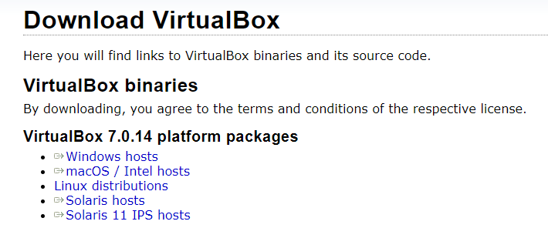
- Specifications for Swansea 1 Server

When setting up the Swansea 1 and London 1 servers I decided to choose 5000MB of memory and 4 processors to make sure it works well. The 5000MB memory gives the server enough space to run its apps without slowing things down. And with 4 processors, the server can handle multiple tasks at the same time, making it run smoothly and respond quickly. This setup helps both servers handle its job efficiently in the virtual network.
Creating the Swansea 1 Server from Windows OS
(note: London 1 was created the same way)
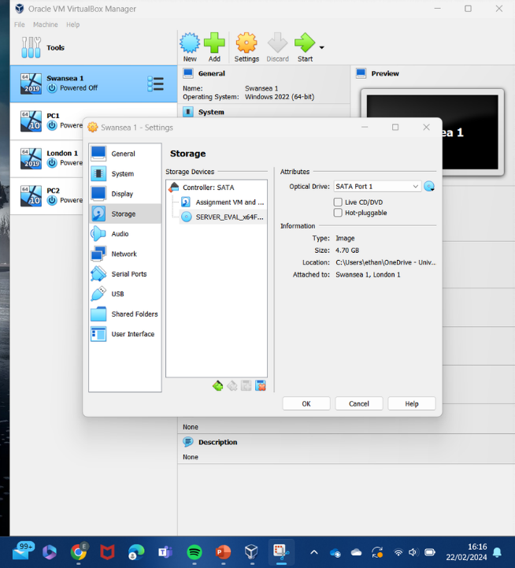
Both PC1 and PC2 have been configured with 2048MB of base memory. This allocation was chosen to ensure that each virtual machine has enough memory to run its operating system and applications smoothly without causing performance issues. By providing 2048MB of memory to each PC, the aim is to strike a balance between efficient resource usage and responsive performance within the virtualized network environment
Creating the PC1 machine from Windows OS
(note: PC2 was created the same way)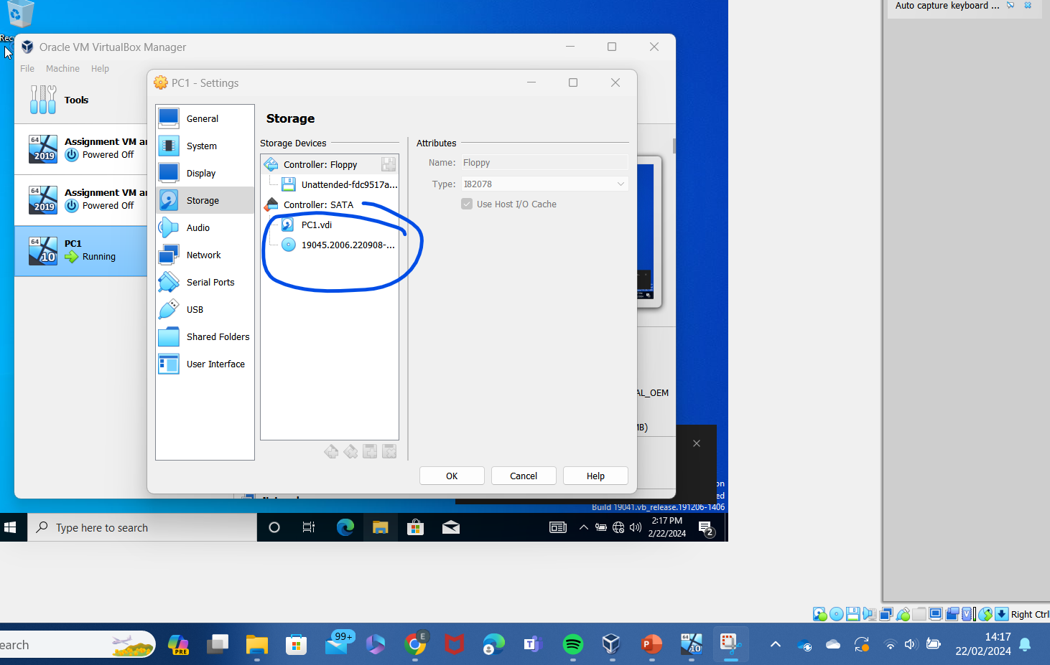

Setting up 2 internal networks for Swansea 1 (note: this was repeated for London 1)
IntLan
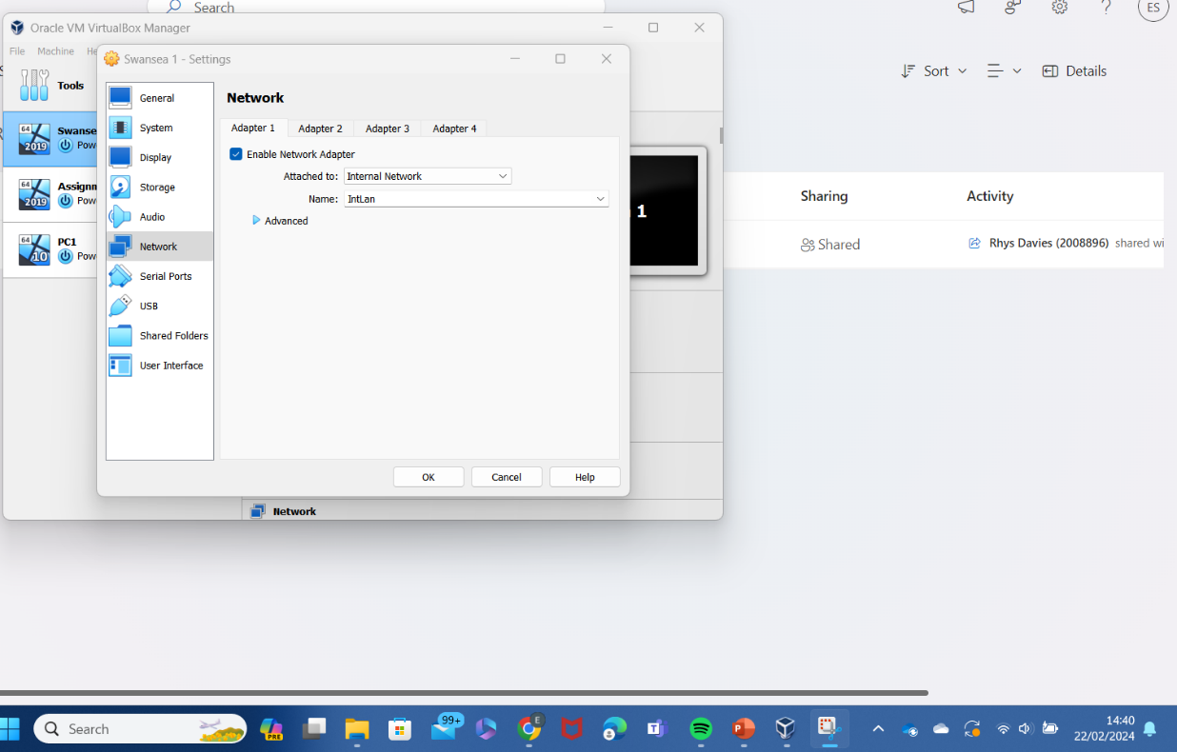
IntSer
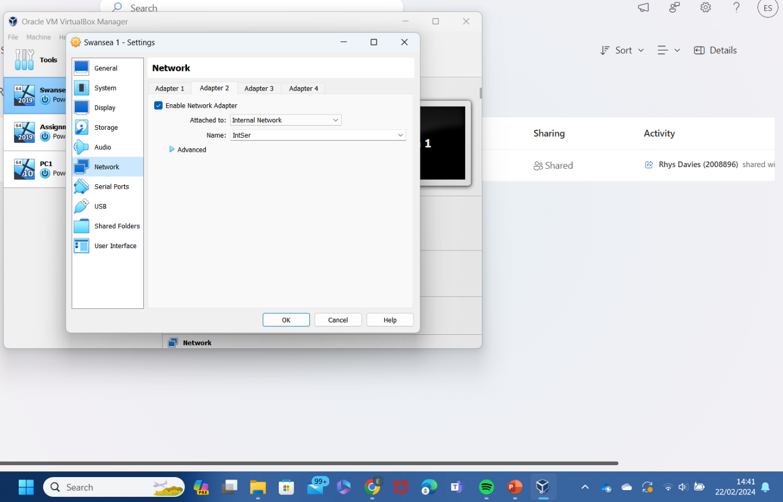

Setting up 1 internal networks for PC1 (note: this was repeated for PC2)
IntLan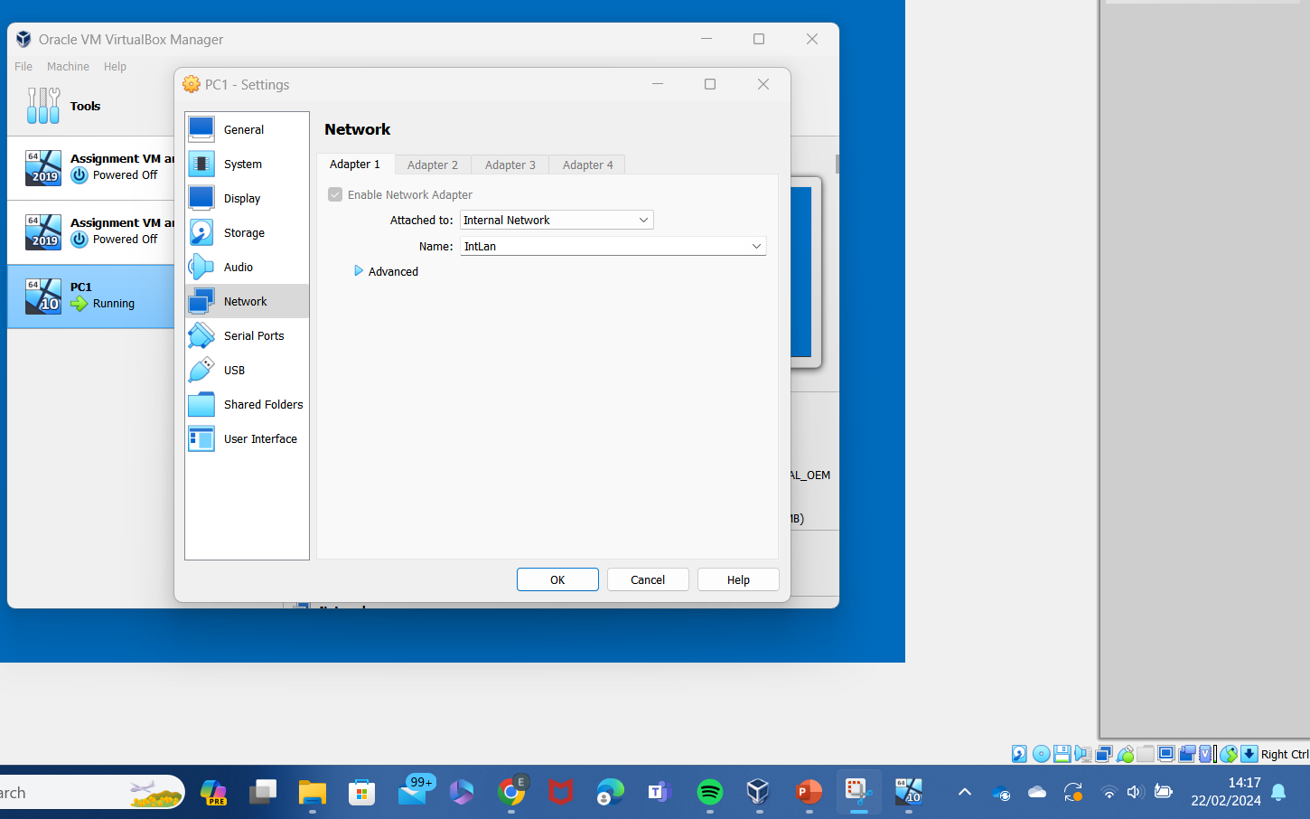
- IP Addressing
- What is an IP Address
An IP address is known as a digital postal code. It job is to uniquely identify devices on the internet and ensure the proper delivery of data. It acts as a very important identifier in the network, facilitating the routing of information between computers. [4]
- Routers and Switches
Routers and switches play a crucial role as ‘traffic directors’ on the internet. They facilitate the smooth flow of data between different networks, guiding it to the correct destination, much like traffic controllers on a busy road. [5]
- Structure and Format of IP Addresses
As explained above we think of IP Addresses like home addresses for devices on the internet. They're made up of four sets of numbers. Each set can be any number from 0 to 255. For example, an IP address could be 192.168.1.1 or 10.0.0.255. [4]
Why 0 to 255? Computers speak in binary code, which is made up of 0s and 1s. An IP address uses four sets of eight 0s and 1s. Since each digit can be either 0 or 1, you get 2^8, which is 256. But we start counting from 0, so it goes from 0 to 255. [6]
Understanding the numbering system helps keep things organized and makes sure devices find each other properly on the internet.
- IPv4 and IPv6
IP addresses come in two types - IPv4 (like the older generation) and IPv6 (the newer version). They both do the same job of giving devices unique addresses on the internet, but they do it in slightly different ways.
IPv4 (Older Version)
In IPv4, we use combinations of numbers up to 255, like 192.168.1.1. But as more and more devices join the internet, we are running out of these unique addresses.
IPv6 (Newer Version)
IPv6 uses a combination of numbers and letters, providing an almost infinite number of unique addresses. An example of IPv6 is something like ‘fe80:0000:0:1:0023:12ff:fe34:5678’
Both IPv4 and IPv6 are currently in use. The option of having both allows for a smooth transition and ensures that devices, whether they speak the old or new "address language," can still communicate with each other on the internet.

Swansea 1 IntLan network IP addressing
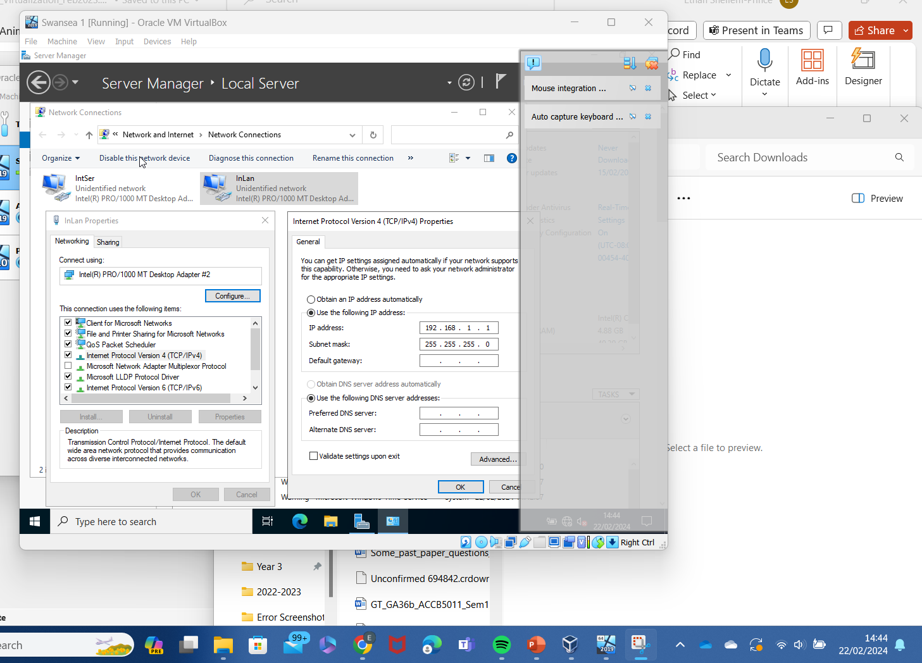
Swansea 1 IntSer network IP addressing 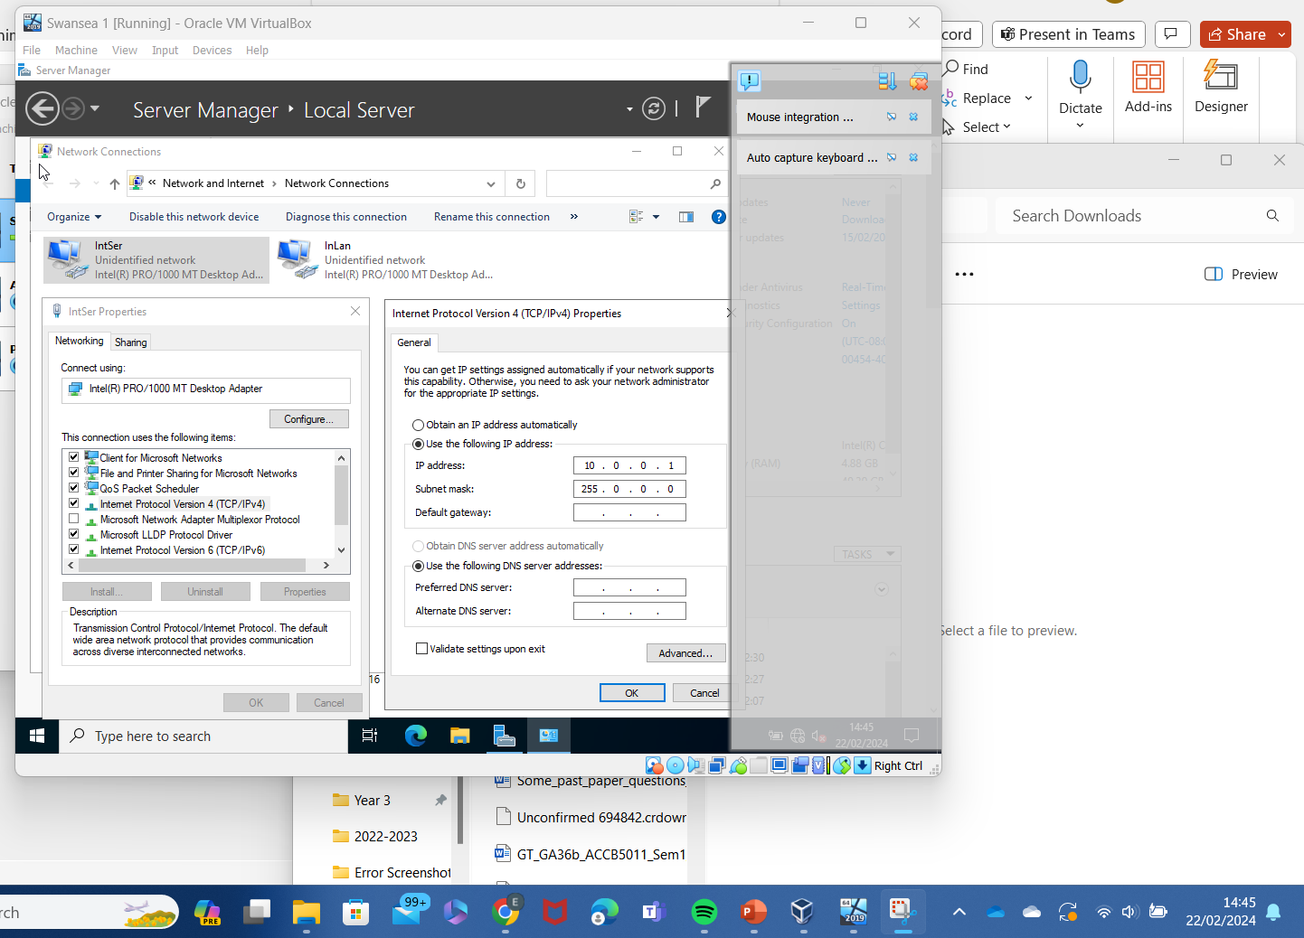

London 1 IntLan network IP addressing
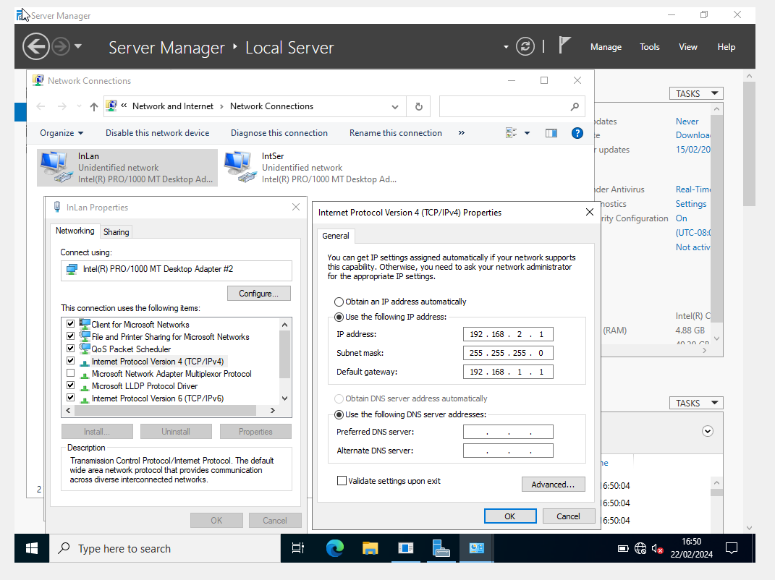
London 1 IntSer network IP addressing
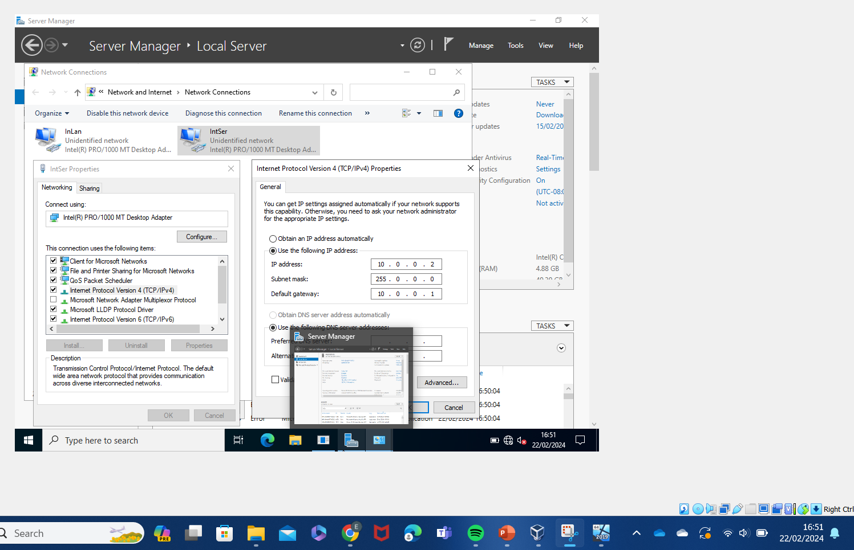

Configuration of my Network and IP Addressing
The setup of the virtualized network revolves around connecting two servers, Swansea (Server 1) and London (Server 2), each hosting a individual network. Additionally, we have two PCs, PC1 and PC2, linked to Swansea and London servers. Below I have separated each component with the networks listed.

PC1
Connected to: Swansea Server
Network:
IntLan: 192.168.1.2

PC2
Connected to: London Server
Network:
IntLan: 192.168.2.2

Swansea (Server 1)
Networks:
IntSer: 10.0.0.1
IntLan: 192.168.1.1
- London (Server 2)
Networks:
IntSer: 10.0.0.2
IntLan: 192.168.2.1

The Swansea and London servers are set up with two separate networks. "IntSer" (10.0.0.x) is for the servers to talk directly to each other, and "IntLan" (192.168.x.x) is how servers connect to PCs.
PC1, which is connected to Swansea Server, has the IP address 192.168.1.2 in the "IntLan" network. PC2, linked to London Server, has the IP address 192.168.2.2 in the same "IntLan" network.
This setup ensures smooth communication. The servers are able to talk to each other internally using "IntSer," and PCs talk to their individual servers through the "IntLan" network.
PC1 Connecting to Swansea Server over network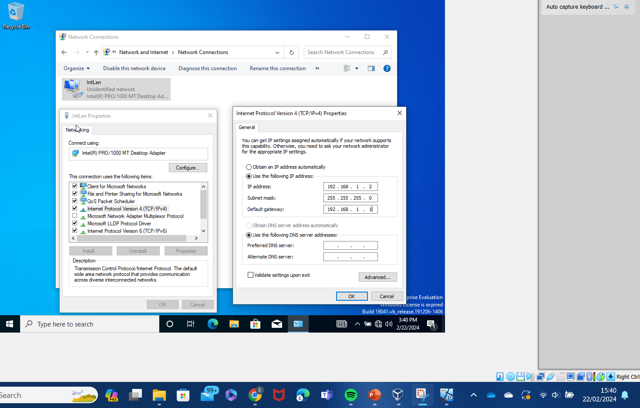
PC2 Connecting to London 1 Server over network
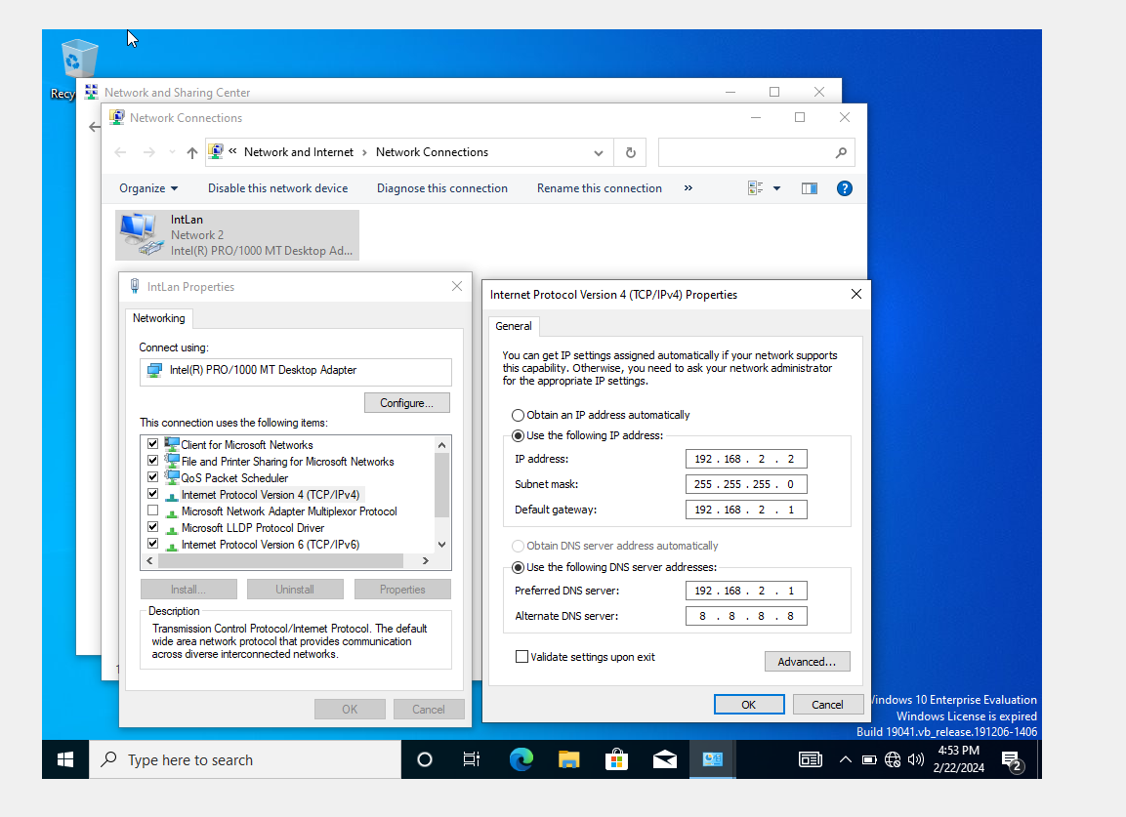
- Testing and Troubleshooting
Connectivity Tests
To confirm that the network is functioning correctly, I will conduct connectivity tests. This involves checking if all devices—servers (Swansea and London) and PCs (PC1 and PC2)—can communicate effectively. I will use tools to ping devices and verify responses to ensure they're connected and responsive.
Swansea 1 Ipconfig
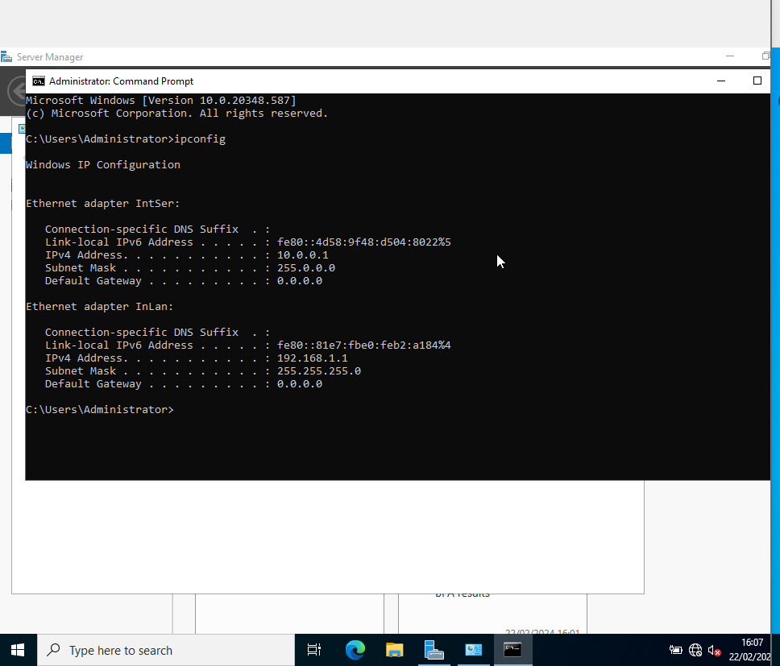
London 1 Ipconfig
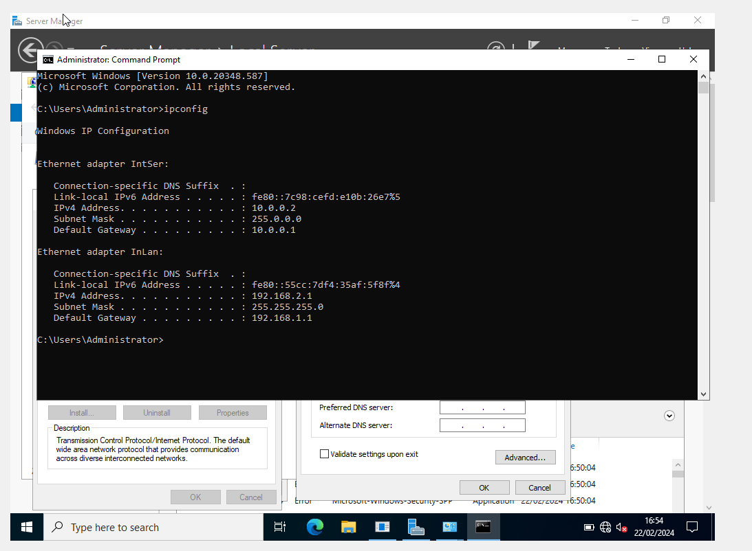

Common Connectivity issues
Many different types of issues can occur, below are the common problems that are resolved when creating similar topology:
IP Address Conflicts: Resolving conflicts to ensure each device has a unique and correct IP address.
DNS Resolutions: Ensuring proper Domain Name System (DNS) resolutions for accurate addressing.
Firewall Configurations: Verifying and adjusting firewall settings to allow appropriate data flow.
[7]
Firewall Configuration Troubleshooting
PC1 not pinging to Swansea 1
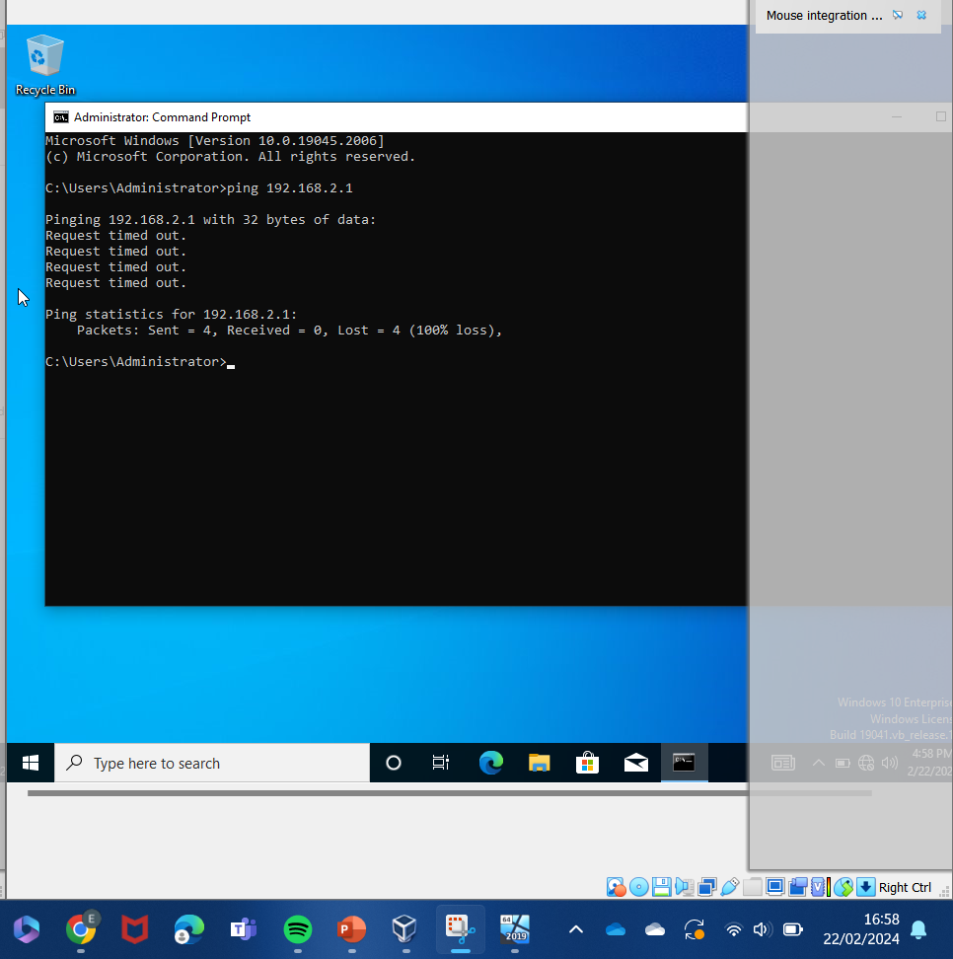

After turning Swansea 1 firewall off
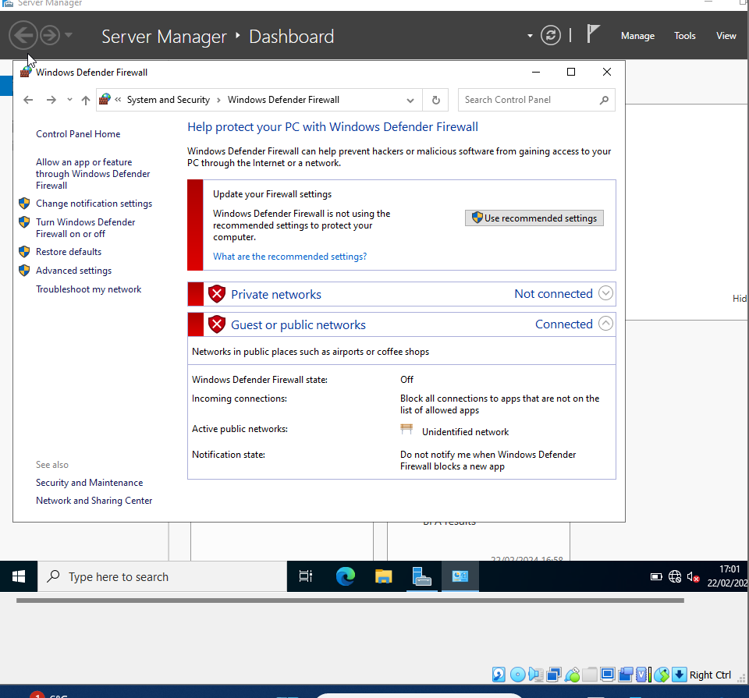
After turning PC1 firewall off
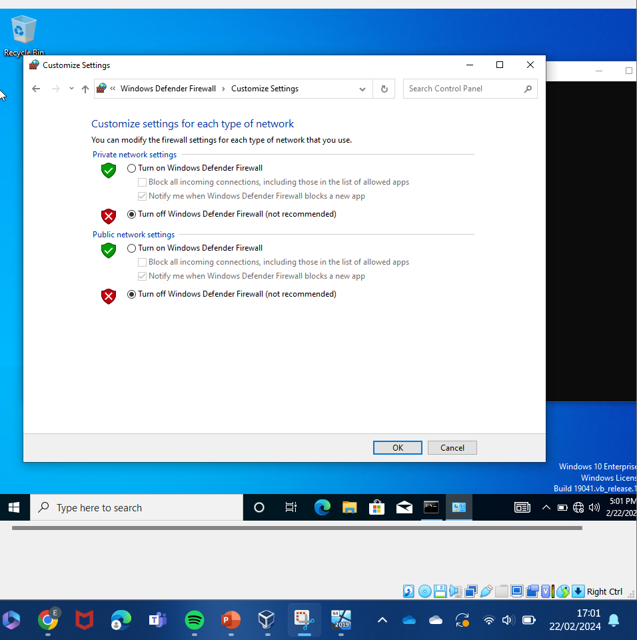

PC1 is now pinging to Swansea 1
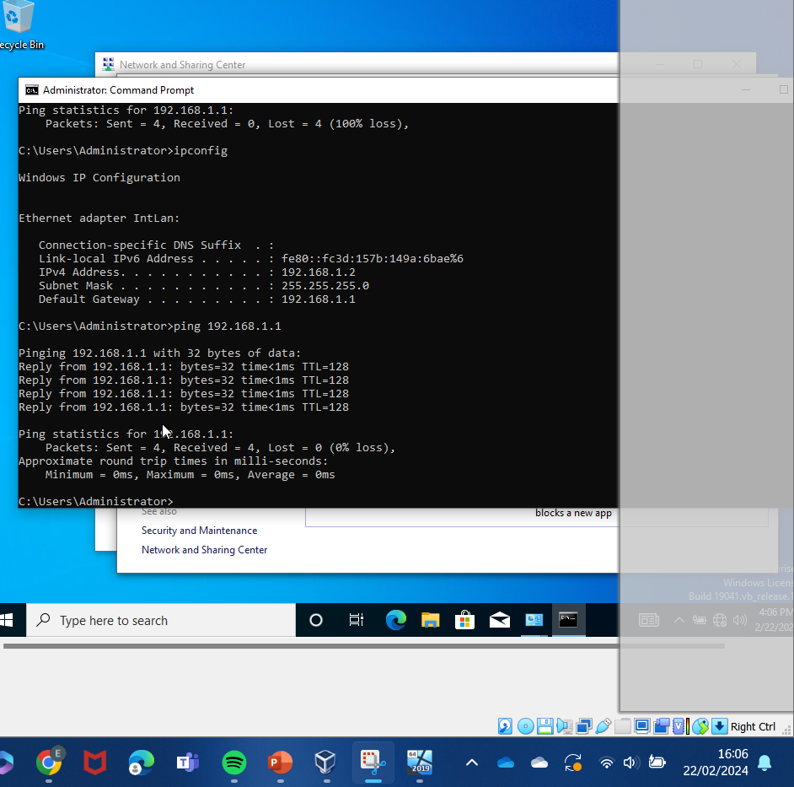
PC2 is now pinging to London 1
(After both PC2 and London 1 firewalls were turned off)
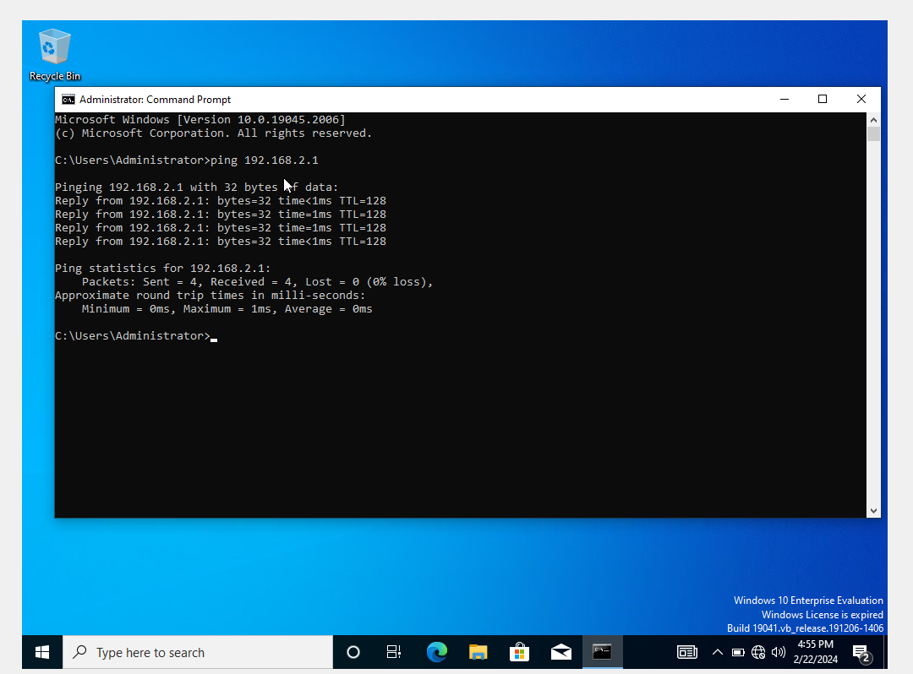
Additional Testing
There are many other tests that can take place to ensure the topology is working correctly. Below are some further examples,
Bandwidth Testing: Assessing the data transfer speed within our network to guarantee it meets our performance expectations.
Packet Loss Testing: Verifying that data packets are reaching their destinations without loss, ensuring efficient communication.
Security Testing: Ensuring that our network is secure from potential threats by evaluating firewall configurations and implementing necessary security measures.
Networking Testing
There are also many ways to test the network is working correctly, below are a few examples,
Conducting Connectivity Tests: Using ping commands to verify communication between servers and PCs.
Bandwidth and Packet Loss Testing: Employing network testing tools to evaluate data transfer speed and identify potential packet loss.
Security Testing: Verifying firewall configurations and implementing security measures.

Swansea 1 Pinging to London 1
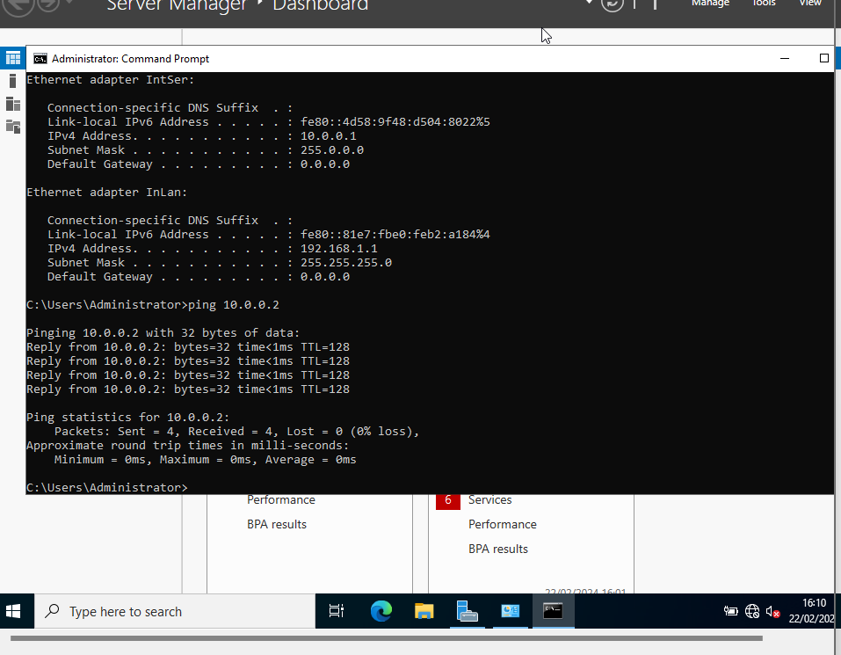

London 1 Pinging to Swansea 1
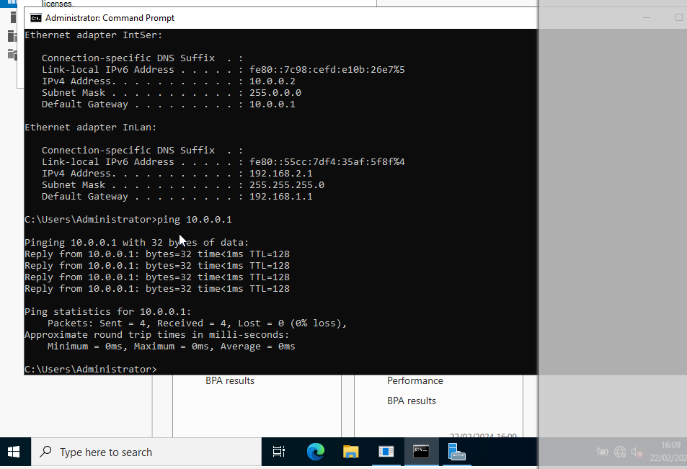

Conclusion
In this project, we have built a virtual network using Oracle VM VirtualBox, connecting virtual machines together such as PC1 and Swansea 1 Server. The overall outcome was to make these virtual machines talk to each other successfully.
What was achieved:
Design: a virtual network was created that imitates a real-world setup, with routers, switches, and virtual machines.
Configuration: Each virtual machine got the correct (windows) operating system and network settings.
Testing: We confirmed that PC1, Swansea 1 server and PC2 , London 1 server could communicate by successfully pinging each other.
Firewalls: While testing there was an issue with firewalls, but after temporarily turning them off our to ping tests worked. It is important to note that this was just for testing purposes keeping firewalls on is important for security.
Troubleshooting: We learned how to find and fix issues with network connections, like checking configurations and dealing with firewalls.
Documentation: Writing down what we did, like network diagrams and IP settings, helped us understand and fix things better.
Overall, we have successfully made virtual machines talk to each other. During this process I have learned a lot about building networks and troubleshooting issues, setting the stage for future projects in network and system work.

- References
[1] S J.Bigelow, Whats the difference between Type 1 vs Type 2 hypervisor. Milwaukee area Technical College: 13 Jan 2021
[2] – K.Stratvert, How to use VirtualBox – Tutorial for Beginners. YouTube tutorial, 27 Jun 2023
[3] – Oracle White Paper, Oracle Virtual Box Overview. Austin Texas, Jun 2021
[4] - Dooley, M. E., & Rooney, T. (2021). IP address management (Second edition.). Wiley. https://doi.org/10.1002/9781119692263
[5] – Cisco, What is a Switch vs a Router. (online source) https://www.cisco.com/c/en_uk/solutions/small-business/resource-center/networking/network-switch-vs-router.html
[6] - Britannica, The Editors of Encyclopaedia. "binary code". Encyclopedia Britannica, 29 Sep. 2023, https://www.britannica.com/technology/binary-code. Accessed 23 February 2024.
[7] - Sowell, G. (2020). Cisco CCNA (200-301) Cert Prep: IP Connectivity and Services. linkedin.com.

