AHHI5017 Contesting Conflict: Representations of War, 1789–Present
Week 6: The Russian Revolution
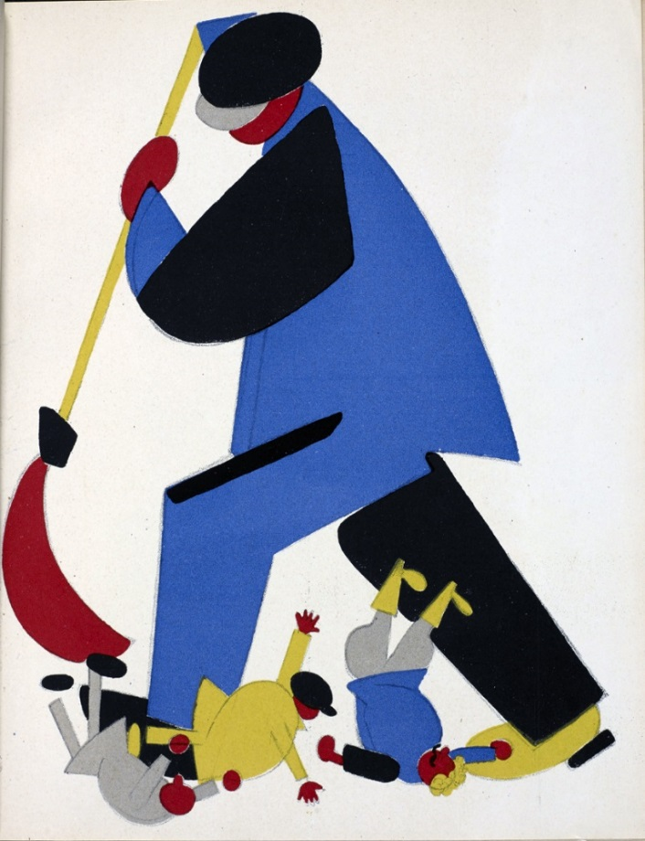
Vladimir Lebedev, ‘A Worker Sweeping the Criminals out of the Soviet Land’ (1923)

Lectures summary:
This week concentrates on the event that “shook the world” in 1917: the Bolshevik Revolution in Russia. Our lectures will explore how art, and especially film, developed in the new Soviet Union, and the manner in which filmmakers were tasked with embodying revolutionary ideals and ideology. The principal focus will be one of the great Soviet auteurs, Sergei Eisenstein, and his film October.
The lecture will begin with a brief overview of the Russian Revolution. Here, students are directed to the timeline which has been added as a required reading. Having established some of the principles of the revolution, attention will shift to how the revolution was embraced by different art forms. What was the relationship between the revolution and the arts, and how did artists embrace revolutionary sentiments in their work? What aesthetics and artistic techniques were associated with the revolution, and why? These questions will then be applied concertedly to a discussion of Soviet cinema and, in particular, October – an assigned viewing for this week. We will examine the principles of Soviet montage and the ideas associated with one of its leading exponents, Sergei Eisenstein.

Required viewing and reading:
- October: Ten Days That Shook the World. Directed by Sergei Eisenstein (Soviet Union, 1928). Available here: https://www.youtube.com/watch?v=tQ9GCi4Gjso
- Lenin, ‘Speech To Propagandists On Their Way To The Provinces,’ January 23 1918; ‘Directions Concerning the Work of the Propaganda-Instructor Trains and Steamers,’ January 25 1920; ‘Directives on the Film Business,’ January 17 1922.
- Timeline of Russian Revolution. From Ekaterina Rogatchevskaia, ed. Russian Revolution: Hope, Tragedy, Myths (London: British Library, 2017), pp. 10–19.

Background reading:
- British Library Russian Revolution online collection (https://www.bl.uk/russian-revolution)
- Orlando Figses Russian Revolution website (https://www.bl.uk/russian-revolution)
- David Bordwell, ‘The Idea of Montage in Soviet Art and Film,’ Cinema Journal, Vol. 11, No. 2 (Spring, 1972), pp. 9–17.
- Sergei Eisenstein, ‘A Dialectic Approach to Film Form’ (1929), in Eisenstein, Film Form Essays in Film Theory (London: Harcourt Brace Jovanovich, 1977 [1949]), pp. 45–63.

Questions to consider:
Lenin speeches and directives
- What functions do Lenin’s speeches and directives identify Soviet propaganda as serving?

- What instruments/vehicles for propaganda do the speeches and directives identify?

- What types of films does Lenin mention? What subjects does Lenin suggest might be suitable ones for propaganda films? Why might film specifically be of particular utility for propaganda purposes?

- What details does Lenin provide about the surrounding context for these directives and how might these effect how you interpret them?
October
- How might one interpret October as a piece of propaganda?

- Does the film adhere to any of the tenets of propaganda discussed by Lenin’s directives? If so, how?

- In what ways might the film have been perceived as expressing or embodying revolutionary sentiments? How might the film’s plot fulfil the ideals of the revolution? And how might the cinematographic techniques and aesthetics be seen as ‘revolutionary’?

- October’s director Sergei Eisenstein is regarded as one of the masters of Soviet cinema. Can you detect anything notable about Eisenstein’s filmmaking techniques? For instance, cinema historians make much of his use of montage editing: what do you understand by this term, and how – and to what ends – is montage discernible in the film?

