Kwame Assa-Agyei

SOFTWARE SOLUTIONS FOR BUSINESS
Component 1- Coursework: Portfolio
NAME: SEWELL LANISHA FERNANDES STUDENT ID: 2539400 MODULE: SOFTWARE SOLUTIONS FOR BUSINESS MODULE CODE: ACCA4026 LECTURER: Kwame Assa-Agyei Fahed Ahmed
Group :2

Contents
Introduction 1
Task 1. e-Commerce Website builders/software solutions 2
1.1 Wix 2
1.2 Shopify 3
Task 2. Mind-map of contemporary software applications 5
2.1 Describe mind mapping and explain the benefits of using mind mapping 5
2.2 Create a mind map of contemporary software applications 7
Task 3. Office Applications 7
3.1 Four office software solutions for business operations 7
Ms Word 7
Ms Excel 8
8
Ms PowerPoint 9
Ms Access 10
3.2 Test any two features 11
Mail Merge/VLOOKUP/pivot table 11
IF Statement 19
Task 4. Communication and Collaboration applications 21
4.1 One contemporary Communication and one Online Collaboration 21
MS OUTLOOK 21
MS TEAMS 22
4.2 Test one feature of a freely available Communication (1) and one feature of a Collaboration (1) application 23
MS Outlook 23
MS Teams 25
Conclusion 27
References 28

Introduction
In today's rapidly developing business environment, technology has become an essential part of how organisations operate and communicate. Businesses of all sizes rely on different software applications and digital tools to complete everyday activities, manage information, communicate with employees and customers, and make effective decisions. The use of appropriate technology can help organisations improve productivity, reduce the time required to complete tasks and provide better services to customers. Therefore, understanding different software solutions and their features is important for employees working in modern business environments.
This assignment explores a variety of software applications and technologies that can be used to support business operations. The first section focuses on contemporary e-commerce website builders and software solutions. E-commerce platforms allow businesses to create online stores, promote their products or services and communicate with customers through digital channels. The assignment will consider two examples and examine how they can support business activities.
The assignment also explores mind-mapping software and how it can be used in business operations. Mind mapping can help employees organise information, develop ideas, plan projects and improve problem-solving. The use of visual representations can make complex information easier to understand and support effective planning and decision-making.
Another important area covered in this assignment is office application software. Applications such as Microsoft Word, Microsoft Excel, Microsoft PowerPoint and Microsoft Access are widely used in businesses for creating documents, analysing data, preparing presentations and managing information. The assignment will examine four office software solutions and consider their uses and benefits. It will also demonstrate practical features in Microsoft Excel, including functions and tools that can help users analyse and manage business data more efficiently.
Finally, the assignment will examine communication and online collaboration applications. These technologies allow employees to communicate, share information and work together effectively, including when working remotely. Overall, this assignment aims to demonstrate how different software applications can support modern business operations and improve efficiency, productivity, communication and decision-making.

Task 1. e-Commerce Website builders/software solutions

1.1 Wix

Wix.com Ltd. (Hebrew: ווִיקס.קוֹם, romanized: wix.com), or simply Wix, is an Israeli software company, publicly listed in the US, that provides cloud-based web development services. It offers tools for creating HTML5 websites for desktop and mobile platforms using online drag-and-drop editing.^{[3]} Along with its headquarters and other offices in Israel, Wix also has offices in Brazil, Canada, Germany, India, Ireland, Japan, Lithuania, Poland, the Netherlands, the United States, Ukraine, and Singapore.^{[4]}
Users can add applications for social media, e-commerce, online marketing, contact forms, e-mail marketing, and community forums to their websites.^{[5][6]} The Wix website builder is built on a freemium business model, earning its revenues through premium upgrades.^{[7]} According to the W3Techs technology survey website, Wix was used by 2.5% of websites as of September 2023;^{[8]} at the end of May 2025, it was 3.8%.^{[9]}

Wix is a popular website development platform that allows users to create professional websites without needing advanced coding or programming skills. It was founded in 2006 and has become widely used by individuals, students, businesses and organisations to create websites for different purposes. Wix provides a simple drag-and-drop editor, which makes it easier for beginners to design and customise web pages. Users can select from a wide range of templates and change elements such as text, images, colours, fonts and page layouts to create a website that matches their requirements.

One of the main advantages of Wix is its ease of use. Users can create a website by choosing a suitable template and editing the content using the Wix Editor. The platform provides tools that allow users to add different features, including contact forms, image galleries, videos, maps and social media links. This makes Wix suitable for creating personal websites, portfolios, blogs, online stores and business websites. Users can also create multiple pages, such as a home page, about page, services page, gallery and contact page, depending on the purpose of their website.

Wix also offers different tools that can help improve the functionality and appearance of a website. For example, users can use Wix's built-in tools to improve search engine optimisation (SEO), helping their websites become easier to find through search engines. Wix also provides mobile-friendly design options, which are important because many people access websites using smartphones and tablets. A responsive and mobile-friendly website can provide a better experience for users on different devices.

Another important feature of Wix is its hosting service. Users can publish their websites online without having to arrange separate web hosting. Wix provides different plans, including free and paid options. The free plan allows users to create and publish a basic website, although it may include Wix branding and a Wix-related web address. Paid plans provide additional features, such as using a custom domain name, increased storage and other professional tools. The availability of different plans allows users to choose an option based on their needs and budget.

However, Wix also has some disadvantages. Although it is easy to use, users may have less control over the technical aspects of their websites compared with people who build websites using HTML, CSS and JavaScript from scratch. Some advanced features may also require a paid subscription. In addition, moving a website from Wix to another platform can be more difficult than moving a website that has been developed independently.

Overall, Wix is a useful website development platform for beginners and users who want to create a website quickly and easily. Its drag-and-drop editor, templates, hosting services and additional website tools make it a suitable choice for many different types of websites. While it has some limitations in terms of advanced customisation and flexibility, Wix remains a practical option for individuals and small organisations that need an accessible way to design and publish a website.

1.2 Shopify
Shopify Inc. is a Canadian multinational e-commerce company headquartered in Ottawa, Ontario that operates a platform for retail point-of-sale systems. The company has over 5 million customers and processed US$292.3 billion in transactions in 2024, of which 57% was in the United States.^{[2]} Major customers include Tesla, LVMH, Nestlé, PepsiCo, AB InBev, Kraft Heinz, Lindt, Whole Foods Market, Red Bull, and Hyatt.^{[3]}

The company's software has been praised for its ease of use and reasonable fee structure.^{[4]} It has been described as the "go-to e-commerce platform for startups".^{[5]} However, the company has faced criticism for allegedly inflating their sales data and for associating with controversial sellers.

Shopify is a popular e-commerce platform that allows individuals and businesses to create and manage online stores. It was founded in 2006 and has become one of the most widely used platforms for selling products and services online. Shopify provides users with the tools needed to create an online shop without requiring advanced programming or web development knowledge. It can be used by small businesses, entrepreneurs and larger companies to sell products to customers through the internet.

One of the main advantages of Shopify is that it provides an easy way for users to create an online store. Users can choose from a range of professionally designed themes and customise different parts of their website, including colours, fonts, images and page layouts. This allows businesses to create an online store that reflects their brand identity. Shopify also provides tools for adding product descriptions, prices, images and stock information, making it easier for businesses to organise and display their products.

Shopify includes several features that support the management of an online business. Store owners can manage their inventory, process customer orders and track sales through the Shopify dashboard. The platform also supports different payment methods, allowing customers to pay for their purchases online. Depending on the location and payment provider, customers may be able to use debit cards, credit cards and other payment options. Shopify also provides tools for managing shipping and calculating delivery costs, which can help businesses organise the process of delivering products to customers.

Another important feature of Shopify is its ability to support marketing and search engine optimisation. Businesses can use Shopify to create product pages that can be discovered through search engines. The platform also allows users to connect their online stores with social media platforms and other sales channels. This can help businesses promote their products and reach a wider audience. Shopify provides analytics and reporting tools that allow store owners to monitor information such as sales, customer behaviour and website traffic. This information can help businesses understand their customers and make better decisions about their products and marketing strategies.

Shopify also offers an app store containing additional applications that can extend the functionality of an online store. These applications can provide features such as email marketing, customer reviews, accounting, stock management and additional payment options. This makes Shopify flexible because businesses can add tools according to their individual requirements.

However, Shopify also has some disadvantages. Unlike some basic website builders, Shopify requires users to pay a subscription fee to use its main services. Additional costs may also occur when businesses use certain third-party applications or payment services. Businesses also need to consider transaction fees and other costs depending on their chosen plan and payment method. Furthermore, although Shopify is relatively easy to use, users may need to learn how to manage products, orders, payments and other e-commerce features effectively.

Overall, Shopify is a powerful platform for creating and managing online stores. Its user-friendly design, payment facilities, inventory management, marketing tools and range of applications make it suitable for businesses of different sizes. Although there are ongoing costs and some limitations, Shopify provides an effective solution for businesses that want to establish an online presence and sell products or services to customers through e-commerce.

Task 2. Mind-map of contemporary software applications

2.1 Describe mind mapping and explain the benefits of using mind mapping

A mind map is a visual tool used to organise information, ideas and thoughts in a clear and structured way. It usually starts with a main topic in the centre, with different branches connecting to related ideas. Each branch can contain smaller topics, keywords, images or examples. Mind maps are useful for students because they can make complex information easier to understand, remember and organise. They can be created using digital tools such as Canva, Microsoft Word, PowerPoint or other mind-mapping software.

A mind map can be used for planning assignments, preparing presentations, developing ideas and organising research. For example, a student preparing an assignment about digital skills could place “Digital Skills” in the centre of the mind map. The main branches could include Microsoft Word, Microsoft Excel, Microsoft PowerPoint, Microsoft Teams, Microsoft Outlook and Microsoft Access. Each branch could then include information about the purpose, features and benefits of each application. This provides a simple visual overview of the topic.

One of the main benefits of using a mind map is that it helps with **organisation**. Instead of writing large amounts of information in paragraphs, ideas can be separated into different branches. This makes it easier to see how different topics are connected. It can also help students plan their assignments before they begin writing.

Another benefit is **improved memory and learning**. Mind maps use keywords, colours, images and connections, which can make information easier to remember. Students can use a mind map when revising for assessments because important information can be displayed in a short and simple format.

Mind maps can also improve **creativity and brainstorming**. Users can quickly add new ideas to different branches without having to follow a strict order. This allows students to explore different possibilities and develop their ideas before choosing the most suitable ones.

A further benefit is **time management**. Creating a mind map before starting an assignment can help students identify the main areas they need to research and complete. This can reduce the time spent deciding what information to include and provide a clear structure for the final piece of work.

Mind maps are also useful for **problem-solving and decision-making**. By displaying different ideas and options visually, users can compare information and identify possible solutions. In the workplace, mind maps can be used during meetings, project planning and team discussions to record ideas and responsibilities.

Overall, mind maps are an effective learning and planning tool. They help users organise information, improve memory, encourage creativity, manage time and understand relationships between different ideas. For students, using a mind map can make academic work more organised and easier to understand. It can also support the development of digital and communication skills that are valuable in both education and the workplace.

2.2 Create a mind map of contemporary software applications
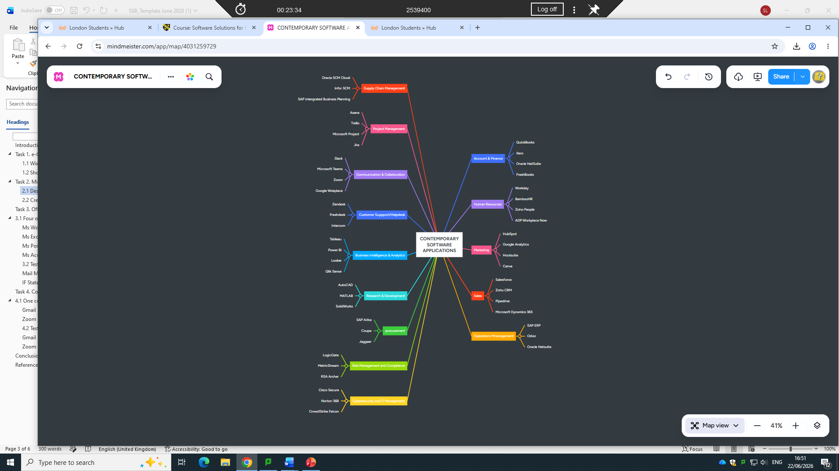

Task 3. Office Applications

3.1 Four office software solutions for business operations

Ms Word

Microsoft Word is a popular word processing software used to create, edit, format, and share text documents. Developed by Microsoft, it helps users make professional letters, resumes, and reports. You can access it on computers, phones, and online.
Microsoft Word is a word-processing application developed by Microsoft. It is widely used by students, teachers, businesses and organisations to create, edit and format documents. Users can create different types of documents, including assignments, reports, letters, CVs and presentations.
Microsoft Word provides many useful features, such as changing fonts, adding headings, inserting images and tables, and checking spelling and grammar. It also allows users to add page numbers, contents pages, references and citations, which are particularly useful for academic work. Documents can be saved and shared digitally, making it easier for people to access and edit their work.
Students can use Microsoft Word to complete assignments and organise information professionally. Businesses can use it to create reports, contracts and other important documents. Overall, Microsoft Word is an important digital tool that helps users create professional, organised and well-presented documents efficiently.
Key Features
- Formatting Tools: Change font types, text sizes, colours, and line spacing.
- Spell Check & Grammar: Automatically finds and fixes typos or bad sentence rules.
- Templates: Offers pre-designed layouts for letters, resumes, and reports.
- Tables & Charts: Lets you add grids, data tables, and visual charts.
- Track Changes: Shows edits and notes made by multiple people working on one file.
- Mail Merge: Quickly sends out custom mass letters or labels to many people.
- Find and Replace:
Locates specific words instantly and swaps them out.
- Word Count: Keeps a live count of total words, pages, and characters.
- Cloud Save: Links with OneDrive to save your work automatically online.
- Export Options: Lets you save files as standard Word docs, PDFs, or web pages.

LIMITATION:
The main disadvantages of MS Word are cost, high system resource needs, and formatting compatibility issues.

Ms Excel


Microsoft Excel is a popular spreadsheet software developed by Microsoft that uses tables with rows and columns to organize, calculate, and analyse data. You can get started or access tools through the official Microsoft Excel site.
Microsoft Excel is a spreadsheet application developed by Microsoft. It is used to organise, calculate, analyse and present data in a clear and structured way. Excel stores information in rows and columns, making it useful for managing large amounts of data.
Excel provides features such as formulas, functions, tables, charts and PivotTables. These tools allow users to perform calculations, identify trends and create visual representations of information. For example, students can use Excel to organise assignment data, calculate results and create charts, while businesses can use it to manage budgets, sales records and financial information.
Excel also allows users to sort and filter data, making it easier to find specific information. It can help save time by automatically performing calculations instead of calculating everything manually. Overall, Microsoft Excel is an important digital tool for data management, calculations, analysis and decision-making in education and the workplace.
Key Features of MS Excel
- Spreadsheets and Data Organization. At its core, Excel is designed to work with spreadsheets. ...
- Formulas and Functions. ...
- Data Visualization. ...
- PivotTables and Pivot Charts. ...
- Data Validation and Drop-Down Lists. ...
- Conditional Formatting. ...
- Data Sorting and Filtering. ...
- Data Analysis Tool Pak.

LIMITATION: The Excel data size limits can make it a challenge to work with big data in Excel. The Excel maximum row is 1,048,576 and the maximum column is 16,384. Many businesses routinely work with larger datasets and need a solution for spreadsheets with more than 1 million rows.

Ms PowerPoint

Microsoft PowerPoint is a popular slide-show presentation program developed by Microsoft. It allows users to combine text, images, videos, and charts onto individual "slides" to visually present information for business meetings, school lectures, and other events. Microsoft PowerPoint is a presentation application developed by Microsoft. It is used to create and deliver professional presentations using slides. Users can add text, images, charts, tables, videos and animations to make information easier to understand and more engaging.
PowerPoint is widely used by students, teachers and businesses. Students can use it to present assignments, projects and research, while businesses can use it for meetings, training sessions and presentations. It provides different templates and design tools that help users create attractive and organised slides.
PowerPoint also allows users to add speaker notes, transitions and references to support their presentations. Presentations can be shared digitally or displayed on a screen during a meeting or classroom session. Overall, Microsoft PowerPoint is an important digital tool that helps users communicate ideas clearly, present information effectively and create professional presentations.
Advanced Design and Animation
- Morph Transition: Animates smooth movements of objects, text, and images across consecutive slides automatically.
- Designer (Design Ideas): Uses AI to suggest customized, professional slide layouts and graphics instantly based on your typed content.
- Cameo: Embeds your live webcam feed directly into a specific spot on a slide as part of the presentation layout.

Delivery and Control Tools
- Presenter View:
Shows your personal speaker notes, a timer, and upcoming slides on your screen while the audience only sees the main presentation.
- Zoom for PowerPoint: Creates non-linear, interactive summary pages that let you jump smoothly to any section or slide on demand.
- Speaker Coach: Evaluates your spoken pacing, pitch, and use of filler words in real time during practice sessions
LIMITATION: PowerPoint can struggle with very large or highly interactive projects. Complex animations or embedded media may slow down performance. For advanced interactivity, other tools or software might work better.

Ms Access

Microsoft Access is a database management tool used to build custom business apps, store structured information, and generate reports. It is part of select Microsoft 365 plans and is designed for Windows. You can explore official plans and details on the Microsoft Access Official Site.
Microsoft Access is a database management application developed by Microsoft. It is used to store, organise, manage and retrieve large amounts of information efficiently. Access allows users to create databases using tables, forms, queries and reports.
Tables are used to store data, while forms make it easier to enter and view information. Queries allow users to search for specific information or perform calculations, and reports can present data in a clear and organised format. For example, a business could use Microsoft Access to manage customer details, employee records, stock information or sales data.
Microsoft Access is useful for organisations that need to manage structured information and retrieve it quickly. It can also connect related tables, reducing the need to store the same information repeatedly. Overall, Microsoft Access is an important digital tool for database management, data organisation, information retrieval and reporting in education and the workplace.
Advantage of your data with the power of Access—without writing code or becoming a database expert:
- Use templates to build databases quickly.
- Easily find and report on data stored in Access.
- Create rich data entry forms.
- Import, transform, and export a variety of data sources.

LIMITATION: General. 2 gigabytes, minus the space needed for system objects. Note: You can work around this size limitation by linking to tables in other Access databases. You can link to tables in multiple database files, each of which can be as large as 2GB.

3.2 Test any two features

Mail Merge/VLOOKUP/pivot table

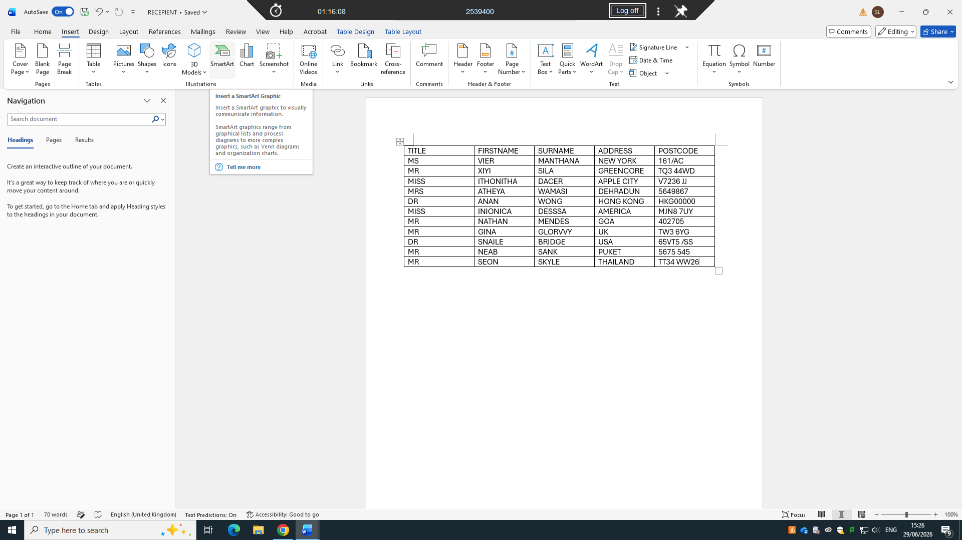
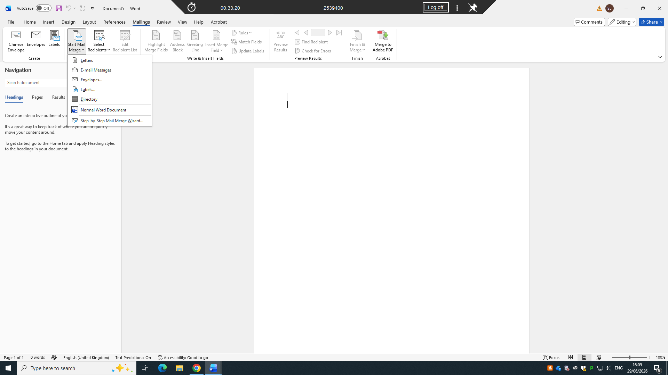
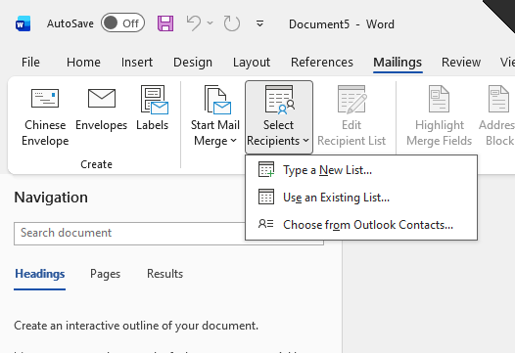

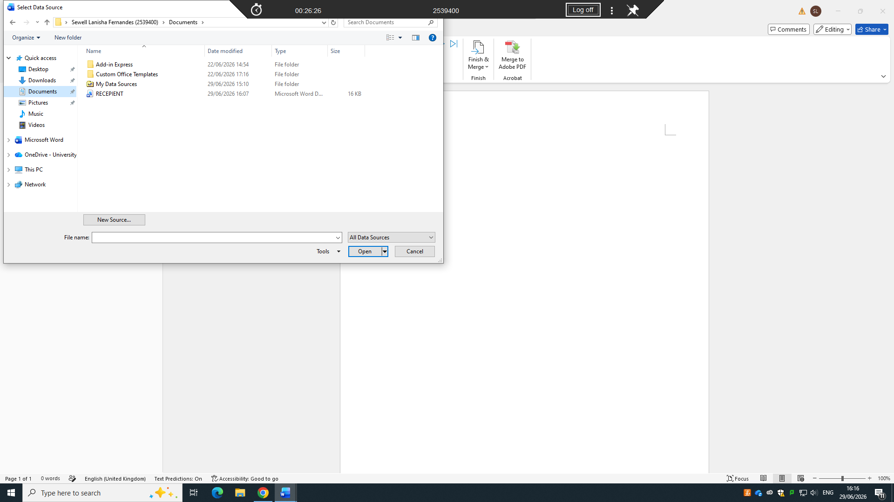
receipients
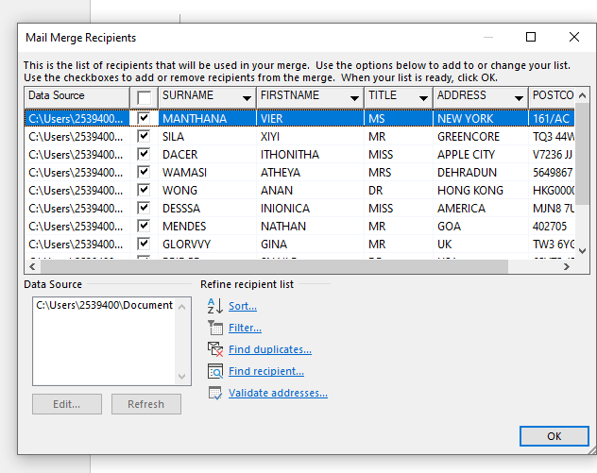
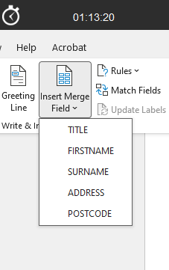

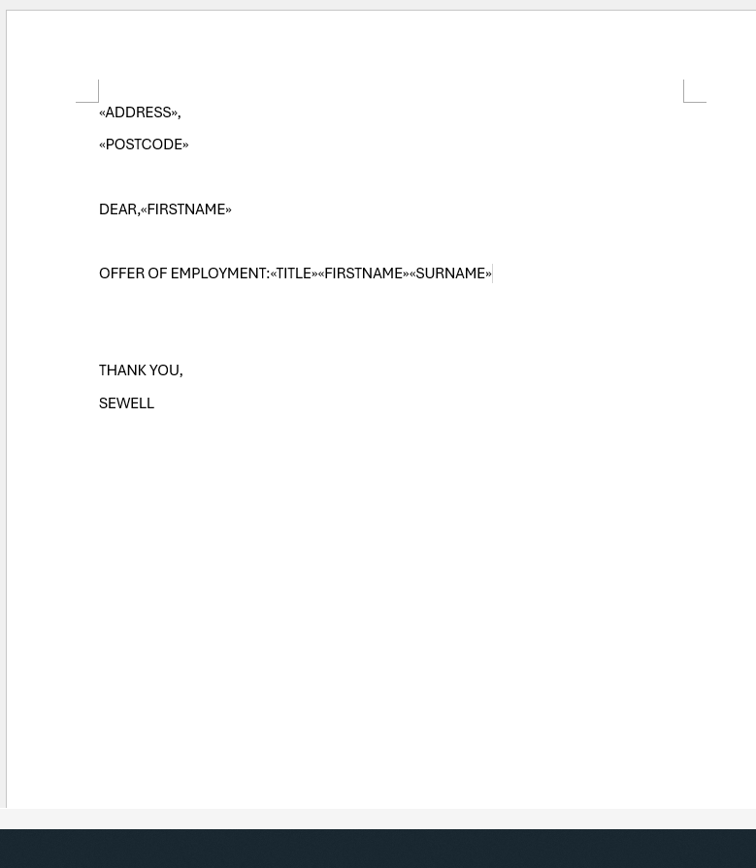
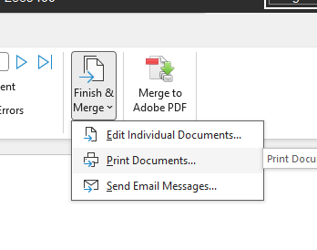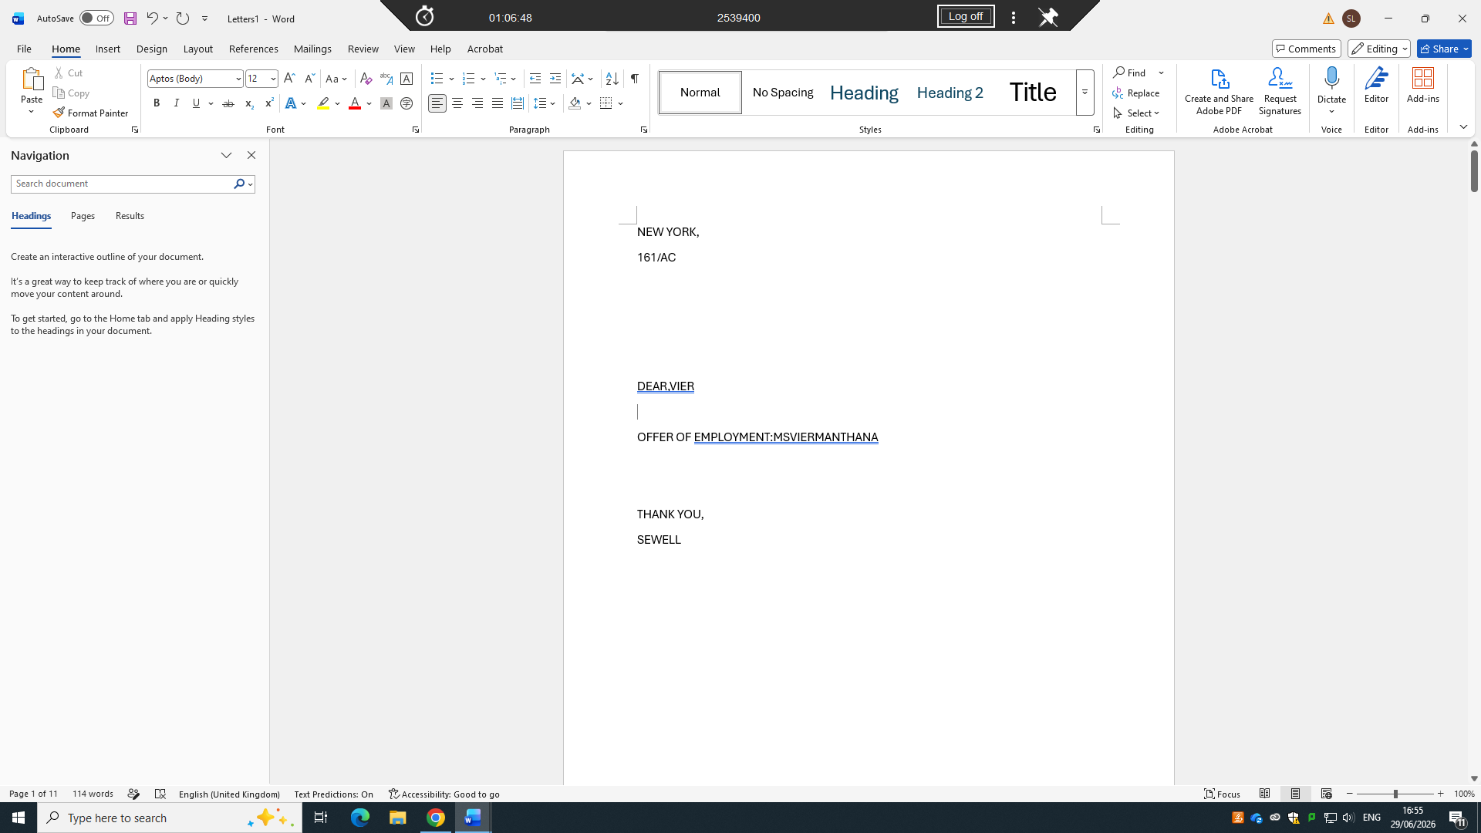
VLOOKUP
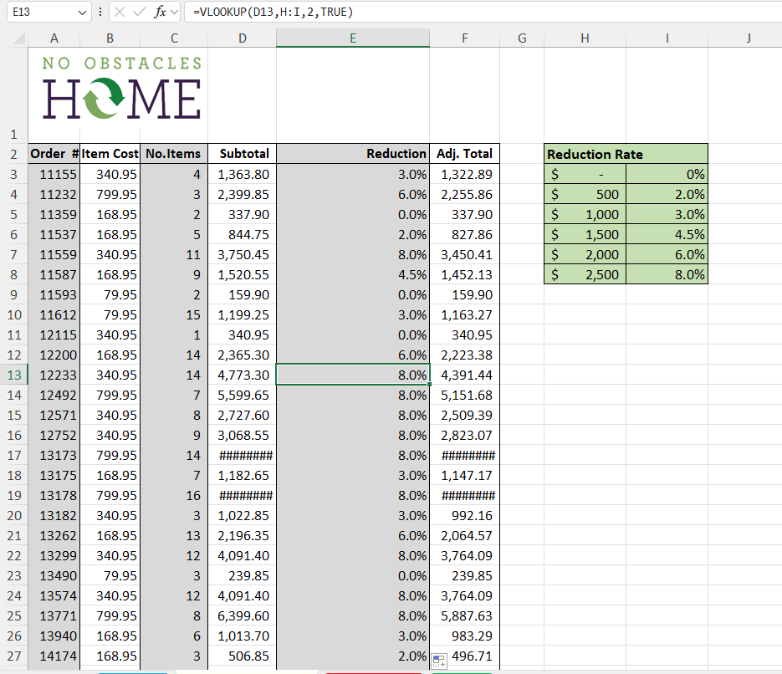
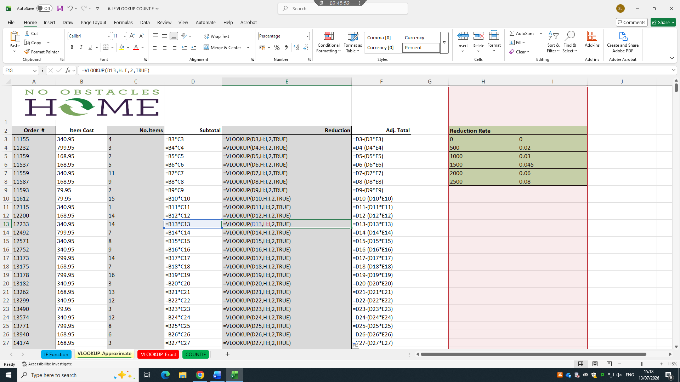

PIVOT TABLE
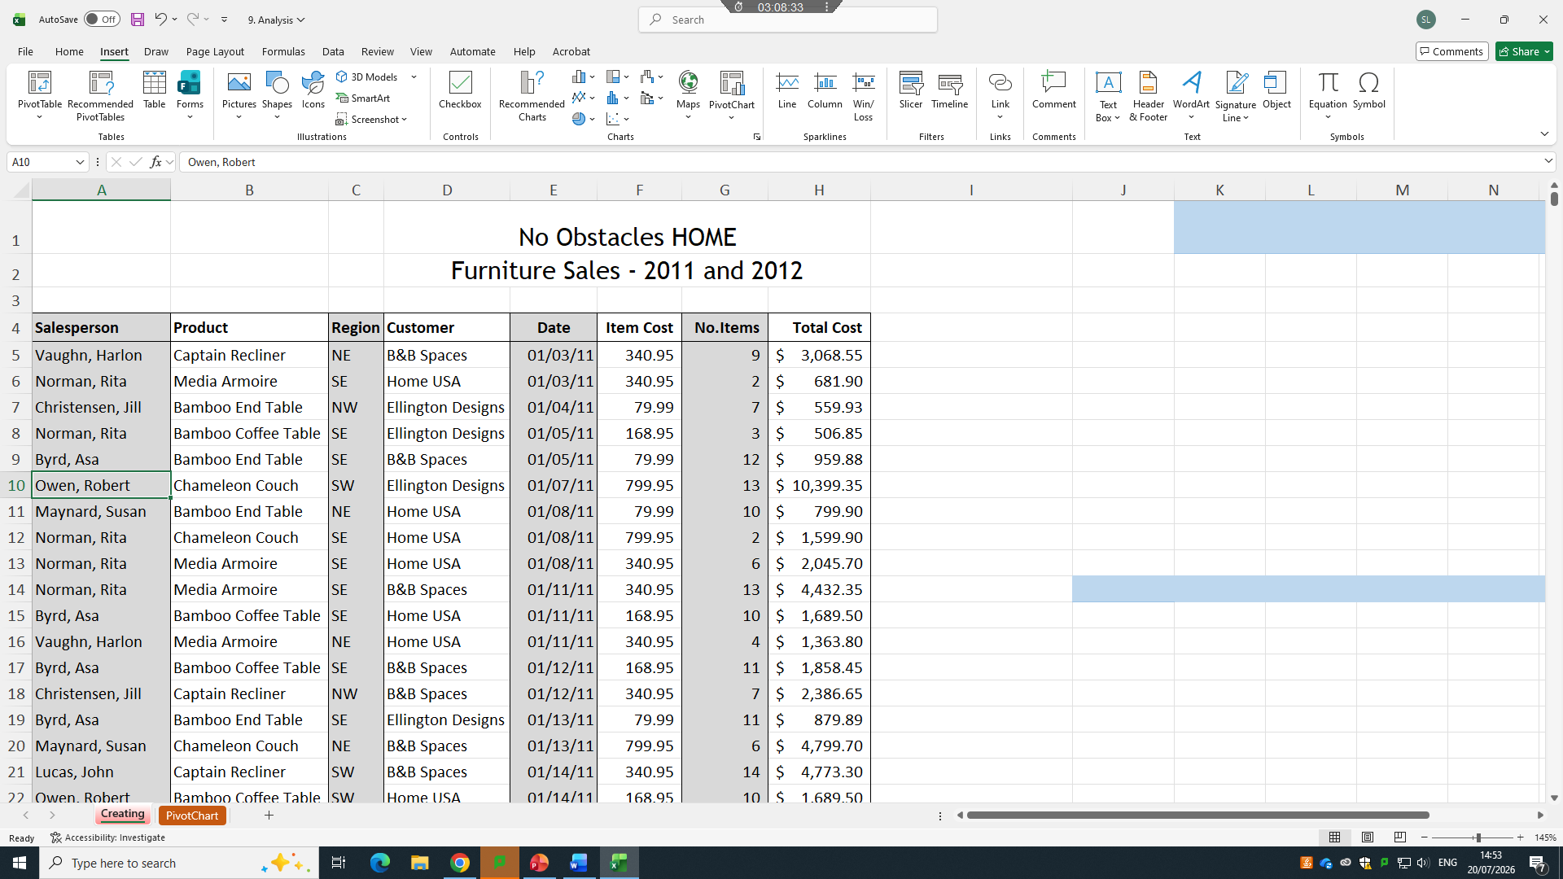
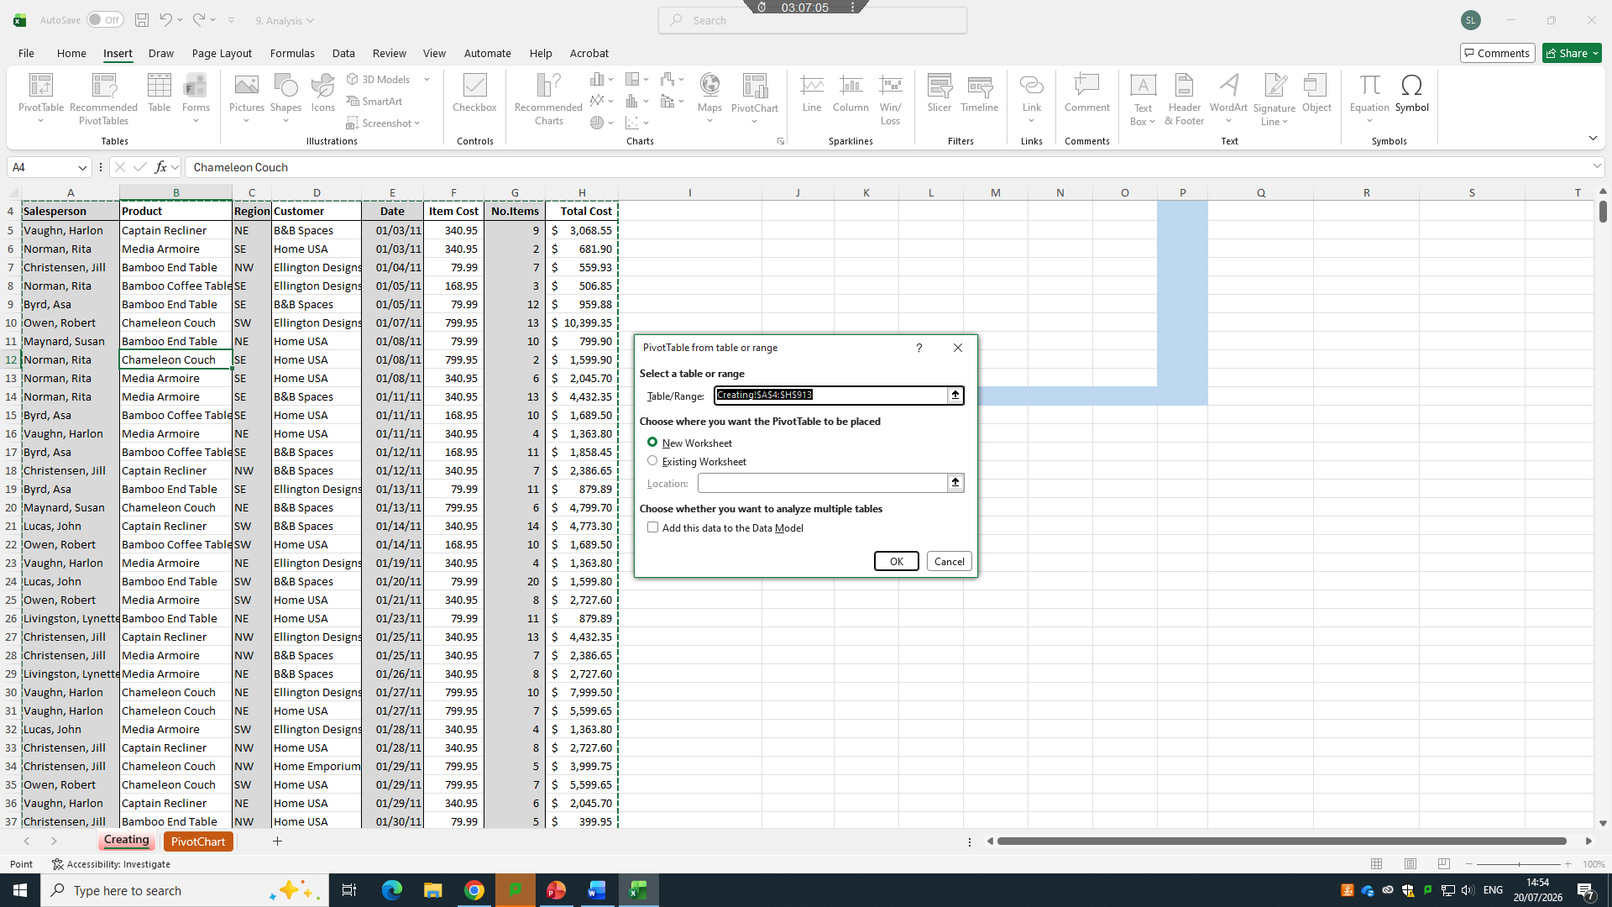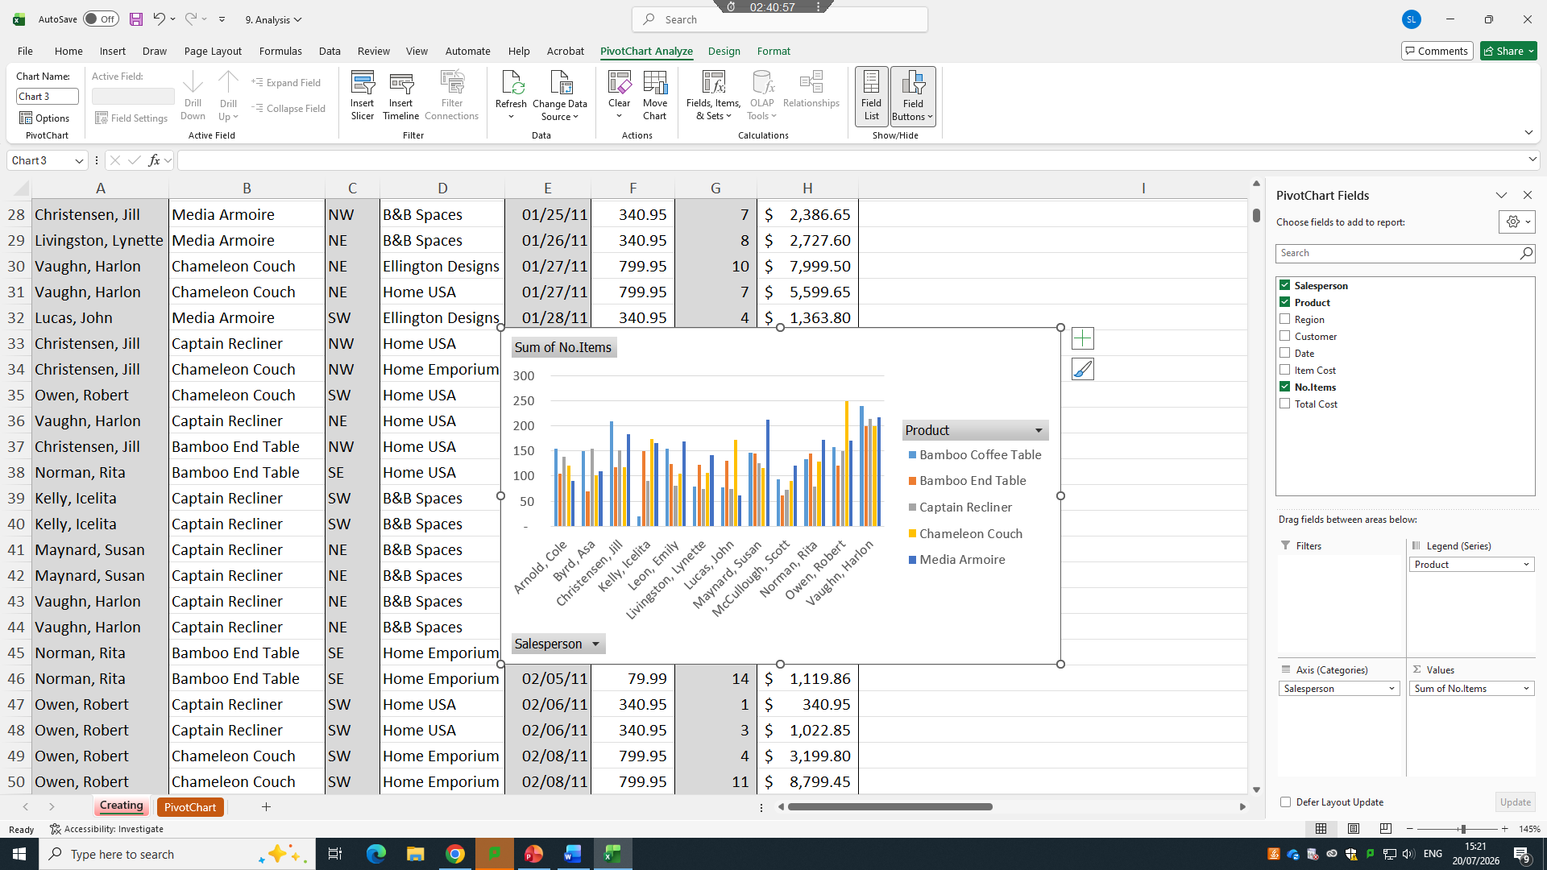
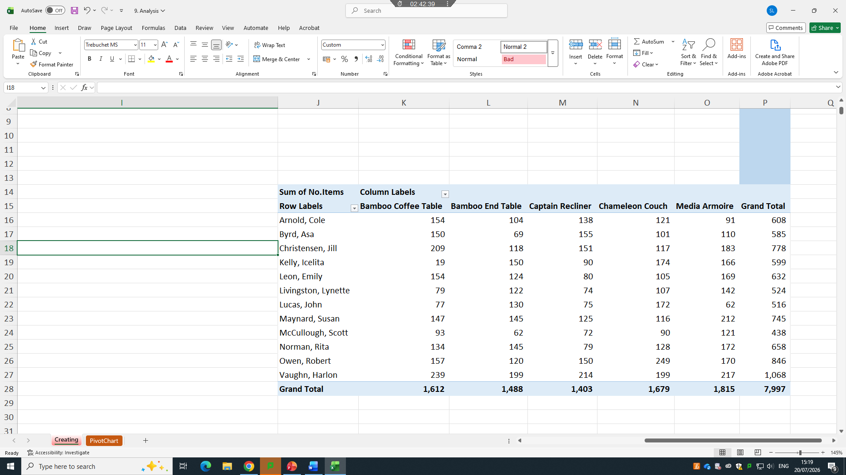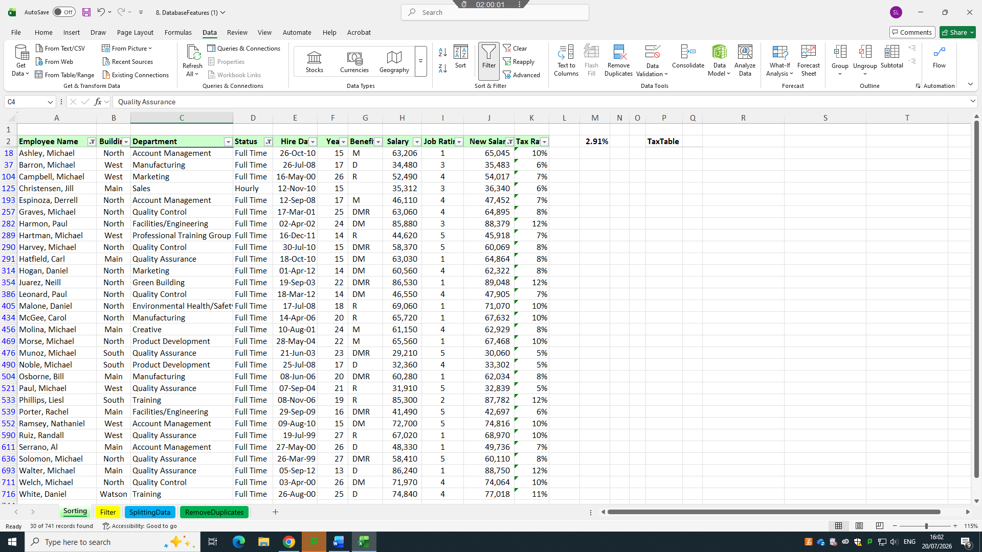

IF Statement
<Practical demonstration h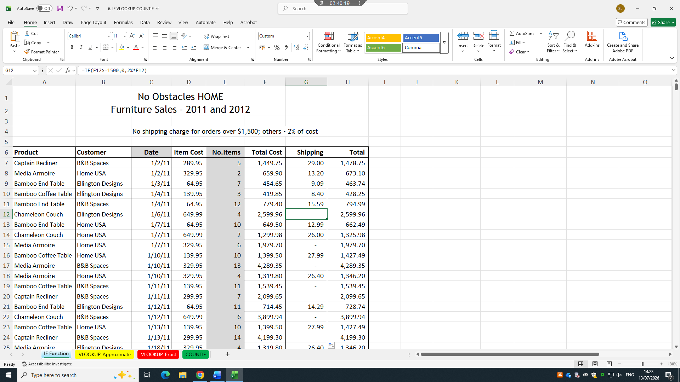

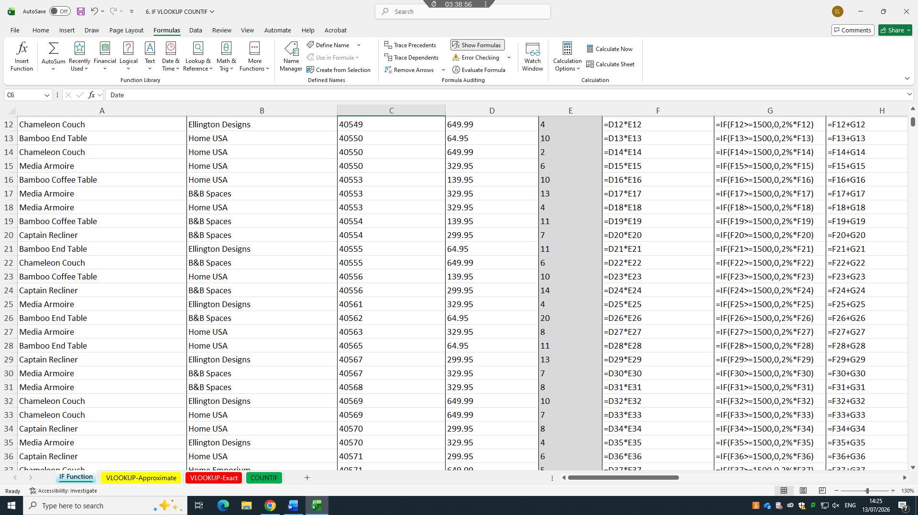

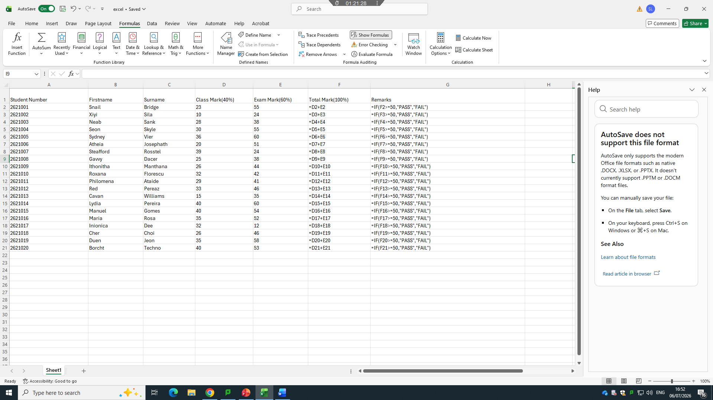

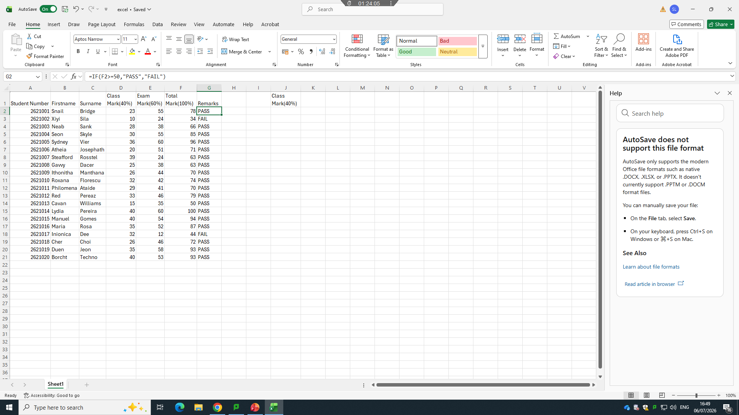

Task 4. Communication and Collaboration applications

4.1 One contemporary Communication and one Online Collaboration

MS OUTLOOK
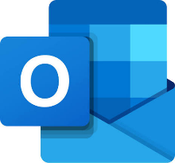
Microsoft Outlook is a free personal email and calendar manager offering web, desktop, and mobile access, basic spam filters, and 15 GB of mailbox storage. Microsoft Outlook streamlines productivity by combining your email, calendar, contacts, and tasks into one central hub. It boasts cross-device syncing, powerful organizational tools like search folders, and seamless integration with Microsoft 365 apps like Word and OneDrive.
Microsoft Outlook is an email and communication application developed by Microsoft. It is commonly used by students, businesses and organisations to send, receive and manage emails. Outlook also provides a calendar feature that allows users to schedule appointments, meetings, classes and important events. Users can create reminders to help manage their time and stay organised.
Microsoft Outlook allows users to organise emails into folders, mark important messages and search for specific information quickly. It can also relate to other Microsoft 365 applications, such as Teams, Word, Excel and OneDrive. For example, users can schedule a Teams meeting directly through Outlook and share documents with other people. Students can use Outlook to communicate with teachers and receive important university information, while businesses can use it for professional communication and managing appointments. Overall, Microsoft Outlook is a useful tool for email communication, organisation and time management.
Organization and Time Management
- Unified Inbox: Combines multiple email accounts, calendars, and contacts into a single easy-to-use screen.
- Shared Calendars: Lets you view coworker availability, schedule meetings, and coordinate group events quickly.
- Smart Tools: Includes features like priority sorting, email pinning, message snoozing, and built-in to-do lists.

MS TEAMS
Microsoft Teams is a digital teamwork hub that combines chat, video meetings, and file sharing into one single workspace. It is part of the Microsoft 365 suite and helps groups work together easily.
Microsoft Teams is a communication and collaboration platform developed by Microsoft. It is widely used by schools, universities and businesses to help people communicate and work together online. Teams allows users to send instant messages, make voice and video calls, and hold online meetings. Users can also create teams and channels to organise conversations and share information with specific groups.
Microsoft Teams provides useful features such as file sharing, screen sharing, online presentations and collaborative document editing. It integrates with Microsoft 365 applications, including Word, PowerPoint, Excel and OneDrive, making it easier to access and work on files in one place. Students can use Teams to attend online classes, submit work, communicate with lecturers and collaborate on group projects. Businesses can use it for meetings, project management and teamwork. Overall, Microsoft Teams improves communication, supports remote working and provides an efficient platform for collaboration.
Benefits of Microsoft Teams
- Integration of all tools in a single place. Microsoft has put convenience at the heart of Teams. ...
- No additional cost for Microsoft 365 users. Additional costs can be a deal-breaker for some companies. ...
- Useful chat additions. ...
- Seamless files search, backup, and collaboration. ...
- Helpful bots.

4.2 Test one feature of a freely available Communication (1) and one feature of a Collaboration (1) application

MS Outlook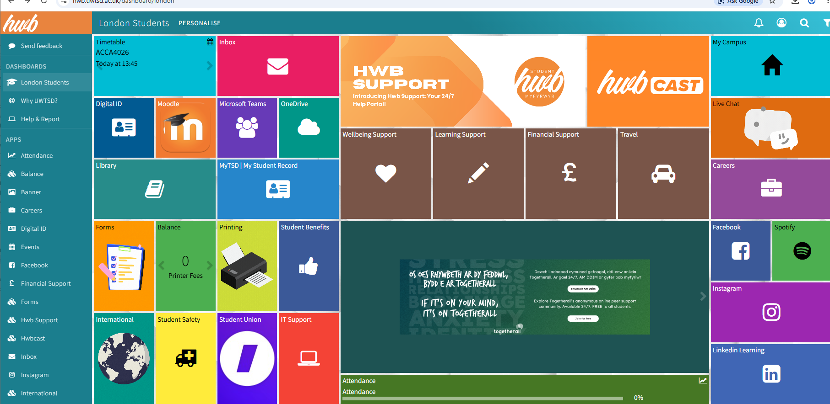

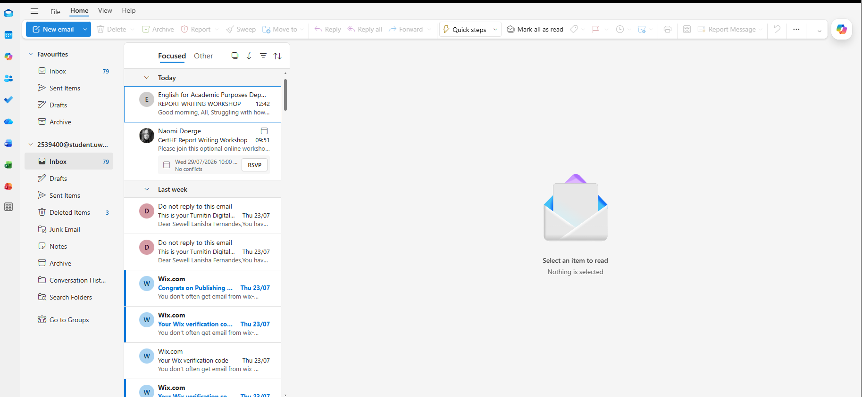

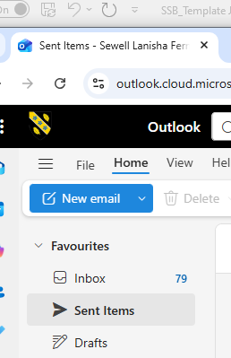

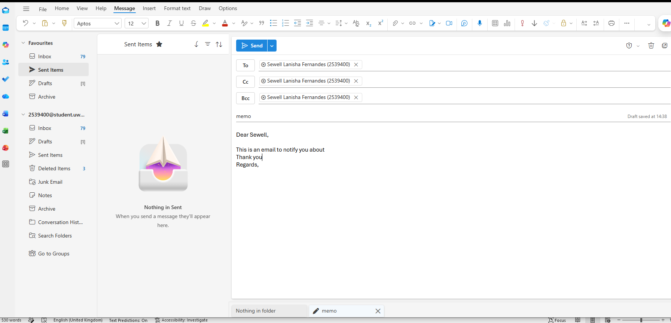

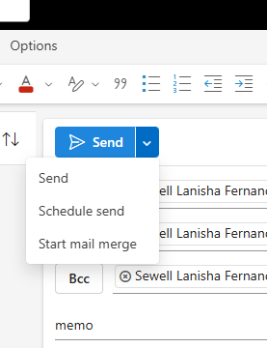

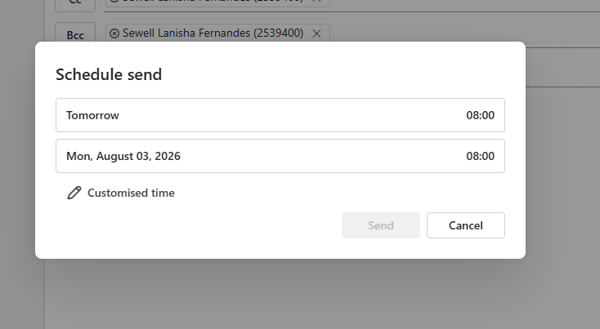

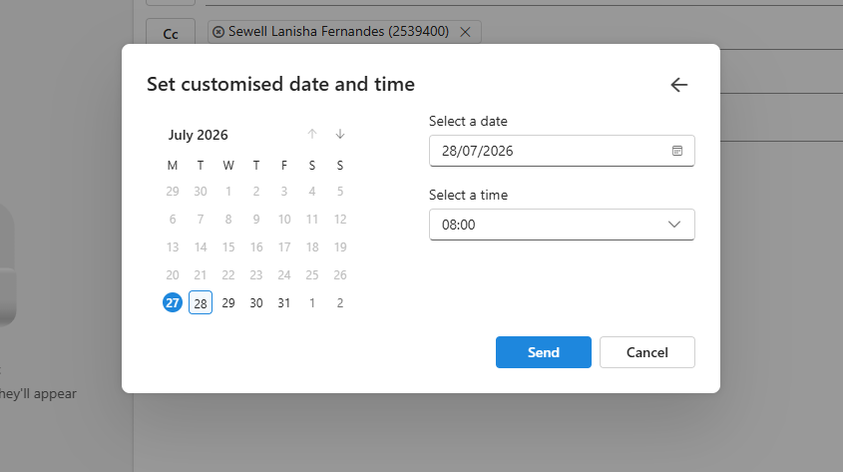

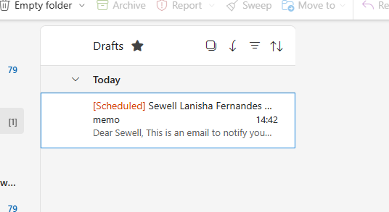

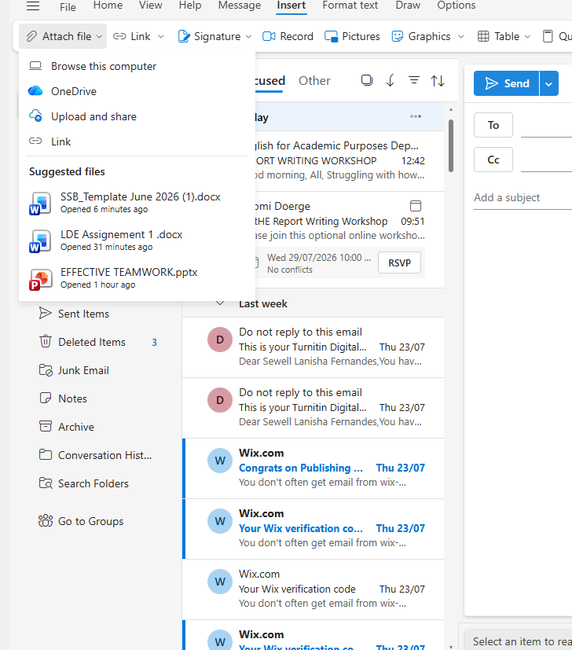

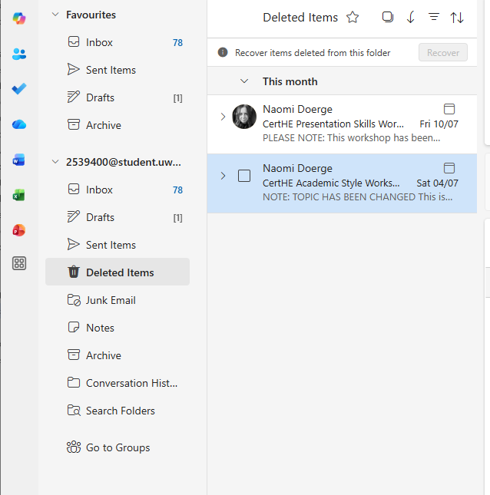

MS Teams
<Practical demonstration here>
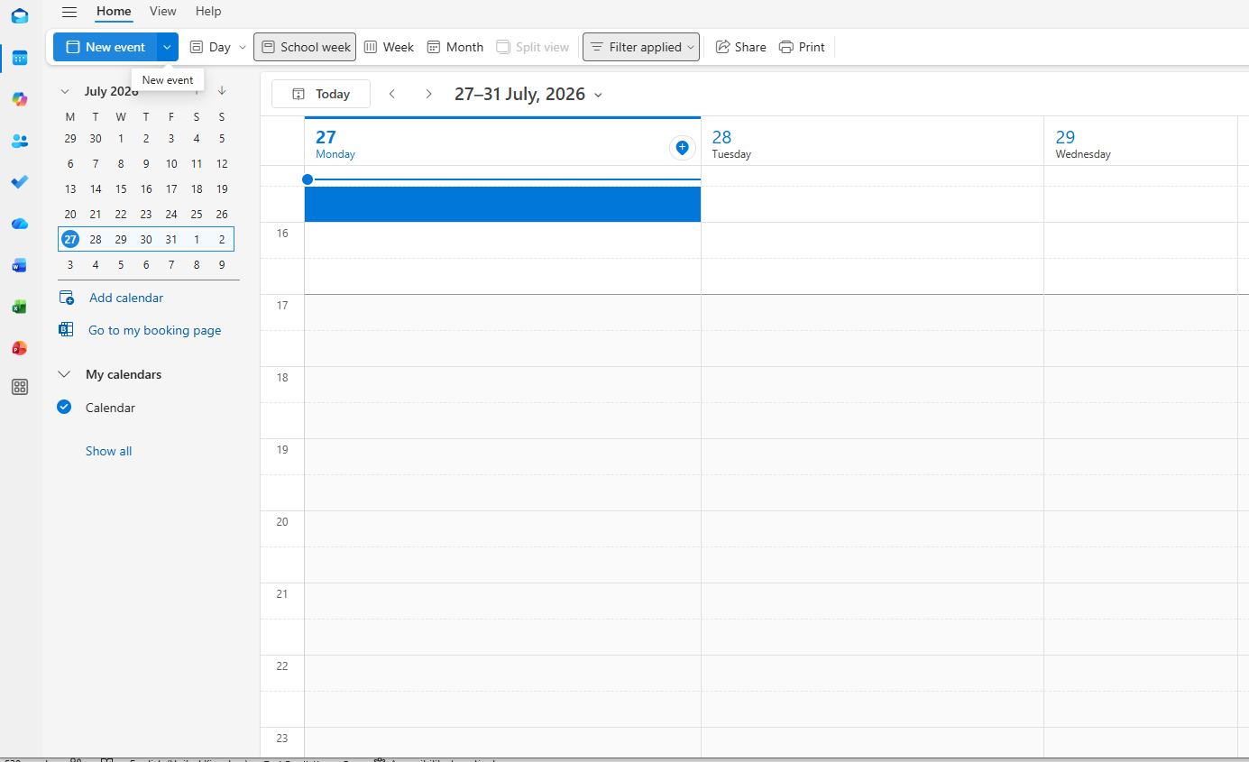
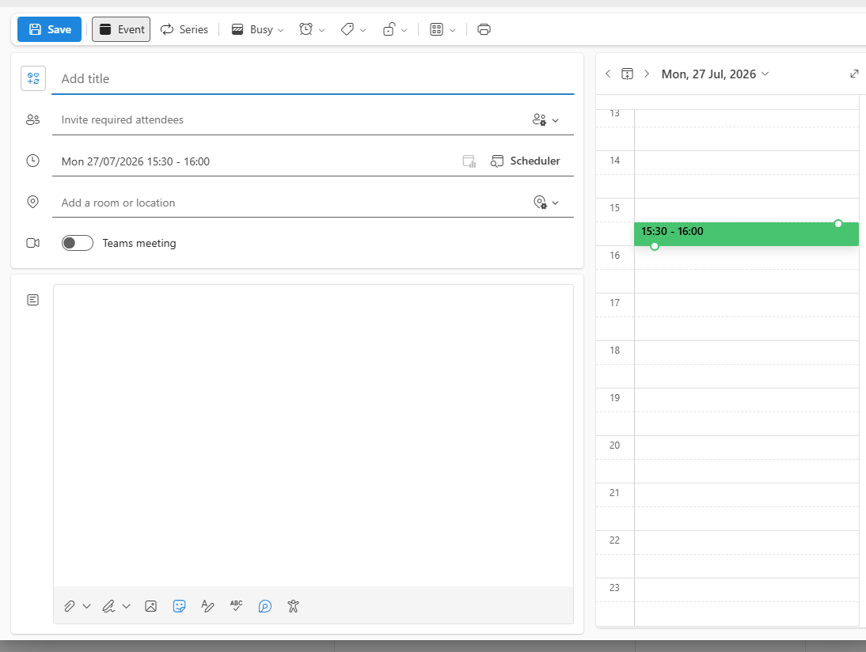
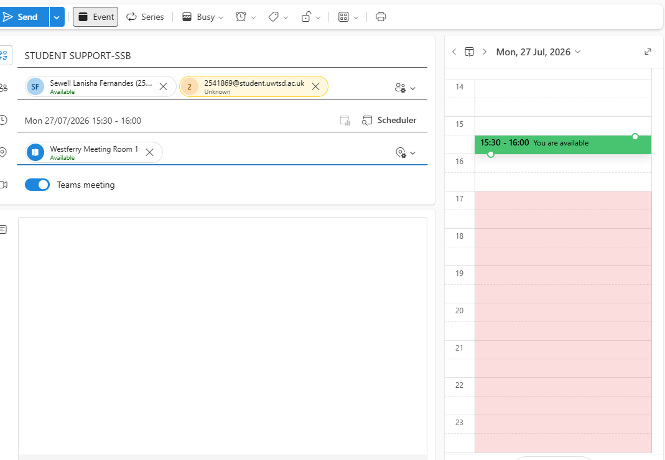
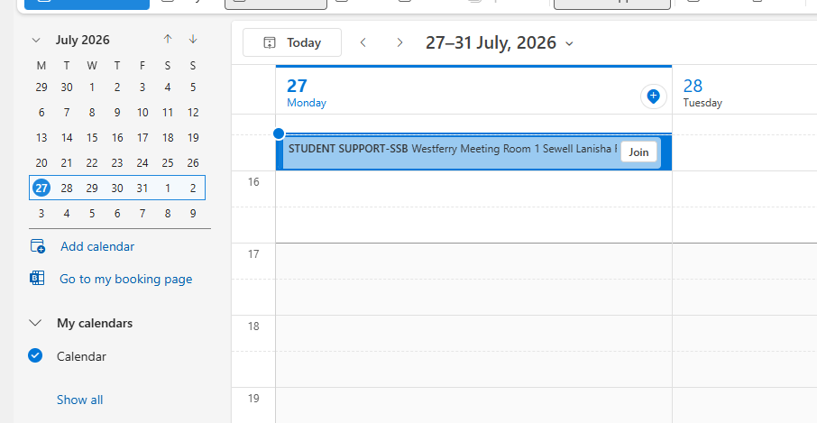

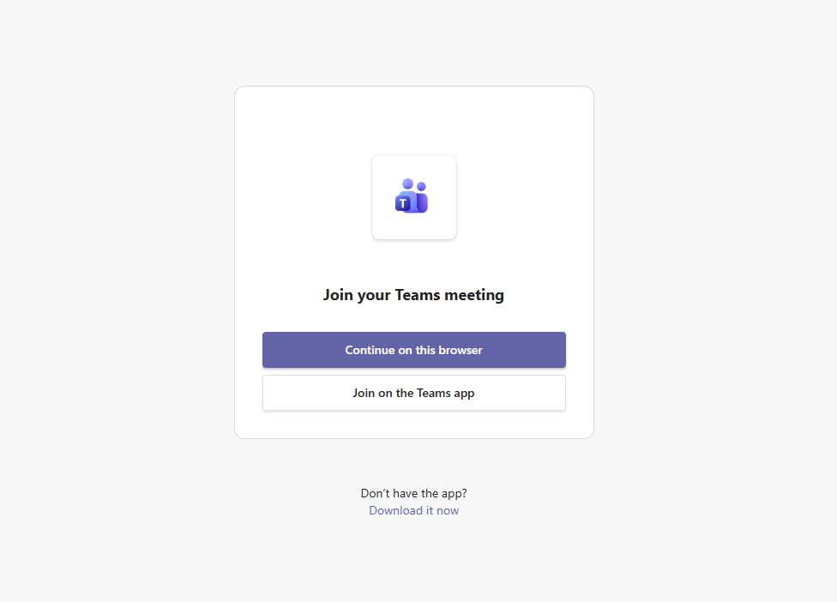
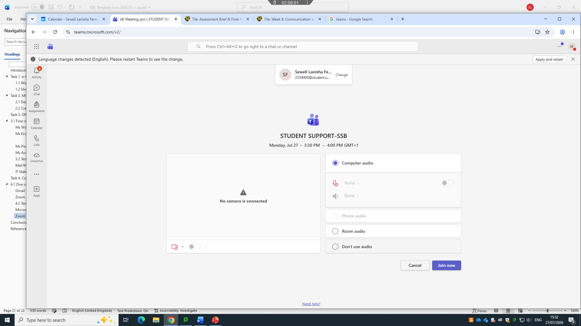

Conclusion
In conclusion, this assignment has explored a range of software applications and digital tools that are commonly used in modern business environments. E-commerce website builders such as Shopify and Wix can help businesses create an online presence and sell products or services more efficiently. Mind-mapping software can also support businesses by helping employees organise ideas, plan tasks and improve decision-making.

Furthermore, office applications such as Microsoft Word, PowerPoint, Excel and Access provide useful tools for creating, managing, presenting and analysing business information and data. Features such as Mail Merge, IF Functions, VLOOKUP and PivotTables can improve productivity, reduce manual work and make data management more effective. Communication and collaboration applications such as Microsoft Teams and Outlook also allow employees to communicate, share information, arrange meetings and work together effectively, even when working remotely. These tools are particularly important in modern workplaces where teamwork and digital communication are essential.

Overall, the effective use of these technologies can improve business operations, productivity, communication and decision-making. Developing knowledge of these digital tools can also improve employees' skills and confidence, allowing them to complete tasks more efficiently. Therefore, understanding and using digital technologies effectively is important for both businesses and individuals to remain productive and competitive in the modern digital workplace.

References

[2] | [Online]. Available: https://www.microsoft.com/en-gb/microsoft-365/products-apps-services.
[3] | “microsoft 365,” [Online]. Available: https://www.microsoft.com/en-gb/microsoft-365/products-apps-services.
[4] | [Online]. Available: https://www.microsoft.com/en-gb/microsoft-365/products-apps-services. [Accessed 03 08 2026].
[5] | R.E.Mayer, “Multimedia learning,2nd ed.cambridge UK,” 2009. [Online]. Available: http://www.cambridge.org.
[6] | B. M. Ralph Mercurio, “Beginning Microsoft 365 Collaboration Apps,” 2021. [Online]. Available: https://link.springer.com/book/10.1007/978-1-4842-6936-7.
[7] | J. Stratton, “Copilot for Microsoft 365,” 2024. [Online]. Available: https://link.springer.com/book/10.1007/979-8-8688-0447-2.
[8] | S. A. Nguyen Phong Nguyen, “Digitalization, inter-organizational collaboration, and technology transfer,” 2024. [Online]. Available: https://link.springer.com/article/10.1007/s10961-023-10031-z.
[9] | A.-A. Deschênes, “Digital literacy, the use of collaborative technologies, and perceived social proximity in a hybrid work environment: Technology as a social binder,” 2024. [Online]. Available: https://www.sciencedirect.com/science/article/pii/S2451958823000842?via%3Dihub.
[10] | T. V. V. K. T. S. Y. S. Olena Hlazunova*, “Development of students' digital competence using Microsoft 365,” 2024. [Online]. Available: https://humstudios.com.ua/en/journals/tom-12-2-2024/rozvitok-tsifrovoyi-kompetentnosti-studentiv-zasobami-microsoft-365.

References

[2] | [Online]. Available: https://www.microsoft.com/en-gb/microsoft-365/products-apps-services.
[3] | “microsoft 365,” [Online]. Available: https://www.microsoft.com/en-gb/microsoft-365/products-apps-services.
[4] | [Online]. Available: https://www.microsoft.com/en-gb/microsoft-365/products-apps-services. [Accessed 03 08 2026].
[5] | R.E.Mayer, “Multimedia learning,2nd ed.cambridge UK,” 2009. [Online]. Available: http://www.cambridge.org.
[6] | B. M. Ralph Mercurio, “Beginning Microsoft 365 Collaboration Apps,” 2021. [Online]. Available: https://link.springer.com/book/10.1007/978-1-4842-6936-7.
[7] | J. Stratton, “Copilot for Microsoft 365,” 2024. [Online]. Available: https://link.springer.com/book/10.1007/979-8-8688-0447-2.
[8] | S. A. Nguyen Phong Nguyen, “Digitalization, inter-organizational collaboration, and technology transfer,” 2024. [Online]. Available: https://link.springer.com/article/10.1007/s10961-023-10031-z.
[9] | A.-A. Deschênes, “Digital literacy, the use of collaborative technologies, and perceived social proximity in a hybrid work environment: Technology as a social binder,” 2024. [Online]. Available: https://www.sciencedirect.com/science/article/pii/S2451958823000842?via%3Dihub.
[10] | T. V. V. K. T. S. Y. S. Olena Hlazunova*, “Development of students' digital competence using Microsoft 365,” 2024. [Online]. Available: https://humstudios.com.ua/en/journals/tom-12-2-2024/rozvitok-tsifrovoyi-kompetentnosti-studentiv-zasobami-microsoft-365.

