BirminghamLives: Community Health Network

Name: Diana Briceag
Student Number: 2408209
Module: Changemakers: Creativity &Value Creation
Module Code: BMHP5014
Assessment Title: Written Assignment

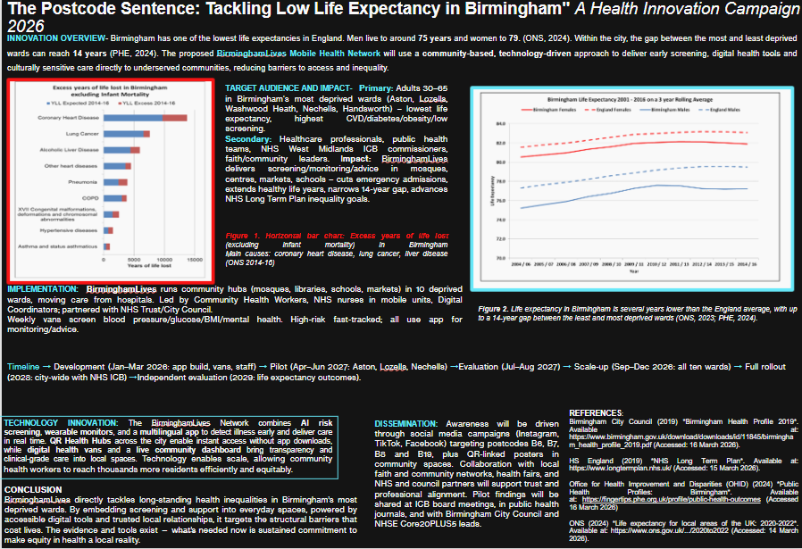

Figure 1: BirminghamLives Mobile Health Network poster

Introduction
Birmingham stands as England's youngest, most diverse city yet exhibits profound health inequalities. Male life expectancy averages 75 years (national: 80); females reach 79 (national: 83) (ONS, 2024). Intra-city disparities are starker still: a 14-year gap separates the most from least deprived wards, comparable to differences between nations (OHID, 2024).
The BirminghamLives Mobile Health Network directly confronts this public health crisis. Building on the adjacent poster evidence, this proposal articulates the intervention's necessity, mechanistic rationale, projected outcomes, and essential stakeholder roles in achieving health equity across Birmingham's underserved communities.

Target Communities and Health Disparities
This initiative targets adults aged 30–65 in Birmingham's most deprived wards Aston, Lozells, Washwood Heath, Nechells, and Handsworth where life expectancy is lowest, cardiovascular disease prevalence exceeds the national average by 40% (NHS West Midlands ICB, 2024), and NHS screening uptake remains consistently poor. These areas encompass 41% of neighbourhoods within England's most deprived decile (OHID, 2023), with child poverty rates double the national average (CPAG, 2023), compounded by entrenched structural determinants including poverty, substandard housing, food insecurity, and protracted public health underfunding (King's Fund, 2019).
These communities demonstrate health engagement when services align with their realities. Current systems fail through inflexible GP scheduling, geographically distant facilities, and monolingual health communications. The BirminghamLives Network systematically eliminates these access barriers through community-embedded delivery

Mechanism of Health Improvement
The BirminghamLives principle is deceptively simple: healthcare delivered to communities, not communities compelled to seek healthcare. Mobile health units operate on published weekly schedules across Birmingham's ten most deprived wards, stationed at mosques, libraries, schools, markets, and community centres. Trained Community Health Workers residents fluent in community languages and embedded within established trust networks deliver free screening for blood pressure, glucose, BMI, and mental health indicators.
Early detection fundamentally alters disease trajectories. For cardiovascular disease, Type 2 diabetes and hypertension, conditions responsible for Birmingham's excess years of life lost timely risk identification substantially reduces emergency admissions, chronic disability, and premature mortality. High-risk individuals access fast-track referral pathways to GPs and specialists, circumventing the diagnostic delays that characterise late-stage presentations in deprived wards.
Digital equity underpins accessibility. The multilingual BirminghamLives app facilitates screening bookings, personalised health guidance, and service location. QR codes at bus stops and community noticeboards ensure smartphone-independent access. This design excludes no resident regardless of linguistic background, socioeconomic status, or digital proficiency.

Policy Alignment and Regulatory Compliance
The BirminghamLives Network integrates seamlessly within existing healthcare infrastructure, directly advancing national policy imperatives. It operationalises the NHS Long Term Plan (2019) commitment to community-centric care and health inequality reduction, while executing the Core20PLUS5 framework's mandate to prioritise cardiovascular disease, diabetes, and mental health interventions within England's 20% most deprived populations.
Data governance adheres rigorously to UK GDPR and Data Protection Act 2018 standards, with anonymised patient information secured on NHS-approved servers. Clinical protocols conform to NICE guidance for cardiovascular prevention and diabetes screening, delivered by NMC/GMC-registered practitioners from CQC-registered mobile units. The Equality Act 2010 informs universal design principles, manifest in the multilingual app and strategically selected community venues.
Strategic delivery partnerships encompass Birmingham Community Healthcare NHS Trust, City Council Public Health directorate, NHS West Midlands ICB, and West Midlands Combined Authority. This constitutes not parallel provision, but systemic reinforcement of established professional architectures.

The Societal Imperative for Universal Civic Engagement
Birmingham's health disparities represent a systemic burden transcending individual circumstances, precipitating NHS capacity crises through preventable chronic disease among working-age adults and perpetuating intergenerational deficits in educational attainment, labour market participation, and social cohesion across deprived communities (Birmingham City Council, 2022). Health inequity constitutes an urban prosperity challenge demanding cross-sectoral mobilisation.
The general public can amplify #BirminghamLives awareness across Instagram, TikTok and Facebook targeting postcodes B6–B19. Healthcare practitioners should advocate referral pathway integration through ICB governance structures. Faith and community leaders are invited to host screening events at mosques and centres within pre-programmed partnership frameworks. Students may join the Community Health Worker training and volunteer delivery programme. Target ward residents should access free mobile screening services and accompany high-risk household members. Health equity demands active participation across all societal strata.

Conclusion
The BirminghamLives Mobile Health Network constitutes an evidence-based intervention addressing Birmingham's entrenched four-decade health inequality crisis. Residents of the most deprived wards experience premature mortality not through personal agency deficits, but through systemic failures in healthcare access, economic opportunity, and living conditions that have persisted despite extensive documentation.
This innovation operationalises place-based healthcare delivery, leveraging technology as an accessibility conduit rather than barrier. Multilingual screening, continuous monitoring, and culturally congruent advice are embedded within trusted community infrastructure, fully compliant with NHS governance and regulatory frameworks. The empirical foundation, technological infrastructure, and professional partnerships stand ready.
Sustained cross-sectoral commitment from policymakers, clinicians, community leaders, and citizens remains the sole prerequisite to transform health equity from aspiration to attainment in Birmingham. Each annum of inaction represents irrecoverable life years across the city's most vulnerable wards. This trajectory demands urgent, collective rectification.

References
Birmingham City Council (2022) *Creating a Bolder, Healthier City 2022-2030*. Birmingham: Birmingham City Council. Available at: https://www.birmingham.gov.uk/download/downloads/id/23756/creating_a_bolder_healthier_city_2022_to_2030.pdf (Accessed: 19 March 2026).
Child Poverty Action Group (2023) *Child poverty in the UK*. London: CPAG. Available at: https://cpag.org.uk/child-poverty/child-poverty-facts-and-figures (Accessed: 23 March 2026).
King's Fund (2019) *Health inequalities in Birmingham: The impact of public health grant cuts*. London: The King's Fund. Available at: https://www.kingsfund.org.uk/publications/health-inequalities-birmingham (Accessed: 21 March 2026).
NHS West Midlands Integrated Care Board (2024) *Cardiovascular disease intelligence profile: Birmingham and Solihull*. West Midlands: NHS West Midlands ICB. Available at: https://www.nhsbmwp.icb.nhs.uk/publications (Accessed: 20 March 2026).
Office for Health Improvement and Disparities (2023) *Public Health Profiles: Birmingham Local Authority*. London: OHID. Available at: https://fingertips.phe.org.uk/profile/public-health-outcomes-framework (Accessed: 22 March 2026).
Office for National Statistics (2024) *Life expectancy in local areas of the UK: 2020-2022*. London: ONS. Available at: https://www.ons.gov.uk/peoplepopulationandcommunity/birthsdeathsandmarriages/lifeexpectancies/bulletins/lifeexpectancyinlocalareasintheuk/2020to2022 (Accessed: 22 March 2026).

