UNIVERSITY OF WALES TRINITY SAINT DAVID
LONDON CAMPUS
Module Name: Software Solution for Business
Module Code: ACCA 4026

Student Name: Valerii Vdovin
Student ID:2510682
Group:4

Lecturer’s Name: Rajeev Nath
Assessment 1
Software Solution for Business

Contents
Introduction 3
Task 1. e-Commerce Website builders/software solutions 3
1.1 Wordpress 3
1.2 Wix 4
Task 2. Mind-map of contemporary software applications 4
a. Mind mapping and explain the benefits of using mind mapping in business operations 4
b. I create a mind map of contemporary software applications 5
Task 3. Office Applications 6
a. Four office software solutions for business operations 6
MS Word 6
MS PowerPoint 7
MS Excel 8
MS Access 9
b. Practical Demonstration of the Two Features 11
Mail Merge 11
IF Function 12
Task 4. Communication and Collaboration applications 13
a. One contemporary Communication and one Online Collaboration 13
MS Teams 13
Miro 14
b. Test one feature of a freely available Communication (1) and one feature of a Collaboration (1) application 16
MS Teams 16
Miro 17
Conclusion 17
References 18

Introduction
In this assignment, I explore modern software applications used in office and business environments and analyse their functional capabilities and practical usage scenarios. As part of the assignment, I studied popular tools for creating websites, Microsoft Office applications, communication tools, and collaboration services. The aim of the work is to study the features of various software solutions, evaluate their advantages and limitations, and demonstrate practical skills in working with them. In addition, practical tasks were completed, including the use of Mail Merge functions in Word and the IF logical function in Excel, and screenshots were prepared to confirm the skills of applying the programmes in practice. The work is aimed at developing an understanding of the role of digital tools in organising work processes and improving user efficiency.

Task 1. e-Commerce Website builders/software solutions

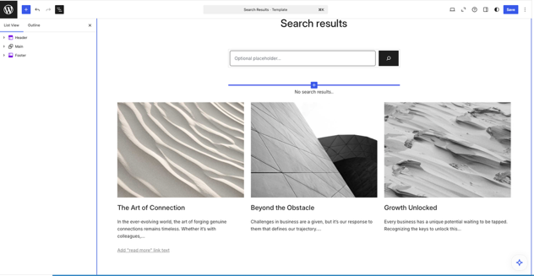
1.1 Wordpress
The first release of this application took place on 27 May 2003 [1]. It is an open-source project, on the basis of which the more well-known wordpress.com was subsequently created. It allows you to create websites online without installing any software (if you'd like to try WordPress for free, you can get started with a free website or blog at WordPress.com [2]. Figure 1 shows templaate Editor in Wordpress
Figure 1: WordPress Template Editor (Personal Collection)
So, wordpress.com allows us to create websites, and the process is quite simple. All you need to do is click on the ‘create a website’ button. Here, you can use AI to create your website by simply describing what you want to see on it.
In my opinion, its strengths are: The ability to easily and simply create a website, using AI to speed up development and help with difficulties.
A large number of plugins that simplify the addition of various functions to your website, such as WooCommerce, which allows you to set up payment on your website [3].
Cons: Many features are hidden behind a paid tier, even simple monitoring requires payment. There is also a paid subscription that removes ads from your site, adds themes, and allows you to install plugins [4].

1.2 Wix
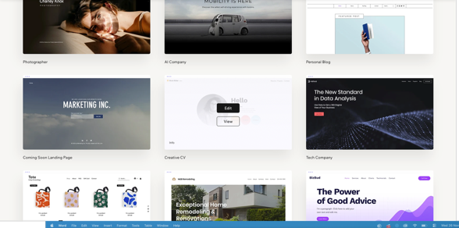
Wix was created in 2006 by three people: Avishai Abrahami, Nadav Abrahami, and Giora Kaplan. In 2008, they created Flash Editor [5].
Wix, like WordPress, allows us to create websites. It offers both ready-made website templates and blank ones. AI features have not been overlooked in this project either, so websites can be created using prompts and explanations of how you want the website to look. Figure 2 shows Template Picker
Figure 2: Wix Template Picker (Personal Collection)
One of the advantages is that there are marketing settings so that you can advertise your website on various platforms such as Google, Facebook, and Instagram. Built-in analytics allow you to track where users come to your website from and monitor the number of users online. Of course, the ability to publish your website directly to the internet is a plus, but you will need to use a Wix domain for this.
Again, one of the downsides is that most of the features are hidden behind a paid subscription, which also gives you free domains and the ability to remove Wix branding from your website. Collaboration is a feature that allows you to work on a website with someone else. The ability to accept payments on your website is also unavailable to free users [6].

Task 2. Mind-map of contemporary software applications

a. Mind mapping and explain the benefits of using mind mapping in business operations
A mind map is a visual, non-linear diagram used to represent ideas and the connections between them around a central concept. It helps to structure information logically and develops creativity, thinking and understanding. Mind maps allow people to explore complex topics and identify relationships. Today, this tool is used in education, healthcare and business to improve planning, analysis and communication [7].
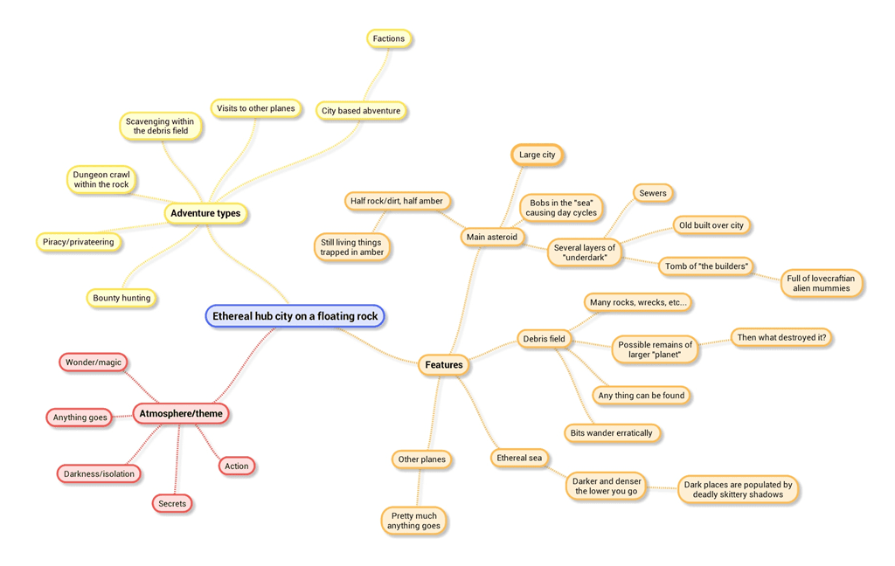 Figure 3: Mind map example [8]
Mind maps have found practical application in planning the recovery of manufacturing industries after the COVID-19 pandemic. With the help of mind maps, the interrelationships between key factors, such as production, personnel management, and supply, were identified. By visualising these connections, organisations were able to set priorities and improve coordination between departments. Senior management also saw how individual problems affect the achievement of goals. Thus, mind maps are not only a creative element, but also an analytical tool for planning in various complex and ordinary conditions [9].
In business, mind maps are utilised to enhance knowledge management and promote innovation. Companies use this method to systematise information from large data sources, such as reports and patents, to identify patterns that help inform management decisions. With their help, teams visualise complex systems, highlight connections between different processes, and find creative solutions to problems. Mind maps also help companies integrate sustainability principles by analysing various factors in a single visualisation. Organisations can make strategic decisions more effectively and strengthen cooperation between different departments by presenting information in a clear and interconnected way [10].
Based on the above, it can be said that mind maps play an important role in modern business and knowledge management. They help to systematise information, identify interrelationships between processes, and make more informed decisions. Thanks to its visual nature, this tool is equally effective for strategic analysis and everyday planning. Mind maps combine creativity and logic, helping organisations to improve communication, coordination, and work efficiency.

b. I create a mind map of contemporary software applications
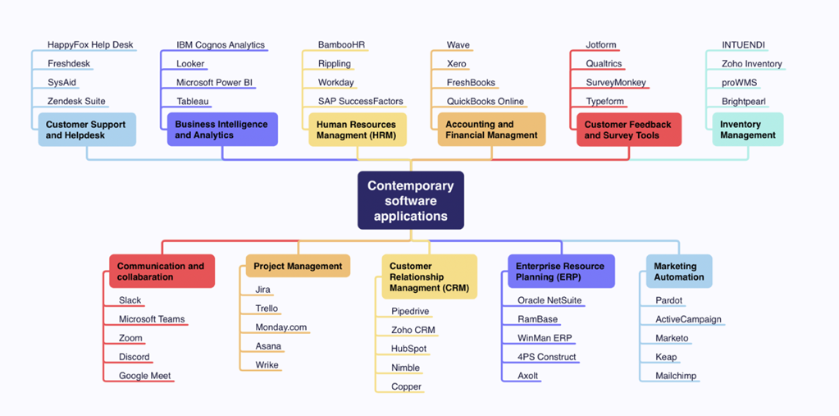
Figure 4: Mind map (Personal Collection)

Task 3. Office Applications

a. Four office software solutions for business operations

MS Word
Microsoft Word is one of the most popular word processors in the world, used both at home and in business. Word is part of the Microsoft Office suite, which provides a complete set of tools for creating, editing, and managing text documents.
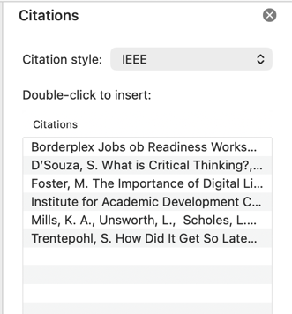
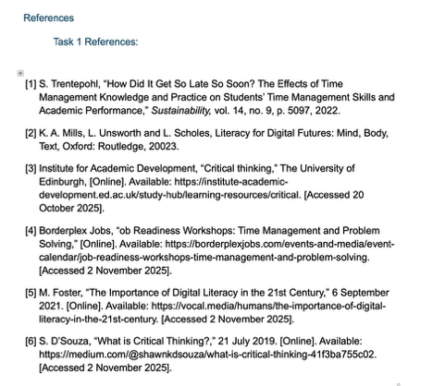
In my opinion, Word's user-friendly interface is a key advantage. Built-in templates, styles, and automatic formatting speed up your work and help you create professional materials without any special design skills. For academic and research tasks, Word offers specialised features such as automatic table of contents creation, footnote management, bibliography generation, and source management using the Reference Tool.
Figure 5: Bibliography view (Personal Collection)
Figure 6: Citations window (Personal Collection)
An important feature of Word is its support for collaboration, especially in modern business. Thanks to integration with OneDrive and SharePoint, users can simultaneously edit documents, leave comments, track changes, and view the document's version history. These capabilities simplify the process of collaborative document creation and approval, reducing communication time and improving teamwork.
In addition to standard text editing, Word supports a wide range of visual and interactive elements. You can add images, tables, charts, SmartArt diagrams, hyperlinks, and even 3D objects to your document. Integration with Excel and PowerPoint allows you to import tables, charts, and presentation materials directly from Excel and PowerPoint, making Word a versatile platform for preparing complex reports and analytical files.
Despite its advantages, most features are only available with a paid Microsoft 365 subscription. Free users only have access to a limited online version of the application, where only basic text editing is available. Free users also do not receive new features in updates, only security updates [11].
To sum up, Microsoft Word remains a key tool for business communication and documentation. Thanks to its rich functionality, ease of use, collaborative editing capabilities, and integration with other Microsoft products, Word enables efficient workflow organisation and remains an indispensable application in today's digital environment.

MS PowerPoint
Microsoft PowerPoint is one of the most widely used tools for creating presentations and visual communications, actively used in business, education, and professional environments. Like Word, PowerPoint is part of Microsoft Office, providing users with a platform for preparing presentations that include text, images, graphs, charts, videos, animations, and various other elements. Thanks to its flexibility and convenience, PowerPoint has become the de facto standard for business meetings, employee training, project presentations, marketing presentations, and academic lectures.
One of the key advantages of PowerPoint is its ability to present complex information in a clear and easily digestible form. Users can create slides themselves or use built-in templates, change colour schemes, fonts, and graphic elements, adapting the design to the corporate style or format of the event. You can also insert tables, charts, and SmartArt objects into your presentation, which makes this application even more versatile.
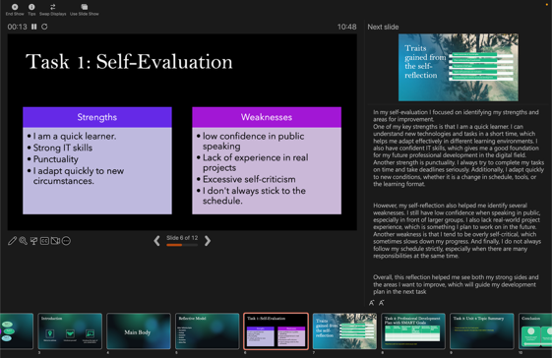
PowerPoint has a Presenter View mode, allowing the presenter to control the presentation. In this mode, you can view notes on the slide and see which slide will be next, while those watching will only see the relevant slide [12]. The ability to record your voice on a presentation makes the application useful for distance learning, preparing video lectures, online courses, and corporate training. These features significantly expand the use of PowerPoint in educational and professional environments, providing flexibility for both face-to-face and remote communication formats.
Figure 7: Power Point Presenter View (Personal Collection)
Collaboration is also an important feature of PowerPoint. Integration with OneDrive and SharePoint allows multiple users to edit a presentation simultaneously, leave comments, and agree on changes. As I understand it, collaboration works the same way as in Word and all other Microsoft Office programmes [13].
I must mention that, even though PowerPoint's extensive capabilities, there are certain limitations. If you overload your slides with too much text and excessive graphics, they will lose their effectiveness as a convenient visual tool. Also, working with heavy multimedia files sometimes leads to reduced performance on weaker devices and can also make it difficult to send presentations. Most importantly, creating high-quality visual content requires design skills to avoid unstructured and visually oversaturated designs.
Consequently, PowerPoint remains one of the key tools for visual communication and presentation activities in the modern world. Its functionality, flexibility, collaboration features, and integration with other Microsoft applications ensure its continued relevance in professional and educational spheres.

MS Excel
Microsoft Excel is an important tool for working with data, analytics, and process automation in modern business. As part of the Microsoft Office suite, Excel provides users with extensive capabilities for performing calculations, organising data, building visualisations, and analysing information. Thanks to its versatility and flexibility, the application is actively used in various professional fields, from accounting and finance to marketing, logistics, technical design, and scientific research.
A key advantage of Excel is its ability to efficiently process large amounts of data. The application allows you to create tables of any complexity, structure information, and perform calculations using a huge set of built-in functions, such as simple arithmetic operations and advanced statistical, logical, and financial formulas. Users can automate tasks using formulas, formatting, sorting and filtering tools, making Excel a convenient tool for everyday business processes.

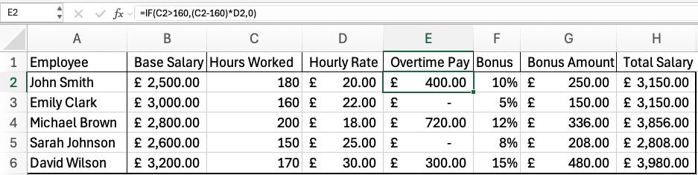
Excel is widely used for data analysis thanks to its analytical capabilities. Tools such as pivot tables and pivot charts allow you to quickly process large amounts of information, identify patterns, build reports, and visualise key metrics. Built-in tools for forecasting and trend analysis enable organisations to make data-driven decisions [14].
Figure 9: Excel sheet example (Personal Collection)
Figure 8: Formula Example (Pesonal Collection)
Visualisation capabilities are also an important part of Excel. The application allows you to create a wide variety of graphs and charts that help present data in a clear way. This is especially useful for preparing presentations, reports, financial summaries, and analytical reviews. Users can customise the appearance of visualisations, combine multiple chart types, and add highlights for key values, which enhances the informativeness of the materials.
Like other Microsoft Office applications, Excel includes cloud collaboration capabilities, but in the context of working with data, these features are particularly important because they allow multiple employees to update tables and analyse information in real time [15].
Despite its many advantages, Excel has certain limitations. Its effectiveness decreases when working with extremely large data sets, where specialised data analysis systems are more suitable tools. In addition, errors in formulas or incorrect data structure can lead to inaccuracies, especially in complex tables. Working with Excel requires some training, such as learning advanced functions and pivot tables, all of which take time and practice.
To summarise, Microsoft Excel remains one of the most important tools for working with data and data analytics in various professional fields. All its features and capabilities make it an important component of timely business processes.

MS Access
Microsoft Access is a database management system designed to create, store, and process structured information. As part of the Microsoft Office suite, Access combines the features of a relational database with a user-friendly interface for users who need a tool to create application solutions without in-depth knowledge of SQL or professional development. Access is used in business, education, and non-profit organisations to manage customer data, inventories, internal processes, records, reports, and other types of structured information [16].
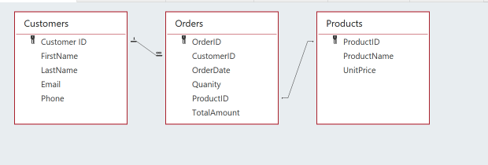
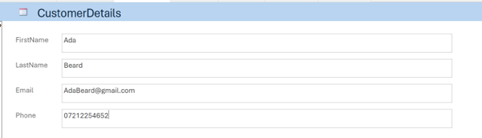
One of the key features of Microsoft Access is the ability to visually design databases. Users can create tables, define relationships between them, configure keys, data integrity rules, and field types without resorting to programming. This makes Access particularly useful in small and medium-sized businesses, where internal information systems are often created by employees without specialised training in development. Forms and reports allow you to create user-friendly interfaces for data entry and analytical reporting, making Access a tool not only for storing data, but also for interacting with it.
Figure 10: Relationship between tables (Personal Collection)

Figure 11: Custom Form (Personal Collection)
Access also provides extensive capabilities for working with queries. Users can extract the data they need using a visual query designer that allows them to filter, sort, and combine information from different tables. This approach makes working with data more intuitive and understandable for those who do not know SQL. This makes Access a tool that helps employees find the information they need and analyse it directly within the application.
In business, Microsoft Access is often used to create small information systems tailored to the specific needs of an organisation. Companies use it to manage orders, track equipment, handle internal document flow, keep track of customers, plan tasks, or collect data for projects. Unlike Excel, which is better suited for analysing data in tables, Access allows you to work with related records and is better at tasks that require structure.
Access also has collaboration features, but they are implemented differently than in other Office products. The database can be divided into two parts: the file with tables is stored in a network location, and the file with forms and reports is stored on each user's computer. This allows multiple employees to work with the same database at the same time [17].
Despite its convenience, Access has its limitations. It is not suitable for large organisations that need to work with very large amounts of data or high loads. In addition, high-quality database design requires an understanding of data structures, which can be difficult for untrained users. However, for small companies, Access remains a convenient and affordable solution thanks to its ease of use, flexible settings, and the ability to quickly create working applications that support internal processes.

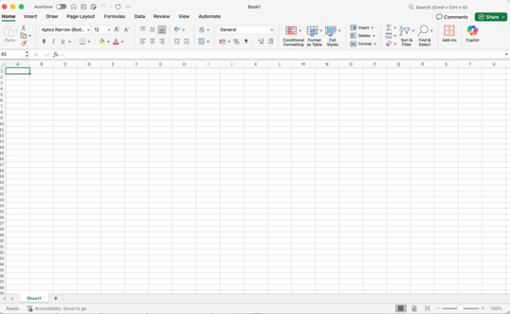
b. Practical Demonstration of the Two Features
Figure 12: Clean xlsx file (Personal Collection)

Mail Merge
To complete this task, I created an Excel file using Microsoft Excel and then created a table within it.
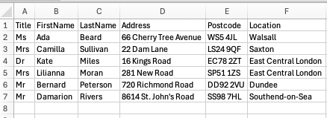
I filled it with recipient data (Title, First Name, Last Name, Address, Postcode, Location) and saved it in a separate file for further use as a data source for the table.

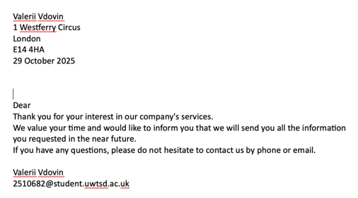
Figure 13: Recipent data table (Personal Collection)
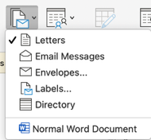
Then I opened a new Word document, in which I wrote a letter template to send to customers, then on the Mailings tab, I selected the Start Mail Merge -> Letters command.
Figure 14: Start Mail Merge (Personal Collection)
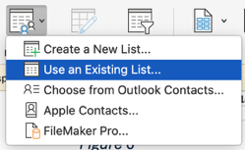
Figure 15: Letter template ((Personal Collection)
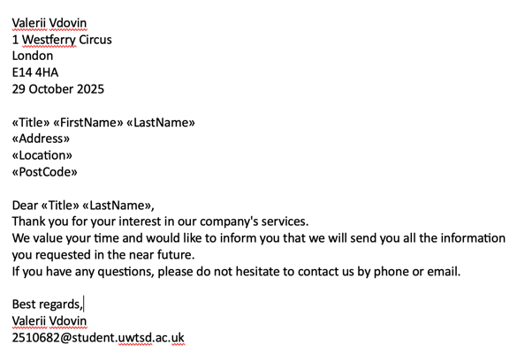
The next step was to select Select Recipients, and in the drop-down menu, I selected Use an Existing List. I selected the file I had created earlier.
Figure 16: Select Recipients (Personal Collection)
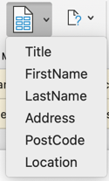
After that, using the Insert Merge Field command, I inserted the corresponding fields in the right places in the letter. Now the letter template looked like a finished letter, but instead of data, there were inserts.
Figure 17: Template with Merge fields (Personal Collection)
Figure 18: Insert Merge (Personal Collection)

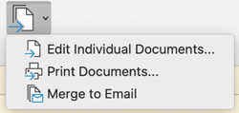
The final step was to click Finish & Merge and select Edit Individual Documents.
Figure 19: Finish & Merge (Personal Collection)

Word automatically created six separate letters, each containing unique personal data for the recipient. In that way, the mail merge function helped me automate mass mailings while maintaining a personalised approach.
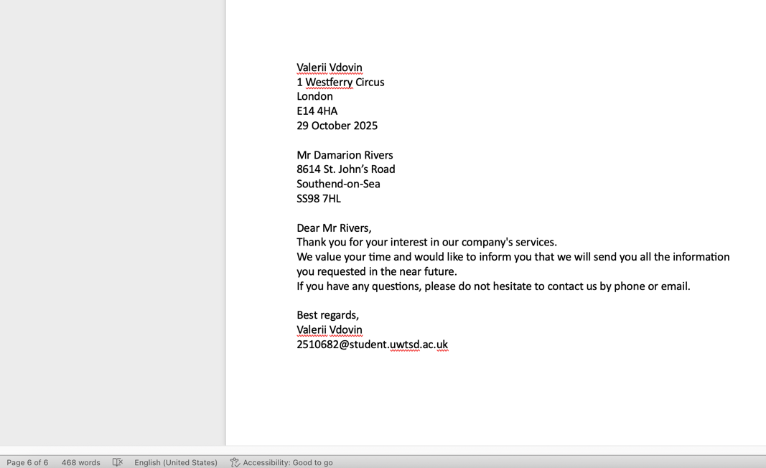
Figure 20: 6 separate letters (Personal Collection)

IF Function
The IF function in Microsoft Excel is used to check conditions and automatically return a result depending on whether the condition is true or false. It allows you to automate data processing and reduce the number of manual calculations. The basic structure of the function is as follows:
=IF(condition, value_if_true, value_if_false)
This means that Excel compares the condition you enter and, if it is true, returns one value, and if not, returns another. The IF function is often used for classifying data, checking results, evaluating, calculating statuses, financial transactions, and building reports. This allows you to quickly analyse information and draw conclusions without manual recalculation.

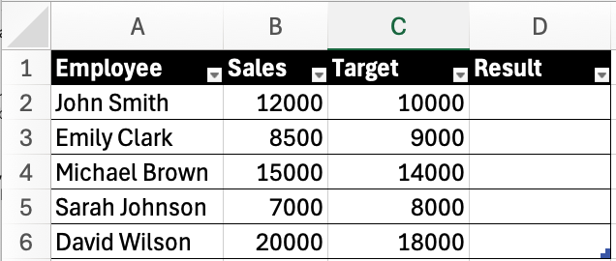
To demonstrate how the function works, I created an xlsx file with fields where the function will calculate whether an employee has achieved their target or not.
Figure 21: Table without Result (Personal Collection)
Go to cell D2 and enter the following formula
Figure 22: IF Function formula (Personal Collection)

After that, we will see the results for the first employee. Then we extend this formula to the entire column D and get the final result.
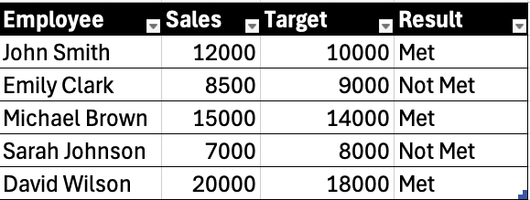
Figure 22: Table with Result column (Personal Collection)

Task 4. Communication and Collaboration applications

One contemporary Communication and one Online Collaboration
MS Teams
Microsoft Teams was launched on 14 March 2017 as a team collaboration and communication tool as part of the Microsoft 365 package [18]. Microsoft Teams combines chat, video conferencing, voice communication, and file sharing features. Unlike instant messengers, Teams is geared towards a professional environment where structure, security, and integration with other services are important.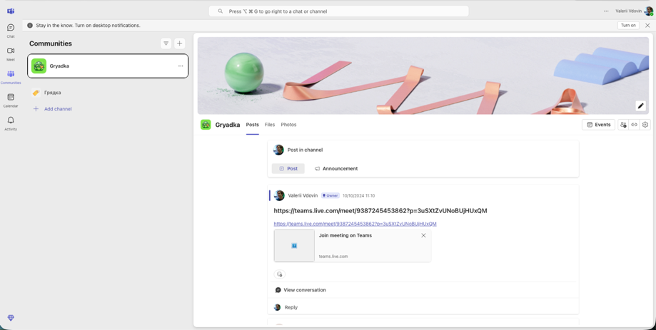
Figure 23: Teams Communities Interface (Personal Collection)
One of its key features is integration with Microsoft 365, including tools such as Word, Excel, PowerPoint, and OneDrive. This allows employees to work on documents collaboratively, edit them, and save them in the cloud. Creating channels in Teams is also a useful feature, as it allows discussions to be divided by project, task, or department.
In addition to text communication, there is also the option of video calls and video conferencing. Screen sharing, virtual backgrounds, reactions, meeting recordings, and cloud storage of training materials improve the quality of remote communication. Teams is used in business environments for meetings, events, and interviews. You can even connect to a session via a browser without installing the MS Teams application.
The built-in calendar, integrated with Outlook, allows you to schedule meetings and assign tasks for the team. Support for integrations with SharePoint and other applications makes Teams the main tool for communication and interaction for the entire company, especially in hybrid and remote working models.
However, Teams still has limitations. Video communication requires a good internet connection. Due to the large number of features, it can be quite difficult for a new user to navigate the interface, and the large number of notifications can be distracting.
Microsoft Teams is also actively used for internal training and knowledge sharing. The application allows you to create separate channels for training, attach training materials, presentations, and links, and conduct interactive online sessions with the ability to share your screen and view documents together. Thanks to cloud storage, information remains accessible at any time, which facilitates the adaptation of new employees and helps to maintain the corporate knowledge base. In addition, using Teams reduces the load on corporate email, reduces the number of documents sent, and makes communication more centralised. The tool helps teams make decisions faster, maintain task transparency, and stay connected regardless of the geographical location of participants.
Nevertheless, Microsoft Teams remains one of the leading tools for business communication, providing a communication structure, broad functionality, and high integration with Microsoft 365, making it a stable standard for modern organisations.

Miro
Miro is a cloud-based platform for real-time collaboration based on the concept of virtual whiteboards. Miro provides a space where teams can interact simultaneously, visualise ideas, create diagrams, make sticker notes, mind maps, and design concepts. The application is actively used in IT, design, and education, as it allows you to combine communication and visual design in one workspace. One of the important advantages of Miro is the availability of a free plan, which makes the tool accessible to students, freelancers, and small teams without requiring any financial investment at the initial level [19].
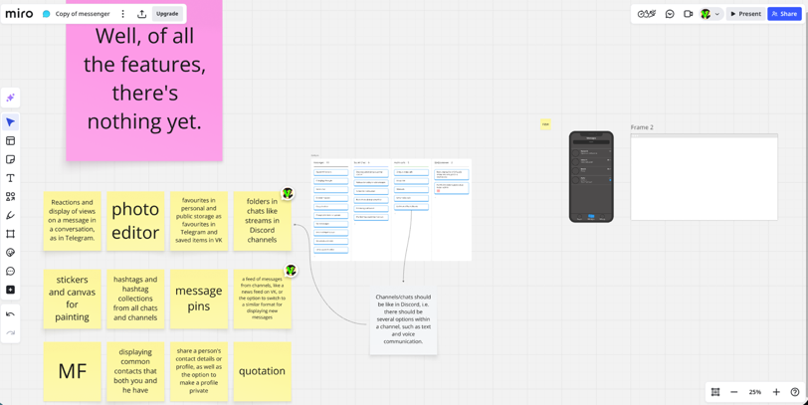
Figure 24: Miro Project (Personal Collection)
Miro's functionality is based on interactive boards where users can place stickers, text blocks, images, diagrams, arrows, shapes, tables, and multimedia elements. This allows you to structure your workflow, brainstorm, describe, design interfaces, and create roadmaps. Thanks to the lack of space restrictions on the board, participants can freely scale the project, move around the workspace, and group blocks of information. Miro provides useful templates for teamwork — Kanban columns, Customer Journey Map, User Persona, SWOT analysis, and UML diagrams — which speed up the project launch process.
Collaboration is at the heart of Miro. Multiple users can work on the same board simultaneously, observe other participants' cursors, leave comments, react to content, and highlight elements. This creates the effect of a ‘live’ meeting and increases team engagement. Built-in video call support makes it possible to conduct online brainstorming directly in the workspace without switching to a third-party communication service. This approach is especially valuable for remote teams, where visual synchronisation plays a key role.
Despite its obvious advantages, Miro has limitations. A paid plan may be required to save large projects or work with multiple boards. Under heavy load, boards can become sluggish, especially if they contain many images. New users need time to adapt to the visual format, and the lack of strict structure rules sometimes leads to ‘visual chaos.’ Nevertheless, for small and medium-sized teams, Miro remains a convenient and flexible tool for collaboration, allowing you to develop ideas, visualise solutions, and accelerate team processes. Thanks to its ease of access, free plan, and extensive collaboration capabilities, Miro continues to hold a strong position as a modern platform for collaboration [20].

Test one feature of a freely available Communication (1) and one feature of a Collaboration (1) application

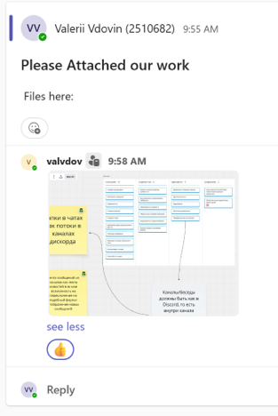
MS Teams
To demonstrate how to use Microsoft Teams, I created a work chat and a channel for communicating with the team. Then I sent a message, attached a file, and made a video call. In this way, you can see that MS Teams is used for messaging, file storage, and online meetings, which is very important for communication.
Figure 25: Create team (Personal Collection)
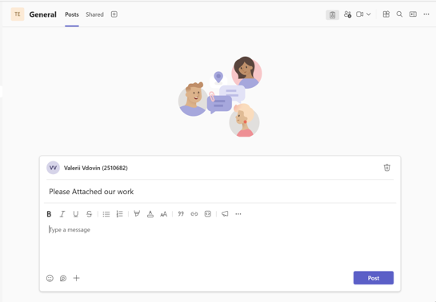
To begin with, I created a team, set a name and description, and added the people I needed there.
Figure 26: Post Creation (Personal Collection)
I created a post where others could send their work. I received an attached image in response and reacted to it.
Figure 27: Attached photos and reactions (Personal Collection)
Additionally, I organised a video conference. 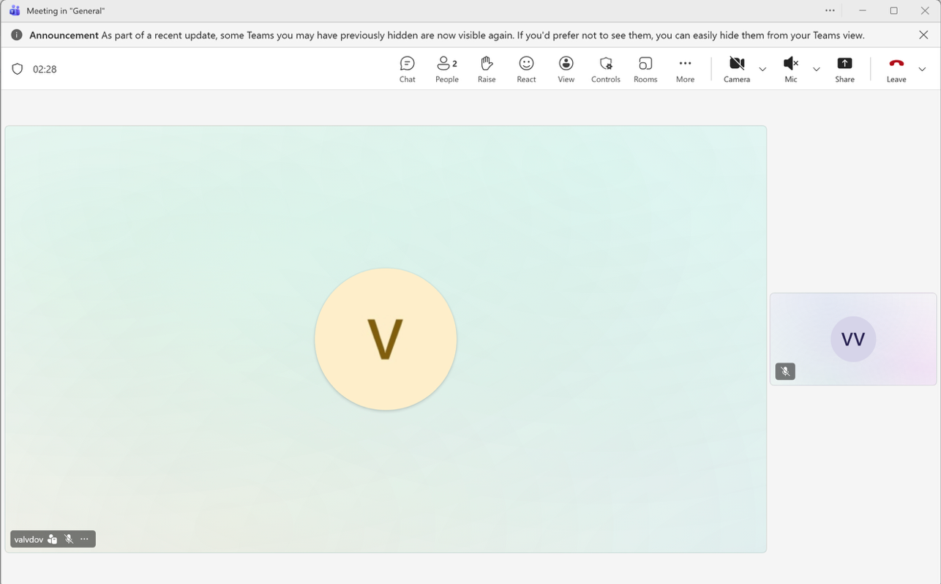
Figure 28: Video meeting screen (Personal Collection)

Miro
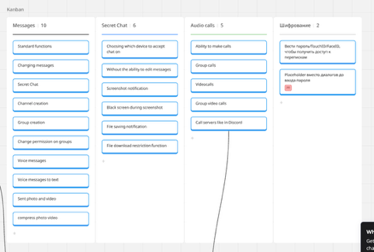
To demonstrate how Miro can be used as a collaboration tool, I created a brainstorming board using stickers and diagrams. I placed several notes, connected them with arrows, and demonstrated how to work with visual objects. This shows how Miro can be used for collaborative brainstorming and task planning.
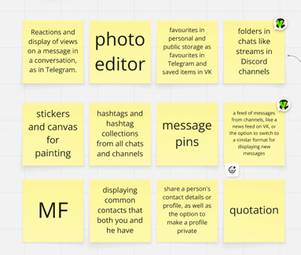
In our joint Miro project, we used stickers to write down the main ideas.
Kanban is another similar visual method, which was used to create a table of possibilities.
Figure 29: Sticky notes (Personal Collection)
Figure 30: Kanban board (Personal Collection)

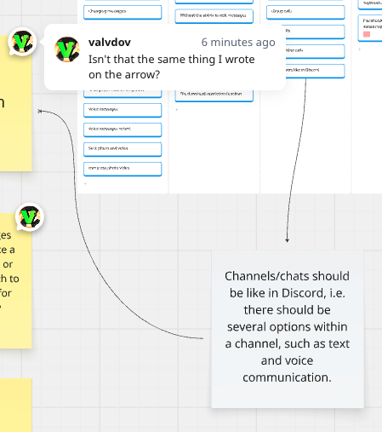
Finally, the ability to leave comments on any note makes interaction between users and task solving much easier.
Figure 31: Comments and arrows (Personal Collection)

Conclusion
Concluding the work done, it can be noted that modern software applications play a key role in managing information, communication, and collaborative activities among users. Analysis of Microsoft Office solutions has demonstrated their importance in data processing, document preparation, and task automation. Research into communication and collaboration tools such as Microsoft Teams and Miro confirmed that digital services significantly simplify team interaction, accelerate information exchange, and enable effective workflow organisation both in the office and remotely. The practical part of the work demonstrated the application of the studied tools to solve real-life tasks — creating a mailing list using Mail Merge, using the IF logical function in Excel, and working with communication and collaboration services. This study confirms the importance of mastering modern digital technologies and highlights their impact on improving productivity and quality of work in a professional environment.

References

[1] | WordPress.org, “About WordPress,” WordPress Foundation, 22 10 2025. [Online]. Available: https://wordpress.org/about/. [Accessed 22 10 2025].
[2] | WordPress.org, “WordPress Hosting — Recommended Web Hosting Providers,” WordPress Foundation, 16 10 2025. [Online]. Available: https://wordpress.org/hosting/. [Accessed 22 10 2025].
[3] | WordPress.org, “WooCommerce — Sell Online With WordPress,” WordPress Foundation, 22 10 2025. [Online]. Available: https://en-gb.wordpress.org/plugins/woocommerce/. [Accessed 22 10 2025].
[4] | WordPress.com, “WordPress.com Pricing — Plans for Any Website,” Automattic Inc., 22 10 2025. [Online]. Available: https://wordpress.com/pricing/. [Accessed 22 10 2025].
[5] | Wix.com, “About Wix — Our Story, Values, and Team,” Wix.com Ltd., 22 10 2025. [Online]. Available: https://www.wix.com/about/us. [Accessed 22 10 2025].
[6] | Wix.com, “Wix Pricing Plans — Create a Website Today,” Wix.com Ltd., 22 10 2025. [Online]. Available: https://www.wix.com/plans. [Accessed 22 10 2025].
[7] | M. Tripathy, “Dimensions of critical thinking in workplace management & personal development: a conceptual analysis,” Multidisciplinary Journal for Education, Social and Technological Sciences, vol. 7, no. 2, pp. 1-19, 2020.
[8] | Gnome Stew, “Mind Mapping Game Prep,” 22 August 2013. [Online]. Available: https://gnomestew.com/mind-mapping-game-prep/. [Accessed 26 November 2026].
[9] | S. Narula et al., “Restarting Manufacturing Industries Post Covid-19: A Mind Map-Based Empirical Investigation of the Associated Challenges in Business Continuity,” International Journal of Strategic Decision Sciences, vol. 11, no. 2, pp. 56-65, 2020.
[10] | C. A. Vanderlei, L. Quoniam, C. T. Kniess and R. R. N. Ferraz, “Patent analysis by automated mind maps: Contribution to sustainability in a water and sewage sanitation company,” Sustainable Operations and Computers, vol. 2, pp. 246-253, 2021.
[11] | Microsoft , “What’s the difference between a Microsoft 365 subscription and free web apps?,” Microsoft , 2024. [Online]. Available: https://support.microsoft.com/en-gb/office/what-s-the-difference-between-a-microsoft-365-subscription-and-free-web-apps-36a2c67d-3488-4cad-ae9d-470d0086e2b9 . [Accessed 03 12 2025].
[12] | Microsoft, “Start the presentation and see your notes in Presenter view,” Microsoft, [Online]. Available: https://support.microsoft.com/en-gb/office/start-the-presentation-and-see-your-notes-in-presenter-view-4de90e28-487e-435c-9401-eb49a3801257. [Accessed 3 12 2025].
[13] | Microsoft , “Work together on PowerPoint presentations,” Microsoft , [Online]. Available: https://support.microsoft.com/en-us/office/work-together-on-powerpoint-presentations-0c30ee3f-8674-4f0e-97be-89cf2892a34d . [Accessed 3 12 2025].
[14] | Microsoft, “Create a PivotTable to analyze worksheet data,” Microsoft, [Online]. Available: https://support.microsoft.com/en-gb/office/create-a-pivottable-to-analyze-worksheet-data-a9a84538-bfe9-40a9-a8e9-f99134456576. [Accessed 3 12 2025].
[15] | Microsoft, “ Collaborate on Excel workbooks at the same time with co-authoring,” Microsoft , [Online]. Available: https://support.microsoft.com/en-gb/office/collaborate-on-excel-workbooks-at-the-same-time-with-co-authoring-7152aa8b-b791-414c-a3bb-3024e46fb104. [Accessed 3 12 2025].
[16] | Microsoft, “Microsoft 365 Access,” Microsoft, [Online]. Available: https://www.microsoft.com/en-us/microsoft-365/access#Resources-3. [Accessed 3 12 2025].
[17] | Microsoft, “Split an Access database,” Microsoft, [Online]. Available: https://support.microsoft.com/en-gb/office/split-an-access-database-3015ad18-a3a1-4e9c-a7f3-51b1d73498cc. [Accessed 3 12 2025].
[18] | Microsoft Corp., “Microsoft Teams rolls out to Office 365 customers worldwide,” Microsoft News Center , 14 March 2017. [Online]. Available: https://news.microsoft.com/source/2017/03/14/microsoft-teams-rolls-out-to-office-365-customers-worldwide/ . [Accessed 5 November 2025].
[19] | Miro , “What is Miro,” Miro , [Online]. Available: https://help.miro.com/hc/en-us/articles/360017730533-What-is-Miro. [Accessed 3 12 2025].
[20] | Miro , “Plans and features available,” Miro , [Online]. Available: https://help.miro.com/hc/en-us/articles/360017730233-Plans-and-features-available . [Accessed 3 12 2025].

