

Joseph Nelhams

Reaction Rate Lab Report

School of Applied Computing
ACDB4011 Chemistry

Academic Year: 2024 - 2025

Lecturer: Ewa Kazimierska

May 2025

Table of Contents
List of Figures 3
List of Tables 4
List of Equations 5
Introduction 6
1.1 Aim of the experiment 6
1.2 Hypotheses 6
1.3 Variables 7
2 Theory 7
3 Results 9
3.1 Recorded data and Observations 9
3.2 Calculations Error! Bookmark not defined.
3.2.1 Equations Error! Bookmark not defined.
3.2.2 Calculations Error! Bookmark not defined.
4 Discussion Error! Bookmark not defined.
4.1 Key Findings Error! Bookmark not defined.
5 Conclusion 18
5.1 Conclusion 18
5.2 Review and further research Error! Bookmark not defined.
References 19
Appendix A (Materials and Methodology) 20
Appendix B Scanned Data sheet Error! Bookmark not defined.

List of Figures
Figure 1 – A Scatter plot showing the effects of HCl concentration on rates of reaction 10
Figure 2 – Scatter plot with added average reaction rate line 11
Figure 3 – A scatter plot showing the effects of temperature on the rate of reaction 13
Figure 4 – Average reaction rate has been plotted on the graph for each temperature 14
Figure 5 – A scatter plot showing the effects of surface area on the rate of reaction 16
Figure 6 – The scatter plot with added rates of reaction line 17

List of Tables
Table 1 - Effects of HCl concentration on the speed of H₂ gas evolution 9
Table 2 - Calculated reaction rates from the HCl concentration experiment 11
Table 3 - Effects of temperature on the speed of H₂ gas evolution 12
Table 4 - Calculated reaction rates from the variable temperature experiment 13
Table 5 - Effects of surface area of Mg on the speed of H₂ gas evolution 15
Table 6 - A table showing the reaction rate of Mg Powder, Mg strip can be found in table 2 (1.0 M) 16

List of Equations
$Mg(s)+2HCl(aq)→MgCl2 (aq)+H2 (g)$ Equation 1 6
$rate=ΔVH2Δt$ Equation 2 6

Introduction

Aim of the experiment
The purpose of the experiment is to measure the factors affecting the rate of reaction between magnesium and hydrochloric acid (equation 1).
$${Mg}_{(s)}+{2HCl}_{(aq)}→{MgCl}_{2 (aq)}+H_{2 (g)}$$Equation 1
The experiment was performed in three parts. The first part investigated the concentration of hydrochloric acid (HCl) and how this affected the speed of hydrogen gas (H₂) evolution. The second part examined the effect of varying temperatures on the rate of reaction, and the last part investigated the surface area of magnesium and how it affected the reaction rate.
The rate of reaction will be determined by measuring the volume of hydrogen gas produced over time. The reaction rate can then be calculated using equation 2:
$$rate=\frac{{ΔV}_{H2}}{Δt}$$Equation 2
The methodology used for the experiment can be found in appendix A.

Hypotheses
- The concentration of HCl will cause the rate of reaction to increase, and therefore the speed of H₂ evolution to increase. This is due to a greater number of particle collisions between the Mg and HCl molecules.
- The greater the temperature of HCl, the faster the reaction rate, which is due to the molecules in HCl having an increased level of kinetic energy, thus increasing the likelihood of particle collisions in the reaction.
- The surface area of Mg will increase the rate of reaction by increasing the frequency of particle collisions, as a greater proportion of Mg particles can collide with HCl particles.

Variables
The independent variables of this investigation are the concentration of HCl, the temperature of HCl, and the surface area of Mg. The dependent variable is the volume of H₂ gas released over time. The controlled variable of the experiment is the pressure of the test tube; all reactions took place at atmospheric pressure.

Theory

Fundamental concepts of kinetics
Several factors effect the rate of reaction [1,2], the main ones are: Temperature of reactants, Concentration of reactants, Surface area of reactants, and the presence of a catalyst. The rate of reactivity can be defined as the number of particle collisions between two or more reactants over time, therefore the more collisions the higher the reactivity
Increasing the temperature of the reactants usually increases the reaction rate, this is due to the particles having more energy. This causes the particles to move faster and collide more often increasing reactivity.
The higher the concentration of reactants the greater the reactivity, as there are more particles to collide with. The larger the surface area the faster the reaction, for a substance with a small surface area this provides a smaller amount of space for reaction to occur. As the particles will have to collide with the first “layers” of particles before being able to collide with the rest of the particles, increasing the surface area increases the number of particles available to collide with at one time.
A catalyst is not a reactant and does not get consumed in the reaction. What the catalyst does is decrease the activation energy required to start the reaction.

Importance of kinetics in the OME industry
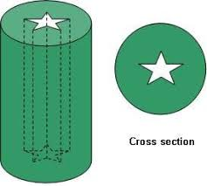
Controlling rates of reaction is key in the energetics industry, in some cases it is important to maximise reactivity to get the most energy out of a system in the shortest time possible. A common example of this is with propellants [3], a lot of energetic industries such as military or aerospace will have a star shape cut out going through their propellant fuel. This is done to increase the surface area of the fuel so that a greater proportion of the fuel can burn at one time. Without this hollow star shape the fuel will burn from the outside toward the centre, this will cause it to burn for much longer.
Figure 1 – A diagram showing the typical shape of a propellant fuel used in rocketry.
From a safety perspective the factors regarding reaction rates must be considered [4]. Energetic materials can be very sensitive to environmental factors which may cause premature unwanted detonation or deflagration. When storing energetics there is a limit on how much can be stored in one space, this is to limit the concentration of energetics within an area, additionally, the temperature at which they are stored at is monitored. An energetic material kept at a high temperature for a long period of time will increase the likelihood of premature reaction. This is mainly due to the increased temperature causing the rate of decomposition to increase, as the energetic decomposes it releases gasses, this causes the pressure of the storage container to rise. Increased pressures can also lead to increased reactivity as well as a decrease in activation energy.

Results

Recorded data and Observations
The data gathered from the investigations is listed in the tables below, and scatter plots accompany each table. The reaction rates are calculated using equation 2. For each test, the instantaneous reaction rate is the first measurement for the volume of hydrogen gas (ΔV_{H2}), the average rate is calculated where Δt = 40s.
Table 1 - Effects of HCl concentration on the speed of H₂ gas evolution
Concentration
0.5 M HCl |  | 1.0 M HCl |  | 1.5 M HCl |  | 2.0 M HCl
time (s) | V H2 (mL) | time (s) | V H2 (mL) | time (s) | V H2 (mL) | time (s) | V H2 (mL)
0 | 0 | 0 | 0 | 0 | 0 | 0 | 0
20 | 3 | 10 | 10 | 10 | 25 | 10 | 42
40 | 6 | 20 | 20 | 20 | 45 | 20 | 57
60 | 9 | 30 | 28 | 30 | 57 | 30 | 65
80 | 12 | 40 | 35 | 40 | 63 | 40 | 70
100 | 15 | 50 | 41 | 50 | 67 | 50 | 74
120 | 17.5 | 60 | 43 | 60 | 70 | 60 | 76
140 | 20 | 70 | 53 | 70 | 73 | 70 | 76
160 | 22 | 80 | 60 | 80 | 74 | 80 | 76
180 | 25 | 90 | 63 | 90 | 75
200 | 27 | 100 | 66 | 100 | 75
220 | 29.5 | 110 | 69 | 110 | 75
240 | 31.5 | 120 | 70
260 | 34 | 130 | 71
280 | 36 | 140 | 72
300 | 38 | 150 | 72.5
320 | 40 | 160 | 73
340 | 42 | 170 | 74
360 | 43.5 | 180 | 74
380 | 45 | 190 | 75
400 | 47 | 200 | 75
420 | 48.5 | 210 | 75
440 | 50 | 220 | 75
460 | 51 | 227.7 | 75
480 | 52.5
500 | 54
520 | 55
540 | 56
560 | 57
580 | 58
600 | 59
620 | 60
640 | 60.5
660 | 61.5
680 | 62
700 | 63
720 | 63.5
740 | 64
760 | 64.5
780 | 65
800 | 66
820 | 66
840 | 66
860 | 66
880 | 66
900 | 66
920 | 66
940 | 66
960 | 66
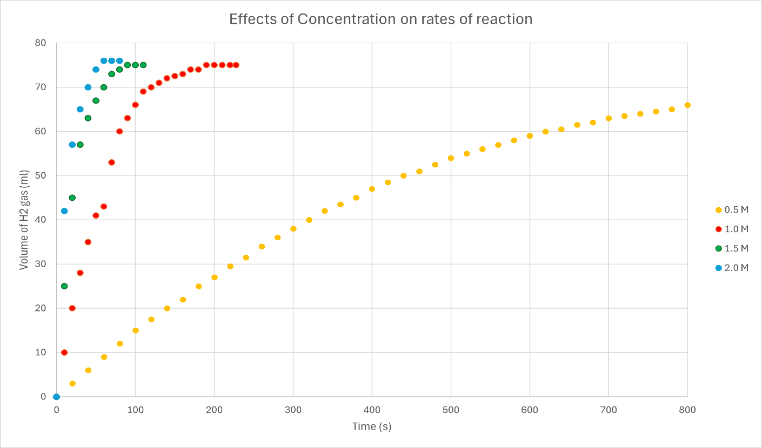
Figure 2 – A Scatter plot showing the effects of HCl concentration on rates of reaction
The data from figure 2 shows that the higher the concentration of HCl the faster the reaction rate as expected, proving hypothesis i to be correct.
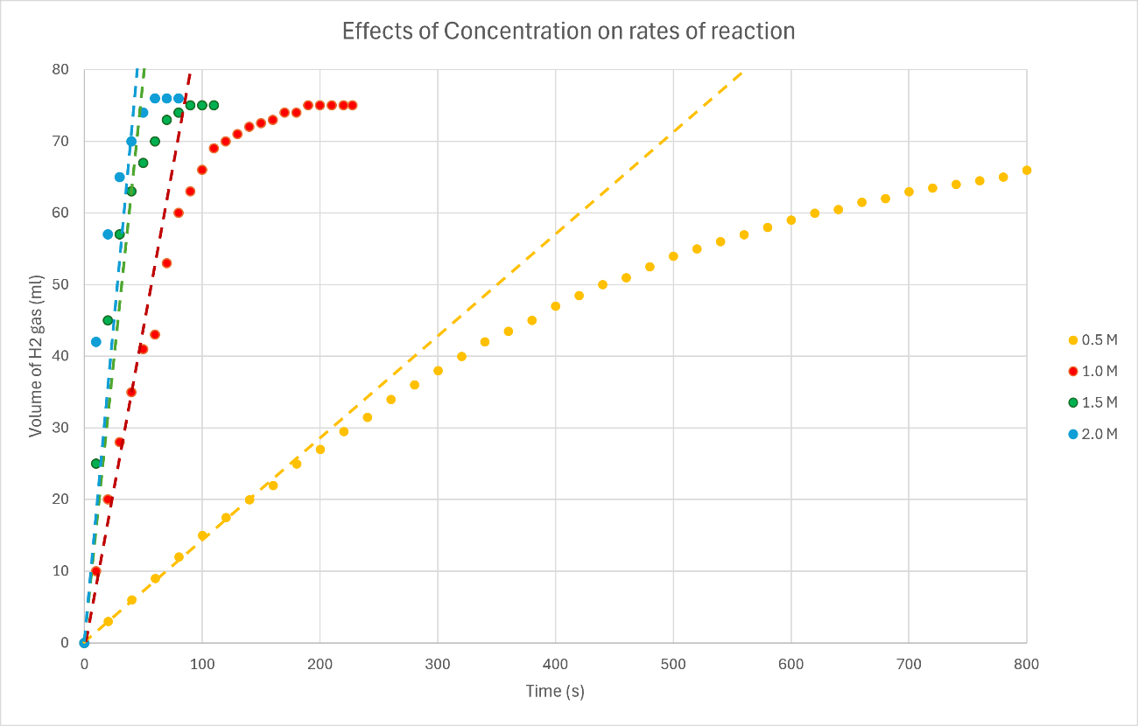
Table 2 - Calculated reaction rates from the HCl concentration experiment
Figure 3 – Scatter plot with added average reaction rate line
HCl Concentration (M) | Time to dissolve Mg (s) | Average Reaction Rate | Instantaneous rate at t=0s
0.5 | 920.0 | 0.15 | 0.15
1.0 | 227.7 | 0.875 | 1
1.5 | 90.0 | 1.575 | 2.5
2.0 | 70.0 | 1.75 | 4.2
The trend line plotted in the scatter graph was done using the equation $y=mx+c$, where the gradient $m$ is the average reaction rate. This equation will be used for each set of data.

Table 3 - Effects of temperature on the speed of H₂ gas evolution
 |  | Temperature (°C)
23.8 |  | 41.2 |  | 53.8
time (s) | V H2 (mL) | time (s) | V H2 (mL) | time (s) | V H2 (mL)
0 | 0 | 0 | 0 | 0 | 0
10 | 10 | 10 | 18 | 10 | 17
20 | 20 | 20 | 31 | 20 | 29
30 | 28 | 30 | 41 | 30 | 38
40 | 35 | 40 | 50 | 40 | 44
50 | 41 | 50 | 57 | 50 | 47
60 | 43 | 60 | 61 | 60 | 50
70 | 53 | 70 | 63 | 70 | 51
80 | 60 | 80 | 64.5 | 80 | 53
90 | 63 | 90 | 65 | 90 | 54
100 | 66 | 100 | 66 | 100 | 55
110 | 69 | 110 | 67 | 110 | 56
120 | 70 | 120 | 68 | 120 | 57
130 | 71 | 130 | 68.5 | 130 | 57.5
140 | 72 | 140 | 70 | 140 | 58
150 | 72.5 | 150 | 70 | 150 | 59
160 | 73 | 160 | 71 | 160 | 61
170 | 74 | 170 | 71.5 | 170 | 62
180 | 74 | 180 | 71.5 | 180 | 63.5
190 | 75 | 190 | 71.5 | 190 | 65
200 | 75 |  |  | 200 | 66
210 | 75 |  |  | 210 | 67
220 | 75 |  |  | 220 | 68.5
227.7 | 75 |  |  | 230 | 69.5
 |  |  |  | 240 | 70.5
 |  |  |  | 250 | 71.5
 |  |  |  | 260 | 72.5
 |  |  |  | 270 | 73.5
 |  |  |  | 280 | 74
 |  |  |  | 290 | 74.5
 |  |  |  | 300 | 75
 |  |  |  | 310 | 75
 |  |  |  | 320 | 75
 |  |  |  | 330 | 75
 |  |  |  | 340 | 75
 |  |  |  | 350 | 75
 |  |  |  | 360 | 75
 |  |  |  | 370 | 75
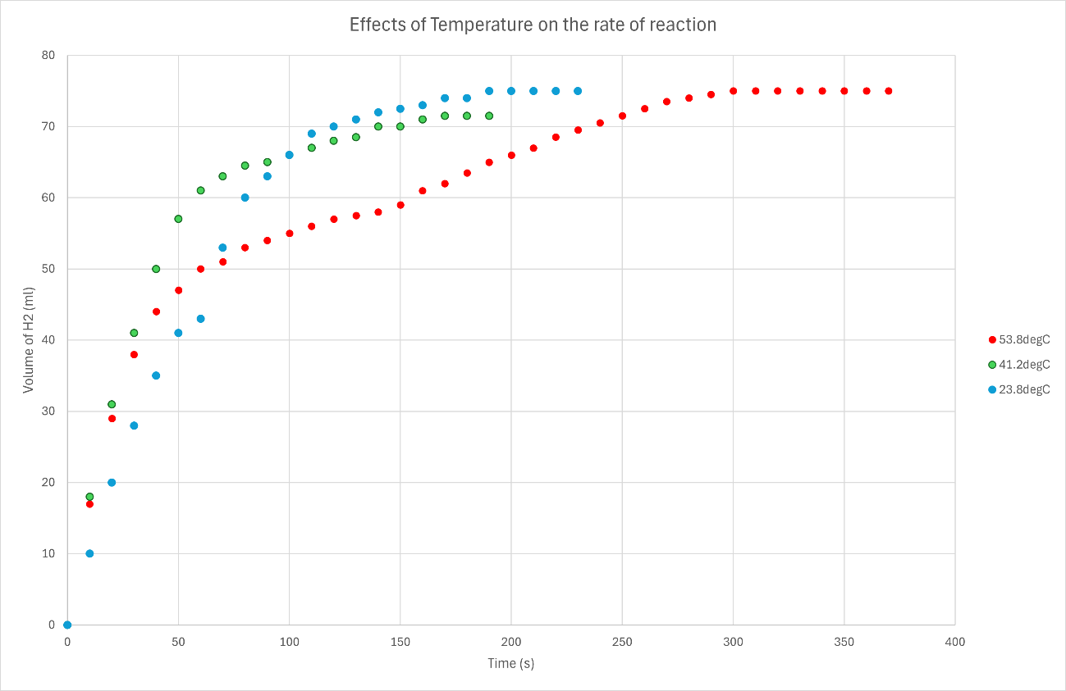
The data shown in figure 4 compares the volume of hydrogen gas released during the reaction at different temperatures, as expected the instantaneous and average reaction rates of the room temperature experiment (23.8°C), shown in table 4, are the lowest. However, it was the hottest experiment that took the longest to fully dissolve the magnesium which is unexpected.
Figure 4 – A scatter plot showing the effects of temperature on the rate of reaction
Table 4 - Calculated reaction rates from the variable temperature experiment
Temperature (°C) | Time to dissolve mg (s) | Average reaction rate | Instantaneous rate at t=0s
23.8 | 227.7 | 0.875 | 1
41.2 | 190.0 | 1.25 | 1.8
53.8 | 371.4 | 1.1 | 1.7

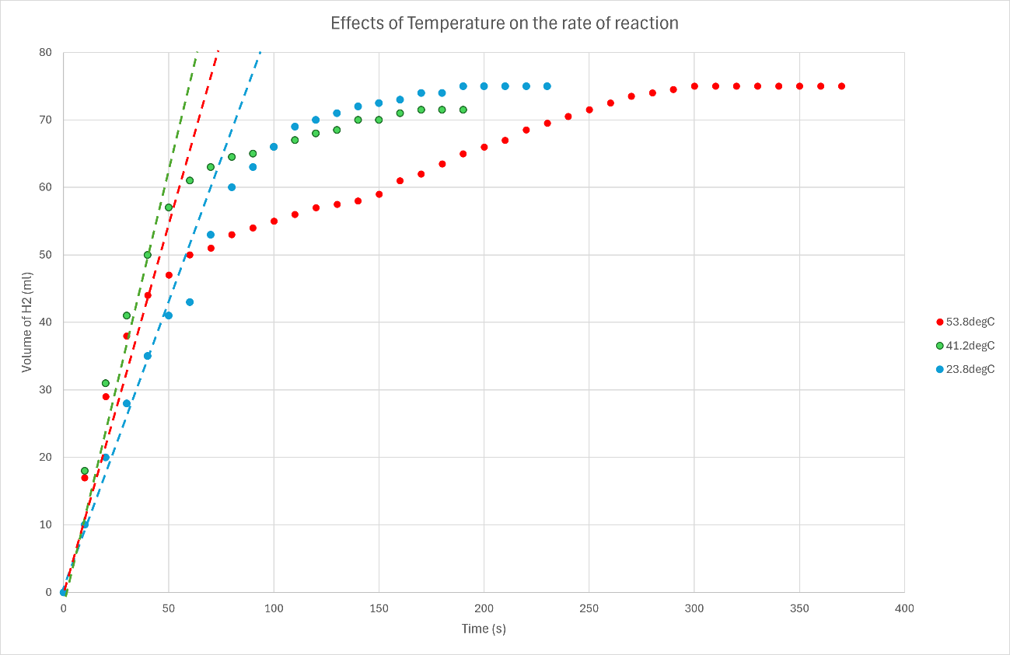
The middle temperature (41.2°C) was the quickest reaction, however the volume of hydrogen gas released was also lower, suggesting that either the quantity of magnesium or the quantity of hydrochloric acid was lower than intended, which would explain why the reaction was faster.
Figure 5 – Average reaction rate has been plotted on the graph for each temperature
With regards to hypothesis ii, which discusses the effects of temperature on reaction rate, a potential improvement to the experimental methodology would be to perform the reaction within an environment where the temperature is controlled. As the HCl was heated up and then poured into a room temperature test tube, the reactant would’ve lost some of its heat to the surrounding apparatus, this increases the measurement error of the experiment by some margin. Further investigation is required to adequately confirm or reject the hypothesis.

Table 5 - Effects of surface area of Mg on the speed of H₂ gas evolution
Mg Powder |  | Mg Strip
time (s) | V H2 (mL) | time (s) | V H2 (mL)
0 | 0 | 0 | 0
20 | 8 | 10 | 10
30 | 15 | 20 | 20
40 | 22 | 30 | 28
50 | 27 | 40 | 35
60 | 31 | 50 | 41
70 | 35 | 60 | 43
80 | 39 | 70 | 53
90 | 43 | 80 | 60
100 | 46 | 90 | 63
110 | 49 | 100 | 66
120 | 52.5 | 110 | 69
130 | 54.5 | 120 | 70
140 | 57 | 130 | 71
150 | 58.5 | 140 | 72
160 | 60 | 150 | 72.5
170 | 61.5 | 160 | 73
180 | 62.5 | 170 | 74
190 | 64 | 180 | 74
200 | 64.5 | 190 | 75
210 | 65 | 200 | 75
220 | 65.5 | 210 | 75
230 | 66 | 220 | 75
240 | 66 | 227.7 | 75
250 | 66.5
260 | 66.5

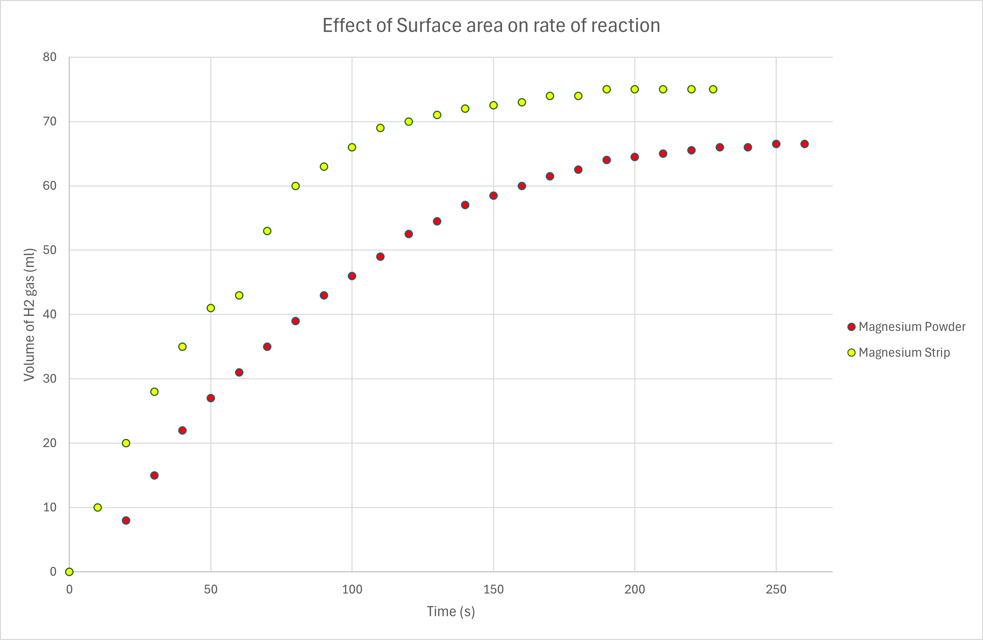
The data from table 5 suggest that the lower the surface area the faster the rate of reaction, which is the opposite of what is expected. There are several factors that effect the rate of reaction and may have caused this, one possible explanation could be the oxidation of the magnesium. As the powder has a greater surface area it is possible that the magnesium powder had oxidised a lot faster than the magnesium strip, causing the reaction to slow drastically. Furthermore, an error during the experiment caused the data to be skewed which will be discussed later on.
Figure 6 – A scatter plot showing the effects of surface area on the rate of reaction
The magnesium strip was not fully immersed in the HCl acid, as it was stuck on the side of the test tube partially immersed, at approximately 60 seconds the strip of magnesium fell fully into the HCl causing a small spike in reactivity which can be seen in figure 6.

Table 6 - A table showing the reaction rate of Mg Powder, Mg strip can be found in table 2 (1.0 M)
Average Mass (g) | Moles (mol) | Average Reaction Rate | Instantaneous Reaction Rate
0.0765 | 0.00315 | 0.55 | 0.67
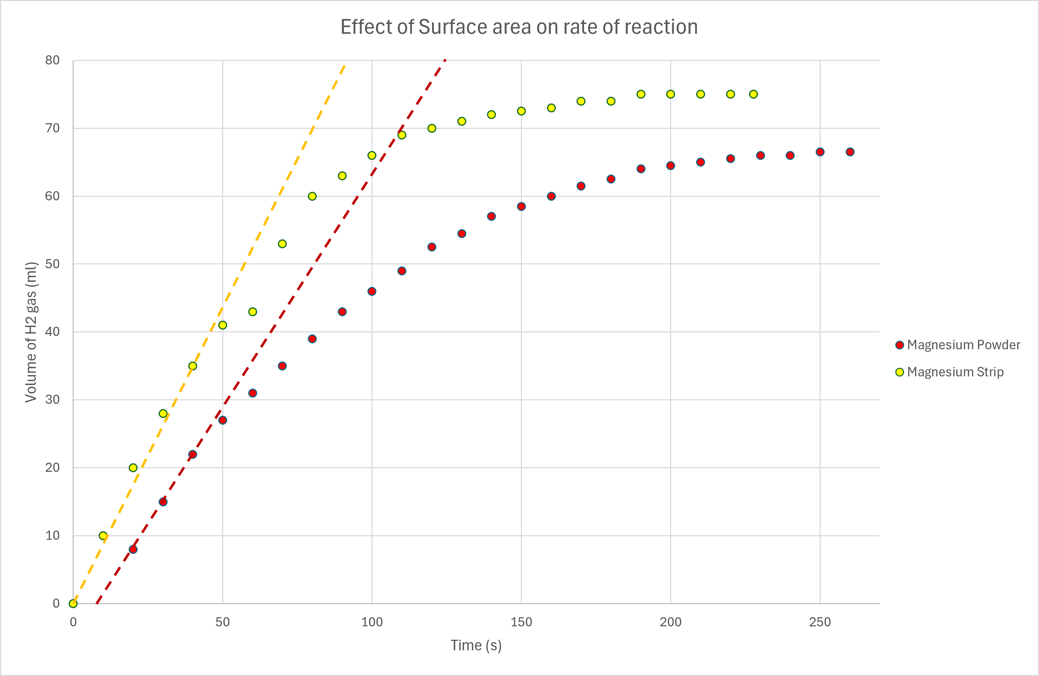
Figure 7 – The scatter plot with added rates of reaction line
An error during the magnesium powder experiment caused the data to be skewed. As the reaction started along with the stopwatch it was noted that the gas syringe had not been reset, in order to not lose all the data the rubber bung was quickly removed and the syringe reset. Due to this, some hydrogen gas was released from the system causing our final measurement to be approximately 8.5ml short. This will also affect the rate of reaction calculations, therefore any insight taken from this experiment is done using observation and assumption, and not entirely based off of the data gathered.
Further investigation should be taken in order to prove or disprove hypothesis iii.

Conclusion

Conclusion
The results of the investigation can confirm that hypothesis i is correct, the concentration of reactants does increase the rate of reaction. Due to errors during the experimental process the data can not conclusively prove hypotheses ii and iii are correct. Further investigation is required to provide an adequate answer.

References
- “Rates of reaction menu.” https://www.chemguide.co.uk/physical/basicratesmenu.html#top
- E. Pollak and P. Talkner, “Reaction rate theory: What it was, where is it today, and where is it going?,” Chaos an Interdisciplinary Journal of Nonlinear Science, vol. 15, no. 2, Jun. 2005, doi: 10.1063/1.1858782.
- F. Marco, “Effect of Al particle shape on solid propellants,” Apr. 30, 2025. https://tesidottorato.depositolegale.it/handle/20.500.14242/203751
- D. Harrington, Safe storage, Handling and Use of Commercial Explosives, vol. 7046. US Department of the Interior, Bureau of Mines, 1939.

(Materials and Methodology)

Materials and Equipment
- Long test tube with arm
- Gas syringe
- Rubber bung and delivery tube
- Two large beakers
- Pipette and filler
- Two clamp stands
- Test tube holder
- Thermometer
- Bunsen Burner
- Stopwatch
- Mg ribbon
- Mg powder
- HCl acid (2.0 M and 1.0 M)
- Deionised water

Methodology

Effect of HCl concentration on the speed of H₂ gas evolution
- Four 20.0 ml solutions of HCl were prepared with differing concentrations: 2.0 M, 1.5 M, 1.0 M, 0.5 M. The HCl was mixed with deionised water to achieve the correct concentration.
- The 0.5 M HCl solution was poured into the test tube attached to the syringe apparatus.
- A 4cm strip of Mg ribbon was added to the test tube, the rubber bung sealed the test tube, and the stopwatch started.
- The volume of hydrogen gas in the syringe was recorded at regular intervals until the reaction stopped.
- Steps 2 to 4 were repeated for each concentration of HCl.

Effect of temperature on the speed of H₂ gas evolution
- Three test tubes were filled with 20.0 ml of 1.0 M HCl solution.
- A water bath was set up and heated using a Bunsen burner to the desired temperature, ~40°C for test tube two and ~50°C for test tube three.
- Once the test tube reached the desired temperature, the solution would be transferred to the tube attached to the gas syringe. Immediately after, a strip of Mg ribbon would be added to the solution, and the rubber bung would seal the test tube. The stopwatch would then be started, and the volume of hydrogen gas in the syringe would be recorded at regular intervals.
- Step 3 is repeated for all three test tubes.

Effect of surface area of Mg on the speed of H₂ gas evolution
- Two test tubes were filled with 20.0 ml of 1.0 M HCl solution.
- The HCl solution was added to the test tube with the attached gas syringe. Immediately, Mg powder was added to the solution, the stopwatch was started, and the rubber bung was inserted into the test tube to seal it. The volume of hydrogen gas in the syringe was measured at regular intervals until the reaction was complete.
- Step 2 was repeated, but with a strip of magnesium ribbon of the same mass.

