Academic Skills - Individual Report (Component 1)
Table of Contents

Introduction 3
Importance of research skills and time management skills for student 3
Recommendations on Research Skills 4
Conclusion 5
References 6

Introduction
Academic skills are essential in student life as they enhance a student's academic abilities. It refers to approaches to learning that enhance students' ability to study and recall information easily (Ashton-Hay and Doncaster, 2021). This report aims to provide a comprehensive view of the importance of research skills and time management skills.

Importance of research skills and time management skills for student
Academic skills refer to a set of approaches where students learn and improve their skills and abilities. Some of the important academic skills that enhance the student life are research skills and time management skills (Gallen et.al 2023). A research skill is the ability to gather and organize information on the topic and analyze and interpret the details for a solution. Another academic skill is time management skill, which refers to effectively planning and allotting time to specific activities so that an activity or task can accomplish on time. This helps students to work efficiently and productively and complete tasks on time.
Mydin et.al (2021) stated that research skills play an essential role in student life, such as boosting curiosity in students. When they start doing research on a particular topic, their curiosity naturally increases, and they ask questions, and interested students are better listeners. This helps in generating new ideas and insights. Research skills help students to create self-awareness when they do research. The benefit of research skill is that they explore many things, which encourages opening their minds and learning new things, such as beliefs and attitudes from others' perspectives.
Furthermore, Vieno et.al (2022) stated that research skills enhance students' communication skills. Through these, students learn to organize their thoughts, present their research, and communicate the research information to different audiences, which helps them effectively communicate. Another importance of research skill is that it helps students achieve academic success. It encourages students to conduct a literature review, gather information, and evaluate existing research. Through this, they can provide well-structured and evidence-based research projects at their university, which will help them in the future. On the other hand, Wilson et.al (2021) argued that time management skills play a crucial role in students' lives. It helps students to achieve goals faster. When students focus on one activity for a specific period of time, it gives better results to the students in achieving goals faster.
Time management skills help students prioritize work as they learn to prioritize work according to the importance of the work and the attention required. While studying, some subjects need more attention and time, and dividing the time into challenging subjects helps students finish their syllabus faster. Another importance of the time management skill is it reduces stress and anxiety in children. It makes the students more relaxed and confident during their exam time because it helps them manage and finish their practice papers and revisions on time. There are some theories of academic skills, one of which is behaviorism theory. It focuses on how students learn while interacting with the environment. It is based on psychology and ideas. It studies the behaviors of people rather than internal thoughts or emotions (Vieno et.al 2022). Through this, students get motivated and complete their research project on time because teachers offer them rewards such as praise and good grades, which encourage students to complete their work on time and enhance their positive behavior.
Furthermore, Honey and Mumford learning models help students to follow learning styles and providing insights on learning through which they can continuously move forward in their career (Lang, 2023). By applying this model on the research skills and time management skills students get better understanding and encourages them in learning.
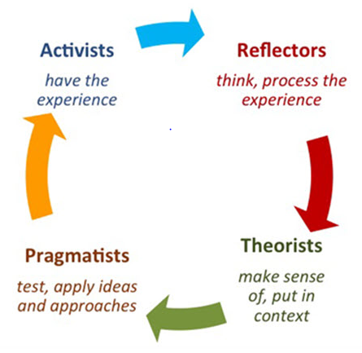
Figure 1: Learning Life Cycle
(Source: Mypersonalitystyle, 2023)
In the above diagram it shows that first student having a experience in the topic and after that reviewing the experience topic and concluding it and in last step planning for the next step. As such, developing skills associated with research and time is a continuous process through which students learn and enhances the personal effectiveness.

Recommendations on Research Skills
In order to develop and enhance research skills, the following recommendations have been made.
1. Students should set a clear goal in life so that it becomes easy to allocate their time on specific activity or task.
2. Students should practice critical reading and gather an expert idea which can help them in problem solving and generates a better solution in the end.
3. Students should make use of technologies such as chatbots and AI-powered technologies to drive meaningful data.

Conclusion
Research skill and time management skill plays a important role in students life. It helps students to manage their crucial time effectively and keep them motivated. These skills help students in their academic success and create a positive impact in their life. Both skills help in the personal development of the students.

References
Ashton-Hay, S.A. and Doncaster, N., (2021). Student success and retention: What’s academic skills got to do with it?. Journal of Academic Language and Learning, 15(1), pp.102-116.
Gallen, C.L., Schaerlaeken, S., Younger, J.W., Anguera, J.A. and Gazzaley, A., 2023. Contribution of sustained attention abilities to real-world academic skills in children. Scientific reports, 13(1), p.2673.
Lang, M., (2023). Learning Styles and On-Line Learning Analytics: An Analysis of Student Behaviour Based on the Honey and Mumford Model. In International Conference on Human-Computer Interaction (pp. 154-166). Cham: Springer Nature Switzerland
Mydin, F., Rahman, R.S.A.R.A. and Mohammad, W.M.R.W., (2021). Research collaboration: Enhancing the research skills and self-confidence of early career academics. Asian Journal of University Education, 17(3), pp.142-153.
Mypersonalitystyle,. (2023). Understanding the Honey and Mumford 4 Learning Styles – Improve Your Productivity [Online]. Available through: <https://mypersonalitystyle.com/wp/honey-and-mumford-four-learning-styles/>.[Accessed on 05th July 2024].
Serrelli, E., (2023). A research skill development framework for education professionals?. PEDAGOGIA E VITA, (81), pp.18-31.
Shafiei, A. and Maleksaeidi, H., (2020). Pro-environmental behavior of university students: Application of protection motivation theory. Global Ecology and Conservation, 22, p.e00908.
Vieno, K., Rogers, K.A. and Campbell, N., (2022). Broadening the definition of ‘research skills’ to enhance students’ competence across undergraduate and master’s programs. Education Sciences, 12(10), p.642.
Wilson, R., Joiner, K. and Abbasi, A., (2021). Improving students’ performance with time management skills. Journal of University Teaching and Learning Practice, 18(4).

