Learning in the Digital Era
BMPS4009 & BMPL4007
Umah Kauser 2227759
21 July 2023

Table of Contents

Task 1: Borton’s Reflective Model 3
Introduction 3
What? 3
So what? 3
Now what? 3
Conclusion 4
Task 2: Becoming a Digital Learner 4
Importance of Digital Learning for Career Development 4
Transferable Skills for the Digital Era 5
Task 3: Mind Map 7
Personal Identity 7
Sense of Place 8
Values and Beliefs 8
How Personal Identity Shapes Me as a Team Player 8
Contribution of Personal Identity to Career in Learning in the Digital Era 8
Conclusion 9
Task 4: Written Summary 9
References 11

Task 1: Borton’s Reflective Model

Introduction
I see the incorporation of digital learning into the existing school system as an important part of my preparation for university. By honing my digital skills and overcoming many obstacles, I was able to effectively traverse the online world to enhance my learning process and academic performance.

What?
In this modern era, I was prepared for university by acquiring new abilities and overcoming challenges. Online courses have changed the way I see education entirely. My familiarity with digital tools and my comfort using them helped me find my way around my new home. In order to be ready, according to Chang and Hwang (2019) on digital skills in contemporary education. This website told me that I needed to do seminars, webinars, and online courses in order to become more technologically literate. These opportunities for education improved my proficiency with the use of digital resources for data mining, teamwork, and research.

So what?
I had a lot of problems as I kept on with my online courses. I was able to better comprehend and overcome these challenges with the help of Smith and Anderson's (2022) research on students' difficulty transitioning to online learning. Time management, self-discipline, and intrinsic drive were all stressed. It motivated me to think about how I learn and to take on these challenges. I realised the need of digital time management. I took control of my time and methodically prepared for my online classes, group projects, and collaborations (Sitthipon et al., 2022). I was able to maintain my sense of regularity and keep my mind on my assignments. Also, I learned the value of having a supportive learning network in the modern day. Online platforms like as message boards, virtual study groups, and social media allowed me to interact with both students and instructors.

Now what?
I want to continue expanding my knowledge of technology and eagerly welcoming its challenges. I'm interested in learning more about state-of-the-art resources for distance education and online study. To supplement my individual study, I want to join an online community and collaborate with other students.

Conclusion
In order to be well-equipped for the challenges of higher education in the digital age, I had to strengthen my foundational skills in digital media and computing. Both Johnson's work on digital skills and Smith and Anderson's research on issues in online education influenced my path. Both reports provided new insights. I found that taking advantage of digital learning opportunities, being efficient with my time, and cultivating a helpful learning network all contributed to my success in navigating and conquering challenges in the digital sphere. My development will proceed apace in the dynamic digital classroom.

Task 2: Becoming a Digital Learner

Importance of Digital Learning for Career Development
To keep up with the rapidly evolving job market, digital education is essential. This exemplifies the experts' adaptability, curiosity, and interest in cutting-edge technologies. To begin with, your employment prospects will rise as a result of your digital education (Qodr et al., 2021). Digital skills are becoming more sought after by employers. Digital education gives people an edge in today's information-based economy. Being proficient in a number of programmes, systems, and technologies gives them a leg up on the competition. Digital education likewise shows adaptability to new forms of media. To thrive in today's competitive job market, you need to be able to pick up new knowledge and techniques with ease. When workers are open to new technologies, they swiftly boost output and efficiency (Hardika et al., 2020).

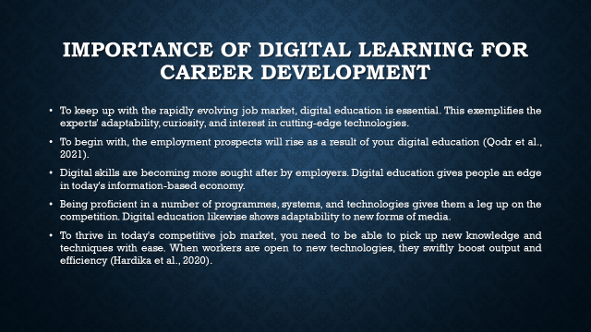

Transferable Skills for the Digital Era
The commitment to one's career and to lifelong learning is on display via the use of digital learning. A dedication to being current and relevant is shown in the use of digital learning. This indicates that they value growth, change, and adaptation to the market. This dedication to improvement helps individuals in their current employment and also creates new ones. Transferable skills and professional growth are both facilitated by digital education (Surahman et al., 2020). Collaboration and communication are essential for remote work and virtual teams. Online material may be accessed and evaluated by anyone with the necessary digital literacy and information management abilities. Digital problem solvers and critical thinkers may find novel approaches to resolving complex digital challenges.
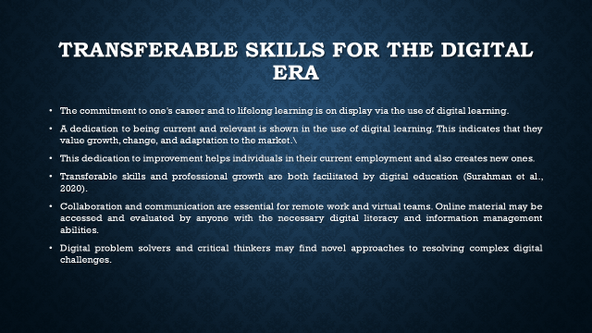

Task 3: Mind Map
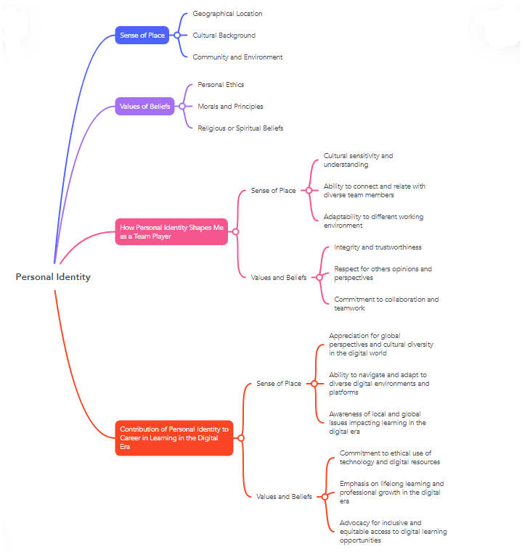

Personal Identity
My sense of location, my values, and my ideology are all significant factors in shaping who I am. One's sense of self, one's relationships with others, and one's ability to exert control over one's environment are all affected by these factors.

Sense of Place
One's sense of identity is heavily influenced by one's physical location. My perspective and worldview are informed by the norms and practises of the culture in which I was raised (Sudibjo et al., 2019). In addition, the unique characteristics and breathtaking scenery of my current location have had an impact on my sense of community and global engagement (Rahmatullah et al., 2022).

Values and Beliefs
Ethics, morals, and values are the bedrock upon which my sense of self rests. My choices, actions, and relationships are all affected by them. Furthermore, the moral and spiritual principles I have learned through my religious or spiritual beliefs give my life meaning.

How Personal Identity Shapes Me as a Team Player
The location is great for my team's productivity. My exposure to and appreciation of many cultures grew as a result of my upbringing in a multiethnic household. My ability to recognise and value divergent viewpoints has helped me communicate and collaborate effectively with a wide range of team members (Hardika et al., 2020). My adaptability has made it easy for me to join and contribute to a wide range of teams and endeavours. My approach to working with people is shaped by my values. Because I am trustworthy and honest, my coworkers respect me and trust me to act in responsible ways. In addition, I find that hearing others' points of view encourages constructive dialogue and teamwork. I am a team player who places a premium on recognising and fostering the strengths of others.

Contribution of Personal Identity to Career in Learning in the Digital Era
Digital education requires me to create a unique identifier. The content I provide online promotes cross-cultural understanding. Because of this, I am able to communicate with individuals from many walks of life and use a wide variety of online resources. As a result of my familiarity with regional and global difficulties impacting digital learning, I am able to participate to discussions and provide solutions that are welcoming to everybody (Rini and Cholifah, 2020). My beliefs and values inform my output. My integrity in the workplace is maintained through the responsible use of all digital resources. Keeping up with the rapid pace of technological advancement requires me to constantly seek out new knowledge and hone my skills. For this reason, I advocate for open and fair digital education for all students.

Conclusion
It concludes that the modern information era, my sense of self and my professional development are shaped by my sense of location, my values, and my beliefs. Constant learning, adaptability to new situations, a focus on doing the right thing, and an appreciation for other cultures are all necessities in this job.

Task 4: Written Summary
Maintaining honesty in the classroom is essential to student success. Students produce work that is authentic and reflective of their values and ideas. To maintain credibility in the classroom, students must refrain from plagiarising the work of others. There are several reasons why maintaining honesty in the classroom is crucial. First, honesty and justice in thought are fostered in an environment of intellectual integrity (Rahmatullah et al., 2022). It ensures that students are responsible and get credit for their efforts. Students’ progress in their fields of study when they do original research, think critically, analyse critically, and treat others with respect.
Second, intellectual integrity helps one advance in one's career and in one's personal life. Students' ability to think creatively and make meaningful contributions to their topics is highlighted in their individual works, which also serve to hone their research and composition skills. Their education benefits from this, and they are better prepared for careers that value originality and integrity in the workplace. Different resources are available for students to use in the creation of original works. Turnitin scans submitted papers against a huge library of academic materials in order to identify instances of accidental or deliberate plagiarism. Websites like this help students learn how to correctly credit their sources in written assignments (Qodr et al., 2021). Writing labs, workshops, and guides to best practises in academic writing are all resources provided by educational institutions. Formats for citing sources in APA and MLA styles, as well as guides on paraphrasing and referencing, are provided. Students are taught proper study and writing habits.
Maintaining honesty in the classroom calls for ongoing study. Professors and universities actively promote these views. Academic honesty and originality could benefit from well-defined expectations, direction, and teacher support. Truthfulness in thought, equality, and growth are all aided by maintaining high standards of academic integrity. Academic honesty requires originality and avoidance of plagiarism (Sudibjo et al., 2019). Tools like plagiarism scanners, writing labs, and style guides all contribute to an environment conducive to learning by helping students avoid plagiarised content and properly attribute sources.

References

Chang, C.Y. and Hwang, G.J., 2019. Trends in digital game-based learning in the mobile era: A systematic review of journal publications from 2007 to 2016. International Journal of Mobile Learning and Organisation, 13(1), pp.68-90.
Hardika, H., Aisyah, E., Raharjo, K. and Soraya, D., 2020. Transformation the meaning of learning for millennial generation on digital era.
Qodr, T.S., Efendi, A. and Musadad, A.A., 2021. Opportunities for using smartphones in the digital era to facilitate students in learning sociology in high schools. Journal of Education Technology, 5(2), pp.263-271.
Rahmatullah, A.S., Mulyasa, E., Syahrani, S., Pongpalilu, F. and Putri, R.E., 2022. Digital era 4.0: The contribution to education and student psychology. Linguistics and Culture Review, 6(S3), pp.89-107.
Rini, T.A. and Cholifah, P.S., 2020. Electronic module with project based learning: Innovation of digital learning product on 4.0 era. Teknologi Pendidikan, 5(2), pp.155-161.
Sitthipon, T., Kaewpuang, P., Jaipong, P., Sriboonruang, P., Siripipattanakul, S. and Auttawechasakoon, P., 2022. Artificial Intelligence (AI) Adoption in the Medical Education during the Digital Era: A Review Article. Review of Advanced Multidispliniary Science, Engineering & Innovation, 1(2), pp.1-7.
Sudibjo, N., Idawati, L. and Harsanti, H.R., 2019, December. Characteristics of Learning in the Era of Industry 4.0 and Society 5.0. In International Conference on Education Technology (ICoET 2019) (pp. 276-278). Atlantis Press.
Surahman, E., Sulthoni, A. and Putra, A.P., 2020. Components and Patterns of Hypercontent Textbook Design as Innovative Learning Resources in Digital Learning Era. world, 7, p.8.

