Task 1:
Clearly define the term Offsite Construction giving examples of the four main categories and how these could be incorporated in the house. (5%)

Offsite construction involves pre-planning, designing, fabricating, and transporting building items to be assembled on-site. This method offers greater speed and precision compared to traditional on-site construction 1.

Offsite Construction:
The four main methods of offsite construction are volumetric, hybrid, panelised, and sub-assemblies and accessories systems. Volumetric construction involves creating three-dimensional units in a factory, which are then transported and bolted together on-site. These frames can be made of steel, timber, or concrete, and the factory production follows quality-controlled systems. Volumetric construction is also referred to as modular construction, and these modules can be basic structural shells or include internal and external finishes and services. This method includes modular construction, where pre-engineered building components are assembled as large volumetric components, and pod construction, where non-structural elements are used within a load-bearing structure, typically in hotels and accommodation spaces.

Hybrid construction combines volumetric and panelised approaches, making it semi-volumetric. It involves manufacturing or prefabricating building facilities in a factory with complete final finishes. These units, often called pods, are transported to the site after finishing. For example, bathrooms and kitchens may be constructed as volumetric units, while the rest of the building uses panels.
Panelised construction uses flat panel units for walls, floors, or roofs to create a complete structural shell. These panels are built in a factory and then assembled on-site to form a three-dimensional structure or to fit into an existing on-site structure. Factory-made structural floors and roofs are also known as "cassettes," which can be load-bearing or non-load-bearing.

Sub-assemblies and Accessories:
The sub-assembly system involves constructing building components offsite before permanent installation. This includes manufacturing small components like roof trusses, floors, piping, staircases, and precast concrete beams and columns. This system incorporates prefabricated foundations, floor cassettes, and roof cassettes. []

Task 2:
- Compare the Ground floor Construction, detailing and junctions with external walls for each method (30%)
- Compare a detailed section and plan detail showing a window opening in the external wall for each method (30%)
- Compare eaves detailing and roof structure– indicating appropriate weathering, fixing and laps for each method (30%)
- Recommend a construction method for the client, explain your reasoning. (5%)

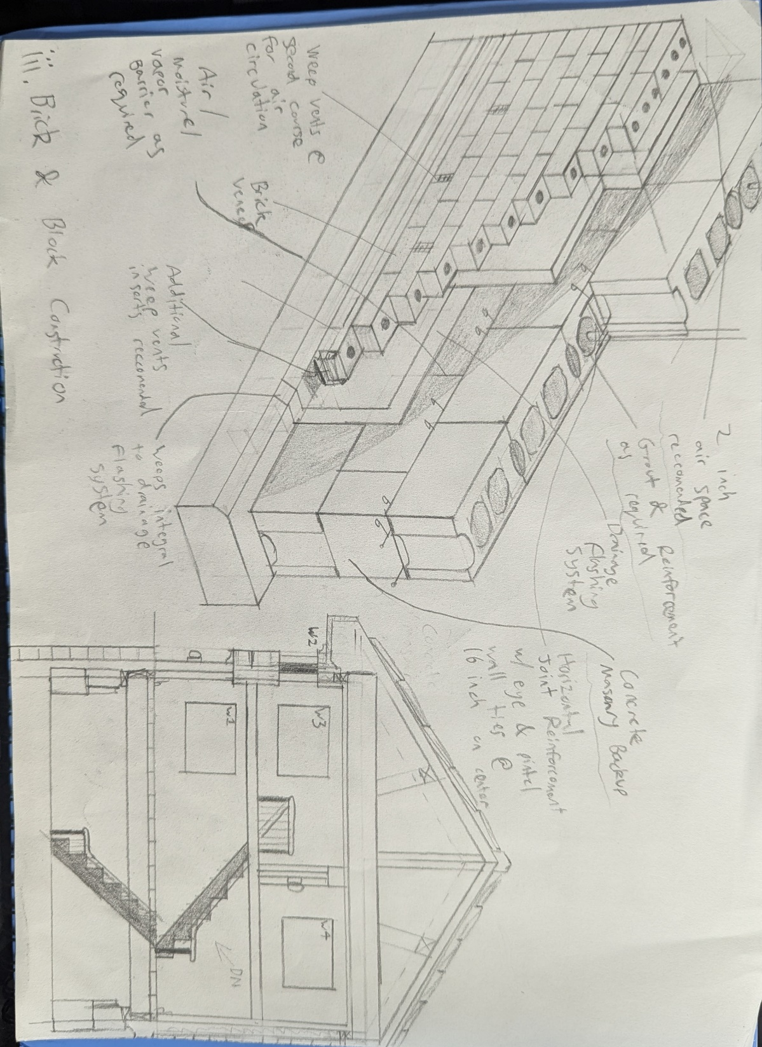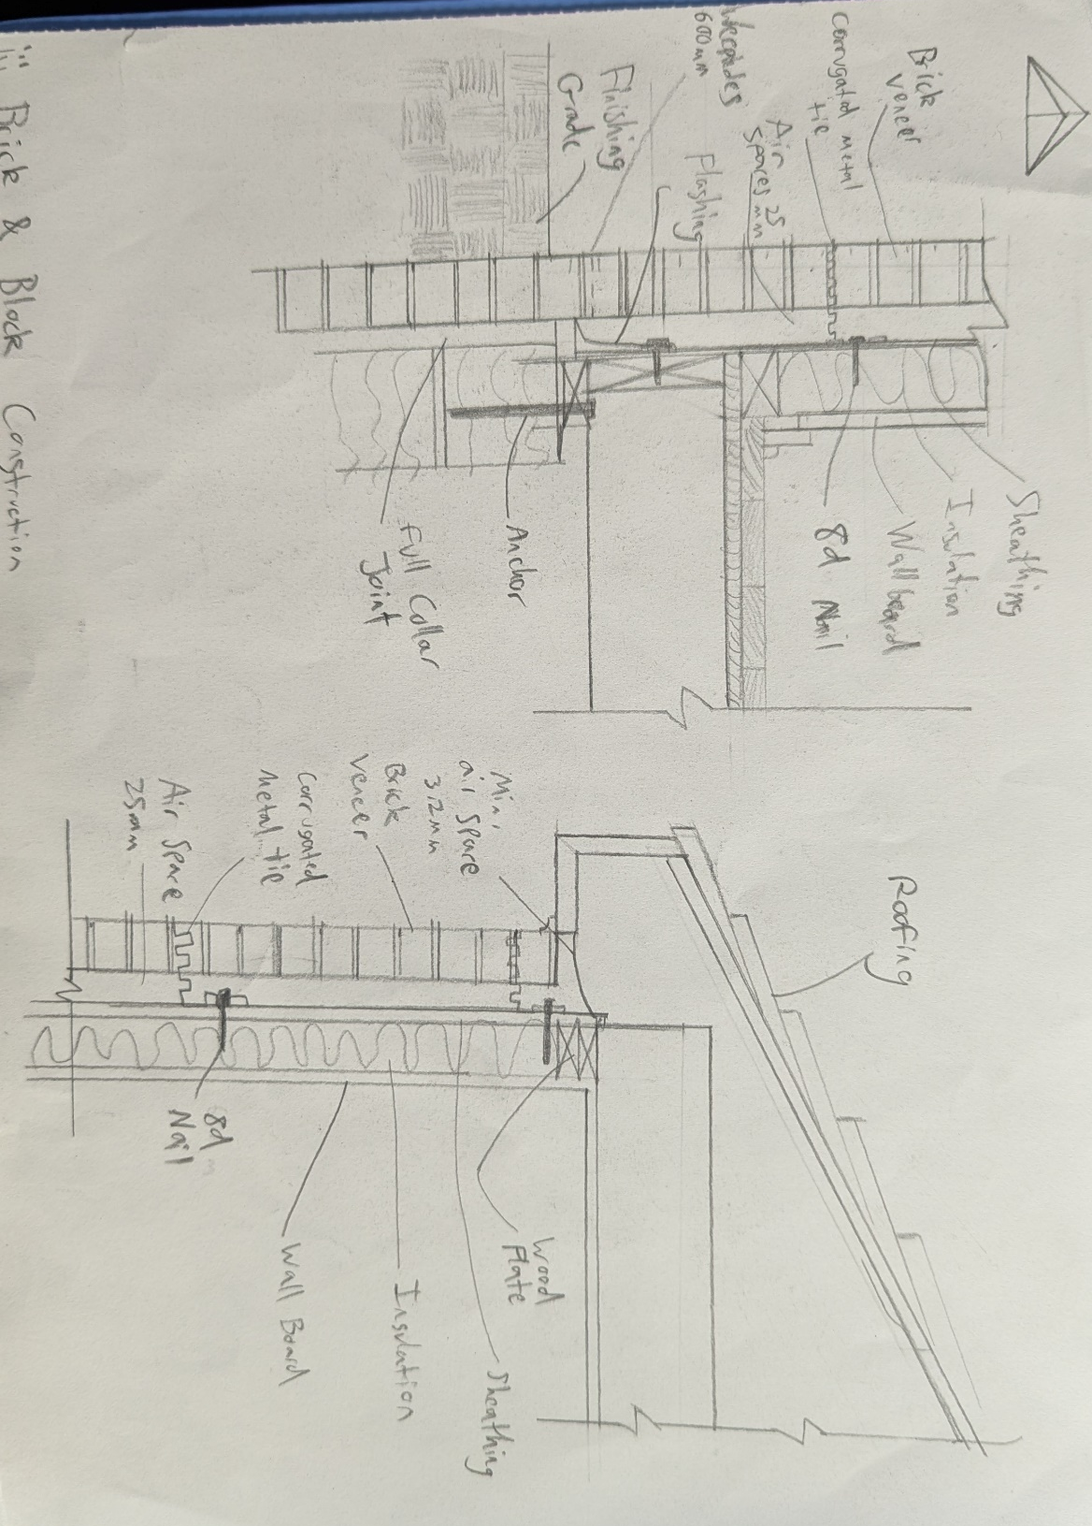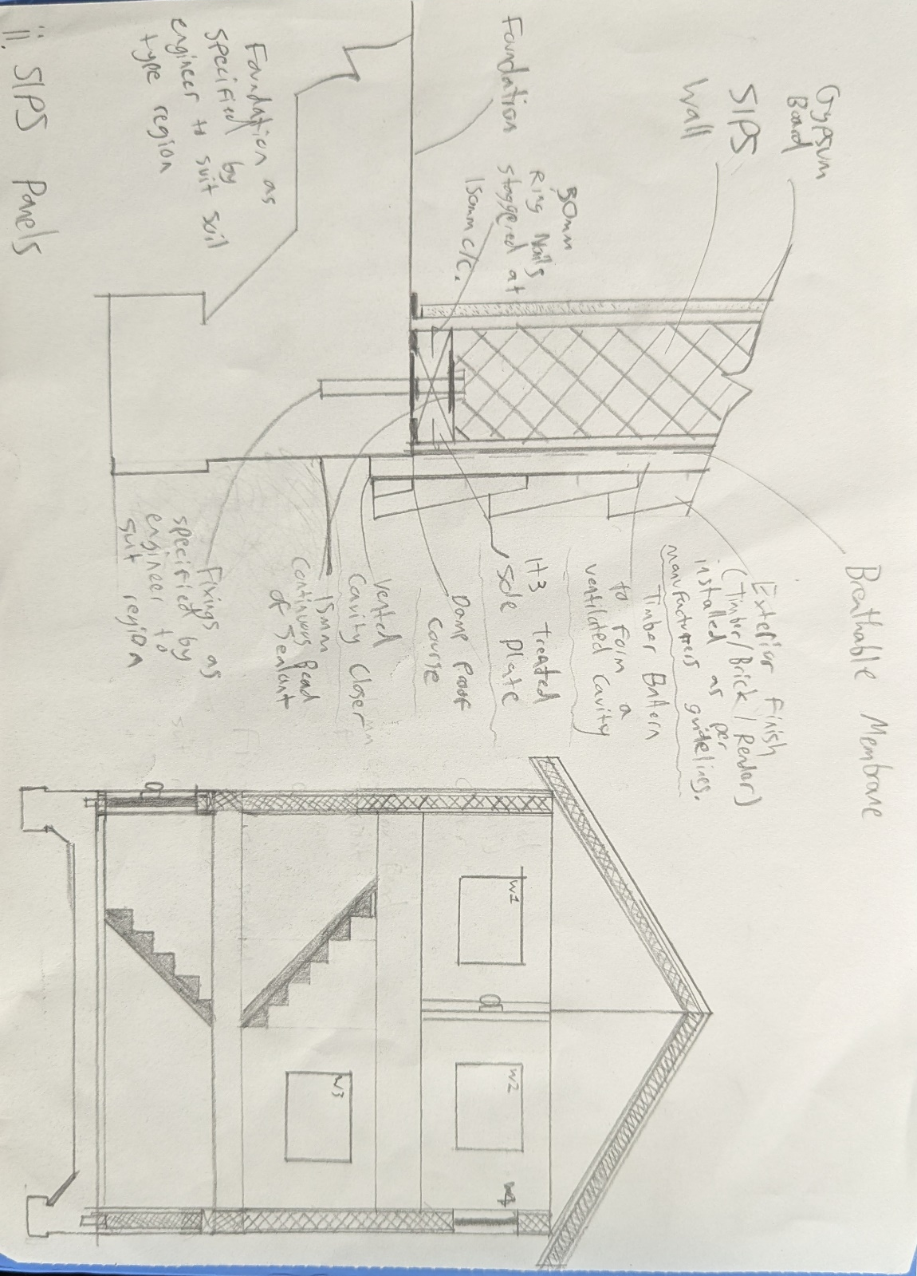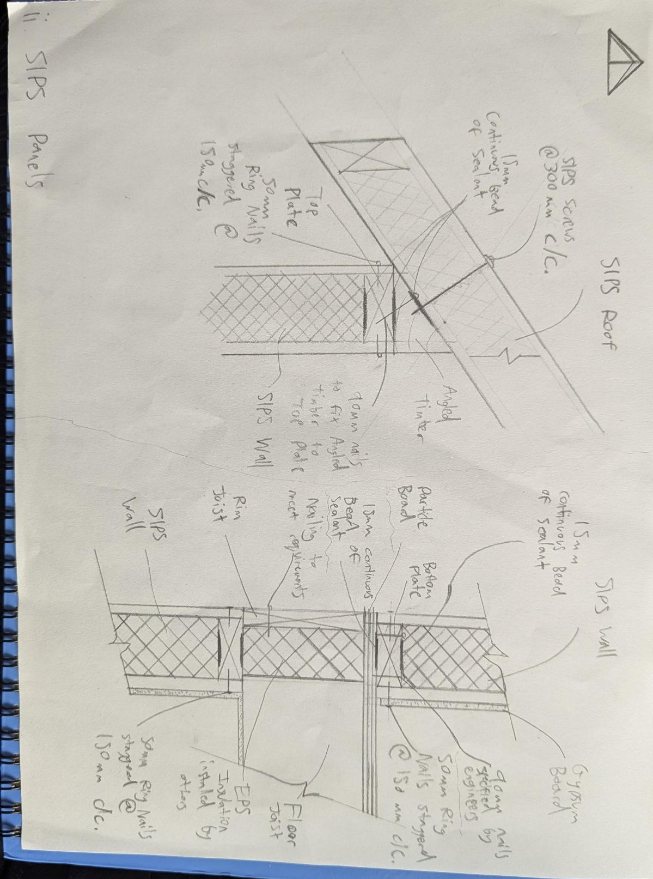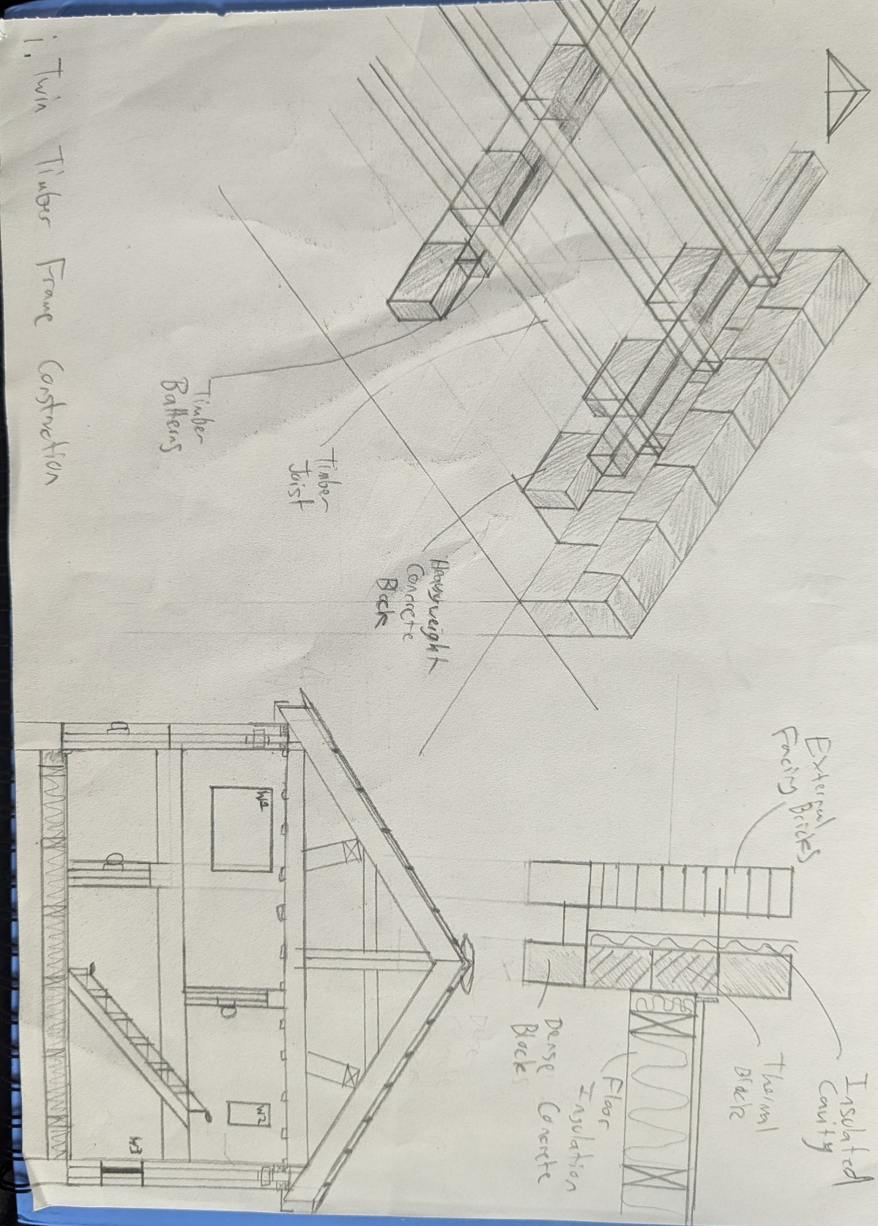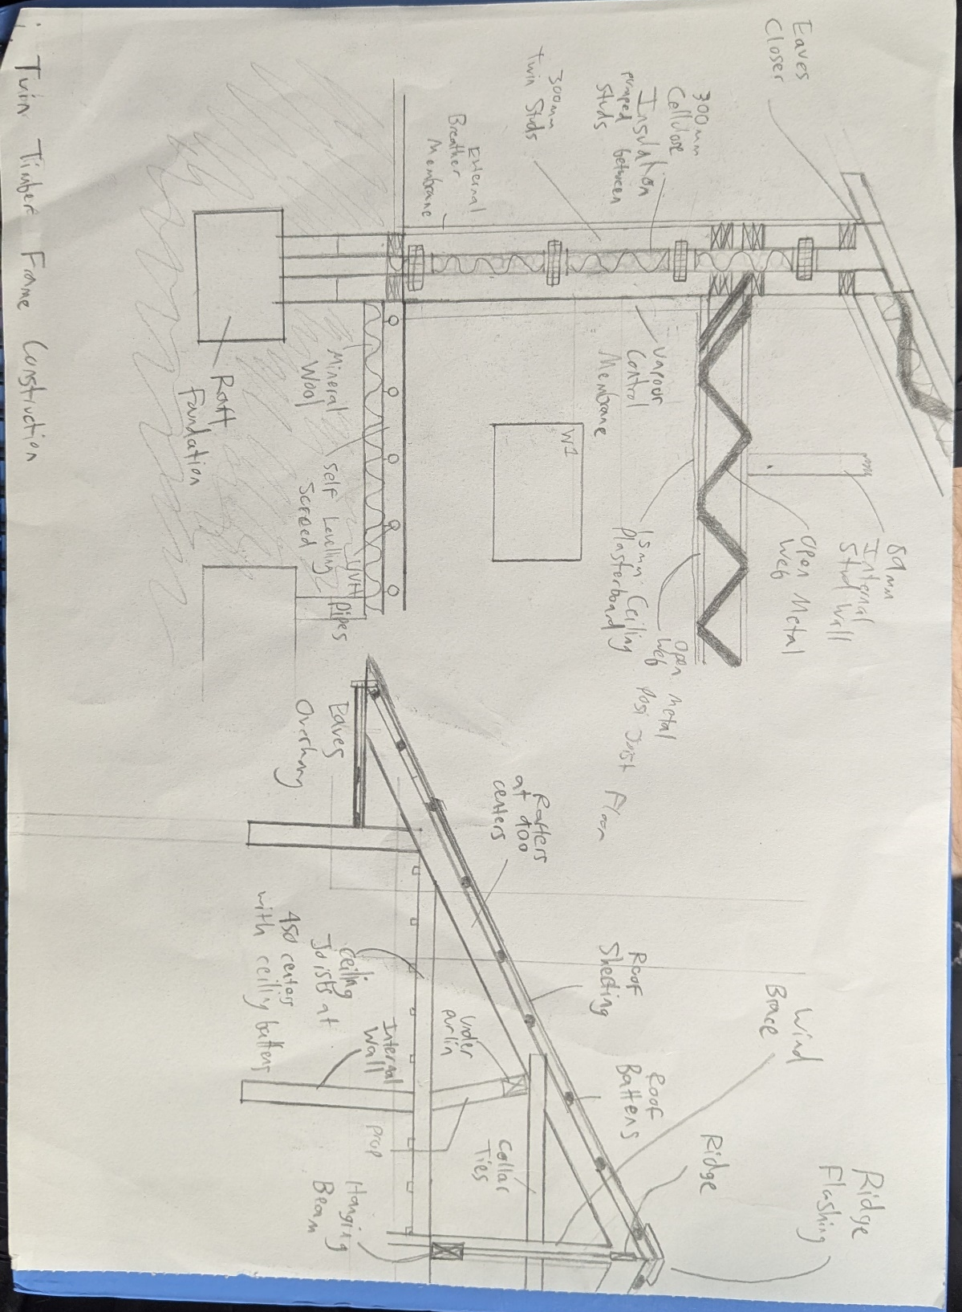

Personal Recommendation:
Structural Insulated Panels (SIPs) are a great material choice because they speed up the building process and are very efficient. SIPs consist of insulation, like polystyrene, between two structural boards, such as oriented strand board (OSB). They are versatile and can be used for external walls, load-bearing internal walls, and roofs. One major advantage of SIPs is their thermal efficiency. SIPs reduce cold bridging because they have fewer vertical timber studs compared to traditional timber frames, which improves insulation. The factory-made panels limit gaps, and the combination of OSB and insulation reduces air leakage, making SIPs suitable for low-energy homes. Using deeper panels can result in even lower U values, which is essential for energy efficiency. SIPs can help meet building regulations, including those in Wales, by providing high airtightness and insulation, reducing energy consumption and carbon emissions. Combining SIPs with proper ventilation, like a mechanical ventilation heat recovery (MVHR) system, ensures good air quality and prevents condensation, which helps to create a healthy indoor environment and comply with regulations. While SIPs may have higher upfront costs compared to traditional timber frames, the speed of construction and lower long-term energy costs can make them cost-competitive overall. []

Reference List
- The Constructor (2020). What is Offsite Construction? [online] The Constructor. Available at: https://theconstructor.org/building/offsite-construction-features-methods/38319/ Accessed [25/04/2025]
- Corfield, A. (2021). SIPs Guide: Everything You Need to Know. [online] Homebuilding & Renovating. Available at: https://www.homebuilding.co.uk/advice/structural-insulated-panels. Accessed [25/04/2025]

What is Offsite Construction?
SIPs Guide: Everything You Need to Know

