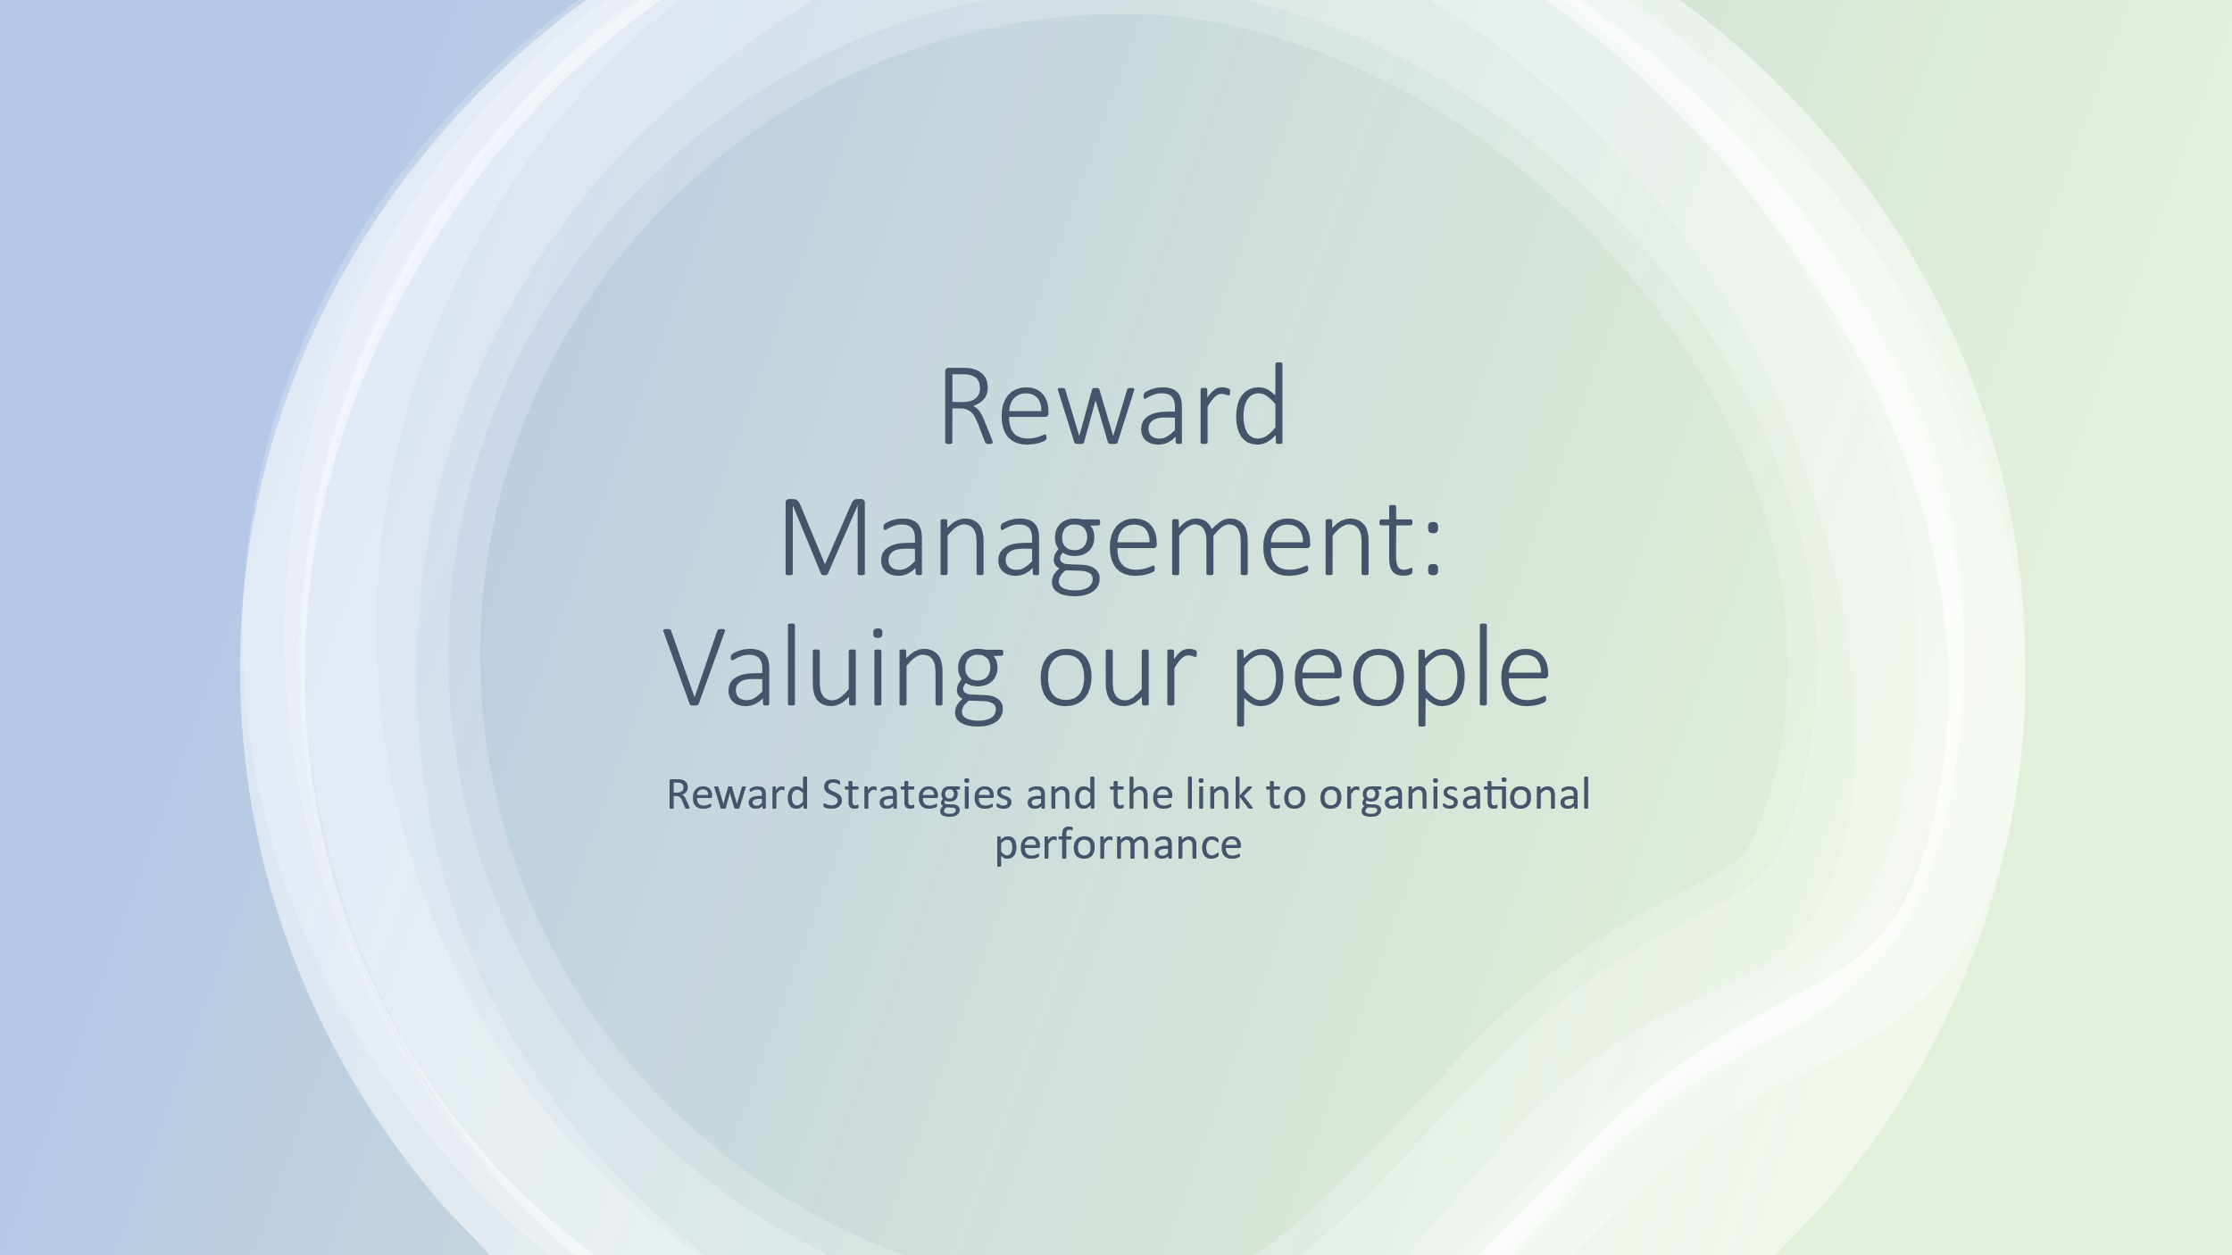

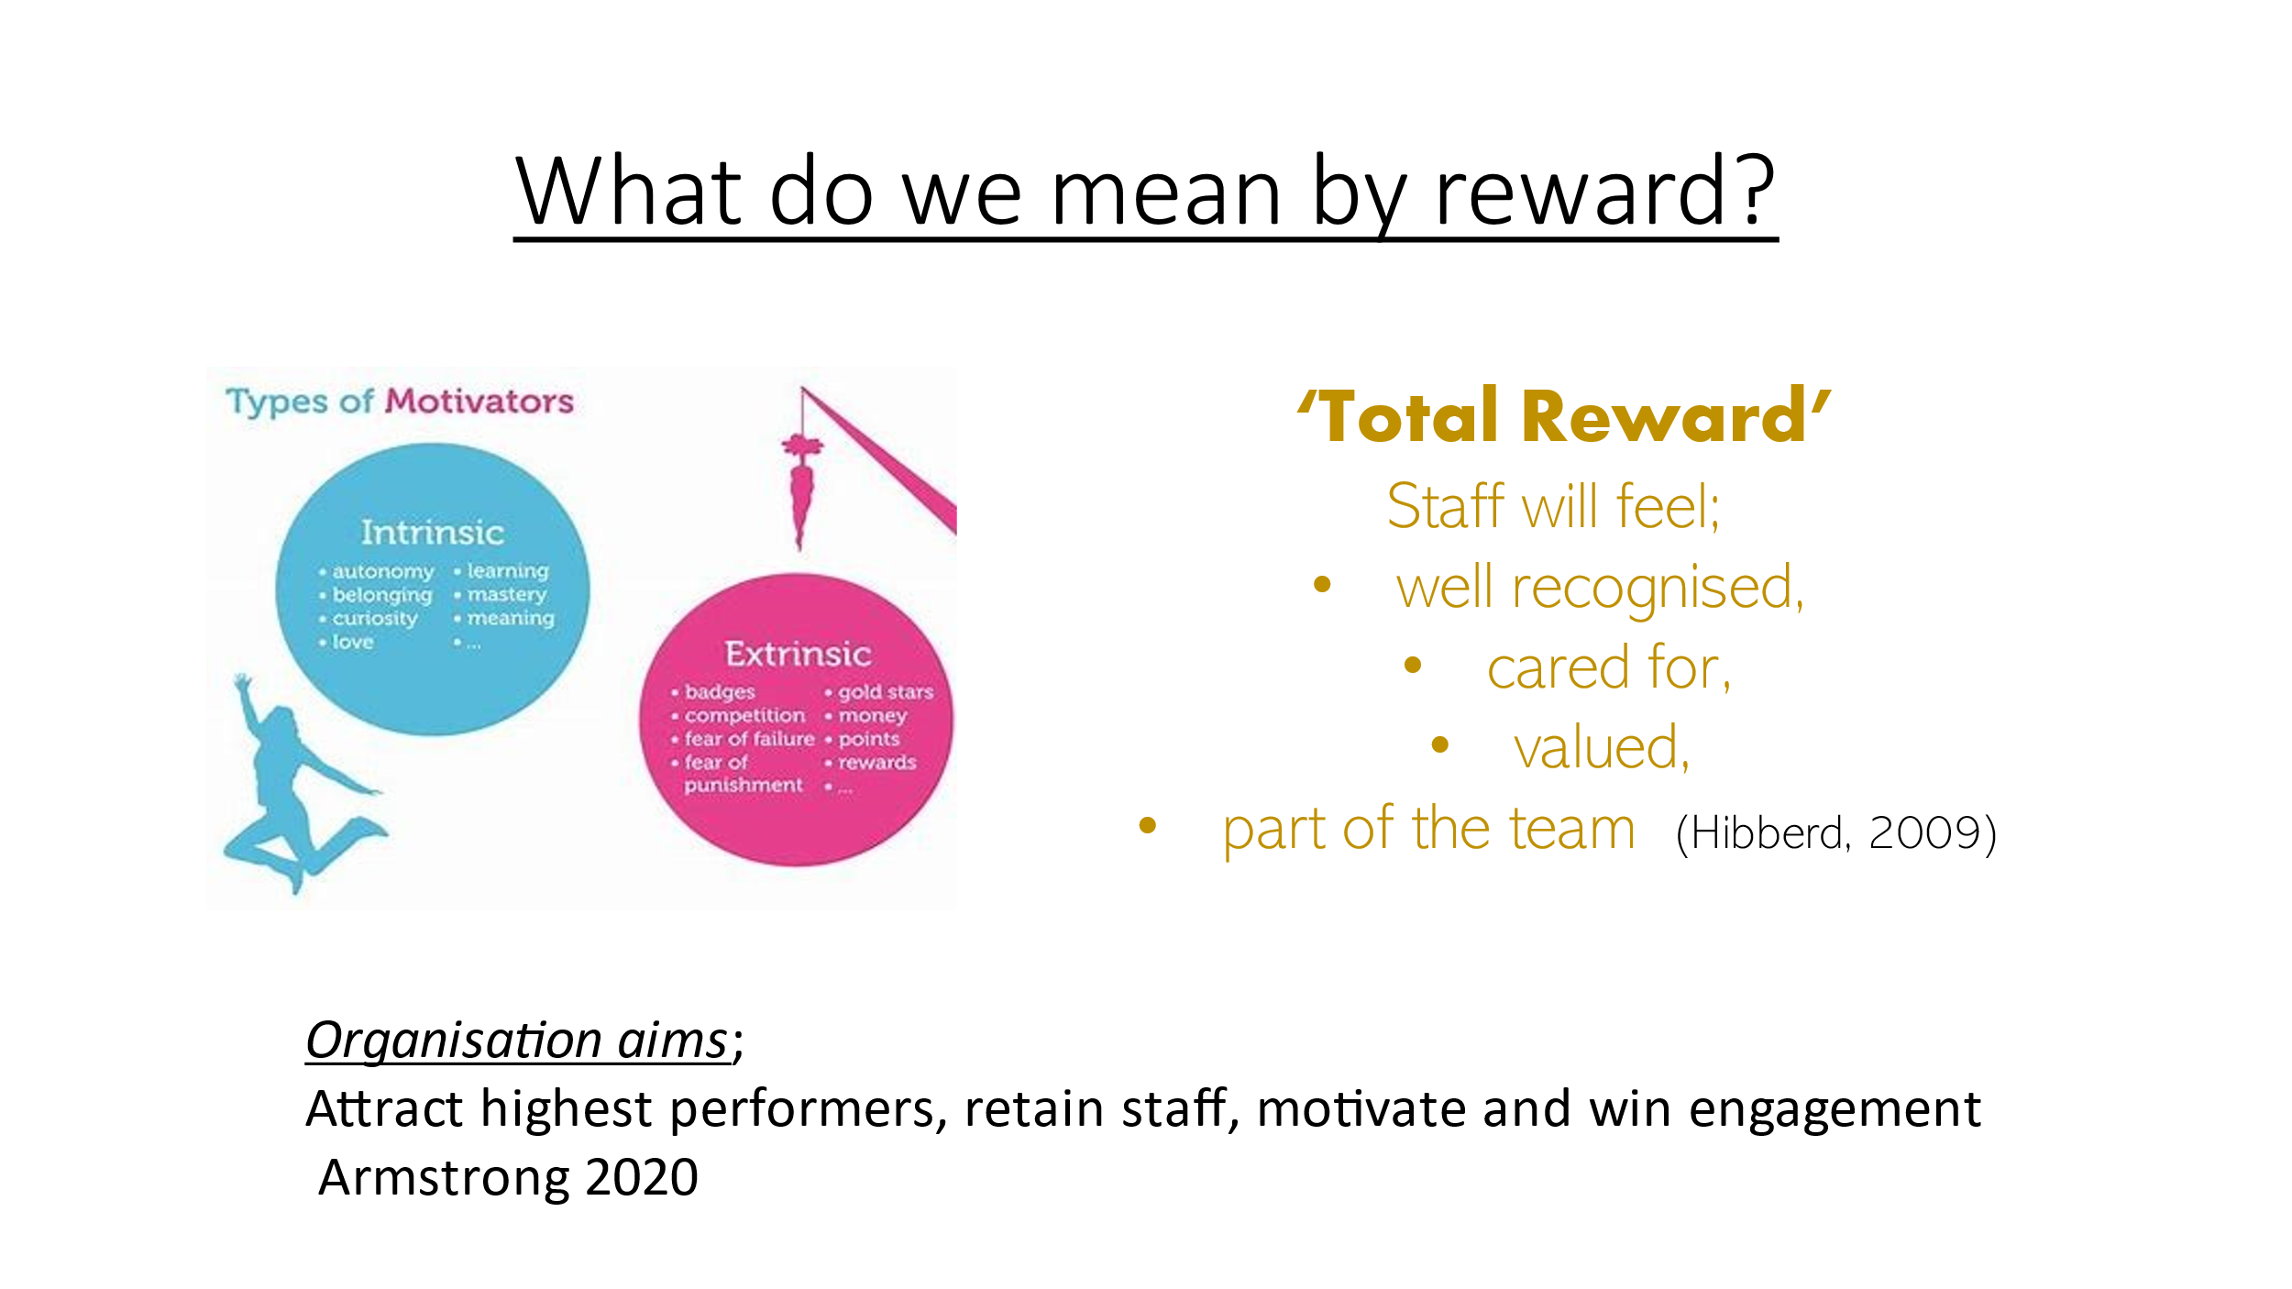

AC 1.1 Reward is the means by which we give more to an employee than their basic pay, Armstrong (2020) defines it as a means of valuing people and then rewarding them according to that value. CIPD (2022) notes it’s more than remuneration, it is a way to add value to each individual beyond the basic expectation of pay. From the slide we can identify some intrinsic and extrinsic reward, many organisations would currently use ‘total reward’ within their management systems (Taylor & Woodhams, 2016), meaning they would encompass ‘all aspects of work that are valued by employees’ (CIPD, 2015). This means as an organisation we also need to consider the impact of a reward system that considers and individual’s learning and autonomy within their role as well as the more ‘obvious’ elements such as increasing competitiveness and earning kudos and recognition. CIPD, 2020 argue that a mixture of these two approaches will serve any organisation better. Armstrong (2019) argues that the extent to which we develop our reward structure on equity as opposed to market-driven incentives, depends on the culture of our organisation. Are we an organisation that is pressured to beat competitors with high levels of pay and reward in order to attract the best employees? If that’s how we are driven on pay, then we may not be able to reward based on fairness and equity to the extent we would like. (Armstrong, 2019). The aim of any reward structure is to stimulate higher performance, retain staff, motivate and win engagement as well as to align with employee needs (Armstrong, 2020). As an organisation do we want a culture where we can add value, rather than attach value to employees? (Goshal & Bartlett, 1995).

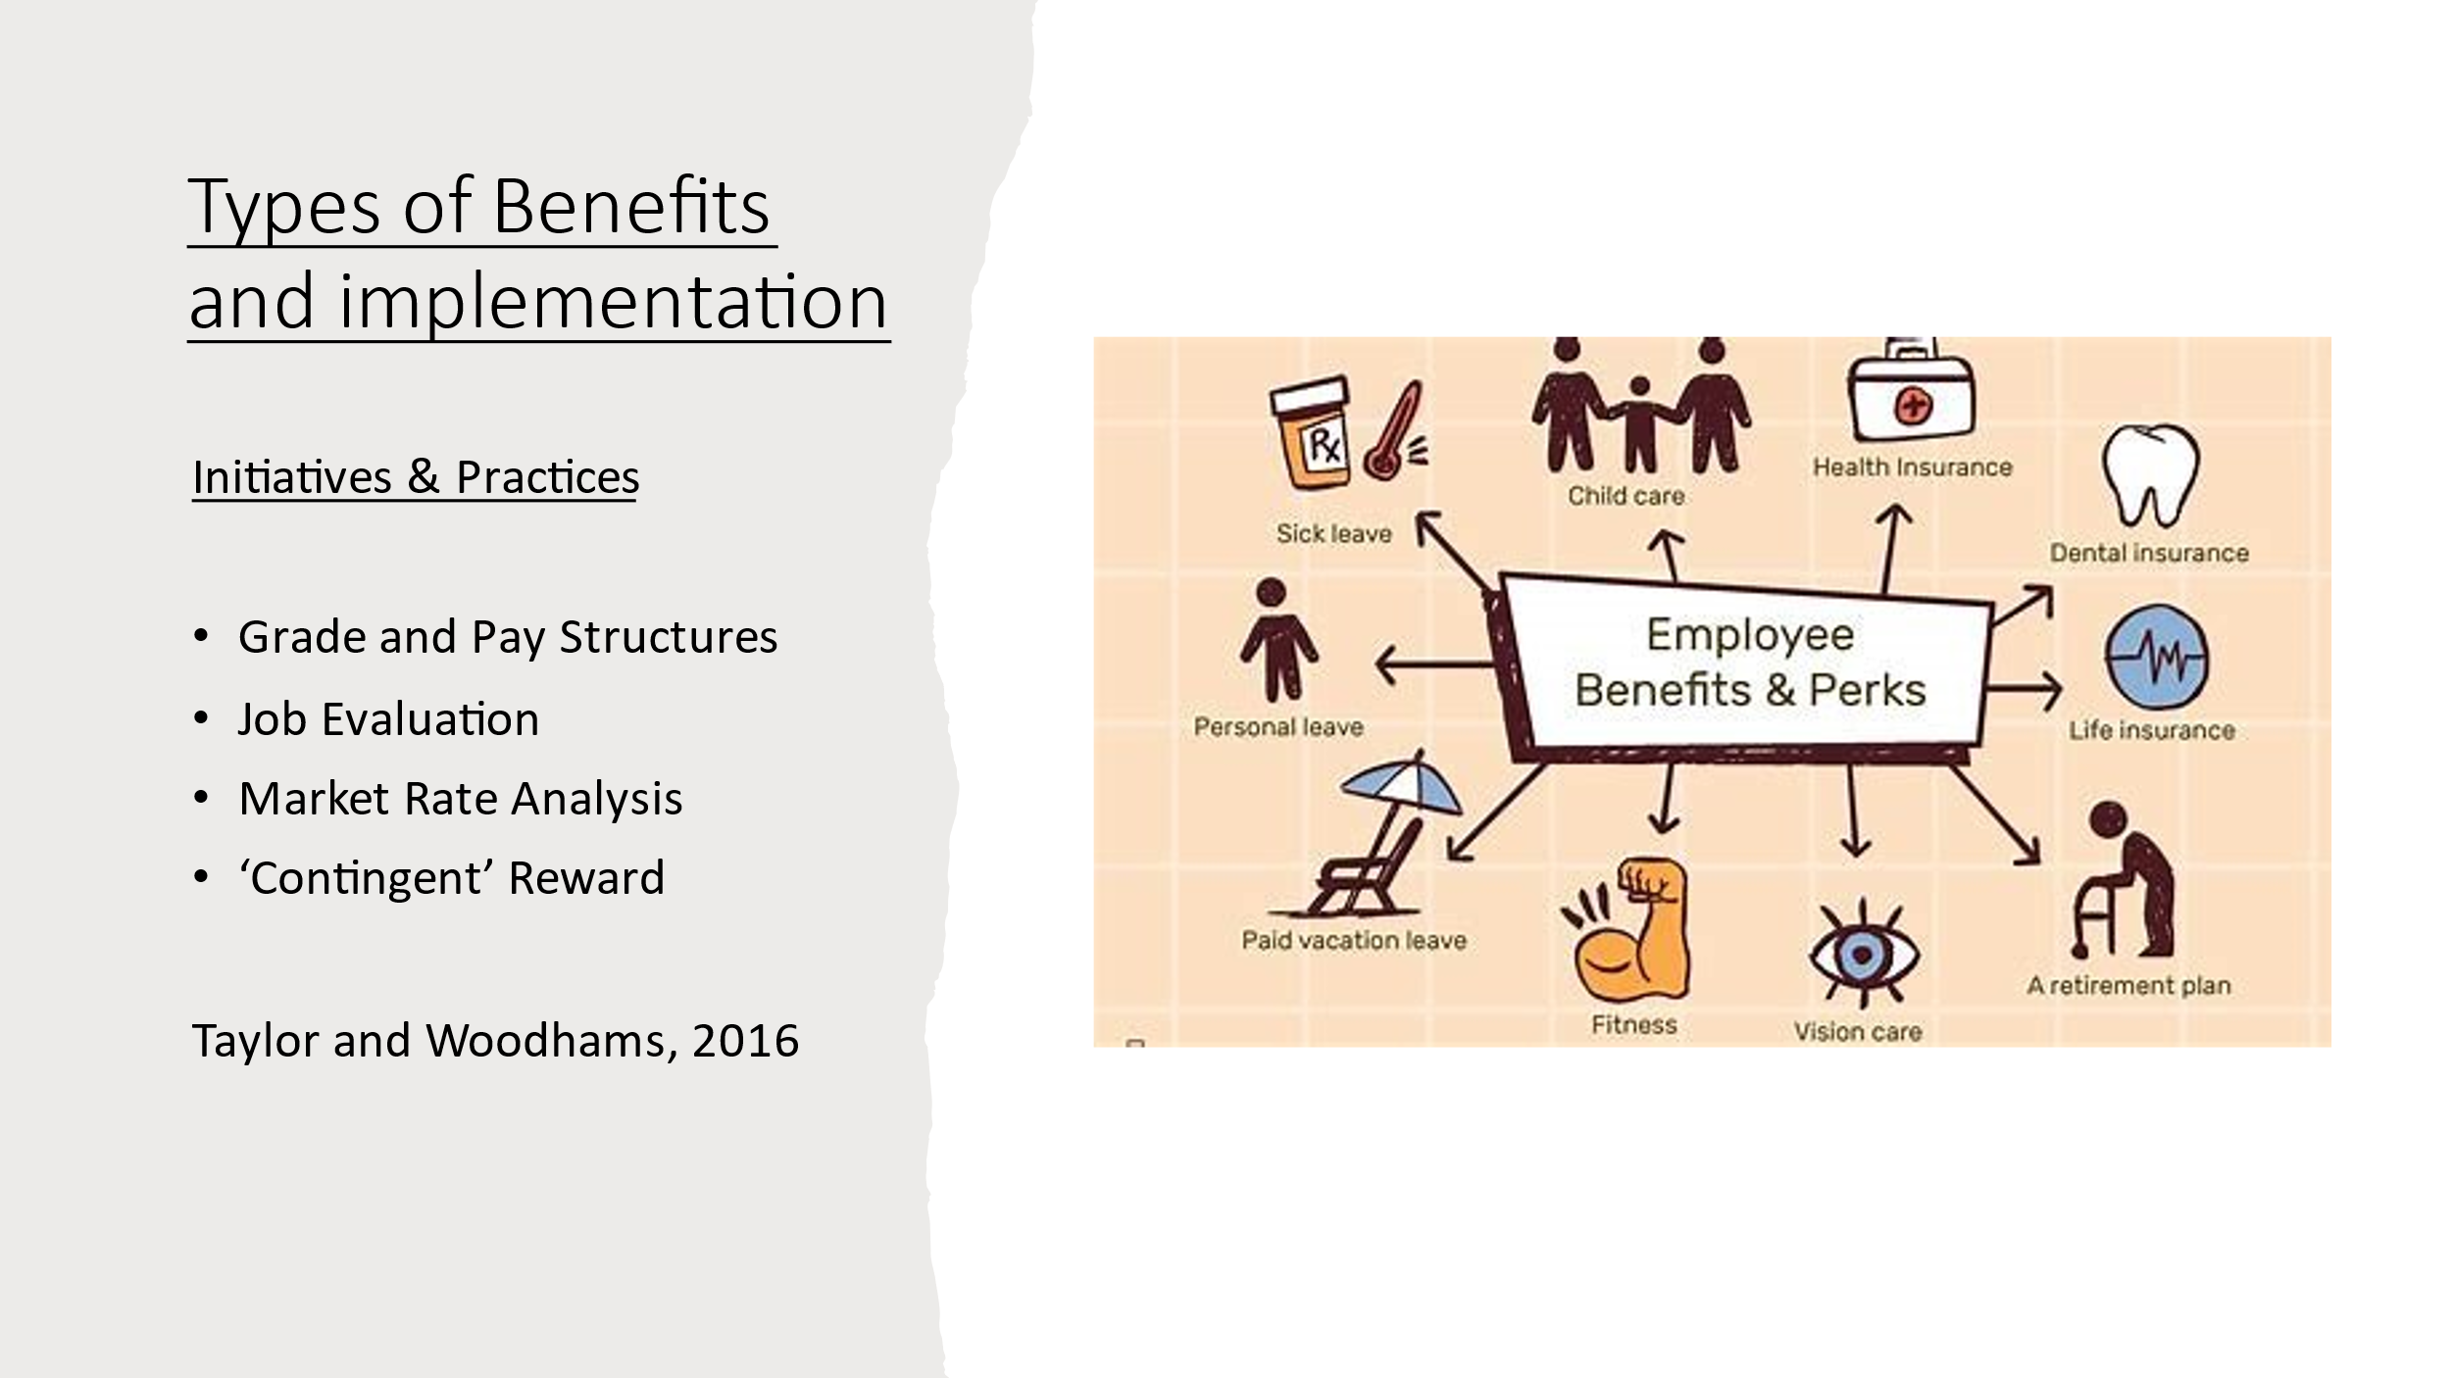

AC 1.2 One of the key elements to a successful reward system or benefits scheme is for employees to see an element of fairness to it. If the system does not ring true as a realistic, achievable benefit to all then it will have the opposite effect. Successful implementation must be consistent (Taylor & Woodhams, 2016). Jacques, 1961 (Armstrong, 2019) developed the ‘felt-fair’ approach, where it was deemed that employees would have an expectation of what fair pay would be for a certain role, and this could then be applied to reward packages, Armstrong warns there is a danger with this that an unhelpful cycle of mistakes could be repeated using this system and would not result in actual equity. Perceived fairness being subject to employee prejudices ingrained and unbroken. As the slide shows there are a number of initiatives and practices that rely heavily on an element of perceived fairness, particularly in the area of pay. It has long been seen as an area of inequity particularly between gender groups and also the gap between the executives and the ‘workers’ (CIPD podcast, 2019) and this can be a fine line to tread when considering being competitive within the market. To implement well Armstrong (2020) recommends a system of continuous goal setting and success criteria in order to measure how well implementation is going.

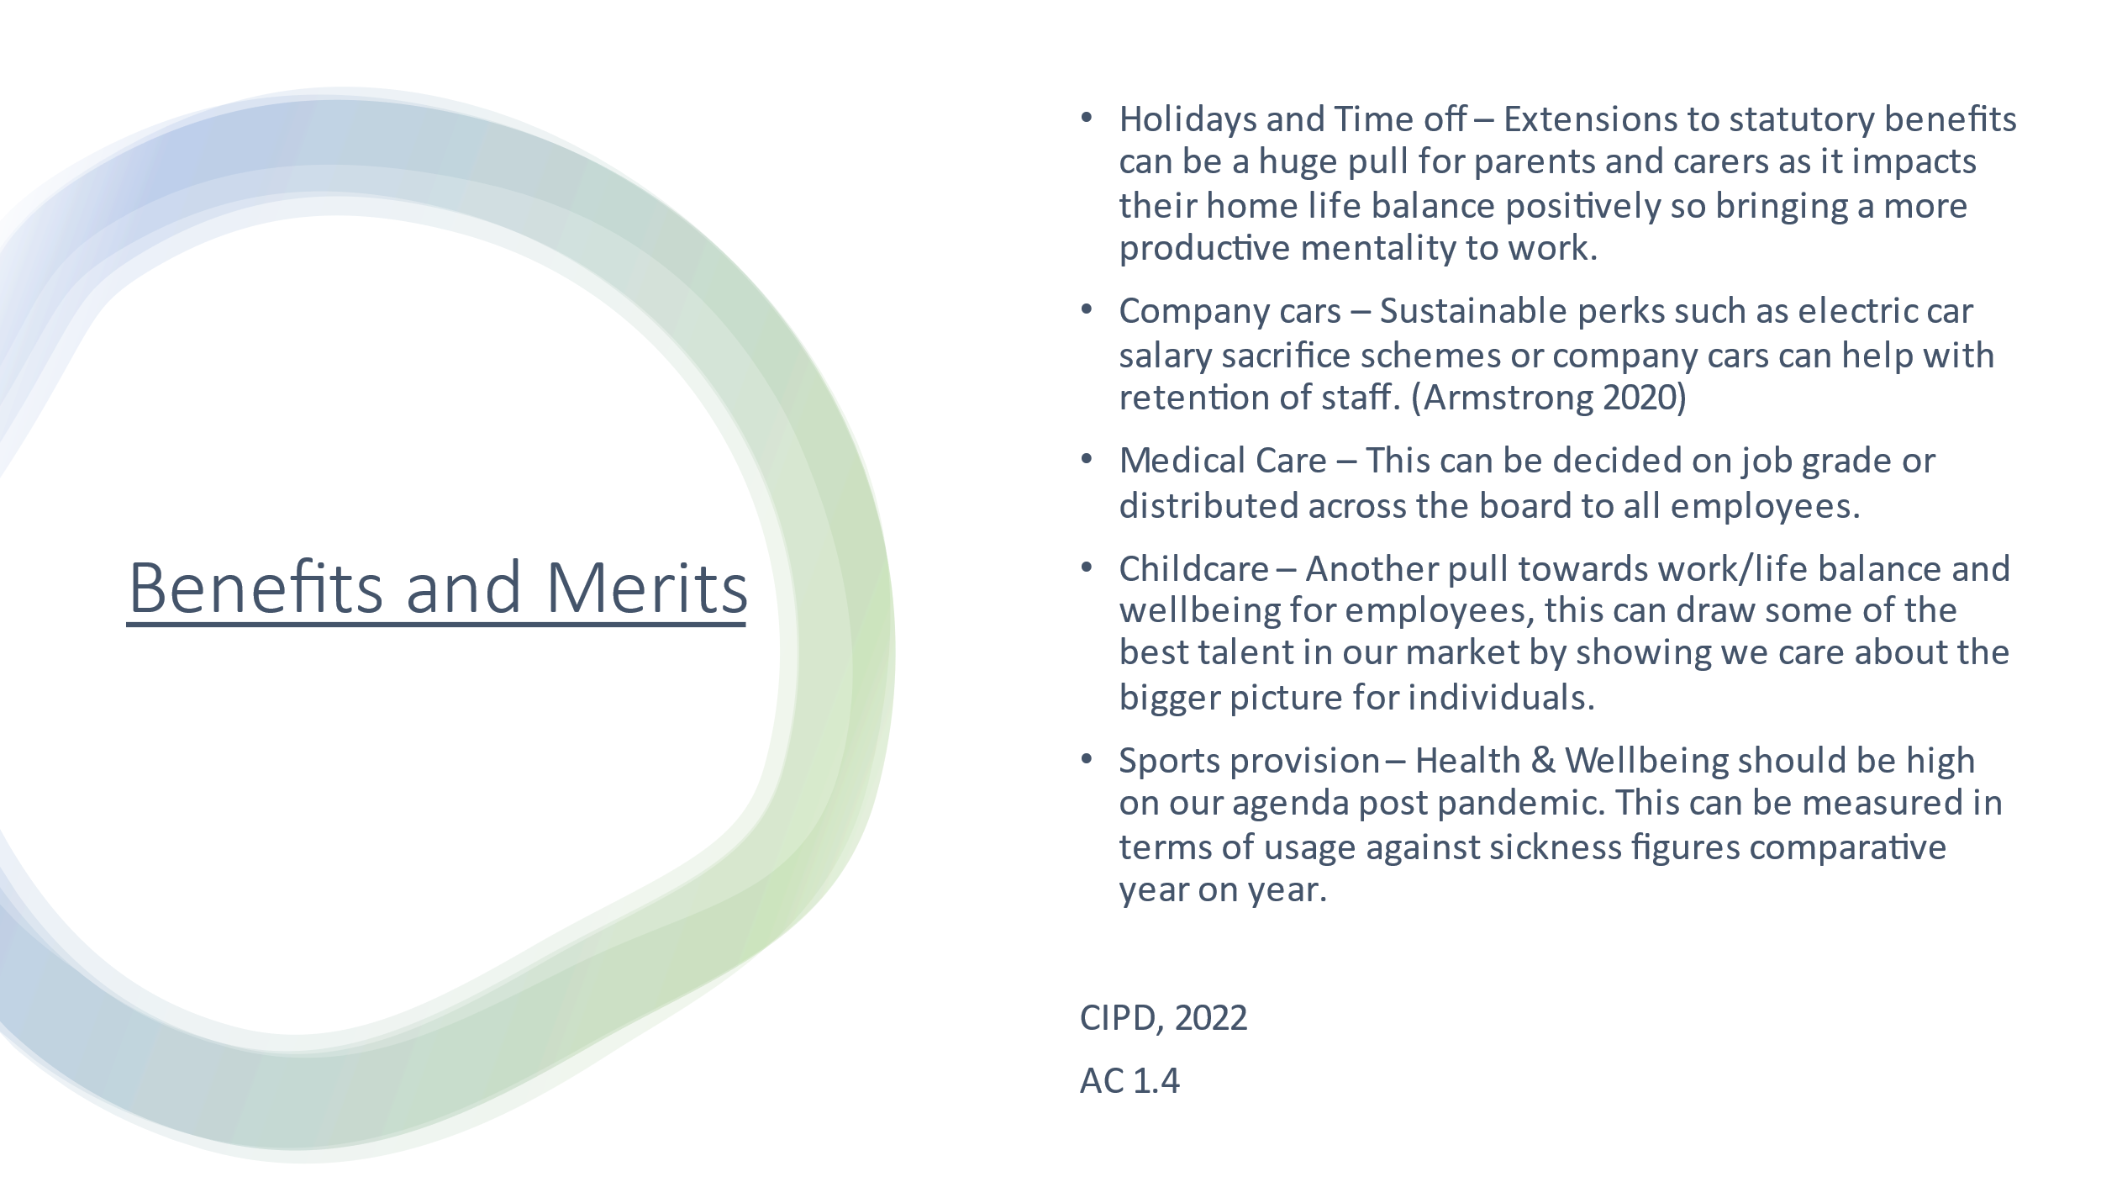

AC 1.3 Farnham, 2015 identifies reward strategies as one of the building blocks for evaluating performance systems within an organisation alongside developing staff to improve performance. Asking the question of why and where are we underperforming and what problem we are addressing can be a great start point for developing and measuring an appropriate reward system. Performance conversations should be ‘ongoing and cultivated’ and involving employees in setting objectives could be helpful in this (J Gifford, 2020). The deciding factors of performance related pay, perks and benefits, job evaluation and flexible benefits system should be based on the market pay do a degree (Armstrong, 2020) but this can lead to a repeat of inequalities across the sector. We could be the leaders in a new structure, grading and motivating in an equitable way, setting the bar high within our market sector and letting others follow. There’s a lot to be said for being the first to try something and standing out that way amongst competitors (CIPD, 2019). Though we know there will always be a tension between the market pressures, financial pressures and internal equity (Armstrong and Taylor, 2020).
AC 1.4 As we look at the slide here and see a few examples of the many benefits we could offer and the merits of each we must consider our own workforce and their primary needs, assessing this through an employee survey as well as recent PADR and exit interview feedback is a great start in considering the most pressing ways our employees are impacting negatively and positively within our organisational culture. If we can start with a system that addresses these needs as fairly and consistently as possible then we be able to more successfully engage and motivate our staff (Taylor & Woodhams, 2016). This engagement should lead to greater retention of staff and ultimately attracting those higher performers across the sector.
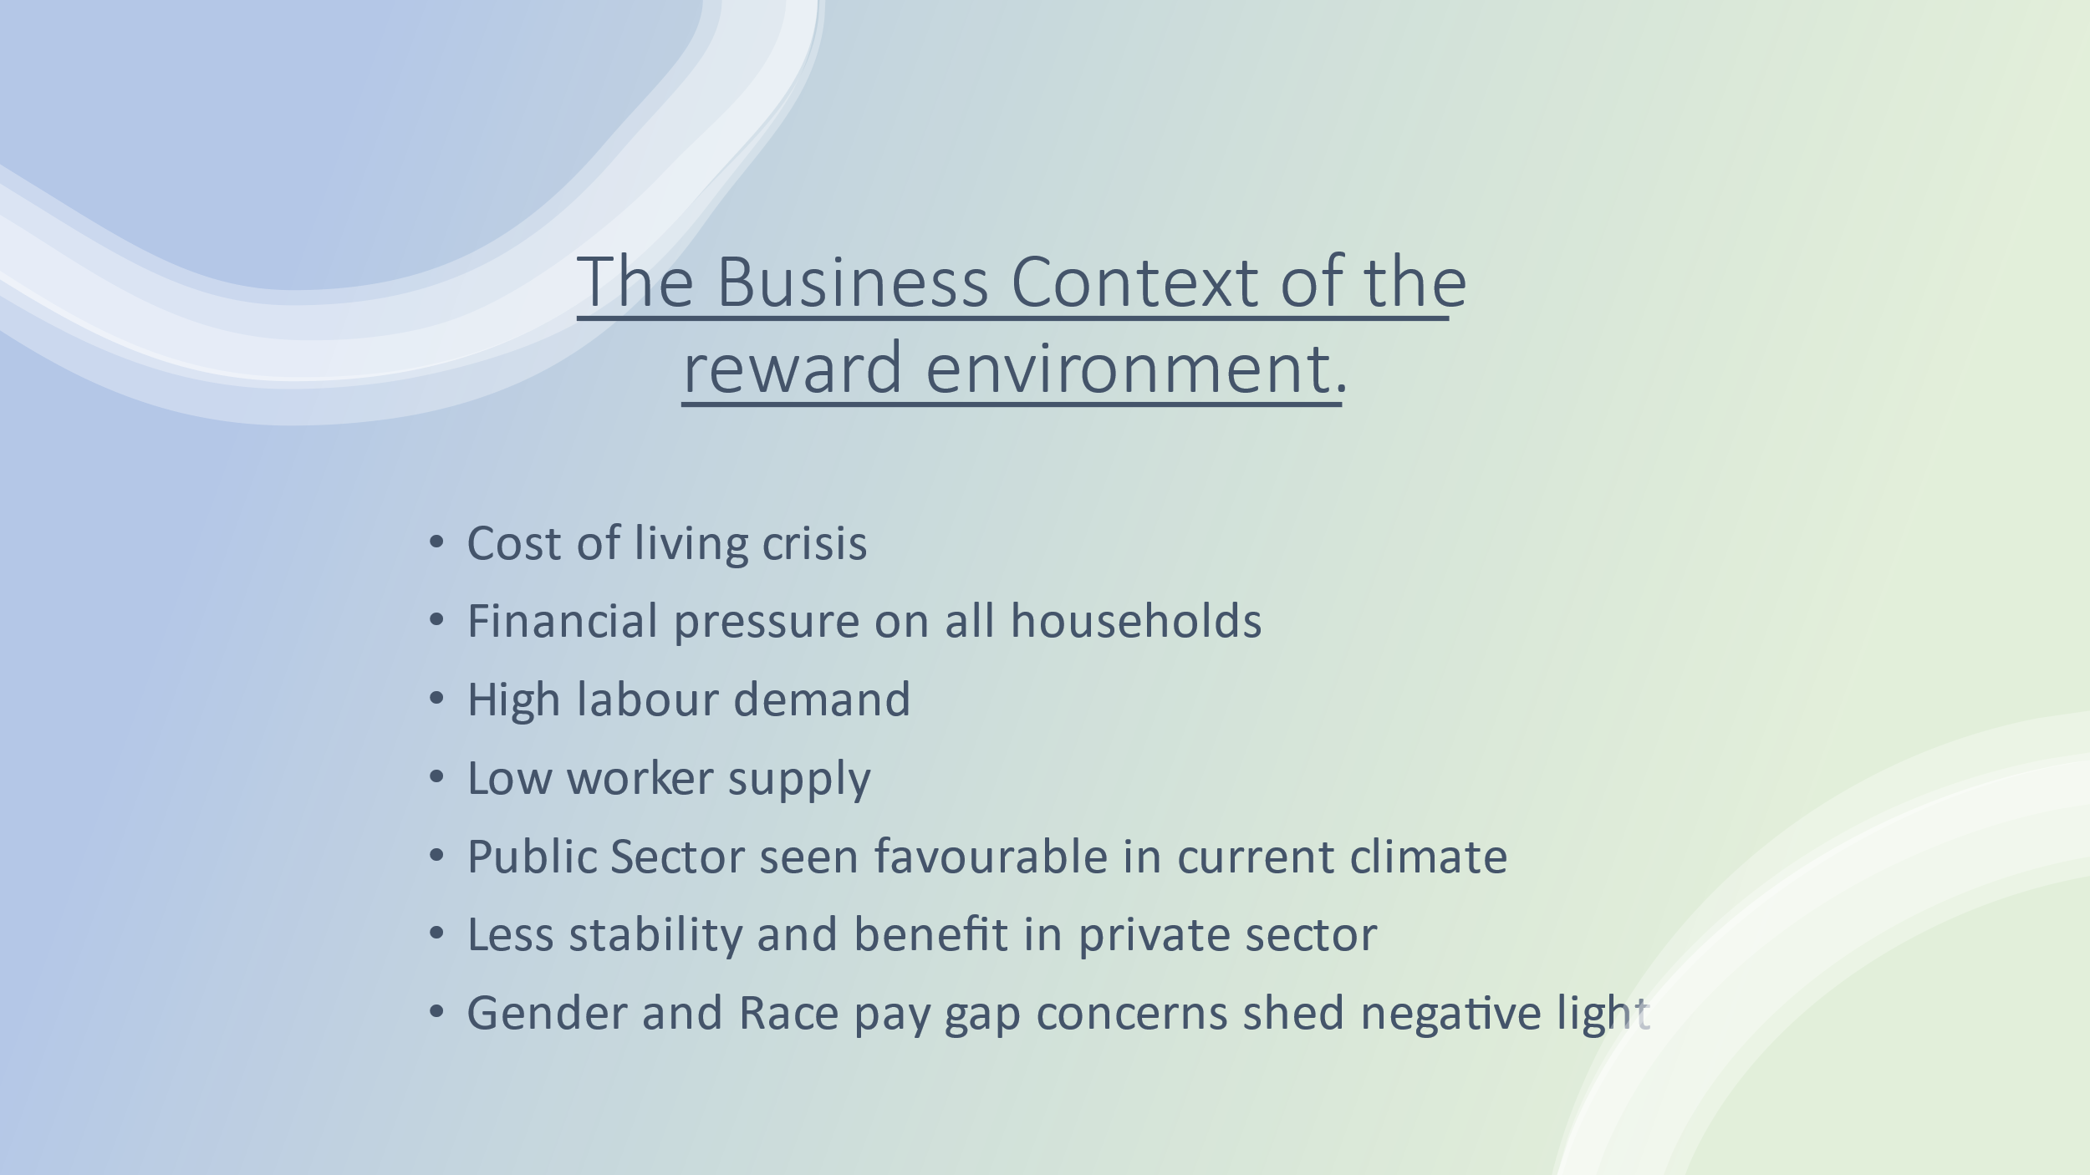

AC 2.1 The current context of reward is heavily influenced by the current cost of living crisis. CIPD, 2022 reports money worries and financial pressures can lead to a rise in absenteeism and presenteeism. This tells us that before we consider non financial rewards we must make sure we are paying wages that employees can live on (the living wage) to relieve these pressures and start to look at performance more effectively. Inflation will have affected our whole market and the rate of economic growth. High demand in labour coupled with a low supply of workers (CIPD, 2022) has led to a real recruitment crisis and the priority for us must be retention of good quality staff. Comparative reward packages within the private sector are often seen as less favourable than the public sector but this is based on a number of myths according to Taylor & Woodhams (2016). It’s possible that the years of collective bargaining through trade unions paired with high earning public sector executives have driven up wages within this sector but private sector organisations are seeing more value than ever in determining competitive pay structures and engaging employees on a psychological level to be able to ‘buy in’ to the bigger vision and mission of the company they’re employed by. We must capitalise on this engagement level if we are to compete within the recruitment market at current levels.
AC 2.2 Benchmarking data can be incredibly useful for us to see how we can compete within the market. Evaluating information that’s reliable and comparable as a source of intelligence for our organisation. Using government surveys and independent reviews and sources such as CIPD and Acas can bring to light patterns and trends in areas of working hours, inflation, and even industrial disputes. This data is a great way of developing evidence based reward schemes and can inform decision making (Armstrong, 2019)

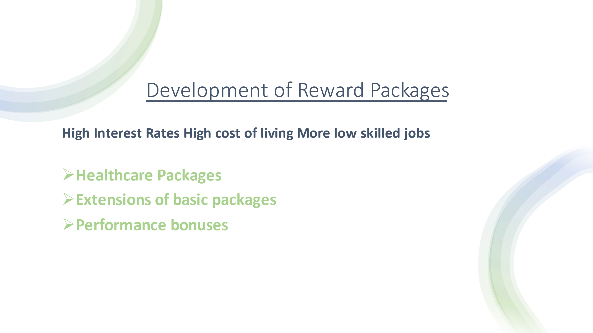

AC 2.3 By considering the current inflation rate of 7% (Bank of England, 2022) and the impact that will have on the cost of living particularly for lower paid employees we recognise the need for a strong basic pay package for those at the lower end of the earnings scale. There has been a considerable rise, since the pandemic of roles in lower skilled jobs across all sectors (IFS, 2022) which means we have a much tougher job attracting the talent and retaining the existing workforce where competitors may be offering more. A reward package that offers extras in areas such as healthcare and an extension of statutory allowances such as extra holiday hours, generous maternity and paternity pay as well as performance related bonuses could help to attract these lower paid workers into our company. We can use these to create the culture of caring and increase motivation amongst existing low grade staff as they see us valuing them through these new incentives.
AC 2.4 Legislation in the areas of pay reporting as well as minimum wage and statutory requirements play a large part in the reward incentives structure and what can be offered. The equal pay act of 1970 as well as the more recent Equality Act (2010) have impacted on what we have to pay as a basic minimum for staff and put the emphasis on us as an organisation to be aware of inequalities and transparency. (Taylor & Woodhams, 2016) In an equal pay case (Hayward v Cammell Laird, Lewis and Sargeant, 2013) it was found that all ‘benefits in kind’ i.e. those things offered in addition to wages, do not defend an inequality of pay. It has recently been reported the gap between CEO and Executive pay and the pay of the general workforce is widening, (CIPD, 2019) this gap cannot be unduly large within our organisation we must ensure transparency in wages for all so that confidence is restored with our employees.

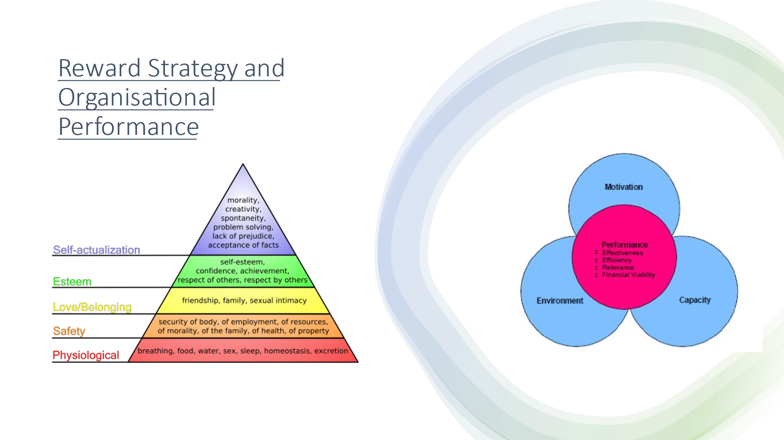

AC 1.5 We must consider the most important factors that will ensure we correctly establish a reward strategy that just does not only serve our workforce but also impacts and improves or organisational performance. We can see from the diagram that motivation is one the 3 defined areas of organisational performance and our rewards structure should eb the driver behind that if done correctly. There are two specific motivating types of reward that will impact the motivation of employees according to Armstrong (2019), extrinsic and intrinsic factors. Extrinsic factors happen to an individual, so we would be considering areas of pay, praise or criticism, opportunities to learn and promote or withholding of certain pay benefits. These can be motivating according to the Instrumentality Theory (Taylor, 1911, Armstrong & Taylor, 2020) because they encourage workers that if they work harder they ‘get more’. Though it has been argued in more modern theories of motivation (Pink, 2009) that experiments have shown workers do not generally increase in productivity with these extrinsic motivators and it can stifle creativity. So we may consider therefore that intrinsic motivators, the things our individuals see their contribution as valuable, can view the bigger picture and carry a sense of autonomy and purpose in their work, will have the greater impact. Rewards that attend to the person as a whole such as extra health benefits and annual leave as well as childcare and carers benefits will have a greater impact on the satisfaction of the employee (Maslow, 1954, Armstrong and Taylor 2020) and will push up these key factors of efficiency and financial viability as well as other areas of creativity and a sustainability of high performance levels. We have also seen in recent years that company’s such as Google have taken away specific parameters around working hours and specific times of work in order to enhance the creativity and life work balance of employees, they have found this has helped employees create some of their best ideas and the company has grown as a result. (Pink, 2011)

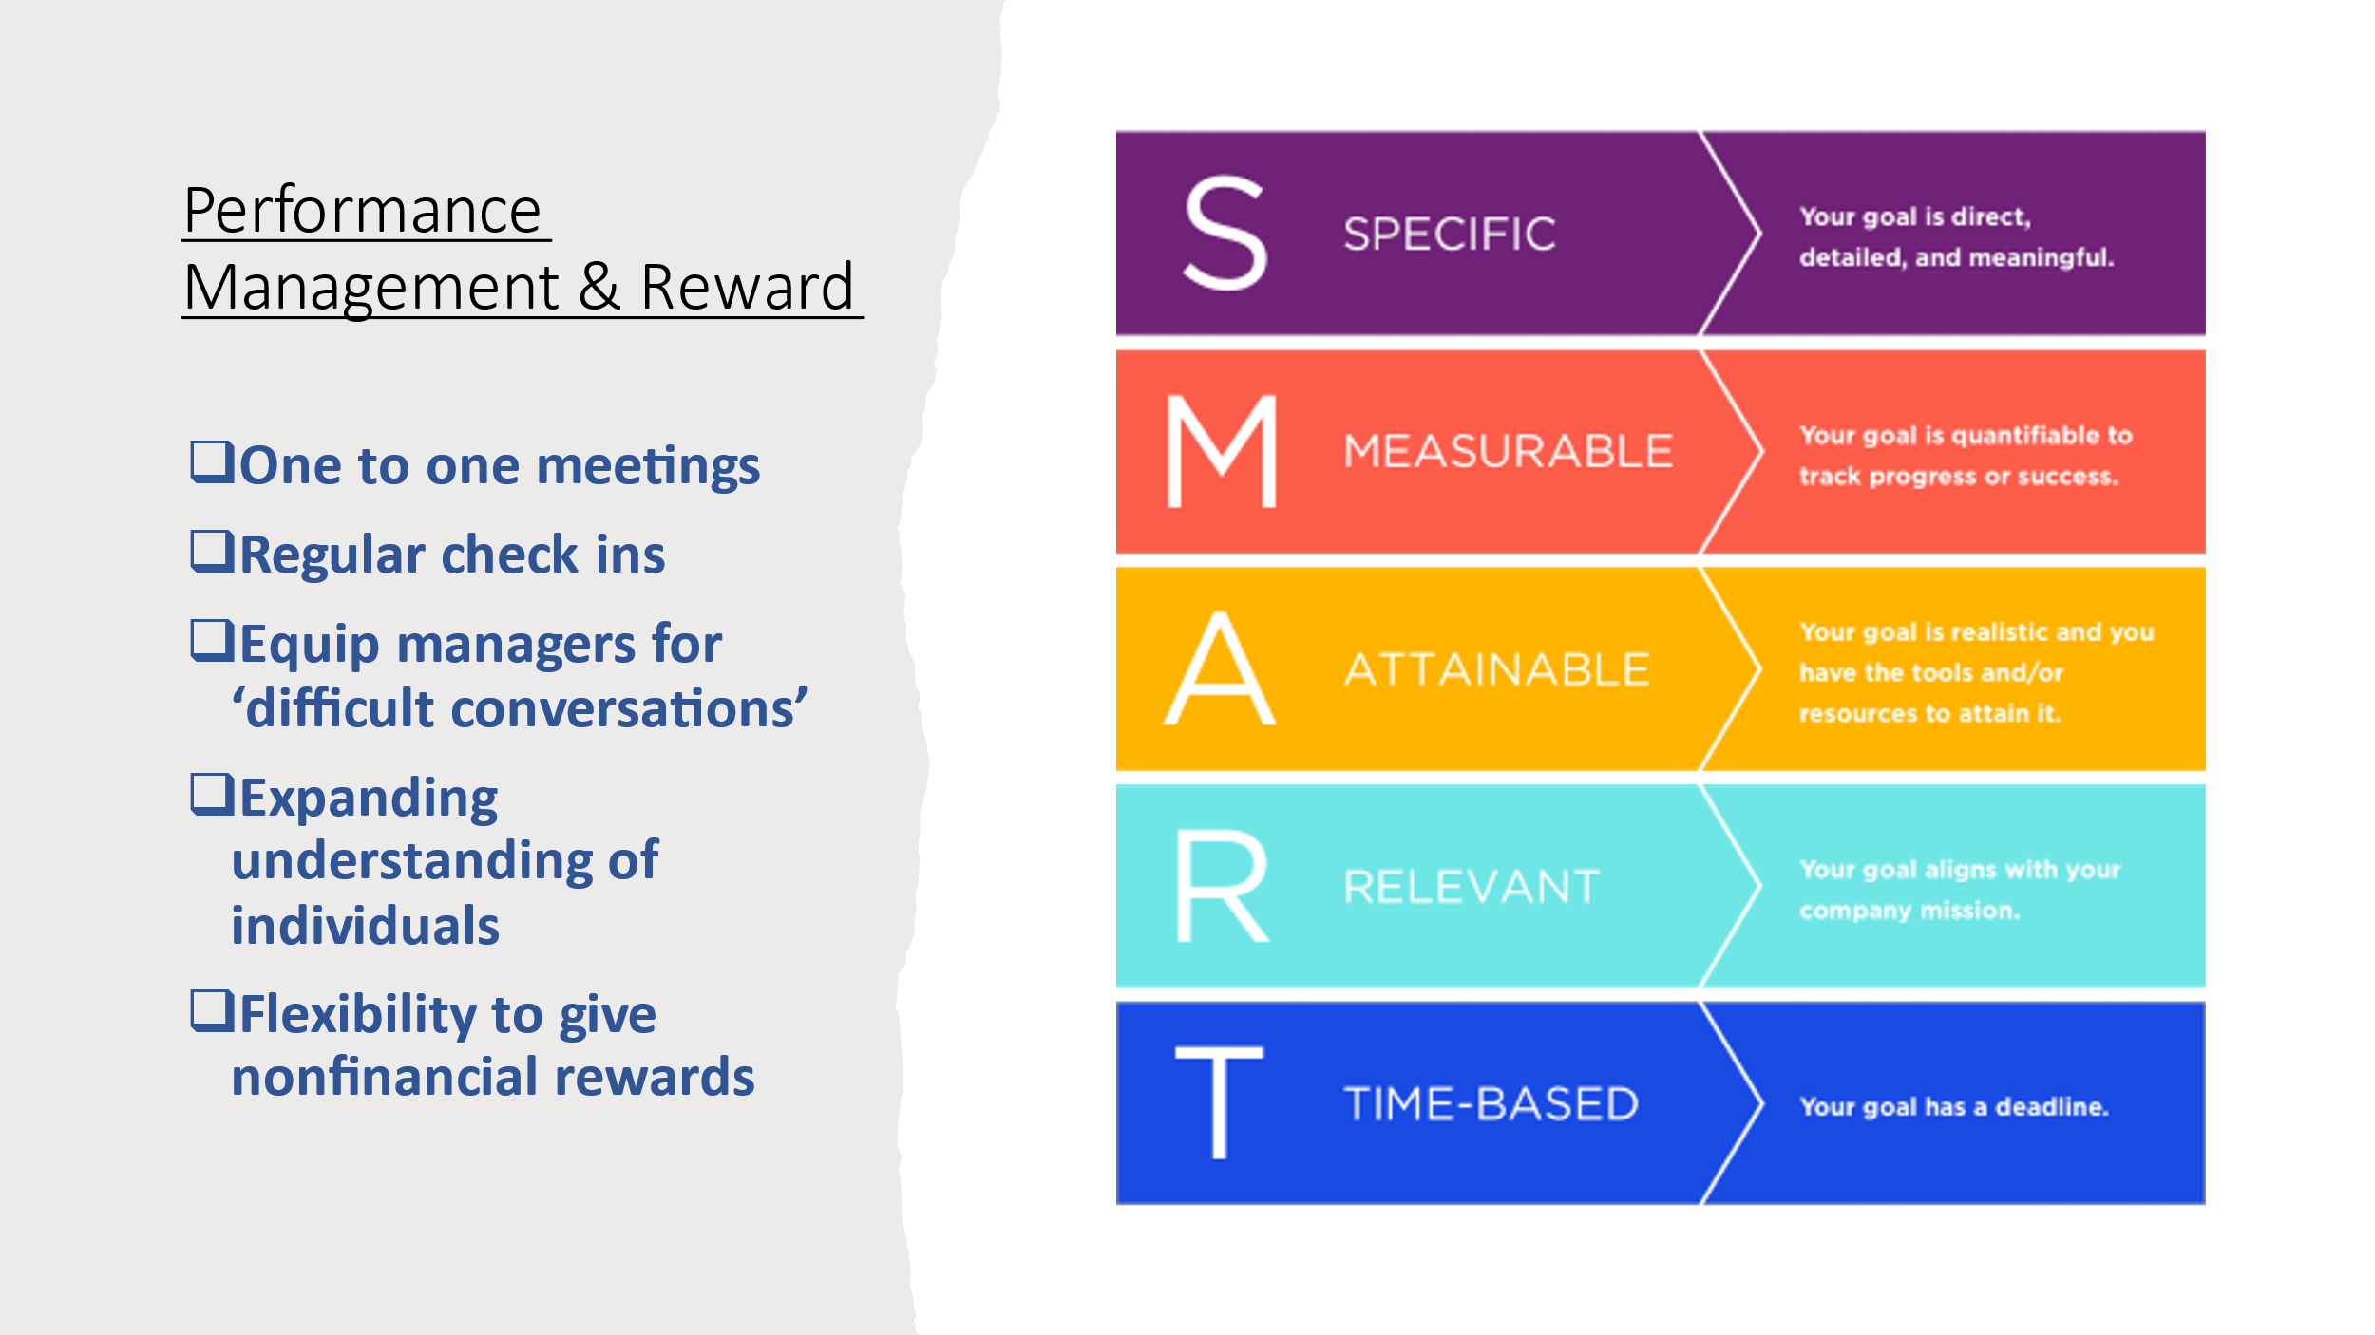

AC 3.1 & 3.3 Performance Reviews have long been used as a means for line managers to measure how employees are succeeding, areas for improvement and goal setting. This is often then linked directly to pay bonuses and incremental rises. Though these annual reviews can be a helpful marker for employees they can become largely subjective, to sporadic and force a reaction from employees of ‘fight or flight’ (Rock et al, 2014, Armstrong & Taylor, 2020). In contrast to this models of continuous professional development and regular mentoring and coaching check ins from managers can have a far more favourable outcome (Buckingham & Goodall, 2015). Another area for concern is how goal setting is managed and the perceived variance in performance by managers compared to actual, Scullen and Mount (2000) note managers have a perception of 62% variance among employee performance, actuals are recorded as 21% amongst the same employees. This shows the clear lack of objectivity amongst line managers. If we then see that applied to a reward structure such as pay progression we can see how an unfairness could arise and inequitable pay gaps could arise. Clear policy making within our organisation can assist managers in considering criteria for pay increases as well as clear goal setting frameworks such as SMART objectives (see slide) so that line managers can create some consistency with what is an achievable and realistic expectation and whether the employee has met that in a timely manner, as a means of assessment. This should not be an annual event but more of an ongoing process to ensure continuous development of the workforce and potential for other rewards along the way. (Armstrong, 2020). The Institute for Employment Studies (2011, Armstrong, 2020) notes a real need to train line managers well in this skill in order for them to measure performance and continuously motivate as well as manage poor performance and handle ‘difficult conversations’. One of the disadvantages of this continuous development of staff is the need for line managers to spend such a large quantity of time on this rather than other elements of their role, though many would argue this is the role. The Institute of Employment Studies, 2013 found that research on managers at Dilys Robinson found high levels of engagement across the board because managers were given time to manage each employee one to one on a weekly basis, developing personal relationships and recognising opportunities to reward appropriately as and when (Armstrong & Taylor, 2020). The success of this approach is striking and one worth adopting when we consider the success.

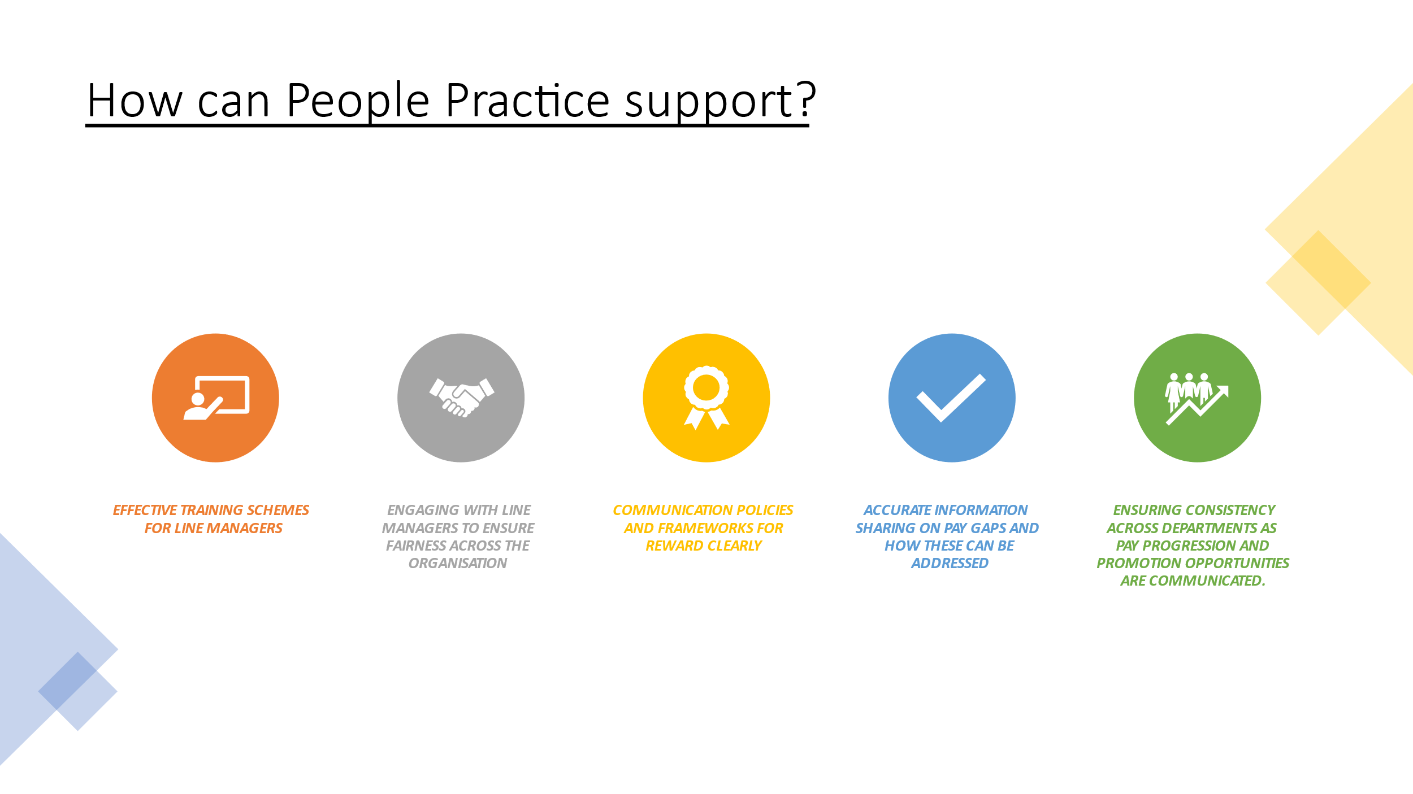

AC 3.2 As people professionals within this organisation we see it as our inherent responsibility to support line managers in the processes they carry out day to day. CIPD, 2020 discusses the need for line managers to firstly develop people skills well in order to help them connect with employees well and therefore make fair and consistent judgements when it comes to applying rewards. Managers note in a recent survey (CIPD, 2021) how they cannot function as good people managers without adequate support and training from HR as well as support to ‘implement new practices successfully’. Without people professionals the article discusses how good line managers cannot exist and are most desperately needed in the ‘world to come’ without the help of HR. Though line managers have the strength of knowing their employees best this can be the problem as it causes bias and unfair decision making, people professionals have the expertise and a ‘layer removed’ meaning they can view things from a more objective, organisation perspective and advise accordingly (Taylor & Woodhams, 2016). People professionals understand the business objectives and stakeholders as well as the workers ‘on the ground’ and this can be a helpful overview when line managers are focused in on their own department and the needs of the individuals they are managing. For the future of our organisation we will effectively seek to combine the wider perspective of the organisation, the performance targets required and the consistency with our competitors, at the same time as serving the needs of line managers to be trained effectively. This training can range from understanding the policies and frameworks they have to work within, when they seek to promote, reward extrinsically and with non financial incentives, and most importantly we can seek engagement form managers as we do this. Allowing them to become part of the process of developing fair reward systems that meet the needs of employees as well as those of our stakeholders.
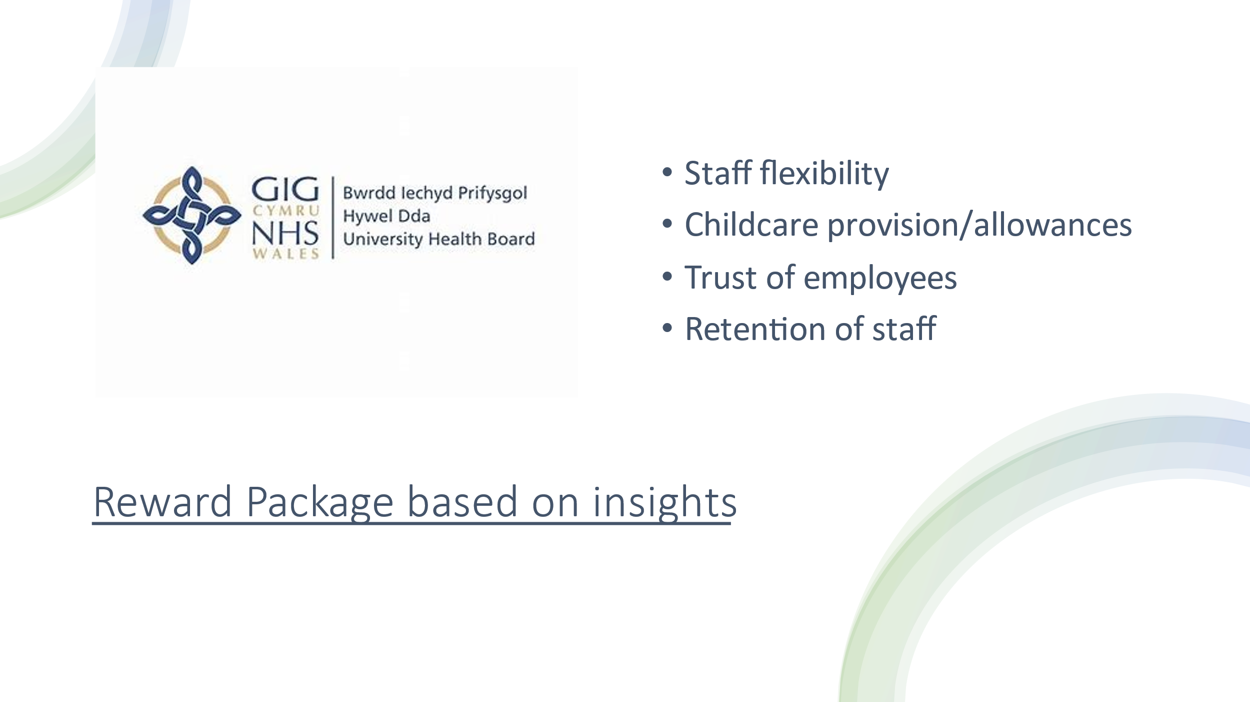

AC 2.3 As a public sector organisation Hywel Dda University Health Board is one of the NHS trusts and therefore has fixed pay structure, banding, pensions schemes in line with all health boards across the UK. Public Sector healthcare will never fare well comparative to private institutions and cannot compete in that arena but it does have opportunity to develop in other areas of reward. In a recent internal survey across health board employees (Hywel Dda, 2021) it was noted that many employees did not feel they had flexibility with their childcare arrangements and working from home options following the pandemic. This was an option many administration staff had come to appreciate and in some cases rely on. It would be an appropriate response from this survey to follow up with some focus groups discussing the reality of how that same flexible approach can work in a realistic way to serve the needs of the patients as well as the staff who must always work on site (healthcares, nurses, doctors, clinical support staff). The impetus has moved from asking all administrative staff to stay home and feel ‘trusted’ to now being asked to be on site, visible and account for hours at home. To allow more flexibility and trust again would be valued by employees and have a huge impact on staff retention at a time when recruitment is increasingly challenging and staffing levels at an all-time low.

