Introduction:
In this report/assessment/assignment I am going to discuss different variables and why are they important, also I am going to discuss the if statements or else statements and what are their purpose, finishing up with loops which I will talk about what they do and what they are used for.
Variables:
Variables are the data types that is reserved as memory, so basically python program gives data to the computer for processing information, as will be shown in the screenshot below:
“City” is my variable that I have created in this scenario, which in our case simply represents city, however since the program cannot make a decisions like humans and it doesn’t know what to do with the variable, if I didn’t set “New York” as one of the cities the variable city would remain intact, and then I used the command “print” to print and display variable city, as the result, it printed out “New York”. The reason why they are important is since variables can be hold as value within system, which then means it can be used multiple times across different occasions.
Finally, variables are a strong tool that can be utilised within the system, however the can be problems with variables sometimes, as they can be used as duplicates to different commands, for example “print” on it’s own if the person types it in manually, it will recognise it as a command, so in order to make it a variable the person would have to start with the capital letter, and that is useful to know to most variables and commands in python.

If/else statements
If or else statements, is basically a command that sets one action and if it fails the person can set another action that would perform straight after. As an example, the person can create a random number generator and if the person does not guess the correct number, then the Python will print something along the lines of “sorry wrong number try again” and then it will restart the whole progress again. This is the simple use and the example of the IF statement, in which if you set the variables and then you can see the addition with which the python will determine if the number is bigger than 100, it will tell the actual score of the calculation. If it goes over 100, it will tell that the score exceeds the total possible score.
score_theory = 40
score_practical = 45
if(score_theory + score_practical > 100):
print("Please check the input. Score exceeds total possible score.")
else:
print("Score validated. Your total is: ", score_theory + score_practical)

Loops in Python
In python loops are used to repeat the sequence of different code repeatedly, until the person would need it to stop or when the program would stop, the important notice to take when creating loops is that the person needs to stop the loop whenever it is necessary, otherwise by a possible mistake the whole program might be on the loop, which can cause mis confusion and different set of problems.
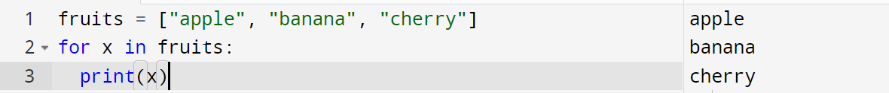
As shown in the example above, with the command “for” I can loop the three fruits that I stated in my variable, and to cut the loop down, you can use the command break, so then the whole code that would be written would not be looped for no reason.

Examples and their solutions, to potential errors
So, in the first example, I used simple coding to show the car model, car make, mileage and number of doors for the car. And it will look like this:
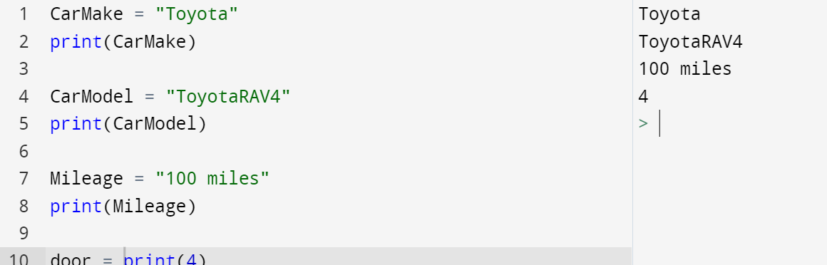
CarMake = "Toyota"
print(CarMake)

CarModel = "ToyotaRAV4"
print(CarModel)

Mileage = "100 miles"
print(Mileage)

door = print(4)
I used different sets of variables and commands to make a simple program which shows the different aspects of my car, but the problems that the person can come across with, in this code is simple error mistakes.
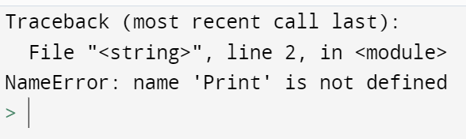
Such as this error mistake that happens when you type in the “Print” command with the capital letter and expect the command to error. Also, another, mistake that should be avoided is the variable mistype, as will be shown in the screenshot below.
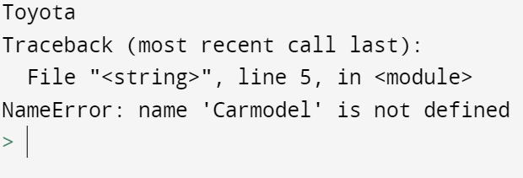
Another exercise I would like to show and use as an example, would be this treasure hunt, basically this is the mini game in which the person has to guess the number among many others, in my case it is 15
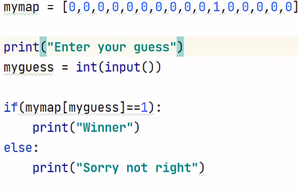
mymap = [0,0,0,0,0,0,0,0,0,0,1,0,0,0,0,0]

print ("Enter your guess")
myguess = int(input())

if(mymap[myguess]==1):
print(Winner)
else:
print("Wrong one, please try again")
The errors that come in with this exercise is the compatibility of the integers and the commands, as they mixed up together and because of that the program, will give out an error like this
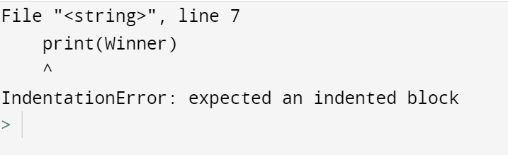
To tackle that error that user to ensure that the variables and the coding is accurate enough, in order to confirm the if/else statement and then when the issue has been taken care of, the program, should work and the result you should get something along the lines of
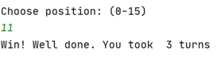
Or any other number and the place that you hid the treasure into.

Another exercise I would like to attend would be the carrots/vegetable bed, for the vegetable bed the amount the person can fit the carrots among the 32cm x 32cm would be 16 carrots, the reason for my answer would lie below:
However, this is the even equations and with that there comes a problem, such as if they vegetable bed is not able to withstand the area, and instead has only 27 cm x 30 cm which would 57cm, and just like that, the person cannot fit all the carrots on the fields due to the lack of space, as has been shown in the screenshot below:
As shown in the screenshot there is a decimal point in the calculations meaning that the carrots are not able to fit properly, in order to tackle this issue the person would have to reduce value of the carrots and only fit 9 one of them on the field, with leaving the free space intact.

