University of Wales Trinity Saint David
Wales Institute of Science & Art



Motorcycle Geometry Analysis and Dynamic Handling Investigation
Motorcycle technology ACHA4003

Parry Hill
2004858
19/11/2021
Table of Contents
Table of Tables 2
Table of Graphs 2
1. Introduction 3
2. Geometry Data 4
2.1 Honda CBR 1000RR 5
2.2 Zero SF R 6
3. Gearing Calculation Honda CBR 1000RR 7
3.1. Dynamometer Results 9
3.2. Resistance To Motion 10
4. Handling characteristics 12
4.1. Comparison of a Zero SF R and a Honda CBR1000RR 13
5. Geometry data for two different bikes 14
6. Alterations 16
7. References 17

Table of Tables
Table 1 - Example Equations used for Centre of gravity 4
Table 2 - 2006 Honda CBR1000RR Geometry Data 5
Table 3 - Zero SR F Geometry Data 6
Table 4 - Gearing calculator - CBR1000RR 7
Table 5 - Formula entered into the gearing calculator 8
Table 6 - Resistance to motion 11

Table of Graphs
Graph 1 - CBR1000RR Dyno Graph 9

Introduction
This report will be investigating the geometry characteristics and dynamic handling of a Honda CBR1000RR and Zero SF R.
It will look at the centre of gravity positions for both motorcycles and how this can affect the way each motorcycle handles from a real-world perspective, it will then go on to dynamically assess the Honda, followed by a comparison of two other modern motorcycles.

Geometry Data
Data was collected from two different motorcycles, the data collected included wheelbase, wheel radius, Front and rear wheel weight, then with and without a rider on level ground followed by the rear wheel lifted on a stool at a height of 0.35M.
Using this data, the centre of gravity values were calculated using the following formulas:
Stool Angle ($θ)$ - ${Sin}^{-1}(\frac{Stool Height}{Wheel base})$
X Centre of Gravity - $\frac{(Rear Wheel ×Wheel Base)}{Total Weight}$
Y Centre of Gravity - $\frac{Wheel base×( Rear Wheel-Rear Wheel Lifted)}{Total weight ×Tanθ}+Rav$
Weight distribution front % - $\frac{(Wheel Base-x CoG)}{Wheel Base}×100$
Weight distribution rear % - $\frac{x Cog}{Wheel Base}×100$
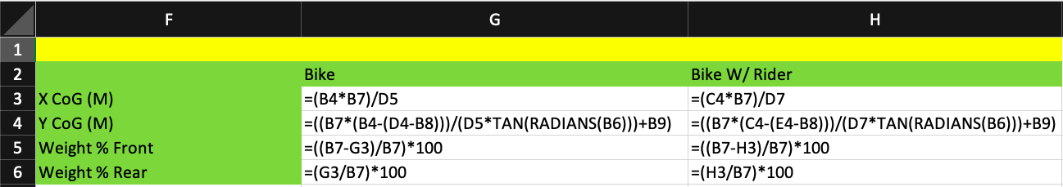
Below is an example of the formulas used in excel for the centre of gravity measurements
Table 1 - Example Equations used for Centre of gravity
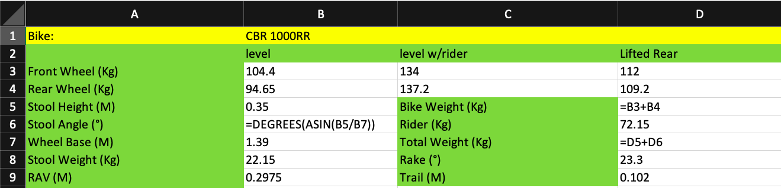

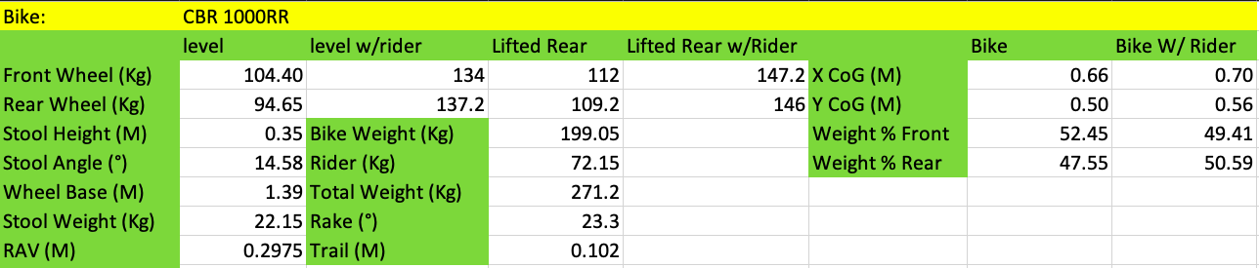
Honda CBR1000RR
Table 2 - 2006 Honda CBR1000RR Geometry Data
Table 2 shows the accurately measured geometry data for the CBR1000RR, the data was then used to determine the centre of gravity position on a drawing created on Solidworks, the drawing was also used to show the rake angle of 23.30° and a trail length of 102mm.
The centre of gravity position is shown to be almost central on the bike.
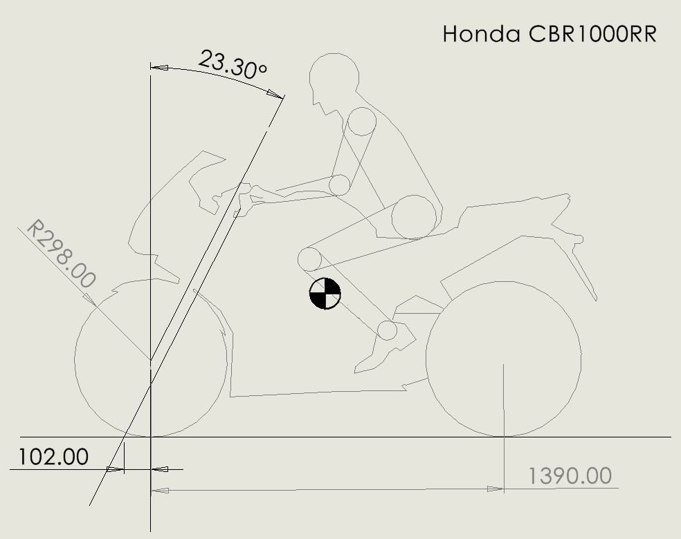

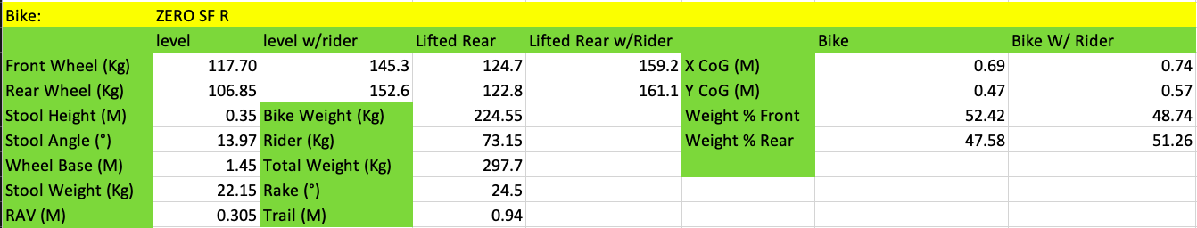
Zero SF R
Table 3 - Zero SR F Geometry Data
Table 3 shows the measured geometry data for a Zero SF R, the same process as the CBR1000RR was used in Solidworks to accurately show the centre of gravity position for this bike as well as the rake angle of 24.50° and a trail length of 94mm.
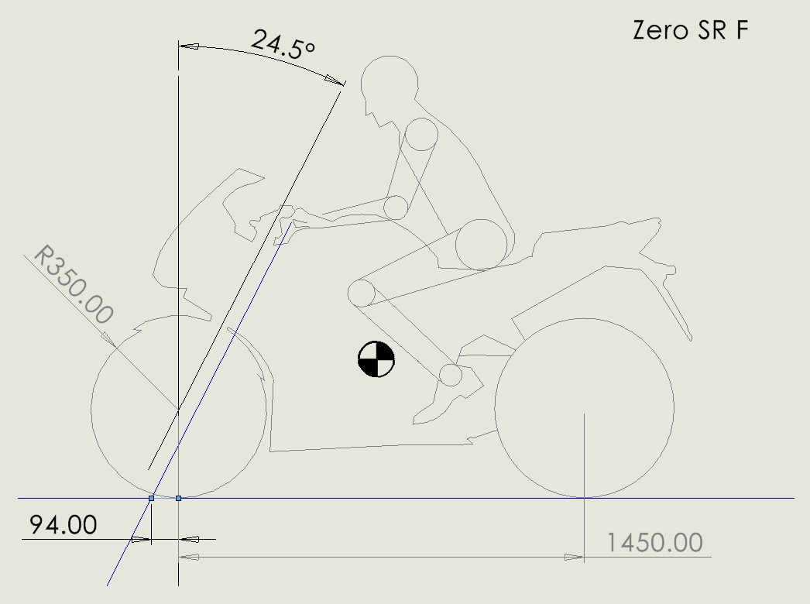
The image shows that whilst the centre of gravity is still relatively central on the Zero, it is slightly lower than the CBR1000RR.

Gearing Calculation Honda CBR 1000RR
Table 4 below shows the gearing calculator created in Excel to demonstrate the CBR1000RR’s theoretical top speed.
The following formulas were used in this table:
Wheel Diameter= (($(\frac{Width}{24.5})×(\frac{Height}{100})×(\frac{Rim}{2})×2×π)×25.4)÷π÷1000$
Speed =$((Rpm×60×(\frac{Mainshaft}{Countershaft})×(\frac{Primary in}{Primary out})×wheel Diameter×π÷1000)×(\frac{Front sprocket}{Rear Sprocket}$)
Next gear RPM’s = $Rpm×(\frac{Mainshaft}{Countershaft})×(\frac{Countershaft}{Mainshaft})$
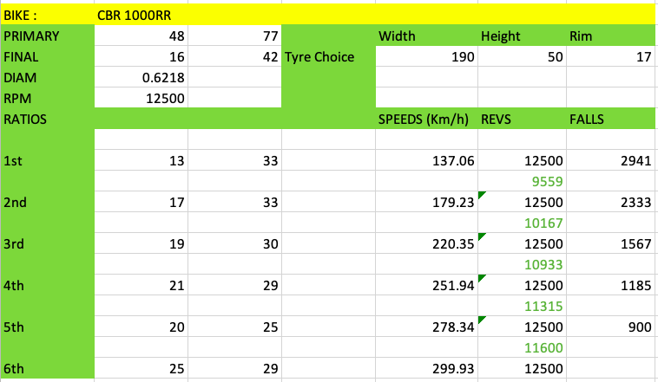
These formulas were then entered into the gearing calculator to work out the road speed, next gear Rpm and the fall in Rpm as the bike changes into the next gear for each gear individually, a drop-down list was used to select what Rpm the bike would be using.
Table 4 - Gearing calculator - CBR1000RR
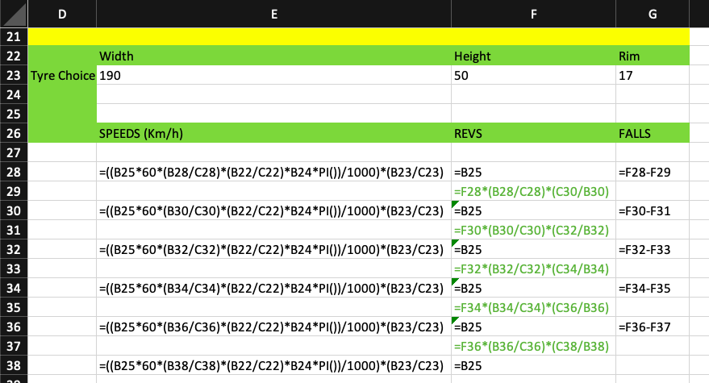
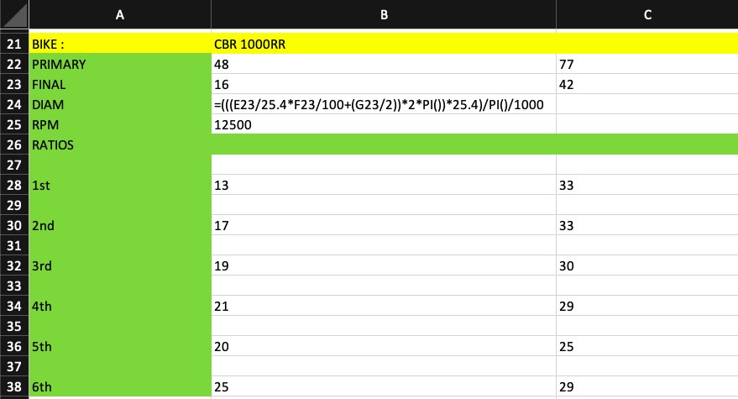
Table 5 - Formula entered into the gearing calculator

Dynamometer Results
To obtain accurate data for the power of the CBR1000RR it was tested on a Dynamometer, the results were then used in Excel to create a dyno graph to show the power output graphically highlighting the power (Hp), Torque (Nm) and the Power (Kw).
The Dynamometer measured the Rpm in increments of 5 so to filter some of the data an equation (=RIGHT(A2,2)=”00”) was used to show increments of 100Rpm.
The resulting graph is shown below.
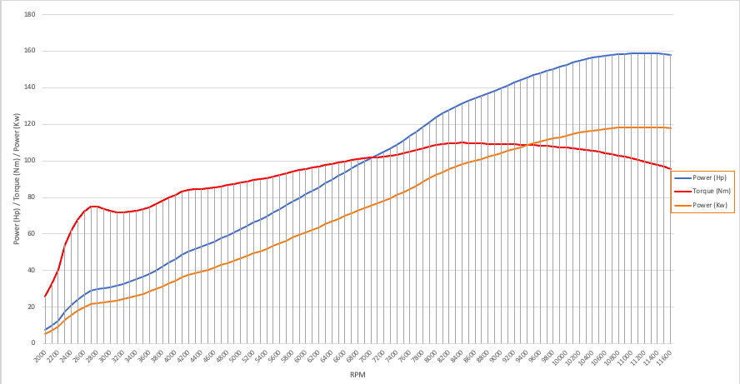
Graph 1 - CBR1000RR Dyno Graph

Resistance To Motion
Using the data from the gearing calculator a resistance to motion sheet was created to determine if the CBR1000RR had the power necessary to reach the theoretical top speed.
To determine this the coefficient of drag ($C_{d})$ used was 0.548149 (Sripathi,2017) then Solidworks was used to create a drawing of the frontal area to be measured shown below, at a value of 0.42m².
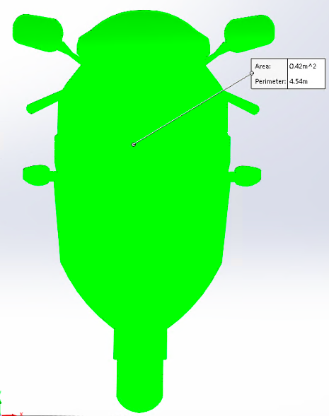
The value for pressure$\left(ρ\right)$ used was 1.167Kgm³ @ 20°C and 987mbar

This Data was entered into the sheet and the following formulas used:
Aero Drag Force (F_{D}) = $\frac{1}{2}ρ×C_{d}×A×V^{2}$
Rolling Resistance (F_{w}) =$0.02×m×g$
Force (F) = $F_{d}+F_{w}$
Power required = ($F×v)÷1000$

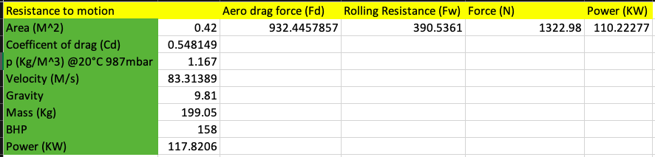
Table 6 clearly shows the CBR1000RR has enough power to reach the top speed shown on the gearing calculator as the power required is 110.22Kw and the power produced by the CBR1000RR is 117.82Kw.
Table 6 - Resistance to motion

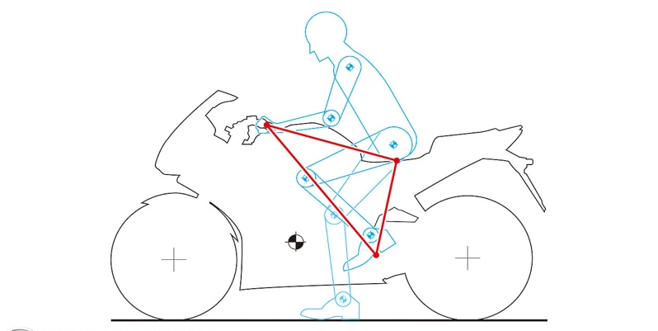
Images used to create Solidworks drawings:
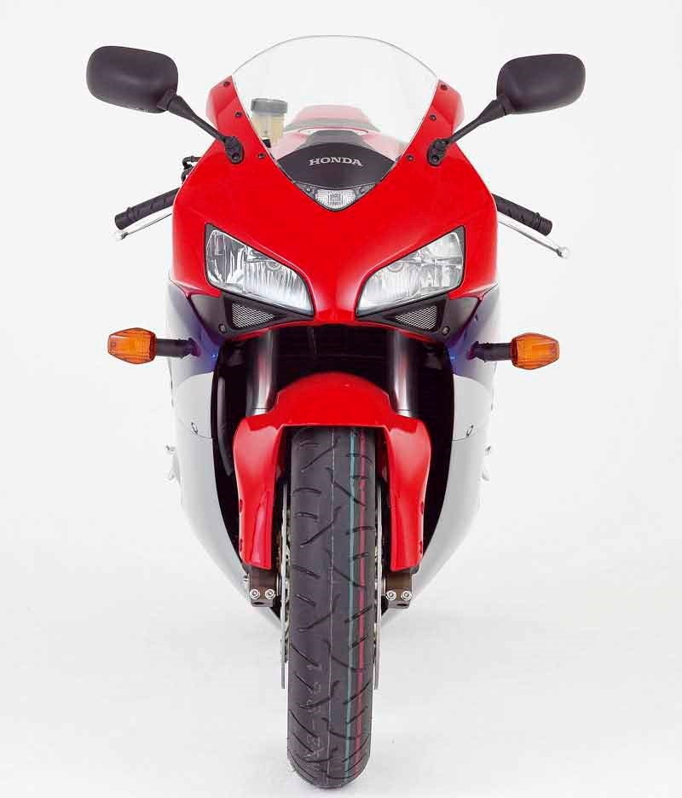
(Dillard,2017)
(Motorcycle News, 2004)

Handling characteristics
When looking at handling characteristics, several factors can affect a motorcycle’s handling and its ability to operate under different applications and terrains. Some of the main contributing factors are rake and trail followed by the centre of gravity.
Rake is the angle of the steering head on the frame of the motorcycle and trail is the length from the motorcycle’s point of contact on the ground and the vertical line through the steering head, typically a larger rake angle will increase the trail length (Lindemann, 2015)
Rake:
Rake angle is used to determine trail length, by either increasing or decreasing this angle will give a shorter or longer trail respectively, this is typically set between 24° to 35°. Different rake angles are used for different disciplines, for example, a sportsbike will have a smaller rake angle than a cruiser as it needs to be able to turn quickly through bends. (Tibu, 2014)
Trail:
Trail length, defined as the measurement between the steering head axis and the tyre contact patch on the ground can have a great effect on the steering stability of a motorcycle and subsequently has a self-centring effect, the greater the trail length, the greater this force is. Therefore, this will make a motorcycle more stable in a straight line but harder to lean into a turn. (Foale, 2006)
Centre of Gravity:
The Centre of gravity (CoG) can have a powerful impact on the way a motorcycle handles under dynamic situations, for example, a high CoG can cause the bike to wheelie under hard acceleration and then the rear wheel to lift under hard braking, comparatively a low CoG can cause the rear wheel to lose traction under hard acceleration or the front wheel to lose traction under hard braking, therefore motorcycles must utilise a good compromise of where the CoG is dependent on the intended use. (Cossalter, 2006 p.81)

Comparison of a Zero SF R and a Honda CBR1000RR
When comparing the Zero and the Honda several key differences arise, firstly the Zero having a shorter trail length means the bike should be able to turn sharper than the Honda, however the Honda would be more stable at high speed as a compromise for a slightly wider turning radius as the Honda has a claimed top speed of around 100km/h faster than the zero.
When comparing the two motorcycles centre of gravity they both have a near 50/50 split across the wheelbase with a rider sat on the bike. However, the two bikes CoG differs in height with the Honda having a more central CoG and the Zero being slightly lower, this is more than likely due to the Honda having additional mass such as fuel at the top of the bike and a large portion of the Zero’s mass being the battery which is placed low down on the motorcycle.
These two different heights affect each bike dynamically with different results, for the Honda a slightly higher and more central CoG allows the mass to be moved more freely, therefore a rider can increase lean angle and increase tire loading allowing good control over the motorcycle through high-speed cornering. However, if the CoG was too high this can cause the motorcycle to oversteer. (Trevvit, 2016)
Comparatively the slightly lower CoG on the zero will give the rider much more low speed control of the bike, allowing it to much easier make its way through tight turns and city traffic making it a more commuter friendly bike for inner city use.

Geometry data for two different bikes
Honda Africa Twin Adventure:
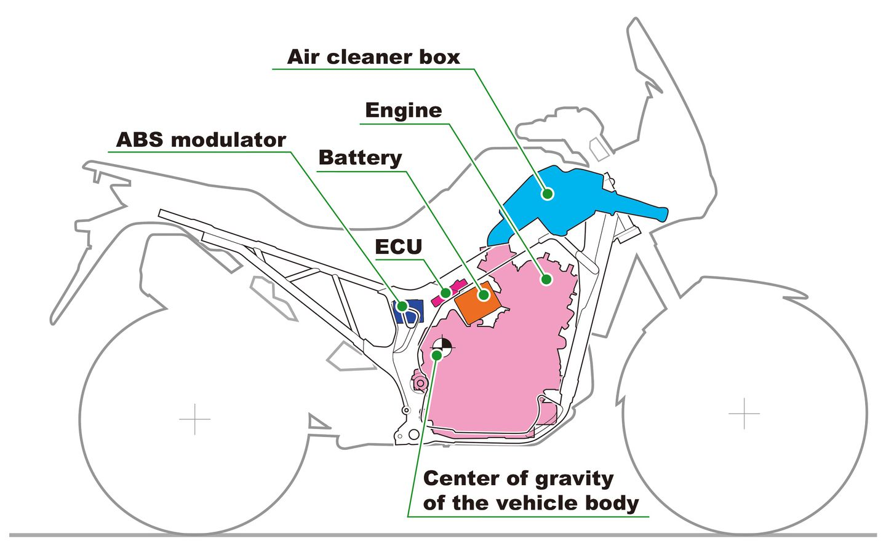
The Africa Twin is a touring motorcycle that has been designed for both on and off-road use, this can present a design problem as the motorcycle will need to be agile on tight roads in suburban areas as well as being stable off-road as it has a total mass of 238Kg. To enable the bike to achieve these characteristics Honda chose a rake angle of 27.50° and trail length of 113mm to create good stability when the bike is in motion, Honda also engineered the bike to have a relatively low and central CoG to allow the motorcycle to handle well at low speeds, this was further reenforced by surrounding the CoG with the bike’s other heavy components in order to keep the majority of the mass centralised. This combination of a low CoG and longer rake and trail values allow this motorcycle to perform well both off and on road. The image below shows the centralised mass and low centre of gravity.
(Klinger, 2016)

Aprilia RSV4 RR:
The Aprilia RSV4 is a super sport motorcycle designed for road use and track application, as standard, this bike comes with 24.5° of rake and a trail length of 103mm making the bike agile in corners and stable at high speeds. However, what sets this bike apart from other manufactures is the adjustability of the geometry; the headstock and therefore the rake can be adjusted to several different positions, the engine can be raised to 5 different heights as well as the swingarm pin height being adjustable. This allows for the rider to change the bikes riding characteristics for different applications such as city riding where a lower CoG is more desirable for low speed tight turns or on track where the rider will be pushing the limitations of the bike on high-speed corners, therefore, needing a much more centralised CoG.

Alterations
When looking at the Honda CBR1000RR one key alteration could be made by slightly lowering the CoG to make the motorcycle more friendly for everyday riding as this would make the bike more manoeuvrable at low speeds, therefore increasing rider comfort in slow-moving traffic.
A solution to this could be one such as what Aprilia has created with the RSV4 RR where the centre of gravity can effectively be adjusted to the application each rider uses their motorcycle for whether it be commuting, pleasure riding or track days.

References
- Cossalter (2006) Motorcycle Dynamics. 2nd edn. Morrisville, North Carolina: Lulu publishing
- Dillard (2014) Design Notes: Centre of Gravity. Available at URL: https://evmc2.wordpress.com/2014/12/20/design-notes-center-of-gravity/ (Accessed 28th November 2021)
- Foale (2006) Motorcycle Handling And Chassis Design the art and science. 2nd edn. Spain: Tony Foale Designs
- Kilenger (2016) What You Need To Know About The Africa Twin – Suspension, Chassis, And Everything Else – 3 of 3. Available at URL: https://www.dirtrider.com/what-you-need-to-know-about-africa-twin-suspension-chassis-and-everything-else-3-3/ (Accessed 9th December 2021)
- Lindemann (2015) Understanding A Motorcycles Rake and Trail. Available at URL: https://www.cycleworld.com/2015/05/22/cycle-world-tips-and-tricks-understanding-motorcycle-rake-and-trail/ (Accessed 3rd December 2021)
- Motorcycle News (2004) Honda CBR1000RR Fireblade 2004-2005 Review. Available at URL: https://www.motorcyclenews.com/bike-reviews/honda/cbr1000rr-fireblade/2004/ (Accessed 1st December 2021)
- Sripathi (2017) The Impact of Active Aerodynamics on Motorcycles Using Computational Fluid Dynamics Simulations Mankato: Cornerstone A Collection of Scholarly and Creative Works for Minnesota State University. Available at URL: https://cornerstone.lib.mnsu.edu/cgi/viewcontent.cgi?article=1719&context=etds (Accessed 1st December 2021)
- Tibu (2014) A Quick Guide to Rake, Trail and Offset Part 1. Available at URL: https://www.autoevolution.com/news/a-quick-guide-to-motorcycle-rake-trail-and-offset-part-1-83482.html (Accessed 2nd December 2021)
- Trivvet (2016) All About Geometry. Available at URL:https://www.cycleworld.com/sport-rider/all-about-geometry/ (Accessed 11th December 2021)

