

Can a Business Intelligence (BI) Tool Support Decision Making within the Covid-19 Vaccination Programme?

By
Katie Rees

Supervisor: Dr Nicola Whitehead
Second Marker: Divya Chidambaram

Project submitted as part of the requirements for the award of
BSc (Hons) Computing (Data and Information Systems)
Monday 24th July 2023

DECLARATION

I, KATIE REES declare that I am the sole author of this Project; that all references cited have been consulted; that I have conducted all work of which this is a record, and that the finished work lies within the prescribed word limits.

This work has not previously been accepted as part of any other degree submission.

FORM OF CONSENT

I KATIE REES hereby consent that my Project, submitted in candidature for the B.Sc. (Hons) Computing (Data & Information Systems) degree, if successful, may be made available for inter-library loan or photocopying (subject to the law of copyright), and that the title and abstract may be made available to outside organisations.

Abstract
This research project aims to identify whether a business intelligence tool, such as a Power BI dashboard, can support decision making within the Covid-19 vaccination programme. It will aim to achieve three objective which includes creating a robust power bi dashboard, to determine whether the dashboard can improve decision-making, and finally a measure to determine whether the dashboard met user experience demands. To meet these objectives a positivist approach has been taken, with a t-test experiment, and the creation if a user survey.
The findings of this research concludes that the power bi dashboard would save end-users time, and therefore improving their decision-making process. It also found users to be accepting of the power BI dashboard, and keen for implementation. The report found that usability is key to the success of the dashboard and therefore a SUS survey is included during the design stage to ensure the dashboard meets user needs. The report had no interaction from the potential user base, and therefore this limitation is discussed throughout. Future recommended work includes introducing a similar tool for the wider immunisation programme, including children’s vaccinations.

Contents
Abstract 1
Table of Figures 5
1/ Introduction 7
1.1/ Background Rationale 7
1.2/ Aim 8
1.3/ Objectives 8
1.3.1/ Objective one 8
1.3.2/ Objective Two 8
1.3.3/ Objective Three 8
1.4/ Report Structure 8
1.4.1/ Literature Review 8
1.4.2/ Research Methodology 8
1.4.3/ Design & Implementation 8
1.4.4/ Evaluation 9
1.4.5/ Conclusion & Recommendations 9
1.4.6/ Reflection 9
2/Literature Review 10
2.1/ Introduction 10
2.2/History of Business Intelligence (BI) 10
2.2.1/Definitions 10
2.2.2/Origins of BI 10
2.2.3/Growth of BI 11
2.3/ Current BI 11
2.3.1/Benefits of BI 12
2.3.2/Challenges 12
2.3.3/BI within Healthcare 13
2.4/ Data Visualisation (DV) 15
2.4.1/ Dashboards 15
2.4.2/ Benefits 16
2.4.3/ Benefits identified in healthcare 18
2.4.4/ Challenges 19
2.4.5/Best Practices & Design Principles 20
2.5/ Usability and User Experience 21
2.5.1/ User Experience (UX) 21
2.5.2/ Usability 21
2.6/ Conclusion 21
3/Methodology 23
3.1/ Introduction 23
3.2/ Philosophy 23
3.3/ Approach 23
3.4/ Strategies 24
3.5/ Risks & Limitations 24
3.5.1/ Measuring Inefficiencies 24
3.5.2/ Costs 25
3.5.3/ Training Issues and Reluctance to Change 25
3.6/ Ethical Issues 25
3.6.1/ Governance 25
3.6.2/ Voluntary and Confidential Participation 25
3.7/ Validity, Reliability & Generalisability 26
3.7.1/ Validity 26
3.7.2/ Reliability 26
3.7.3/ Generalisability 26
3.8 Data Evaluation Methods 27
3.8.1/ Data Collection 27
3.8.2/ Data Evaluation 27
3.9/ Development Methodology 27
3.9.1/ Software Development Methodology 27
3.10/ Resources 28
3.10.1/ Hardware Resources 28
3.10.2/ Software Resources 28
3.10.3/ Information Resources 28
4/ Design & Implementation 29
4.1/ Requirements 29
4.1.1/ Must Have, Should Have, Could Have, Won’t Have (MoSCoW) 29
4.1.2/ High-level Document 30
4.1.3/ User Personas 30
4.1.4/ User Stories (US) 32
4.2/ Design 34
4.2.1/ Interviews 34
4.2.2/ Dashboard Prototype 34
4.2.3/ System Usability Scale (SUS) 36
4.4/ Implementation 41
4.4.1/ Database Design 41
4.4.2/ Data Transformation 42
4.4.3/ Visualisations 44
4.4.4/ Testing 49
4.5/ User Survey 51
4.6/ Time-measure Experiment 55
5/ Evaluation 58
5.1/ T-Test 58
5.2/ Survey 58
5.3/ Aims and Objectives 59
5.4/ Lessons Learnt 60
6/ Conclusion and Recommendations 61
6.1/ Conclusion 61
6.2/ Suggestions for Further Work 61
7/ Reflection 62
8/ References 63
10/ Appendices 68
Appendix A: User Personas 68
Appendix B: User Stories 70
Appendix C: Interview Questions 73
Appendix D – User Survey 74
Appendix E: User Survey Results 77
Appendix F: SUS Results 81

Table of Figures
Figure 1. Pharmacy Export: Stock Level tab (Current Solution) 6
Figure 2. Summary of Power BI and Tableau [39] 15
Figure 3. Benefits of Data Visualisation [41] 16
Figure 4. Predictive Life Cycle [65] 27
Figure 5 MoSCoW Framework [39] 28
Figure 6. High-level Requirement Document 29
Figure 7. User Persona A 30
Figure 8. User Persona D 31
Figure 9 Summary of User Stories 31
Figure 10 Detailed User Story 1 32
Figure 11. Dashboard Prototype Version 1Figure 3. Dashboard Prototype Version 1 33
Figure 12. Dashboard Prototype Final Version 34
Figure 13. SUS Feedback Questions 1 and 2 35
Figure 14. SUS Feedback Questions 4 and 5 36
Figure 15 SUS Feedback Question 6 37
Figure 16 SUS Feedback Question 7 37
Figure 17 SUS Feedback Raw Data 38
Figure 18 Final SUS Scores 38
Figure 19 ERD 39
Figure 20. CREATE tables 40
Figure 21 Insert rows generated by Mockaroo [69] 40
Figure 22 Data Transformation (1) 41
Figure 23 Data Transformation (2) 41
Figure 24 Outstanding Checks Visual 42
Figure 25 Number of Appointments V Total Stock Visual 43
Figure 26 Empty Slots Visual 43
Figure 27 Wastage and DNA Visuals 44
Figure 28 Drill down DNA and Wastage Visual 44
Figure 29 Date Slicer4.2.6/ Drill-down 45
Figure 30 Tooltip 45
Figure 31 Measures 46
Figure 32 Test Case Example 46
Figure 33 User Survey Question 48
Figure 34 User Survey Questions (2) 49
Figure 35 User Survey Questions (3) 50
Figure 36 Pre-Defined Tasks 52
Figure 37 Collated Experiment Responses 52
Figure 38 T-Test Outcome 53
Figure 39 User Survey Results 55

1/ Introduction

1.1/ Background Rationale
The Welsh Immunisation System (WIS) is the digital response to support the Covid-19 vaccination roll-out across Wales built by Digital Health and Care Wales (DHCW). WIS is used to mass book Covid-19 appointments, record Covid-19 vaccine results, and capture vaccine management data, such as deliveries, transfers, stock checks and refrigerator temperature monitoring.
Lead Pharmacists across Wales currently receive a daily export containing all data that has been input into the Vaccine Management section of WIS the day previous. This is automatically exported into a spreadsheet and a member of the WIS team e-mail this to pharmacists daily. An example of the stock level tab within the export is displayed in figure 1.
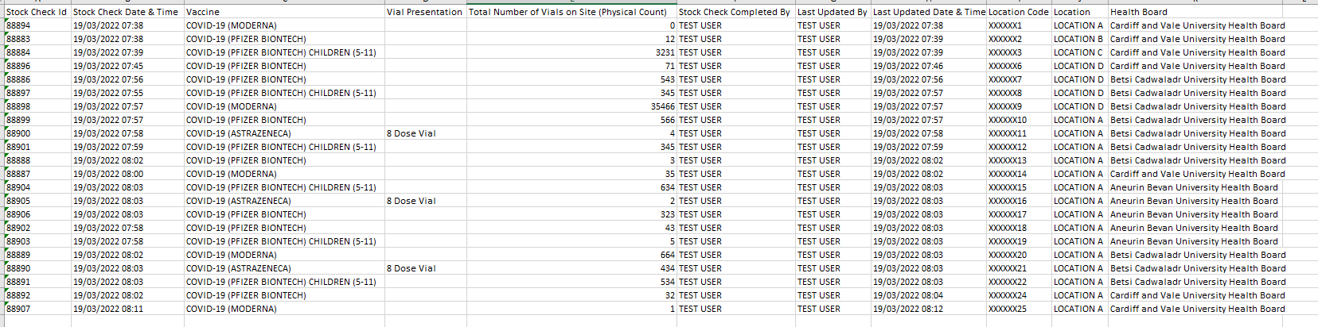
Figure 1. Pharmacy Export: Stock Level tab (Current Solution)
From this, the following decisions are made: -
- Which locations have outstanding vaccine stock checks?
- Which locations which have outstanding refrigerator monitoring checks?
- Do locations have enough vaccine stock for the upcoming appointments?
- Which locations, if any, have higher than usual wastage figures?
The aim of this project is to identify whether a business intelligent (BI) solution, such as a dashboard, would be more advantageous to the programme than the current solution.

1.2/ Aim
Whilst the current solution meets the basic requirements, it’s not necessarily the most suitable solution. With the covid-19 programme consistently under immense pressure, a solution that could improve the speed and accuracy of decision making is paramount. The aim of this research paper is to therefore investigate whether a BI tool such as a Power BI dashboard could offer a more desirable solution.

1.3/ Objectives

1.3.1/ Objective one
To design and develop an extensive Power BI dashboard that conforms to best practice and requirements outlined by users.

1.3.2/ Objective Two
To critically compare the time-difference between the current and proposed solution.

1.3.3/ Objective Three
To thoroughly evaluate user experience and usability by collecting and analysing user feedback.

1.4/ Report Structure

1.4.1/ Literature Review
The literature review aims to consider the history of BI and dashboard use, specifically within healthcare, to understand the impact it can provide.

1.4.2/ Research Methodology
The research methodology has been identified and justified to ensure the research project outcomes are focused and effective.

1.4.3/ Design & Implementation
This section evaluates the design choices made when building the dashboard and discussing the implementation process.

1.4.4/ Evaluation
This section critically analyses the outcomes of the research and discusses whether the objectives were met.

1.4.5/ Conclusion & Recommendations
This section summaries the project and suggests any areas of further research.

1.4.6/ Reflection
This section discusses areas for improvement and what the author learnt during the project.

2/Literature Review

2.1/ Introduction
This literature review will focus on understanding BI, along with benefits and challenges it can propose. A focus will be placed on dashboards, and those within the healthcare sector, analysing current literature to determine whether a Power BI dashboard can support quick decision making within the Covid-19 vaccination programme.

2.2/History of Business Intelligence (BI)

2.2.1/Definitions
BI can be difficult to define with many different authors inventing varying definitions. Raymond et al. [1] suggests BI turns business-related data into actionable knowledge through a set of methodologies, processes, architectures, and technologies. Gartner’s definition expands to suggest BI improves decision-making and performance through applications, infrastructure, tools, and best practices that enable the access and analysis of information [2]. Whilst the above definitions of BI are straightforward, Ranjan [3] suggests BI is split into two basic definitions, both relating to intelligence. First is the human intelligence that is applied in business activities, also known as intelligence of business, relating to applying the human cognitive faculties as well as artificial intelligence tools to manage and support business problems. The second outlines intelligence as information that’s current and relevant. Whilst Ranjan [3] believes BI is split into two definitions of intelligence, his conclusion follows similar definitions to Raymond et al. [1] and Gartner [2], reinforcing that BI is a set of applications and technologies which help business conclude better decisions, by gathering, providing access and analysing business data.

2.2.2/Origins of BI
According to Drake et al. [4], the earliest mention of BI is from Richard Millar Devens within his ‘Cyclopaedia of Commercial and Business Anecdotes’ written in 1865. Devens relays how a banker named Sir Henry Furnese gathered information that gave him an advantage over his competitors, using his profits to spread misinformation. Whilst Furnese may have been the first to suggest the process of BI, many argue Luhn was the first to use BI within technology, in his article published in the IBM journal [5]. Jou et al. [6] agrees, with Hans defining BI as “the ability to apprehend the interrelationships of presented facts in such a way as to guide action toward a desired goal” [7] .

2.2.3/Growth of BI
Watson suggests [8] BI is no longer a “nice to have”, instead it’s a necessity to remain competitive within business. Xou et al. [9] explains that BI has had growing attention over the past 20 years and it’s now in a phase of linear growth with “cloud computing” being the latest hot topic. In 2012, Chen et al. [10] argued that BI become increasingly significant to both academic and business communities, with the IBM Tech Trends Report highlighting BI as one of the four major technology trends of 2010. The MIS Quarterly article agrees by quoting a survey by Bloomberg Businessweek outlining that a huge 97% of companies generating revenue over $100 million were using BI [11]. Chen et al. [10] highlights further growth by including the McKinsey Global Institute prediction that the United States would face shortages of almost 200,000 people with appropriate analytical skills by 2018 [10]. Liang and Lui [12] pose a counter argument and whilst they agree and have proven through their research that there has been growth within BI since 1990, they prove that this growth has been steady in comparison to other relevant topics such as Big Data (BD). They conclude that whilst BI emerged before BD, the growth rate since 2013 of BD exceeds that of BI with them identifying 1,168 journals that highlights BI as opposed to 10,637 referencing BD. With BI being a sub-set of BD, it could however be argued that those referencing BD may also include research into BI.

2.3/ Current BI
Today BI also includes a focus on deeper analysis of the data using analytics such as data mining, predictive analytics, statistical analysis and natural language processing solutions [1]. The concept of current BI is no longer just tools and technology behind data analytics; it’s the entire solution which can transpire into a management tool [9]. With cloud computing a trending topic, cloud BI has become the current desirable solution, most likely down to associated cost-benefit [13]. Without BI, organisations may not be able to predict or achieve goals, as well as make decisions and improve performance. Therefore, if costs can be saved by using BI on a cloud platform, organisations should consider [13].

2.3.1/Benefits of BI
BI can pose a plethora of benefits to any organisation by aggregating data from multiple sources and locations, providing an analysis and insight into the data, thus improving decision making [13]. It creates a competitive advantage for businesses, enabling well informed and accurate business decisions [3]. Ranjan [3] lists numerous advantages that BI can pose on different organisations, such as improving communication and eliminating guesswork by allowing access and analysis appropriate data. It analyses customer trends and competitors’ actions, ensuring business decisions are well informed [3]. BI encourages faster and more informed decision making by gathering, storing, accessing, and analysing data, to combine with an analytic tool which provides complex business information that is accurate and up to date [14]. Weng et al. [14] continues that BI benefits can be categorised into three attributes: technological, human competencies and supports specific business processes. The study concludes that successful BI implementation supported service continuity the most [14]. A lot of companies adopt BI systems to become more efficient which has been proven to improve both efficiency and competitiveness therefore if a firm were to introduce BI will a focus on competitiveness as well as efficiency, it could be argued that they could achieve dominance within the market and hold a strong competitive advantage over competitors [15].
Not only benefiting companies, but it can also improve customer experience by improving response quality and rate, and offer helpful marketing by predicting spending habits, advantageous to both consumer and business. This could be applied to healthcare, with being beneficial to both patients and system provider. It can identify profitable customers, in turn identifying future customers of similar criteria. In a healthcare scenario it could be argued that this suggests BI could be used to identify healthy citizens and what makes them healthy, to improve the health of the nation. It enables companies to stay one step ahead of competitors by analysing customer trends and adapting to changing customer demands.
Whilst the existing literature creates a strong argument for BI, the quality of the solution, including the data being used, is paramount to utilise the benefits [16].

2.3.2/Challenges
Current architecture must be scrutinised before introducing BI. The desired architecture depends on the size and goals of a company, with larger firms requiring the setup of a data warehouse (DW), introducing a cost impact to build and maintain [17]. DW may not be cost-effective for many medium to smaller firms and in this case a data mart (DM) can be considered [17]. Whilst discussing BI within big data (BD), Mehboob et al. [18] introduces us to the 5 V’s: volume, velocity, value, veracity and variety. He explains that data volume can be a costly implication of big data, requiring large volumes of data to be stored, but also retrieved at high speeds, thus creating the need for specialised and most likely expensive technologies [18]. Cost however is not the only issue with BI adoption with Salisu suggesting lack of knowledge and skills impacting that decision to adopt [19]. Chang et al. [20] explains that BI reporting allows creation of specific reports without any programming, thus allowing non-technical users, such as managers, to create their own reports. However, literature suggests that whilst managers find BI reports useful, they are not willing to create their own reports, and are instead using IT professionals to create the reports that they require [21]. This is likely down to lack of knowledge, confidence, and time. However, through this approach, managers are not utilising the time-benefit of BI reporting and creates an apathetic environment towards it [21]. MIS Quarterly [11] echoes the concern over lack of knowledge within the industry, and Manyika et al. [22] predicted that by 2018, there would be a shortfall of 1.5 million data-savvy managers as well as a shortage of almost 200,000 people with deep analytical skills in the United States with Liang and Lu [12] explain that from a management perspective, the biggest challenges that raise concern are privacy and security issues.
The challenges discussed, namely the difficulty around reporting, argues in favour of introducing a Power BI dashboard, as opposed to reporting. Not all pharmacists are confident with technology, and therefore if proven simple in the following research, dashboards will be more advantageous. Due to heavy workloads and the costs associated, minimal training would be useful.
Whilst several challenges present themselves in the current literature, Liang and Lu [12] consider the lack of research into the impact of BI, namely the negative side, and further research would be beneficial to truly understand the value of BI.

2.3.3/BI within Healthcare
Peixoto et al. [23] explains information exchange among people, systems and organisations is an essential, with industries having to adapt to advances in technologies and systems to continue providing knowledge through data. in healthcare specifically, retaining high quality treatment to patients, with exchanging and sharing clinic information is one of the principal ways to improve service quality.
The healthcare sector already reaps the rewards of interoperability with projects such as the electronic health record (EHR) which is defined as health information that’s shared across healthcare organisations through the correct channels in a timely manner [24]. Peixoto et al. [23] enforces that in recent years, healthcare organisations have increased their acquisition of computer technologies, and suggest this is essential to gain greater efficiency, reduce cost and improve patient safety. Fonkych and Taylor discuss the impact of the adoption within healthcare information technologies (HIT), analysing multiple studies, most of which suggest adoption of HIT increases productivity, financial well-being, and size [25]. However, their findings conclude hospitals that are more efficient and productive in the first place may be more likely to afford HIT adoption [25].
Ramakrishnan et.al [26] explains that due to the ever-expanding knowledge within the healthcare sector, BI tools ensure the right information is being supplied in the right format at the right time. He continues to explain that creating an environment for successful use of BI is more important than any tool or technology [26]. In comparison to other sectors such as industrial, there is little research into BI within the healthcare sector specifically [27]. Mettler however discusses preconditions required for the effective use of BI which include collaboration, knowledge, trust, institutions, and governance [27]. Ramakrishnan [26] believes lack of research and adoption may be a consequence of no clear framework being developed highlighting capabilities to implement BI successfully into the healthcare sector thus his research highlights three main capabilities to ensure full utilisation of BI benefits. These include providing suitable infrastructure for BI healthcare tools, using BI tools to improve on current processes, and finally, integrating BI tools within the healthcare organisation and Ramakrishnan et al. insist being aware of these capabilities which support successfully BI implementation can alleviate misconceptions surrounding healthcare use of BI [26].
This research concludes that a BI tool has the potential to impact the covid-19 programme positively, assuming data quality is sufficient, and the correct architecture is in place. The project aim however is specifically whether a dashboard can create an impact, therefore analysis of data visualisation, which is a crucial component of a successful dashboard, is imperative.

2.4/ Data Visualisation (DV)
Whilst DV is a broad topic, it can be defined as a process which is split into three criteria; it’s based on quantitative or qualitative data, it displays results as an image representing the raw data, and it is imperative that it’s easy to read by users, and supports exploration, examination, and communication of the data [28]. Engbretsen et al. [29] explains DV is a set of technologies that transform the way we see and relate to reality and supports the view that both qualitative and quantitative data can be visualised. Both Engretsen et al. [29] and Kirk [30] agree that DV’s are created to ‘facilitate understanding’, with Engretsen suggesting it can be used for persuasion also.
Even though both Engretsen [29] and Azzam et al. [28] have attempted to define DV, they agree that the topic is broad, and it’s much more than a simple definition.

2.4.1/ Dashboards
Dashboards are BI tools that strive to provide essential data to the desired user group, in a visual way, to support decision making. They aggregate all information, across multiple systems, and present in a single display [31]. Dashboards introduce visual data which is crucial for users to easily understand the information, thus making necessary decisions. Dashboards can also provide drill-down techniques if more in depth information is required [32]. There are numerous tools available for dashboard creation, including Power-BI and Tableau.

2.4.1.1/ Power BI
Microsoft Power BI was introduced in 2014 and is under continuous improvement to keep up with the rapid changes of “big data” [33]. The tool visualises both simple and complex data and allows its users to create reports and drill-down into the data in a simplistic way, no matter how complex the data is [34]. Power BI offers a free desktop version, with visualisations free to upload to the web. It also offers a cloud service which allows sharing of visualisations throughout an organisation and even though it comes at a price, it is much cheaper than other tools on the market such as Tableau [35].

2.4.1.2/Tableau
Tableau is a competitor of Power BI and allows businesses to analyse data through use of visual elements, thus creating easy to understand data, much like Power BI [36]. S. Batt et al. [37] discuss the incentives of using tableau over other visualisation tools such as GIS (Geographical Information Systems) and Excel, declaring Tableau a tool which offers all these features in one place.
Whilst Tableau is a popular visualisation tool, it is not widely used in the healthcare industry [38]. Chang et al. [38] research highlights the simplicity of Tableau, allowing beginner use. Simple views exploring data can be created, as well as various visualisations including but not limited to tables, heatmaps, bar charts and maps.
A summary of advantages and disadvantages for both tools in figure 2 and has been carried out by the author in previous research [39].
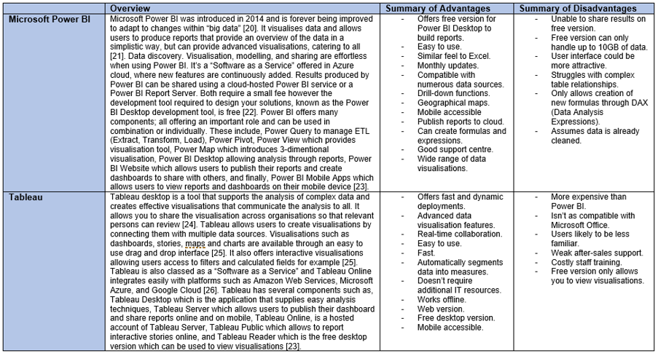
Figure 2. Summary of Power BI and Tableau [39]

2.4.2/ Benefits
Steady improvements in technology have meant that it’s much easier to collect, store and access data. To most, data itself is futile; people are interested in the information that’s provided by the data [40]. DV is an ideal way to help understand and explore large datasets [40]. Yau [40] uses unemployment rates during 2009 in the United States (US) as an example to prove how powerful DV Between 2007-2009 unemployment rates throughout the US had risen from 4.6% to 9.8%, however these figures do not answer specific questions and generalises the entire country. When the data was visualised using a map of the US, it became obvious that certain areas were affected more than others, and therefore made it easier for policy makers to allocate support.
Agreeing, Gatto [41] explains that DV allows consumers to understand large datasets through organisation of the data which accentuates relationships, patterns and even gaps, suggesting that DV is an essential tool as knowledge becomes reliant on data. Humans are becoming more exposed to DV’s thus gaining familiarity, through charts being used on TV such as weather and election charts, and even in sports with player statistics. His diagram below outlines the ‘why’ behind DV [41].
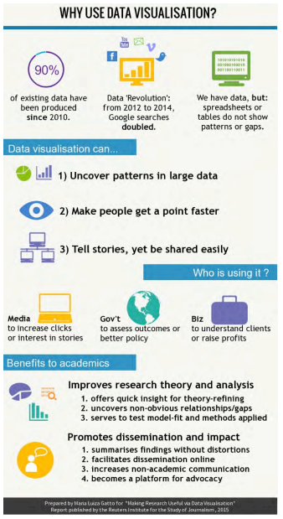
Figure 3. Benefits of Data Visualisation [41]

Jinpon et al. [42] explains displaying important information creates rapid decision making, reduces costs and can also increase confidence of users. Dashboards display up-to-date and easy to read data, advancing historic static reporting [43]. Ward et al. [44] states they speed up the decision-making process assuming clean and consistent data is provided. Ward et al. [44] concludes that
“Analytics…will fundamentally shape the future of medicine and care delivery.”
For healthcare specifically, Ward et al. [44] continues that quality of care and efficiency can be improved using dashboards, which is a driving factor to support the research aim.

2.4.3/ Benefits identified in healthcare
DV within healthcare can be traced back as far as the 1800s with Florence Nightingale’s innovative work analysing the causes of hospital deaths during the Crimean War (1853-1856) [45]. According to Bostridge, her work in the Crimean war cemented her legendary status and describes her as one of the greatest analytical minds of her time, modernising nursing, improving hospital conditions and design, and advising Governments on Army health reform [46].
Guimaes et al. [47] research highlights the importance of data visualisation in creating relationships between medication and vital signs, which will support better decision making. This research within ICU also identified that there were data quality issues and therefore visualisation was used to identify the source of data gaps. It highlighted that before any analysis can take place, it is important that the raw data is transformed into the correct format [47].
Chinneswary et al. [48] research discussing that the visualisation of big data, using GIS, to help understand the spread of disease. It can highlight areas where action is required, allowing them to introduce awareness of the specific disease, and health centres can be set up with correct recourses, with the aim to reduce fatalities.
Data within healthcare has grown tremendously due to the Electronic Health Record (EHR) [49] and whilst it has introduced numerous advantages, it creates the need to manage and process the data so it can get to the right people at the right time in the right format [50]. The large volume of raw clinical data can pose difficultly for clinicians understanding patients’ conditions and making decisions using data across different systems [51]. Less patients may be seen due to the increased time taken to understand the data and can encourage human errors [49], especially in a high-pressured environment. Reports that summarise numerical data are no longer suffice with lots of organisations insisting on graphical representations to make understanding the data more straight forward [52].
With increased data, it’s clear to see that DV is becoming a necessity in accurate and quick decision making. Whilst DV poses a plethora of benefits, it’s important the challenges are considered to ensure these are considered when building and designing the pharmacy dashboard.

2.4.4/ Challenges

2.4.4.1/ Challenges on Society
Prodromou [53] explains the importance of citizens fully understanding the DV to ensure they are not misinterpreted. These interpretations could lead to incorrect decisions; therefore, the skillset of the users is a vital consideration. Some DV’s are created to encourage incorrect conclusions, encouraging users to pose strong DV skills to recognise this. The designer of the pharmacy dashboard will ensure no DV will encourage misinterpretation however it can occur if the correct skillset is not held by the designer [53]. To overcome this, Prodromou [53] advises that data should have, at a minimum, context and outlined data limitations.

2.4.4.2/ Challenges on the Business
One of the biggest hurdles to overcome, as explained by Park et al. [54] is the culture within the organisation. It’s important that leaders are accepting of the dashboard supporting the process and they must encourage adoption within the team. Without support this could encourage resistance to adopting the tool, and any lack of trust in the accuracy of the dashboard could lead to the team being unwilling to adopt the new processes [54].
Most clinical systems aren’t designed to encompass analytical tools, and therefore data can often be difficult to extract [44]. It’s also vital that data quality is high for a successful DV and whilst this is important to a designer, it will not be as important to those reviewing it. For a clinical system like WIS in a high-pressured environment their goal will be to get data onto the system as fast as possible, which can lead to poor data. To overcome this, it is important that systems incorporate data validation, helping users to avoid data input errors.
Data privacy and governance must be adhered to when working with sensitive data. This can be challenging as highlighted by Ward et al. [44] however Information Governance teams should provide advice.
Common benefits and challenges within DV have been discussed, highlighting how powerful they can be to making quick, correct and informed decisions, when clear visualisations that include context are paramount.

2.4.5/Best Practices & Design Principles
Kimball [55] outlines key design principles for dashboards including accessible, consistency, adaptable and provide accurate and up to date data. Kimball summarises these considerations with arguably the two most important points, the data must be trustworthy, and accepted by the community [55]. The dashboard must offer what the business needs, not what the developer wants, especially when BI utilisation can be optional [55].
Cahyadi et al. [31] research offers a similar opinion and continues that it is important to consider not only the organisational culture, but unique requirements for different user types, determining the granularity of different users by offering drill-down functionality.
Kimball argues designing what the business needs is essential to successful BI implementation, which is echoed by Cahyadi et al. [31] who identified the key component to designing dashboards is understanding the usefulness of the dashboard, allowing the design team to remain focused and understand the purpose.
Gatto [41] summarises best practices including: -
- Know your audience’s needs,
- Identify appropriate chart,
- Categories should be meaningful to audience,
- Labels should be simple
- Clear titles
- Provide underlying data
These should be considered throughout the design process to ensure a successful dashboard.

2.5/ Usability and User Experience

2.5.1/ User Experience (UX)
UX can be defined as a person’s response to using a product, system or service [56]. UX testing is much broader than usability and encompasses a wider goal of optimising the whole UX from interaction to reflection [56]. Kristohoff’s [57] identifies bad UX is as important to understand as good UX and discusses how understanding this allows designers to improve user experience.

2.5.2/ Usability
Most agree that usability is part of UX alongside affect and user value [58]. Usability can be defined as how a product is used to achieve goals with effectiveness, efficiency and satisfaction [56]. Usability testing should use these as a measure, however factors such as cognitive psychology should be considered [57]. Usability testing is done in a controlled environment to record user performing usual tasks [57]. Quantitative data is usually collected through interviews and questionnaires to calculate performance times, which helps identify errors [57]. Usability testing measures such as the system usability scale (SUS) can be successful even with a small sample size [59].
Krug [60] explains the first rule of usability is “Don’t make me think!”. Systems should be intuitive, with buttons obviously clickable and actions should be clear. Using systems that don’t make you think means less time and energy is spent trying to work it out [60]. This should be paramount to an NHS dashboard, where time is of essence.
With a main driving factor of dashboard being quick decision making its clear that poor consideration around usability and UX could counteract the success of the dashboard. The literature suggests that both should be paramount throughout the project.

2.6/ Conclusion
The literature review has discussed the plethora of benefits that can be introduced for both company and consumer when introducing a BI tool such as a dashboard. It has been investigated whether these benefits have been seen in the healthcare industry and considered the challenges previously faced to ensure the project incorporates best practices. Finally, UX and usability has been researched, highlighting the importance of both to successful adoption.

3/Methodology

3.1/ Introduction
To achieve the research objectives, a suitable methodology approach should be chosen to keep the research focused.

3.2/ Philosophy
This project will take a positivist approach to the research question set. This approach aims to reduce the possibility of human bias [61], especially as there is a relationship between end-users and the researcher. If a qualitative approach, such as interview, was carried out, those who do not wish to adapt to new ways of working will state no advantages whereas quantitative data gives us facts. Positivist approach allows for larger data collection, thus reaching a larger user base which increases reliability.
Positivist approach however does not always consider all variables, in this case variables such as familiarity of the system. For example, the users may be more familiar with the current solution and therefore time may be increased when using the dashboard due to training issues. To overcome this, a demonstration will be carried out to ensure comfortability before carrying out analysis. Quantitative approaches do remove the option for deep understanding of “why”. Qualitative approaches can give participants freedom in their answers; however, this can be more complex to measure, especially with larger sample sizes. To overcome this limitation, the author could consider follow-up questionnaires in further research.

3.3/ Approach
A deductive approach will be taken allowing both structure and theory driven data [62]. Deductive is easily repeatable especially if there are some unexpected responses during the experiment [63]. Author bias must be considered through the deductive approach, with the author naturally wanting the dashboard to perform well in the experiment, therefore end-users to time themselves. The author could also bring an external researcher to monitor the time measurements however, cost resource doesn’t allow.
Deductive reasoning allows doesn’t offer the flexibility for patterns to emerge from the data, however the researcher felt it was important for a definite conclusion to be drawn from this research to be able to answer the overarching aim.

3.4/ Strategies
The strategies chosen to reach the objectives include a literature review, an experiment and a survey.

3.4.1/ Literature Review
A literature review extended the authors current knowledge on the topic of BI and dashboards and ensured that the research question has not already been answered. It was the first introduction to Power BI with the author previously using Tableau. It identified best practices undertaken by other Power BI developers to ensure the correct steps are implemented, avoiding previous mistakes and failures. The literature review worked towards proposing a hypothesis and concluded a strong argument for the suitability of the research project within the Covid-19 programme [64].

3.4.2/ Experiment
An experiment will identify quantitative measures to confirm whether the new solution will save users time, thus money and resource, a driving contributor to determine whether the dashboard is a success. It can identify areas for further research if there are elements which are not successful as the researcher thought. It will also highlight successful elements, which could be considered for further versions.

3.4.3/ Survey
Anonymous surveys will consist of closed questions for quick and cheap conclusions. These will lack flexibility of other strategies such as interviews; however, surveys allow for larger participation, anonymity reducing potential bias and are convenient, which is particularly useful in fast-past environments such as healthcare.

3.5/ Risks & Limitations

3.5.1/ Measuring Inefficiencies
To avoid researcher bias, and to save on cost, users will record their time-measurements, which introduces risk of incorrect data recording. Strict work instructions will be distributed to all participants, they will all collate their data on the same form and must use the same instrument to record time elapsed.

3.5.2/ Costs
Within NHS cost must be considered, the project could have utilised face-to-face interactions, offering a thorough understanding of user perception however the cost implication of attending sites meant this was not possible.
The use of Power BI over Tableau is another cost led decision however whilst Tableau offers a better user interface and allows more complex visuals, Power Bi is sufficed for the visuals displayed on the pharmacy dashboard.

3.5.3/ Training Issues and Reluctance to Change
Reluctance to change within the participants can create sampling bias. The researcher will attempt to overcome this by ensure end-users are comfortable with Power BI. Power BI offers familiarity as it’s a Microsoft tool and is already used throughout the NHS. If Tableau had been chosen, users may be less accepting and reluctant to learn a system that is familiar.

3.6/ Ethical Issues

3.6.1/ Governance
Building of the Power BI dashboard was originally planned against the BETA environment of WIS. Due to data privacy concerns however the database had to be simulated on SQL server and test data generated. Changes will therefore be required before this project is distributed to a production environment. Whilst as much data as possible has been generated, issues with larger data sets such as performance may not have been noted.

3.6.2/ Voluntary and Confidential Participation
No pressure should be put on participants to partake. Surveys and experiment will be completed within work hours therefore voluntary involvement must be clear to avoid any undue stress where work commitments don’t allow time to participate. Participants may be embarrassed or stressed due to their lack of technical confidence, also driving the need for voluntary participation.
All data regarding participants is confidential. No identifiable information is required to meet any of the objectives set in this project thus will not be collected. This will be made clear to all participants, boosting confidence for those who are unsure on taking part.

3.7/ Validity, Reliability & Generalisability

3.7.1/ Validity
For the experiment, the same time measure tool, a timer, will be used by all participants, increasing validity. Participants will time themselves to reduce researcher bias. It’s also important to consider selection bias when gathering the sample, therefore user personas will be identified to ensure it’s a reflection of the users. It could be beneficial to the researcher to use those confident in power BI use, however, this could skew results.

3.7.2/ Reliability
Quantitative research usually means higher reliability. The surveys have been completed online, which can lead to greater dishonesty from participants [65], such as answering questions to please the researcher or completing without reading the questions. To overcome this, the survey will be no longer than 10 questions, and will be written in clear language. The benefit of true results on the participants will also be stressed. Experiments also have strong reliability and generalisability as it can be repeated in different settings, and with different user groups.
A sample size that is too large or small can skew data [65]. For quantitative data, generally the larger the sample size, the better with researchers suggesting that sample size of 30 should be the minimum to perform data analysis on therefore the author will aim to receive at least 30 responses to both questionnaires [65].

3.7.3/ Generalisability
Participants from different demographics and characteristics should be included to support predictions on a wider audience. However, as this research is specific to pharmacists within the WIS system this does make it complex. During the design of the survey, the author should keep in mind generalisability, and consider how the research outcomes could be used for similar healthcare focused dashboards.

3.8 Data Evaluation Methods

3.8.1/ Data Collection
For the experiment, quantitative data will be collected using a timer, with results being input into an excel spreadsheet based on a form generated by the researcher. This should include at least 10 participants, however due to the time associated, the response may be less. If this is the case, the researcher will attempt to recruit participants from other areas of the NHS which match user personas identified.
The survey should receive at least 30 responses and will be completed online. The survey will be distributed via e-mail following a demonstration of the dashboard, and follow-up contact will be considered if they are not completed. The questionnaires will be closed questions with quantitative data and will be collected using google forms. Previous research has suggested that questionnaire participation can be low so context and explanation as to why participation is important should be outlined.

3.8.2/ Data Evaluation
For the survey, the data will be evaluated using descriptive statistics and patterns in the data will be analysed. The experiment will use a paired t-test using 0.05 as the level of statistical significance. If the t test creates a figure less than 0.05, then it can be concluded that there is statistically a significant difference between time taken to use the new solution as opposed to the current solution. Due to the low participation required, the t-test will be performed using Microsoft Excel.

3.9/ Development Methodology

3.9.1/ Software Development Methodology
Agile has been chosen as WIS is fast paced and susceptible to change therefore the flexibility of agile was desirable. Stakeholders should be included in review meetings offering an opportunity to highlight issues and rectify before releasing the final product, essential for a time bound project. Alternative methodologies such as waterfall could lead to unsuccessful design, or requirements not met, with no chance of rectification. The agile approach is summarised in figure 4. As requirements have already been gathered, a predictive life cycle, as displayed below should be taken [66].
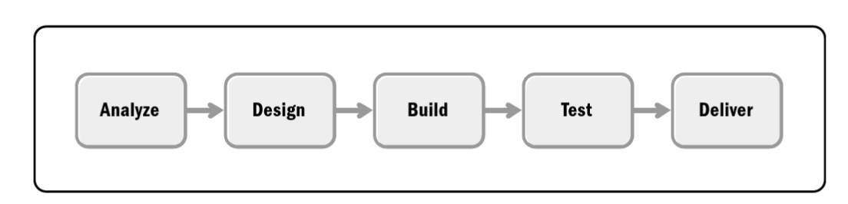
Figure 4. Predictive Life Cycle [66]

3.10/ Resources

3.10.1/ Hardware Resources
The hardware being used will be a normal networked PC. There should be no additional PCs required and the current solution required the same hardware as the new solution.

3.10.2/ Software Resources
Software required will be access to the Power BI dashboard. As Power BI is already used within the NHS, most end-users should already be set up however this should be accessed before releasing the dashboard and if there are any users without access currently, they should be set up in preparation. Those who require access to the dashboard will be collated by the pharmacy leads before release.

3.10.3/ Information Resources
External data required includes data fed from WIS. Due to governance concerns, this will not be possible therefore a simulation has been developed, however an understanding of how WIS collects pharmacy data is required.
Usability testing will be carried out and therefore 30 participants should be contacted following a demonstration of the dashboard.
Once the methodology had been identified, the design of the dashboard could be considered.

4/ Design & Implementation

4.1/ Requirements

4.1.1/ Must Have, Should Have, Could Have, Won’t Have (MoSCoW)
The Covid-19 programme is a fast-paced environment and has developed drastically since the first release. The requirements for the Pharmacy export were gathered back in August 2020, and during previous research, it was highlighted that not of the current solutions elements are still required.
Requirements for the Power BI dashboard had been captured through qualitative interviews during the industrial based research [39], where a MOSCOW framework was gathered, as shown in figure 1. This was carried out not only to identify requirements but supported prioritisation and gave ideas to further development.
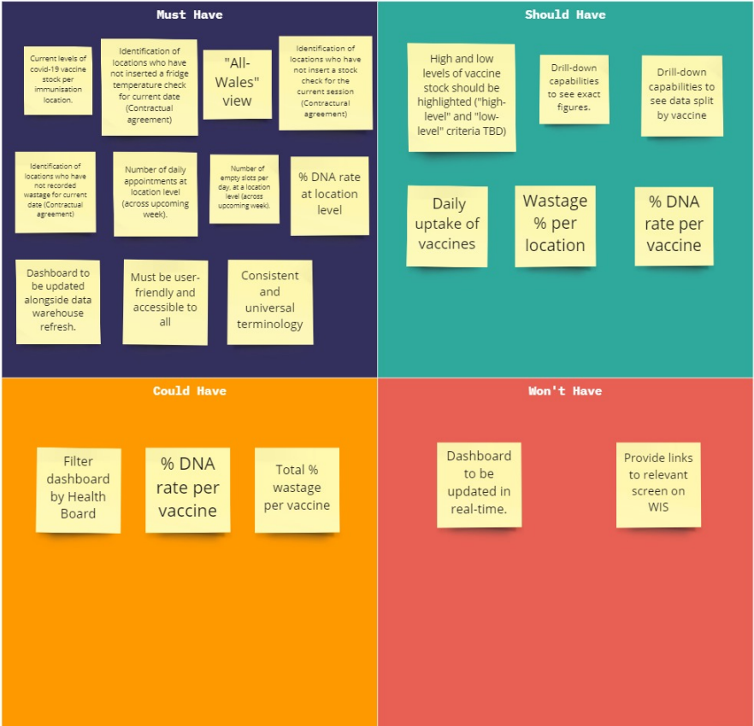
Figure 5 MoSCoW Framework [39]

4.1.2/ High-level Document
Following the MOSCOW gathering, requirements were collated into an excel spreadsheet and e-mailed these back to the stakeholders for confirmation. This ensured no requirements had been misinterpreted, and if they had, the issue could be resolved before development begins. Figure 2 displays the excel spreadsheet containing the requirements gathered.
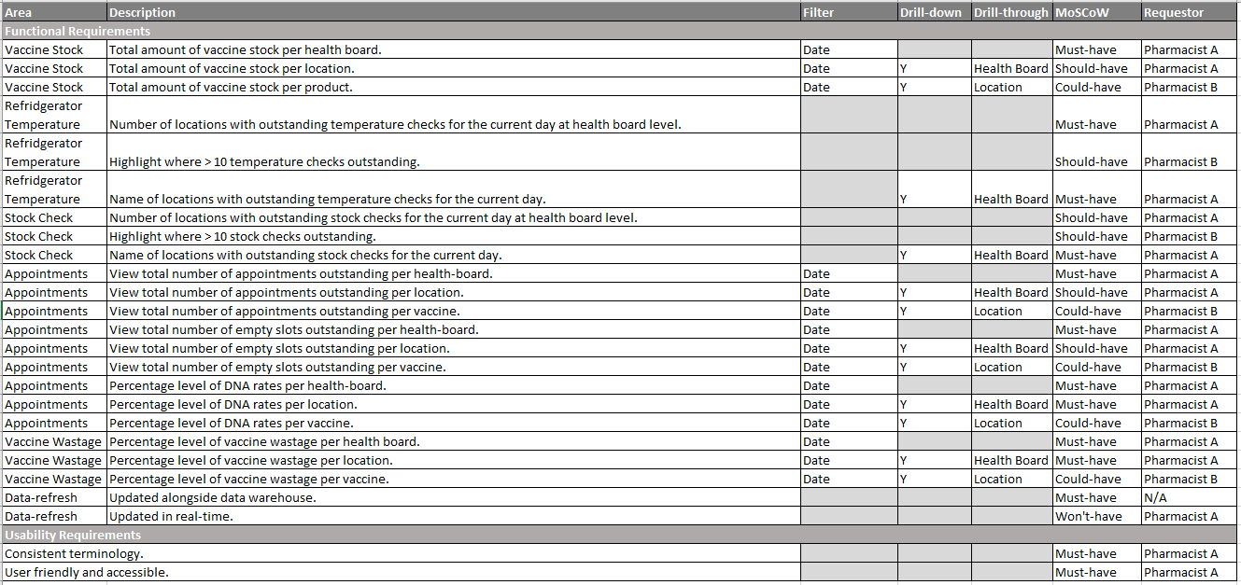
Figure 6. High-level Requirement Document
Unfortunately, no response was received to this e-mail therefore development continued assuming the requirements hadn’t changed.

4.1.3/ User Personas
Before the design stage, types of end-users were considered to ensure the dashboard is designed with those in mind. It’s easy to assume that all users will be using the dashboard for the same thing, however this is almost never the case, and users will have different goals and pains. To understand this, four user personas have been generated, which have been generated from previous experience working with pharmacy team for over three years. Ideally thorough user research would have taken place, however, due to time and cost constraints, this was not possible. An example of one of the user personas is displayed in figure 7, with all personas included in Appendix A.
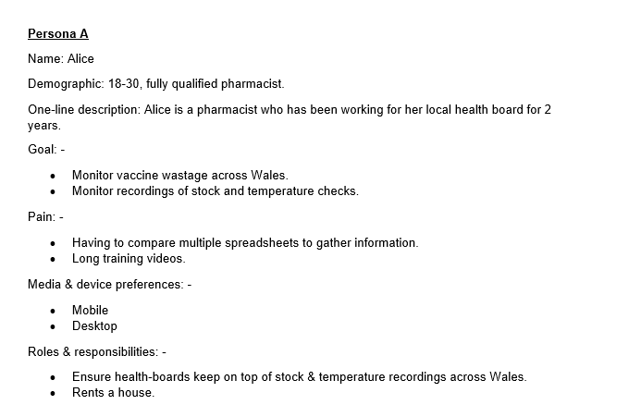
Figure 7. User Persona A
These will be considered throughout the design process to ensure their needs and wants are met, where possible. The requirement for intuitive design is imperative to meet the needs of new starters like the user persona highlighted in figure 8.
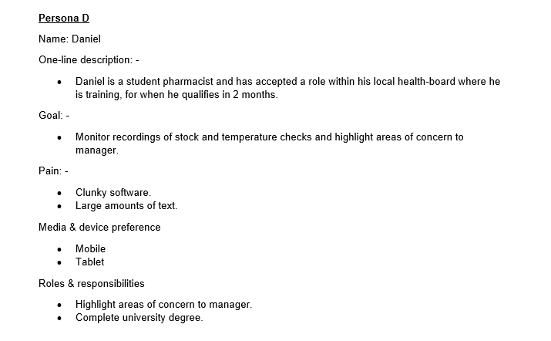
Figure 8. User Persona D
Combing both high level requirements document and user profiles, user stories have been created.

4.1.4/ User Stories (US)
Detailed US were created to split the work into smaller achievable pieces of work, as shown in figure 7, and were prioritised using the MoSCoW framework.
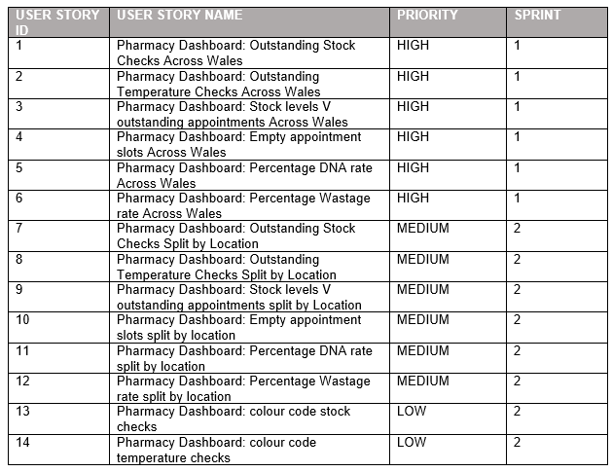
Figure 9 Summary of User Stories
The user stories contained a description and testable acceptance criteria to ensure all requirements were met as displayed in figure 8. For all user stories please refer to appendix B.
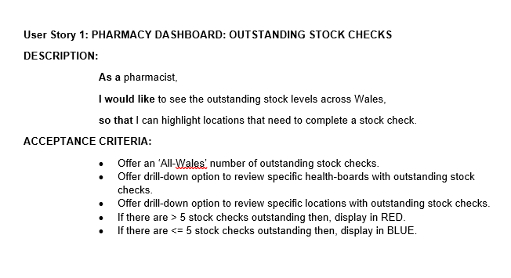
Figure 10 Detailed User Story 1
Once the user stories are generated, ideally a backlog refinement takes place with the development team to ensure the stories are ready for development. This has not been carried out due to the nature of this research project.

4.2/ Design

4.2.1/ Interviews
Before the design stage took place, interviews with DHCW Power BI experts to ensure previous successes and lesson learned were considered. Interview questions were considered outlined in appendix C however, due to time constraints, this stage was never carried out. Instead, best practice principles highlighted during the literature review were adhered to.

4.2.2/ Dashboard Prototype
Following this, the first dashboard prototype was designed as shown in figure 9.
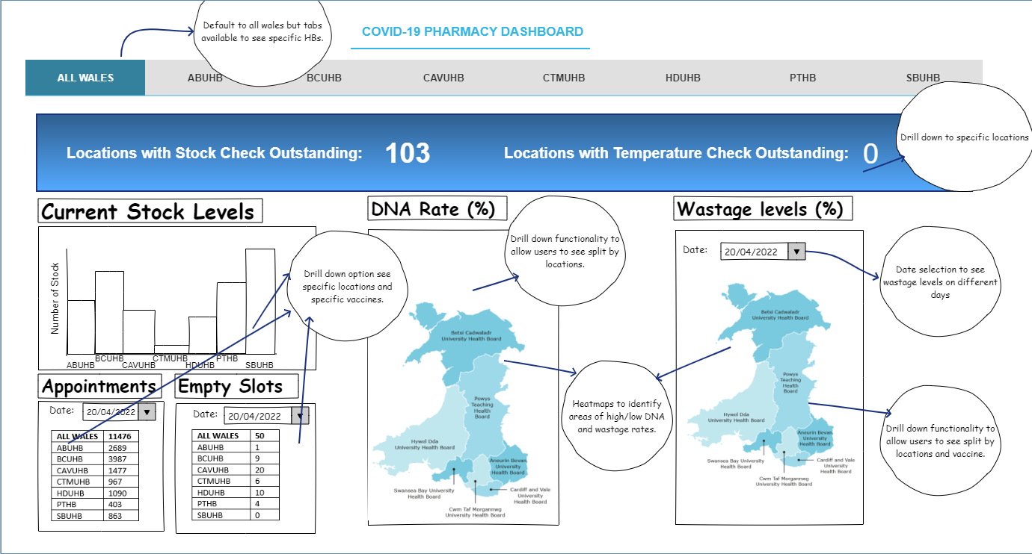
Figure 11. Dashboard Prototype Version 1Figure 3. Dashboard Prototype Version 1
The first design focused on using GIS to display did not attend (DNA) and wastage figures, following the success highlighted in the research of both Chinneswamy et al. [48] and Yau [40]. The GIS visualisation useful however review the requirements, for easy comparison of appointments and current stock levels, the author felt a better visualisation could be created, as displayed in figure 10.
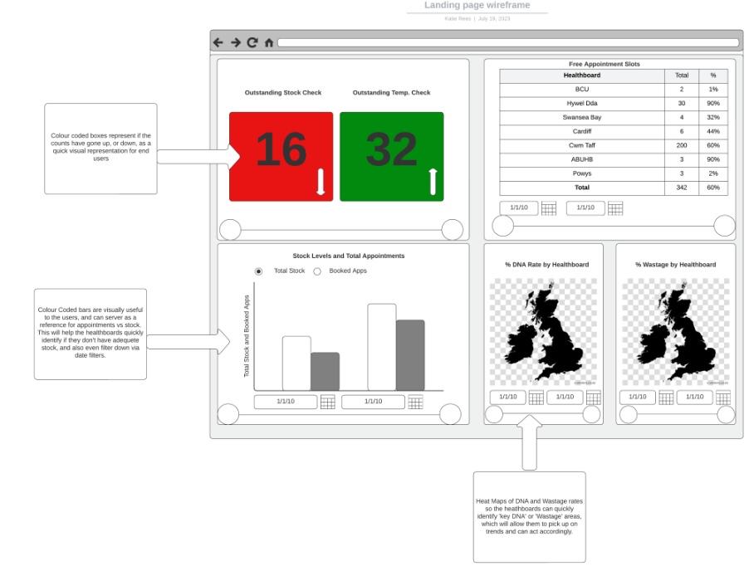
Figure 12. Dashboard Prototype Final Version

This new design allows for quicker comparison of total stock levels against upcoming appointments.
As the researcher became more confident in Power BI, it also became clear that tabs for each health board would not be required, and the requirements could instead be met with drill down functionality.

4.2.3/ System Usability Scale (SUS)
The final version of the prototype was demonstrated to users to gather usability feedback. To gather this information, a SUS has been distributed. This has been considered at this point in the design phase to ensure there are no major issues which would hinder the success of the dashboard. Deadlines also meant that it was vital to identify major concerns before development begins, following the agile process. It aims to avoid loss of time and cost and ensures the best possible usability design is adopted [67]. The SUS scale provides a tried and tested measure of potential user’s perception of the system and can be done in a short time frame [68]. A demonstration and feedback were attempted from end-users; however, no response was received. Further contact was made; however, participation is voluntary and therefore feedback was gathered from 12 participants, including colleagues, friends and family. Whilst 12 is not ideal sample size, Tullis and Stetson’s [59] research previously discussed in the literature review suggests this is sufficed.
Figure 11 shows a graph of the response received for the first 2 questions on SUS.
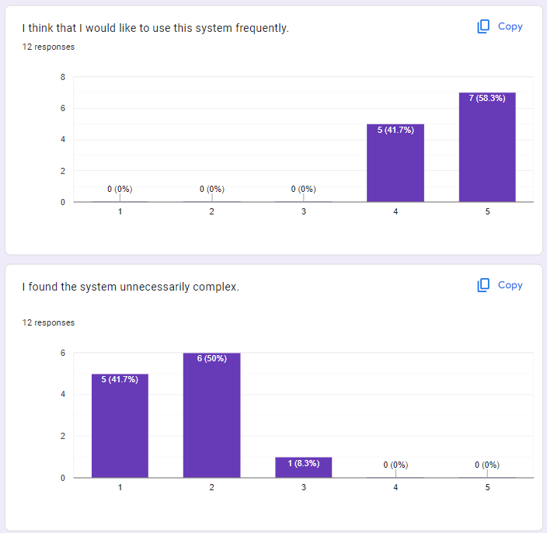
Figure 13. SUS Feedback Questions 1 and 2
The above feedback suggests the design has been successful with all participants agreeing they’d like to use the system frequently. There is however room for improvement with simplifying the system and this should be during the design stage.
Questions 4 and 5 received a more distributed response as shown in figure 12.
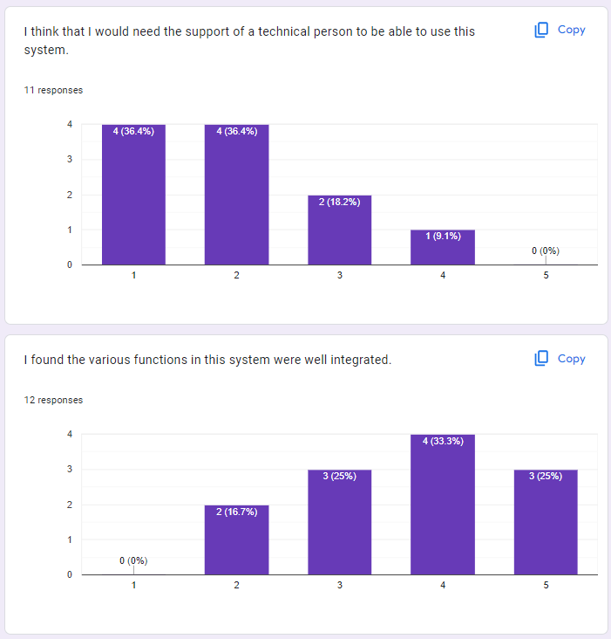
Figure 14. SUS Feedback Questions 4 and 5
Figures 12 and 13 infer that training would be useful to ensure end-users are comfortable using the system. As many participants are DHCW colleagues and technically confident this outcome was not expected. Simplicity during development must be considered as well as training if the decision is made for implementation. These results agree with Chang et al. [20] and Salisu’s [19] research who discuss the challenge of knowledge gaps when introducing BI.
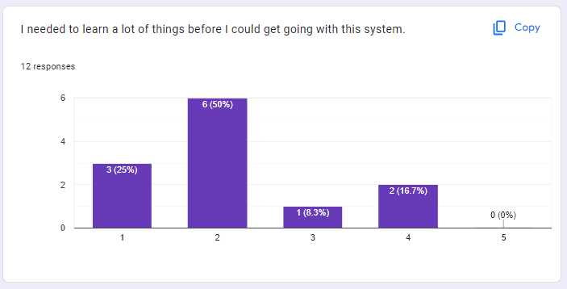
Figure 15 SUS Feedback Question 6
The results in figure 14 however pose a contradicting opinion to the above with most suggesting quick learning.
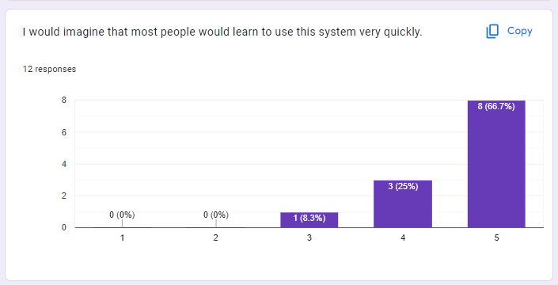
Figure 16 SUS Feedback Question 7
These results could suggest participants lack confidence in their own ability but feel the dashboard is intuitive. Even so, simplicity will be at the forefront when developing the dashboard to ensure the best solution is created.
Individual SUS scores have been calculated with participants 1-8 raw scores shown in figure 15.
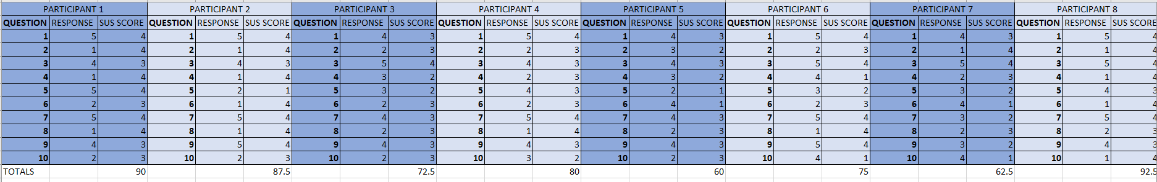
Figure 17 SUS Feedback Raw Data
The final scores have been collated into figure 16.
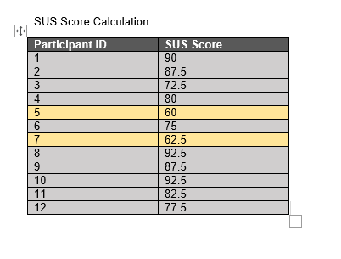
Figure 18 Final SUS Scores

The average SUS score is 68 and so participants 5 and 7 have been highlighted for further investigation.
Participant 7 answered ‘3’ on 3 occasions, highlight potential confusion or rushing of the survey. Participant 5 however felt there was too much inconsistency and therefore this will need to be monitored during development, especially being a key principle in usability success.
Figure 16 displays a positive usability outcome however participants were colleagues, family and friends of the researcher which can create bias, even with participant anonymity. It concludes that the design of the prototype provides positive usability, however consideration for consistency would be beneficial.

4.4/ Implementation

4.4.1/ Database Design
Due to governance concerns, the dashboard was unable to use the current database schema for WIS therefore a simulated database was created using SQL Server Manager.
An entity-relationship diagram was created to simulate the WIS database, ensuring appropriate relationships between tables to allow for the creation of a dashboard which meets the requirements. The ERD is displayed in figure 19.
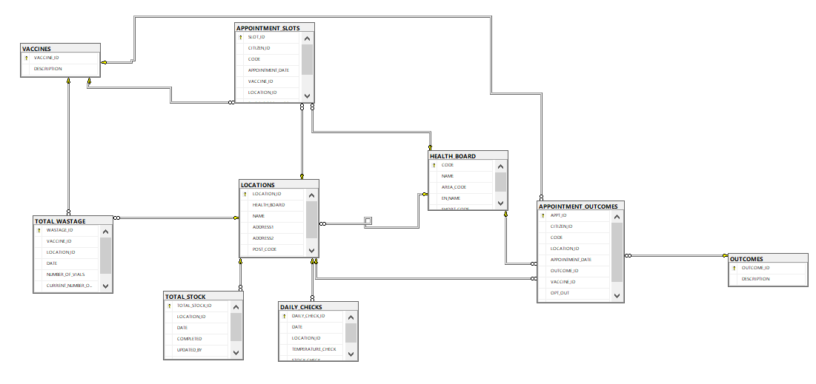
Figure 19 ERD
Tables were then created using CREATE statements with an example shown in figure 20.
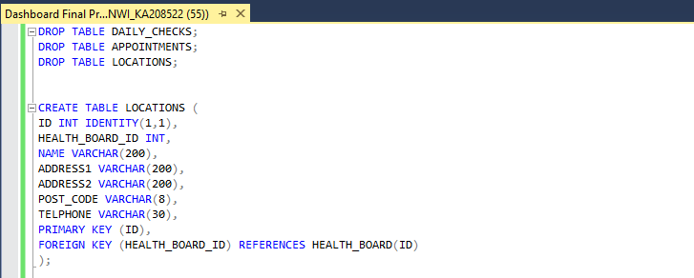
Figure 20. CREATE tables
“Mockaroo” [69] was used to generate test data, as shown in figure 19.
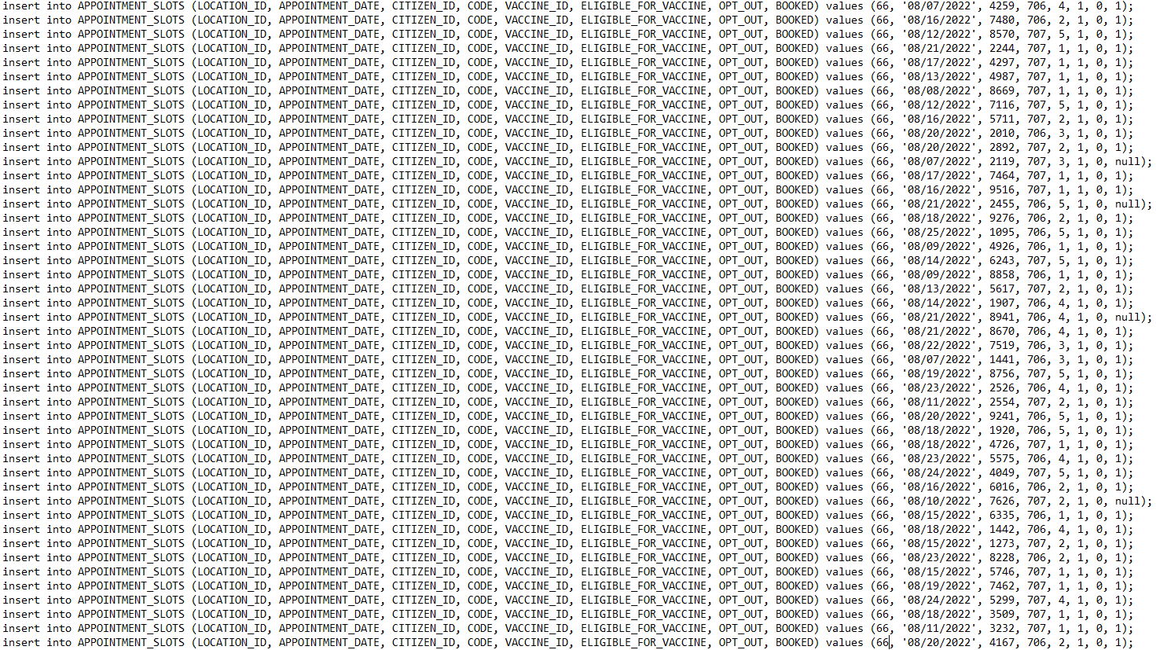
Figure 21 Insert rows generated by Mockaroo [69]
Following create of the database, including test data, the data was fed into Power BI.

4.4.2/ Data Transformation
Within DHCW data is usually fed to the data warehouse first where extract, transform and load (ETL) process could have been utilised. As information is coming from the same source, data has instead been transformed once loaded into power BI. A summary of how the data has been transformed, including removal of certain column and changing data types is outlined in figure 22 and 23.
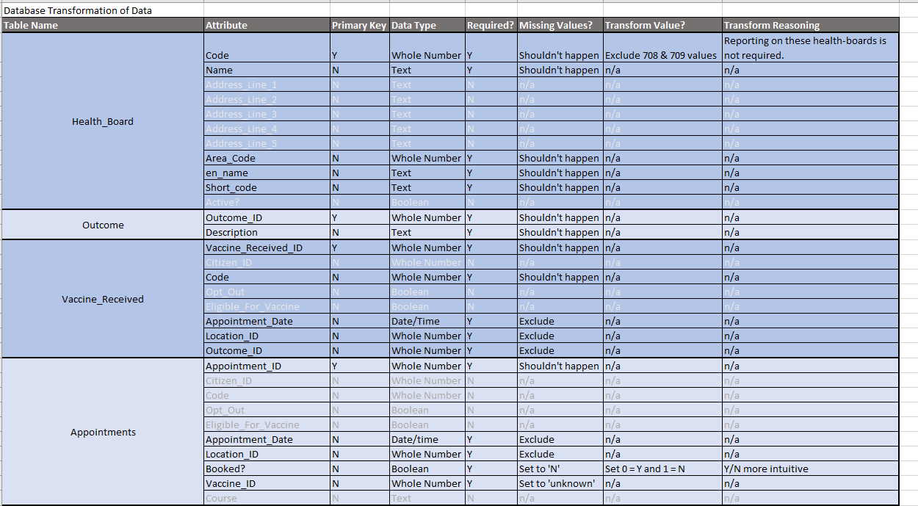
Figure 22 Data Transformation (1)
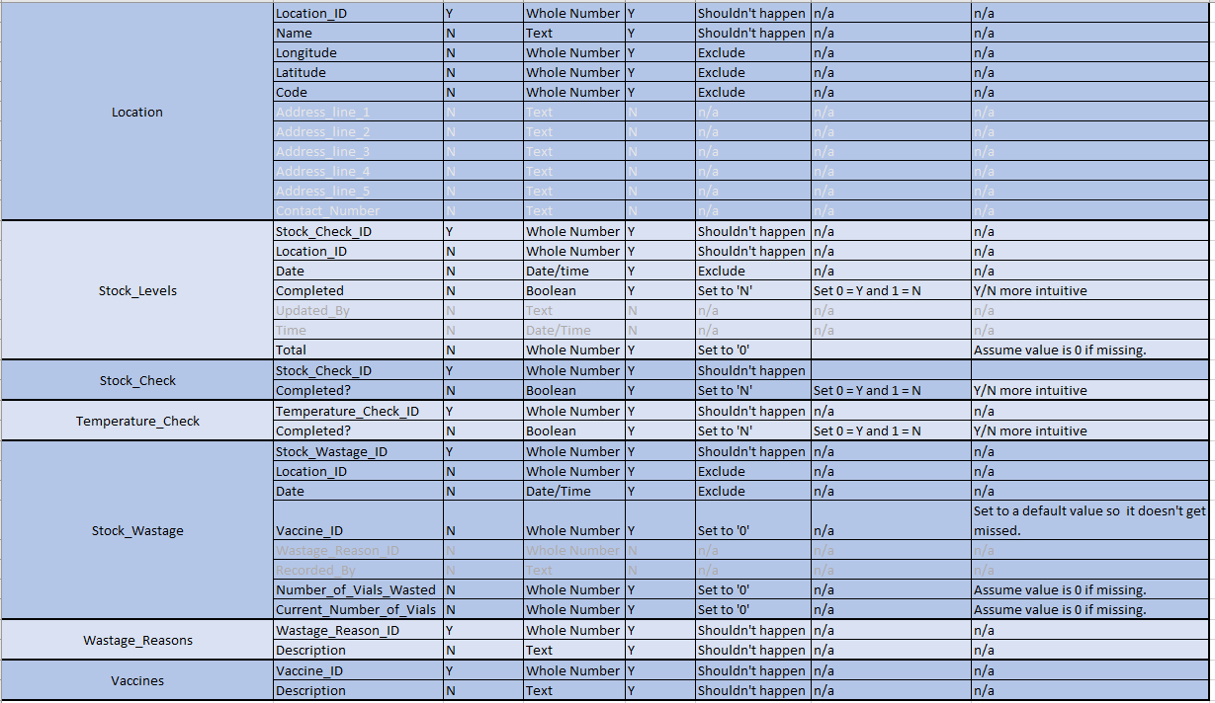
Figure 23 Data Transformation (2)
Once the data was transformed, the database build begun.

4.4.3/ Visualisations

4.4.3.1/ Stock and Temperature Checks
As users are most interested in whether there are any outstanding stock checks, a display of a total figure seemed most appropriate. The option to drill-down into health board and then by location will be available to allow users to identify specific details if required. This raises immediate alarm, rather than the user having to search through a list of health boards to see if there are any areas with outstanding checks.
Consideration in the colour scheme identified that visualisations that contain red and green, with similar lightness cannot be read by those with colour-vision deficiency [70]. Therefore, the visualisation display in the standard blue, and only red to highlight a problem as shown in figure 24. The number will always display offering an alternative for those who prefer to view a figure.
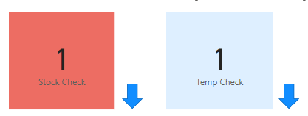
Figure 24 Outstanding Checks Visual

4.4.3.2/ Stock and Appointment Levels
Conversely to daily checks, users need to view figures split by health board for stock and appointment levels as one figure for all Wales would provide little value. For example, one health board could have excess stock however this would not be obvious from the visual. Bar charts are one of the most used graphs thus the familiarity would be particularly desirable for user personas such as Catherine who lacks confidence [71]. If the stock was being shown over a time-period, then a line chart could have been considered, however a bar chart is more appropriate for discrete data [72].
A dual bar chart as shown in figure 25 has been so users can quickly identify where stock doesn’t meet demand or there is an excess in supply. Drill downs will provide specific location data supporting the distribution of vaccines through the health board. It should also contribute to improved wastage rates due to less excess stock.
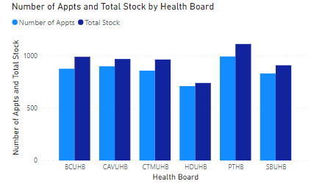
Figure 25 Number of Appointments V Total Stock Visual

4.4.3.3/ Empty Slots
Empty slots are displayed as a table view, split by health board. This highlights specific figures so users can contact managers to investigate. Specific figures are important for this visual, and can differ dramatically between health board, which is why a table view has been chosen. Heatmaps or bar charts could have been used, however specific figures would not have been as obvious.
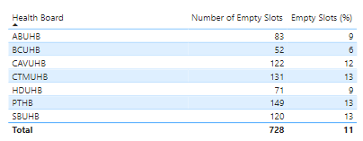
Figure 26 Empty Slots Visual

4.4.3.4/ DNA and Wastage Levels
Both DNA and wastage figures have been shown using a heatmap against a map of the health boards, as shown in figure 27. This could have been shown in a bar chart for familiarity however these allow quick identification of where rates need to be monitored. The drill-down functionality will provide further details of rates at locations.
Colour gradient is used to highlight areas of high and low values. Blues were chosen to conform with DHCW protocol thus remaining consistent with other DHCW dashboard, a key factor identified in SUS outcome. If this colour scheme hadn’t already been set the author would have ensure the colour contrast was suitable by using tools such as an online colour contrast checker and usability testing.
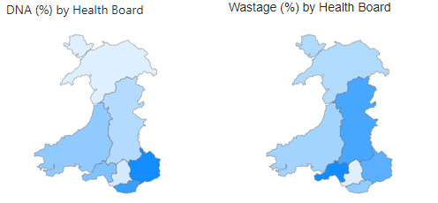
Figure 27 Wastage and DNA Visuals
Consistency is continued through to the drill-down with areas of high DNA or wastage rates displaying larger blue bubbles as shown in figure 28.
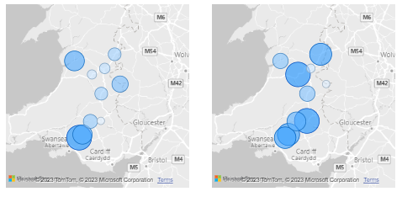
Figure 28 Drill down DNA and Wastage Visual
The DNA drill-down can prompt investigation into whether a location doesn’t have enough transport links, or whether citizens are being appointed into a location that is too far and they’d be better suited to a different location.

4.4.3.5/ Slicer
A date slicer has been included to filter the visuals by date, as shown in figure 28. This allows users to see figures over a specific time frame, without having to concatenate numerous excel spreadsheets, as per current process. This can predict trends, such as high DNA rates or number of empty slots during specific times of the year, and appointment invites within this timeframe could be avoided in future. This kind of analysis can save the NHS money by being able to predict when appointment slots are less likely to be filled, with resource being adjusted accordingly.
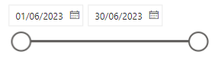
Figure 29 Date Slicer4.2.6/ Drill-down

4.4.3.6/ Tool Tips
Tooltips will display through the dashboard to give users a breakdown of specific figures as shown in figure 30 for total stock and appointments. This is useful for when users require specific figures for transferring stock to different locations if they have excess or not enough.
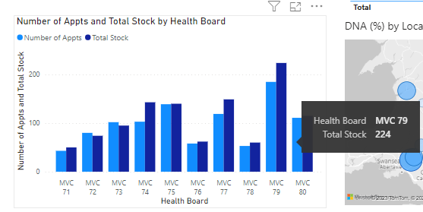
Figure 30 Tooltip

4.4.3.7/ Measures
For percentages to display, measures were created in power BI. An example of one of the measures created is shown in figure 31.
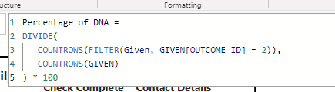
Figure 31 Measures
The final dashboard design is displayed in figure 33 and 34. All charts have been clearly labelled to conform with Gatto’s [41] best practice principles.

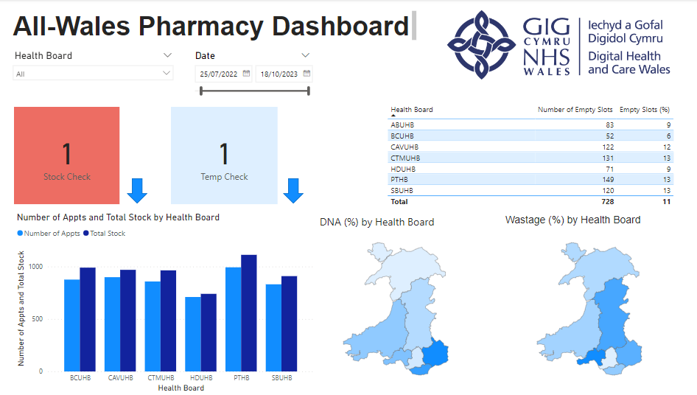
Figure 33 All-Wales View of Pharmacy Dashboard
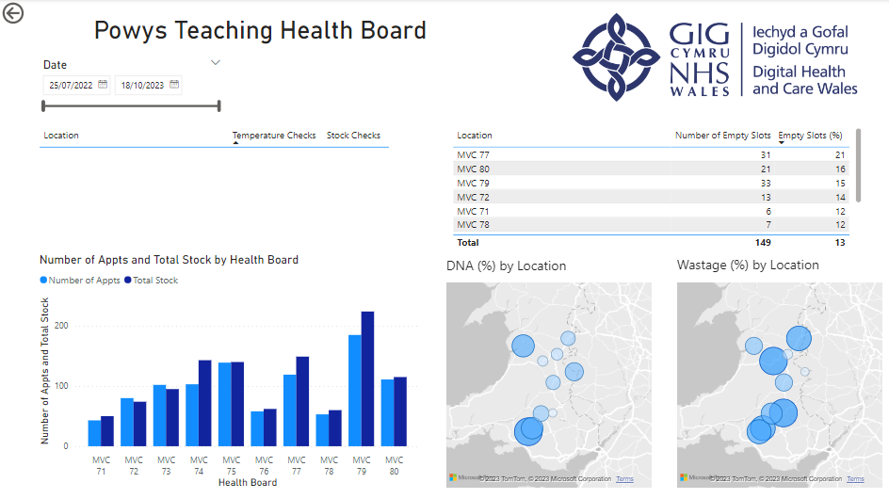
Figure 34 Health Board View of Pharmacy Dashboard

4.4.4/ Testing
On completion of user stories, visuals were tested to ensure they meet the requirements.
Test cases were generated for unit testing and an example is shown in figure 32.
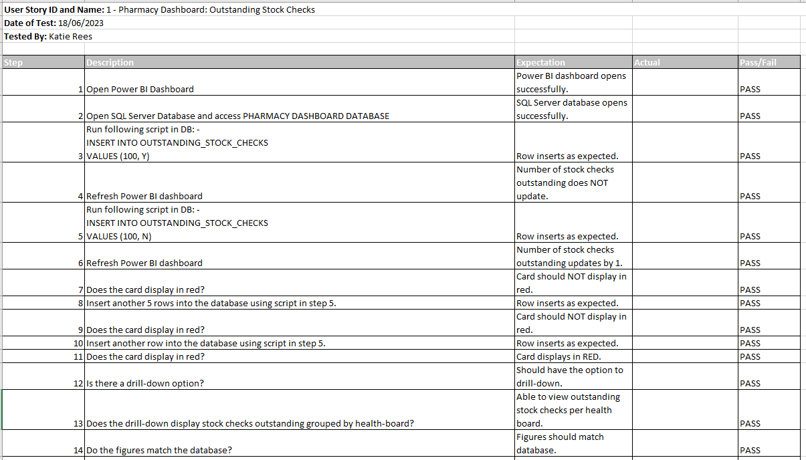
Figure 32 Test Case Example
One major bug that was identified during unit testing was that a filter that was meant to be applied to one chart, was applied to the entire report. This has passed the unit testing of the original chart, as it didn’t become apparent until a second chart was created that didn’t require the filter. The original chart therefore had to have the filter removed, and instead a measure was generated. The chart then had to be retested to ensure that didn’t cause any further issues.
Another bug identified was the date slicer was displayed in an incorrect format. This identified an issue with the transformation of data process, and the format of the appointment date column within the ‘Appointment_Outcomes’ table had to be updated from ‘whole number’ to ‘date’. Once the dashboard had been refreshed, the slicer then displayed dates rather than unusable whole numbers.
If this project was a larger, then user acceptance testing (UAT) should have taken place at the end of each sprint to ensure the user is happy with the product. Interaction with end users has proved difficult and therefore UAT was out of scope.
Once testing was signed-off, the dashboard was published to ‘my-workspace’ within power BI to allow for demonstrations to take place. Ideally, the dashboard would have been distributed however as this project has yet to be approved, this was not possible.

4.5/ User Survey
A user survey was created to gather constructive feedback from potential users following a demonstration of the Power BI dashboard. Ideally, they would have been able to use the dashboard, however it’s yet to be approved. The survey was created on Google forms and consists of closed, pre-coded questions to gather nominal data as it’s easy to analyse, cheap to implement and takes less time due to the answers already being coded [73]. It includes two multiple choice questions, and each question contains a ‘Not Sure’ option. This has been included to ensure that users who genuinely don’t know, due to knowledge gaps, don’t generate a blank response, or include an answer that they have been forced to choose to complete the survey [73]. Questions have been written in a clear and unambiguous way, and the technical terms included, such as visualisation and Power BI dashboard are ones that all should understand following the demonstration. Most questions are attitudinal, and the two behavioural questions have been placed at the beginning to ensure the attitudinal questions do not impact the way they answer the behavioural [73]. For example, if the question in figure 33 was asked last, the participant may be more likely to state they use dashboards more often than they do, as they feel experienced due to the previous questions. An example of the survey questions is shown in figure 33 however all 10 questions distributed are in appendix D.
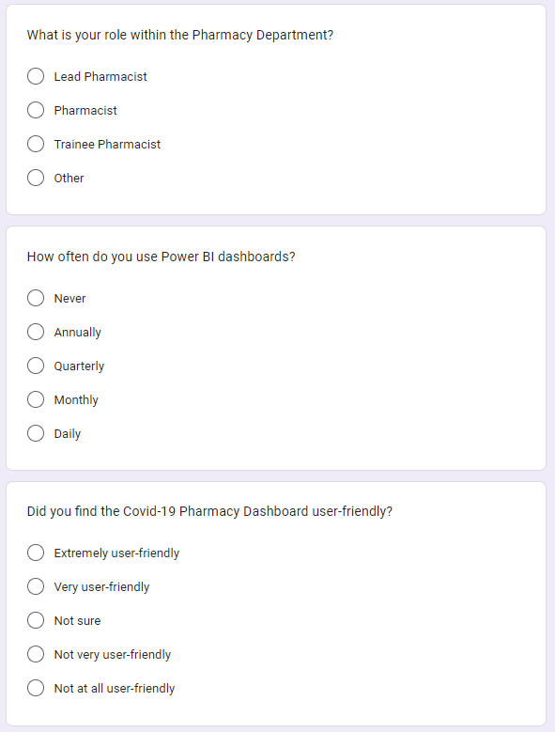
Figure 35 User Survey Question
The user survey was distributed to gauge the interest of introducing a Power BI dashboard, and whether potential users think they’d find it useful. Unfortunately, only 11 responses were received, and none of those responses were from potential end-users. Instead, fellow colleagues, friends and family, where the majority are IT-literature completed the survey following a demonstration. This does create a bias, not only as the participants knew the researcher, but because the major are either familiar with Power BI or they are confident using IT solutions. The results of of someone who is less confident using IT solutions have not been truly reflected. This is highlighted in the results, as most participants conclude that the dashboard would be successful and could provide a useful addition to the Covid-19 vaccination programme as shown in figure 34.

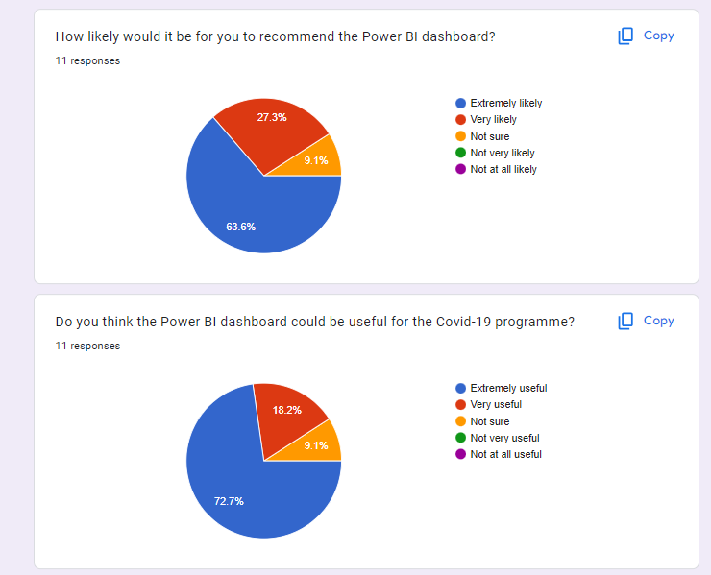
Figure 36 User Survey Questions (2)
90% of participants concluded that they liked both heatmaps, and even more impressively, no one said they didn’t like them, as shown in figure 35.
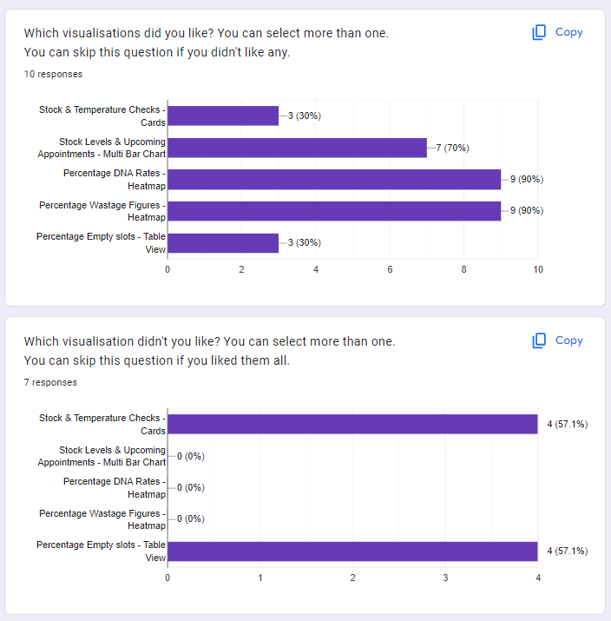
Figure 37 User Survey Questions (3)
The multi bar chart is also liked, which could be down to simplicity and familiarity. For both the temperature & stock check cards, and the empty appointment slot tables, 57.1% of the participants did not like them. The author had originally thought that the table view would have been good for familiarity and clear figures however comparing the liked and disliked designs suggests that the empty slots visual may have been better as a heatmap and therefore that is something that could be considered in further releases. It’s again worth highlighting here the participants skillset may not match that of the actual users and therefore pharmacists may prefer the familiarity of the table view.

4.6/ Time-measure Experiment
One major benefit that was reiterated by several authors in the literature review is that dashboards can introduce quick decision-making. This is so crucial in a sector such as healthcare where workers are historically stretched, and quick and improved decisions can save the organisation time, money and resource. For example, the Power BI dashboard has the potential to inform the user locations where there is not enough vaccine supply for the upcoming appointments. The very same graph can tell them which location may have excess stock and organising transfer of sufficient vaccine stock. This not only saves the health board refusing patients due to lack of stock, it also avoids potentially expiry of excess stock, both money-saving exercises.
To measure the potential time saved by the introduction of a Power BI dashboard, a positivist approach has been taken to analyse the time taken to carry on their daily tasks on the current solution (an excel spreadsheet) as opposed to the proposed solution (a Power BI dashboard). The daily task was a predefined set of questions, based on the requirements given, as shown in figure 36. All questions can be answered using both the old solution and the new solution; therefore, some graphs will not be used as part of this experiment as they are not available on the current solution. For example, number of outstanding appointments, and DNA figures are not something that is currently provided by the excel spreadsheet and is instead captured by database views. Unfortunately, access to these views is unavailable for this experiment and therefore these have not been included. To carry this out, participants were given a copy of the current solution, with mock data, and access to the Power BI dashboard with the same mock data. They measured time it took to carry out the pre-defined tasks, first on the old solution, and then on the new solution.
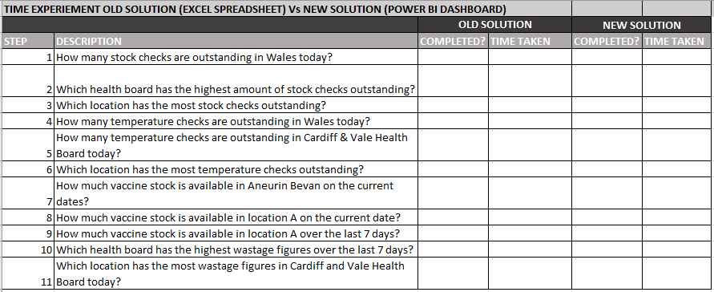
Figure 38 Pre-Defined Tasks
The time taken to complete each task on the old solution will be totalled alongside the new solution, and the data for each participant was collated into another spreadsheet, as shown below in figure 37.
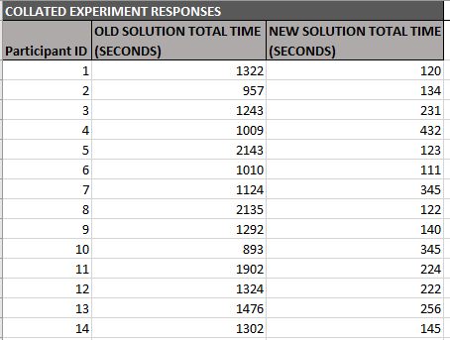
Figure 39 Collated Experiment Responses
The timer did also collect milliseconds however these have been rounded to the nearest second for simplicity.
It’s abundantly clear from the results above that completing daily tasks takes less time when using the Power BI dashboard. However, to ensure that the difference is statistically significant, a paired t-test has been performed. The paired t-test allows us to compare the mean time using the current solution with the participants, against them using the proposed solution, with the same participants, explaining whether future users are most likely to make decisions quicker when using the proposed solution. If there were more participants, it would have been useful to put this data into a programme such as ‘R’ to first identify any outliers, these could have then been removed and a t-test would have been performed however due to the small sample size, excel was chosen. The experiment was based on the below hypotheses.
NULL HYPOTHESIS: There is no significant difference between the time taken to complete daily tasks between the two systems.
ALTERNATIVE HYPOTHESIS: The time taken to complete daily task is reduced when using the proposed system (Power BI dashboard).

Using a p value of 0.05, the t-test confirmed that the null hypothesis, as shown in figure 38 below, could rejected and the alternative hypothesis could be accepted.

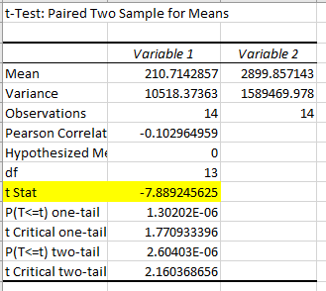
Figure 40 T-Test Outcome

5/ Evaluation

5.1/ T-Test
It’s evident to see that the outcome of the data is that a Power BI dashboard would be useful for the Covid-19 programme proven by both t-test experiment and a positive user survey.
The experiment proves that on average, making decisions takes 1156 seconds longer (approximately 19 minutes), on the current solution (excel spreadsheet) as opposed to the proposed solution (dashboard). This agrees with Mane et al. [74] research who when discussing the motivation behind his study of a Power BI dashboard, explains that they can assist decision makers with understanding a narrative, thus improving not only time but providing reliable information.
The t-test suggests high statistically significance between the two time-measures however this experiment would have been more beneficial if the participants include pharmacists. The results may have shown a higher figure when using power BI due to a lack of familiarity and confidence. However, it could also be considered that involving pharmacist in this experiment would have created bias towards the excel spreadsheet as they use it daily. Pharmacist who are reluctant to change may have deliberately taken longer with power BI to ensure the results were in favour of the current solution.
The t-test only compares tasks that can be completed on both the current and proposed solution therefore leaving a gap within the experiment. The researcher only had access to the export and therefore any other systems that are used to compare against the export to reach decisions could not be timed. If comparison between multiple system is required to decision-make however, it could be assumed that this would perform in favour of the dashboard.

5.2/ Survey
The survey results also supported a shift towards the use of Power BI dashboard with over 80% voting in favour of a dashboard, with the remaining 20% wishing to use a mixture of both solutions, as shown in figure 39.
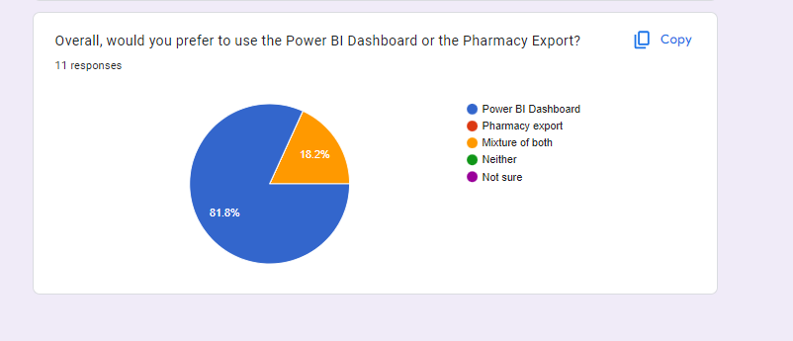
Figure 41 User Survey Results
The remaining 20% could include those who less confident technology users, and hopefully overtime would become more familiar. It would be useful to reuse this survey after implementation to conclude whether this would be the case.
This agrees with fellow researchers within the field, such as Ward et al. [44] who suggest that dashboards and DV’s can increase the speed of decision making.
The research does contradict the survey results also, with suggestions of the culture within an organisation a difficult hurdle to overcome [54] . The Power BI dashboard hasn’t been implemented however the user survey suggests users are already keen to adopt. This could be down to the current solution being so poor, or users could already be familiar with Power BI and therefore confident.

5.3/ Aims and Objectives
The aim has been met, concluding a power BI dashboard offers users a quicker decision-making tool than the current solution. The accuracy of those decisions however has not been measured therefore we’re unable to confirm the decisions are more informed. We can infer this from the data through information being easily accessible however no experiment has confirmed this.
Whilst all objectives have been met, there could have been further research into user experience to ensure the best possible solution is being introduced. Best practices were highlighted through literature review; however, interviews could have been carried out with internal DHCW experts to identify previous successes and lessons learnt.
The overall outcome of the literature review suggested power BI dashboard would be useful in the covid-19 programme would be beneficial, which the outcome of this research agrees with. It highlighted graphs which users found most useful, such as geographical maps, which correlates to other research within healthcare where GIS has introduced benefits such as reducing the spread of disease. Not only has the dashboard proved time-saving abilities by quick decision making, but it also concludes a keen interest from the end-users to adopt this new process.
Whilst the author was expecting the dashboard to perform well both in experiment and user perception, the extent to which it has performed has been more than expected. This does raise concern around the participants that participated due to lack of response from pharmacy users. Whilst the author tried to get pharmacist to participate the demand was no longer high and therefore there is potential participant bias. This could have skewed the figures with a lot of participants being technology confident and being familiar with the researcher.

5.4/ Lessons Learnt
If the research was carried out again, the distribution of participants technology skillset would be considered. Whilst not all those who contributed were technology gifted, and large proportion were, which is not a fair reflection on the end-users.

6/ Conclusion and Recommendations

6.1/ Conclusion
To conclude, a positivist approach has been taken to identify whether a BI tool, such as a dashboard, could support the covid-19 programme. The literature review offered other researchers experience within DV, highlighting how powerful it can be within the healthcare sector.
User stories have been generated based on requirement gathered in previous research to build a robust dashboard. A SUS survey was distributed during the design stages to ensure that key factors such as consistency were considered and that there were no immediate issues with the design.
A paired t-test experiment was carried out to prove the time saved by introducing a dashboard. These findings are imperative to a sector such as healthcare, where resource and money is minimal.
The survey distributed also presented an argument to introduce a dashboard with most participants in favour of the dashboard.
Throughout this research project, a consistent limitation of the sample size has been raised. Not only is the sample size small for all strategies, but it also doesn’t necessarily reflect the end-users. It would be suggested that this research should be reconsidered if approved for production environment.

6.2/ Suggestions for Further Work
Further research into improving the accuracy of decision making could be considered, potentially providing a stronger argument to introduce dashboards into programme.
There is also potential to offer similar benefits for the wider vaccine programme, such as child immunisations, therefore further research could be applied to whether a dashboard could be useful there.
This project has yet to be approved therefore the creation of user groups within Power BI has not been considered. If it is decided to replace the current solution, then further research should be carried out to ensure the correct governance protocols are followed.

7/ Reflection
I was apprehensive before carrying out this research project as I’ve never built a technical solution before, let alone something that could offer a significant improvement to a multitude of NHS professionals. I lacked confidence in my technical abilities and would be reluctant to take on anything that involved development.
This project has taught me that whilst coding isn’t my strength, I’ve gathered the skillset to produce a product such as a Power BI dashboard. I can plan a project and create solutions to overcome obstacles that may arise.
I have been disappointed in the interest of this project within the pharmacy department, especially as it was in demand last year. The covid-19 programme however is forever changing and whilst this project focuses on the covid-19 vaccine, this dashboard could offer the same benefits for wider vaccine programmes, such as child immunisations, potentially increasing interest. The project has highlighted how much I have learnt over the past four years at university, from data analysis and visualisation to data mining and usability engineering.
Numerous lessons learnt within this project, can and will be applied to my current role. During the development cycle, we strive for an agile approach, however this is not also met. This project has highlighted just how beneficial an agile approach is and improvements such as including stakeholders in sprint reviews is something I’d like to adopt.
I started my degree in 2019, whilst a Support & Business Analyst in DHCW with no prior experience in software. This project has seen my technical confidence improve and now, completing the course as a Principal Support & Business Analyst, the skillset I’ve developed over the last 4 years have contributed to my new role.

8/ References

[1] | R. T.-y. Ng, Perspectives on business intelligence, Morgan & Claypool, 2013.
[2] | Gartner, “Analytics and Business Intelligence,” Gartner, 2023. [Online]. Available: https://www.gartner.com/en/information-technology/glossary/business-intelligence-bi. [Accessed 12 April 2023].
[3] | J. Ranjan, “BUSINESS INTELLIGENCE: CONCEPTS, COMPONENTS, TECHNIQUES AND BENEFITS,” Journal of Theoretical and Applied Information Technology, vol. 9, no. 1, pp. 60-70, 2009.
[4] | B. Drake and A. Walz, “Evolving Business Intelligence and Data Analytics in Higher Education,” Wiley, 2018.
[5] | M. Tutunea and R. Rus, “Business Intelligence Solutions for SME's,” Procedia Economics and Finance, vol. 3, pp. 865-870, 2012.
[6] | S. Jou and R. Ng, “Introduction and the Changing Landscape of Business Intelligence,” in Perspectives on Business Intelligence, Cham Springer, 2013, pp. 1-5.
[7] | H. P. Luhn, “A business intelligence systems,” IBM Systems Journal, vol. 2, no. 3, pp. 314-319, 1958.
[8] | H. J. Watson, “Tutorial: Business Intelligence – Past, Present, and Future,” Communications of the Association for Information Systems, vol. 25, no. 1, 2009.
[9] | Z. Xou, J. Cheng, K. Huang and Y. Gui, “Research on the Developments of Business Intelligence and it's Enlightenment based on Bibliometric Statistics and Knowledge Map Analysis,” Journal of Physics: Conference Series, vol. 1176, no. 4, p. 42089, 2019.
[10] | H. Chen, R. Chaing and V. Storey, “BUSINESS INTELLIGENCE AND ANALYTICS: From Big Data to Data Impact,” MIS Quarterly, vol. 36, no. 4, pp. 1165-1188, 2012.
[11] | H. Chen, R. H. Chiang and V. C. Storey, “Business Intelligence and Analytics: From Big Data to Big Impact,” MIS Quarterly, vol. 36, no. 4, pp. 1165-1188, 2012.
[12] | T.-P. Liang and Y.-H. Liu, “Research Landscape of Business Intelligence and Big Data analytics: A bibliometrics study,” Expert Systems with Applications, vol. 111, pp. 2-10, 2018.
[13] | F. Hamidinava, A. Ebrahimy, R. Samiee and H. Didehkhani, “Presenting a model of cloud business intelligence in industrial SMEs: Meta-synthesis and interpretive structural modelling approaches,” Technology analysis & strategic management, pp. 1-18, 2022.
[14] | S. Weng, M. Yang, T. Koo and P. Hsiao, “Modeling the prediction of business intelligence system effectiveness,” SpringerPlus, vol. 5, no. 1, p. 737, 2016.
[15] | C. Nyanga, J. Pansiri and D. Chatibura, “Enhancing competitiveness in the tourism industry through the use of business intelligence: a literature review,” JOURNAL OF TOURISM FUTURES, vol. 6, no. 2, pp. 139-151, 2020.
[16] | R. Mavi and C. Standing, “Cause and effect analysis of business intelligence (BI) benefits with fuzzy DEMATEL,” Knowledge Management Research & Practice, vol. 16, no. 2, pp. 245-257, 2018.
[17] | B. Xia and P. Gong, “Review of business intelligence through data analysis,” Benchmarking, vol. 21, no. 2, pp. 300-311, 2014.
[18] | T. Mehboob, I. A. Sumra and A. Afzal, “Big Data Issues, Challenges and Techniques: A Survey,” Pakistan Journal of Engineering and Technology, vol. 5, no. 2, pp. 216-220, 2022.
[19] | I. Salisu, M. Sappri and M. Omar, “The adoption of business intelligence systems in,” Cogent Business & Management, vol. 8, no. 1, pp. 1-22, 2021.
[20] | Y.-W. Chang, P.-Y. Hsu and Z.-Y. Wu, “Exploring managers’ intention to use business intelligence: the role of motivations,” Behaviour & Information Technology, vol. 34, no. 3, pp. 273-285, 2015.
[21] | Y.-W. Chang, P.-Y. Hsu and W.-L. Shiau, “An empirical study of managers' usage intention in BI,” Cognition, Technology & Work, vol. 16, no. 2, pp. 247-258, 2014.
[22] | J. Manyika, M. Chui, B. Brown, J. Bughin, R. Dobbs, C. Roxburgh and A. Byers, Big Data: The Next Frontier for Innovation, Competition & Productivity, McKinsey & Company Inc, 2011.
[23] | H. Peixoto, A. Domingues and B. Fernandes, “Steps towards Interoperability in Healthcare Environment,” in Applying Business Intelligence to Clinical and Healthcare Organisations, Medical Information Science Reference, 2016.
[24] | E. Li, J. Clarke, H. Ashrafian, A. Darzi and A. Neves, “The Impact of Electronic Health Record Interoperability on Safety and Quality of Care in High-Income Countries: Systematic Review,” Journal of Medical Internet Research, vol. 24, no. 9, p. 38144, 2022.
[25] | K. Fonkych and R. Taylor, The State and Pattern of Health Information Technology Adoption, RAND Corporation, 2005.
[26] | T. Ramakrishnan, A. Kathuria and T. Saldanha, “Business Intelligence and Analytics (BI&A) Capabilities in Healthcare,” in Advances in healthcare information systems and administration : theory and practice of business intelligence in healthcare, IGI Global, 2020, pp. 1-17.
[27] | T. Mettler and V. Vimarlund, “Understanding business intelligence in the context of healthcare,” Health Informatics Journal, vol. 15, no. 3, pp. 254-264, 2009.
[28] | T. Azzam, S. Evergreen, A. Germuth and S. Kistler, “Data Visualisation and Evaluation,” New Directions for Evaluation, vol. 2013, no. 139, pp. 7-32, 2013.
[29] | M. Engretsen and H. Kennedy, Data Visualisation in Society, Project Muse, 2020.
[30] | A. Kirk, Data Visualisation: a handbook for data driven design, SAGE Publications, 2019.
[31] | A. Cahyadi and A. Prananto, “Reflecting design thinking: a case study of the process of designing dashboards,” Journal of Systems and Information Technology, vol. 17, no. 3, pp. 286-306, 2015.
[32] | M. Pestana, R. Pereira and S. Moro, “Improving Health Care Management in Hospitals Through a Productivity Dashboard,” Journal of Medical Systems, vol. 44, no. 4, p. 87, 2020.
[33] | A. Toic, P. Poscic and D. Jaksic, “Analysis of Selected Business Intelligence Data Visualisation Tools,” Central European Conference on Information adn Intelligent Systems, pp. 25-32, 2022.
[34] | W. Thomas, “Power BI: An Analytical View,” Journal of Accountancy, vol. 229, no. 3, pp. 40-51, 2022.
[35] | L. Becker and E. Gould, “Microsoft Power BI: Extending Excel to Manipulate, Analyse, and Visualise Diverse Data,” Serials review, vol. 45, no. 3, pp. 184-188, 2019.
[36] | L. Beard and N. Aghassibake, “Tableau,” Journal of the Medical Library Association, vol. 109, no. 1, pp. 159-161, 2021.
[37] | S. Batt, T. Grealis, O. Harmon and P. Tomolonis, “Learning Tableau: A Data Visualisation Tool,” The Journal of Economic Education, vol. 51, no. 3-4, pp. 317-328, 2020.
[38] | I. Ko and H. Chang, “Interactive Visualisation of Healthcare Data Using Tableau,” Division of Biomedical Informatics, vol. 23, no. 4, pp. 349-354, 2017.
[39] | K. Rees, “Can a Business Intelligence Tool be Successful Within Covid-19 Vaccination Programme?,” 2022.
[40] | N. Yau, Visualize this: the flowingdata guide to design, visualization, and statistics, Wiley-Blackwell, 2011.
[41] | M. Gatto, “Making Research Useful: Current Challenges and Good Practices in Data Visualisation,” Reuters Institute for the Stude of Journalism, 2015.
[42] | P. Jinpon, M. Jaroensuutasinee and K. Jaroensutasinee, “Business Intelligence and its Applications in the Public Healthcare System,” Walailak Journal, vol. 8, no. 2, pp. 97-110, 2011.
[43] | M. Ghazisaeidi, R.Safdari, M.Torabi, M.Mirazee and J. Farzi, “Development of Performance Dashboards in Healthcare Sector: Key Practical Issues,” Acta Informatica Medica, vol. 23, no. 5, pp. 317-321, 2015.
[44] | M. J. Ward, K. A. Marsolo and C. M. Froehle, “Applications of Business Analytics in Healthcare,” Business Horizons, vol. 57, no. 5, pp. 571-582, 2014.
[45] | S. O'Connor, M. Waite, D. Duce, A. O'Donnell and C. Ronquillo, “Data visualization in health care: The Florence effect,” Journal of Advanced Nursing, vol. 76, no. 7, pp. 1488-1490, 2020.
[46] | M. Bosridge, Florence Nightingale: The Woman and Her Legend, Penguin, 2015.
[47] | T. Guimaraes, J. Duarte, I. Quesado, I. Tavares, M. Passos, M. Santos and A. Silva, “Knowledge Extraction from ICU Data Using Data Visualization,” in Big Data Analytics and Artificial Intelligence in the Healthcare Industry, Medical Information Science Reference, 2022, pp. 129-149.
[48] | A. Chinnaswamy, A. Papa, L. Dezi and A. Mattiacci, “Big data visualisation, geographic information systems and decision making in healthcare management,” Management decision, vol. 57, no. 8, pp. 1937-1959, 2019.
[49] | M. E. Khatib, S. Hamidi, I. A. Ameeri, H. A. Zaabi and R. A. Marqab, “Digital Disruption and Big Data in Healthcare - Opportunities and Challenges,” ClinicoEconomics and Outcomes Research, vol. 14, pp. 563-574, 2022.
[50] | E. Yuliani, H. Subawanto and A.Oktaviani, “Business Intelligence Dashboard Implementation on a Travel Agency in Jakarta,” International Journal of Advanced Engineering Research and Science, vol. 4, no. 6, pp. 63-68, 2017.
[51] | J. Caban and D. Gotz, “Visual analytics in healthcare – opportunities and research challenges,” Journal of the American Medical Informatics Association : JAMIA, vol. 22, no. 2, pp. 260-262, 2015.
[52] | M. Monsey and P. Sochan, Tableau for Dummies, Wiley, 2016.
[53] | T. Prodromou and T. Dunne, “Data Visualisation and Statistics Education in the Future,” in Data Visualisation and Statistical Literacy for Open and Big Data, IGI Global, 2017, pp. 1-28.
[54] | K. W. M. M. Park, D. P. Smaltz, D. M. McFadden and W. M. S. M. Souba, “The Operating Room Dashboard,” The Journal of surgical research, vol. 164, no. 2, pp. 294-300, 2010.
[55] | R. Kimball, The Data Warehouse Toolkit: the definitive guide to dimensional modelling, Wiley, 2013.
[56] | N. Bevan, “What is the difference between the purpose of usability and user experience evaluation methods?,” Proceedings of the Workshop UXEM, vol. 9, no. 1, pp. 1-4, 2009.
[57] | I. Kristoffersen, “Usability Evaluation of GIS used for Viticulture Purposes : Empirical study of GIS in Israeli vinyards with focus on the user experience,” 2008.
[58] | O. Bitkina, H. Kim and J. Park, “Usability and user experience of medical devices: An overview of the current state, analysis methodologies, and future challenges,” International Journal of Industrial Ergonomics, vol. 76, p. 102932, 2020.
[59] | T. Tullis and J. Stetson, “A comparison of questionnaires for assessing website usability,” Usability Professionals Association (UPA) 2004 Conference, pp. 7-11, 2004.
[60] | S. Krug, Don't make me think: a common sense approach to wrb usability, New Riders, 2013.
[61] | H. H. Alharahsheh and A. Pius, “A Review of key paradigms: positivism VS interpretivism,” Global Academic Journal of Humanities and Social Sciences, vol. 2, no. 3, pp. 39-43, 2020.
[62] | J. Fereday and E. Muir-Cochrane, “Demonstrating Rigor Using Thematic Analysis: A Hybrid Approach of Inductive and Deductive Coding and Theme Development,” International Journal of Qualitative Methods, vol. 5, no. 1, pp. 80-92, 2006.
[63] | R. W. Schwester., Teaching research methods in public administration, Information Science Reference, 2015.
[64] | W. M. Lim, S. Kumar and F. Ali, “Advancing knowledge through literature reviews: 'what', 'why', and 'how to contribute',” The Service industries journal, vol. 42, no. 7-8, pp. 481-513, 2022.
[65] | L. Cohen, Research Methods in Education, Routledge, 2018.
[66] | Project Management Institute, Agile Practice Guide, Project Management Institute, 2017.
[67] | A. Milton and P. Rodgers, Research methods for Product Design, Laurence King Pub, 2013.
[68] | J. Brooke, “SUS: Aretrosprective,” Journal of Usability Studies, vol. 8, no. 2, pp. 29-40, 2013.
[69] | “Mockaroo,” [Online]. Available: https://www.mockaroo.com/. [Accessed 12 June 2023].
[70] | F. Crameri, E. Shephard and J. Heron, “The misuse of colour in science communication,” Nature Communications, vol. 11, no. 1, p. 5444, 2020.
[71] | J. Talbot, V. Setlur and A. Anand, “Four Experiments on the Perception of Bar Charts,” IEEE transactions on visualization and computer graphics, vol. 20, no. 12, pp. 2152-2160, 2014.
[72] | M. Khan and S. Khan, “Data and information visualization methods, and interactive mechanisms: A survey,” International Journal of Computer Applications, vol. 34, no. 1, pp. 1-14, 2011.
[73] | I. Brace, Questionnaire design how to plan, structure and write survey material for effective market research, Kogan Page, 2003.
[74] | S. Khilari, C. Singh and B. Mane, “Business Intelligence Tool-Power BI for Performance Management,” 2022.
[75] | T. A. M. F. D Korte, “Business Intelligence in the Hospitality Industry,” Internation Journal of Innovation, Management and Technology, vol. 4, no. 4, pp. 429-434, 2013.
[76] | T.-P. Liang and Y.-H. Liu, “Research Landscape of Business Intelligence and Big Data analytics: A bibliometrics study,” Expert systems with applications, vol. 111, pp. 2-10, 2018.
[77] | “Improving Health Care Management in Hospitals Through a Productivity Dashboard,” Journal of Medical Systems, vol. 44, no. 4, pp. 1-19, 2020.
[78] | M. L. Huang and W. Huang, Innovative Approaches of Data Visualisation and Visual Analytics, Information Science Reference, 2014.
[79] | B. Tran, “The Nature of Research Methodologies: Terms and Usage within Quantitative, Qualitative, and Mixed Methods,” in Mixed Methods Research for Improved Scientific Study, Information Science Reference, 2016, pp. 1-27.
[80] | S. Cilesiz, “A phenomenological approach to experiences with technology: current state, promise, and future directions for research,” Educational Technology Research & Development, vol. 59, no. 4, pp. 487-510, 2011.
[81] | V. Braun and V. Clarke, “Using thematic analysis in psychology,” Qualitative Research in Psychology, vol. 3, no. 2, pp. 77-101, 2006.
[82] | A. Huffcutt, S. Culbertson and W. Weyhrauch, “Employment Interview Reliability: New meta-analytic estimates by structure and format,” International Journal of Selection and Assessment, vol. 21, no. 3, pp. 264-276, 2013.
[83] | “DAX function reference,” Microsoft, [Online]. Available: https://learn.microsoft.com/en-us/dax/dax-function-reference. [Accessed 1 June 2023].

10/ Appendices

Appendix A: User Personas
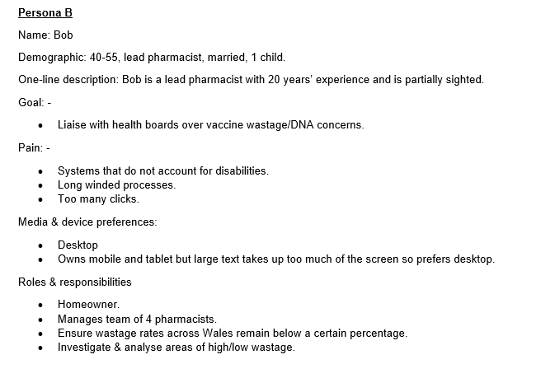
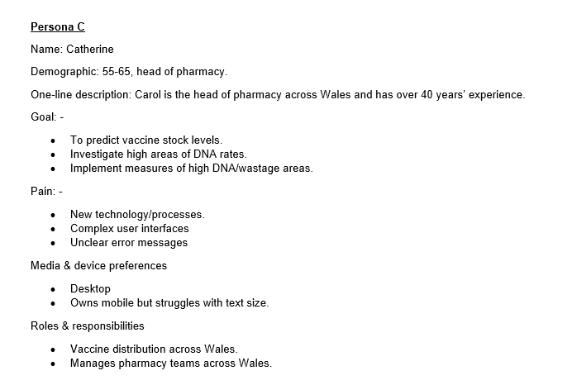

Appendix B: User Stories
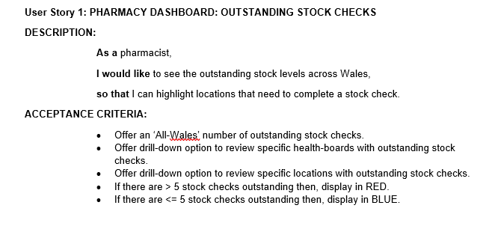
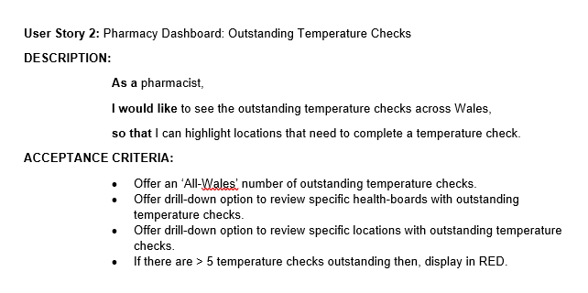
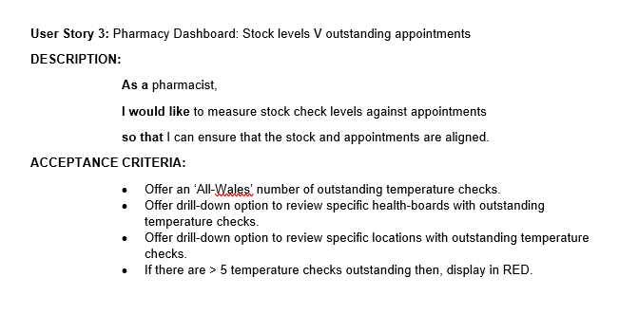
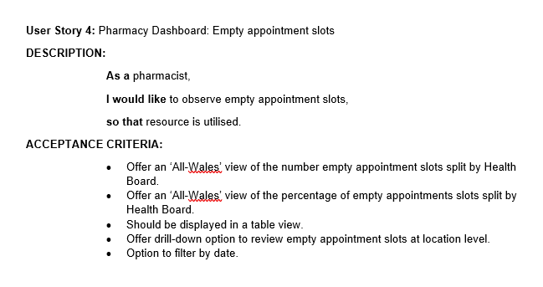
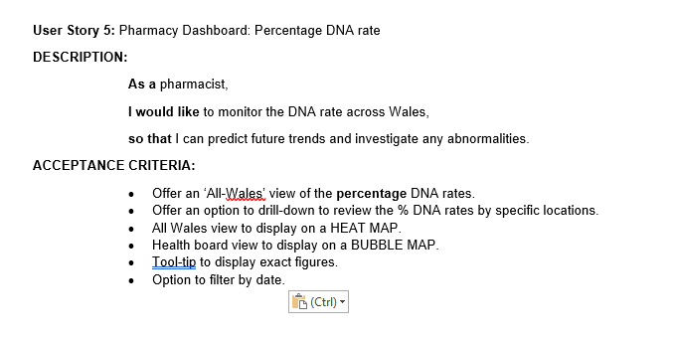
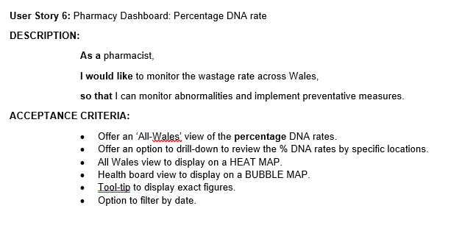

Appendix C: Interview Questions
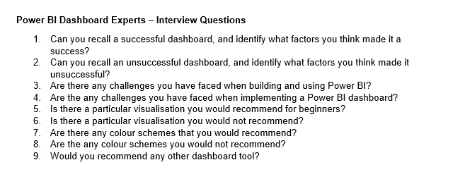
Appendix D: User Survey
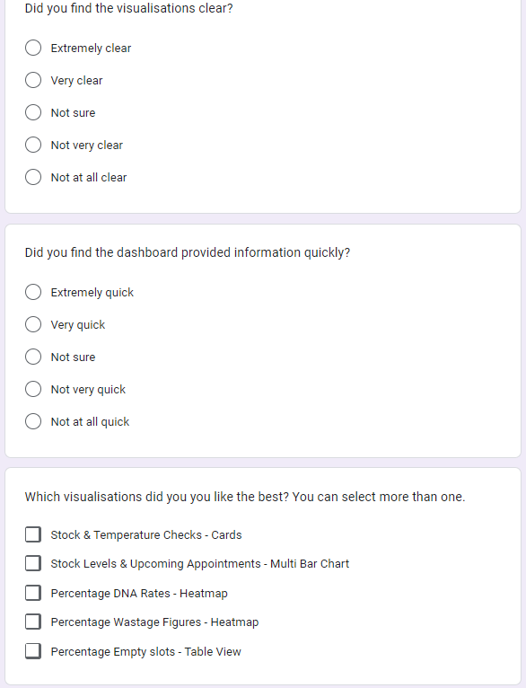
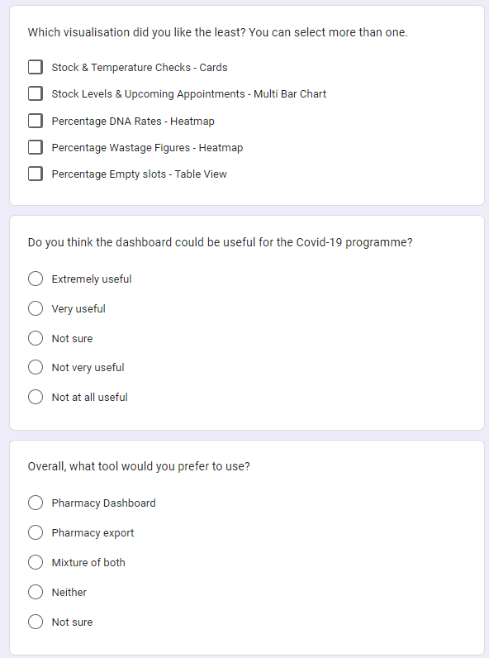
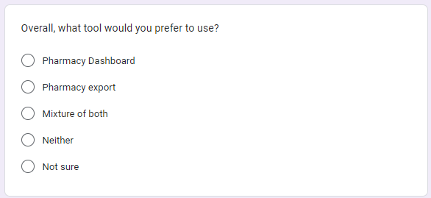

Appendix E: User Survey Results
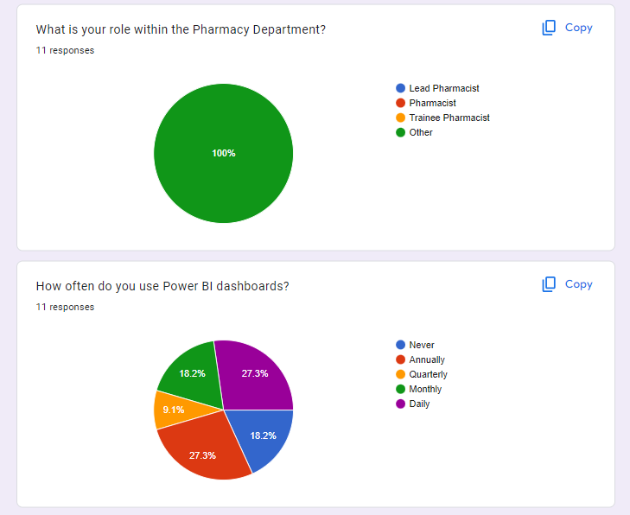
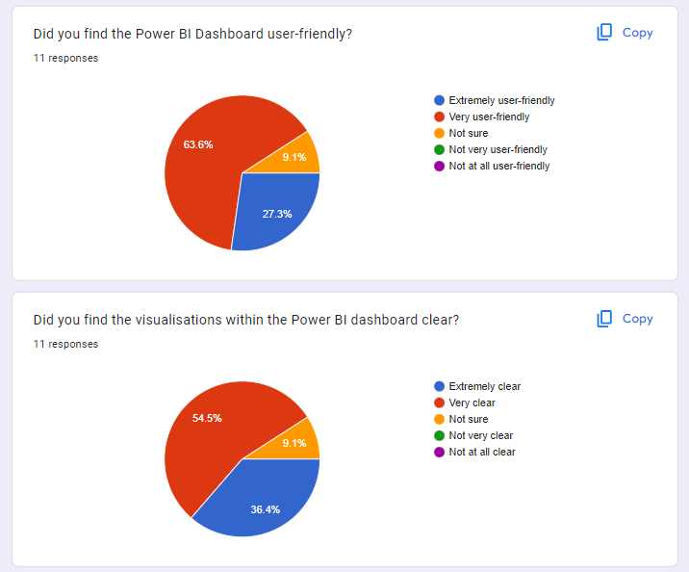
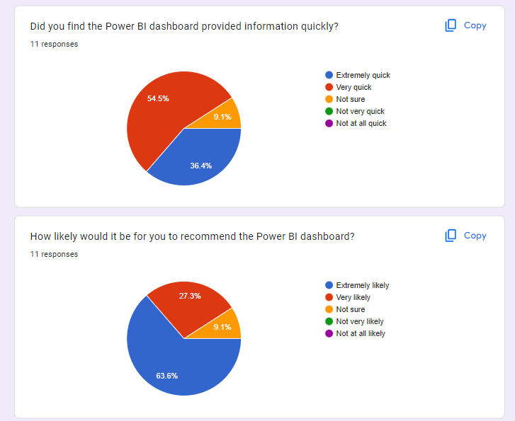
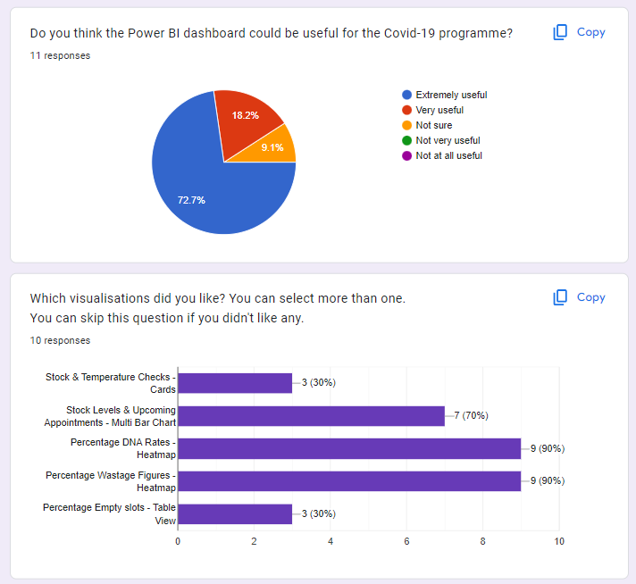
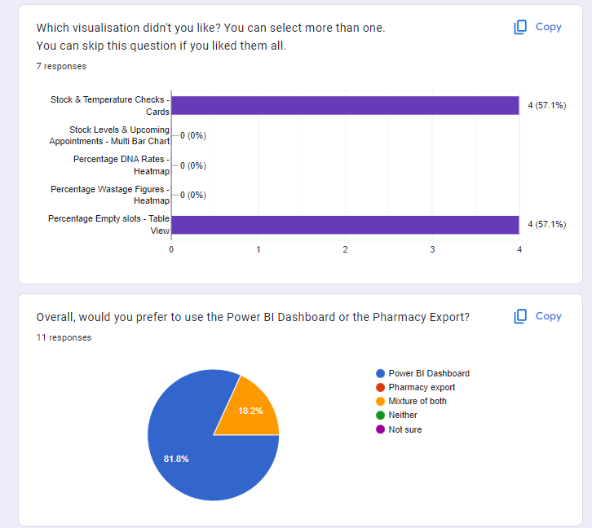

Appendix F: SUS Results

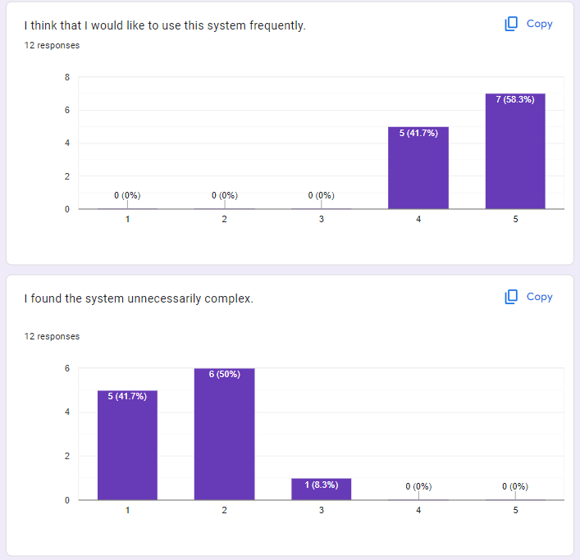
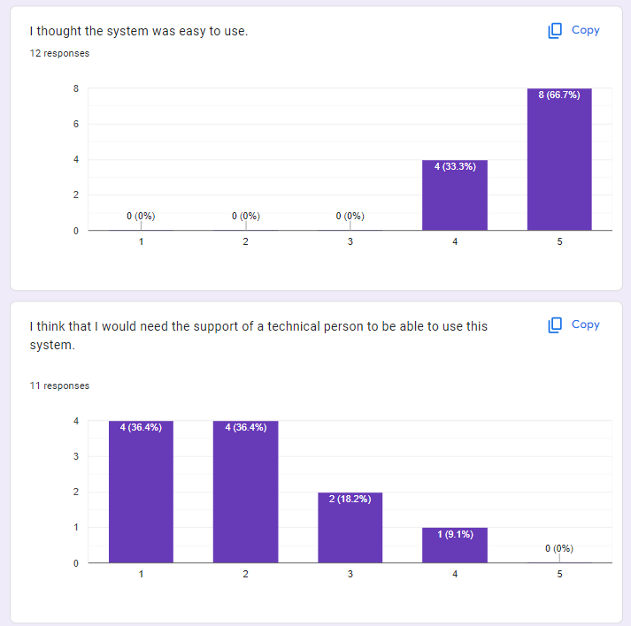
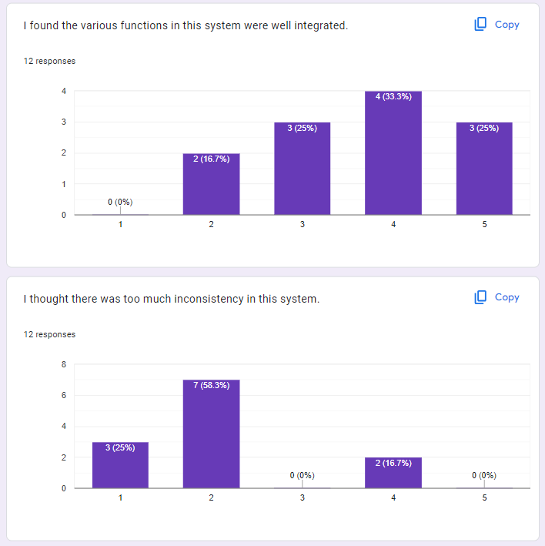
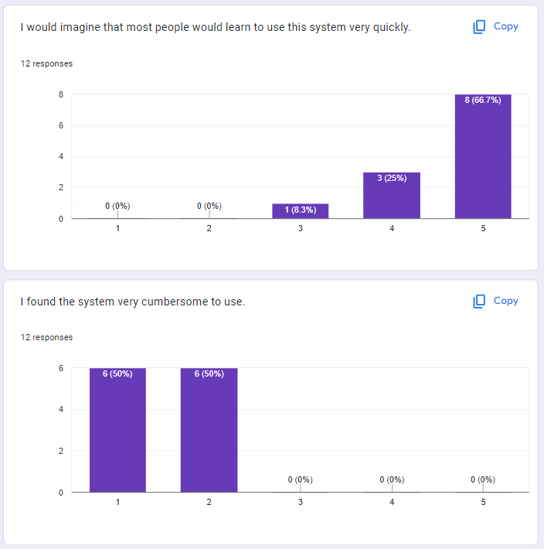
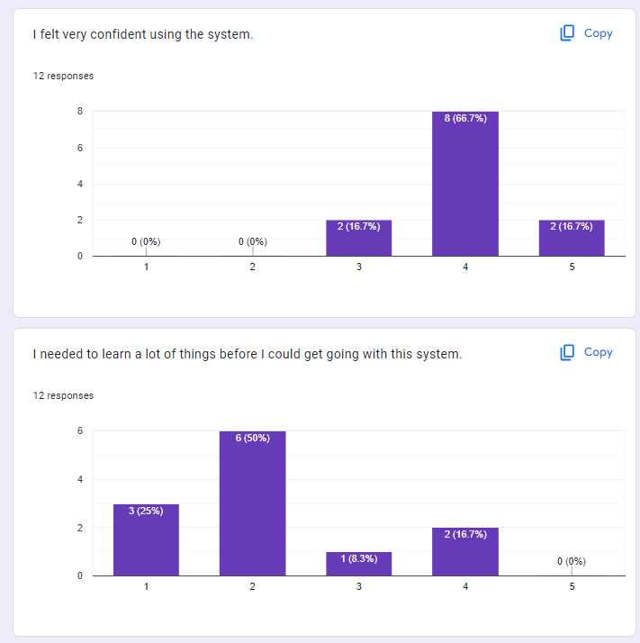

Appendix G: Database Creation SQL
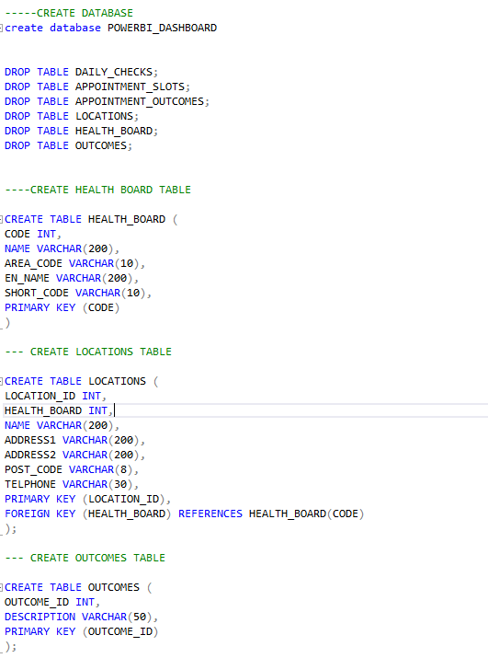

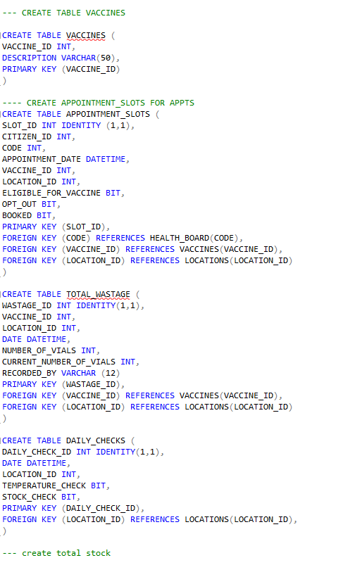
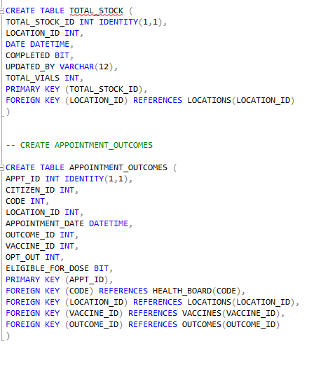

Appendix H: Test Data Creation



