Microsoft’s strategic choices and positioning
Academic report
Valentin Gotsev
Student in UWTSD
Student Number: 1912864
Module: Strategic Management for SME’s
Lecturer Maria Heffernan
Prepared by

Table of Contents
1.0 Executive Summary 2
2.0 Introduction 5
3.0 Main Findings 8
3.1 Introduction of Microsoft – 8
3.2 Financial Stakeholders 11
3.3 SWOT ANALYSIS 13
3.3.2 Opportunities 13
3.4 PESTLE Analysis 15
3.5 Mintzberg Schools of Strategy 16
3.6 PORTERS 5Force Framework 17
3.6.1 Threats of substitute – 18
3.6.2 Rivalry Among Existing Competitors: 18
3.7 Porter’s Generic Model 20
3.7 Microsoft Dynamic Approach to Strategy 21
3.8 Inside-out Framework for Microsoft 23
3.9 Investor Stakeholders of Microsoft 25
3.10 Analysis of Microsoft Profit from strategic Investments 26
4.0 Conclusion 28
5.0 Appendix 31
5.2 Appendix 2 PESTLE analysis 32
5.3 Appendix 3 - Financial Stakeholders 33
5.4 Appendix 4 = Porters Five Forces 35
5.5 Appendix 5 – Porter’s Generic Model 36
5.6 Appendix 6 - Inside out and Outside in Approach 37
5.7 Appendix 7 – Stakeholders Analysis 38

1.0 Executive Summary

This comprehensive report examines Microsoft Corporation, a technology giant founded in 1975, and its strategic position in the ever-changing global market. The corporation's global presence, financial performance, mission statement, strategic developments, potential risks, and the role of stakeholders are highlighted. Microsoft's impressive market cap, steady growth under the new leadership of CEO Satya Nadella, and a strategic shift towards cloud computing and AI are key factors contributing to its success. However, certain challenges are imminent, especially associated with the security risks of cloud computing and the adoption of AI technology.
Microsoft's SWOT and PESTLE aspects, reveal its strategic advantages, threats, opportunities, and influential external factors. Key societal influences on Microsoft’s strategy, including the ageing population, the rise of remote work, and the increased value placed on privacy are also discussed.
Mintzberg's model is an effective framework for understanding strategic processes, allowing for a balance between rationality and creativity. However, it has faced criticism for becoming outdated, particularly with the increase in unpredictability in business environments. Microsoft has long embraced a "learning school" approach, exemplified by its adoption of a "learn-it-all" culture under CEO Satya Nadella and strategic acquisitions such as LinkedIn.
Although Microsoft has a solid record of strategic planning, it's increasingly struggling with the rise of flexible, emergent strategies, such as those proposed by Porter. The Learning School, emphasizing constant organizational learning, has played a pivotal role in Microsoft's strategic approach. However, this does not seem to mitigate the current predicament. The examination of Porter's Five Forces highlights the significant threats of substitute products and intense competition Microsoft faces. Even Porter's Generic Strategies, though useful in creating competitive advantage, are not sufficient to protect Microsoft from the current business environment.
Microsoft's strategy has always been dynamic, responding efficiently to external changes. Its emphasis on desktop computing sets it apart from its competitors. Nevertheless, the constant innovation and adaptability have led to instability, underscoring the need for a strategy change.
The company has a strong Inside-out approach. The brand is well known for unique products coming inside the company. However, the outside-in strategic approach has also benefits from which Microsoft can take an advantage. Due to the specifics of Microsoft as a business, a hybrid strategy is recommended following the example of other successful organisations.
Analysis of Microsoft's financial performance reveals certain strategic vulnerabilities. The corporation's approach to the acquisition of Activision Blizzard has encountered more opposition than initially anticipated, which triggers adverse financial implications. Additionally, the lack of clear reporting on its cloud business performance makes evaluating the company's position in the cloud market a complex task. Nevertheless, despite prior challenges, the company's Q2 2023 results have shown impressive profits from its cloud services.
Additionally returns on investments in Xbox and PC products have not been as promising, thereby revealing an area of underperformance. Given the existing financial situation, it seems that Microsoft's current strategic direction is facing significant challenges, particularly in its gaming and PC products domain.
Nevertheless, despite prior challenges, the company's Q2 2023 results have shown impressive profits from its cloud services and AI investments.
The cloud services division, which includes Azure, Office 365, and Dynamics 365, has been a powerhouse of growth, contributing significantly to the overall profits. This can be attributed to a growing number of businesses transitioning their operations to the cloud, thus relying on Microsoft's comprehensive cloud solutions. The company's strong positioning and its ability to offer scalable solutions for businesses of all sizes have played crucial roles in this success.
2.0 Introduction
This report is focused on undertaking an exhaustive exploration of Microsoft, This analysis shows the strategic strengths and challenges faced by the technology giant. Microsoft was established in 1975 by Bill Gates and Paul Allen. The company has been a significant player in the tech industry. Its focus on cloud computing and artificial intelligence has further solidified its global standing and ongoing success.
SWOT analysis is often conducted to give light on the major threats and opportunities that contribute to shaping Microsoft's growth trajectory. An integral part of this exploration is an investigation into the company's historical reliance on the PC market. While this focus served as a support for Microsoft's initial success, it also presents challenges as the technology landscape continues to evolve. Similarly, ongoing legal issues—often an inherent part of operating in such a dynamic sector—are probed for their potential impact on Microsoft's future. (Microsoft n.d)
The examination of the external social factors that influence Microsoft's strategy, is anchored in the PESTLE framework. Factors such as the demographic shift towards an ageing population, the escalating trend of remote work fueled by advances in technology, and intensifying privacy concerns in an increasingly digitized world. Understanding these societal shifts is crucial, as they significantly influence Microsoft's approach to developing technological solutions and tailoring the user experience. (Akbalic et al., 2019)
The critical role of stakeholder management in shaping corporate strategy is a universal business truth, and Microsoft is no exception. An in-depth exploration of stakeholder roles, with a specific focus on employees and shareholders, yields valuable insights into the dynamics propelling Microsoft's success. The process of addressing these stakeholders' needs and expectations is not merely a corporate responsibility—it's a strategic lever that, if properly managed, can improve Microsoft's strategic initiatives and boost performance. (Varvazevszki, 2000)
Henry Mintzberg's schools of thought, spotlight the Learning School. Under the astute leadership of CEO Satya Nadella, Microsoft has embraced a culture of learning. It has eschewed a "know-it-all" mentality in favour of a "learn-it-all" approach, underscoring the importance of continuous improvement and adaptability in a fast-paced industry. (Hempel, 2019) The strategic ramifications of this cultural transition and its influence on Microsoft's decision-making processes form a significant part of this examination.
Strategic frameworks and models such as Porter's Five Forces Model are utilized to evaluate Microsoft's competitive standing. The model provides a holistic understanding of threats stemming from potential substitutes and the intensity of competition in the tech industry (Mindtools, 2023). It serves as a lens through which to view Microsoft's struggle for market share and differentiation.
Additionally, Porter's Generic Strategies have implications on Microsoft's competitive positioning. Despite the value of these models, their inherent limitations are not ignored. Notably, their static nature—representing a snapshot in time—and their lack of consideration for internal resources and capabilities are acknowledged.
The evidence of Microsoft's dynamic approach to strategy is a testament to its adaptability. A focal point of this strategy is its commitment to desktop computing, even as the company continues to diversify its offerings.
This nimble strategy empowers Microsoft to respond to external environmental changes effectively. The investigation concludes by evaluating the inside-out and outside-in frameworks, demonstrating how Microsoft balances the exploitation of its internal strengths with the need to remain responsive to market trends and evolving customer needs.

3.0 Main Findings

3.1 Introduction of Microsoft –

Founded in 1975 by Bill Gates and Paul Allen, Microsoft has been a key innovator in the technology sector. Through the years the company has been developing numerous computer products such as computer input and output devices, and software such as Word, Excel, Powerpoint and Windows. The company headquarters is in Redmond, Washington. The company, however, does not limit its presence in one country but has numerous research units and offices across the globe. Some of the first research labs have been established in Cambridge, England in 1997 and in Bejing China 1998 (Reynancia, 2017)
Microsoft’s market cap is valued at 2.05 trillion dollars. The company’s spending worldwide in 2021 is valued at 249 billion dollars. The corporation’s worldwide revenue has had a steady growth in the last five years. Microsoft’s revenue for 2022 is valued at 198.27 Billion dollars which is 30 billion higher than the past year 2021 (Statista, 2022) (2) Microsoft is publicly traded on the NASDAQ stock exchange. In order to operate as a whole, the company consist of several strategic business units called SBUs, such as Windows Division, Online Services Division and etc. (Moralez, 2014)
One of the reasons for the steady growth of the company in the last years is claimed to be its new CEO Satya Nadella has become a member of the board of directors in 2014. The new CEO is associated with bringing new energy to the company which transformed into
new technological horizons for Microsoft. The new CEO had shown an innovative vision for the company which led to inevitable growth (Wash, 2014)
Over the last five years, Microsoft has gone through several strategic developments. The company emphasized Cloud Computing and Artificial Intelligence (AI) in its strive to catch up with its competitors. Under the leadership of the new CEO Satya Nadella, Microsoft had invested aggressively a lot of its resources in the Azure Cloud platform which became the first rival of the Amazon Web Service platform starting the first cloud computing ‘’war’’ (Novet 2019) (4)
A mission statement is crucial to an organisation’s strategy and is a ‘’strategic beacon that can guide decision-making and behaviour (Rajasekar, 2013). A well-structured message highlights the company’s purpose and acts as a compass that can align every stakeholder’s effort by promoting a sense of unity and coherence (Kirk & Beth Nolan, 2011)
Organisations that have clear mission statements demonstrate improved performance and employee morale. The mission statement highlights employees’ impact on both organisation’s strategy and culture (Bart, Bonits & Taggar, 2001) Emphasizing on mission statement has a significant role in establishing long-term goals, essentially acting as a strategic tool that provides a framework for strategic planning (David et.al 2014)
Furthermore, a mission statement can differentiate an organisation often highlighting its unique selling propositions and guiding its market strategy (Analou & Karami, 2012). However, the mission statement should be continuously open to change rather than staying static. The mission statement needs to evolve considering the dynamics of the market (Rajasekar, 2013)
With the stepping in of the new CEO of the company, new energy has come which made it necessary to change its mission statement. Satya Nadella had warned that due to the unstable performance ‘’though choices’’ have come ahead. The new CEO’s official goal changed to ‘’to empower every person and every organisation on the plan to achieve more’. This new philosophy hides many secret messages it shows that the company is devoted to supporting other companies around the globe with its new cloud and AI services. There is also visible the mark of its former creator Bill Gates who has shown bias towards a more sustainable world (Statt, 2015) (5)
However, although the company has the resource to invest and be strategically ahead Cloud computing has numerous security risks. Cloud misconfigurations and data loss or exposure can lead to destroying business and doing exactly the opposite of Microsoft’s new mission statement. Considering that the expectations are that 55% of the business workloads will be uploaded to cloud in the next year any security risk could end up as a disaster putting a lot of pressure in front of those who offer cloud services (Bar-Dayan, 2022) (6)
Changing a company strategy towards Ai also hides risks. Paul Bold, a company CEO, highlights 5 barriers to adopting AI in front of the company. Creating AI needs a huge amount of data in order to be efficient. The more data a company possesses the greater power it has; however, Microsoft has faced a lot of data gaps during creating the AI platform. This has also led to choosing the right partners to work with. The CEO marks this as the most important strategic decision that they have to make. Bold marks that ensuring Microsoft partners have the same values as the company is essential to talk the same language and not just wasting time (Bold, 2019)

3.2 Financial Stakeholders -
[Appendix 3]
The financial stakeholders can be defined as those who have financial ties or interests in the company. This may include investors, creditors, and stakeholders (Hilman & Keim, 2001) The stakeholder’s involvement in companies’ decision-making is key in order to align the interests of both sides. They are the ones who drive companies to reduce costs and improve productivity. (Arths & Busteinz, 2016)
A key contribution of the financial stakeholders is their impact on corporate governance. The active stakeholders can improve the governance inside a corporation by monitoring its management decisions. They are able to establish this control and monitoring through the resources and shares they hold inside the organisation (Aguilera et.al. 2008)
Another responsibility for the financial stakeholders is involvement inside the organisations in their impact on Corporate Social Responsibility (CSR). They are the ones that can urge companies to adopt CSR policies in order to be socially responsible. Stakeholders and investors are also increasingly considering environmental, social and governance (ESG) factors in their investment decisions (Schroder, 2004)
Although financial stakeholders play a key role in shaping the direction and performance of companies in many situations there are challenges that may arise.
Some financial stakeholders prioritize short-term investment over long-term goals. This short-term orientation may lead companies to prioritize immediate gains over strategic planning (Rappaport, 2005) The short-term investment may affect badly companies’ CSR and ESG goals.
Conflicting interests are another barrier that may occur between financial stakeholders and corporations. The conflict of interest can also be described by stakeholders having different priorities than those of the company. For instance, some stakeholders may prioritize higher dividends, while creditors may prefer lower dividends to avoid default risk (Al-Malkawi et al. 2010)
Some ethical issues may also arise between the stakeholders and the company. Sometimes in order for the stakeholder to profit could be at the expense of other stakeholders like employees and communities. For example, ignoring environmental factors to gain profit can lead to consequences such as damaging the company’s reputation and loss in the long run and putting it at the bottom of social responsibility ratings. (Carne et al. 2014)

3.3 SWOT ANALYSIS
[Appendix 1]
3.3.1 Weaknesess
Microsoft’s historical dependence on the PC market, particularly through its Windows operating system and Office Suite, leaves it vulnerable to shifting market dynamics. While the PC market remains significant, growth in this sector has been slowing down. Emerging economies show a high rate of mobile adoption due to higher affordability and high convenience, which the company had failed to show. Tech giants like Apple embraced this opportunity and were able to surpass the company in this market (Arthur, 2011)
Over the years Microsoft has constantly been subject to legal issues and regulations. In 2022 the U.S. federal government returned a major case back. The cases questioned the acquisition of one of the world's biggest gaming developers Activision Blizzard. Although often unsuccessful those issues can have an impact on the company’s reputation (Levin & Downes, 2023) The legal battles can have potentially bad consequences by affecting investor relations and stock price. Often the stakeholders can lose confidence in the organisation and this can affect the company’s ability to affect future investments (Bhagat & Romano, 2002)

3.3.2 Opportunities

Microsoft’s efforts to tackle climate change by exploring nuclear fusion as a carbon-free energy resource is also an opportunity for the company to change its historical dependency on the PC and Gaming market (Couthberson, 2023)(17). Microsoft has reportedly partnered with Helion a nuclear fusion energy company. This strategic investment demonstrates a forward-thinking approach to a cleaner energy supply for the future# (Calma, 2023) (16)
Moreover, Microsoft is leveraging its Azure cloud computing services in manufacturing industries. The company is demonstrating a collaboration with Westinghouse, which aim is to boost productivity and at the same time reduce the carbon footprint.(Microsoft, 2022)
3.4 PESTLE Analysis
[Appendix 2]
3.4.1 Social
Microsoft’s strategy is significantly changed by various social factors. Company’s main goals include innovative technology solutions and maintaining a competitive edge in a rapidly changing digital landscape (Cusmano, 2019)
One of the key social factors influencing Microsoft’s strategy is the ageing population. The increased number of adults around the globe implies increasing demand for user-friendly and accessible technologies. In response to that Microsoft has begun investing in accessibility features and creating software and services that can be used comfortably by older adults. Microsoft’s AI for Accessibility programme is clear proof of this strategy (Microsoft, 2022)
During the rapid rise of remote working due to the COVID-19 Pandemic and the consequent acceptance of flexible work agreements has significantly impacted Microsoft’s strategy. In response Microsoft has expanded its cloud-based services such as Microsoft Teams, becoming a key tool for adapting to the remote work environment. (Fitzgerald, 2022)
A significant factor impacting Microsoft’s strategy is the increased social value placed on privacy. In a world where data breaches and hacking happen every day, customers around the globe are becoming more aware and concerned about their own privacy (Mansell, 2020) Acknowledging this concern, Microsoft has made privacy a core element of its business strategy. Its privacy statement emphasizes a clear alignment with social expectations (Microsoft, 2022)
Social responsibility is key in order to retain the trust of its major stakeholders related to Microsoft.

3.5 Mintzberg Schools of Strategy
A successful framework for the analysis of companies’ stakeholders is Henry Mintzberg’s ‘ten schools of Thought’. This framework provides a robust understanding of strategic processes from various perspectives, ranging from planned to emergent approaches. (Mishra, 2016). Mintzberg’s model integrates analytics during the process of forming a strategy and is a balance between rationality and creativity. (Mintzberg, et al., 2009)
However, some authors argue that the model is becoming outdated. In an article in Forbes Kait Moore highlights that in the past decade, Planning School is becoming more and more relevant. With so many variables in the businesses, it is getting harder and harder to predict the changes and more flexible approaches like Porte’s ideas are much more relevant.
The Learning School highlights that strategies can be effectively implemented through a process of continuous organizational learning and evolution. Emphasizing the emergent rather than deliberate planning (Mintzberg et al, 2009)
Under CEO Satya Nadella’s management since 2014 Microsoft has embraced the qualities of a learning organisation moving from a ‘’know-it-all’’ culture to a ‘’learn-it-all’’ mentally (Nadella, 2017) This transformation highlights the commitment of the organization to continuous learning and improvement (Nadella, 2017)
Microsoft’s acquisition of LinkedIn in 2016 further indicates The Learning School principles of Microsoft. Despite that Microsoft is established in the digital market the company has found a lot of opportunities to learn and integrate its systems with the social network. The acquisition is also described as a positive step in delivering the ‘ultimate professional experience’’ (Tyagi, 2016)

3.6 PORTERS 5Force Framework

[Appendix 4]

Porter’s Five Forces Model is a widely used strategic tool that allows businesses to analyze their industry’s structure at a competition level (Porter, 2008) The model provides a comprehensive analysis that encourages a comprehensive view of the competitive environment considering the various forces that influence certain industry (Grant, 2016). The model can aid the companies by enabling good strategic decision-making by helping them understand the strength of their competition (Karagiannopolus et al., 2015)
However, Porter’s Five Forces model has its limitations. It is very static by nature and does not account for the dynamic nature of the environment. The model also tends to neglect other influences like government regulations for example (Dulcuc et al., 2012). Other sources suggest that the model is designed for industry analysis and does not translate well into firm-level strategies. It tends to neglect the firm’s internal resources and capabilities (Grundy, 2006).

3.6.1 Threats of substitute –
One of the two major factors highlighted in Porter’s 5 Force analysis that has an impact on Microsoft’s strategic planning is the Threat of Substitutes. Since its establishment, Microsoft has faced many companies trying to copy their products. For instance, in terms of operating systems, Google’s Android and Apple’s iOS are significant substitutes for Microsoft Products. (Arthur, 2015).
A more recent substitute threat that had emerged recently is the partnership between Amazon Web Services (AWS) and Hugging Face. This partnership’s aim is to rival and became a substitute for Microsoft’s Azure OpenAI service. This partnership arrives exactly when Microsoft was at the beginning of its partnership with OpenAi. The company had already started integrating systems like chatGPT with products like Edge, Bing and Microsoft 365 which will help the company stay relevant in the long term (Msv, 2023)

3.6.2 Rivalry Among Existing Competitors:
Microsoft operates in a competitive market with established companies such as Apple, Google and Amazon as competitors. In the software market, its competitors like Linux and Apple macOS are well established on the market and continue to innovate. In order to maintain its market share Microsoft has to continuously improve and update Windows (Kumar, 2012)
The gaming industry also presents a fierce rivalry with Microsoft. The company Xbox platform competes with Sony PlayStation and Nintendo’s gaming consoles. These competitors frequently launch new products and services to attract more gamers making this market highly competitive (Kushner, 2020). On May 2023 the CEO of Xbox Phill Spencer admitted that the company has lost the gaming war with PlayStation. The last generation of Xbox did not meet the expectations of the gamers who decided to choose from other consoles. This has opened up the path for Nintendo which is now a more significant competitor of Xbox (Hetzner, 2023)

3.7 Porter’s Generic Model

[Appendix 5]
Porter’s Generic Strategies offer valuable guidance for organisations in their strategy for competitive advantage, providing direction for strategic planning through the focus on cost leadership, differentiation, or a focused approach (Porter, 1980). However, the use of these strategies has its advantages and disadvantages.
A critique of Porter’s Generic Strategies is the potential oversimplification of the strategic options. The model highlights differentiation and cost leadership as mutually exclusive categories, which is not always the case. In the digital age, companies can leverage digital technologies to offer unique products while keeping costs low (Denning, 2023)
The intense focus on only one strategy may lead to neglecting other important aspects and potentially leaving organisations vulnerable to certain market forces (Dobbs, 2014)
Throughout the years Microsoft has distinguished itself in the tech industry through a robust differentiation strategy. The company has been able to effectively establish unique products for its customers (Grant, 2016)
A recent trend highlighting Microsoft’s differentiation strategy is its significant investment in research and development (R&D). As Microsoft outlines in APAC News Centre they have identified four trends to watch in 2023, including the democratization of technology, sustainability and the blending of the physical and digital worlds, all of which will be driving their R&D Initiatives (Microsoft, 2022) By consistently allocating resources towards R&D, Microsoft ensures that their products are future-oriented and not only produced to meet the demand in order to be recognized as a distinct in the market (Grant, 2016)

3.7 Microsoft Dynamic Approach to Strategy

In essence, a dynamic strategy is an adaptable approach to organisational planning and execution, allowing businesses to respond effectively to changes in their external environments. These changes may be driven by shifting customer needs, technological advancements, competitive dynamics, legislative changes, or evolving market trends (Wang & Ahmed, 2007).Moreover, implementing a dynamic strategy requires capabilities in environmental scanning, strategic flexibility, organisational learning, and change management. Environmental scanning is the process of monitoring the business environment to identify emerging trends, opportunities, and threats. Strategic flexibility involves the ability to adjust and realign organisational resources and capabilities in response to environmental changes. Organisational learning refers to the process of acquiring, assimilating, and applying new knowledge, which can lead to improved organisational performance and innovation. Finally, change management involves the procedures and approaches to managing the people side of change to achieve the required business outcomes (Eisenhardt & Martin, 2000).
A unique aspect of Microsoft's approach to dynamic strategy is its emphasis on desktop computing, in contrast to many of its competitors who focus more on server-to-server interaction. Microsoft aims to maximize the value of desktop PCs for customers by enabling them to leverage their systems of record (mainframes, Unix servers, etc.) more effectively. This focus has led to the development of new runtime services and the usage of XML as a common SOA foundation to facilitate this process (CSO Online, 2023)
However, the constant pursuit of adaptability and innovation might result in instability, as the organization continually revises its strategies, structures, and processes. This could disrupt operational efficiency, create confusion and insecurity among employees, and potentially loose customers who value consistency in the company's offerings and the financial, managerial, and organizational costs involved in fostering and managing dynamic capabilities. These capabilities often require substantial investment in research and development, technology, and training, as well as structural and cultural changes within the organization, which can be complex to manage and disruptive in the short term. (Collis & Anand , 2021)

3.8 Inside-out Framework for Microsoft
[Appendix 6]
The inside-out strategy, also known as the capabilities-driven strategy, primarily focuses on an organisation’s internal capabilities and expertise to design and deliver products and services. This approach, underpinned by the capabilities-based view (CBV), emphasises the idea that an organisation's strategic edge lies within its unique abilities and resources, which, when fully exploited, contribute to sustainable competitive advantages (Sydle, 2022)
This strategy is fundamentally about self-awareness. Organisations must first identify and understand their core competencies and strengths, which often arise from specialised knowledge, unique skills, proprietary technologies, or efficient processes (Teece, 2018). Once identified, these competencies become the foundation upon which companies build their products, services, and overall business strategies.
Microsoft is a prominent example of a company that employs an inside-out strategy. They have continuously harnessed their inherent strengths, such as their deep technical knowledge, research capabilities, and established brand to develop and refine their product offerings, such as Windows, Office Suite. The company continues to innovate in 2023 (Fabrizi, 2023)
The blended approach combines the best of both the inside-out and outside-in strategies, enabling companies to leverage their unique strengths while remaining cognizant of market trends and customer needs (Morino, 2020)
Microsoft, though well-known for its inside-out approach, has also made strategic moves that reflect the outside-in perspective. This is especially evident in the company's foray into cloud computing with its Azure platform, a response to the growing demand for cloud-based solutions (Nadella, 2017)
Other tech giants, like Apple, have successfully employed a blended strategy. Apple, for instance, is recognised for its innovative products, such as the iPhone, a clear result of leveraging internal competencies (inside-out). However, its services like Apple Music and iCloud show an outside-in approach, designed in response to market demands for streaming and cloud storage services. This strategy has proven sucesful bringing record revenues for 2023 and expecting to hit 110 million subscribesrs by 2025 (Forde, 2023)

3.9 Investor Stakeholders of Microsoft

[Appendix 7]
Stakeholders are individuals, groups, or organizations that have an interest or concern in an organization's activities and are affected by the organization's actions, objectives, and policies. These stakeholders could be internal such as employees, managers, or board members, or external such as customers, suppliers, the community, or investors. Each stakeholder group has different expectations and demands, which the organization must balance to ensure its long-term success (Miles, 2017)
Focusing on Microsoft's investor stakeholders, these individuals and groups are of significant importance as they provide the necessary capital for the company to maintain and expand its operations. Their primary interest is usually in the company's financial performance and growth prospects.
Among the key investors in Microsoft are The Vanguard Group, Inc., Fidelity Management & Research Co. LLC, Geode Capital Management LLC, Capital Research & Management Co. (World Investors), Capital Research & Management Co. (Global Investors), and Bill Gates. Each of these investor stakeholders holds significant shares in the company, and their investment decisions can influence the company's strategic direction (MarcetScreener, 2023)

3.10 Analysis of Microsoft Profit from strategic Investments
Despite the Federal Trade Commission (FTC) losing its appeal to challenge Microsoft's acquisition of Activision Blizzard, the tech giant has been facing significant regulatory hurdles. This protracted and complex process has exposed deficiencies in Microsoft's approach to strategic acquisition. One major hurdle is the need for approval from the U.K.'s Competition and Markets Authority (CMA) by a tight July 18 deadline. Should Microsoft fail to resolve the CMA's concerns by the deadline, it faces two tough choices: request an extension from Activision Blizzard or pay a hefty $3 billion breakup fee. Overall, Microsoft's strategy of acquiring Activision Blizzard has encountered more resistance and challenges than initially anticipated. The regulatory scrutiny, coupled with the potential financial penalty if it doesn't meet the deadline with the CMA, highlight strategic weaknesses in Microsoft's approach to this acquisition (Pequeno, 2023)
However, despite the difficulties in 2023, Microsoft’s Q2 data reveals that Revenue from strategic investments has increased. Microsoft's overall revenue for Q2 FY23 was $52.7 billion, marking a 2% increase year-over-year. The Productivity and Business Processes increased by 7% to $17.0 billion, with Office 365 Commercial revenue growing 11% highlighting the strong presence of the company discovered in the SWOT Analysis of the report. The Intelligent Cloud segment reported a revenue increase of 18% to $21.5 billion, with revenue from Azure and other cloud services growing 31%.The Intelligent Cloud segment reported a revenue increase of 18% to $21.5 billion, with revenue from Azure and other cloud services growing 31%. The revenue data from Azure highlights the strategic investments the company has made in this sector have been successful. LinkedIn and Dynamics products and cloud services saw revenue growth of 10% and 13% respectively. The acquisition of LinkedIn in order to promote the continuous learning approach of the company have proven successful also in financial terms.
Microsoft’s 2023 Q2 results also highlight the weak points of the company strategies. The revenue of the PC segment fell by 19% to $14.2 billion. The major contributors to this decrease were the Windows OEM revenue and Devices revenue, which both saw a decrease of 39%. Specifically, regarding Xbox, content and services revenue decreased by 12% (8% down in constant currency).(Microsoft, 2023)
In Q2 FY23, Microsoft returned $9.7 billion to shareholders via share repurchases and dividends, an 11% decrease compared to the same quarter of the previous fiscal year (Microsoft, 2023)
4.0 Conclusion
In conclusion, Microsoft's journey as a global technology leader is rooted in strategic foresight, innovation, and adaptability. The company's phenomenal growth and expansion under the leadership of CEO Satya Nadella has been influenced by an intense focus on cloud computing and AI technologies, solidifying its competitive edge in the evolving digital landscape.
The transformation of Microsoft's mission statement under Nadella's leadership, underlines the company's pivot to a more sustainable, inclusive, and globally connected approach, with a commitment to empowering individuals and organizations across the world.
Financial stakeholders also play a pivotal role in influencing Microsoft's trajectory. Their active participation can lead to improved corporate governance and encourage the adoption of responsible practices. However, a potential focus on short-term investment gains, conflicting interests, and ethical considerations can pose challenges to the corporation's strategic and CSR goals.
Microsoft remains a formidable force in the technology industry, harnessing its position to leverage opportunities and adapt to new market trends and societal shifts. While threats persist, such as its historical dependence on the PC market and legal controversies, the company has shown robust resilience. Notably, its venture into carbon-free energy resources and expansion of Azure cloud computing services signifies a broader focus beyond its traditional business spheres.
The PESTLE analysis demonstrates Microsoft's attention to shifting social values, emphasizing its investment in user-friendly technologies and digital privacy. Furthermore, the significance of stakeholder engagement is underscored in shaping the company's strategy and maintaining robust performance.
Reflecting on Mintzberg's Schools of Thought, Microsoft under Satya Nadella has demonstrated a commitment to continuous learning and evolution, mirroring the principles of the Learning School. This is evident in their strategic acquisitions, such as LinkedIn, showcasing an interest in integrating with and learning from other established platforms.
However, it's important to remember that the success of any strategy is heavily dependent on the changing external environment and internal dynamics of the organization. The key to Microsoft's continued success would be to remain vigilant, adaptable, and committed to innovation and learning, keeping the best interest of its stakeholders at the core of its strategy.
Microsoft's dynamic approach to strategy, focusing on adaptability and innovation, enables the company to effectively respond to shifting market trends and customer demands. The company's unique focus on desktop computing illustrates how it has innovatively maximized the value of its products for its customers. However, it's important to note that such constant strategic revisions and innovation can result in short-term disruptions and increased costs.
By employing an inside-out strategy, Microsoft has successfully harnessed its inherent strengths while remaining responsive to the changing external environment.
However, despite its historical profitability and dominance in the technology industry, Microsoft is currently facing significant challenges that are affecting its financial performance. Our comprehensive strategic analysis reveals a concerning trend in Q2 2023, highlighting the need for a strategic shift in some strategies of the company. Even though Microsoft has effectively used several strategic models and frameworks, recent market dynamics have revealed certain vulnerabilities. The rise of substitute products, increased competition, and financial repercussions from strategic investments have underscored the need for change.
On the other hand, Microsoft has shown substantial growth in profitability from strategic investments in Q2. The most trending markets such as AI and Cloud computing have provided positive profits for the organization. The continuous learning approach of Microsoft has enabled the company to become a real competitor against Amazon Cloud Service and Open AI corporations.

5.0 Appendix
5.1 Appendix 1 – Swot Analysis
The Appendix below is compiled using the information gathered during the research for the report by the Author in the Reference list.

Weaknesses
Strengths
Opportunities
Treats
(Downie, 2022)

5.2 Appendix 2 PESTLE analysis

(Abbas, 2020)
(Ferguson, 2023)

5.3 Appendix 3 - Financial Stakeholders

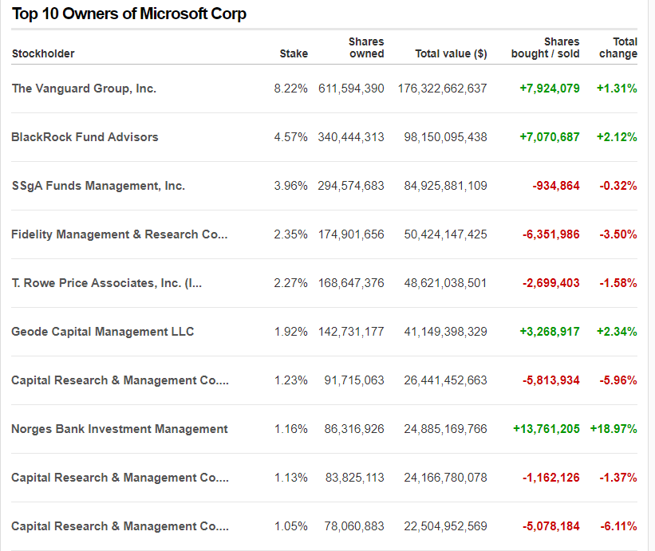
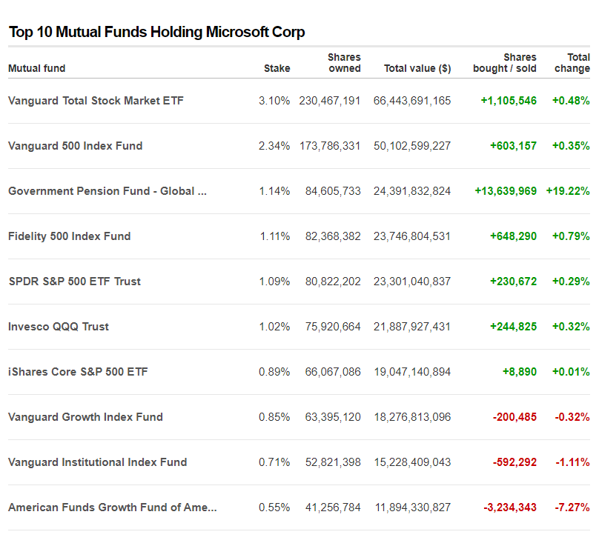

5.4 Appendix 4 = Porters Five Forces

5.5 Appendix 5 – Porter’s Generic Model
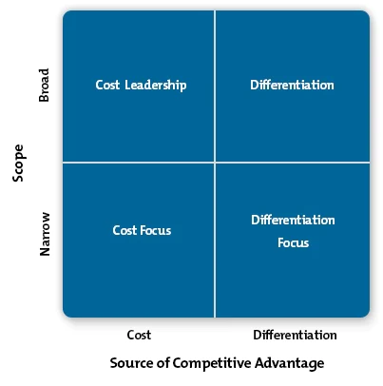

(Mindtools, 2023)

5.6 Appendix 6 - Inside out and Outside in Approach

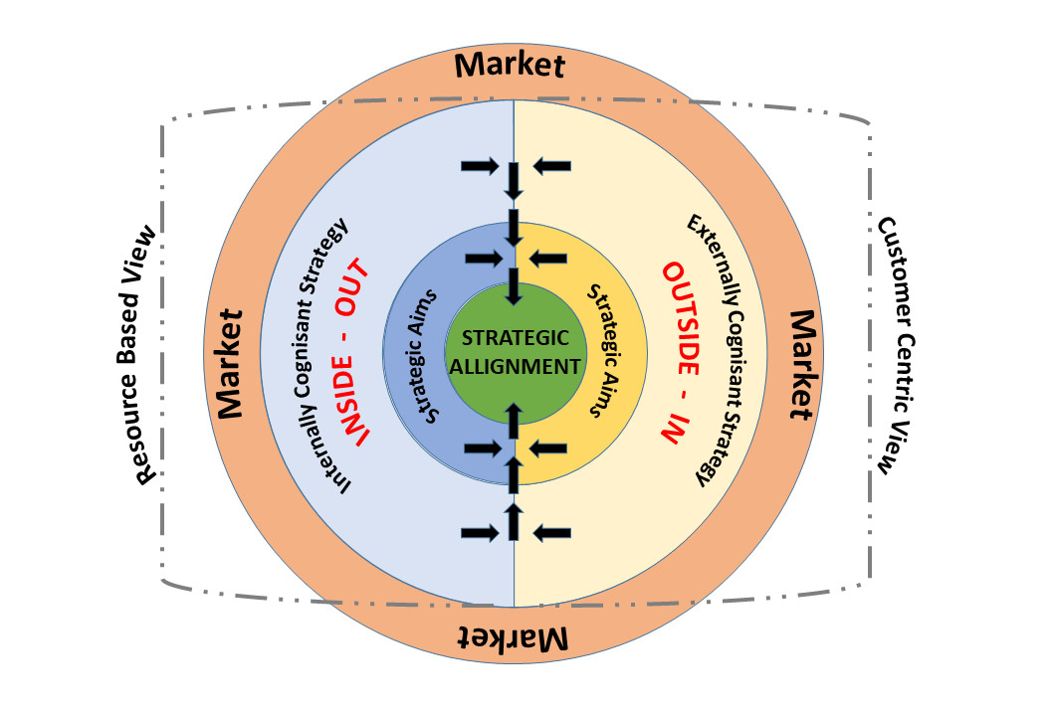

Clarke (2017)

5.7 Appendix 7 – Stakeholders Analysis
1.0 Economic Stakeholders | Customers  Competitors – Amazon, Sony, Open AI  Shareholders and investors – Outlined in appendix 3
2.0 Social/Political Stakeholders | Governments – Laws, Legislations, Changes in governments taxes  Workers Unions
3.0 Technological Stakeholders | Tech companies and community – Linkedin, IT professionals.  Partner organisations – Activision, Mojang
4.0 Community Stakeholders | Local communities and organisations  Universities
5.0 Internal Stakeholders | Management and Employees

- Aguilera, Ruth & Filatotchev, Igor & Gospel, Howard & Jackson, Gregory. (2008). An Organizational Approach to Comparative Corporate Governance: Costs, Contingencies, and Complementarities. Organization Science. 19. 475-492
- Akbalik, Murat & Çitilci, Tuğberk. (2019). The-Importance-of-PESTEL-Analysis-for-Environmental-Scanning-Process. 10.4018/978-1-7998-2559-3.ch016.
- Al-Malkawi, Husam-Aldin & Rafferty, Michael & Pillai, Rekha. (2010). Dividend Policy: A Review of Theories and Empirical Evidence. International Bulletin of Business Administration. 9. 171-200.
- Arthur, C. (2017) “Microsoft falls behind Apple for first time in 20 years,” The Guardian Available at: https://www.theguardian.com/technology/2011/apr/28/microsoft-falls-behind-apple [Accessed 19 Jul. 2023].
- Arthur, R. (2015). Digital Wars: Apple, Google, Microsoft and the Battle for the Internet. Kogan Page Publishers.
- Arthurs, Jonathan & Busenitz, Lowell. (2006). Dynamic Capabilities and Venture Performance: The Effects of Venture Capitalists. Journal of Business Venturing. 21. 195-215
- Bar-Dayan, Y. (2022) “Risk-Based Security Keeps Businesses Grounded When Migrating To The Cloud,”. Available at: https://www.forbes.com/sites/forbestechcouncil/2022/04/06/risk-based-security-keeps-businesses-grounded-when-migrating-to-the-cloud/?sh=7a57651d2aa1. [Accessed 19 Jul. 2023]
- Bhagat, S., & Romano, R. (2002). Event studies and the law: Part II: Empirical studies of corporate law. American Law and Economics Review, 4(2), 380-423.
- Blog SYDLE. (2022). Learn What Inside-Out and Outside-In Strategies Are and How Automation Can Help Them. [online] Available at: https://www.sydle.com/blog/inside-out-and-outside-in-strategies-6144a26be83193407d5fbb26#:~:text=The%20inside%2Dout%20strategy%20is.
- Bock, L. (2015) Work Rules!: Insights from Inside Google That Will Transform How You Live and Lead. John Murray Press.
- Bolt, P. (2019) “5 barriers to AI adoption: learnings from our own journey,” Microsoft Industry Blogs - United Kingdom [Preprint]. Available at: https://www.microsoft.com/en-gb/industry/blog/cross-industry/2019/06/13/5-barriers-to-ai-adoption/ [Accessed 19 Jul. 2023]
- Calma, J. (2023) “Microsoft just made a huge, far-from-certain bet on nuclear fusion,” The Verge. Available at: https://www.theverge.com/2023/5/10/23717332/microsoft-nuclear-fusion-power-plant-helion-purchase-agreement [Accessed 19 Jul. 2023].
- Clegg, S., Kornberger, M., & Pitsis, T. (2018) Managing and Organizations: An Introduction to Theory and Practice. Sage Publications.
- Collis, D.J. and Anand, B.N. (2021). The Virtues and Limitations of Dynamic Capabilities. Strategic Management Review, 2(1), pp.47–78.
- Crane, Andrew & Palazzo, Guido & Spence, Laura & Matten, Dirk. (2014). Contesting the Value of ‘Creating Shared Value’. California management review. 56. 130-153.
- Cusumano, M. (2019) 'The Business of Platforms: Strategy in the Age of Digital Competition, Innovation, and Power', Harper Business.
- Cusumano, M. (2019). The Business of Platforms: Strategy in the Age of Digital Competition, Innovation, and Power. Harper Business.
- Cuthbertson, A. (2023) “Microsoft makes world first nuclear fusion energy deal,” The Independent, 12 May. Available at: https://www.independent.co.uk/tech/nuclear-fusion-energy-microsoft-helion-b2337825.html [Accessed 19 Jul. 2023].
- De Wolf, Daniel & Mejri, Mohamed. (2013). Crisis management: Lessons learnt from BP Deepwater Horizon Spill Oil. Business Management and Strategy. 4. 67-90.
- Denning, S. (2023) “What’s New About Strategy In The Digital Age. Available at: https://www.forbes.com/sites/stevedenning/2023/05/03/whats-new-about-strategy-in-the-digital-age/?sh=466ada484f4b [Accessed 19 Jul. 2023].
- Dobbs, M. (2014). Guidelines for applying Porter's five forces framework: a set of industry analysis templates. Competitiveness Review, 24(1), 32-45.
- Downie, R. (2022) “Microsoft's Competitive Advantage: An Inside Look,” Investopedia [Preprint]. Available at: https://www.investopedia.com/articles/insights/072516/microsofts-competitive-advantage-inside-look.asp [Accessed 19 Jul. 2023].
- Dulčić, Želimir & Gnjidić, Vladimir & Alfirevic, Niksa. (2012). From Five Competitive Forces to Five Collaborative Forces: Revised View on Industry Structure-firm Interrelationship. Procedia - Social and Behavioral Sciences. 58. 1077-1084. 10.1016/j.sbspro.2012.09.1088.
- Ferguson, E. (2016). Microsoft Corporation’s PESTEL/PESTLE Analysis & Recommendations. [online] Panmore Institute. Available at: https://panmore.com/microsoft-corporation-pestel-pestle-analysis-recommendations. [Accessed 18 Jul. 2023]
- Fitzgerald, M. (2022) 'Digital Transformation: Surviving the pandemic and beyond', MIT Sloan Management Review, vol. 63, no. 2, pp. 1-6.
- Forde, E. (n.d.). Forecast: Apple Music To Hit 110 Million Subscribers By 2025. [online] Forbes. Available at: https://www.forbes.com/sites/eamonnforde/2022/06/14/forecast-apple-music-to-hit-110-million-subscribers-by-2025/?sh=35532672142f [Accessed 18 Jul. 2023]
- Frau, Moreno & Moi, Ludovica & Cabiddu, Francesca. (2020). Outside-in, Inside-out, and Blended Marketing Strategy Approach: A Longitudinal Case Study. International Journal of Marketing Studies. 12. 1. 10.5539/ijms.v12n3p1.
- Freudenburg, W. R., & Gramling, R. (2011) Blowout in the Gulf: The BP Oil Spill Disaster and the Future of Energy in America. MIT Press.
- Graham, John & Harvey, Campbell & Rajgopal, Shiva. (2004). The Economic Implications of Corporate Financial Reporting. Journal of Accounting and Economics. 40. 3-73.
- Grant, R. M. (2016). Contemporary strategy analysis: Text and cases edition. John Wiley & Sons.
- Grundy, Tony. (2006). Rethinking and reinventing Michael Porter's five forces model. Strategic Change. 15. 213 - 229. 10.1002/jsc.764.
- Hempel, J. (2019). Satya Nadella on growth mindsets: ‘The learn-it-all does better than the know-it-all.’ [online] Available at: https://www.linkedin.com/pulse/satya-nadella-growth-mindsets-learn-it-all-does-better-jessi-hempel/.
- Hern, A. (2020) “Microsoft productivity score feature criticised as workplace surveillance,” The Guardian, 2 December. Available at: https://www.theguardian.com/technology/2020/nov/26/microsoft-productivity-score-feature-criticised-workplace-surveillance [Accessed 19 Jul. 2023].
- Hetzner, C. (2023) “Microsoft exec admits the console wars are over: ‘We lost the worst generation to lose. Available at: https://fortune.com/2023/05/05/microsoft-exec-phil-spencer-admits-the-console-war-lost-sony-playstation-nintendo-switch/ [Accessed 19 Jul. 2023].
- Hillman, Amy & Keim, Gerald. (2001). Shareholder Value, Stakeholder Management, and Social Issues: What's The Bottom Line? Strategic Management Journal - STRATEGY MANAGE J. 22. 125-139.
- Karagiannopoulos, G. & Georgopoulos, N. & Nikolopoulos, K.. (2005). Fathoming Porter's five forces model in the internet era. Info. 7. 66-76. 10.1108/14636690510628328.
- Kirlaya, Vinayachandra & Karani, Krishna Prasad. (2020). Executing Product Broadening Procedures for the Sustainability of an Innovation Organization Microsoft Corporation Vinayachandra. 3. 29-40. 10.5281/zenodo.3510312.
- Kumar, R. (2012). Windows Vs. Linux Vs. Mac. International Journal of Innovative Research in Advanced Engineering (IJIRAE)
- Levin, B. (2023) Microsoft, Google, and a new era of antitrust. Available at: https://hbr.org/2023/02/microsoft-google-and-a-new-era-of-antitrust [Accessed 19 Jul. 2023].
- Liu, S. (2022). Microsoft: revenue 2002-2018 | Statista. [online] Statista. Available at: https://www.statista.com/statistics/267805/microsofts-global-revenue-since-2002/. [Accessed 19 Jul. 2023]
- Mansell, R. (2020) 'Imagining the Internet: Personalities, Predictions, Perspectives', Rowman & Littlefield Publishers.
- MarketScreener (2023). MICROSOFT CORPORATION : Shareholders Board Members Managers and Company Profile | MarketScreener. [online] www.marketscreener.com. Available at: https://www.marketscreener.com/quote/stock/MICROSOFT-CORPORATION-4835/company/.[Accessed 19 Jul. 2023]
- Mind Tools (2022). Porter’s Five Forces - The Framework Explained. [online] www.mindtools.com. Available at: https://www.mindtools.com/at7k8my/porter-s-five-forces. [Accessed, 19/07/2021].
- Mintzberg, Henry & Ahlstrand, B. & Lampel, Joseph. (2009). Strategy Safari: A Guided Tour Through The Wilds of Strategic Management.
- Mishra, A. (2016) “Henry Mintzberg’s 10 Schools of strategic thought,” Linkedin’’Available at: https://www.linkedin.com/pulse/10-schools-strategic-thought-abhijeet-mishra/. [Accessed 19 Jul. 2023].
- Mishra, A. (no date b) “Henry Mintzberg’s 10 Schools of strategic thought,” www.linkedin.com [Preprint]. Available at: https://www.linkedin.com/pulse/10-schools-strategic-thought-abhijeet-mishra/ [Accessed 19 Jul. 2023].
- ‌ Microsoft.com (2023). FY23 Q2 – Earnings release - Microsoft. [online] Available at: https://www.microsoft.com/en-us/Investor/earnings/FY-2023-Q2/more-personal-computing-performance [Accessed 19 Jul. 2023]
- Morales, A.S. (n/d) Microsoft’s Strategic Business Units. Available at: https://prezi.com/rgixboyzievc/microsofts-strategic-business-units/. [Accessed 19 Jul. 2023]
- Msv, J. (2023) “AWS And Hugging Face Partner to Offer An Alternative To Microsoft’s Azure OpenAI Service,” February. Available at: https://www.forbes.com/sites/janakirammsv/2023/02/22/aws-and-hugging-face-partner-to-offer-an-alternative-to-microsofts-azure-openai-service/?sh=4e6bf0f558d8 [Accessed 19 Jul. 2023].
- Nadella, S. (2017). Hit Refresh: The Quest to Rediscover Microsoft's Soul and Imagine a Better Future for Everyone. HarperBusiness.
- Novet, J. (2019) “Amazon’s cloud competitors keep hammering home the same message: We won’t compete with you,”. Available at: https://www.cnbc.com/2019/02/12/microsoft-google-cloud-pitch-vs-aws-we-wont-compete-with-you.html. [Accessed 19 Jul. 2023]
- Novet, J. (2022). Here’s how much money Google estimates Microsoft’s cloud business is actually losing. [online] CNBC. Available at: https://www.cnbc.com/2022/12/21/google-leaked-doc-microsoft-azure-losing-money-on-29-bln-in-revenue.html.
- Pequeno, A. (2023) Court Denies FTC Appeal To Block $69 Billion Microsoft-Activision Deal—Likely Ending U.S. Regulatory Battle. [online] Forbes. Available at: https://www.forbes.com/sites/antoniopequenoiv/2023/07/14/court-denies-ftc-appeal-to-block-69-billion-microsoft-activision-deal-likely-ending-us-regulatory-battle/ [Accessed 19 Jul. 2023].
- Porter, M. E. (1980). Competitive Strategy: Techniques for Analyzing Industries and Competitors. The Free Press
- Rappaport, Alfred. (2005). The Economics of Short-Term Performance Obsession. Financial Analysts Journal - FINANC ANAL J. 61. 65-79.
- Reynancia, R.N. (2017) Company Background of Microsoft. www.academia.edu. [online] Available at: https://www.academia.edu/31860379/Company_Background_of_Microsoft.
- Schröder, Michael. (2004). The Performance of Socially Responsible Investments: Investment Funds and Indices. Financial Markets and Portfolio Management. 18. 122-142
- Statt, N. (2015) “Microsoft CEO Nadella wants to help the world ‘to achieve more. Available at: https://www.cnet.com/tech/tech-industry/microsoft-ceo-satya-nadella-outlines-new-mission-statement/. [Accessed 19 Jul. 2023]
- SWOT analysis https://cdn.uconnectlabs.com/wp-content/uploads/sites/82/2020/02/Microsoft.pdf
- Teece, D. J. (2018). Business models and dynamic capabilities. Long Range Planning, 51(1), 40–49.
- Varvasovszky, Zsuzsa & Brugha, Ruairi. (2000). Stakeholder analysis. Health policy and planning. 15. 338-45. 10.1093/heapol/15.3.338.
- Wang, & Ahmed, P. K. (2007). Dynamic capabilities: A review and research agenda. International Journal of Management Reviews : IJMR, 9(1), 31–51. https://doi.org/10.1111/j.1468-2370.2007.00201.x
- Wash, R (2014). Microsoft Board names Satya Nadella as CEO. [online] Available at: https://news.microsoft.com/2014/02/04/microsoft-board-names-satya-nadella-as-ceo/. [Accessed 19 Jul. 2023]

