ACCB4002 – Data Analysis and visualisation

Assessment 2

Desislava alyosheva palikarova

Id number: 2020966

Bsc cloud computing

03/09/2021

Suneth Fernando

Contents

- Introduction
- What is mean t-test
- What is hypothesis? How to develop null and alternative hypothesis?
- Develop an appropriate set of testable hypotheses (null and alternative) for the above data
- The testing of your hypotheses to significance level p=0.10, p=0.01, p=0.02
- The presence of any outliers in the data and the effect that they have on the outcome
- Any other features of the data that appear during your investigation of the dataset
- Any other factors that might affect the results but have not been considered in the stated experimental set – up, together with ideas as to how you might control these factors
- Conclusion
- Reference

- Introduction:
The last two years all the world is effected in any sectors from the pandemic of COVID-19 virus. In this regard, we have to make and analyse the ratio of the infected percentage and the truth of the findings between the white and BAME people in the United Kingdom. In order to identify that ratio we will use the details given in the assessment brief. The people involved in this research are between 20 and 100 years old. The total number of people involved is 50. With the help of t-Test and data analyse we will find the rate of infected people.

What is mean t-Test?
T-Test is the so-called statistical test with which to compare data of two groups. Very often t-test is used when two groups are differ from each other, process or treatment is tested how it affected the population of interest. The t-Test is only can use for two group of data information if need it for more than two or multiple of data can’t use the t-Test it will be helpful for compare of post-hoc test or ANOVA test. This is parametric a test for the difference, which mean that is makes the same suggestion for the data as other parametric test. This type of test receives information of data as independent, as normally distributed, and as a similar amount of variation in which the group is compared. Depending on what sought in a given task mine to use several type of t-Test. They can be: one-sample, two-sample or paired t-Test. It will be also helpful in choosing a t-Test to consider whether the groups being compared came from one or two different populations and whether the difference should be tested in a particular direction. The t-Test is used to determine whether the means of two sample differ statistically significantly degree. When we know the data by the formulas calculating can find the difference between the groups.
There are no sources in the current document. [1] [2]

What is hypothesis? How to develop null and alternative hypothesis?
A hypothesis is a prediction or statement that is expected to occur in a given research or phenomenon. The hypothesis in some researches is short summary of the prognosis, which may or may not be supported by the results. One research can have one or more hypothesis. In the research of two groups, two hypothesis can be assumed. One is when the researcher’s prognosis is described, and the other is all other predictions. In principal, the researcher’s prediction is called an alternative hypothesis and all the others as a null hypothesis, which mean the opposite of the prognosis researcher’s. For example, between two quantities, if the prediction is that they are the same, then the only result would be that the quantities are not the same. In some case, its turns outs that the research prognosis does not make a difference, and therefore it is necessary to find support for the null hypothesis in order to reject the alternative. In order to determine the validity of a statistical statement, both the null hypothesis and the alternative must be determined. The notations for null hypothesis (H) and for alternative hypothesis (Ha). These hypothesis contain opposing viewpoints. The null hypothesis is that there is no difference between the mean values of data, which means that the difference is equal to 0. The alternative hypothesis is contradictory to the null one, which means that we reject the null. After having sufficient evidence to support one hypothesis the other one is rejected and the decision is made. The decision option is two. If they reject N0 or do not reject N0 in case of the information given. The choice of symbol is depend of the hypothesis test. In H0 is always have symbol equal but in Ha never can have symbol equal. Variables in hypotheses is independent and dependent. Independent is that variables the research can changes or controls. Dependent variable is that the researcher observes and measures. [3]

Data Given in Assessment brief:
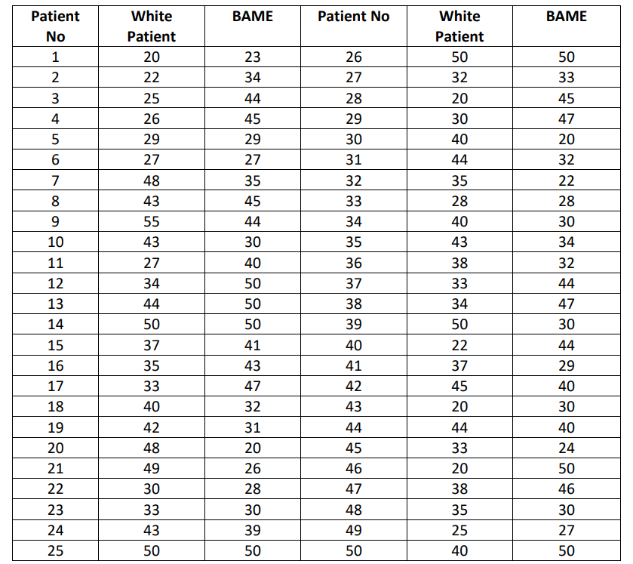

Develop an appropriate set of testable hypotheses (null and alternative) for the experiment for the above data.
In this case study given we can find the two variables. There are two background given White and BAME. So the firs variable is White ethnicity and the second is BAME ethnicity. As we know the variables can be independent and dependent. So we can recognise in this case independent variables is the – infected rate, and the dependent is- ages. After that we have to analyse the hypotheses is it null or alternative. In the requirement given from BBC news the null hypothesis and alternative hypothesis will be as follows:
H0 – There are no difference between White and BAME ethnicity.
Ha – There is significant difference between dose two group ethnicity.
Testable with Hypotheses to significance level = 0
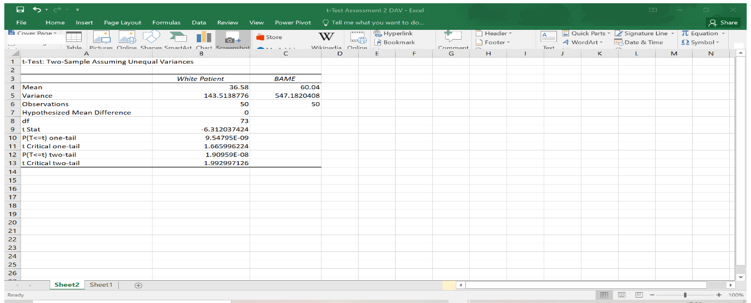 Picture: 1
Testable with Hypotheses to significance level p=0.10:
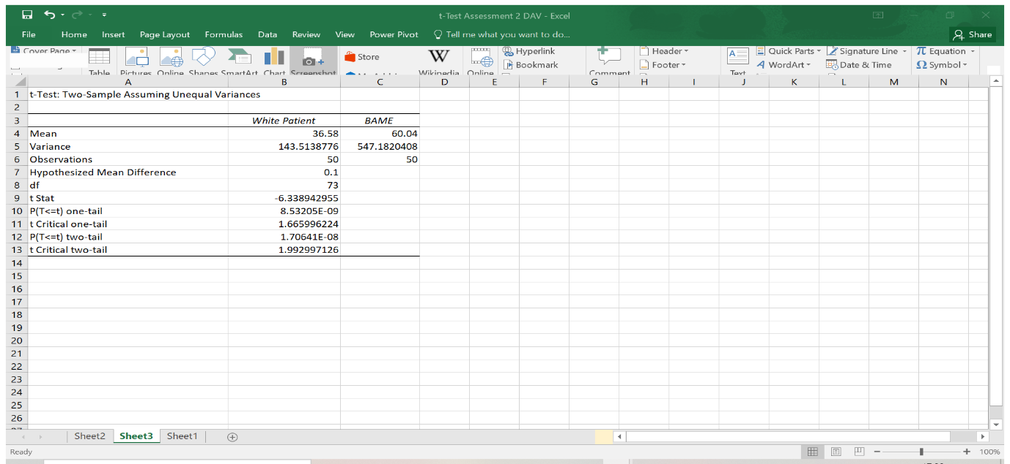Picture: 2

Testable with Hypotheses to significant level p=0.01:
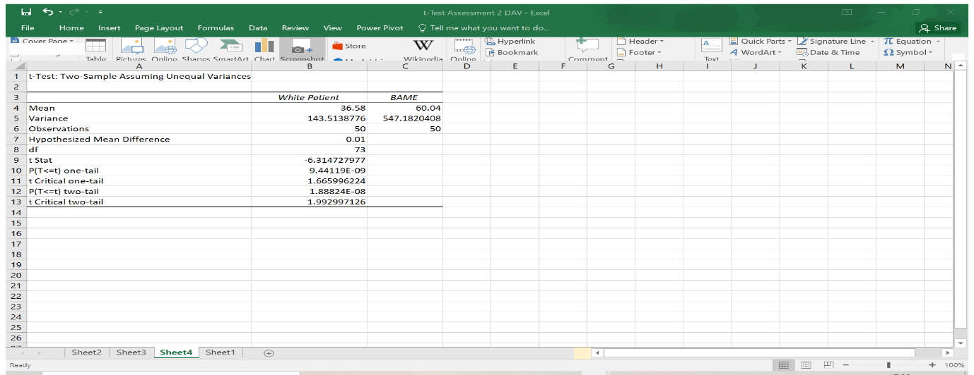Picture: 3
Testable with Hypotheses to significant level p=0.02:
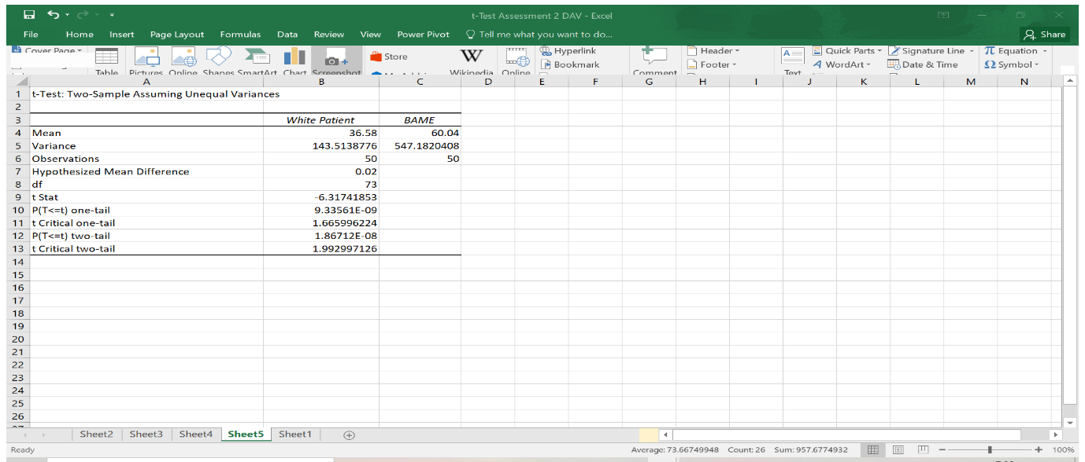Picture: 4
Conclusion analysis:
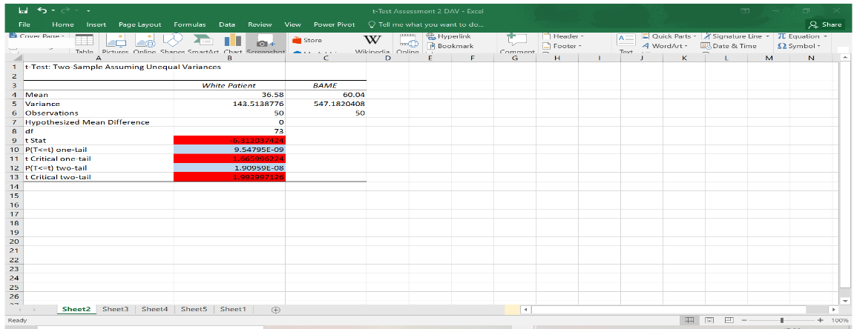
Picture: 5
The analyses in this case with all testable we have to check the t start and the t critical two-tail. If the t start is bigger than t critical two-tail value we reject the hypotheses null. As we know we refuse the sign (–) and take always exact value. Than by the check in this case in all testable the t stars is always bigger than t critical two-tail, that’s mean we have to reject the null hypothesis. The other way we can check as well with the p value is smaller than alpha value we reject the hypotheses null. As we can see in all pictures 1; 2; 3 and 4 the p two-tail firs we have to format the value than we can check if its smaller or not.
Picture 1:
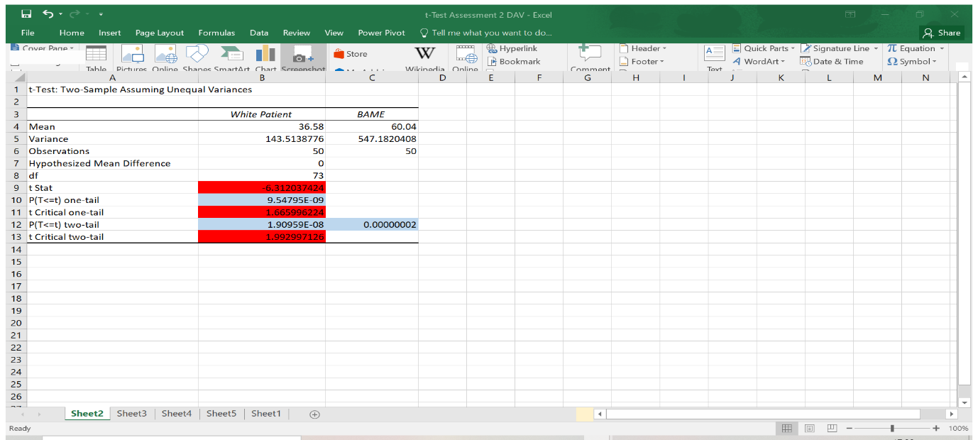
So p (0.00000002) < alpha (0)
Picture 2
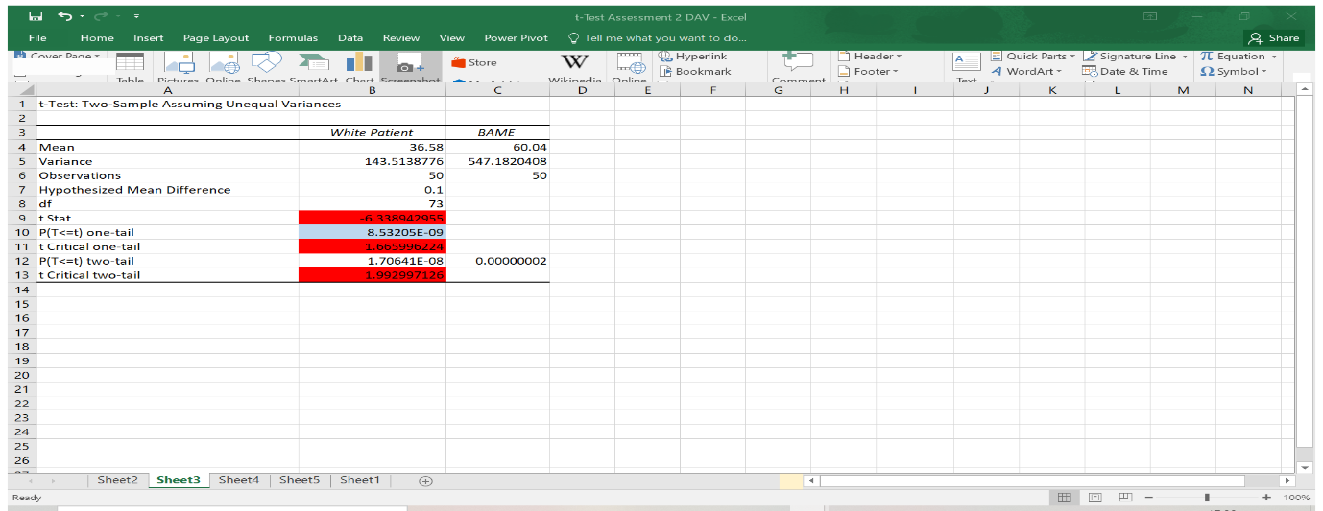
So p (0.00000002) < alpha (0.1)

Picture 3
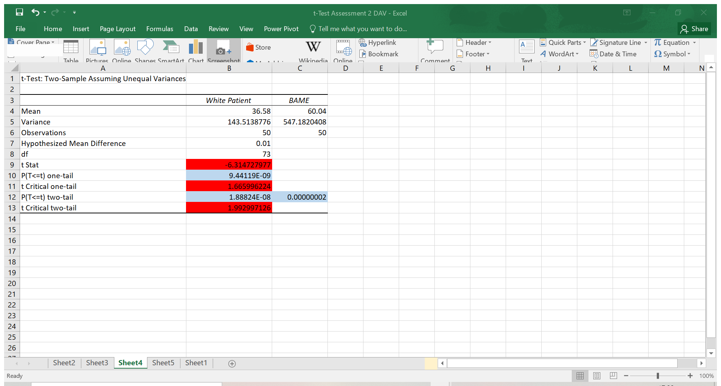
So p (0.00000002) < alpha (0.01)
Picture 4
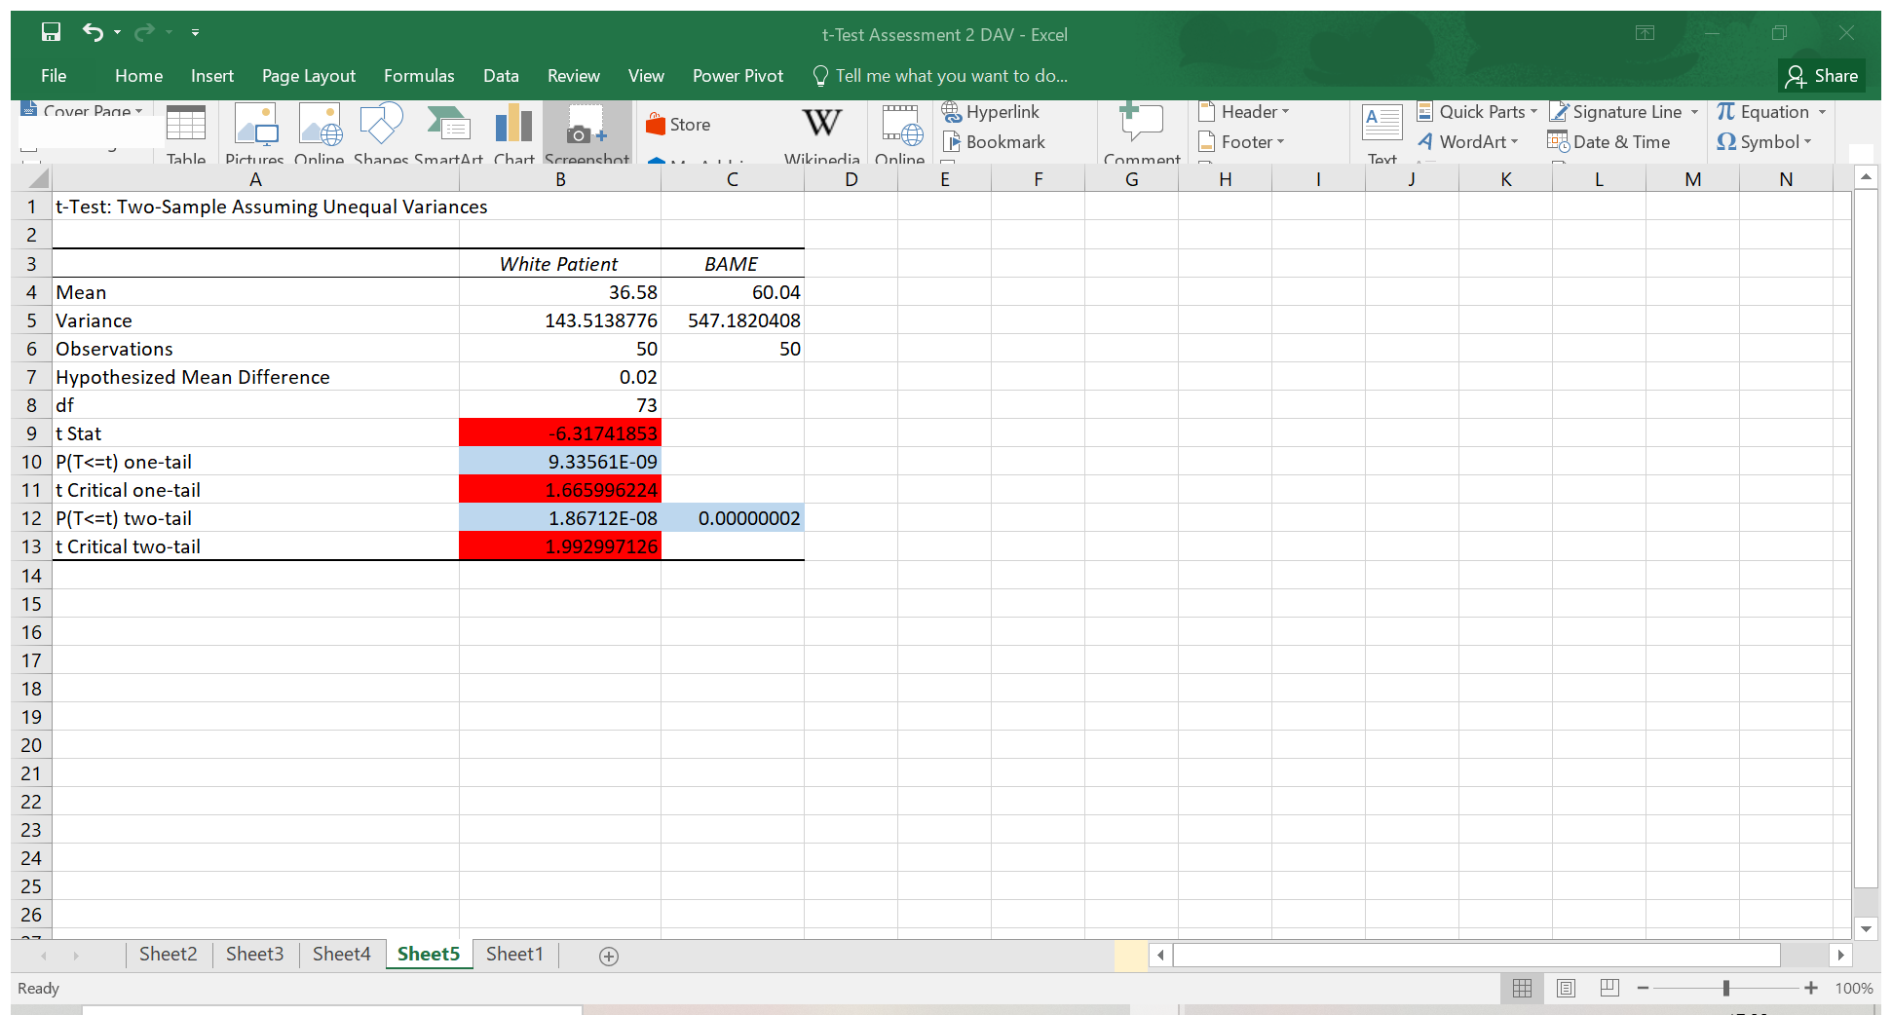
So p (0.00000002) < alpha (0.02)
That’s check also show we have to reject the hypotheses null.
The presence of any outliers in the data and the effect that they have on the outcome
When testing the data, it will be seen that if we do not accept the exact values of mine, to reverse the decision taken by the researcher. The other things to pay attention to is whether the values are the correct numbers or whether they need to be formatted as we do with p values.
Any other features of the data that appear during your investigation of the dataset
The scenario given is investigation on the group between the age 20 and 100, but the data given as we can see there in the white patient have two patients smaller than 20 years old one of them is 14 years and the other is 13 years old. In the BAME group is also one patient smaller than 20 years old, that patient is 19 years old. If we refuse that patient the test is also shows the same hypotheses null have to reject. It’s so important to follow the requirement of the scenario.
Any other factors that might affect the results but have not been considered in the stated experimental set-up, together with ideas as to how you might control these factors
The factors which is very important for one investigation is the mean, the range, the mode and variance standard deviation. In this case which is given in the assessment brief the factors which can affect the result of infected rate is the ages. [4]; [5]

Conclusion:
The solution of the case given it’s not possible to find difference between the groups in the experimental research. Is matter the age of the patient and from that is coming the percentage of infection. The result is when we reject the null it’s take the alternative hypotheses.

Reference:

[1] | A. Hayes, “T-Test,” Investopedia.com, 22 March 2020. [Online]. Available: https://www.investopedia.com/terms/t/t-test.asp. [Accessed 30 August 2021].
[2] | R. Bevans, “An introduction to t-Test,” scribbr.com, 31 January 2020. [Online]. Available: https://www.scribbr.com/statistics/t-test/. [Accessed 30 August 2021].
[3] | D. J. Rumsey, “How to Set Up a Hypothesis Test: Null versus Alternative,” https://www.dummies.com/, 2021. [Online]. Available: https://www.dummies.com/education/math/statistics/how-to-set-up-a-hypothesis-test-null-versus-alternative/. [Accessed 1 September 2021].
[4] | B. O. a. C.-h. Yu, “Threats to validity of Research Design,” in Threats to validity of Research Design, https://web.pdx.edu/~stipakb/download/PA555/ResearchDesign.html.
[5] | A. W. Brown, “Issues with data and analyses: Errors, underlying themes, and potential solutions,” https://www.pnas.org/, 12 March 2018. [Online]. Available: https://www.pnas.org/content/115/11/2563. [Accessed 1 September 2021].

