BMIH6007
International Meetings Management for the Hotel Industry
Report: Event Strategic Planning and Delivery Considerations for an International Meeting.
Shahekur Rahman
Chirs Wilkin
Word Count: 2551

I confirm that I have not presented any AI generated text as my own work. I confirm I have copies of my drafts, notes, and other resources I used before, and after the use of AI tools which I may be asked to provide in evidence.

Executive Summary
This report uses methods such as the Embok model, Marketing mix and Pestel analysis to analyse the strategic approach to delivering a successful wedding fair. It discusses the process of event planning, including budgeting, promoting the fair and organising the event. To measure the success of the event the management will rely on consumer feedbacks, revenue and engaging with all stakeholders to understand how well the event has succeeded. The analysis will also present any flaws and issues that may have aroused during the event and how they can be prevented in the future. The impact of cultural trends and situational considerations can define how changes can impact the success of the event.

Table of Contents

Introduction 4
Location 4
The Event Cycle 4
Event Concept 6
Aim and Objectives of the Event 6
Marketing 8
Event Budget 9
Industry Trends / Issues / Impacts 10
Situational and Cultural Considerations 10
Conclusion 11
Reference 12

Introduction
Winter wedding fairs are very popular events in the current market, it is an exhibition of all the requirements and tailor-made services available for a couple’s big day. MICE is an acronym for MICE is an acronym that stands for meetings, incentives, conferences, and exhibitions. As substitutes for MICE, the phrases "meetings industry" and "events industry" have grown in use in recent years (Hahn, 2024). The events sector has seen a notable recovery after being severely damaged by worldwide lockdowns and social distancing measures. With the sector rebounding and growing in novel and surprising ways, the shift from survival to growth mode is clear. A pent-up demand for live experiences and the use of new technologies that have expanded the reach of an event are the main drivers of this comeback (BE Event, 2024). This event will give the opportunity to exhibitors to obtain contact information from couples in return for information packets, chatting with and obtaining business cards from other wedding industry professionals, and the customers can indulge in just one incredibly tasty, exquisitely decorated cupcake (Moments, 2018)

Location
This wedding fair will be held at Marriott Hotel in Leicester. The venue is very popular for weddings, it has a beautiful wedding hall with lovely floral decorations. The hotel has previously held Christmas fairs and benefited from them. Due to that reason the hotel will sponsor the event as this attracts potential clients and customers book to stay at the hotel during the event.
The Event Cycle
The consumers are the most important factor in event success management. Since the consumers ultimately determine whether or not the event was a success, all action items centre on maximising the customers experience (Kaunisto, 2021). The five steps of the event cycle will help deliver this event successfully (Austine, 2023). Below is how the 5 steps manage the wedding fair:
- Plan- The master plan is part of the event design step. Finding a location that can accommodate the event's theme, guest count, and goal was the first step. Throughout the planning process, collaborating with venue staff is important to improve communication and ensure a seamless event (Younts, 2021). The budget was set from gathering estimated income from sale of tickets, sponsors and exhibiting stalls and calculating the cost of expenditures, this includes decorations, stalls, food, audio visual, promotion, insurance and licenses.

- Organise. Organising the event in another word verify that the location has been reserved and confirmed. Think about what equipment are required such as stalls, stage and runway for the catwalk to showcase dresses and suits, audio visuals. Book speakers and performers and ask what they anticipate from you. It can take months for certain licenses to be obtained, so find out the rules for that location as soon as possible (Wed Pro, 2021). Implementing these ideas and creating structure will define the delivery of the event. Promotion will be required; this will be done via the hotel’s website and banners. Advertising on social media and put tickets and stalls on sale during this stage is also vital as this will contribute towards the budget.

- Measure- An essential step in assessing the success of an event is event measurement. In order to carry out event planning and strategy, it entails analysing data such as attendance rates, participant satisfaction, and social media involvement on previous wedding fairs in the area. From basic measures like attendance and conversion rates to more complex elements like lead generation, Net Promoter Score (NPS), session attendance, and sustainability metrics, key performance indicators (KPIs) are used to gauge the effectiveness of the event. The success of event measurement hinges on the selection of pertinent indicators that complement the goals of the event, the effective use of analytical tools, and the application of learned lessons to maximise ROI and future events (VEO Events, 2020).

- Analyse- Timely Follow-Ups by getting in touch with the leads that were gathered during the event as soon as possible after the wedding show. By expressing gratitude for their visit in a personalised thank-you email. Remind them of any exclusive show offers and provide them further details about the offerings. When it comes to turning leads into customers, timeliness can be crucial.
Evaluating and examining the outcomes of everyone’s involvement with the wedding show. Keep track of the success received from the event and how well the exhibitors have done. This evaluation aids in calculating the return on investment of the show and directs future involvement choices. Feedback back is essential, getting input from guests about their impressions of the event and how relevant it was to the purpose will showcase the success of the fair. Recognise what worked during the event and what needs improvement. This insightful feedback can assist guiding future wedding show strategies (Beavis, 2023).

- Share- Oberserving the depth of knowledge and understanding that builds up by the conclusion of the winter wedding fair as an event planner is crucial. Create individualised and impactful post-event follow-ups by using this information about the sessions the stakeholders have attended, the displays they have seen, the next events they have signed up for, and their reactions to each. Automating, pre-building, and replicating dynamic campaigns that initiate tailored follow-up based on how the attendees during the event is the simplest method to expedite this process (Certain, 2022). This again helps make changes for future events and also show appreciation of how well everyone one did, whether it’s the staff, suppliers or other stakeholders.
Event Concept
The winter wedding will be full of entertainment, information, showcasing new trends and fashion. It will be an opportunity to make bookings, set the dates. Check all the latest trends that you only see on TikTok videos and other social media platforms. The guests will get VIP seating during the catwalk show, welcome drinks on arrival and goodie bags which include a wedding planning book, pen and keyring as well as entertainment and plenty of shopping chances from local traders (National Wedding Show, 2024). There will be stalls which will include; merchandise, photographers to capture the special moments, music and entertainment - such as photo booths, artists, violinist and DJ, food caterers, drink merchants, cake bakers, favours and most importantly the venue itself. It will be great chance to explore the Marriott Hotel’s wedding venue and what they can offer for the big day. Exhibitors can secure booking from customers and customers can taste and trial what is to offer as well as customise products for their big event. There will foods such as tapas available on the day, however customer can also by snacks, cakes and bakes from exhibitor stalls.

Aim and Objectives of the Event
A wedding fair is expected to have a specific format, but how well-run the event is will determine whether it is worthwhile to attend. A variety of wedding vendors will be present in addition to the venue staff, each with their own booth or display area. The majority of them will also have flyers and business cards for customers to take home. (Insposa, 2024). The aim is to give the opportunity to the venue and exhibitors such as local traders and small businesses to be able to promote their business and gain more customers. It will also allow guests to plan their wedding day and find everything they are looking for in one place. It will be a great day out for families, couples and even a group of friends. Using the SMART objectives method, the objectives of this wedding fair is outlined below:
Specific | Measurable | Attainable | Relevant | Time-Bound
Sell all tickets an exhibiting stall for both days of the wedding fair | Sell all tickets before the event and secure booking of stalls from exhibitors maximising the potential of the wedding fair. | Promoting the wedding fair on Event Brite, the hotel’s website and social media events pages. | The success of the fair will be dependent on the guests and attendees. | This will be done before the event as this will contribute to the events budget.
Create brand awareness of this event and retain customers | Promoting engagement with all the stakeholders, this could be seen through feedbacks, supporters and contents on social media | When traders and suppliers sign up to the next upcoming wedding fair after the success of the current one. | This will create a forever standing relation the stakeholders and be of use for future events. | This will be proven after the success of the wedding fair.

Event Management – What skills and resources will be required for the meeting/event? - - Operational / Planning / Marketing Activities…..?
The International EMBOK Executive's mission is "to develop a framework of event management knowledge and procedures that can be tailored to different cultures, governments, educational programs, and organisations." The event team completes many tasks at each stage. The knowledge, abilities, and procedures are not the same. For instance, the event manager is researching the event's viability during the Initiation. The planning stage begins as soon as it is determined that the event is viable. It should be noted that the Event and Closure phases could be considered a component of the Implementation (Embok, 2024). The figure below is what the Embok models looks like.
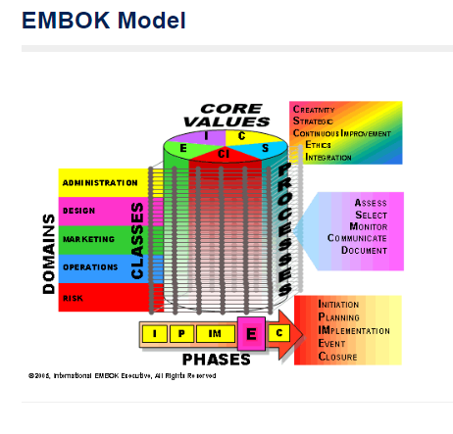
Figure 1: Embok Model (2024)
The 5 phases of the Embok model structure portray how the event will be managed.
Phase 1- Initiating the event, during this phase, extensive research and analysing was done to obtain the feasibility of the winter fair and whether it is worth the while.
Phase 2- During the Planning stage it is important to consider the budget required, staffing, venue, structure, decorations and discovering all requirements for the success of this event.
Phase 3- Implementation means putting the plan in to action, funding sources for the wedding fair such as sale of tickets, sponsors and securing booking with suppliers, venues and other stake holders. Carrying out staff training and setting up the event.
Phase 4- At this stage the event takes place, all the planning and research is finally implemented and the big day is taking please. During this phase you must manage the event accurately to prevent any issues.
Phase 5- The closure of the event, measuring the success and getting feed back on how well you did and what could have been done better.

Marketing
The four Ps—product, pricing, promotion, and place—are frequently used to characterise the marketing mix. Using these four criteria while planning an event will help you create a wedding fair that attracts the correct audience and effectively communicates the message (Milano, 2024).
Product- The products offered are the requirements for a perfect wedding.
Price- Tickets costs and exhibition costs will also be advertised.
Promotion- Promotion will be carried out online to reach vast majority of audience but also posters and banners in the local area and surrounding towns.
Place- The venue itself is a beautiful hotel with wedding packages available to explore on the day.
Even while different events may take place in different sectors and industries, they will all have one thing in common: the attendees are the first focus. Therefore, it's critical to understand what motivates your audience and take advantage of this information. The Hierarchy of Needs by Maslow. The sequence in which our many wants should be satisfied is typically represented by a pyramid. These can be applied to this event to define real occurrences and make some analogies (Garcia, 2023).
Physiological- Making sure food, beverages, and amenities that would always make the guest feel at ease must be available to them when selecting the venue
Safety- Making guests feel protected is one way to satisfy this desire when it comes to event planning. Ensuring security is in place and hygiene is also taken care of throughout the event.
Love and Belonging- Networking is useful in this situation. In any social situation, people naturally need connection, inclusion, and a sense of belonging. Offer a variety of networking opportunities and ensure that customers can navigate clearly.
Esteem- To satisfy stakeholders desires for achievement, status, and respect by seeking out chances to present prizes or acknowledge them. This will be done clearly making sponsors visible.
Self-Actualisation- Personal development is a process. For this reason, social media hashtags are necessary to maintain the conversations, videos and snaps of the fair that are accessible through a digital publishing platform. This hotels website and events online pages on social media.

Event Budget
The feasibility of the event is dependent on the budget and revenue (Pountney, 2022). A successful event will bring profit for the businesses and sponsors associated with the event. The estimated financial forecast budget can be seen on figure 2 below:
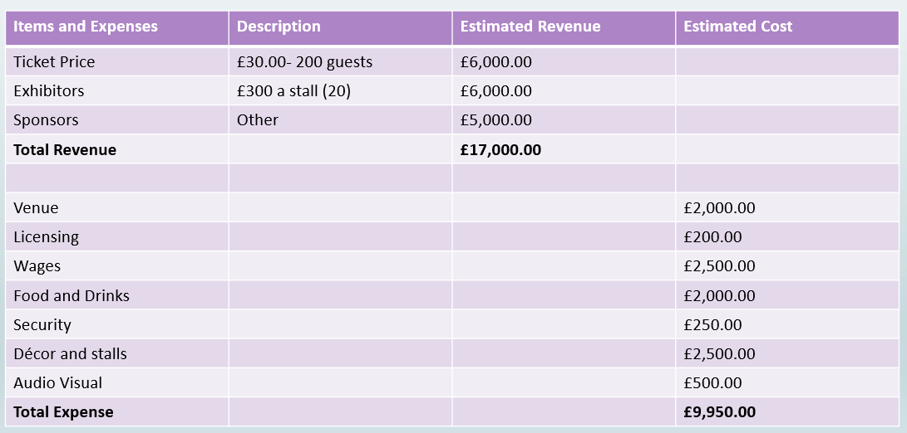
Figure 2: Event budget

Industry Trends / Issues / Impacts
Identifying the major forces influencing events in the future, from the emergence of hybrid events to the increased emphasis on sustainability, diversity, and technology. Examining the trends that are changing how the different generations get together, connect, and celebrate, whether in a venue team, client, event management, or organizer (ICC Belfast, 2024). The event sector is hardly an exception to how technology has changed how businesses run. To maximize event performance and create remarkable guest experiences by utilising data and customization (Fakhruddin, 2024). The amazing rise of virtual events as a driving factor behind people operations was one of the most notable event trends of 2023. These online events transcended conventional limits, increasing their effect and influence in a number of areas such as training staff and delivering vital information (Akhtar, 2024).
Some businesses have implemented sustainable green practices, and information about these activities was made public. By looking at different ways to make sustainable green efforts better (Liu & Lei, 2021), reducing waste by using recyclable cups and plates during the event. Many venues are still hesitant to commit to rates far in advance because inflation is still an issue and they are still suffering from high energy prices. Consequently, event teams encounter challenges when attempting to estimate venue expenses (Akinsowon, 2024). Having a good knowledge and tracking these changes will ensure the event remains within budget.

Situational and Cultural Considerations
The professionalism of the individuals you are collaborating with, the appropriateness of the locations, the objectives and goals to be met, the calibre of the speakers, the variety of organisations involved in the event, and so on and so forth. Each of these individuals in various departments has distinct objectives, desires, and needs. Unfortunately, culture is frequently overlooked despite being a very significant factor. Cultural "mistakes" have the power to make an event great or just good. Communication skills are essential for this event in order to make sure clear instructions are provided on how this event is managed. Other factors that is important to consider are analysed using the PESTEL analysis tool is shown on Figure 3 below.
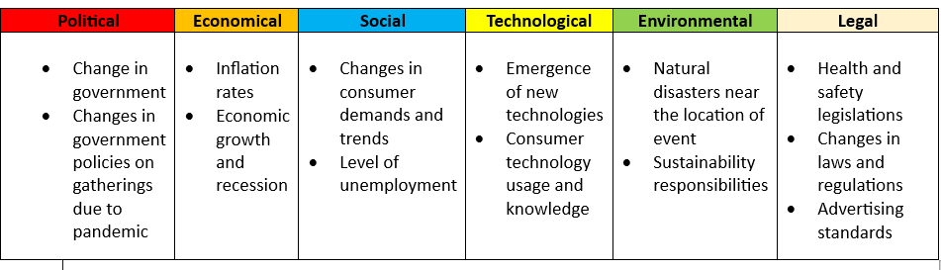
Figure 3: PESTEL Analysis

Conclusion
Finally, this report has indicated that the Winter Wedding Fair is very feasible, it has the potential to generate a good source of income. The process from planning, organising, implementing and achieving the objectives has been explained using the Embok Model. The methods used to show the steps of the event cycle have made it easier to plan and execute the wedding fair. The event will be a massive hit among the customers and businesses, as it brings everyone together.

Reference
Akhtar, A. (2024) vFairs: Event Trends & Predictions for 2024. Available at: Event Trends & Predictions for 2024 [Accessed on: 02 November 2024]

Akinsowon, V. (2024) Cvent: 5 Ways the Economic Downturn is Impacting the Events Industry. Available at: 5 Ways the Economic Downturn is Impacting the Events Industry | Cvent Blog [Accessed on: 02 November 2024]

Austin, A. (2023) Event Brite: Event Life Cycle: Before, During, and After an Event. Available at: Event Life Cycle: Before, During & After an Event | Eventbrite Event Life Cycle: Before, During & After an Event | Eventbrite [Accessed on: 01 November 2024]

BE Event (2024) The 2024 Events Industry Forecast: Growth, Challenges, and Opportunities. Available at: The 2024 Events Industry Forecast: Growth, Challenges, and Opportunities - BE Event Hire [Accessed on: 02 November 2024]

Beavis, K. (2023) Magpie Wedding: The Ultimate Guide To Wedding Shows: Maximising Your ROI As A Wedding Supplier. Available at: The Ultimate Guide To Wedding Shows [Accessed on: 01 November 2024]

Certain (2022) 5 Steps to Successful Post-Event Follow Up. Available at: 5 Steps to Successful Post-Event Follow Up - Certain, Inc [Accessed on: 01 November 2024]

Embok (2024) Embok Model Phases. Available at: EMBOK - Event Management Body of Knowledge - Phases [Accessed on: 01 November 2024]

Fakhruddin, H. (2024) Eventify: 15 Key Event Trends Shaping the Industry In 2024. Available at: 15 Event Industry Trends That You Must Be Aware Of In 2024 [Accessed on: 02 November 2024]

Garcia, S. (2023) Event Case: Event Psychology: How to Create Event Strategies That Work. Available at: Event Psychology: How To Create Event Strategies That Work ➡ EventsCase.com [Accessed on: 03 November 2024]

Hahn, J. (2024) Cvent: What Is MICE? Your Guide to Meetings, Incentives, Conferences, and Exhibitions. Available at: What Is MICE? Guide to Meetings, Incentives, Conferences, and Exhibitions | Cvent Blog [Accessed on: 01 November 2024]

ICC Belfast (2024) 11 Important Event Industry Trends for 2024. Available at: 11 Important Event Industry Trends for 2024 | ICC Belfast [Accessed on: 02 November 2024]

Insposa (2024) What’s the difference between a Wedding Fair, Showcase, Open Day and Show? Available at: What's the difference between a Wedding Fair, Showcase, Open Day and Show? – Insposa | The Online Wedding Magazine [Accessed on: 01 November 2024]

Kaunisto, A. (2021) LYYTI: Introducing the Event Cycle – The Core of Event Success Management. Available at: Introducing the Event Cycle – The core of Event Success Management [Accessed on: 01 November 2024]

Liu, Yun Qing; Lei, Weng Si (Clara) (2021) Event Management: Towards Sustainable Practice in the Event Industry: Insights from Practitioners. Volume 25, Number 3, 2021, pp. 213-226(14)

Milano, S. (2024) CHRON: What Is the Right Marketing Mix for Event Marketing? Available at: What Is the Right Marketing Mix for Event Marketing? [Accessed on: 02 November 2024]

Moments To (2018) How to Handle a Wedding Fair Successfully. Available at: How to Handle a Wedding Fair Successfully ⋆ Moments To [Accessed on: 03 November 2024]

National Wedding Show (2024) Treat Yourself To The Vip Experience. Available at: The National Wedding Show 2025 [Accessed on: 01 November 2024]

Pountney, B. (2022) Becca Pountney: How to sell more at a wedding show. Available at: How to sell more at a wedding show! - Becca Pountney [Blog] [Accessed on: 02 November 2024]

Rip, I. (2019) MPI: Event Planning & Unpeeling the Cultural Onion. Available at: Event Planning & Unpeeling the Cultural Onion [Accessed on: 03 November 2024]

VEO Events (2020) 25 Important KPIs For Measuring Event Success. Available at: Event Measurement: 25 Important KPIs To Track Success | Veo Events [Accessed on: 01 November 2024]

WedPro (2022) A Practical Guide to Wedding Fairs and Open Days. Available at: A Practical Guide to Wedding Fairs and Open Days - [Accessed on: 01 November 2024]

Younts, D. (2021) The Midlothian Conference Centre: The Perfect Plan: What Are the Five Stages of Event Planning? Available at: The Perfect Plan: What Are the Five Stages of Event Planning? [Accessed on: 01 November 2024]

