The Project Manager
This report demonstrates how it is actually viable to determine the effective manager competence profile in a typical housing society.
XYZ
2-3-2023



Table of Contents
1 Executive Summary 1
2 Introduction 2
3 Characteristics of an Effective Project Manager 4
3.1 Human Skills 4
3.2 Conceptual and organizational skills 4
3.3 Technical skills 5
3.4 Project manager career path 5
4 Project Management Principles 6
4.1 Defined scope 6
4.2 Effective planning 7
4.3 Risk management 7
4.4 Stakeholder engagement 7
4.5 Collaboration 7
4.6 Effective communication 7
4.7 Quality management 7
4.8 Cost control 8
4.9 Continuous improvement 8
5 Characteristics of other Stakeholders in the Construction Industry 8
5.1 Quantity Surveyors 8
5.1.1 Financial expertise 8
5.1.2 Analytical skills 9
5.1.3 Attention to detail. 9
5.1.4 Communication skills 9
5.2 Architects 9
5.2.1 Creative thinking 9
5.2.2 Technical skills 9
5.2.3 Communication skills 9
5.2.4 Problem-solving skills 9
5.3 Civil Engineers 9
5.3.1 Technical expertise 10
5.3.2 Analytical skills 10
5.3.3 Project management skills 10
5.3.4 Communication skills 10
6 Project Management of a Typical House 10
6.1 Gantt Chart inclusion of house construction 11
7 Conclusion 15
8 References 16

Executive Summary
A project manager is a professional responsible for leading and coordinating a project from start to finish. They play a crucial role in ensuring that projects are completed on time, within budget, and to the desired quality standards.
The project manager is responsible for:
- Developing project plans and schedules.
- Allocating resources, including personnel and equipment.
- Managing and motivating a cross-functional team.
- Communicating with stakeholders, including customers and other team members.
- Monitoring and controlling project progress.
- Identifying and resolving issues and risks.
- Ensuring that the project is completed within budget and on time.
- Maintaining project documentation and records.
The importance of the project manager lies in their ability to effectively coordinate and manage all aspects of the project, ensuring its success. They are the central point of contact for the project team and stakeholders and play a critical role in ensuring that project objectives are met.
The project manager is also responsible for managing relationships with stakeholders and ensuring that project requirements are understood and met. They must be able to negotiate with stakeholders and make informed decisions that are in the best interest of the project.
In conclusion, the project manager is a vital member of any project team, and their leadership, organizational, and communication skills are crucial to the success of the project. They play a critical role in ensuring that projects are completed on time, within budget, and to the desired quality standards.
Project-based industries are becoming more and more conscious of the connection between performance and management capabilities. One of the most complicated and dynamic project-based industrial sectors, the construction industry, was the focus of this report's investigation into the skill profile of "effective" project managers. Their behavioral abilities and job-task competencies were also evaluated in the research. The findings show that while the behavioral abilities of excellent project managers are primarily generic in character and apply to a variety of other management roles, their job-task competencies are extremely specialized to the industry in which they operate. This study demonstrates how it is actually viable to determine the effective manager competence profile and use this framework to oversee the performance of this important management group.

Figure 1: Basic hierarchy in a project

Introduction
Risk management in construction projects refers to the process of identifying, assessing, and mitigating potential risks that could impact the successful completion of the project. Risks in construction projects can include delays in construction schedules, cost overruns, and safety hazards, among others. Effective risk management involves understanding the potential risks associated with a project and taking proactive measures to minimize their impact [1].
There are several steps involved in risk management in construction projects, including:
- Identification of Risks: The first step in risk management is to identify the potential risks that could impact the project. This includes analyzing the project scope, schedule, and budget, and identifying potential sources of risk such as changes in regulations, weather conditions, or supply chain disruptions.
- Assessment of Risks: Once the risks have been identified, the next step is to assess the likelihood and impact of each risk. This involves determining the probability of each risk occurring and its potential impact on the project.
- Development of Mitigation Strategies: Based on the assessment of risks, the next step is to develop strategies to minimize the impact of risks on the project. This can include developing contingency plans, negotiating contracts with suppliers and contractors, and implementing risk-mitigation measures.
- Monitoring and Review: Ongoing monitoring and review of risks is an important part of risk management. This includes regularly reviewing the status of risks, updating mitigation strategies as necessary, and taking corrective action to minimize the impact of risks on the project [1], [2].
Being an assistant project manager, coordination and delivery of project information is critical to the success of construction projects. This involves ensuring that all stakeholders have access to the information they need to complete their tasks, and that information is shared in a timely and effective manner [3].
There are several steps involved in coordination and delivery of project information, including:
- Information Management: Information management involves collecting, storing, and sharing project information, including project documents, schedules, and budget information. This is an important part of coordination, as it ensures that everyone has access to the information, they need to complete their tasks.
- Document Management: Document management involves organizing, storing, and sharing project documents, including drawings, specifications.
Project managers' abilities are frequently put to the test by crises, ambiguity, and excitement. They constantly struggle with deciding how to carry out their tasks in the face of ambiguity, wide diversity, and an abundance of potentially useful information [3]. Despite having little direct influence over most of them, project managers attempt to accomplish their goals through a sizable and diverse group of individuals. Below are some key elements of being a successful project manager in a house developing society.

Characteristics of an Effective Project Manager
Realizing what project managers do, the kind of talents they exhibit, and their career paths would seem to be crucial steps in the formation of an effective manager who is able to handle any challenge and achieve unique results within a tight timeframe with limited resources [4].
Here are some of the qualities and characteristics of an effective project manager.

Human Skills
This ability is used to connect a project manager's capacity to collaborate well with others and foster teamwork within the team he leads. The project manager's ability to notice and identify the attitudes of his superiors, peers, and subordinates, as well as his own behavior in response to those perceptions, are exhibited. Therefore, working with people is the focus of human talent. The wants and motives of people in his project are adequately perceptible to a project manager who has a well-developed human competence. He is adept at explaining to others what he means by his actions in their situations.
Thus, according to Katz [5], a successful administrator must develop his or her own point of view toward human activity so that that he or she will be able to:
- Recognize the emotions and thoughts that he or she brings into a scenario.
- Have an outlook about one's own perceptions that will allow one to reflect on and gain knowledge from them.
- Create the ability to understand what other people attempting to convey to him through their words and actions (expressly or impliedly); and
- Develop the ability in successfully communicating his ideas and attitudes to others.

Conceptual and organizational skills
This ability is connected in this research to the project manager's capacity for project vision. It entails understanding how a project's many functions are interdependent, and how modifications to one component might have an impact on all the others.
It also includes seeing how a particular initiative is related to its parent company. The project manager should therefore be able to behave in a way that promotes the general welfare of the project and the parent organization after recognizing these linkages and recognizing the key components in every given circumstance. Chester I. Barnard [6], [7], a past leader of the New Jersey Bell Telephone Company, suggests conceptual competence when he says:
“The sense of the company as a whole and of the overall circumstances pertinent to it is the important component of the (executive) process”.
A project manager should attempt to sense the overall surroundings and have a clear view of the entirety of his or her project to have certainty of goals and solid planning. In other words, there is a connection between the analytical abilities and the organizing competence [7].

Technical skills
Technical skill, as defined in this report, denotes knowledge of and competence in a certain type of activity, particularly one that incorporates methods, processes, protocols, or strategies. Project managers who succeed ought to be knowledgeable about the technology needed by the projects they oversee or have appropriate expertise in it [8].
Technical talent is the ability to employ the tools and procedures of the profession, such as building engineering or computational modeling, with specialized knowledge and analytical skills.

Project manager career path
A career is a changing series of jobs that people hold throughout the course of their lives, along with the attitudes, skills, and knowledge that go along with them. Three factors, according to Jones [9], are crucial for recognizing a career's significance in its whole.
A career firstly entails progressing along a course through time. A career also incorporates the connections between organizational and individual factors. Thirdly, a career gives you a professional identity.
The employment and situational aspects that influence each career orientation and raise the possibility of an individual's attraction, retention, sense of competence, and pleasure in each work setting are described by [10] identified six basic career orientation patterns: traditional, creative, realistic, social, entrepreneurial, and investigative.
Project managers frequently exhibit sociability, tact, friendliness, understanding, and helpfulness, as per [11]. They concentrate their efforts on motivating people to accomplish project goals. A competent project manager should be communicative, ambitious, active, and self-assured.
Four further unique career orientation patterns were identified by Brousseau et al. [12]: circular, specialist, progressive, and transitional.
The direction and frequency of mobility inside and between the various types of work hours are the main differences between the four career conceptions. Each of the four career conceptions is underpinned by a unique set of motivations and career management.
Other than that, an effective project manager has the following characteristics:
- Leadership: Ability to lead and motivate a cross-functional team towards a common goal.
- Planning and Organization: Ability to create a project plan and organize resources effectively to ensure successful project execution.
- Communication: Strong verbal and written communication skills to keep all stakeholders informed and engaged throughout the project.
- Problem Solving: Ability to identify and solve problems in a timely and effective manner.
- Adaptability: Ability to adapt to changing project requirements and adjust the project plan accordingly.
- Risk Management: Ability to identify potential project risks and develop contingency plans to minimize their impact.
- Time Management: Ability to effectively manage and prioritize tasks to meet project deadlines.
- Technical Expertise: Understanding of the technical aspects of the project and the ability to make informed decisions.
- Stakeholder Management: Ability to manage relationships with all stakeholders, including customers, vendors, and team members.
- Results-driven: Focused on delivering results and ensuring the project is completed on time, within budget, and to the desired quality standards.

Project Management Principles
Project management principles in the construction industry are a set of guidelines and best practices that help to ensure that construction projects are completed successfully [13]. The following are some of the key principles of project management in the construction industry:

Defined scope
The project scope must be well defined and clearly communicated to all stakeholders. This includes the scope of work, project deliverables, and project requirements [13].

Effective planning
Project managers must create a detailed project plan that outlines the project timeline, budget, and resource allocation. This plan should consider the project scope, risks, and constraints, and should be regularly reviewed and updated throughout the project lifecycle [13].

Risk management
Construction projects are subject to a range of risks, including cost overruns, delays, and quality issues. Effective project managers must identify and assess these risks and develop contingency plans to minimize their impact [14].

Stakeholder engagement
Stakeholder engagement is critical in the construction industry, as projects often involve multiple stakeholders, including owners, contractors, subcontractors, and regulatory agencies. Effective project managers must be able to manage stakeholder relationships, resolve conflicts, and ensure that project requirements are understood and met [15].

Collaboration
Collaboration is key to the success of construction projects, as they often involve a large and diverse team of professionals, including architects, engineers, and construction workers. Effective project managers must foster a collaborative and communicative team dynamic and ensure that all team members are working towards a common goal [15].

Effective communication
Effective communication is critical in the construction industry, as it helps to ensure that project requirements are understood, and stakeholders are kept informed about project progress. Project managers must be able to communicate effectively with all stakeholders, including technical and non-technical stakeholders, and ensure that project communications are clear, concise, and accurate [16].

Quality management
Quality management is an important principle of project management in the construction industry, as it helps to ensure that construction projects are completed to the desired quality standards. Effective project managers must develop and implement quality control processes, and regularly monitor and assess project quality to ensure that standards are being met [16].

Cost control
Effective cost control is critical in the construction industry, as projects often have limited budgets and tight deadlines. Project managers must monitor project costs, identify, and address cost overruns, and ensure that project budgets are met [17].

Continuous improvement
Project management in the construction industry is an iterative process, and effective project managers must continuously assess and improve their processes and methods. They must be willing to learn from past experiences and make changes to their approaches as needed to ensure that projects are completed successfully [17].
In conclusion, the principles of project management in the construction industry are essential to ensure that construction projects are completed successfully. Effective project managers must be able to apply these principles and must have a deep understanding of the construction industry, its risks, and its unique requirements.

Characteristics of other Stakeholders in the Construction Industry
The construction industry involves many different stakeholders, each with their own unique role, responsibilities, and skills. In this section, we will describe and discuss the characteristics of three key stakeholders in the construction industry: quantity surveyors, architects, and civil engineers.

Quantity Surveyors
Quantity surveyors are professional who manage the financial aspects of construction projects. They are responsible for estimating and tracking project costs, and for ensuring that project budgets are met. Quantity surveyors play a critical role in the construction industry, as they are responsible for ensuring that projects are completed within budget, and for managing the financial risks associated with construction projects [18].
Key characteristics of quantity surveyors include:

Financial expertise
Quantity surveyors must have a strong understanding of financial principles, including budgeting, accounting, and risk management.

Analytical skills
Quantity surveyors must be able to analyze and interpret financial data, and to use this information to make informed decisions.

Attention to detail.
Quantity surveyors must be meticulous and detail-oriented, as they are responsible for tracking project costs and ensuring that budgets are met.

Communication skills
Quantity surveyors must be able to communicate effectively with project stakeholders, including owners, contractors, and suppliers, and to negotiate and resolve conflicts as needed.

Architects
Architects are professional who design buildings, structures, and other built environments. They are responsible for creating the overall design and layout of construction projects, and for ensuring that projects meet the functional, aesthetic, and safety requirements of the stakeholders [18], [19].
Key characteristics of architects include:

Creative thinking
Architects must be able to think creatively and develop innovative solutions to design challenges.

Technical skills
Architects must have a deep understanding of building technology, construction methods, and building codes, and must be able to use this knowledge to create functional and safe designs.

Communication skills
Architects must be able to communicate effectively with clients, contractors, and other stakeholders, and to present and defend their designs.

Problem-solving skills
Architects must be able to identify and resolve design challenges, and to develop solutions that meet the needs of the stakeholders.

Civil Engineers
Civil engineers are professionals who design and oversee the construction of infrastructure projects, including roads, bridges, buildings, and other structures. They are responsible for ensuring that projects meet the technical and safety requirements, and for managing the construction process from start to finish [18]–[20].
Key characteristics of civil engineers include:

Technical expertise
Civil engineers must have a deep understanding of engineering principles and techniques and must be able to apply this knowledge to the design and construction of infrastructure projects.

Analytical skills
Civil engineers must be able to analyze complex data, and to use this information to make informed decisions.

Project management skills
Civil engineers must be able to effectively manage and coordinate construction projects, and to ensure that projects are completed on time, within budget, and to the desired quality standards.

Communication skills
Civil engineers must be able to communicate effectively with project stakeholders, including owners, contractors, and regulatory agencies, and to negotiate and resolve conflicts as needed.
In conclusion, quantity surveyors, architects, and civil engineers are three of the key stakeholders in the construction industry, each with their own unique roles, responsibilities, and skills. Effective collaboration and communication among these stakeholders are essential to the success of construction projects, and project managers must be able to effectively manage these relationships and ensure that all stakeholders are working together towards a common goal.

Project Management of a Typical House
Construction projects, including residential projects such as building a house, require the coordination and collaboration of multiple stakeholders, including architects, contractors, engineers, and project managers [10]. Being an assistant project manager, this report will outline the work involved in building a typical house, including a description of the tasks involved and the relationships between stakeholders. A basic Gantt chart will be included to illustrate the timeline and interdependencies of the tasks involved.
The following is a summary of the tasks involved in building a typical house:
- Site Preparation: This includes tasks such as site clearance, excavation, and preparation of the building foundation.
- Foundation Construction: The foundation of the house is constructed, including tasks such as pouring concrete, installing footings, and constructing retaining walls.
- Framing: The frame of the house is constructed, including tasks such as erecting walls, installing roof trusses, and installing windows and doors.
- Plumbing and Electrical Installation: Plumbing and electrical systems are installed, including tasks such as running pipes and wiring, installing fixtures, and connecting to utility services.
- Insulation and Drywall Installation: The walls and ceilings of the house are insulated and covered with drywall, including tasks such as installing insulation, hanging drywall, and taping and finishing joints.
- Finish Carpentry: The interior of the house is finished, including tasks such as installing trim, cabinetry, and flooring.
- Painting and Wall Finishing: The walls and ceilings of the house are painted and finished, including tasks such as applying paint, wall coverings, and wall treatments.
- Landscaping: The exterior of the house is landscaped, including tasks such as installing sidewalks, driveways, and planting trees and shrubs.

Gantt Chart inclusion of house construction
A Gantt chart is a graphical representation of the tasks involved in a project, and the relationships between tasks. The following is a basic Gantt chart for building a typical house:

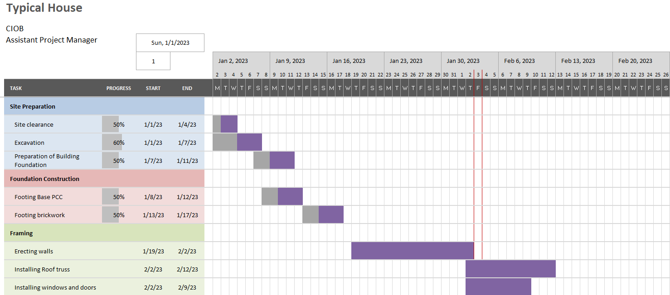
Figure 2: Gantt Chart showing activities of a typical house construction (Week 1 displaying)
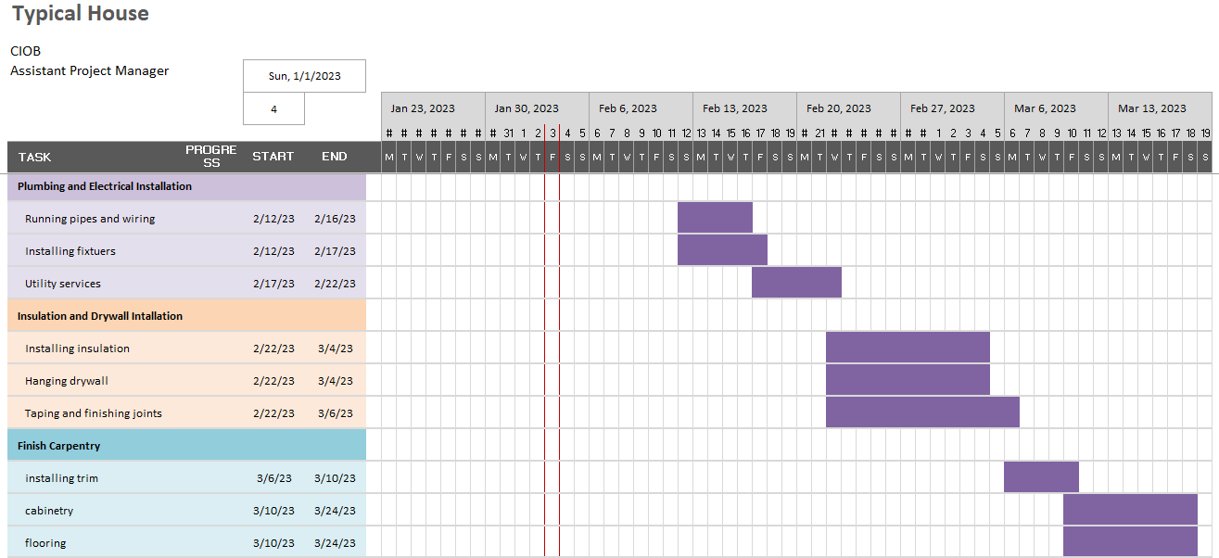
Figure 3: Gantt Chart showing activities of a typical house construction (Week 4 displaying)

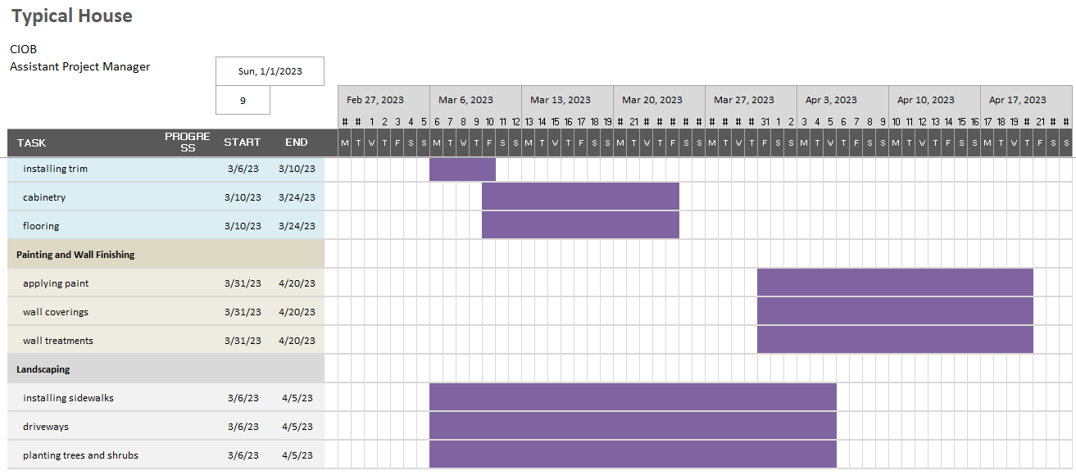
Figure 4: Gantt Chart showing activities of a typical house construction (Week 9 displaying)
As shown in the Gantt chart, tasks such as site preparation, foundation construction, and framing are interdependent and occur concurrently. Other tasks, such as plumbing and electrical installation, insulation and drywall installation, and finish carpentry, occur in sequence, with later tasks depending on the completion of earlier tasks.

Conclusion
In conclusion, building a typical house involves a complex series of tasks and requires the coordination and collaboration of multiple stakeholders. A Gantt chart can be used to illustrate the timeline and interdependencies of the tasks involved, and to help ensure that the project is completed on time and within budget. An effective assistant project manager in a local housing developing society plays a crucial role in ensuring the successful delivery of housing projects. They are responsible for assisting the project manager in various tasks such as planning, budgeting, risk management, and coordinating with various stakeholders. The assistant project manager should possess a range of skills and traits such as strong leadership, communication, problem-solving, and organization. By effectively utilizing these skills, an assistant project manager can help ensure the smooth execution of housing projects and deliver high-quality homes that meet the needs and expectations of homeowners. Ultimately, an effective assistant project manager is a valuable asset to any local housing developer and plays a critical role in the success of the organization.

References
[1] S. Jayasuriya, G. Zhang, and R. Jing Yang, “Challenges in public private partnerships in construction industry: A review and further research directions,” Built Environment Project and Asset Management, vol. 9, no. 2, pp. 172–185, Apr. 2019, doi: 10.1108/BEPAM-01-2018-0024/FULL/HTML.
[2] A. Nawaz, A. Waqar, S. Adnan, R. Shah, M. Sajid, and M. I. Khalid, “An innovative framework for risk management in construction projects in developing countries: evidence from Pakistan,” mdpi.com, doi: 10.3390/risks7010024.
[3] T. Baloyi, A. O.-M. W. of Conferences, and undefined 2020, “Strategic risk management among small enterprises in the construction industry,” matec-conferences.org, doi: 10.1051/matecconf/202031202013.
[4] R. S. C. Goodwin, “Skills Required of Effective Project Managers,” Journal of Management in Engineering, vol. 9, no. 3, pp. 217–226, Jul. 1993, doi: 10.1061/(ASCE)9742-597X(1993)9:3(217).
[5] “Skills of an Effective Administrator.” https://hbr.org/1974/09/skills-of-an-effective-administrator (accessed Feb. 03, 2023).
[6] “Barnard, C. I. (1938). The functions of the executive. Cambridge, MA Harvard University Press. - References - Scientific Research Publishing.” https://www.scirp.org/(S(i43dyn45teexjx455qlt3d2q))/reference/ReferencesPapers.aspx?ReferenceID=244000 (accessed Feb. 03, 2023).
[7] P. D. Gonçalves, M. Ometto, G. Sendoya, C. Lacet, L. Monteiro, and P. J. Cunha, “Neuropsychological Rehabilitation of Executive Functions: Challenges and Perspectives,” J Behav Brain Sci, vol. 04, no. 01, pp. 27–32, 2014, doi: 10.4236/JBBS.2014.41004.
[8] A. Jena, S. Suvasweta, and S. A. Professor, “Importance of Soft Skills in Project Management,” Int J Sci Res, vol. 5, p. 57, 2015, doi: 10.18535/ijsrm/v5i7.45.
[9] G. Johns, Organizational behavior: Understanding and managing life at work. 1996. Accessed: Feb. 03, 2023. [Online]. Available: https://psycnet.apa.org/record/1996-97658-000
[10] J. J. Jiang, G. Klein, and R. Discenza, “Pre-project partnering impact on an information system project, project team and project manager,” European Journal of Information Systems, vol. 11, no. 2, pp. 86–97, Jun. 2002, doi: 10.1057/PALGRAVE.EJIS.3000420.
[11] A. Dainty, M.-I. Cheng, and D. Moore, “A Comparison of the Behavioral Competencies of Client-Focused and Production-Focused Project Managers in the Construction Sector,” https://doi.org/10.1177/875697280503600205, vol. 36, no. 2, pp. 39–48, Jun. 2005, doi: 10.1177/875697280503600205.
[12] K. R. Brousseau, M. J. Driver, K. Eneroth, and R. Larsson, “Career pandemonium: Realigning organizations and individuals,” https://doi.org/10.5465/ame.1996.3145319, vol. 10, no. 4, pp. 52–66, Nov. 1996, doi: 10.5465/AME.1996.3145319.
[13] G. Anwar, N. A.-A. E. Science, and undefined 2021, “A Project Management Improvement Program: Enhancing Production With Implementing the Knowledge Management Principles,” papers.ssrn.com, 2021, Accessed: Feb. 03, 2023. [Online]. Available: https://papers.ssrn.com/sol3/papers.cfm?abstract_id=3824702
[14] D. Heigermoser, B. de Soto, … E. A.-A. in, and undefined 2019, “BIM-based Last Planner System tool for improving construction project management,” Elsevier, Accessed: Feb. 03, 2023. [Online]. Available: https://www.sciencedirect.com/science/article/pii/S0926580518305673
[15] J. Kawuki, “Application of the project management principles on a design and build projects; case study proposed design and construction of an aviation maintenance base at,” 2022, Accessed: Feb. 03, 2023. [Online]. Available: http://196.43.133.114/handle/10570/10217
[16] R. Gupta, Q. Tat, J. O’Brien, M. Shaw, … E. C.-T. A. J. of, and undefined 2022, “Utilization of lean project management principles and health informatics to reduce operating room delays in a vascular surgery practice,” Elsevier, Accessed: Feb. 03, 2023. Available: https://www.sciencedirect.com/science/article/pii/S0002961021004207
[17] Y. Fomina, S. A.-E. and S. D. B. of, and undefined 2019, “Green project management: Balancing of sustainable development principles,” researchgate.net, Accessed: Feb. 03, 2023. [Online]. Available: https://www.researchgate.net/profile/Rauf-Gushkhani/publication/341734748_THE_CURRENT_STATE_OF_THE_AZERBAIJAN_REPUBLIC_BUDGET_POLICY_AND_THE_PROSPECT_OF_ITS_IMPROVEMENT/links/5ed105a8299bf1c67d271a9a/THE-CURRENT-STATE-OF-THE-AZERBAIJAN-REPUBLIC-BUDGET-POLICY-AND-THE-PROSPECT-OF-ITS-IMPROVEMENT.pdf#page=1515
[18] E. Safapour, S. Kermanshachi, S. Kamalirad, and D. Tran, “Identifying Effective Project-Based Communication Indicators within Primary and Secondary Stakeholders in Construction Projects,” Journal of Legal Affairs and Dispute Resolution in Engineering and Construction, vol. 11, no. 4, Nov. 2019, doi: 10.1061/(ASCE)LA.1943-4170.0000332.
[19] A. Urbinati, P. Landoni, F. Cococcioni, and L. de Giudici, “Stakeholder management in open innovation projects: a multiple case study analysis,” European Journal of Innovation Management, 2020, doi: 10.1108/EJIM-03-2020-0076/FULL/HTML.
[20] M. Ajmal, M. Khan, and H. Al-Yafei, “Exploring factors behind project scope creep – stakeholders’ perspective,” International Journal of Managing Projects in Business, vol. 13, no. 3, pp. 483–504, May 2020, doi: 10.1108/IJMPB-10-2018-0228/FULL/HTML.

