APPLICATION FOR ETHICAL APPROVAL
SECTION A: About You (Principal Researcher)
 | Full Name |  |  | Eduard Slavu
 | Tick all boxes which apply: |  |  | Member of staff: |  | Honorary research fellow:
 | Undergraduate Student |  |  | Taught Postgraduate  Student |  | Postgraduate Research Student
Institute/Academic Discipline/Centre: |  |  | International Hotel Management
Campus: |  |  | Swansea
E-mail address: |  |  | 2022664@student.uwtsd.ac.uk
Contact Telephone Number: |  |  | 07738036026
For students:
Student Number: |  |  | 2022664
Programme of Study: |  |  | International Hotel Management
Director of Studies/Supervisor: |  |  | Rodrigo Fernandes Aguilera
1
%
Where research activity is carried out in collaboration with an external organisation
Does this organisation have its own ethics approval system? | YES |  | NO
If yes, please attach a copy of any final approval (or interim approval) from the organisation
SECTION E: Details of Research Activity
Indicative title: |  | Hotel Placement Project
Proposed start date: |  | 04/05/23 | Proposed end date: | 07/07/23
Introduction to the Research
The research will focus on the "Front Office night audit function at the Coldra Court Hotel" located in Newport Wales.
Purpose of the Research
The main purpose of this research is to observe the performance of the front office night audit process. Usually, night audits are a part of the Hotel's accounting process that is used to record, analyse, and observe the financial activities of the hotel, taking place on a daily basis. This project is focused on improving different processes of the company's operation. Activities such as simplifying the "night audit tasks, promoting financial accuracy, improving the visitor experience at late hours" and so on, will be proposed through this research.
Research Questions
What are the potential opportunities that can be considered to improve the existing night audit process?
How do you explain the correctness and viability of the financial activities done, in the existing night audit process?
What are the potential ways through which, the overall efficiency of the existing Night Audit process can be improved?
Aims of the Research Activity
The following research aims to explore the existing activities of the "night audit process" of Coldra Court Hotel and suggest ways of enhancing its effectiveness by simplifying the techniques involved to develop the Night Audit.
 | Objectives
3
%
/
Sampling Size and Technique
The researcher will use the purposive sampling technique. This approach helps the researcher in selecting the sample population on purpose (Campbell et al., 2020). In this research, the researcher samples out 5 Managers working at Coldra Court Hotel.
Data Analysis Technique
The data collected by the researcher will be analysed by the formation of themes. The thematic analysis technique is suitable to perform an in-depth analysis of the data and identify that patterns that correlates with the research topic (Kiger and Varpio, 2020). This technique of data analysis will also allow the researcher to clearly explain the data obtained through the Interview process.
Project Time Scale
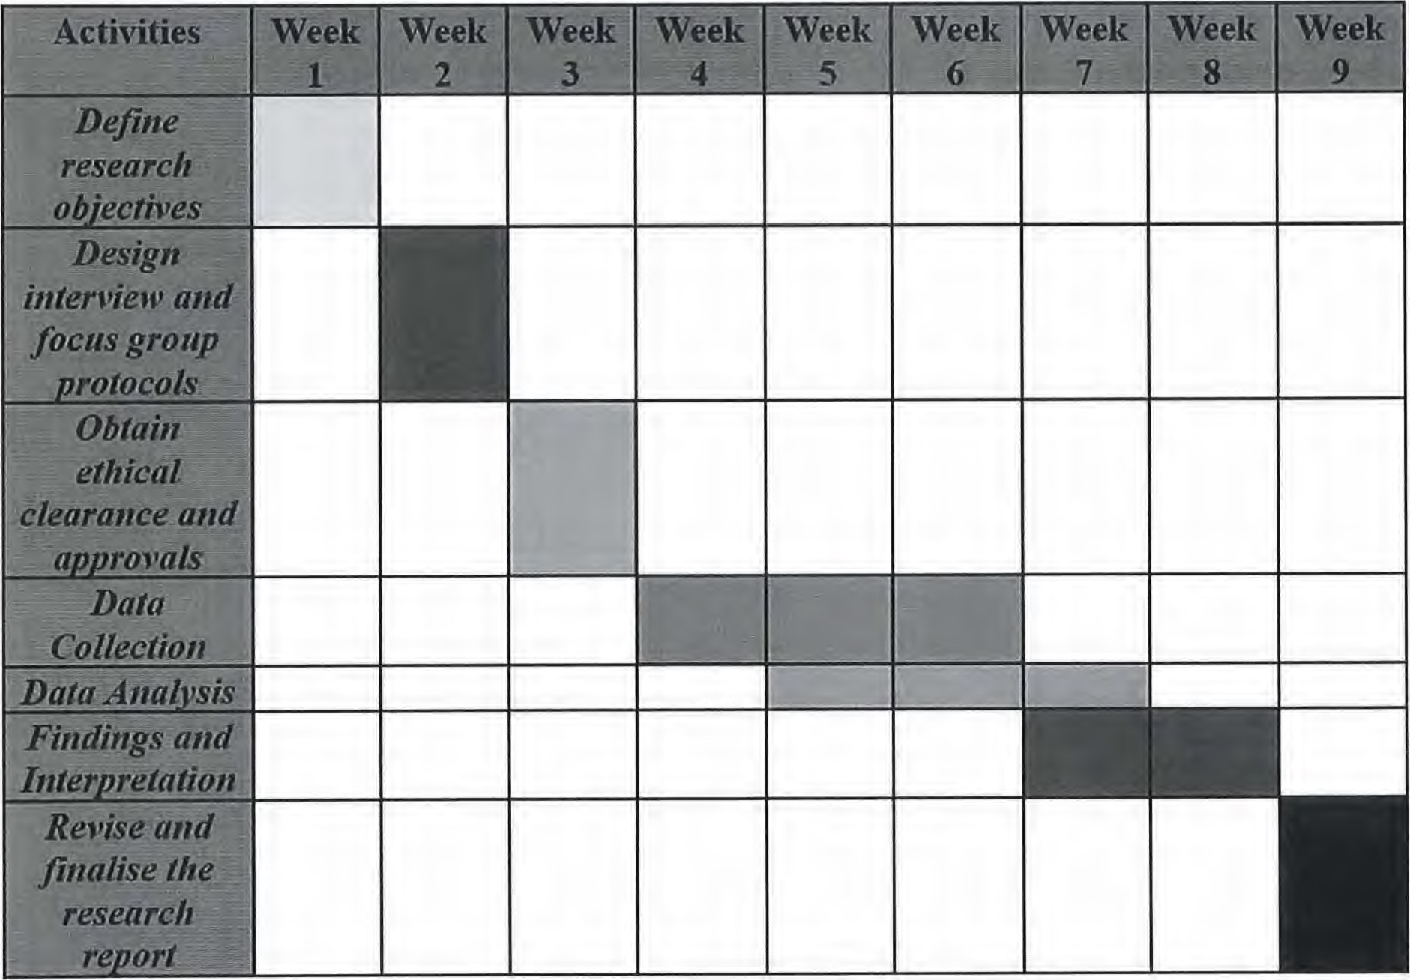
Figure: Project Timeline
(Source: Learner)
References
Tamminen, K.A. and Poucher, Z.A., (2020). Research philosophies. In The Routledge international encyclopaedia of sport and exercise psychology (pp. 535-549). Routledge.
5
 1

SECTION F: Scope of Research Activity
Will the research activity include: | YES | NO
Use of a questionnaire or similar research instrument?
Use of interviews?
Use of diaries?
Participant observation with their knowledge?
Participant observation without their knowledge?
Use of video or audio recording?
Access to personal or confidential information without the participants' specific consent?
Administration of any questions, test stimuli, presentation that may be experienced as physically, mentally, or emotionally harmful / offensive?
Performance of any acts which may cause embarrassment or affect self-esteem?
Investigation of participants involved in illegal activities?
Use of procedures that involve deception?
Administration of any substance, agent, or placebo?
Working with live vertebrate animals?
Other primary data collection methods, please explain in this box.
For example, 'focus groups'. Please indicate the type of data collection method(s) in this box and tick the accompany box.
Details of any other primary data collection method:
If NO to every question, then the research activity is (ethically) low risk and may be exempt from some of the following sections (please refer to Guidance Notes).
If YES to any question, then no research activity should be undertaken until full ethical approval has been obtained.
7

Will you tell participants that their data will be treated with full confidentiality and that, if published, it will not be identifiable as theirs?
Will you debrief participants at the end of their participation, in a way appropriate to the type of research undertaken?
If NO to any of above questions, please give an explanation
Information for participants: | YES |  | NO | NIA
Will participants be paid?
Is specialist electrical or other equipment to be used with participants?
Are there any financial or other interests to the investigator or University arising from this study?
Will the research activity involve deliberately misleading participants in any way, or the partial or full concealment of the specific study aims?
If YES to any question, please provide full details
N/A
9

SECTION I: Feedback, Consent and Confidentiality
Feedback
What de-briefing and feedback will be provided to participants, how will this be done and when?
N/A
Informed consent
Describe the arrangements to inform potential participants, before providing consent, of what is involved in participating. Describe the arrangements for participants to provide full consent before data collection begins. If gaining consent in this way is inappropriate, explain how consent will be obtained and recorded in accordance with reviling data protection legislation.
I'll make sure that the Ethic committee must approve both the consent procedure and the consent form. It is necessary to provide adequate information to potential volunteers who are able to volunteer for research studies so they may decide whether or not to join. When the consent form is drafted, signed, and throughout the research study, I will make sure the participant is aware of all the crucial details. Prior to the start of those online questionnaires, prospective participants will be given the same details required in a formal consent declaration either verbally or in writing
Confidentiality / Anonymity
Set out how anonymity of participants and confidentiality will be ensured in any outputs. If anonymity is not being offered, explain why this is the case.
The researcher will provide anonymity and confidentiality.
I'll use a variety of techniques to protect the privacy and anonymity of my subjects' identities. First and foremost, use password-protected files and encryption when exchanging information over the internet to keep the records safe, will be considered. Avoid recording data in a method that associates subject responses with personal information (often by using a code that only they know). And be sure that the first step in protecting a participant's identity is to remove the contributor's name. Besides, avoiding more pieces of information that are presented together, for example: job title, age, gender, length of service, membership of clubs, and strongly expressed opinions. I will often only report aggregate findings, not individual-level data, to the public.
1 1

/
- Implement organisational and technical safeguards to thwart any illegal access. A strong password is the best approach to confirm a user's identity. Strong passwords should have the following characteristics: length (the longer, the better), a combination of letters (upper and lower case), digits, and symbols with no connection to your personal information, and no dictionary terms.
- Define precise access guidelines. Create a method to permit or prohibit access to specific data based on predetermined user lists and access permissions, such as allowing just myself and my supervisor to view data and restricting access based on each user's role in the project.
- Set up the processes so that you have the most control feasible, such as by allowing access to be tracked (through a logbook).
- No participant's data will be recorded in a way that connects their responses to the subjects' questions to personal information often by using a code that only they know
All Data Storage
Will the research activity involve any of the following activities: | YES | NO
Electronic transfer of data in any form?
Sharing of data with others at the University?
Sharing of data with other organisations?
Export of data outside the European Union or importing of data from outside the UK?
Use of personal addresses, postcodes, faxes, emails, or telephone numbers?
Publication of data that might allow identification of individuals?
Use of data management system?
Data archiving?
If YES to any question, please provide full details, explaining how this will be conducted in accordance with the GDPR and DPA (and/or any international equivalent):
1. Check the security of the storage. Even if my data is stored on my local PC, a portable storage device, or the cloud, storage issues are still crucial. For instance, operating system controls (authentication and access control), the use of passwords to access electronic files (e.g., using the text editor function to save a document password-protected), local encrypted storage (enabling the full disc encryption, the file system encryption, and the text editor encryption), and database encryption: converting data into an unintelligible form (for anyone not having access to the key).
- Transfer the data using secure electronic transmission. The protection of data and data carriers when they are physically transferred (on paper notes, a laptop, etc.) includes encrypted communication (SSL/TLS); using web services whose URLs begin with "https://" rather than just "http://," firewall systems and access control lists (e.g., making sure the firewall service is enabled on my PC), and anti-virus & anti-malware systems.
- Verify additional technical IT controls. Computer configuration: security-conscious user settings (such as applying security updates, anti-virus protection, local backups, and prohibiting the installation of specific applications, etc.
List all who will have access to the data generated by the research activity:
Myself.
List who will have control of, and act as custodian(s) for, data generated by the research activity:
13
%
SECTION K: Declaration
The information which I have provided is correct and complete to the best of my knowledge. I have attempted to identify any risks and issues related to the research activity and acknowledge my obligations and the rights of the participants.
In submitting this application, I hereby confirm that I undertake to ensure that the above named research activity will meet the University's Research Ethics and Integrity Code of Practice which is published on the website: https://www.uwtsd.ac.uk/research/research-ethics/
Signature of applicant: | Eduard Slavu | Date:  31.05.2023
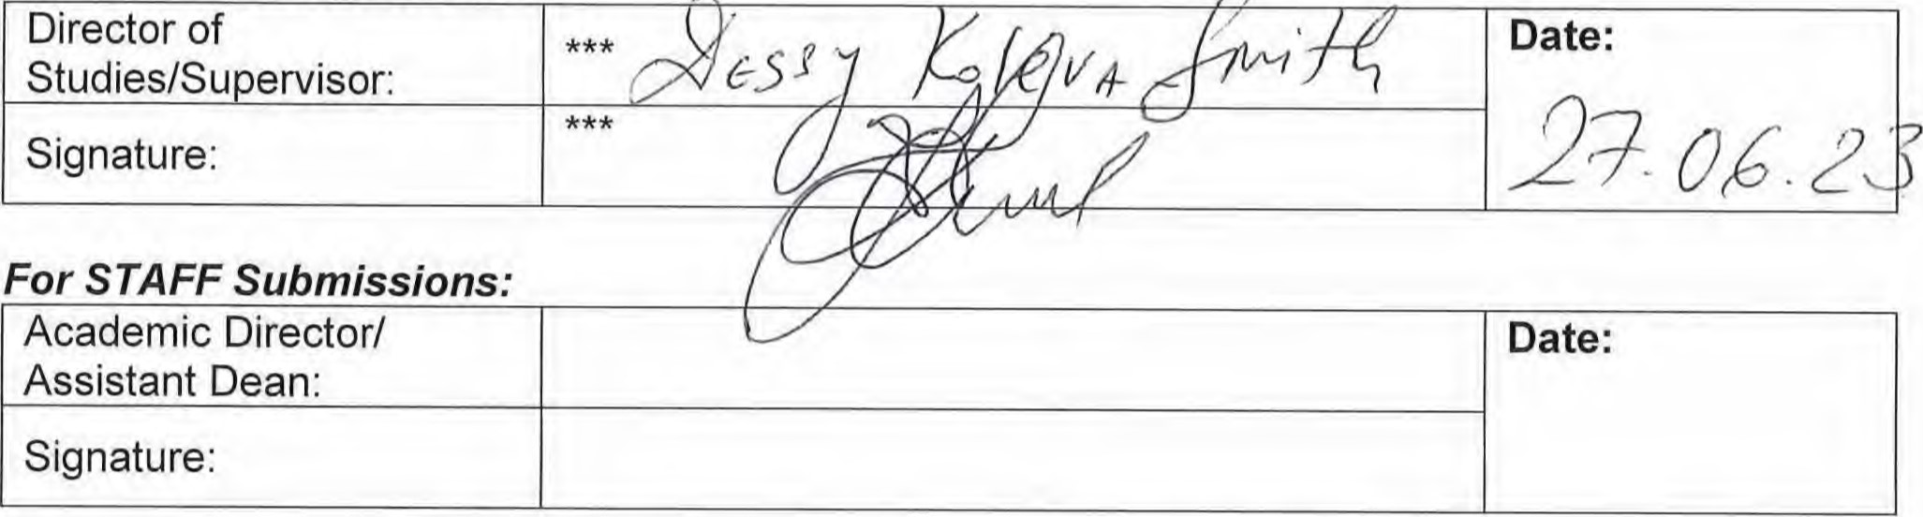For STAFF Submissions:
For
STUDENT
Submissions:
Checklist: Please complete the checklist below to ensure that you have completed the form according to the guidelines and attached any required documentation:
I have read the guidance notes supplied before completing the form.
I have completed ALL RELEVANT sections of the form in full.
I confirm that the research activity has received approval in principle
I have attached a copy of final/interim approval from external organisation (where appropriate)
I have attached a full risk assessment (and have NOT completed Section H of this form)
(Where appropriate) ONLY TICK IF YOU HAVE ATTACHED A FULL RISK ASSESSMENT
I understand that it is my responsibility to ensure that the above-named research activity will meet the University's Research Ethics and Integrity Code of Practice,
I understand that before commencing data collection all documents aimed at respondents (including information sheets, consent forms, questionnaires, interview schedules etc.) must be confirmed by the DoS/Supervisor, module tutor or Academic Director.
I have deleted the guidance notes before submitting the PG2 for consideration
15

