Name:_Biniyam Memberu_________________

Student Number: 2405357_________________
_______________________________________

WORKSHEET 1 – TESTING (Using Variables)

- Original code:
[Copy and paste your original code from Moodle into this box. Do not change it.]
print("Please enter all of the detail ")
sureName=input("Enter your sure name ")
age=int(input("Please enter your age"))
if age <0 or age>100:
print("Age must be greater than zero")
age=int(input("Please enter a valid age "))
else:
print("thanks for enter your age")
nationalInsurance=(input("Enter the national insurance number"))
if len(nationalInsurance)>8:
print("your national insurance number must be eight digits")
nationalInsurance = (input("enter the national insurance number"))
else:
print("Thanks for entering national insurance number")
workHour = float(input("please enter the work hour"))
if workHour < 0 or workHour > 80:
print("Please enter a valid hour rate")
else:
print("Thanks for entering your work hour")

- Code Testing

For each test below, run your code and enter the values provided. Present a screenshot of the programme running. Did the programme behave correctly or did it do something unexpected, and if so, why?

Surname:
- Enter JONES
- Leave blank
- Enter A
- Enter 123

National Insurance Number:
- Enter PE534121B
- Leave blank
- Enter AB11223344556677 (ie too long for National Insurance number format)
- Enter 22PE4088A (ie wrong format)

Age
- Enter 34
- Enter 150
- Enter -4
- Enter a letter

Number of working hours per week:
- Enter 37.5
- Enter 150
- Enter 0
- Enter -2

Fill in a box for each test above. You should present 16 separate boxes, 1 for each test. (Note: the first two boxes are provided as a template)

Test: Surname i. Enter JONES
Screenshot(s) of output:
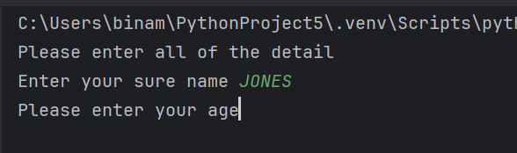
Result: Did the programme behave as expected ie syntactically and logically correct?
YES/NO (delete as appropriate)
If NO, what went wrong?
If YES, comment on what happened
Yes, it accepts any string the user enters; it is syntactically correct, and there is no validation of the surname.

Test:
Surname ii Leave blank

Screenshot(s) of output:
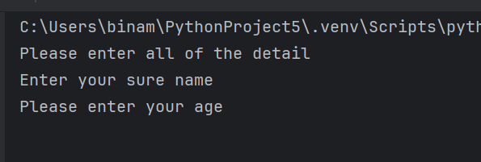
Result: Did the programme behave as expected ie syntactically and logically correct?
YES/NO (delete as appropriate)
If NO, what went wrong?
If YES, comment on what happened

No. The programme works; it accepts empty strings and is syntactically correct, but logically incorrect. It doesn’t check empty input, and it needs validation.

- Test: Enter A

Screenshot(s) of output:
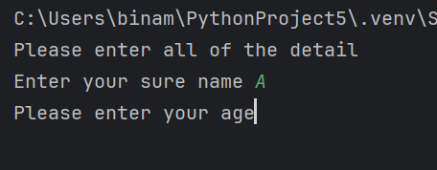
Result: Did the programme behave as expected ie syntactically and logically correct?
YES/NO (delete as appropriate)
If NO, what went wrong?
If YES, comment on what happened

Yes, it accepts the value, is syntactically correct and logically questionable (there is someone I know who is a comedian who uses one letter as a full name)

Continue the rest of the tests below. (Copy and paste a box for each one)

- Test: Enter 123

Screenshot(s) of output:
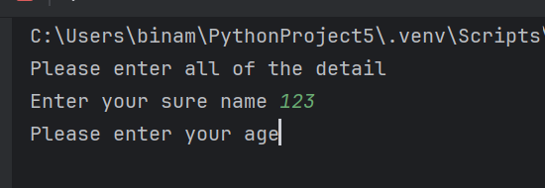
Result: Did the programme behave as expected ie syntactically and logically correct?
YES/NO (delete as appropriate)
If NO, what went wrong?
If YES, comment on what happened

No, it accepts because it doesn’t have validation; it is syntactically correct, but logically, a surname shouldn’t be a number.

- Test: Enter PE534121B

Screenshot(s) of output:
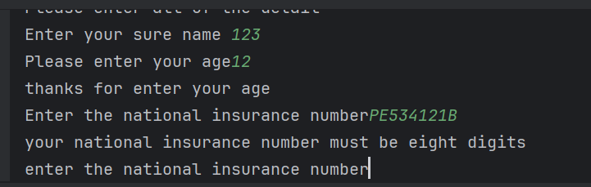
Result: Did the programme behave as expected ie syntactically and logically correct?
YES/NO (delete as appropriate)
If NO, what went wrong?
If YES, comment on what happened

NO, logically incorrect. NI numbers are 9 characters, not 8 digits. It won't pass validation (the validation rule won't accept it because it exceeds 8), but it is syntactically correct.

- Test: Leave blank

Screenshot(s) of output:
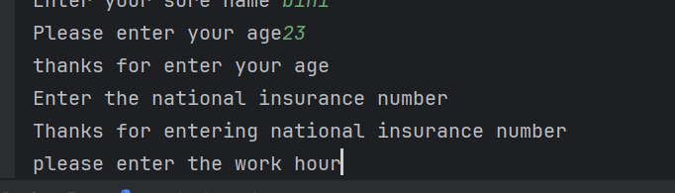
Result: Did the programme behave as expected ie syntactically and logically correct?
YES/NO (delete as appropriate)
If NO, what went wrong?
If YES, comment on what happened
NO, it accepts the validation but only checks for the length. It is syntactically correct. Logically incorrect blank NI should never be accepted.

Test: Enter AB11223344556677

Screenshot(s) of output:
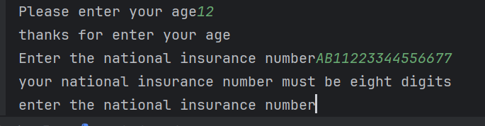
Result: Did the programme behave as expected ie syntactically and logically correct?
YES/NO (delete as appropriate)
If NO, what went wrong?
If YES, comment on what happened

NO, it won't pass validation (the validation rule won't accept it because it exceeds 8).

Test: Enter 22PE4088A

Screenshot(s) of output:
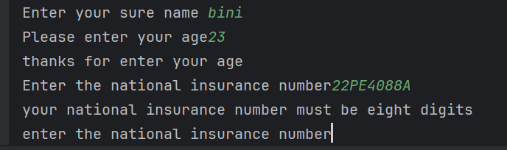
Result: Did the programme behave as expected ie syntactically and logically correct?
YES/NO (delete as appropriate)
If NO, what went wrong?
If YES, comment on what happened

NO, it won't pass validation (the validation rule won't accept it because it exceeds 8), not because of the wrong format.

- Test: Enter 34

Screenshot(s) of output:
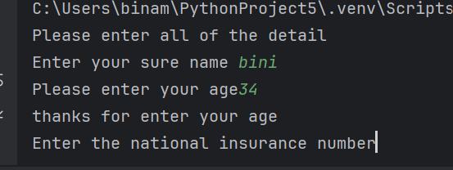
Result: Did the programme behave as expected ie syntactically and logically correct?
YES/NO (delete as appropriate)
If NO, what went wrong?
If YES, comment on what happened

Yes, it accepts the age, and the validation accepts it (between >0 and <100).

- Test: Enter 150

Screenshot(s) of output:
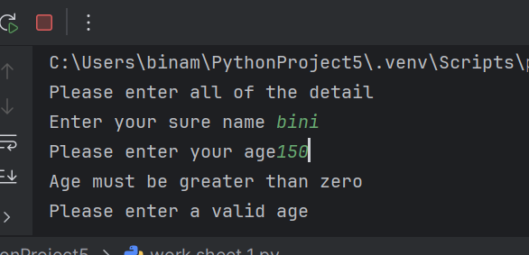
Result: Did the programme behave as expected ie syntactically and logically correct?
YES/NO (delete as appropriate)
If NO, what went wrong?
If YES, comment on what happened

No, it rejects the validation rule, but it clarifies the reason (age must be greater than zero). It is a syntactically correct and logically incorrect message.

- Test: Enter -4

Screenshot(s) of output:
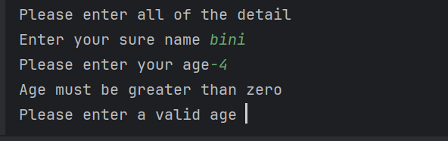
Result: Did the programme behave as expected ie syntactically and logically correct?
YES/NO (delete as appropriate)
If NO, what went wrong?
If YES, comment on what happened

Yes. It is syntactically and logically correct. Then it asks again for a valid age. It rejects the validation rule.

- Test: Enter a letter

Screenshot(s) of output:
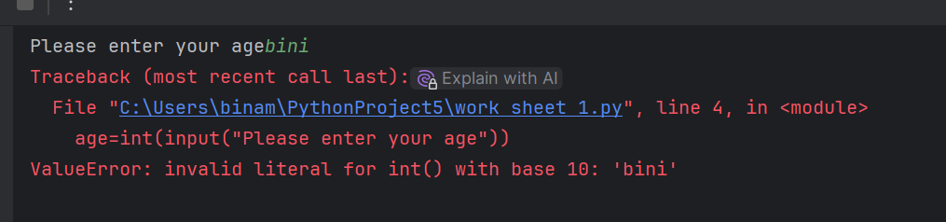
Result: Did the programme behave as expected ie syntactically and logically correct?
YES/NO (delete as appropriate)
If NO, what went wrong?
If YES, comment on what happened

No, it is an error or an invalid program crash. Set a rule to accept integers but not accept letters.

- Test: Enter 37.5

Screenshot(s) of output:
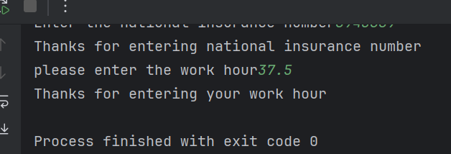
Result: Did the programme behave as expected ie syntactically and logically correct?
YES/NO (delete as appropriate)
If NO, what went wrong?
If YES, comment on what happened

Yes, it accepts without any problems, converts the input to a float, and applies the validation rule.

- Test: Enter 150

Screenshot(s) of output:
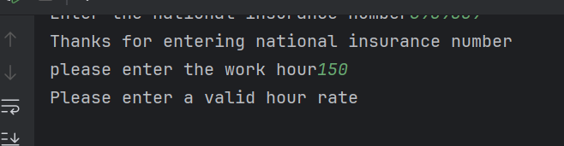
Result: Did the programme behave as expected ie syntactically and logically correct?
YES/NO (delete as appropriate)
If NO, what went wrong?
If YES, comment on what happened

No, it won't accept it because the validation rule (if workHour < 0 or workHour > 80).it is syntactically correct and logically incomplete; the user is not forced to re-enter a valid number

- Test: Enter 0

Screenshot(s) of output:
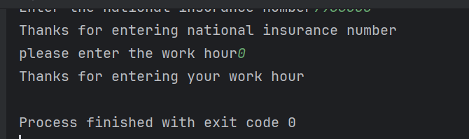
Result: Did the programme behave as expected ie syntactically and logically correct?
YES/NO (delete as appropriate)
If NO, what went wrong?
If YES, comment on what happened

Yes, it accepts validation between 0 and 80. It is syntactically correct but logically questionable, depending on whether 0 hours per week is valid.

- Test: Enter -2

Screenshot(s) of output:
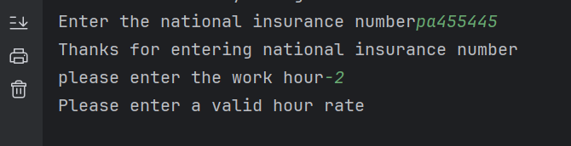
Result: Did the programme behave as expected ie syntactically and logically correct?
YES/NO (delete as appropriate)
If NO, what went wrong?
If YES, comment on what happened

YES, the program rejects; it is syntactically and logically correct. The validation is negative.

- Consider the results of the above tests and revisit your code in order to solve the problems. (Note: you may not be able to solve all of them, but solve as many as you can.)

Paste your revised code here:

[Copy and paste your revised code here – note, do not use a screenshot]
import math
print("Please enter all of the detail ")
sureName=input("Enter your sure name ")
while sureName=="" or not sureName.isalpha():
print(" Sure Name must contain letters only and can not be blank")
sureName = input("Please enter a valid Sure Name ")
print("Thanks for entering a sure name.")
age=int(input("Please enter your age"))
if age <0 or age>100:
print("Age must be greater than 0 and less than 100")
age=int(input("Please enter a valid age"))
else:
print("Thanks for enter your age")
nationalInsurance=input("Enter the national insurance number")
while nationalInsurance=="" or len(nationalInsurance)!=9 or not nationalInsurance.isalnum():
print("your national insurance number must be nine digits and can not be blank")
nationalInsurance=input("enter the national insurance number")
else:
print("Thanks for entering national insurance number")
workHour = float(input("please enter the work hour"))
while workHour < 0 or workHour > 80:
print("Please enter a valid hour rate")
workHour=float(input("please enter the work hour"))
else:
print("Thanks for entering your work hour")

