Cycle 1: Researching the learning: what, how and why am I teaching? Yasmin Scrine – 1902590
ecad4010-c May 2020
A critical analysis and evaluation of the observation research tool, ‘leuven scale’

Target 1 | Continue to develop my academic voice.
Target 2 | Include additional viewpoints to strengthen the discussion.

In this assignment I will compare a range of literature and evaluate the use of observation as a research skill in education, specifically the strengths and limitations of using the Leuven Scale. I have observed a travel agents role play video clip, involving three children, to find out what extent the role play environment provides opportunities for pupil’s involvement and learning (Department for Education, 2011). According to the Welsh Government (Curriculum for Wales 2015) the Foundation Phase environment should include a variety of indoor and outdoor experiences that promote independence and discovery. The curriculum encourages children to be creative and imaginative, using a blend of child-initiated and teacher-led activities. Kay (2012) and the Welsh Government (Curriculum for Wales 2015) believe practitioners need to understand children’s developmental needs to provide appropriate experiences and resources, based on their abilities, developmental stages and understanding; allowing children to become confident learners. Therefore, by practitioners observing children, they can provide suitable learning opportunities within the environment, which encourage development. This is supported by Miller and Pound (2011) who state that, schools with a ‘Reggio Emilia’ approach view the environment as the ‘third teacher’ because it provides stimulating and appealing experiences indoor and outdoor, that children can engage with. My observation specifically shows the importance of play for providing learning opportunities and experiences. According to Bruce (2011) play is vital for children to make connections and bring meaning to their learning independently. The Welsh Government (Curriculum for Wales 2015) considers play important to provide first-hand experiences; allowing children to practise and consolidate their learning by taking risks, solving problems, experimenting and making decisions. This suggests that play develops children’s understanding of themselves and their world, through discovery; which is important in The Foundation Phase Framework.
The Welsh Government (Education Wales, 2019) explains that the Foundation Phase is a progressive framework for three to seven year olds in Wales and although play is a central role in this framework, it includes seven Areas of Learning which propose to be delivered through stimulating activities and experiences. It is believed that practitioners are the ones who make a difference within education (Education Wales, 2018) with the support of the curriculum; suggesting that practitioners should provide suitable and stimulating experiences that extend children’s knowledge and skills further. In support of this, Vygotsky (cited in McLeod, 2018) states that social interactions precede development and proposed two theories; the ‘More Knowledgeable Other (MKO)’ and the ‘Zone of Proximal Development (ZPD)’. These both suggest that children need a skilful tutor who have more knowledge in the activity or subject; to help the child achieve a better understanding. The ‘ZPD’ “refers to the difference between what a learner can do without help and what he or she can achieve with guidance and encouragement from a skilled partner” (McLeod, 2019, https://www.simplypsychology.org/Zone-of-Proximal-Development.html). Therefore, this means that practitioners have a vital role to encourage and enable children to achieve higher development levels, than they can independently. On the other hand, Piaget (1936, cited in McLeod, 2018) believes that children learn best by discovering and actively exploring their environments themselves, because some things cannot be taught and must be discovered. Rousseau (cited in Kay, 2012) agrees, stating that children develop thinking and reasoning through play and therefore, should not be interrupted but only observed; to consider how children use their own knowledge. This allows children to independently explore their world and think differently for themselves. Play has been recognised to educate emotionally, socially, cognitively and physically and therefore is deemed of significant importance for children’s learning and development (Walsh, McMillan and McGuinness, 2017). Broadhead (2004, cited in Wood, 2013) also said that play is educationally purposeful and specifically, socio-dramatic play (including characters and roles) encourages representational thinking and symbolic actions. Broadhead (stated in Wood, 2013) also suggests that role-play, my observation focus, promotes high independence and creativity. However, Estyn (2017) reported that sometimes, schools misunderstand the importance and value of what children achieve through playing. Suggesting that, they view it as a time for children to play when they have finished their ‘real’ work or to let some steam off. This means that schools are not providing enough enriching experiences and resources within the environment. However, (Katz, 2008, p.147) argues that it is unclear what particular types of learning are supported by play and there is not enough understanding on how adults (parents and teachers) can maximise the learning potentials in the various cultural backgrounds, that children are growing up in. In saying this, the Welsh Government (2017) believes that observing play, enables practitioners to determine children’s developmental levels; which permits adults to enhance the curriculum areas of learning. This proposes that observation helps adults to gain an insight into children’s needs and abilities.
Observation is deemed as an important research tool for everyday practice in the Foundation Phase. The Welsh Assembly Government (2008) believe that observation allows practitioners to identify where children are on the continuum; in order to move them along by planning an appropriate curriculum, which provides suitable opportunities to consolidate their learning. This means, they can plan appropriately based on children’s learning preferences and interests. However, there are limitations to observation because if you focus too much on one thing it is possible to unintentionally miss/ignore other things. Everyone has different views, beliefs and biases, so it is inevitable that people will observe differently. Therefore, New South Wales (NSW) Government (2019) propose that observation needs to be planned carefully to ensure there is a clear understanding of the questions to be answered; ensuring that important information is not missed. The planning for my observation involved a schedule (see Appendix A) to ensure that I kept the focus on my research question and to define what I was looking at. It was important that I included the context of the lesson, the timings of the observation, additional comments and a reminder of the five-point involvement ‘Leuven Scale’ (see appendix B), because if anyone else was to undertake the observation it would be clear. In support of this, Denscombe (2014) suggests that good practice schedules ensure that all researchers look out for the same things and record data in a standardised fashion. Laevers (2011) explains that the ‘Leuven Scale’ focuses on two dimensions: ‘emotional well-being’ and ‘level of involvement’ of the learner; which refers to the child being at ease as well as showing concentration and focus. Laevers (2011) also suggests that deep learning occurs when high levels of both dimensions are evident and by observing children’s well-being and involvement; empowers practitioners to develop children’s potentials. However, before undertaking any observation, researchers must obide by ethical codes of practice. Shawa (2017) states that ethics are central in educational research and no research can be conducted without considering ethics.
“Ethics are a set of moral principles or norms that are used to guide moral choices of behaviour and relationships with others” (Gray, 2018, p.70). Ethical decisions are usually choices related to the balance between the benefit and risk of the research, guided by ethical guidelines. The ‘British Education Research Association (BERA)’ (2018) believes that researchers have a responsibility for participants who are involved in or touched by the research and should respect a person’s ethics. BERA (2018) also suggests that acquiring informed consent at the start of a research observation is essential; where the participants understand the research, data collected, the risks and give a voluntary agreement to participate. However, in a Foundation Phase setting, it is harder to gain consent due to their lack of ability to understand; being unfamiliar with research or even their circumstances. Sibley, Sheehan and Pollard (2012) argue that it is still ethically appropriate that children are involved in the decision making of the research participation, but at an appropriate level, even when relying on parents’ consent. BERA (2018) agrees by stating that participants whose capacity, age or other vulnerable circumstance may limit their voluntary agreement to participate; must be supported by those responsible for them. This is where researches gain ‘assent’ from parents/those legally responsible for the participant; in order to carry out the research study. Although, the participant would still be informed they are part of a study and what activities are expected of them. BERA (2018) also states that consent must be ongoing, and children should have the right to withdraw at any time; in a setting where participants are too young to socially respond researchers need to be mindful of their body language and behaviour. Having said this, to ensure research is ethical, it is recommended by (GOV, 2018) that a consent form is provided to participants or those responsible; with information needed about the research study and their own rights. A specific participant right within research is that of privacy. Howe and Moses (1999) explains that privacy is also central within ethical research, involving two principles; anonymity and confidentiality. To consider confidentiality, the researcher must ensure that any information which might identify the participant or allow them to be traced, is not disclosed. Anonymity is when the participant cannot be identified by anybody (including the researcher) from provided information. This suggests that, measures should be taken during observation research to protect participants and consider their ethical rights. This could be done by researchers not taking unnecessary information e.g. address, name, date of birth etc and anonymising data by changing the identifiers e.g. removing, substituting or generalising; ensuring a person’s identity is not directly or indirectly disclosed. UNICEF (1990) state that children have a right to privacy which shows the important role that ethics play in research; by considering ethics you would be adhering to participant’s rights. I considered the ethical rights in my observation schedule by ensuring that information collected; would not lead to identification of the participants and only collect relevant data. The data that I collected using the ‘Leuven Scale’ would suggest that children’s involvement whilst in a role play environment is high and learning is always evident. The scores were on the higher end of the scale throughout the observation, suggesting that a role play environment does provide learning opportunities. The American Academy of Paediatrics (2009) support this by stating that children learn life skills through play that teach them how to cooperate and when to lead or follow. It was evident that the children were learning language and social skills, showing the various learning opportunities in role-play. On the other hand, (Lewis, accessed 11/5/20) argues that children’s levels of well-being and involvement fluctuate throughout the day and so it is unrealistic to assume that children’s levels will always be high in role-play. This suggests that the ‘Leuven Scale’ does not always provide accurate data; the video clip I observed was a short clip, considering the amount of time children spend in school. Therefore, it may be more appropriate to carry out another research type as well as observation to gain a more accurate conclusion for the study. Considering the different views on conducting research via observation, would suggest that no research is perfect because they all have advantages and limitations.
Ultimately, the (OECD, 2004) report states that using the ‘Leuven Scale’ for well-being and involvement is the most economic way to assess the quality of an educational setting. Although, alongside (Kay, 2012), also suggests that involvement should include adults setting up a challenging but motivating environment, that encourages children’s development. I have found, using the ‘Leuven Scale’, that children engage well within role-play, but the environment should be carefully planned by a teacher, to provide the learning resources. In saying this, Appleby (2010) believes that practitioners need to reflect on their practice in order to make a difference in education. Through observation, practitioners can examine and listen to children to support their understanding of them; allowing them to test and reflect on their ideas in practice. Wenger (1998, cited in Appleby, 2010) proposed that reflecting on practice is a learning journey that never ends because practitioners’ thinking, and actions will always need to suit the children’s needs; which develops a sense of responsibility for the children’s outcomes. Therefore, this suggests that practitioners need to encourage development by ensuring the environment is appropriate, to maximise children’s learning in ways that grasp their interest and curiosity. However, using the ‘Leuven Scale’ is not enough for practitioners to reflect on practice and therefore, they should carry out more than one research study, involving qualitative and quantitative research. By using mixed methods of approaches it allows practitioners to gain deeper insights into the children. With this in consideration, I now understand the impact research has on reflective practice. Therefore, throughout my professional learning journey, I will consider the different research methods to help me transform my practice. If I was to undertake a research study in the future, I would like to focus on the play aspect in practice; ‘does outdoor play have more impact on children’s learning, than indoor play?’. I would aim to achieve findings for this research question by conducting various research studies that involve outdoor and indoor play, to explore if there is more impact on children’s learning from being outdoors.

References
American Academy of Paediatrics (2009) Healthychildren.org: Young children learn a lot when they play. Available at: https://www.healthychildren.org/English/ages-stages/toddler/fitness/Pages/Young-Children-Learn-A-Lot-When-They-Play.aspx (Accessed: 13th May 2020).
Appleby, K. (2010) ‘Reflective Thinking; Reflective Practice’ in Reed, M. and Canning, N. (ed.) Reflective practice in the early years. London: SAGE.
British Education Research Association (BERA). (2018) Ethical Guidelines for Educational Research 4th Ed. BERA: London. Available at: https://www.bera.ac.uk/publication/ethical-guidelines-for-educational-research-2018-online#participants (Accessed: 11th May 2020).
Bruce, T. (2011) Learning Through Play: For babies, toddlers and young children 2nd Ed. Hodder Education: London.
Denscombe, M. (2014) The Good Research Guide: For small-scale social research projects 5th Ed. Open University Press: England.
Department for Education. (2011) Early Years Foundation Stage: Children play at being travel agents [video] Available at: https://www.youtube.com/watch?v=yt69atPdg3I (Accessed: 1st May 2020).
Education Wales. (2018) The new national approach to professional learning for education practitioners in Wales [video]. Available at: https://www.youtube.com/watch?v=a4Ih2okz2dI (Accessed: 1st May 2020).
Estyn. (2017) Active and Experiential Learning: Effective Foundation Phase practice in delivering literacy and numeracy in Year 1 and Year 2. Available at: https://moodle.uwtsd.ac.uk/pluginfile.php/366015/mod_resource/content/2/Estyn%20Active%20and%20experiential%20learning_E_Accessible_1.pdf (Accessed: 8th May 2020).
GOV.UK. (2018) Getting informed consent for user research. Available at: https://www.gov.uk/service-manual/user-research/getting-users-consent-for-research (Accessed: 12th May 2020).
Gray, D. (2018) Doing research in the real world. London: SAGE Publications Ltd.
Howe, K. and Moses, M. (1999) ‘Ethics in Educational Research’, Review of Research in Education, Vol 24, pp. 21-59. Available at: https://www-jstor-org.ezproxy.uwtsd.ac.uk/stable/1167266?seq=1#metadata_info_tab_contents (Accessed: 12th May 2020).
Katz, L. (2008) ‘Play and Learning in Early Childhood Settings: International Perspectives’ International Journal of Early Childhood, 40(2), pp. 147-149.
Kay, J. (2012) Good Practice in the Early Years 3rd Ed. London: Continuum.
Laevers, F. (2011) ‘Experiential Education: Making Care and Education More Effective Through Well-Being and Involvement’, Encyclopedia on Early Childhood Development, 14th February. Available at: http://expertisecentrum.cego.be/wp-content/uploads/2019/07/Laevers_2011_ChildEncyclopedia.pdf (Accessed: 10th May 2020).
Lewis, K. (no date) Early Learning HQ: Ferre Laevers emotional well-being and involvement scales. Available at: https://www.earlylearninghq.org.uk/earlylearninghq-blog/the-leuven-well-being-and-involvement-scales/ (Accessed: 11th May 2020).
McLeod, S. (2018) Simply Psychology: Jean Piaget’s Theory of Cognitive Development. Available at: https://www.simplypsychology.org/piaget.html (Accessed: 4th May 2020).
McLeod, S. (2018) Simply Psychology: Lev Vygotsky. Available at: https://www.simplypsychology.org/vygotsky.html (Accessed: 5th May 2020).
McLeod, S. (2019) Simply Psychology: The Zone of Proximal Development and Scaffolding. Available at: https://www.simplypsychology.org/Zone-of-Proximal-Development.html (Accessed: 6th May 2020).
Miller, L. and Pound, L. (2011) Theories and Approaches to Learning in the Early Years. SAGE Publications Ltd: London.
NSW Government. (2019) Observation: a guide for use in evaluation. Available at: https://education.nsw.gov.au/teaching-and-learning/professional-learning/evaluation-resource-hub/collecting-data/observation#Advantages0 (Accessed: 10th May 2020).
OECD, (2004) Starting Strong, Curricula and Pedagogies in Early Childhood Education and Care: Five Curriculum Outcomes. Available at: http://expertisecentrum.cego.be/wp-content/uploads/2019/07/OECD_2004_FiveCurriculumOutlines.pdf (Accessed: 13th May 2020).
Shawa, L. (2017) Research Gate: Ethics in educational research. Available at: https://www.researchgate.net/publication/312069857_Ethics_in_educational_research (Accessed: 11th May 2020).
Sibley, A. and Sheehan, M. and Pollard, A. (2012) ‘Assent is not consent’, Journal of Medical Ethics, 38(1). DOI: 10.1136/medethics-2011-100317 (Accessed: 12th May 2020).

The Welsh Government 2015, Curriculum for Wales: Foundation Phase Framework. Available at: https://hwb.gov.wales/storage/d5d8e39c-b534-40cb-a3f5-7e2e126d8077/foundation-phase-framework.pdf (Accessed: 1st May 2020).
The Welsh Government 2017, Foundation Phase Profile Handbook. Available at: https://hwb.gov.wales/storage/f9d85dba-85a4-4e87-bb58-a24730ad7e57/foundation-phase-profile-handbook-revised-september-2017.pdf (Accessed: 6th May 2020).
The Welsh Government 2019, How is my child doing in the Foundation Phase: A guide for parents and carers. Available at: https://gov.wales/sites/default/files/publications/2019-07/how-is-my-child-doing-in-the-foundation-phase-a-guide-for-parents-and-carers.pdf (Accessed: 4th May 2020).
UNICEF (1990) A Summary of the UN Convention on the Rights of the Child. Available at: https://downloads.unicef.org.uk/wp-content/uploads/2019/10/UNCRC_summary-1_1.pdf?_ga=2.48305510.1557701983.1589371493-232177359.1580938287 (Accessed: 13th May 2020).
Walsh, G. and McMillan, D. and McGuinness, C. (2017) Playful Teaching and Learning. SAGE Publications Ltd: London.
Welsh Assembly Government. (2008) Observing Children. Available at: https://s3-eu-west-1.amazonaws.com/hwb-live-storage/a8/9c/a8/ee/f299432c801d025d875da415/observing-children.pdf (Accessed: 9th May 2020).
Wood, E. (2013) Play, learning and the early childhood curriculum 3rd Ed. SAGE: Los Angeles.

Images
Scrine, Y. (2020) Observation Schedule. Available at: https://uowtsd-my.sharepoint.com/:w:/g/personal/1902590_student_uwtsd_ac_uk/EQ1H9VtmkA9PqzMIHFtWmbgBvSfqbPeoqdzbhagUkRKmAQ?e=q6fn4h (Accessed: 11th May 2020).
Wells, R. (2015) The Leuven Scale for Involvement (in learning). Available at: https://eduwells.files.wordpress.com/2015/02/the-leuven-scale-for-involvement-ipadwells.jpg (Accessed: 11th May 2020).

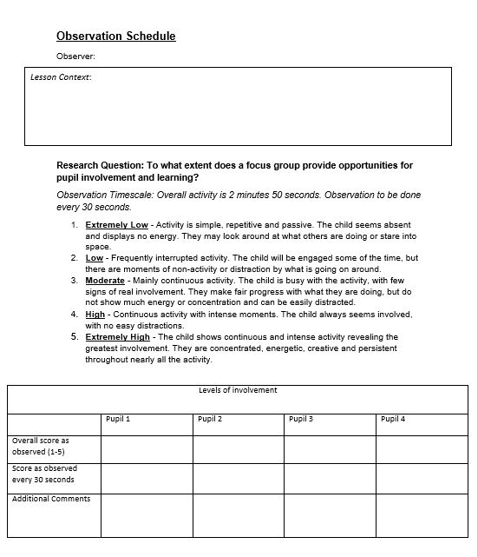
Appendices

Appendix A
Image: Yasmin Scrine (2020)
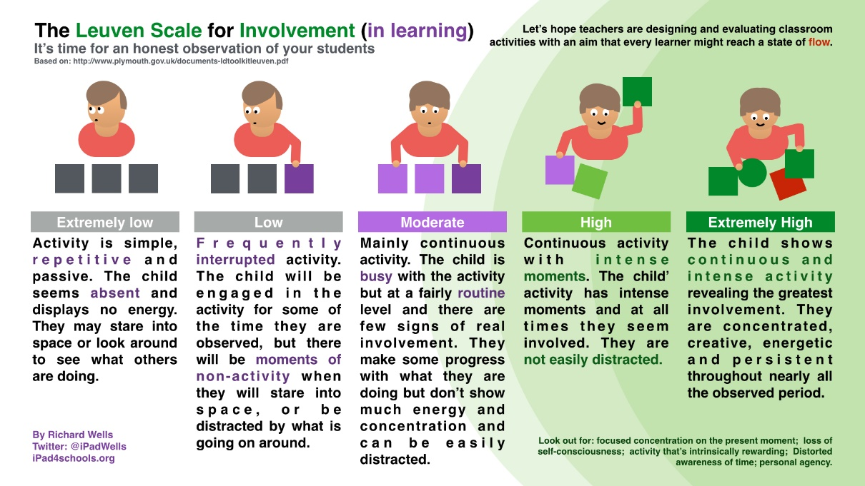
Appendix B
Image: EDUWELLS

