

Module Code: LCHS 4008
Module Title: Introduction to Public Health

Module Leader: Gillian Weaver
Assignment Title: Assessment 2 - Report on a Health Issue: Tuberculosis

Student Name: Nikita Nana Angelina Wilson
Student ID:

Table of Contents
1. Introduction 3
2. Critical Discussion of the Disease 4
2.1 Different approaches to measure and monitor these diseases 4
2.2 Disease control 4
2.3 Consequences of the illness on people in the community 5
2.4 Health and social care support services required to meet the needs of individuals affected by this condition within the community 6
3. Conclusion 7
Reference list 8

1. Introduction
Tuberculosis (TB) is a chronic infectious disease that is caused by the Mycobacterium tuberculosis bacterium (CDC, 2024). It occurs mostly in the lungs (pulmonary TB) but may also affect the kidneys, spine and the brain.
According to Mayoclinic (2025), the disease is mostly spread through airborne droplets, typically released from coughing and sneezing by an infected person. Common symptoms and signs include a continuous cough which lasts for over three weeks, chest pain, coughing up blood, fever, night sweats, fatigue and weight loss.
TB is considered to be one of the key public health issues worldwide. In 2024, it was estimated that 10.7 million individuals developed the disease, while a 1.23 million mortality rate has been evidenced, including 150,000 individuals who are living with HIV (WHO, 2025). Comparatively, in the UK, tuberculosis remains one of the highest rates of disease prevalence, especially in Western Europe, with 5,490 notifications from England in 2024 (GOV.UK, 2025). This has marked a 26% rise since the last two years (2022-2023). Further, London shows a record high of 20.6 per 100, 000 people, which highlights that TB is still serious in both the global setting and in the UK.
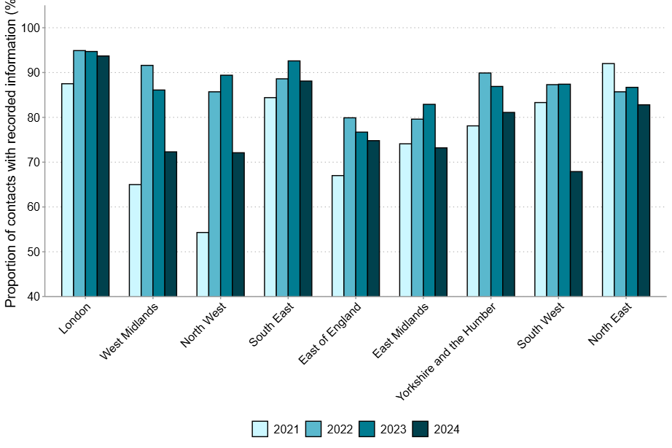
Figure 1: Recorded TB cases across England from 2021-2024
(Source: GOV.UK, 2025)

2. Critical Discussion of the Disease

2.1 Different approaches to measure and monitor these diseases
The monitoring of tuberculosis depends on a systematic surveillance & diagnostic procedure. Globally, as evidenced by the WHO (2024), TB surveillance is typically organised by the "World Health Organisation" (WHO) through its "End TB Strategy", which prioritises standardised measurement, including cases, electronic health records (EHR), and data collection through surveys on incidences such as deaths and drug resistance. According to Ajudua and Mash (2025), surveillance is the systematic monitoring, examination and recording of TB cases, where countries systematically monitor trends and assess various intervention strategies.
In the UK, TB monitoring is observed by the "UK Health Security Agency" (UKHSA) through statutory notification systems (Andrews et al., 2023). Clinicians need to inform the suspected TB cases within three days of diagnosis, which contributes to a quick response in terms of public health. The microbiological culture is the most common way of establishing a diagnosis, which provides detailed data regarding how to deal with drug resistance and the patterns of transmission. Further in the UK, the TB "Strategy Monitoring Indicators" are introduced, which enable the local health authorities to measure their performance against national targets, as well as compare prevalence rates regionally while measuring service requirements (PHE, 2025).
In essence, global surveillance, statutory notification, microbiological diagnostics, and performance indicators represent a holistic approach in society for detecting TB incidences, tracking the progression of the disease, and providing an appropriate controlling strategy.

2.2 Disease control
In the UK, the approach to managing TB is enhanced by the "National TB Action Plan" (GOV.UK, 2026). As explained by Zhao et al., (2025) the strategy aligns with the World Health Organisation's "End TB Strategy", thus signifying an integrated intervention for disease control. This plan has marked specific targets, such as reducing TB incidences by 90%, which includes mortality and morbidity.
As such, key control measures identified in the UK are:
- Statutory Notification - It is mandatory to report all suspected TB cases within three days (Andrews et al., 2023). Through this information, it can be stated that a prompt response from the community health and contact tracing can be undertaken.
- Diagnostic Testing - TB is confirmed by the microbiological culture and molecular diagnostic tests (for example, GeneXpert) (Zeka et al., 2021). This not only identifies drug resistance but also ensures a proper treatment regimen.
- Treatment Protocols - Based on the evidence by HIV.gov (2022), "Standard Therapy" is introduced for 6 months, depending on antibiotics (isoniazid, rifampicin, pyrazinamide and ethambutol), but the dosage might change in case of complications and symptoms. Besides, the "Directly Observed Therapy" (DOT) is used in specific instances for monitoring adherence (Stoner et al., 2022).
- Vaccination - Infants and high-risk groups, especially those in locations with higher incidences, for example, London, receive Bacillus Calmette-Guerin (BCG) to fight against the disease (Starshinova et al., 2025).
- Specific Interventions - Apart from the above measures, screening initiatives are also considered, which aim at the high-incidence groups, such as migrants in high-incidence regions, homeless people, and HIV-infected individuals.
- Public Health Campaigns - Awareness programs are meant to be used to discourage stigma, foster early diagnosis and adherence to treatment (PHE, 2025).
Nevertheless, in 2024, the number of TB cases in England increased by 26% compared to 2023 (GOV.UK, 2025). This evidence particularly implies that sustained vigilance, as well as improved interventions at the community level, are necessary.

2.3 Consequences of the illness on people in the community
Tuberculosis (TB) is a highly contagious disease that spreads beyond the physiological condition. The evidence provided by TB Alliance (2024), informs that TB impact individuals, families, and even communities. From an individual perspective, the disease is embedded in chronic ill health with the symptoms, which include chronic cough, fever, night sweats, and weight loss, thus causing fatigue and inability to perform any activities (Mayoclinic, 2025). Upon indicating the dilemma, the health regulatory bodies like the WHO and PHE necessitate a long treatment plan, which may range from 6 months to 2 years. However, adherence in most cases can be challenging due to certain factors, including socioeconomic status, lack of knowledge and others. Tiberi et al., (2022) explained that treatment in drug-resistant TB is even more complicated, lengthy and accompanied by serious side effects. This is a significant burden to patients, who often experience stigmatisation, isolation, and psychological trauma. Besides, misconceptions about the disease, HIV complications, and poverty further added to the disparity.
Apart from the individual effect, in the case of a family, TB increases financial distress. As demonstrated by TB Alliance (2024), income loss under critical health conditions, medical costs, dietary needs and frequent hospital visits are unprecedented challenges for deprived communities in the UK. Children, on the other hand, are often burdened with family responsibilities to provide care to TB patients rather than schooling (Atkins et al., 2022). Overall, this implies that families with TB patients experience a cycle of events, which creates disadvantages for the household.
Further, TB presents a significant challenge to the community. Since the disease is contagious, the infection is transmitted in the form of air droplets; therefore, overcrowded living places, homelessness, and migration are predisposing factors (CDC, 2024). High-TB communities are characterised by poor health services, since the resources needed are allocated for diagnosis, treatment, and prevention (Chilala et al., 2024). Moreover, vulnerable populations such as migrants, homeless individuals and immune-compromised people are disproportionately affected by the disease, making health disparities worse.
At a global level, TB is one of the leading causes of mortality. Correspondingly, in the UK, the disease continues to be highly-incidental, thus indicating that continuous vigilance is mandatory. The social stigma surrounding TB adversely impacts individuals' perception of seeking early medical attention, thus complicating the treatment process. Hence, it can be stated that the impact of TB is not only a physical but also a social and economic issue, thus reinforcing the strength of the integrated provision of health and social care to address these issues.

2.4 Health and social care support services required to meet the needs of individuals affected by this condition within the community
Patients with tuberculosis (TB) in the UK need both health care expertise and social support. As reported by NHS (2026), clinical care is available in NHS TB clinics, which offer diagnostic testing, treatment, and monitoring. Correspondingly, the 6-month antibiotic treatment provided to patients, and support aided by the "Directly Observed Therapy" (DOT), act as strategic imperatives to oversee the intake of medication to eliminate drug resistance (HIV.gov, 2022).
In addition to medical care, the public health departments play a vital role in contact tracing, screening people at risk (for example, migrants, homeless individuals and people with HIV), and offering vaccination (such as BCG) when needed. Social care services, further evidenced by Starshinova et al., (2025), are more comprehensive, such as helping homeless people with proper housing, dietary counselling, and psychological aid to alleviate stigma and isolation.
Apart from the already implemented measures, "Integrated Care Pathways" (ICP) is a suggested approach in TB treatment and prevention. Bousquet et al., (2024) explained that ICPs guarantee coordination among hospitals, GPs, social workers, and voluntary organisations, which allows patients to receive medical and social support. This holistic approach is necessary to enhance the recovery process, lower transmission rates, and address health inequalities in the UK communities.

3. Conclusion
Tuberculosis is one of the major health issues among the population of the UK and worldwide. Although the disease can be prevented and treated, the evidence demonstrates the significance of effective surveillance, early diagnosis, and efficient methods of treatment. The disease affects individuals not only with long-term illness and stigma but also by increasing economic and social pressures on families and societies. In the UK, increasing incidence rates indicate that vigilance, interventions and a combination of health and social care support are required for effective disease management. Further, to mitigate transmission rates, enhance patient outcomes, and reduce inequalities for better TB treatment, an integrated holistic care approach is needed.

Reference list
Ajudua, F.I. and Mash, R. (2025) ‘Implementing active surveillance for tuberculosis: A quality improvement project.’ South African Family Practice, 67(1). Available at: https://doi.org/10.4102/safp.v67i1.6106
Andrews, F.M., Welch, S., Scandrett, K., Kaur, H., O’Shea, M.K. and Dedicoat, M. (2023) ‘Outcomes of TB contact tracing and predictors of success: a 10-year retrospective cohort analysis in Birmingham, UK.’ International Journal of Tuberculosis and Lung Disease, 27(10), pp.766–771. Available at: https://doi.org/10.5588/ijtld.22.0575
Atkins, S., Heimo, L., Carter, D., Ribas Closa, M., Vanleeuw, L., Chenciner, L., Wambi, P., Sidney-Annerstedt, K., Egere, U., Verkuijl, S., Brands, A., Masini, T., Viney, K., Wingfield, T., Lönnroth, K. and Boccia, D. (2022) ‘The socioeconomic impact of tuberculosis on children and adolescents: a scoping review and conceptual framework.’ BMC Public Health, [online] 22(1). Available at: https://doi.org/10.1186/s12889-022-14579-7 [Accessed 11 March 2026]
Bousquet, J., Schünemann, H.J., Sousa-Pinto, B., Zuberbier, T., Togias, A., Samolinski, B., Bedbrook, A., Czarlewski, W., Hofmann-Apitius, M., Litynska, J., Vieira, R.J., Anto, J.M., Fonseca, J.A., Brozek, J., Bognanni, A., Brussino, L., Canonica, G.W., Cherrez-Ojeda, I., Cruz, A.A. and Vecillas, L. de las (2024) ‘Concepts for the Development of Person-Centered, Digitally Enabled, Artificial Intelligence–Assisted ARIA Care Pathways (ARIA 2024).’ The Journal of Allergy and Clinical Immunology: In Practice, [online] 12(10), pp.2648-2668.e2. Available at: https://doi.org/10.1016/j.jaip.2024.06.040
CDC (2024) About Tuberculosis. Tuberculosis (TB); CDC. https://www.cdc.gov/tb/about/index.html [Accessed 11 March 2026]
Chilala, S.B., Silumbwe, A., Zulu, J.M., Tetui, M., Bulawayo, M., Chewe, M. and Hangoma, P. (2024) ‘Individual, community and health systems factors influencing time to notification of tuberculosis: situating software and hardware bottlenecks in local health systems.’ BMC Health Services Research, 24(1). Available at: https://doi.org/10.1186/s12913-024-11697-3
GOV.UK (2025) TB rates in England continue to increase in 2024. [online] GOV.UK. Available at: https://www.gov.uk/government/news/tb-rates-in-england-continue-to-increase-in-2024 [Accessed 11 March 2026]
GOV.UK (2026) 1. Tuberculosis incidence and epidemiology, England, 2024. [online] GOV.UK. Available at: https://www.gov.uk/government/publications/tuberculosis-in-england-2025-report/1-tuberculosis-incidence-and-epidemiology-england-2024 [Accessed 11 March 2026]
HIV.gov (2022) Mycobacterium tuberculosis Infection and Disease | NIH. [online] clinicalinfo.hiv.gov. Available at: https://clinicalinfo.hiv.gov/en/guidelines/hiv-clinical-guidelines-adult-and-adolescent-opportunistic-infections/mycobacterium [Accessed 11 March 2026]
Mayoclinic (2025) Tuberculosis. [online] Mayo Clinic. Available at: https://www.mayoclinic.org/diseases-conditions/tuberculosis/symptoms-causes/syc-20351250 [Accessed 11 March 2026]
NHS (2026) NHS England» National latent tuberculosis infection testing and treatment programme. [online] www.england.nhs.uk. Available at: https://www.england.nhs.uk/ourwork/prevention/tuberculosis-programme/national-latent-tuberculosis-infection-testing-and-treatment-programme/ [Accessed 23 March 2026]
PHE (2025) Public Health Profiles. [online] Phe.org.uk. Available at: https://fingertips.phe.org.uk/profile/tb-monitoring [Accessed 11 March 2026]
Starshinova, A., Kudryavtsev, I., Rubinstein, A., Dovgalyuk, I., Kulpina, A., Churilov, L.P. and Kudlay, D. (2025) ‘BCG vaccination: historical role, modern applications, and future perspectives in tuberculosis and beyond.’ Frontiers in Pediatrics, 13. Available at: https://doi.org/10.3389/fped.2025.1603732
TB Alliance (2024) Cycle of Poverty - TB Alliance | Putting science to work for better, faster TB cures. [online] TB Alliance | Putting science to work for better, faster TB cures. Available at: https://www.tballiance.org/why-new-tb-drugs-cycle-poverty/ [Accessed 11 March 2026]
Tiberi, S., Utjesanovic, N., Galvin, J., Centis, R., D’Ambrosio, L., van den Boom, M., Zumla, A. and Migliori, G. (2022) ‘Drug resistant TB – latest developments in epidemiology, diagnostics and management.’ International Journal of Infectious Diseases, [online] 124. Available at: https://doi.org/10.1016/j.ijid.2022.03.026
WHO (2024) TB mortality estimates for the End TB Strategy 2025 milestone and 2030 target assessment: data sources, analytical methods and process Background document 2, for meeting of WHO Global Task Force on TB Impact Measurement. [online] Available at: https://cdn.who.int/media/docs/default-source/hq-tuberculosis/global-task-force-on-tb-impact-measurement/meetings/2024-09/background-documents/background2-tbmortalityestimates-v1.pdf?sfvrsn=9bd8ad55_3 [Accessed 11 March 2026]
WHO (2025) Tuberculosis. [online] World Health Organization. Available at: https://www.who.int/news-room/fact-sheets/detail/tuberculosis [Accessed 11 March 2026]
Zeka, A.N., Tasbakan, S. and Cavusoglu, C. (2021) ‘Evaluation of the GeneXpert MTB/RIF Assay for Rapid Diagnosis of Tuberculosis and Detection of Rifampin Resistance in Pulmonary and Extrapulmonary Specimens.’ Journal of Clinical Microbiology, 49(12), pp.4138–4141. Available at: https://doi.org/10.1128/jcm.05434-11
Zhao, C. Y., Song, C., Lu, Y. B., Huang, A. C., Zeng, C. M., Liu, R. H., Li, W. W., Xie, Z. H. and Zhu, Q. D. (2025) ‘A New Era in Tuberculosis Prevention and Treatment: Breakthroughs in Drug Development and Future Prospects.’ Infectious Diseases and Therapy. Available at: https://doi.org/10.1007/s40121-025-01221-3

