Name: Owain Maybanks
Student number: 1706433
User Experience Design
M5X01239
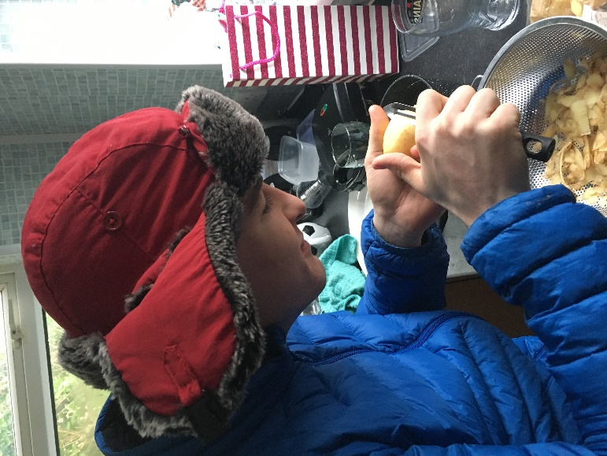
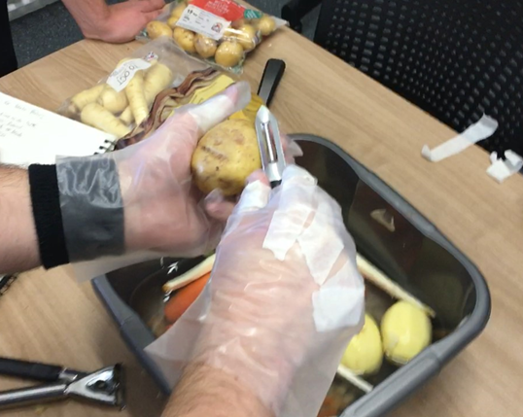
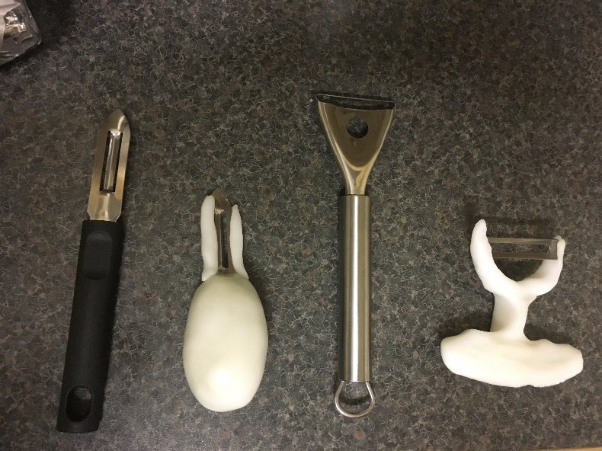
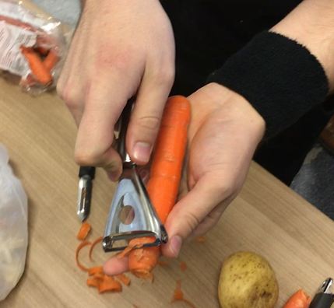
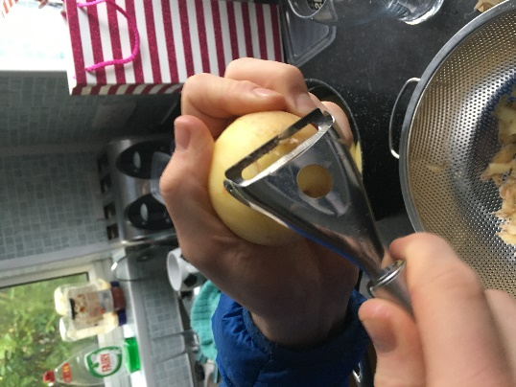
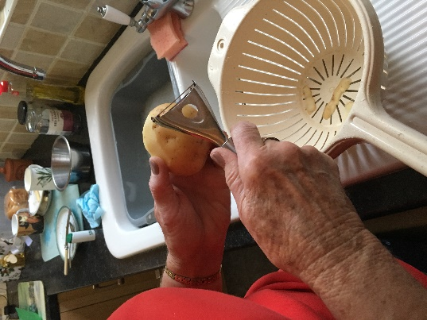
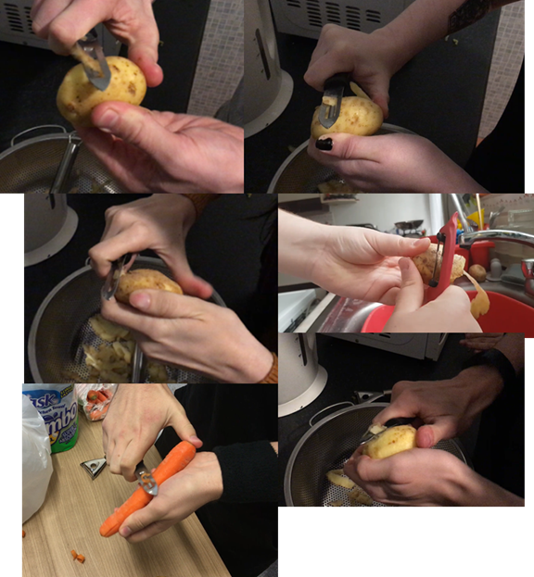
Word count: 2158
Contents
Introduction
Overview of current peelers
Health issues and Empathy testing
Design issues with current peelers plus focus group feedback
New peeler designs
Test method
Statistics
Conclusion and Evaluation
Appendices

Introduction
The aim of this report is to highlight and identify the problems with the current design of two potato peeler types, then with this knowledge we will be able to design and make new versions of these peelers that have been designed to be better than their previous counterparts. This will be done using various methods such as empathy modelling, user testing and statistical analysis to gain a result conclusion as to what is needed in a peeler and how the original design can be changed.
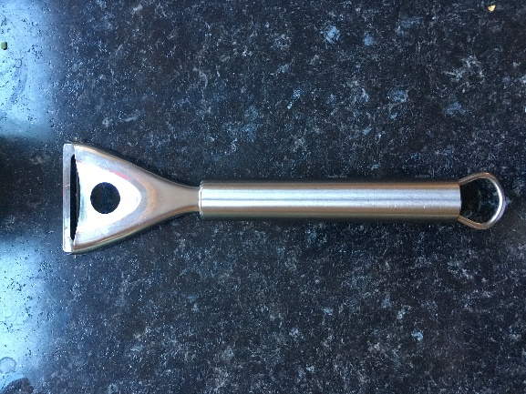
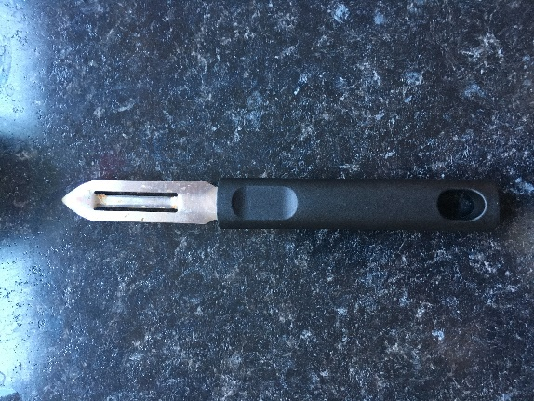
Peeler Type 1
Weight: 23g
Materials: Plastic handle, stainless steel blade
Peeler Type 2
Weight: 53g
Materials: Stainless steel blade, metal handle possibly aluminium.

Current Peelers
The two standard peelers purchased were from two separate retailers, as to not be bias towards one shop and because one of these shops only had one peeler in stock. Peeler 1 was brought from Wilkinson’s, a much cheaper product only costing 60p this was chosen for the example and testing during this assignment. Peeler 2 was purchased from Tesco, more expensive than type 1 costing £3, costing more because of the materials it is made from. Both peelers have a very simplistic design with a straight rounded handle with a hole at the end for it to be hung up. Peeler 1’s hand is the only peeler out of the two with any sort of grip in the handle in the form of the indentation near the blade, this is repeated on the back as well. Both have been designed for all round use by everyone without taking specific groups of people or people with health issues into consideration.

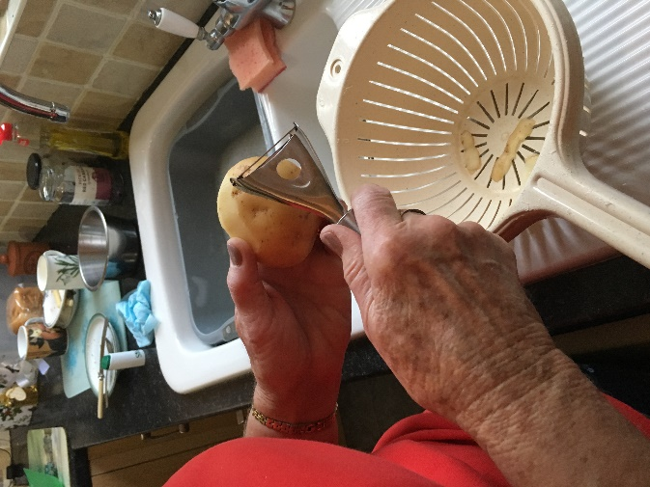
Health Issues
These peelers should not and are not difficult to use for someone with no medical conditions restricting hand and joint movement. But peelers aren’t just being used being by people with full use of their hands. Osteoarthritis is the most common form of arthritis, it causes swelling of the finger joints, inflammation, a reduction in joint movement and pain caused by exposure of small nerves in the joints. Older people are more likely to develop arthritis therefore a larger percentage of older people may find using one or both standard peelers hard to use. Other conditions similar to osteoarthritis include stenosing tenosynovitis, also known as trigger finger, the most frequent cause of this is prolonged exposure to vibrations. This can cause pain and stiffness in the fingers effected.
This can make holding, gripping and using a peeler very difficult, these conditions had to be considered during the research and development stage of designing a new peeler. So that the new peelers would be suited and usable for a wider range of users.
Empathy Testing
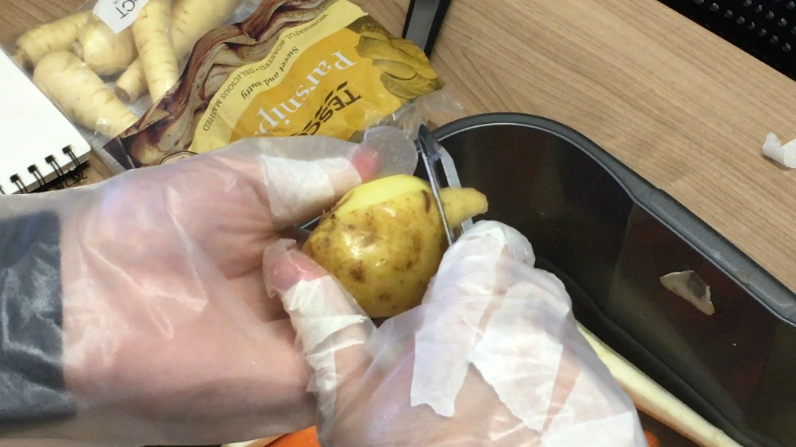
Empathy testing helps designers gain a deeper understanding of the problems and realities of the people being designed for. It involves learning about the difficulties people face as well as the needs they have in a product. Allowing the designer to get close to experiencing the problems people have without having a disability or problem, in this case arthritis. This was done by wrapping tape around finger joints and wearing plastic gloves to simulate lack of joint movement and reduced tactile senses.
Design Issues
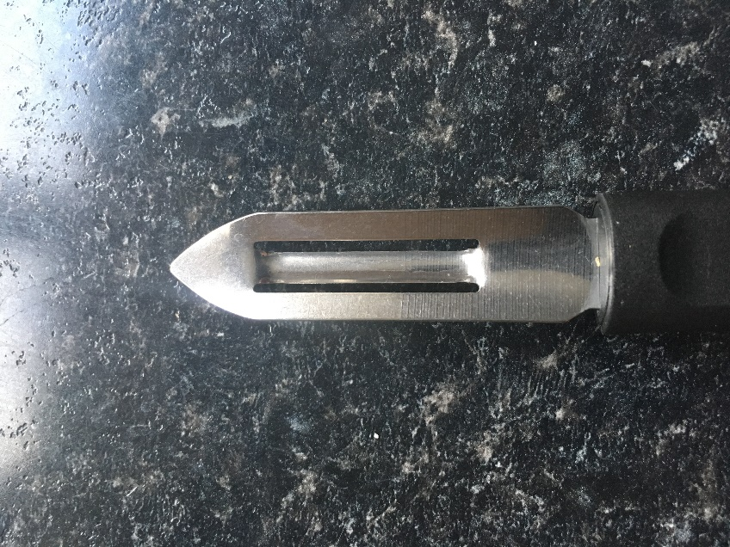
During the research stage of this project, a few issues were found in the design of the original two peelers.
Peeler 1:
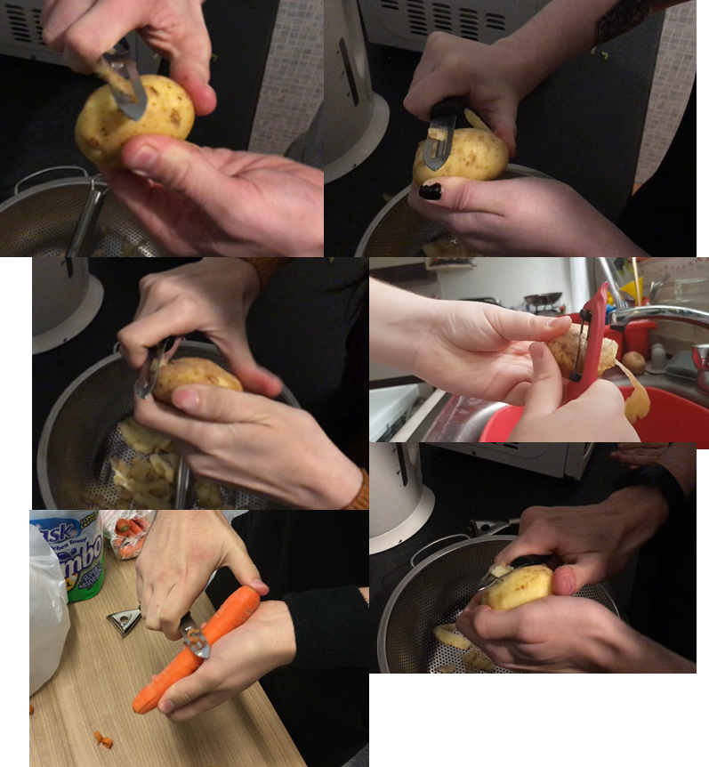
When testing with this peeler and questioning those who used it, many of them found that this peeler was not sharp enough and required a lot of force to peel the skin from a potato, however its more accurate when peeling compared to the standard type 2 peeler. Also, after observing several people use this peeler, similarities began to appear in the way they held the peeler and the item being peeled.
Due to the shape of this particular type of peeler a few of testers felt that they might cut themselves while using it. This was addressed in the development of the next type 1 peeler by having the metal blade more protected.
One person, part of the focus group, is 80 years old. She said that she prefers peeler type 2, due to her hands becoming more and more arthritic because of this she can’t hold peeler 1. But that doesn’t mean that she doesn’t have trouble holding peeler 2 because of the handle size and her arthritis. However, when she was younger, she always used to use peeler 1.
This shows arthritis has an effect on the type of peeler someone would use.
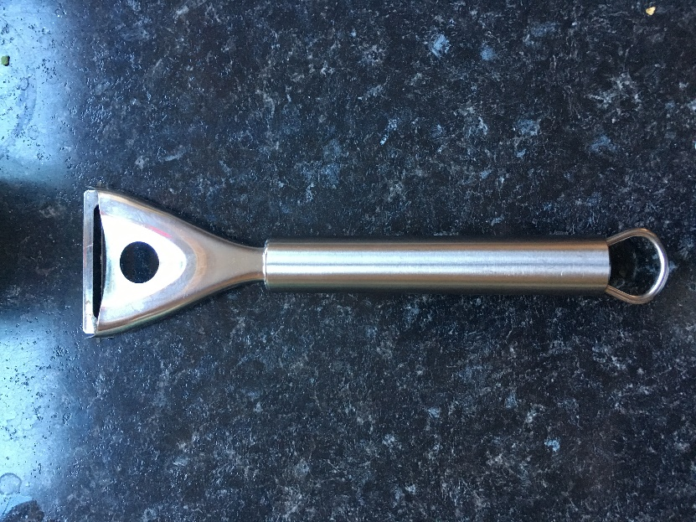
Peeler 2:
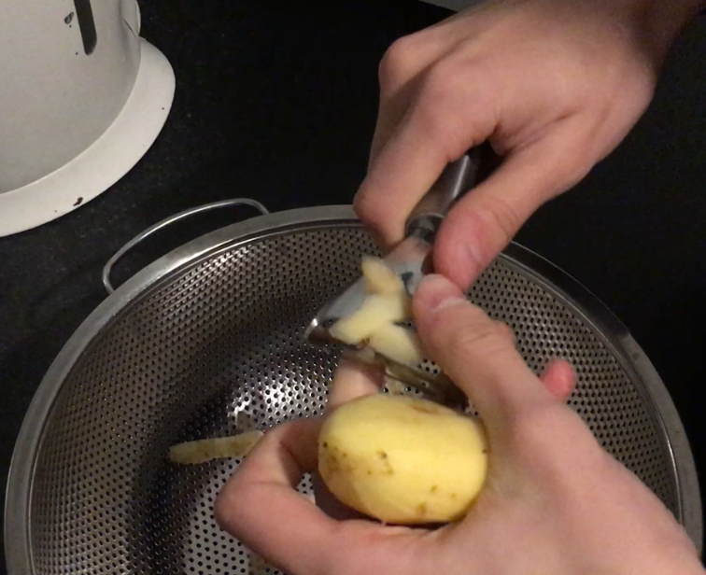
This peeler has a cylindrical handle made of metal with not grip patches, ridges or indentations for fingers to go. There is no specific part on this peeler of the user to remove eyes and brown patches, therefore a knife is needed to remove these areas or more potato is removed to get at these areas, increasing waste. The rotating peeler blade turns between two points, it wont rotate 360degrees, this can cause the gap between the blade and the metal holding it to become clogged up with peeling. Meaning the blade will get stuck in a position that won’t peel. But apart from that this peeler has no real problems if the blade doesn’t get stuck.

Focus Group feedback on these peelers:
Krystian, 19:
Type 2, 100%
It’s slightly more awkward to use than type 1 but it’s much safer and hence I can peel a potato faster despite having to move the peeler around a bit because I don’t have to worry about cutting myself.
It’s fine with standard roundish potatoes but more weird shaped ones that have bits sticking out, type 1 would probably be more useful. However, I feel that I don’t come across weird potatoes often, so I prefer peeler type 2.

Paulina, 19:
I use peeler type 1 because it’s easier to use and I can’t use the other one. I peel away from myself because it’s easier and safer.

W. Jones, 80:
I use a Type 2 type peeler because as my hands get more arthritic I can't grip and peel with the other one. I even have trouble with the silver one now because I can't hold the potato properly with my left hand and often manage to scrape a bit off my hand. When I was younger, I always used the Type 1 peeler. The handle of peeler 1 is better, it has the thumb grip part.

Jack, 19
I prefer this peeler type 1 because its more accurate even though it takes a little longer to peel the potato.

Beth, 22
Don’t really like this peeler. Its hard to use and I feel it removes too much potato with the skin. (Peeler type 2) Peeler type 1 is utterly shocking.

New designs
Research, testing and development led to new ideas with the peelers that have changed and improved the way we use them.
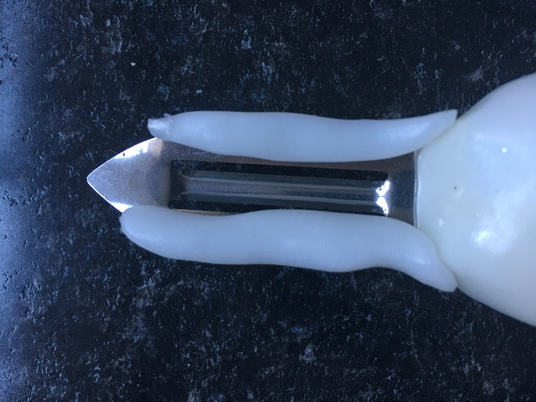
New peeler type 1:
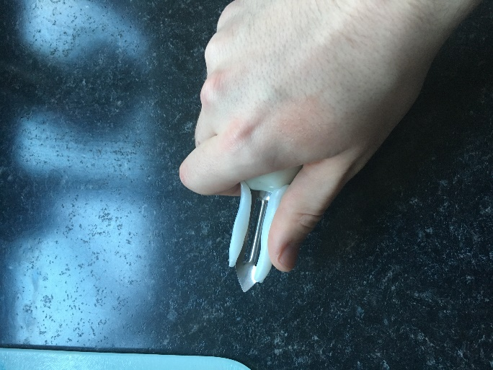
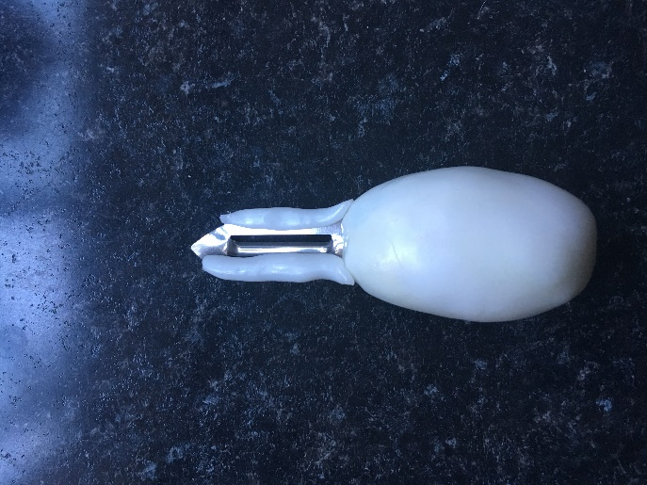
This design has a much more rounded shape compared to the original type 1 peeler, this lets it fit into the hand of the user much easier. Its wider handle means less grip strength is needed to hold the peeler in one’s hand therefore it’s much more suitable for someone with a condition such as arthritis to use because they wouldn’t have to bend their fingers around a thinner handle. In addition to this, rounded strips of plastic line the sides of the metal peeler to protect the user’s fingers from being cut, this was added because of member of the focus group feeling they might cut themselves on the peeler. This also makes the peeler more comfortable to hold while in use.
This prototype weighs 86 grams which is 43 grams heavier than the original version

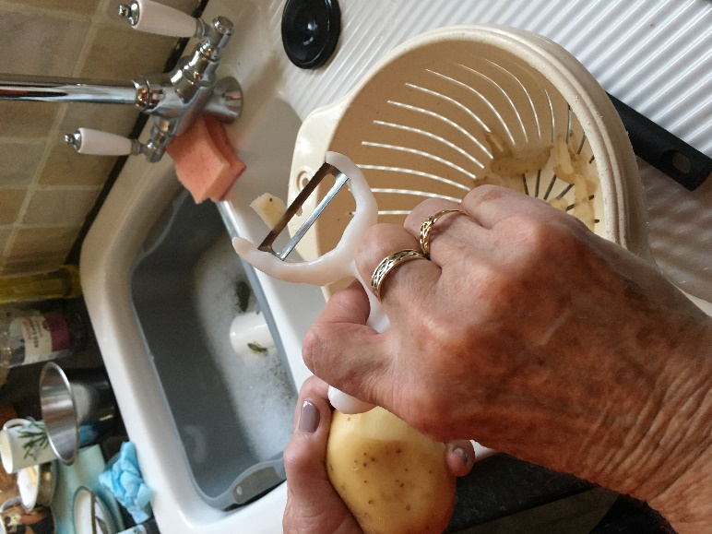
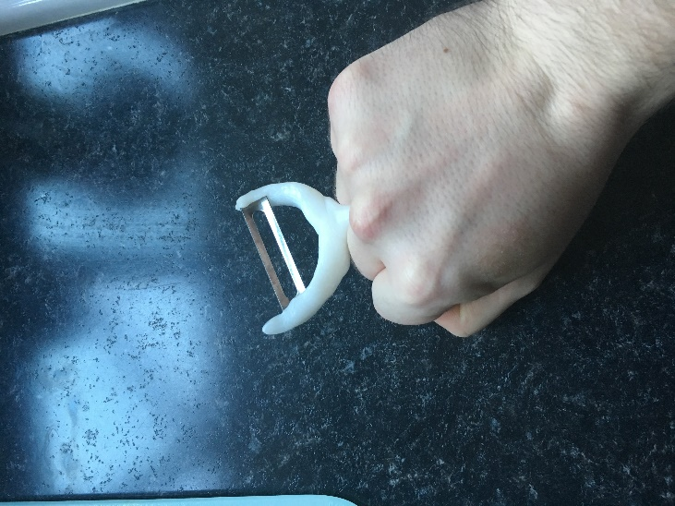
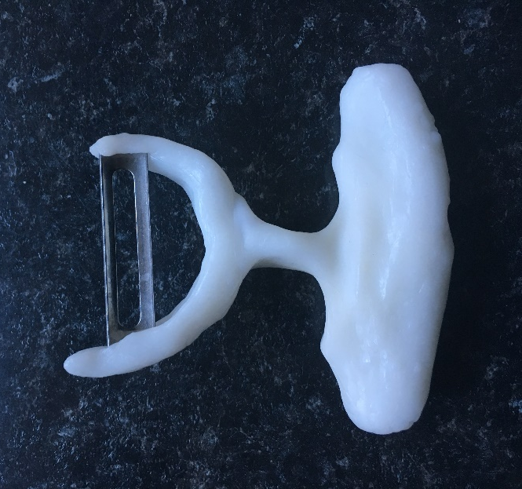
New peeler type 2:

This peeler can be held in a few different ways depending on the persons grip strengths and finger positions, an example of this can be seen in the pictures above. One person may hold it with the peeler sticking through the middle and ring finger, while another holds it between the middle and index finger. The peeler is usable by both left handed and right-handed people. This peeler, unlike its previous version has a sharp pointed tip on the left of the peeler blade which is used for removing potato eyes, brown patches or mouldy areas of what needs peeling.
This prototype weighs 49 grams which makes it slightly lighter than the original by 4 grams.

Test method
The testing done involved for all four peelers to gain an overview and comparison over both generations of peelers. Before testing four potatoes of similar shape, size and weight(grams) would be selected for use, testing would then begin with the user being timed using the originals of either peeler type 1 or 2. Once the first potato has been peeled the time taken is recorded, the end weight of the potato is also recorded and subtracted from the starting weight to give us the weight of the amount of waste produced (Start weight – end weight = waste produced), next use fills out the questionnaire about their experience using the peeler. The questionnaire contains the Likert scale which is a scale used to determine the attitudes of people towards a topic, in this case the scales are used to find out people’s views on the function, aesthetics, usability, effectiveness and efficiency. The age and gender of the person testing is also recorded for basic biographical data but also to see if there is a correlation between the age of the user and the time it takes to peel a potato.
After both the original peelers have been tested with and all the information is recorded, the new peelers get tested in the exact same way under the same conditions to reduce any change in variables.
Testing should be done in an alternating order between the peelers type 1 and 2 e.g. Type 1, type 2, type 1 new, type 2 new. This helps reduce any transfer effects between the peelers and how the user peels with them.
The Likert Scales on the questionnaire only contain four points on it, instead of a typical five, because it stops people from voting in the middle with a neutral vote. Meaning they must give a positive or negative response to the question. 1 being the least positive result, 4 being the most positive result.
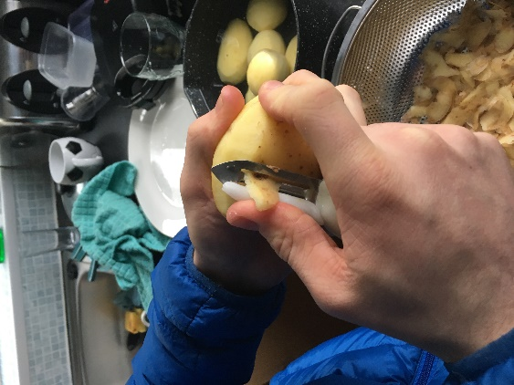
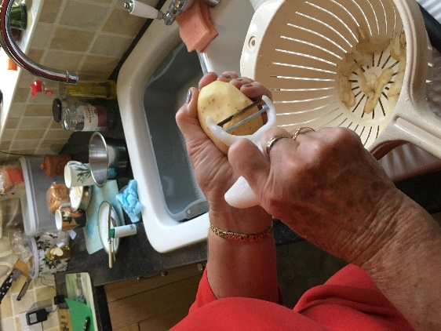
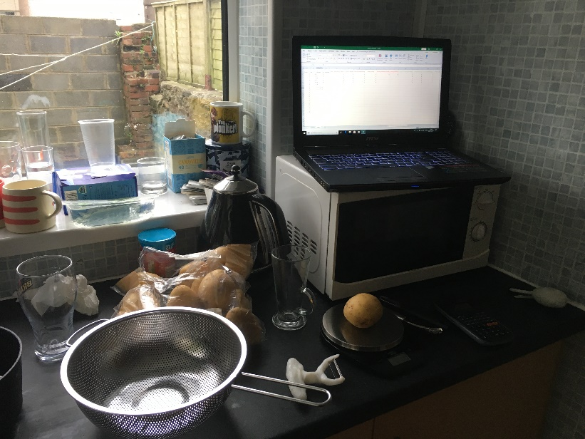

Statistics
Mean age: 32
Average peeling time:
- Original peeler type 1- 67 seconds
- Original peeler type 2- 93.45 seconds
- New peeler type 1- 79.09 seconds
- New peeler type 2 – 97.70 seconds
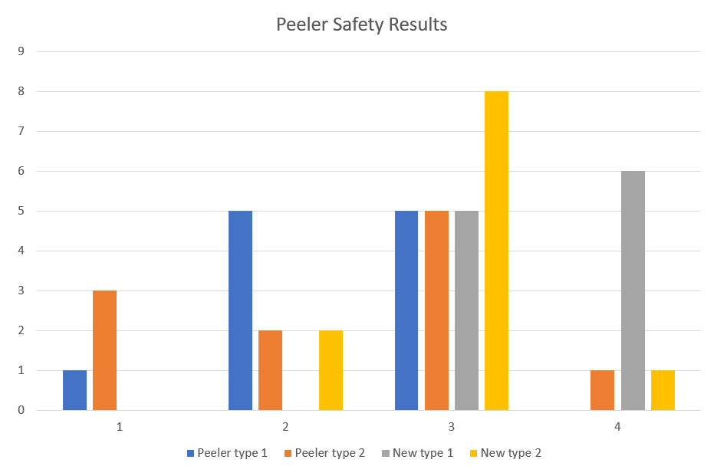
There clear differences between the results from some of the peelers.
The newer peelers where found to be a lot safer to use than the originals. More people gave higher, much more positive votes on the Likert scale for safety on the new peelers compared to the originals.
1-4 are the Likert Scale points

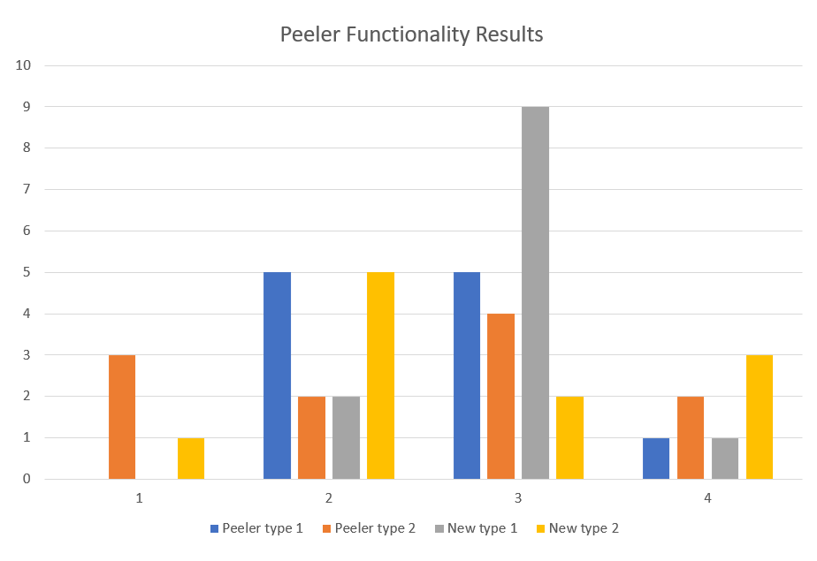
All four peelers are functional, the focus group and testers agreed that the new version of peeler type 1 is more functional than its previous version and the new peeler type 2 as well. With very few low opinions and a high percentage of positive opinions.
1-4 are the Likert Scale points
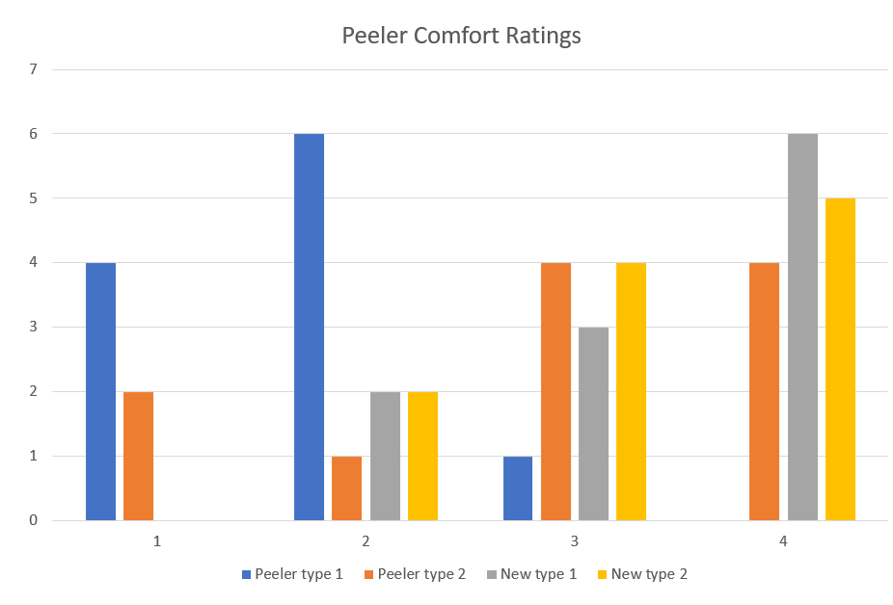
There is a definite relationship between the user comfort and user safety, both new peelers 1 and 2 have high safety ratings which are then reflected in the comfort ratings. A near direct correlation.
1-4 are the Likert Scale points

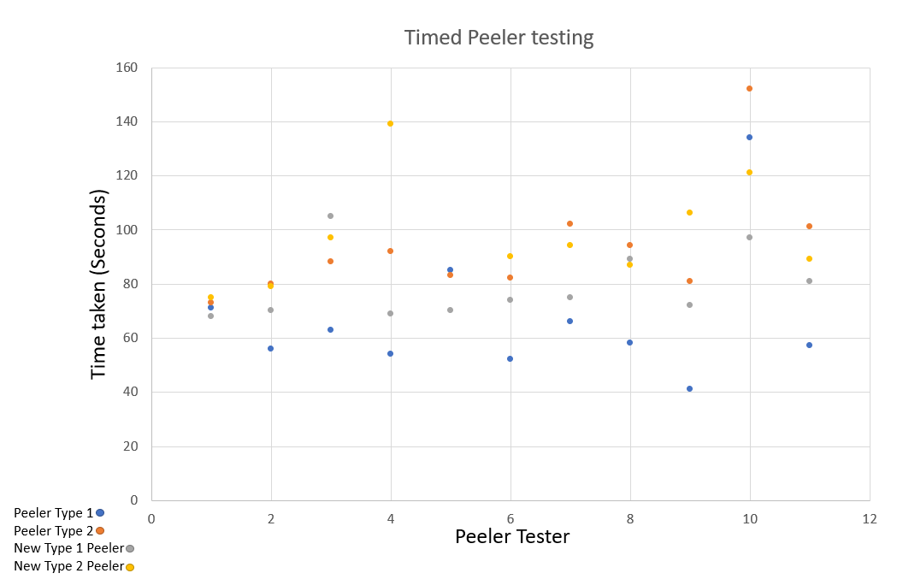
Overall the original peelers are a lot worse in terms of user design, comfort and safety but they still function as peelers in the way they were intended to. Sometimes giving a low mark might either be because the user was not experienced in using that specific type of peeler, or the quality of peeler was not the best.

Conclusion and evaluation
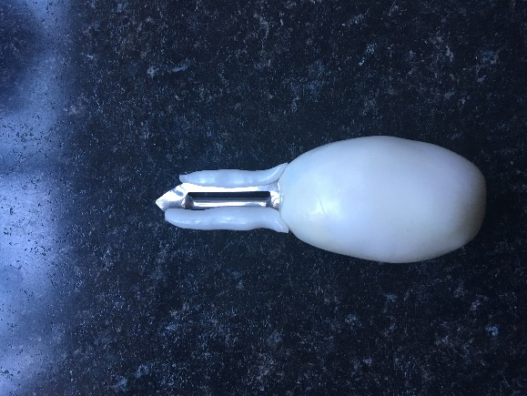
To conclude the results of the designing, testing and evaluation the best design is the new design for peeler 1. It has best results from the user testing with a lot of more positive opinions than all the other peelers across the board. Its only fault is the amount of past it produces while peeling but after looking at original peeler type 1’s results both exhibit high waste. This is most likely due to the blade shape itself. But other than that, this peeler is the best design.

Test method improvements
The Likert Scale could be changed to include more points as to get a more defined, precise opinion from the tester. Instead of four opinion points possibly have six, possibly seven to include the middle neutral vote but with a more points for positive and negative opinions it might not be selected as often.
Make sure to have enough potatoes and things to peel for the testing section.

Future design improvements
- Wrist strap in case the peeler is dropped.
- Different shaped peeler blades

Appendices
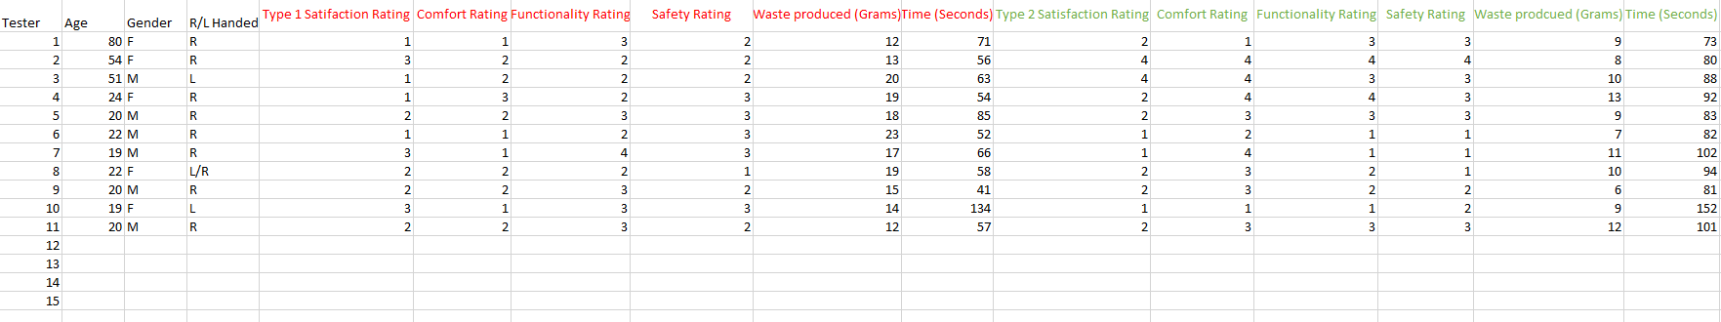
Raw data from testing and questionnaire
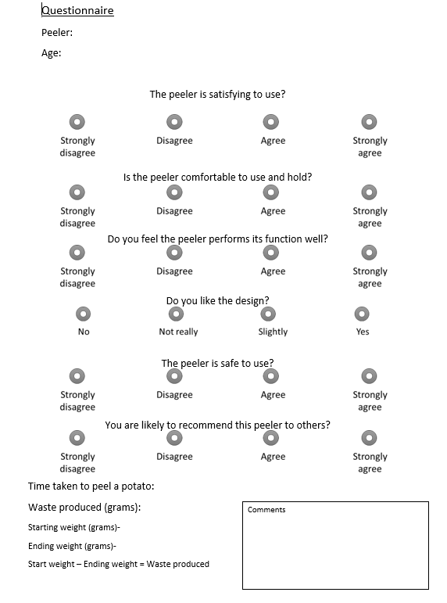
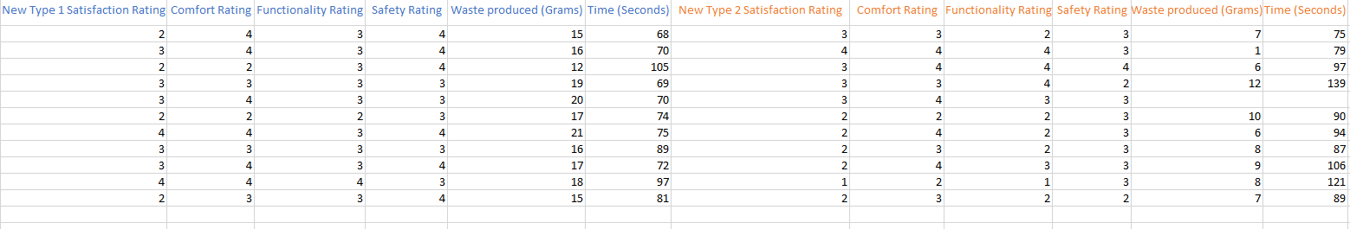
References:
https://www.nhs.uk/conditions/osteoarthritis/
NHS website for information on arthritis.
Questionnaire

