

Name: Irina Merlan
1818268
Lecturer: Husam Helmi
07.05.2020

Table of content

- Define a complex problem in the workplace including its scope and impact(motivation in the workplace) 1-2 slides
- Analyze information on the identified problem 1-2 slides
- Propose a range of alternative solution to the problem 1-2 slides
- Use a decision-making technique to evaluate a range of solutions to identify the most appropriate option 1-2 slides
- Develop a plan for implementing the solution 1-2 slides
- Communicate the plan to stakeholders 1-2 slides
- Assess appropriate , monitoring and review technique to ensure successful implementation of the solution 1 slide

1.Introduction

One of the most complex problems at the workplace is motivation. It can be seen either to an employee’s eyes or to an employer’s eyes in different ways. I will analyse the motivation in both ways. I can say that motivation at the workplace is one of the most important achievements that an employer can have because it can help both the employer and the employee to achieve their goals.
As an employee you can see different issues either simple or complex in the workplace. People tend to do three things when faced with a problem:
- they can get either afraid or uncomfortable and they wish it would disappear;
- they feel that they need to find a solution and it must be the proper answer
- they search another person to blame

Most of the time two reasons appear which explain why we tend to see a problem as a problem: firstly because the problem needs to be solved and we're not sure about a way for the most pleasant solution. Therefore will most likely appear conflicts about which is the best arrangement that needs to be made. The vast majority of us will be "strife disinclined". We don't feel good managing strife and we will in general have the inclination that something awful will occur. The major goal for a decent critical thinking process is to make us and our organization more "clash amicable" and "struggle equipped" so as to consider a to be as something worth being thankful for and to grasp its comprehending on the grounds that they happen constantly and they are chances to improve the connections between employees.

2. Analyse information on the identified problem 1-2
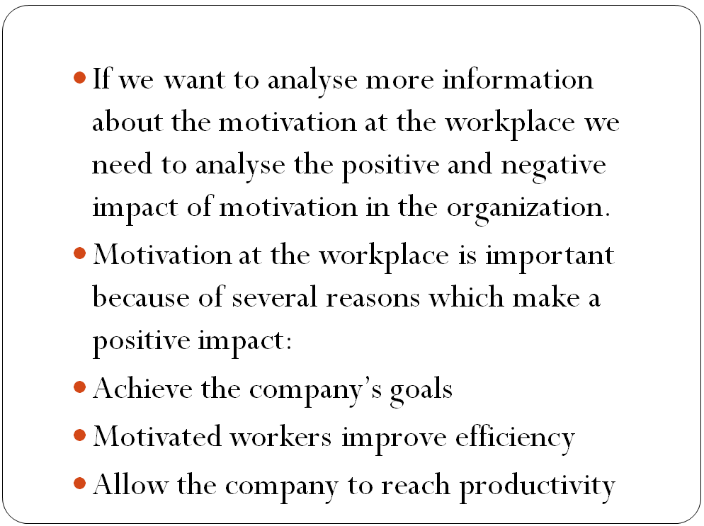
In order to recognize such a dynamic problem in the workplace we need to examine more about the positive and negative impact of motivation in the organization and how to address certain issues which are relevant to the efficiency of any business-related operation.
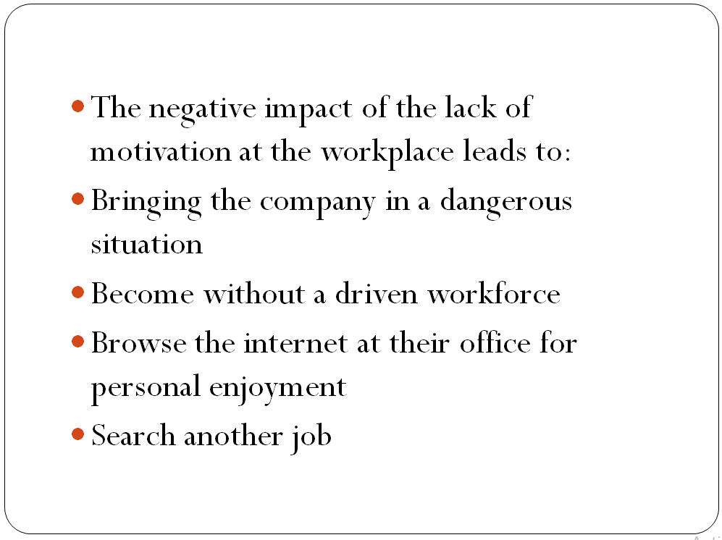
There are several reasons why motivation is important for the employees. This is particularly because it helps managers to achieve the company’s targets because we realize that corporations will be put in danger or in a very precarious situation without a driven workforce if they are taking out some action with persons. Motivated workers will bring in improves efficiency and allow an enterprise to reach higher production rates. Imagine getting an unmotivated staff. They are likely to use the opportunity to browse the internet at their office for personal enjoyment or even to search for another career.
3. Propose a range of alternative solution to the problem
Here are three quick actionable strategies to improve employee motivation in the workplace:
Improve communication
The best way to improve the employee motivation is by constructive on-the-job interactions. Never depending entirely on emails so ensuring that they communicate to their staff in person and, if necessary, at personal level.
Seek to set aside any time a day to speak with employees or you should join them at coffee breaks instead of staying at your office. By doing so, you actually make employees feel like you are part of the team; a leader rather than just the boss. Experts agree that communicating with a team is extremely valuable.
Employees also want to see that the business that they work with to prosper. Most of them have outstanding concepts and ideas, varying from money saving to operational improvements. The management wants to make an attempt to inquire and listen to suggestions. Nothing is better than feeling valued.
Value individual contributions
Management should ensure that the staff is aware of how their individual efforts and contributions plays an important part of the overall goals and direction of the company. Employees can take pleasure and in their jobs because they are conscious of how their actions create an impression for the business; no matter how large or small their contributions are.
Management will not have to compensate its staff with present each time they do a successful job on a mission. Sometime, a quick “Thank You” or “Good Work” would also be enough. Such important words appreciate commitment, create morale and inspire workers to work much harder.
Positive workplace environment
Often employees lose their motivation because there is no positive work climate for their working. To remedy this, management should send out surveys and get input from workers to address the challenges they might be experiencing
Management may even add a good quotation or image which is noticeable near the copier, coffee machine or somewhere else that is visible and which attracts heavy foot traffic so that everyone can see. Flora and fauna also tend to build a healthy work atmosphere for the staff, so why not throw a few plants around the room. Management should also consider innovative ways to keep their workers motivated as much as possible.
4. Use a decision-making technique to evaluate a range of solutions to identify the most appropriate option
As a decision making technique I have used the cause and effect analyse and I have made a cause and effect diagram for one of the most complex problems at the workplace and it is the lack of Motivation at the workplace. I have decided to use this analysis because it creates a picture in my mind of what is happening and why and I can focus on which are the causes for the problem.
I think that three of the most common causes for the lack of motivation at the workplace are related with CHALLENGE, DEVELOPMENT and OPPORTUNITY. An individual may not feel motivated it he is not challenged, if he can’t develop during his activity at the company or if he can’t receive any opportunity in which he can start to feel motivated.
He can’t feel challenged if he can’t recognise which are the core values of the company and how to base his actions on them. That stops the leading people to create a positive company culture. Feedback makes employees feel important in shaping the company culture and even in self-development in the business. If employees don’t receive a feedback they don’t understand exactly what is wrong or right in their actions or how to become better and to be productive. The lack of recognition and rewards leads to unmotivated employees because they are not challenged in being recognised for their work.

Walk the walk is one of the most effective engagement and management tactics to lead by example. An employee can’t develop if the leading team is not providing a good example of leading. There are some incompetent employers which don’t use the employee advocacy program. This program should engage employees throw content and to the values and the culture of the company.
If an employee doesn’t receive any opportunity it is an issue for him to be motivated at the workplace. Usually, if they feel rejected or left behind because they receive wrong answers is one of the negative impact for lack of it.
Another issue for the opportunity is synchronization: if the time isn’t right or it may look like it take too long to wait for something to happen. Poor communication can lead to lack of opportunity because if employers don’t in having an open communication and so the employees feel unvalued.
Another issue for poor communication is wrong usage of technology or the fact that they don’t use it at all to communicate. It has been proven that having shared technology will boost networking and effective communication.

5. Develop a plan for implementing the solution
I want to develop a plan because I want to start to implement a solution to bring the motivation at the workplace. The method that I am using for implementation is the ADKAR process because an organization change can be represented in 3 stages of change: current state, transition state and future state.
If the gap is: | Corrective actions:
Awarness | Management needs to improve the communication with the employees and to explain the positive and negative impacts face-to-face.
Desire | Management need to search for the causes of the lack of motivation and they were identified with the cause and effect diagram.
Knowledge | Management needs to invest in training for employees in order to help them with self-development and change.
Ability | Management needs to encourage employees with rewards & recognition on training stage and afterwards.
Reinforcement | The right leading team can sent the right message to employees and it will discover any gaps and change what is wrong.

6. Communicate the plan to stakeholder’s 1-2 slides
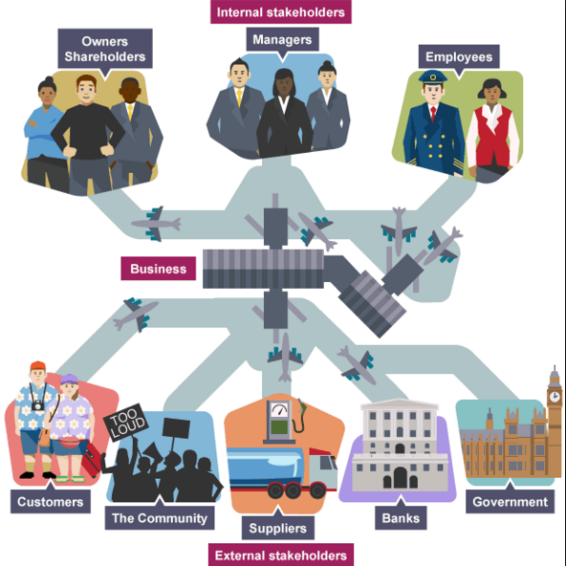
In order to achieve the main goal for implementing the solution which was found by using the ADKAR method, the main thing is about communication as it was found as a cause of the lack of motivation at the workplace. Poor communication is the main issue in every interaction between individuals, especially in a business. As we know, for a business to gain it’s goals it has to work not only between employees and employers, but to communicate effectively with internal and external stakeholders.

That means that the leading team need to communicate and to develop relationships with stakeholders. Two-way communication is a good way in which we can lead to a better understanding. We can use dialogue, face-to-face communication and negotiation. Another important cause of the lack of motivation is the lack of feedback so we must monitor it not only for employees but also we need to analyse what is the feedback that we are receiving from internal or external stakeholders. That means to develop a base for discussion and action which can lead to productivity and effectiveness and to implement the solutions for the problem.

7. Assess appropriate, monitoring and review technique to ensure successful implementation of the solution
The environment inside which an organization works isn’t static and the interests and power of internal and external stakeholder groups will change after some time so a normal review of stakeholder connection is fundamental if we want high power and high interest.
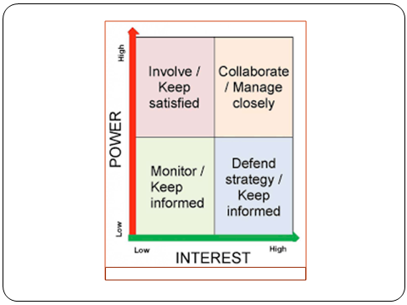
Monitoring or reviewing the changes the accurate tracking systems should be confirmed and developed (Shapira, 2013). We need to monitor their feedback, to keep informed by having two-way communication. We need to involve in building a strong relationship with stakeholders and we need to collaborate with them and we need a strong management which can lead effectively and manage closely any defending strategy for the business.

- Conclusion
If we want to identify a complex problem at the workplace we can say that is not an easy task and it take necessary courses of actions. In order to solve such a complex problem as motivation at the workplace we need to implement a plan in a effective way and to manage to use all the tools and methods that we have. Since I have used the cause and effect diagram to search for all the causes of the issue and after I have found the main causes, I have used the ADKAR method to implement the plan successfully. Of course that any other monitoring and reviewing techniques were shown as in the graph bellow and are shown there to be sure that we can finish successfully the process of problem solving and decision making for the business.

- References
- Leonard, B. (2017). Multidimensional decision making. Emerald.
- Shapira, Z. (2013). Organizational decision making. Cambridge University Press.
- Allwood, C., &Selart, M. (2016). Decision Making. Springer Netherlands.
- Adair, J. (2012). Decision making and problem solving.
- Daft, R., & Lane, P. (2015). Leadership. Cengage Learning.
- Dery, D. (2013). Decision-making, problem-solving and organizational learning. Omega, 11(4), 321-328. https://doi.org/10.1016/0305-0483(83)90025-7
- Helfand, M. (2017). Shared Decision Making, Decision Aids, and Risk Communication. Medical Decision Making, 27(5), 516-521. https://doi.org/10.1177/0272989x070270050101

