Jenson Davies (2316793)
[Email address]
2316793
Computing (Data & Information Systems)
Introduction to web and datbase concepts - coursework
Jenson Davies

L4 - Introduction to Web and Database Concepts
Contents
L4 - Introduction to Web and Database Concepts 1
Investigation 2
Database Design and Implementation 4
Application of Database Management System 6
Report Design 9
Forms Design, User Interface and Menus 11
Section B 14

Investigation

Wales is an ever-growing tourist destination for many across the world; as a result, businesses that specialise in tourism in Wales are implementing Database Management Servers (DBMS) in order to deal with the numerous records that these organisations hold. I will be creating a DBMS for a costal tourism company called “Costal Getaways”. The aim of this system is to allow tourists, local businesses and database administrators to use a system that is tailored towards the costal tourism experience.

Section A:
1.
A plethora of different types of users will be accessing the database for different needs. One type of user that will be using the database is tourists. These users will be provided with tools that will allow them to effectively make bookings for specific locations. The database will include a registration form that will allow the tourist to create an account, it will also allow them to view costal packages that highlight their price and availability, so that they can decide what reservations that they want to make on the reservation form that will be included. This form will also accurately automatically calculate the total cost for the customer's booking. Furthermore, contact information such as the company’s phone number or email address will be on display so that customers can contact the company if they have any questions, and there will be an option to leave a review on their experience which will be used to help the company improve upon itself.
Another type of user that will use the database is database administrators. This type of user will be able to view all of the contents of the database, make queries on the database, and make changes such as edits, deletions and creations of new tables, reports and forms within the database. The database administrator will have access to the majority of the tools in the database, as it is their responsibility to maintain the database and its data so that it is useful for the business.
Another type of user that will be using the database is local businesses. Local businesses will be able to add information to the database that relates to their business and what they have to offer to tourists. The information may include the business’ name, location and what they do.

2.
One department that will be using the database is database administration. Their responsibility will be to ensure that the database is properly maintained and optimised, in order to ensure that the database is useful for the business and that the data is reliable. So that the administrators can do this they will need access to all of the tools available within the database so that they can carry out the maintenance to its full extent.
Another department that may use the database is the customer support department. They will need viewing access to the customer’s reviews and feedback, as well as their name, contact information and booking details as long as it is not an anonymous review. This is so that they assist tourists with any potential issues that they may be having. This access will also allow them to identify potential areas for improvement for the business and what aspects of the business customers enjoy.
Another department that may use the database is the customer booking department. They will need access to all reservation data and will have access to change data such as availability and price. This department will need to update the availability of packages and change the price if necessary; they will also need to ensure that customers are informed of any changes with their bookings or if there are any issues.

Database Design and Implementation

3.
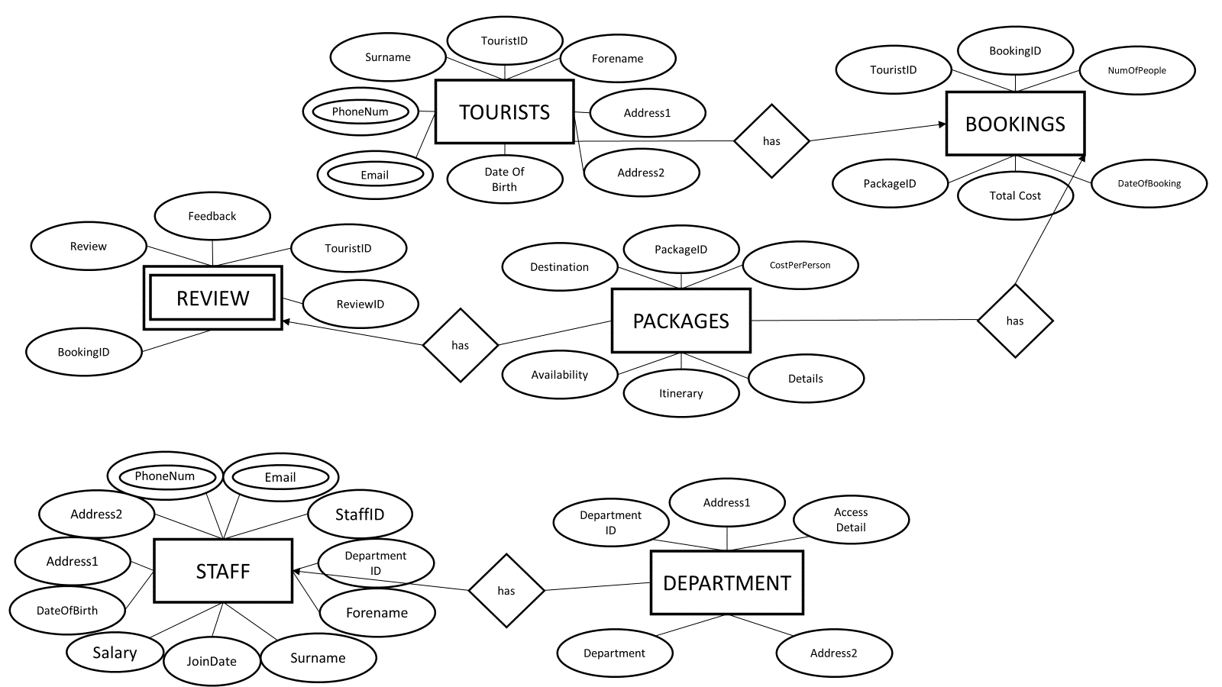

In my database design I included 6 tables that I thought would be necessary for the CTMS, these tables being: Tourists, bookings, review, packages, staff and department. I included a tourist table as the database will be used by tourists to make reservations; the tourist table includes a variety of needed information such as the tourists' name and contact information so they can be contacted. The tourist table includes two multi valued attributes, “PhoneNum” and “Email”; this is due to the fact that the tourist may have multiple phone numbers or email addresses that can be used to contact them. In addition, the staff table also includes these same attributes for the same reason. In the staff table, I included attributes that I thought would be relevant to their job, for example, personal information, the date at which they were hired and their salary. I also included a foreign key in the form of “DepartmentID”, that forms a relationship with the department table, where a department can have many staff. The department table includes attributes that highlight where the staff work and what access rights they have.
Moreover, I also included a booking table, this table will allow the tourist to make reservations; the tables have a relationship where tourists have bookings. In the booking table, it includes the number of people in the booking, the date of booking, the package id, the tourist id and an automatic calculation of the total cost of the booking.
Furthermore, I also included a packages table, this table included information on the cost of the package, availability, the location and itinerary. They were included as it is the information that best helps the user decide where they want to go. The package table can have reviews on it, and the package table can also have bookings.
Additionally, I also included a review table, where the user can leave a rating and provide feedback on their booking.
4.
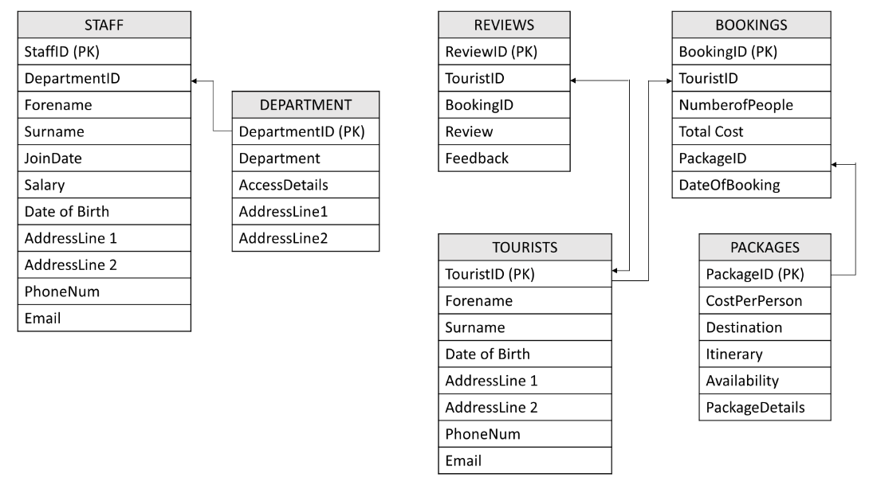

Application of Database Management System
5.
To begin, I created all of the tables from the schema and established relationships. I did this using the relationship tab, which allowed me to form the relationships between the tables.
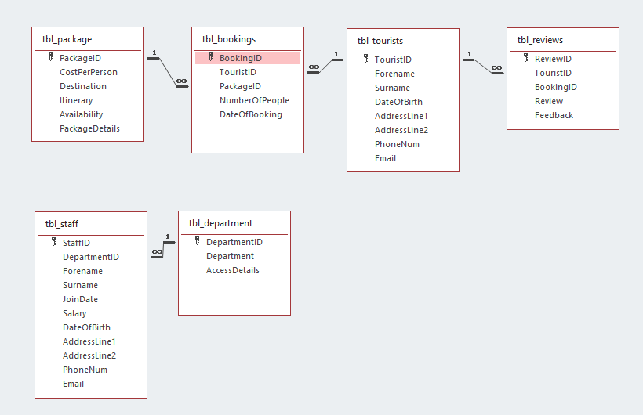
After that, I created a variety of different needed validation rules across the tables.
In the bookings table, I added a validation rule that ensures the booking date is more than or equal to the current date, this is to avoid the error of a customer accidentally booking a date that has already gone by.
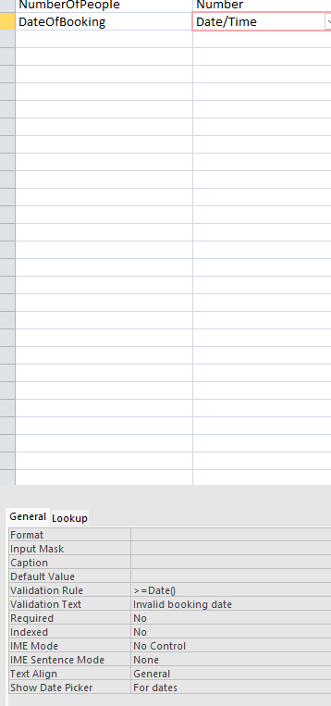
In the package table, a created a combo box for the destination column, so that the customer could only select the available destinations.
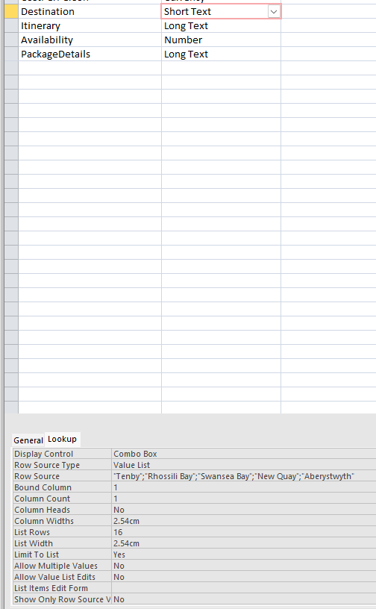

I then created another combo box in the review table; in the review column it includes a combo box that gives the customer the option to rate their experience out of 5, as this is an easy way to how the user felt in regard to their experience.
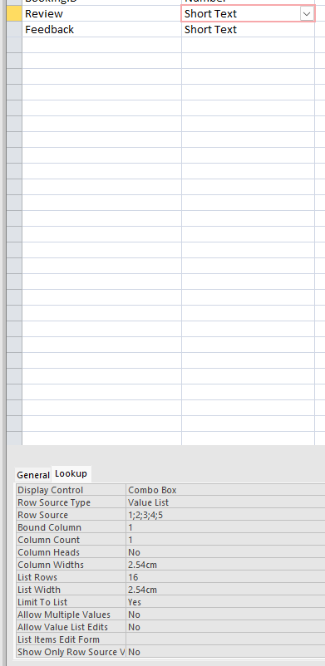
Moving to the staff table, I changed the field size for both forename and surname to 25 as I thought it was more appropriate due to the fact that the large majority of names are not longer than 25 characters.
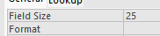
I then created a validation rule for the JoinDate column that ensures that the join date is less than or equal to the current date. As the workers can only input their data once they have started working for the company, meaning that a future date would be invalid.
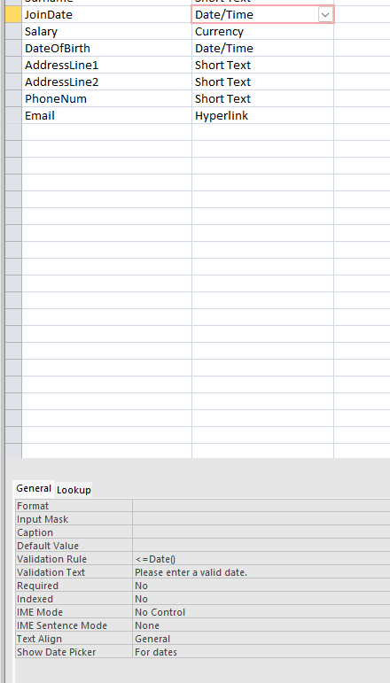
I also created a validation rule that ensures the salary input is over £20000, as this is the lowest the company will be paying their staff.
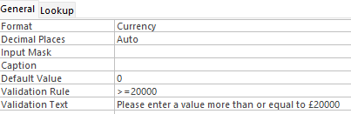
I also created a custom input mask for the staff phone numbers that adheres to the UK standard.
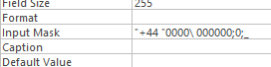
I then ensured that the user inputs a @ when filling out the email column.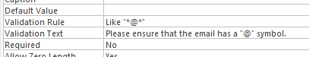
This was also repeated in the tourist table.

Report Design
6.

Before the creation of the reports a drew a design of the reports so that I had a better understanding of what was needed when creating them. Here is the design for the revenue report:
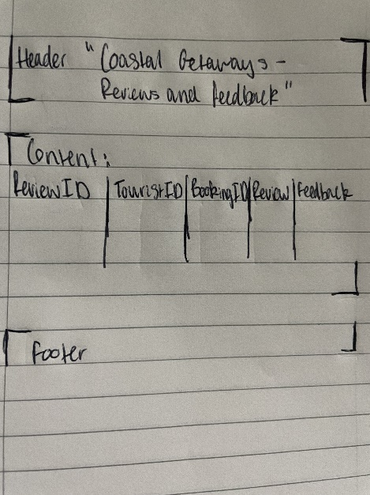
And here is the design for the review and feedback report:
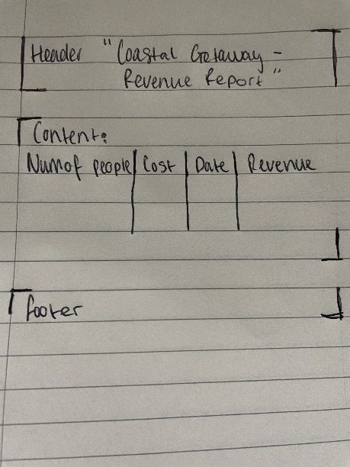
- To begin the creation of my reports, I created a report that displays all of the money made from the bookings along with a column that highlights the revenue made within the month of May.
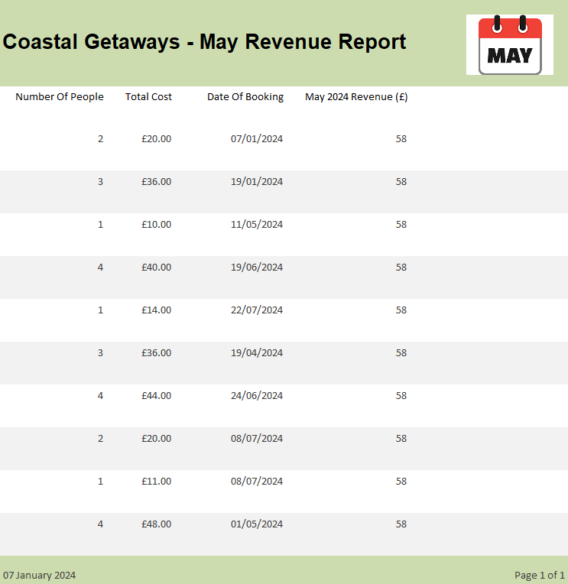
I generated the revenue using the following control source:
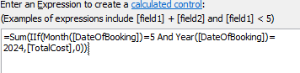
I also included conditional formatting to highlight which dates are the ones that will be added.
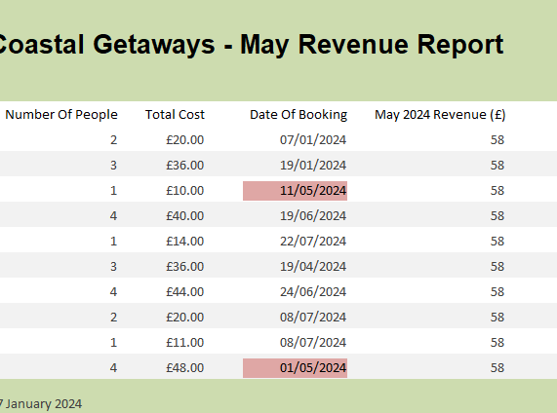
B) After that I created a report that showed the tourists reviews and feedback, following the same style as the previous report, so that my documents were consistent.
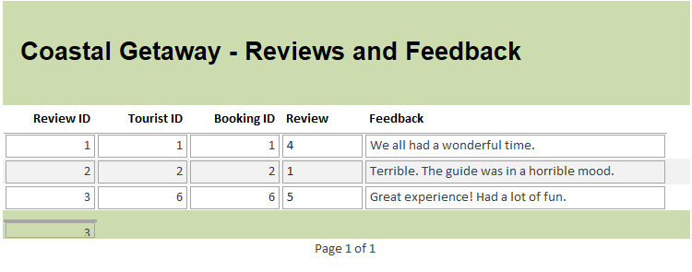

Forms Design, User Interface and Menus
7.
- Here is the complete reservation form:
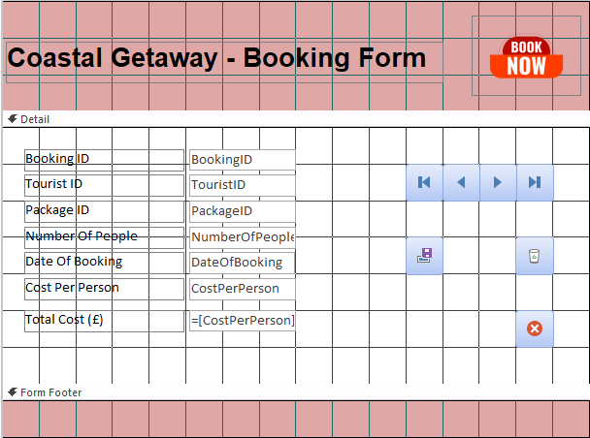
In this form I included all of the fields included within the booking table along with a validation rule that ensures the user cannot book a slot on a date that has already occurred, as this means that they could otherwise pay for a booking that they cannot attend. The form also includes and automatically calculated field in the form of total cost, this was done through setting the control source as the cost per person multiplied by the number of people.
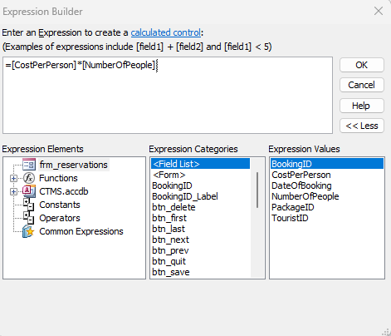
I also included a variety of buttons. The top row of buttons allows the user to navigate through the records, this allows them to look for their own record, or it can be used to create a new record. The middle row of buttons allows the user to save or delete their record. The final button allows the user to close the application from the form.
- Here is the event form:
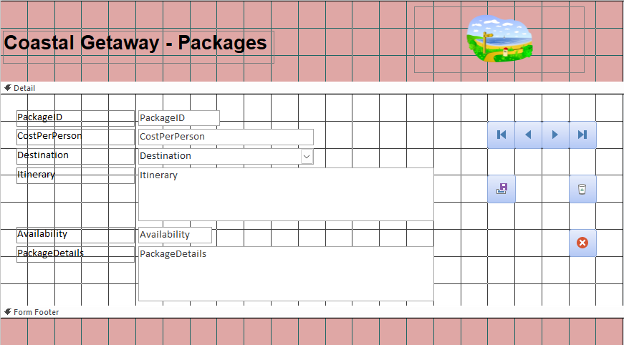
Here I included all of the package fields, this gives the event planner the capability to change any of the information if necessary. Furthermore, a combo box was included for the destination field in order to ensure that the destinations that are available are the only ones that can be selected. In addition to this, the same buttons that were included on the reservations report were also included in this form as seen on the right-hand side.
8.
To begin I create a plethora of separate macros that open specific forms, reports and tables when clicked. These macros will then be linked to buttons on my navigation menu in order to allow the user to freely navigate through the database.

Tables:
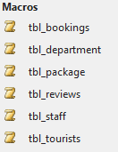
Forms:
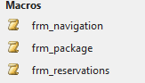
Reports:
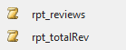
I then created all of the button that are related to the macros by selecting the following:
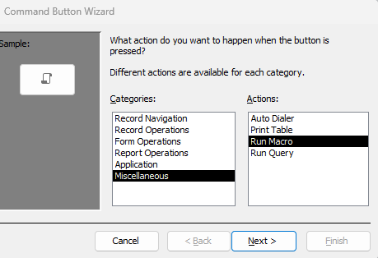
Here is the completed navigation form, it also includes a button that will shut down the application:
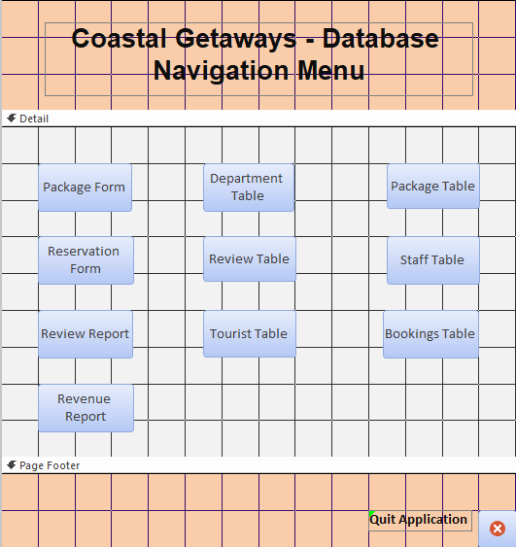

Section B
9.
It is important for Coastal Getaway to have an MS Access database as it helps to solve a plethora of issues that they may have faced when using alternatives for their costal tourist management. For example, using an MS Access database can help improve the security and integrity of the businesses data. MS Access gives data administrators the tools to implement user-level security and assign levels of access to users based on their role within the organisation [1]. This helps to ensure that users only see the data that is appropriate and relevant to them and as a result prevents potential data from being leaked or damaged. Another benefit of using MS Access is that it is easy to use and learn [1], this means that new staff will be able to efficiently garner an understanding of the database works, and as a result they will be able to confidently use the software quickly. Furthermore, MS Access can be accessed on multiple devices and as a result the database can be used by multiple users. This can help improve the productivity of the tourist management as users cannot be blocked from working even if there are a plethora of users on the database. Moreover, data can be gathered from the database quickly through queries [2]. These queries allow the user to view specific records and data based on their requirements, which is a faster and more efficient method compared to manual alternatives.

10.
Transitioning from manual database management to a computerized system can bring upon myriad benefits and challenges for Coastal Tourism Management. An example of a benefit to this transition is that a computerized system will avoid some of the input errors that may be present in manual methods, as features such as validation techniques can help minimize the amount of spelling mistakes and formatting errors that may cause the data to be inaccurate [3]. Another benefit to the transition is that can help to reduce costs for businesses who are managing coastal tourism, as computerized systems require less employees as many of the processes can be automated and as a result staff are not needed to carry them out.
On the contrary, there are also negatives to this transition that a computerized database is prone to failures. A database failure can be detrimental to an organisation as it could result in a loss of data and even money [4]. However, a DBMS system can help with this challenge as it allows the organisation to create frequent backups and as a result the data will be able to be recovered if a failure was to occur. Another negative to this transition is that there will be a high cost for hardware as a large disk storage may be required to store the vast amount of data. However, a DBMS will help with this challenge as it allows the organisation to integrate a cloud storage alternative, meaning data will be stored on the cloud instead of physical drives.

References:
[1]
TheKnowledgeAcademy, “Advantages and Disadvantages of Microsoft Access: Updated in 2023,” www.theknowledgeacademy.com. https://www.theknowledgeacademy.com/blog/advantages-and-disadvantages-of-microsoft-access/
[2]
“Paper Documents vs Digital Documents: Pros and Cons - Chaffinch Document,” Dec. 01, 2021. https://chaffinchdocument.co.uk/paper-documents-vs-digital-documents-pros-and-cons/
[3]
N. Gunnoo, “Manual Data Entry: Challenges and solutions in 2023 | Parseur,” parseur.com, Jun. 18, 2022. https://parseur.com/blog/manual-data-entry
[4]
K. Castro, “Limitations of Database Management System,” Tutorialspoint.com, Jul. 25, 2018. https://www.tutorialspoint.com/limitations-of-Database-Management-system
‌

‌

‌

