A COMPARISON OF THE MARKETING METHODS OF TWO MULTINATIONAL HOTEL BRANDS
Name of the student: Cornelia Cislaru
Name of the university: University Trinity Saint David
Student ID number: 2134157
Module Title: Marketing Essentials BMIH4005
Lecturer's Name: Christopher Wilkin
Word Count: 1615 words
Introduction
The marketing strategies of a brand reflected on setting the business goals including helping in enhancing the business operations and offerings to satisfy the ideal customers and making plans to reach them easily. The marketing strategy of the brand focuses on making proper planning of actions and implementing them in the marketing activities that allow the organization to grow the business. The discussion in this essay has aimed to compare the marketing strategies of the two chosen multinational hotel brands that are Moxy and Six Scenes.
The discussion will focus on comparing the marketing strategies with the utilization of situational analysis tools and discussing the ways in which organizations market their services and products. The discussion will also highlight the use of STP (segmentation targeting and positioning) of both the hotel brands and will use the marketing mix to discuss their marketing practices of them. Highlighting the marketing communication of the brands with the target audiences will help in demonstrating better knowledge of the marketing strategy comparison of Six Scenes and Moxy. A similar web analysis tool will be utilised to highlight the differences and similarities in the respective marketing strategies for making supportive recommendations for developing the business activities and enhancing the marketing practice cells of the chosen brands.

Comparing the marketing approaches and strategic positioning of the two chosen multinational hotel brands it is important to highlight the background of the hotel operations. Six Scenes is one of the popular and award-winning hotel groups founded in 1995, continuing the business operations by offering exclusive experiences to guests in exquisite and remote locations such as romantic valleys, mountains, and inspiring cities that have a great historical background and beautiful bays (Six senses, 2023). The CEO of Six Scenes is Neil Jacobs and Viri Kaur Chopra was the Global corporate director of residential of the hotel. The strategic advisor was Wolf Hengst and Jonathan Heath was the corporate food and beverage director of Six Scenes. The current revenue of Six Scenes was $289 million (2021). The number of employees in the hotel is around 2,678. The hotel is continuously offering family-friendly, exclusive and luxurious services to the people with better facilities and personal attention. On the other hand, introducing the business operations of Moxy it can be stated that Moxy is a multinational Hotel brand, which offers affordable, playful and stylish design services for guests according to their needs and demands. The hotel brand operates more than 60 hotels open across Europe, Asia Pacific, North America and many other countries worldwide. It can be estimated that the annual revenue of Moxy hotels is approximately $261.98 million in 2021 (Moxy Hotels, 2023). The company operates with more than 1,052 employees with exclusive learning business strategies of maintaining stylish design, use of latest technologies in hotel services and other approachable services to capture the attention of the next generation travellers.
Highlighting the marketing choices in order to improve the marketing strategies the situation analysis tools will be utilised to evaluate the practices and identify the changes in business offerings. According to the Similarweb analysis tool, the marketing mix that has been presented by the director of sales and marketing manager of Six Scenes the Products offered to the customers are Guest rooms, an Executive lounge, Food and beverage, Conference facilities, Health and wellness facilities, parking facilities etc. (de Oliveira and Sousa, 2020). As shown in appendix 3, the distribution and place of Six Scenes are reflected in different choices like the outskirts of the city, hill stations, cities and historical places. According to the digital research, results from the similarweb analysis tool the direct and indirect methods both are used by the hotel chain. Focusing on the traditional methods of advertising the hotel takes help from Event Planners and print media. On the other hand, making recent changes in marketing activities, digital advertisement has been utilised by the services of the Hotel like Website Booking Systems (WBS) and Online Travel portals. The promotional activities of Six Scenes are Brochures, Television commercials, Facebook pages, Hotel pens etc. The prices of Six Scenes are quite high as it maintains the quality of the services targeting mainly the high-income group people (Morgan, 2019). Comparing the marketing mix with the Moxy Hotel business it can be stated that the product of the hotel similar to Six Scenes like it also offers Guest rooms, Express check-in checkout services, Health and wellness facilities, Parking facilities, a Travel desk, Banqueting rooms, Recreational facilities, Food and beverage, Executive lounge and Business center.
However, compared with the traditional methods the hotel chain utilizes digital marketing strategies like online pay per click or Banner Advertisements through Facebook Advert and Google ads. Considering the results of shopper intelligence from the Similar Web analysis tool the marketing strategies of Moxy Hotel's traditional advertisements may not be as fruitful for them. Online advertising is low-cost and reaches a wide audience at a time (Kingsnorth, 2022). The promotional activities of Moxy reflected making changes in marketing activities recently with the use of various channels both online and offline like Scratchpads with hotel logos, Hotel Websites, Television commercials, Google + Page and Billboards. Comparing the prices of the services with Six Scenes, it offers the most affordable hotel services to the customers targeting medium to high-income groups of customers.
Comparing the current marketing positions of the two Hotel brands Moxy and Six Scenes and the marketing strategies, STP analysis will be presented. The Segmentation strategies of Six Scenes reflect on Geographic Segmentation that focuses on building hotels in locations that are historically rich, popular and travel friendly like Bankside, Canary Wharf, Aldwych etc. (Fahy and Jobber, 2019). Reflecting on the Sales Intelligence results of the Similarweb analysis tool shown in appendix 4, the targeting strategies of Six Scenes the organization mainly targets high-income people as they can spend more financial support to support the growth and maintenance of luxurious services by Six Scenes. The current positioning of Six Scenes is reflected in the market share of the brand, which is approximately 12.3% (de Oliveira and Sousa, 2020). Compared to Six Scenes, Moxy demands of customers with revenue growth by 13.56% compared to the previous year. The results of digital marketing research from the Simmilarweb analysis tool utilised by Moxy reflected on utilising demographic segmentation targeting the customers who are mainly young age and low level of income.
Focusing on contemporary issues like the Global pandemic the threat of Covid-19, Brexit, the Ukraine war and other Geopolitical events has forced both hotels to make changes in marketing activities and business operations to ensure the continuity of the business offerings (Paley, 2021). Highlighting the Global events of Brexit it has forced make changes in business practices and marketing strategies following the current trends in the market. Focusing on the social concern it can be stated that the labor force of the Hospitality Services in both Moxy and Six Scenes is affected as the hotel industries are heavily dependent on the workers of the EU and they have been forced to enhance the marketing practices concerning the changing market trends (Morgan et al., 2019). Focusing on the Ukraine war the companies were forced to stop targeting the people from the country as it might create global issues due to the threats of geopolitical events. Focusing on the comparison between the changes in marketing activities after the arrival of Covid 19 pandemic can be stated that of both the hotels Moxy and Six Scenes. They have forced to make various changes in marketing like implimented contactless payment options, proper sanitization, room cleaning services and other service maintenance that has been advertised to enhance the social concern of the Hotels.
Comparing and contrasting the sustainability issues due to the contemporary and geopolitical events both the hotels Moxy and Six Scenes focus on improving the marketing messages with the utilization of better marketing channels like Facebook, Twitter, Pinterest, Linkedin, YouTube and Instagram in order to capture the attention of the people targeting the customers offering better services (Kingsnorth, 2022). Compared with the marketing message Moxy focused on cultural conversation and advertisement with a long-lasting move to make changes in marketing activities highlighting the perspective of maintaining customer satisfaction. On the other hand, Six Scenes focus on making changes in traditional marketing practices using the print media in a better way to advertise the current changes in maintaining the business services and sustainability in hotel management and marketing. It can be recommended to both of the hotels Moxy and Six Senses to combine both family and individual branding strategies to improve the business practices (Katsikeas et al., 2020). Determining the target audience is important to make possible changes in business the attributes of marketing strategies highlight the differences in global changes in the hotel industry.

Conclusion
Having a focused and clear marketing strategy will allow the brands in the hospitality industry to enhance the success of the business. Comparing the marketing activities of the chosen hotel brands Six Scenes and Moxy the discussion developed knowledge about the different strategic approaches of marketing. It has articulated the use of social media and digital marketing to make comparisons with traditional advertising techniques and marketing methods. Highlighting the business operations of the chosen brands has successfully demonstrated the choices of marketing activities to make the effective direction of the business. It has also evaluated the historical background of the brands and changes that have been implemented in their marketing approach. The current market positions and marketing strategies of Moxy and Six Scenes are discussed here highlighting the considerations that have been made within their marketing approaches. The marketing messages that have been given to the potential customers and the change in the messages over time have been discussed throughout the essay.

References
de Oliveira, C.P. and Sousa, B.M., (2020). Green consumer behavior and its implications on brand marketing strategy. In Green marketing as a positive driver toward business sustainability (pp. 69-95). IGI Global.
Fahy, J. and Jobber, D., (2019). EBOOK: Foundations of Marketing, 6e. McGraw Hill.
Katsikeas, C., Leonidou, L. and Zeriti, A., (2020). Revisiting international marketing strategy in a digital era: Opportunities, challenges, and research directions. International Marketing Review, 37(3), pp.405-424.
Kingsnorth, S., (2022). Digital marketing strategy: an integrated approach to online marketing. Kogan Page Publishers.
Morgan, N.A., Whitler, K.A., Feng, H. and Chari, S., (2019). Research in marketing strategy. Journal of the Academy of Marketing Science, 47, pp.4-29.
Moxy Hotels. (2023). Stylish Budget Hotels.Moxy Hotels. Available at: https://moxy-hotels.marriott.com/ (Accessed: January 31, 2023).
Paley, N., (2021). The manager's guide to competitive marketing strategies. Routledge.
Six senses. (2023) Luxury Resorts, Wellness Spas, and Five Star Hotels | Six Senses. Available at: https://www.sixsenses.com/en (Accessed: February 9, 2023).

Appendices
Appendix 1: Branding MOXY
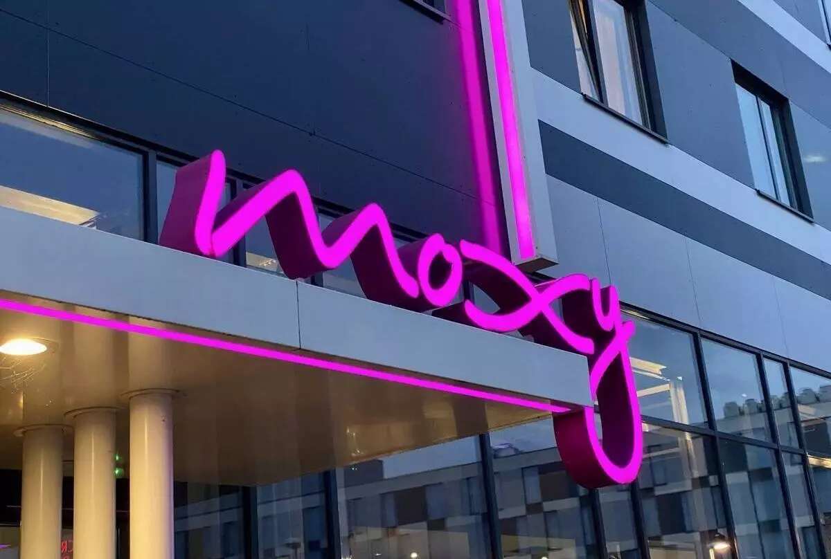
Figure 1: Branding Moxy
(Source: Moxy Hotels, 2023)

Appendix 2: Branding Six Senses
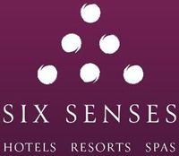
Figure 2: Branding Six Senses
(Source: Six senses, 2023)
Appendix 3: Marketing Mix
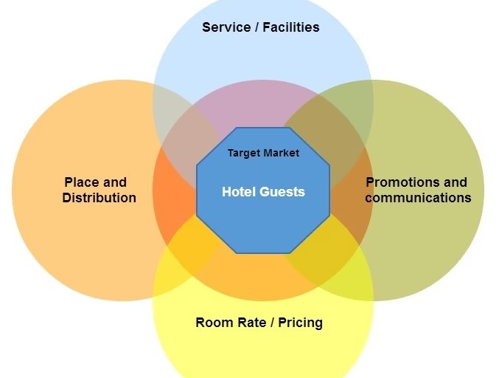
Figure 3: Marketing Mix
(Source: Fahy and Jobber, 2019)
Appendix 4: Similarweb analysis tool results
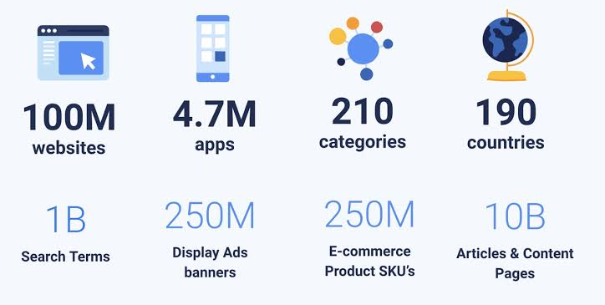
Figure 4: Similarweb analysis tool results
(Source: Kingsnorth, 2022)

