

How effective are current accountability procedures in ensuring the lawful and proportionate use of firearms by police officers in England and Wales?

Rhys Taylor
2319876
BSc (Hons) Professional Policing Practice (PCDA)

Acknowledgements

I would like to firstly thank my family, specifically my partner, mother, father, brother and grandparents, for supporting me throughout my university studies, along with my colleagues and various supervisors I have had at work throughout this project, providing me support and guidance. This has been a challenging final year of studies for me, balancing work, home life and university studies, and I would like to say thank you to everyone who helped me along the way.
I would like to provide a special mention to my nan, my biggest supporter, who sadly passed away at the start of my studies and the start of my career at my organisation and would have also loved to see me progress throughout my studies and career.
I would finally like to say thank you to my organisation for providing me the opportunity to complete a university degree alongside my apprenticeship and provide me qualifications I would have not otherwise achieved.

Declaration
This work has not previously been accepted in substance for any degree and is not being concurrently submitted in candidature for any degree.
Signed: R.R.TAYLOR
Date: 28/06/2026

This dissertation is being submitted in partial fulfilment of the requirements for the degree of BA.
Signed: R.R.TAYLOR
Date: 28/06/2026

This dissertation is the result of my own independent work/investigation, except where otherwise stated.
Other sources are acknowledged by footnotes giving explicit references. A bibliography is appended.
Signed: R.R.TAYLOR
Date: 28/06/2026

I hereby give consent for my dissertation, if accepted, to be available for photocopying and interlibrary loan and for the title and summary to be made available to outside organisations.
Signed: R.R.TAYLOR
Date: 28/06/2026

I hereby give consent for my dissertation, if accepted, to be available on the university’s IT system to those who have consent to use the system.
Signed: R.R.TAYLOR
Date: 28/06/2026

Abstract

This dissertation examines how effective the current accountability procedures are in ensuring the lawful and proportionate use of firearms by police officers in England and Wales. A mixed-method approach using both qualitative and quantitative data collection was used in a survey in order to collect a review of responses from police officers, authorised firearms officers and members of the public. The findings show that there is effectiveness in the current process in holding officers accountable for their actions; however, there are concerns regarding the transparency of investigations, timescales of investigations, communication to the public and the police and impacts on officer wellbeing. It concludes that improvements in these areas would further improve the current effectiveness of the accountability procedures in the use of force by firearms officers in England and Wales.

Table of Contents
Acknowledgements 2
Declaration 3
Abstract 5
Chapter 1 - Introduction 8
1.1 - Background 9
1.2 - Rationale 9
1.3 - Aims and Objectives 10
1.4 - Structure 11
1.5 - Conclusion 12
Chapter 2 – Literature Review 13
2.1 - Introduction 13
2.2 - Police Use of Firearms within England and Wales 14
2.3 - Current Accountability Framework for Police Firearm Use 16
2.4 - Authorised Professional Practice & European Convention on Human Rights 16
2.5 - Independent Oversight & Review 17
2.6 - His Majesty's Inspectorate of Constabulary and Fire & Rescue Services (HMICFRS) Governance 18
2.7 - Post-Incident Procedures & Post-Deployment 19
2.8 - Organisational Learning 20
2.9 - Policy Debates & Legislation Reform 21
2.10 - Conclusion and Research Gap 22
Chapter 3 - Methodology 23
3.1 - Introduction 23
3.2 - Research Philosophy 24
3.3 - Approach 25
3.4 - Design 25
3.5 - Sampling Strategy 26
3.6 - Data Collection 27
3.6.1 - Data Analysis 27
3.7 - Limitations 27
3.8 - Ethical Considerations 28
3.9 - Conclusion 29
Chapter 4 – Analysis of Results and Findings 29
4.1 - Knowledge of IOPC in Firearms Incidents 30
Figure 1 - Likert Scale - Familiarity with the role of the Independent Office for Police Conduct (IOPC) in firearms incidents 30
4.2 - Transparency 31
Figure 2 - Likert Scale - Transparency of current investigation process following a police firearms discharge in England and Wales. 32
4.2.1 - Qualitative Analysis of Transparency 32
4.3 - Proportionality 34
Figure 3 - Likert Scale - The current accountability procedures' effectiveness in ensuring use of force by firearms officers is proportional. 34
4.3.1 - Qualitative Analysis of Proportionality 35
4.4 - Public Trust 36
Figure 4 - Likert Scale - The confidence in the police being held accountable following a police firearms discharge. 36
4.4.1 - Qualitative Analysis of Public Trust 37
4.5 - Key Themes of Current Accountability Process 39
Figure 5 - Key themes of the current accountability process diagram 39
4.6 - Conclusion 40
Chapter 5 - Conclusion and Recommendations 40
5.1 - Completion of Aims and Objectives 40
5.1.1 - Conclusion 42
5.2 - Recommendations 44
5.3 - Limitations 45
Bibliography 47
Appendices 54
Appendix A - Blank Research Survey Entry 54
Appendix B - Research Survey Responses 58

Chapter 1 - Introduction

Arguably, one of the most criticised areas of policing within England and Wales is the use of firearms by police officers. Despite the core responsibility of the role of a police officer being to protect life and remain in line with the European Convention on Human Rights (ECHR), namely Article 2, the Right to Life, there must be a balance between the right to an individual's life and reasonable use of force (College of Policing, 2023). BBC News (2024) insists that the police shooting of Chris Kaba in 2022 sparked concerns in the public’s confidence in current accountability procedures for lawful and proportionate use of force by police officers routinely carrying firearms in England and Wales. The significance of research for an undergraduate dissertation will explore the effectiveness of the accountability procedures for the proportionality and lawfulness of policing, human rights and the public's trust (Farrow, 2023). Existing procedures used by the Home Office, such as the Independent Office for Police Conduct (IOPC), criminal proceedings against firearms officers and misconduct procedures that are conducted by the officer's professional standards department, will be examined to assess the transparency of the investigation, the welfare of those involved and compliance with maintaining police legitimacy and public confidence (College of Policing, 2024).

1.1 - Background

In England and Wales, armed policing is governed by the European Convention on Human Rights (ECHR) Article 2 – Right to Life and the National Decision-Making Model (NDMM) with Authorised Professional Practice (APP) set out by the College of Policing. There is, however, a significant pressure on armed policing officers to face post-deployment accountability following a police firearm discharge, despite the frameworks and guidance in place (Brennan and Cole, 2024). The Home Office provides detailed annual statistical reports on the police service’s firearm usage, and the Independent Office for Police Conduct (IOPC) takes responsibility for investigating police firearm discharge incidents as the police ombudsman. Nevertheless, there remains an ongoing tension of public trust and officer accountability when the police discharge a firearm at a person.

1.2 - Rationale

The rationale for this research is to address the ever-growing scrutiny that the public has for current accountability procedures for the use of firearms by police officers in England and Wales. Jama (2024) suggests that the case of Chris Kaba (September 2022) involving the Metropolitan Police Service became a topic of widespread debate nationally, which challenged officers' accountability procedures and public trust, which has led to a systematic change to armed policing. The accountability and justice process perceived by armed police following the incident was detrimental to officers due to the identity of the officer, ‘NX121, Martin Blake’, being revealed to the public; this led to some armed officers in the Met Police refusing to carry firearms as a result of this. There were, however, issues with public transparency. Coles (2024) argues that police officers should be treated with the same accountability processes as the public and welcomed the decision to publicly name the officer. The current systems' effectiveness in satisfying the police and the public is struggling for confidence. Rationalising a review of the effectiveness of current accountability procedures in ensuring the lawful and proportionate use of firearms.

1.3 - Aims and Objectives

The overarching aim of this research is to establish the effectiveness of the current accountability procedures in place to ensure the lawful and proportionate use of firearms by police officers in England and Wales. In order to achieve this aim, this study will look to explore the following objectives:

- To analyse existing legal and policy frameworks that currently ensure accountability for the police’s use of firearms, including the role of the Independent Office for Police Conduct (IOPC) and internal force misconduct procedures.

- To examine the perception that the public and the police have of the current investigative and disciplinary process in England and Wales.

- To identify areas for improvement to improve accountability and public trust in armed policing in England and Wales.

- To provide recommendations for the current accountability procedures for use of firearms by police officers in England and Wales

1.4 - Structure

This dissertation will be formatted into five chapters, which will consist of the following:

- Chapter 1 will introduce the topic of my chosen study, which will discuss the background, rationale, aims and objectives.

- Chapter 2 will present a review of the current literature which is available for the topic and provide an in-depth breakdown of topics relating to current accountability procedures in ensuring the lawful and proportionate use of firearms by police officers in England and Wales. I will also identify gaps in research which is currently available.

- Chapter 3 will provide the research methodology for my study relating to my research topic in which I will explain the philosophy and design of my survey, how I will collect data for my survey and ethical considerations I have made for the collection of data.

- Chapter 4 will present an analysis and findings that I have found from the study that was conducted, in which I will examine the results.

- Chapter 5 will present a conclusion and recommendations for the future, in which I will summarise research and findings.

1.5 - Conclusion

In conclusion, this chapter has provided an introduction to the topic, which has highlighted the current importance of ECHR Article 2 and the College of Policing frameworks/guidelines, in which high-profile firearms discharges by the police result in extreme public and investigative scrutiny. This chapter has presented the rationale for studying and identifying a gap and the necessity for further study to directly address the question, How effective are current accountability procedures in ensuring the lawful and proportionate use of firearms by police officers in England and Wales? During the following chapter I will seek to explore the topic in further detail, examining previous research and reports produced for armed policing in England and Wales as well as achieving the first aim for the dissertation. To analyse existing legal and policy frameworks that currently ensure accountability for the police’s use of firearms, including the role of the Independent Office for Police Conduct (IOPC) and internal force misconduct procedures.

Chapter 2 – Literature Review

2.1 - Introduction

The use of firearms by police officers in England and Wales is one of the most scrutinised aspects of modern-day UK policing. Unlike the United States and many European countries, England and Wales do not routinely arm their officers; instead, firearms are only carried by specially trained officers. Authorised Firearms Officers (AFOs) are only deployed to the most serious incidents. The use of firearms is statistically rare, and the consequences of using a firearm against another person can be deadly. Following the police’s deployment and use of firearms within England and Wales, when death or serious injury has been caused, this can invite legal, political and public scrutiny not only from the officer(s) involved but to the police service nationally. The accountability procedures relating to the police’s use of firearms within England and Wales are governed by legal frameworks enacted by parliament and policies by the College of Policing. The use of force in question must be to achieve a lawful objective and must be reasonable in the circumstances of its use. The European Convention on Human Rights (ECHR) is the overarching obligation of rights for police officers to follow, with several articles providing relevance to the accountability of armed officers. Section 3(1) Criminal Law Act 1967, Section 117 Police and Criminal Evidence Act (PACE) 1984, Common Law, Section 76 of the Criminal Justice and Immigration Act 2008 and the Police Conduct Regulations (2020) are of relevance (College of Policing, 2023).

This literature review will examine the effectiveness of current accountability procedures for the lawful and proportionate use of firearms by police officers in England and Wales. The accountability procedures currently in place for AFOs within England and Wales are understood as the standards expected to be held by a constable within the police services as governed by the code of ethics and the standards of professional behaviour, acts of parliament, independent reviews of incidents conducted by an internal forces professional standards department (PSD) and the Independent Office of Police Conduct (IOPC), post-incident procedures and His Majesty's Inspectorate of Constabulary and Fire & Rescue Services (HMICFRS) reports for organisational feedback and learning. The effectiveness of these procedures will be reviewed to evaluate whether or not these accountability methods act as a safeguarding method for the police service and government against the public's and media’s scrutiny, or whether the policies and organisations in question are acting in the interest of the public, ensuring the lawful and proportionate use of firearms by police officers in England and Wales.

2.2 - Police Use of Firearms within England and Wales

The police's use of firearms within England and Wales can be described as a rare event, as opposed to a routine tactic that is used. The Home Office (2025) highlights the latest annual statistics for the use of firearms between April 2024 and March 2025, in which there were 17,249 firearms operations throughout England and Wales, but only 4 incidents in which firearms were discharged at persons (0.02% of total firearm operations). Relating this to the past 10 years, the highest discharge at persons per year was April 2018 - 2019 at 13 discharges at persons; the average discharges at persons per year is 6.3.

However exceptional these statistics are, the impact of firearm discharge on a person, on the officer(s) involved, on the person the firearm has been discharged at, on the families, on the police force and on the public far outweighs the frequency that they occur. Squires and Kennison (2010) argue that a single police shooting incident can result in shaping the public’s perception of the police for decades, which is very important in modern-day England and Wales policing, which relies upon policing with the public's consent. In opposition to this, Hanway (2024) suggests that the public respond less favourably to police officers carrying firearms; however, the presence of armed officers and isolated firearm discharges alone do not damage long-term public trust or justice, and the decision-making quality taken by police is far more impactful on decreasing the public's long-term trust.

Increases in armed deployments and discharges of persons may be a result of a reflection of the current threats and counterterrorism risks within England and Wales, rather than an increase in AFOs wanting to use lethal force (the Home Office, 2025). Bradford (2024) contests that the public's trust in the police has fluctuated over the past 25-year period, regardless of isolated firearm discharges, due to factors such as fairness, transparency, and overall performance. This has a significant impact on the accountability procedures for police firearms use, as it demonstrates that they are most effective when there is clear evidence shown by the AFO(s) that the decision made to discharge the firearm was lawful, proportionate, and would withstand public scrutiny. This shows that in England and Wales, the importance of the reported threat that AFOs pose is less important to the public than the accountability procedures that take place to review the use of lethal force following the discharge of a firearm.

2.3 - Current Accountability Framework for Police Firearm Use

The current accountability framework for the use of firearms by police in England and Wales can be seen through combining Acts of Parliament (legislation), the professional standards and accountability that a police officer holding the office of constable must follow, the independent oversight and reviews conducted on the police, human rights arguments and obligations, and inspections conducted by HMICFRS. The effectiveness of the accountability framework currently in place remains contested among most. Torrible (2020) asserts that the balance of being independent but still providing oversight to the police can undermine the accountability of external bodies such as the IOPC; however, independent oversight of the police complaints system is critical. The Home Office (2020) argues that a significant improvement of the IOPC has taken place since its establishment; the timeliness and quality of the decision-making process that takes place in the IOPC reinforces the accountability for officers, ensuring the force used is lawful and proportionate, independently of their internal organisation.

2.4 - Authorised Professional Practice & European Convention on Human Rights

Accountability for the professional standards for armed policing is set out by Authorised Professional Practice (APP), created by the College of Policing. The APP guarantees the protection of the ECHR, namely, Article 2, in which lethal force may only be used where it is no more than absolutely necessary to protect life, as per McCann and Others v. United Kingdom (1995). The ECHR clarified that accountability does not only stand with the individual officer's actions but also the planning and control of the operation as a whole. This is taken into consideration with the APP, which emphasises all decisions made in line with the National Decision-Making Model (NDMM), the police decision-making model, relating to deployment rather than on a singular officer. Chapman (2014) argues that professional standards and accountability processes can lack transparency and independence from the investigation. When accountability procedures are internally investigated, there is a risk that they can become an attempt to be compliant with guidance contrary to whether the use of force decision-making genuinely meets the McCann threshold of being absolutely necessary. McFarlane and Amin (2021) support this, stating the importance of investigating bodies recognising the evident organisational, cultural, and supervisory impact on decision-making. Organisational culture and an officer’s supervisor can have a huge impact on how the APP and a force's policy can be interpreted and applied, therefore affecting the decisions an officer may take at a deployment.

2.5 - Independent Oversight & Review

An independent oversight and review of firearm deployment within England and Wales is crucial for the accountability and actions of the officers who attend and discharge firearms. Within England and Wales, police incidents that result in death or serious injury must be referred to the Independent Office of Police Conduct, which will scrutinise the incident to find any wrongdoing (IOPC, 2024). There is an evident challenge for complex and serious incidents that the IOPC investigates, which result in death or serious injury, in terms of the timescale of investigations. Martin (2021) argues that the investigation process of the IOPC is obscure, overly critical, and unnecessarily lengthy for everyone involved in an investigation, with the public often dissatisfied with the outcome. This often leads to dissatisfaction and scepticism from the involved bereaved families and the media. Porter (2012) discusses that external police ombudsmen, like the IOPC, provide a valuable role in ensuring lawful and proportionate policing, which certifies that the police are accountable for their actions. This shows that while the effectiveness of the IOPC can be critiqued, the need for independent oversight of policing incidents is vital for maintaining the public's confidence in the accountability procedures, ensuring the lawful and proportionate use of firearms by police officers in England and Wales.

2.6 - His Majesty's Inspectorate of Constabulary and Fire & Rescue Services (HMICFRS) Governance

The HMICFRS provides further accountability measures in the process by providing regular independent assessments of policing/firearm policing capabilities and decision-making (Winchester, 2020). HMICFRS (2023) states a report was conducted in 2023 on the effectiveness of the deployment of firearms within police forces in England and Wales; the report concluded that firearm deployments are well structured and managed; however, further transparency and accountability could be implemented in further forces. Following a review of post-incident debriefs, the HMICFRS only found one police force using bodyworn video to record the debrief; this was later recommended to all forces. A weakness of the HMICFRS is the recurrence of reports specifically related to firearms policing. The HMICFRS would produce reports for all 43 police forces in England and Wales every 2 years; however, from 2025, this would be changed to a 4-year cycle (HMICFRS, 2025). Home Office (2020) highlights a limitation that can be seen related to the HMICFRS and the Home Office statistics that are published annually and biannually. Upon analysis, some police service recording systems do not record the data recording requirements and were not collected, therefore making some statistics inaccurate. This literature does raise questions regarding the recording practices, accountability and trust that the public will have in the inspection findings/statistics produced (IPCC, 2016).

2.7 - Post-Incident Procedures & Post-Deployment

A post-incident procedure and investigation is a crucial welfare and legal safeguarding process for officers involved in incidents ending in death or serious injury. The College of Policing (2024) states that discharge of a firearm does not follow the ‘regular’ post-incident procedure and instead follows the post-deployment procedure. The College of Policing implements the guidance via the APP; however, it states that the procedures can range from force to force according to the circumstances. Considerations should be made for impact on the community, media management, a debrief report and/or, when appropriate, an apology to people affected. The importance of understanding and scrutinising the use of lethal force is vital for ensuring the police take accountability for its use. Waring (2011) argues that being accountable and blamed often can influence how an officer documents and justifies the actions they have taken, showing that post-deployments are more than just an administrative process for police but are critical for officer/force learning. Squires and Kennison (2010) contend that effective handling post-incident is of the same importance as the police firearm discharge itself. They argue that delayed transparency and accountability towards the public can result in distrust in the public, regardless of whether the officer’s actions were lawful and proportionate. Javid (2019) agrees with this; effective post-deployment procedures were conducted following the Manchester Arena terrorist attack in 2018, which proved to be successful and concluded the incident for the police and the IOPC swiftly.

2.8 - Organisational Learning

The organisational learning that comes from a firearm discharge is paramount for learning and improvement for future firearm deployments nationwide. Following incidents that mandate a referral to the IOPC, learning recommendations are often published to the force in question to prevent recurrence in future, relating to policy, training and supervision (IOPC, 2025). However, the Police Federation of England and Wales (POLFED) questions the effectiveness of the overall procedure conducted by the IOPC; there is currently no statutory time limit on police misconduct investigations, and the position in which many firearms officers find themselves following a firearm discharge. POLFED argues that previous cases have been prolonged for years, affecting officer mental health and wellbeing along with their operational competence – particularly if the officer has been placed on long-term restricted duties or suspension from duty. Prolonged investigations can often weaken the public’s belief in the outcomes; instead of timely and meaningful learning outcome recommendations, some cases can take several years for outcomes, sometimes providing outdated policy recommendations (POLFED, 2025). Following the revised IOPC guidance in 2019, Javid (2019) argues that the conclusions on IOPC investigations and inquests have improved considerably, improving officer welfare and preventing further distress to the families involved. However, an independent review of the IOPC was conducted by the Home Office in 2023, in which it was found that, despite improvements, IOPC investigations are still untimely and take too long, with the average investigation taking 9 months and 15% of investigations taking over a year (Fairfield, 2023).

2.9 - Policy Debates & Legislation Reform

The ongoing policy debates and legislation for police accountability are changing and shaping the future for police officers, both armed and unarmed, in England and Wales. Richards (2022) suggests that an accountability policy reform is needed as a result of high-profile misconduct scandals destroying the public’s trust not just of constables but also of senior leaders of the service. Due to the complex, multi-layered policy, legislation and uncertainty of what may occur during proceedings following a firearms discharge. Farrow (2024) argues that the fear of a firearms officer being blamed for their decision-making resulting in criminal and misconduct proceedings may result in discouraging proactive policing and influencing organisational culture. Following a rapid review for police accountability in 2025, Lord Hanson (2025) insists that the current accountability legal framework is inconsistent and confusing, providing low police morale, particularly for firearms officers. Both legal issues raised have been accepted by the government; the legal test for police misconduct cases relating to the use of force has been raised from the civil to criminal standard. Further to this, the threshold for unlawful killing inquests is reverting from a civil standard of proof to criminal.

2.10 - Conclusion and Research Gap

This literature review has examined the effectiveness of current accountability procedures in ensuring the lawful and proportionate use of firearms by police officers in England and Wales. The research I have evidenced shows that the firearms policing accountability procedures are very extensive, incorporating acts of parliament, ECHR obligations, standards of professional behaviour, independent review bodies such as the IOPC and HMICFRS, post-incident and deployment procedures, organisational learning and recent policy debates and legislation changes. Policing with the consent of the public is the overarching theme of policing within England and Wales; the extensive intent to investigate and make the police accountable for their actions reflects this. The College of Policing APP, along with the test for article 2 of the ECHR, as informed by McCann and Others v United Kingdom, provides a robust test for lethal force being absolutely necessary, lawful and proportionate in the circumstances. Both the IOPC and the HMICFRS play a significant part in scrutinising police firearm deployments and firearm discharges across England and Wales. However, the literature reviewed has shown that there are challenges in practice, with the balance of keeping public confidence in the police service and investigating an incident thoroughly often creating lengthy investigations with prolonged outcomes affecting officer welfare and competence.

Furthermore, the review of literature has shown that the public's trust in police firearms accountability is affected more by the transparency and fairness of the investigation as opposed to the discharge itself. Whilst it has been argued that police morale is so low, especially among firearms officers following recent criminal and misconduct proceedings, excessive scrutiny may discourage firearms officers from working and policing proactively in future, in fear that they may be blamed for their actions. Overall, the literature that has been reviewed has shown that the current accountability procedures, in principle, were effective; however, the execution in practice is not. There is a strong legal framework in place with a strong range of statutory law to ensure that a firearms officer is accountable, lawful and proportionate with their use of force, yet the effectiveness of investigating these officers following a death or serious injury incident remains a controversy among most without an effective balance between accountability and criminal/misconduct investigations. This risks continuing to undermine both the public's and a firearms officer’s confidence in the future of firearms policing in England and Wales.

Chapter 3 - Methodology

3.1 - Introduction

During the previous chapter of my dissertation, I achieved the first aim and objective by analysing existing legal and policy frameworks that currently ensure accountability for the police’s use of firearms, including the role of the Independent Office for Police Conduct (IOPC) and internal force misconduct procedures, by conducting a review of existing literature. I will now seek to achieve the second objective, which is:
To examine the perception that the public and the police have of the current investigative and disciplinary process in England and Wales.

The methodology this study will be using is a mixed-method approach in which a combination of quantitative and qualitative data will be collected and analysed; this will be conducted in a survey-based method. Brynan (2012) suggests that an effective survey design can implement collection of quantitative data whilst also providing the opportunity for qualitative insight from participants. Tashakkori and Creswell (2008) argue that mixed-method research can be effective in providing an individual's perspective and providing quantitative data. This methodology was chosen due to its effectiveness in gathering views from both the police and members of the public, along with collecting the perceptions they have of the current investigative and disciplinary process in a qualitative approach. This section will discuss the philosophy, approach and design for the survey that will be conducted, along with the sampling strategy and methods for collecting data. The ethical considerations will also be discussed in order to safeguard participants' anonymity and compliance with relevant data protection legislation.

3.2 - Research Philosophy

The philosophical method of my research will be a pragmatic approach. Elgeddawy and Abouraia (2024) suggest that pragmatism is widely regarded as an effective philosophy for mixed methods of research in which pragmatism values both quantitative and qualitative values; this method of philosophy is effective, as pragmatism prioritises the research question, which in this study is the core principle. However, Hampton and McKinley (2023) argue that pragmatism can at times struggle to uncover the deeper issues behind the research topic. To prevent this from occurring, this study will ensure it questions the bigger picture present to current effectiveness and accountability.

3.3 - Approach

There are two types of approaches to research that are commonly used academically. ‘Deductive’ and 'Inductive', this study will use a combined approach between both of the methods in order to achieve the aim set out in this section. Creswell and Creswell (2018) highlight that a combined approach to methodology can provide high-quality and balanced research for complex studies. In opposition to this, Saunders, Lewis, and Thornhill (2023) note that combining both methods can sometimes lead to results being contradictory and complicated. To prevent this, this study will ensure that the research is focused on the effectiveness of accountability; however, it will also offer an opportunity for the perception of the police and public to provide in-depth qualitative responses.

3.4 - Design

The design of the research study is composed of both quantitative and qualitative components, comprising a mixed-method deductive and inductive study. Both quantitative and qualitative responses will be gathered using the same survey method. The quantitative section of the survey will consist of Likert-scale questions (strongly agree, agree, neutral, disagree and strongly disagree). The quantitative section will be used to offer the participant a statement relating core values to accountability; this will be used to measure the overall effectiveness of current procedures and to identify trends in data. The qualitative section of the survey will be used to follow the Likert-scale questions, allowing the participant to provide reasoning for their response. This will provide views and opinions from personal experiences which will offer a greater insight for current accountability procedures. The core values in which will relate to current accountability procedures are transparency, public trust and proportionality, which will further encourage qualitative insight on current accountability frameworks. A design of the survey can be seen at Appendix A.

3.5 - Sampling Strategy

The strategy of sampling in this study uses a purposive sampling strategy in which three groups of persons have been targeted: members of the public, police officers, and police officers who are authorised firearms officers. A purposive sampling strategy uses a non-probability technique in which researchers can select specific groups of persons due to their unique characteristics; this method will be effective for the sampling of my study to target police officers / authorised firearms officers to gather their insight to achieve the aim of this study (Lewis-Beck et al., 2004). The survey was distributed to a team of response police officers and a team of authorised firearm officers of South Wales Police and to approximately five to ten members of the public. The diversity of distribution aimed to achieve a balanced oversight into how the current accountability procedures are perceived by both sides of participants. The study aimed to achieve twenty to forty participants, which are a diverse sampling of the three groups; however, it must be noted that this sample size may not truly represent views of the wider public / police due to time and resource constraints of both the survey and police officers facing high operational demands may affect the response rates; despite this, responses have been gathered from both frontline response police officers and authorised firearm officers.

3.6 - Data Collection

The data collection process was conducted via a digital survey using the platform ‘Microsoft Forms', which allowed for a simple distribution process and ensured participant anonymity. An incompleted copy of the digital survey has been provided via Appendix A of the dissertation.

3.6.1 - Data Analysis

The data analysis process will be completed using the data obtained via the research survey conducted, which will be analysed using software provided by Microsoft in order to generate visual representations of data such as charts and graphs for quantitative data such as Likert scales. Qualitative data will also be analysed. The responses from the research survey can be found in Appendix B of the dissertation.

3.7 - Limitations

The limitations of sample size for this study must be noted; however, due to time constraints present, it will be sufficient to complete the aim of this section. As previously noted in 3.5 - Sampling Strategy despite the research survey being distributed to two teams of police officers, high operational time constraints likely influenced the overall response rate of the study, potentially placing bias on those with more or less time to complete the survey. Despite the anonymous approach of the survey, police officers' responses may be influenced by the culture of the organisation or refrain from discussing sensitive IOPC or professional standards investigations. A further limitation to this study relates to the distribution of the study, as this study was focused on South Wales Police officers; it may not reflect the wider view of other forces across England and Wales.

3.8 - Ethical Considerations

The ethical considerations that were present during the creation and dissemination of the research study were firstly to ensure that the survey was entirely voluntary to complete and all participants had a right to withdraw their responses at any stage prior to completion. The responses requested from participants would remain anonymous and confidential and would not gather information such as names, collar numbers or callsigns – this was especially important for police officers and authorised firearm officers. In addition to this, considerations were made for the General Data Protection Regulation (GDPR), the Data Protection Act 2018 and the Official Secrets Act 1989. This was provided to participants prior to them answering the survey in an opening statement to remain transparent and honest.

3.9 - Conclusion

This chapter has demonstrated the form of methodology which has been used for the dissertation as well as achieving the second aim for the project in examining the perception that the public and the police have of the current investigative and disciplinary process in England and Wales. During the next chapter of the dissertation, the data collected during the chapter will be presented and analysed.

Chapter 4 – Analysis of Results and Findings

During this chapter, I will present and analyse the results and findings from the research survey I have conducted as a part of this dissertation. The survey received a total of twenty responses from the survey submitted to the three groups of interest; the responses received will allow for a qualitative and quantitative insight and will allow me to achieve aims two and three of this research: to examine the perceptions that the public and the police have of the current investigative and disciplinary processes in England and Wales. To identify areas for improvement to improve accountability and public trust in armed policing in England and Wales.

4.1 - Knowledge of IOPC in Firearms Incidents

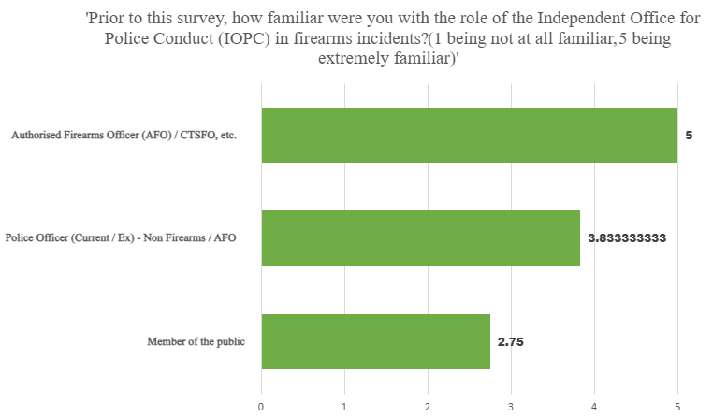

Figure 1 - Likert Scale - Familiarity with the role of the Independent Office for Police Conduct (IOPC) in firearms incidents

Initially, participants were questioned on the familiarity of the role of the IOPC in firearms incidents prior to the survey; as to be expected, authorised firearms officers (AFOs) were extremely familiar with the role of the IOPC due to current guidance provided by the College of Policing related to post-deployment, which armed officers receive upon becoming an AFO (College of Policing, 2026). The data highlights a clear pattern of familiarity, with non-firearm police officers displaying a relatively high level of awareness, followed by members of the public who displayed much less familiarity with the IOPC's role. The findings suggest that there is a gap in members of the public's familiarity with the IOPC for firearms incidents, which may impact the public trust and perceptions of how a firearms incident is investigated as well as how they perceive current accountability procedures.

4.2 - Transparency

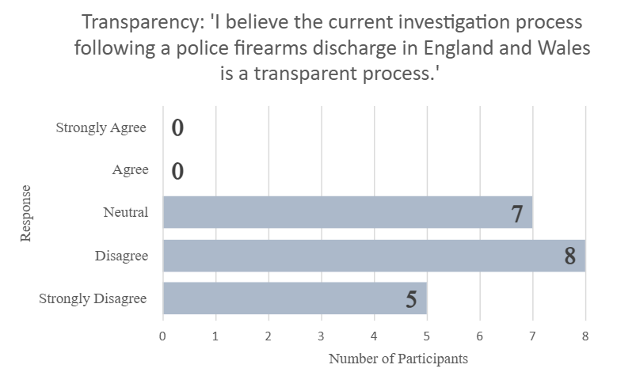

Figure 2 - Likert Scale - Transparency of current investigation process following a police firearms discharge in England and Wales.

Participants were then asked if they believed that the current investigation process following a police firearms discharge in England and Wales was a transparent process. The findings revealed that there is a lack of transparency in the current process, as no participants selected ‘Agree’ or ‘Strongly Agree': this finding suggests that the investigation process following a firearms discharge by police is currently not meeting the expectations of the public or the police who were surveyed. From the participating responses, 65% of participants answered negatively and 35% neutrally, which may undermine the public's and police’s trust in current accountability procedures along with outcomes following an investigation. Furthermore, Lord Sharpe of Epsom (2024) argues that many police officers do not have trust that they will be treated fairly during firearm discharge investigations; this impacts the willingness of officers to want to become / remain firearms officers. Moreover, both the public and the police have concerns about the current fairness and timeliness of the current accountability procedures.

4.2.1 - Qualitative Analysis of Transparency

90% of participants provided a further qualitative response to their reasoning for Figure 2. A recurring theme throughout the responses was a lack of updates provided to officers who were under the investigative process for use of force and police firearm discharges. Further to this, several participants noted that they had felt unsupported throughout the process, with one participant stating that they felt a ‘shocking lack of support from superiors'. Further concerns were also raised by participants relating to the ability of investigators, whether IOPC or internal, to have a direct lack of frontline experience to truly understand the reality of being a firearms officer and to have the context to understand decisions which were made in a high-pressure split-second environment. Responses from members of the public in this section highlighted the importance of transparency for the public to trust the police and investigators, in which it was suggested that investigators should provide greater transparency to the public to prevent the spread of misinformation by the media and provide better transparency by producing documents publicly for viewing. Poirier et al. (2024) argue that providing a transparent approach to the public and being able to view investigation documents, such as body-worn video cameras, in the United States has increased the trust that the public has in officers; however, without informed context of documents provided, the public can sometimes be misinformed.

4.3 - Proportionality

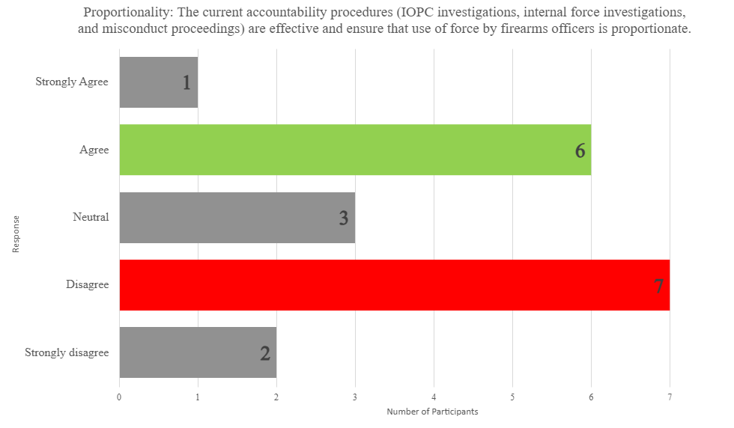

Figure 3 - Likert Scale - The current accountability procedures' effectiveness in ensuring use of force by firearms officers is proportional.

When analysing the participants' responses to the current accountability procedures' effectiveness in ensuring use of force by firearms officers is proportionate, there was a noticeable mixed response from participants. 36.8% of participants provided a ‘positive’ response, answering 'Agree' or 'Strongly Agree'. However, a greater part of the participants provided a ‘negative’ response, answering ‘Disagree’ or ‘Strongly Disagree’ with 47.7% of the total responses. A further 15.8% remained neutral. These findings may highlight different beliefs by participants; police officers and AFOs may view investigation proportionality differently from members of the public due to potential direct involvement in an IOPC, internal force investigation or misconduct proceedings. Members of the public who may have had no involvement in witnessing / being part of this process may have a different view on what they deem to be 'proportionate'. This finding is key to highlighting that there is an ongoing struggle to provide an accountability process that meets the expectations for the police and the public.

4.3.1 - Qualitative Analysis of Proportionality

85% of participants provided a further qualitative response to their reasoning for Figure 3. A common topic discussed by participants was the pressure prolonged investigations that are conducted internally and by the IOPC can place on an officer and their family. Participants provided that these investigations can ‘severely affect the mental health and welfare’ of involved police officers, especially following a suspension or removal from frontline policing as a result of an incident. Some respondents noted that the current accountability system is looking to punish police officers instead of finding out the truth, with one participant stating, ‘From seeing recent media and own experiences, it seems to be guilty until proven innocent, which discredits officers and often leads to incorrect outcomes'. Whilst many participants agreed that firearms officers and police officers should be held to account for their actions, the scrutiny that is placed on officers following use of force incidents has resulted in some participants providing a response that could be seen as dangerous to police officers and members of the public for the future of policing, in which it was stated that, ‘The process on investigating UOF is so overbearing that officers do not feel comfortable using force.' Overall, the responses have highlighted its concerns with the current system; however, there seems to be a common agreement between participants that if an officer's actions are not lawful, then they should be held accountable by means of the relevant process.

4.4 - Public Trust

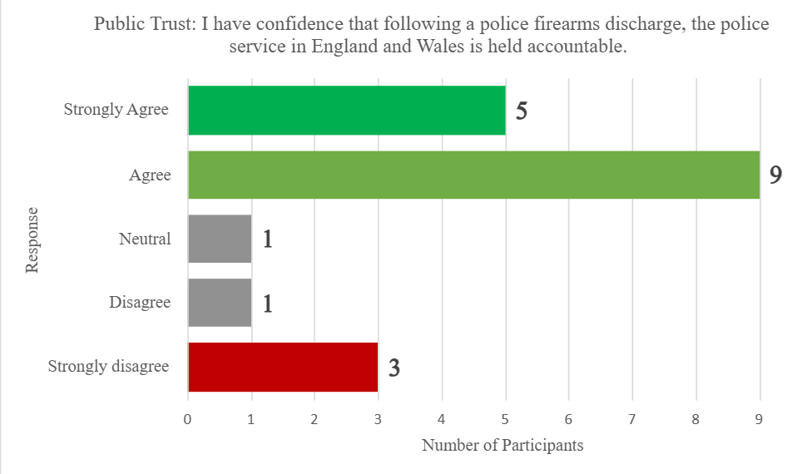

Figure 4 - Likert Scale - The confidence in the police being held accountable following a police firearms discharge.

Participants were then provided a statement relating to the confidence they had in the police service in England and Wales being held accountable following a police firearms discharge. Key findings arose from this statement, with a substantial number of participants (73.7%) indicating that they ‘Agree’ or ‘Strongly Agree’ with the statement provided; in contrast to this, 21.1% of participants provided a negative response, 'Disagree' or ‘Strongly Disagree', with 5.3% remaining ‘Neutral’. Whilst there was an overwhelming negative response to the transparency of the current investigation process following a police firearms discharge – Figure 2 – there still remains a belief that the police service is still held accountable for their actions following a police firearms discharge. This shows that, whilst the participants may not believe that the process is a transparent process, there remains an overall confidence that the police service, during firearm discharge investigations and at the outcome, is held accountable.

4.4.1 - Qualitative Analysis of Public Trust

90% of participants provided a further qualitative response to their reasoning for Figure 4. A large number of participants provided that they believe that the police are held accountable for their actions following a police firearm discharge. Participants suggested that the police’s action following a firearms discharge is often scrutinised by the media and public despite actions often being lawful. However, a topic mentioned again by participants discusses the cost to the officer and their well-being throughout the process of being held accountable, with one participant providing, ‘They do not account for the officers' well-being during the investigation and are too centred around what the public perception may be.' Despite the responses provided believing that the police are held accountable following a firearms discharge, there remained scepticism towards the police from some respondents, in which it was stated by a member of the public that 'I don't believe the police are ever really truly held to account for their actions. This shows that despite a smaller-level sample size, there still remains a lack of confidence in the current accountability process following a police firearms discharge. Concerns regarding transparency also arose during the findings when a different member of the public stated that they had seen videos on social media involving a police firearms incident but did not know how the police were held accountable for their actions. There is currently no specific guidance in place regarding the police using social media to disclose information or investigations after they take place; this is also the case with firearm discharge incidents (Police Foundation, 2014). The College of Policing (2026) suggests that forces may use social media; however, all use is governed by that force's policy. There is no College of Policing guidance or APP in place to dictate what information a force should publish following a firearms discharge incident, if any at all. There is currently no independent body overview of this matter, which may lead to transparency issues with the current accountability system.

4.5 - Key Themes of Current Accountability Process
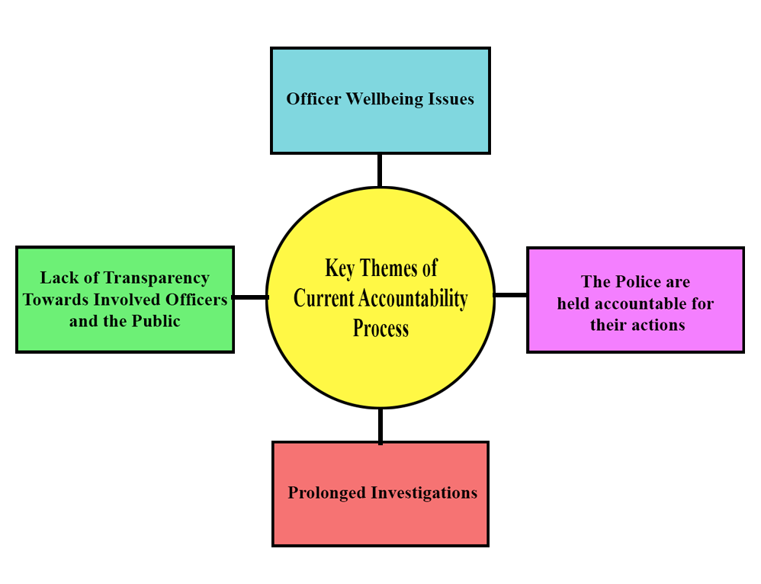

Figure 5 - Key themes of the current accountability process diagram

The above diagram refers to the four key themes highlighted from the findings for the current accountability process for firearm incidents / discharges.

4.6 - Conclusion

During this chapter, the findings of the methodology have been analysed from the qualitative and quantitative data which were gathered from the research survey conducted. The second and third aims for the dissertation have also been achieved in this chapter by examining the perception that the public and the police have of the current investigative and disciplinary process in England and Wales and identifying areas for improvement to improve accountability and public trust in armed policing in England and Wales. The final chapter will follow, which will conclude the dissertation and will discuss possible recommendations surrounding the topic as well as seek to answer the question: how effective are current accountability procedures in ensuring the lawful and proportionate use of firearms by police officers in England and Wales?

Chapter 5 - Conclusion and Recommendations

5.1 - Completion of Aims and Objectives

This dissertation aimed to establish how effective current accountability procedures are in ensuring the lawful and proportionate use of firearms by police officers in England and Wales. The objectives which were set for the completion of this dissertation were:

- To analyse existing legal and policy frameworks that currently ensure accountability for the police’s use of firearms, including the role of the Independent Office for Police Conduct (IOPC) and internal force misconduct procedures.

This was completed successfully during Chapter 2 of the dissertation by conducting an analysis of existing literature.

- To examine the perception that the public and the police have of the current investigative and disciplinary process in England and Wales.

This was successfully completed during Chapter 3 and Chapter 4 of the dissertation by completing a research survey receiving the public's perceptions of the current investigative and disciplinary processes in England and Wales.

- To identify areas for improvement to improve accountability and public trust in armed policing in England and Wales.

This was successfully completed during Chapter 4 of the dissertation by completing a research survey, asking the public's and police’s views on the subject. This will also be developed upon in Chapter 5.

- To provide recommendations for the current accountability procedures for use of firearms by police officers in England and Wales

The final aim will be completed during Chapter 5 of the dissertation.

5.1.1 - Conclusion

The research explored how effective current accountability procedures are in ensuring the lawful and proportionate use of firearms by police officers in England and Wales. The literature review provided an extensive view on the vast legal framework surrounding the use of firearms by police officers in England and Wales, which is the European Convention on Human Rights (ECHR); Acts of Parliament (UK legislation); Authorised Professional Practice (APP) provided by the College of Policing; the National Decision Making Model (NDMM) provided by the College of Policing; independent oversight from the Independent Office for Police Conduct (IOPC); internal investigations (Professional Standards Departments); and external oversight from HMICFRS. The literature which was reviewed highlighted that there is an extensive accountability process in place; however, the public's trust in the accountability system is affected largely by the transparency and fairness of the investigation as opposed to the police discharging the firearm in the first place. The review also highlighted that the current accountability procedures are effective in ensuring accountability for firearms officers using force; however, the balance between the effectiveness of the investigators and timescales of investigations following a police incident resulting in death or serious injury arguably is ineffective, which risks undermining both the public's and firearms officers' confidence in current accountability procedures.

Findings of the research study conducted for this dissertation supported the themes of the review of literature, with many participants' general belief being that the police are held accountable for their actions in the current accountability system. However, transparency in the current process is overall viewed negatively, with 65% of participants providing a view that the process was not transparent and 0% of participants believing that it was a transparent process. Furthermore, vast amounts of responses for police officers / AFOs regarding the current accountability procedure suggested that the current system is prolonged and results in a severe impact on officer wellbeing and willingness for a police officer to carry a firearm in their duties. But despite the negative responses received, there was overall confidence that police officers were held accountable for their actions following a police firearms discharge; the impact of this is significant, as it shows that the current legal frameworks and processes in place are sufficient; however, the process in which they are delivered to both the public and the police is ineffective.

To conclude, the effectiveness of current accountability procedures in ensuring the lawful and proportionate use of firearms by police officers in England and Wales is effective at ensuring the lawful and proportionate use of firearms through a vast legal framework; however, the practical execution of this framework is affected by transparency to the public and involved officers, prolonged investigations, communication with involved officers and the public and involved officers' welfare post-incident. The current accountability procedures would be strengthened following improvements to these areas and would improve the public's and police’s perception and trust in the system upon implementation.

5.2 - Recommendations

Following the research and literature review conducted, the recommendations that are proposed are:

- Increase transparency to the public and the police throughout the investigation conducted on police firearm discharge incidents, providing regular updates to both the public and police when it is appropriate to do so.

The sensitivity of ongoing investigations must be taken into account. However, implementation of this would prevent misinformation about the case and improve transparency with all of those involved; this would also improve officer welfare, as they would be aware of every step of the investigation and not be ill-informed about the process.

- Officers who are involved in post-deployment procedures / investigations following a firearms discharge should be provided with better welfare support and faster investigation processes.

A timelier investigation process and better support for welfare and mental health would result in increased belief in the process being proportionate by firearms officers and police officers, whilst scrutiny would still be present by the public and investigator of the incident; this would likely reduce impact on officer wellbeing. However, a timelier investigation should not be prioritised over a quality investigation, and an effective balance should be maintained.

- An Authorised Professional Practice (APP) should be considered by the College of Policing for communication with the public following a police firearms incident / discharge.

Currently, there is no APP in place to dictate the communication with the public following any incidents; this is solely dictated by an individual's forces' policy. Implementation of an APP of this nature would ensure that all police firearm incidents / discharges would be consistent force-per-force, and releasing information such as body-worn video / evidence where appropriate to do so may improve transparency with the public.

5.3 - Limitations

A limitation present during the dissertation was sample size. During Chapter Three, the number of participants cannot be representative of all police officers / firearms officers in England and Wales. Also, participants who were police personnel were used from South Wales Police, which is not representative of all police officers across England and Wales.

Bibliography
BBC News (2024) Chris Kaba Shooting Available at: https://www.bbc.co.uk/news/topics/c89z4w95kz4t (Accessed 19 January 2026).
BBC News (2024). Police chief: Kaba shooting claims fuelled 'dangerous narrative'. Available at: https://www.bbc.co.uk/news/articles/c0mzlvgjz04o (Accessed: 03 November 2025).
Bradford, B. (2024) What goes up must come down? 25 years of public trust in the police. Available at: https://discovery.ucl.ac.uk/id/eprint/10203174/1/Bradford-2024-what-goes-up-must-come-down-25-years-of-public-trust-in-the-police.pdf (Accessed: 19 January 2026).
Brennan, C., & Cole, J. (2024). Post-traumatic Embitterment Disorder in UK Authorised Firearms Officers Following Post-incident Procedures: A Cross-Sectional Web Survey. Journal of Police and Criminal Psychology.
Bryman, A. (2012) Social Research Methods. 4th edn. Oxford: Oxford University Press.
Chapman, C. (2014) An Independent Review of the Police Disciplinary System – Final Report. London: Home Office. Available at: https://assets.publishing.service.gov.uk/media/5a7cf830e5274a2af0ae293e/An_Independent_Review_of_the_Police_Disciplinary_System_-Report-_Final.pdf (Accessed: 19 January 2026).
Coles.D (2024) Chris Kaba: Firearms officer named. Available at: https://inquest.org.uk/news-and-comment/press-releases/chris-kaba-firearms-officer-named/ (Accessed: 22 June 2026).
College of Policing (2013) Armed policing ‑Authorised Professional Practice. Available at: https://www.college.police.uk/app/armed-policing (Accessed: 3 November 2025).
College of Policing (2018). Core planning principles. Available at: https://www.college.police.uk/app/operations/operational-planning/core-planning-principles (Accessed: 03 November 2025).
College of Policing (2023) ‘Discharge of firearms’, Authorised Professional Practice, 27 November. Available at: https://www.college.police.uk/app/armed-policing/discharge-firearms (Accessed: 23 June 2026).
College of Policing (2024) Post-deployment. Available at: https://www.college.police.uk/app/armed-policing/post-deployment (Accessed: 19 January 2026).
College of Policing (2024). Post Deployment. Available at: https://www.college.police.uk/app/armed-policing/post-deployment (Accessed: 03 November 2025).
College of Policing (2025.) Armed policing: Legal framework. Available at: https://www.college.police.uk/app/armed-policing/legal-framework (Accessed: 19 January 2026).
College of Policing (2026) ‘Social media’ Available at: https://www.college.police.uk/app/media-and-communications/social-media (Accessed: 23 June 2026).
European Court of Human Rights (ECHR) (2025) Guide on Article 2 of the European Convention on Human Rights: Right to life. Available at: https://ks.echr.coe.int/documents/d/echr-ks/guide_art_2_eng (Accessed: 19 January 2026).
Fairfield, G. (2023) Independent review of the Independent Office for Police Conduct (IOPC). London: Home Office. Available at: https://www.gov.uk/government/publications/independent-office-for-police-conduct-public-body-review-2024/independent-review-of-the-independent-office-for-police-conduct-iopc-accessible-version (Accessed: 20 January 2026).
Farrow, K. (2023) Legitimacy & Confidence in Policing. Windsor: Cumberland Lodge. Available at: https://www.cumberlandlodge.ac.uk/wp-content/uploads/2023/12/Legitimacy-and-Confidence-in-Policing-SCREEN (Accessed: 3 November 2025).
Hanway, P. (2024) Public perceptions of policing: A review of research and literature. London: Home Office. Available at: https://www.gov.uk/government/publications/public-perceptions-of-policing-a-review-of-research-and-literature/public-perceptions-of-policing-a-review-of-research-and-literature (Accessed: 19 January 2026).
HM Inspectorate of Constabulary and Fire & Rescue Services (HMICFRS) (2023) How effective police forces are in the deployment of firearms. Available at: https://hmicfrs.justiceinspectorates.gov.uk/publication-html/how-effective-police-forces-are-in-the-deployment-of-firearms/ (Accessed: 20 January 2026).
HM Inspectorate of Constabulary and Fire & Rescue Services (HMICFRS) (2025) Who we inspect. Available at: https://hmicfrs.justiceinspectorates.gov.uk/about-us/who-we-inspect/ (Accessed: 20 January 2026).
Home Office (2025) Police use of firearms statistics, England and Wales: April 2024 to March 2025. Available at: https://www.gov.uk/government/statistics/police-use-of-firearms-statistics-april-2024-to-march-2025/police-use-of-firearms-statistics-april-2024-to-march-2025 (Accessed: 19 January 2026).
Home Office (2025) Police use of force statistics, England and Wales: April 2024 to March 2025. Available at: https://www.gov.uk/government/statistics/police-use-of-force-statistics-april-2024-to-march-2025/police-use-of-force-statistics-england-and-wales-april-2024-to-march-2025 (Accessed: 19 January 2026).
Hough, M. (2020). Good Policing: Trust, Legitimacy and Authority. Bristol: Policy Press. (Accessed 03 November 2025).
Independent Office for Police Conduct (IOPC) (2024) Minimum standards for handling complaints. Available at: https://www.policeconduct.gov.uk/sites/default/files/documents/IOPC-minimum-standards-guidance-March2024.pdf (Accessed: 20 January 2026).
Independent Office for Police Conduct (IOPC) (2025) Learning the lessons. Available at: https://www.policeconduct.gov.uk/our-work/learning/learning-the-lessons (Accessed: 20 January 2026).
Independent Police Complaints Commission (IPCC) (2016) Use of force by the police. Available at: https://www.policeconduct.gov.uk/sites/default/files/documents/IPCC_Use_Of_Force_Report.pdf (Accessed: 19 January 2026).
IOPC (2025). Annual Report and statement of accounts 2023/24. Available at: https://www.policeconduct.gov.uk/publications/annual-report-and-accounts-202324-large-print. (Accessed: 3 November 2025).
Jama.F (2024) Accountability or Anonymity - A Critical Analysis of Police Reform in England and Wales. Available at: https://www.mountfordchambers.com/accountability-or-anonymity/ (Accessed: 22 June 2026).
Lord Hanson (2025) Police accountability: Written ministerial statement. Available at: https://questions-statements.parliament.uk/written-statements/detail/2025-10-23/hlws985 (Accessed: 19 January 2026).
Lord Sharpe of Epsom (2024) ‘Police Accountability’, House of Lords Hansard, 28 October. Available at: https://hansard.parliament.uk/lords/2024-10-28/debates/1A569A4A-3F9B-4F12-B42D-05C4BE8016B3/PoliceAccountability (Accessed: 23 June 2026).
Martin, R. (2021) When police kill in the line of duty: mistaken belief, professional misconduct and ethical duties after R. (W80). Available at: https://eprints.lse.ac.uk/113672/1/When_police_kill_in_the_line_of_duty.pdf (Accessed: 19 January 2026).
McFarlane, P. and Amin, A. (2021) ‘Investigating fatal police shootings using the Human Factors Analysis and Classification System (HFACS)’, Police Practice and Research, 22(7), pp. 1777–1791. Available at: https://discovery.ucl.ac.uk/10120020/1/McFarlane_Investigating%20fatal%20police%20shootings%20using%20the%20human%20factors%20analysis%20and%20classification%20framework%20HFACS.pdf (Accessed: 19 January 2026).
Porter, L.E. (2012) Police oversight in the United Kingdom: The balance of responsibility and the role of independent oversight agencies.
Rowe, M. (2021) Policing and social identity: Accountability, legitimacy and ethics. London: Routledge. (Accessed 03 November 2025).
Squires, P. and Kennison, P. (2010) Shooting to Kill? Policing, Firearms and Armed Response.
Tashakkori, A. and Creswell, J.W. (2008) ‘Editorial: The New Era of Mixed Methods’, Journal of Mixed Methods Research, 2(1), pp. 3–7.
The Police Foundation (2014) ‘Social media and the police’ Available at: https://www.police-foundation.org.uk/wp-content/uploads/2017/08/Social_media_briefing_FINAL.pdf (Accessed: 23 June 2026).
Torrible, C.N. (2021) ‘Police complaints and discipline: integrity, lesson learning, independence and accountability: some implications of the reforms under the Policing and Crime Act 2017’, Policing and Society, 31(9), pp. 1–16.
Waring, S. (2011) An examination of the impact of accountability and blame on police judgments and decisions in critical incidents. University of Liverpool. Available at: https://livrepository.liverpool.ac.uk/5275/3/WaringSar_Sept2011_5275.pdf (Accessed: 19 January 2026).
Winchester, J. (2020) Police accountability. House of Lords Library. Available at: https://lordslibrary.parliament.uk/research-briefings/lln-2020-0013/ (Accessed: 20 January 2026).

Appendices

Appendix A - Blank Research Survey Entry
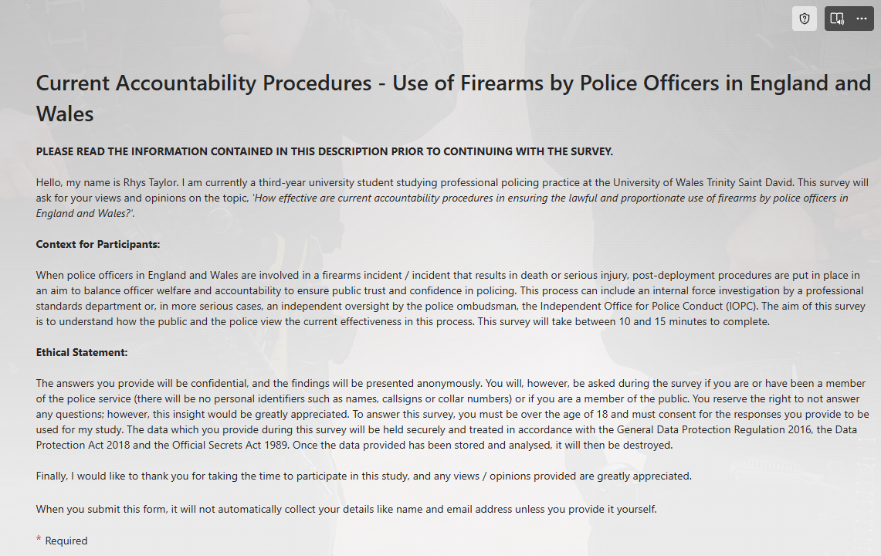
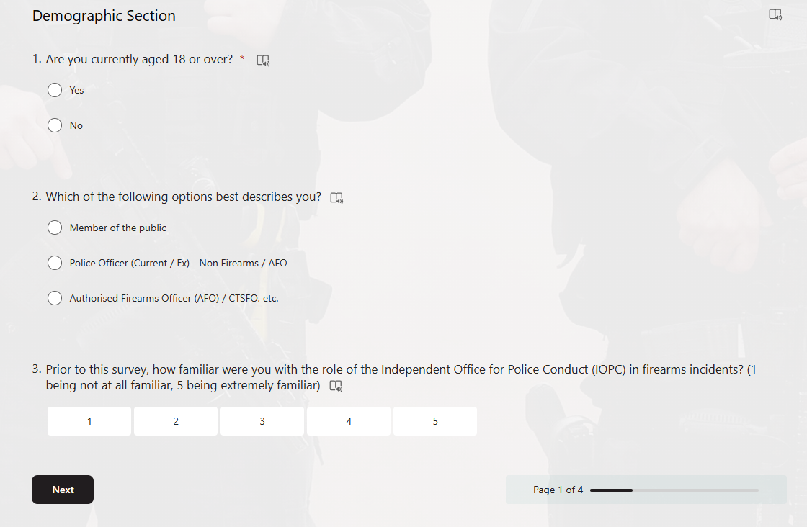
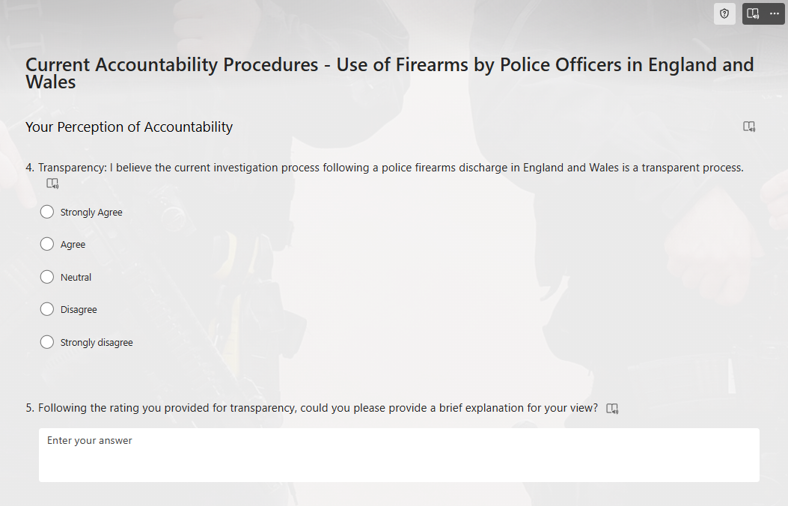
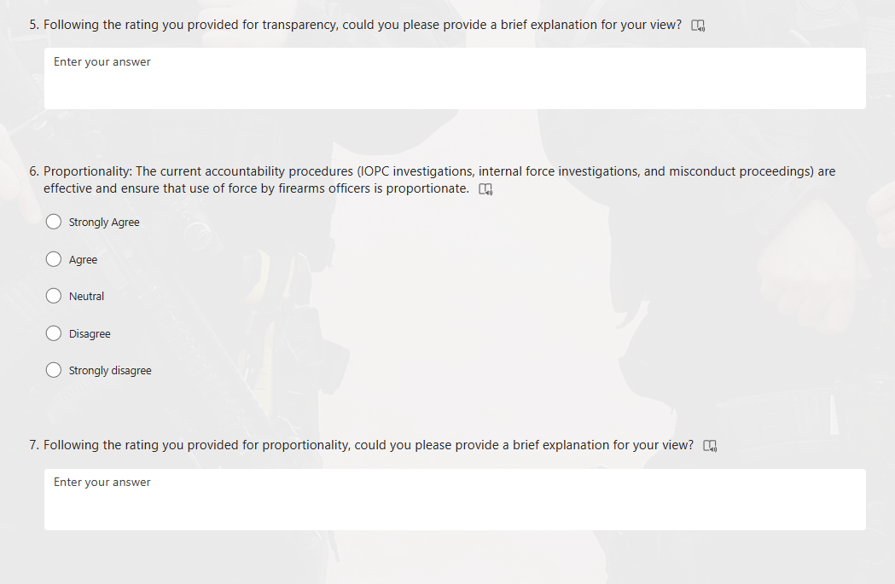
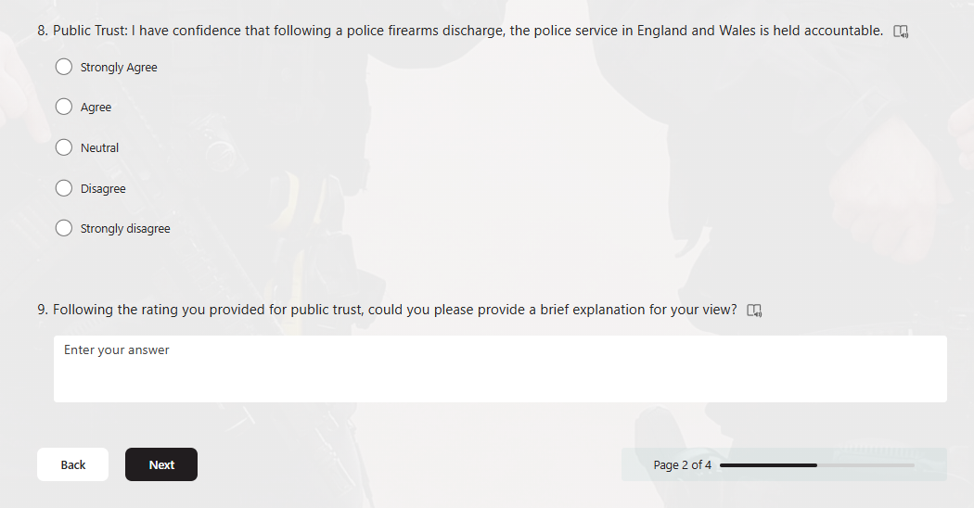
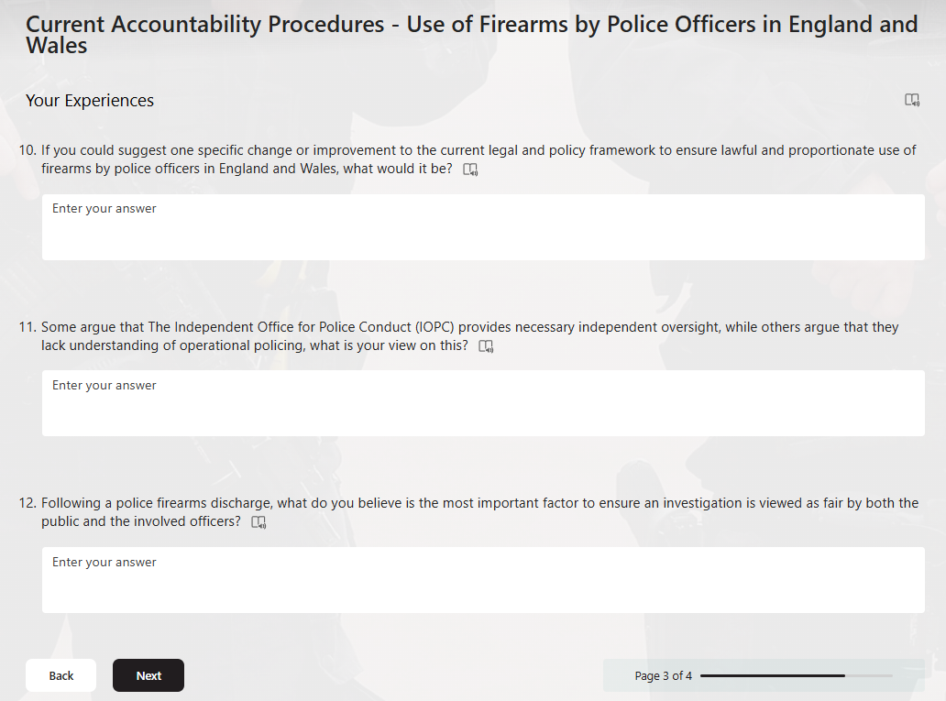
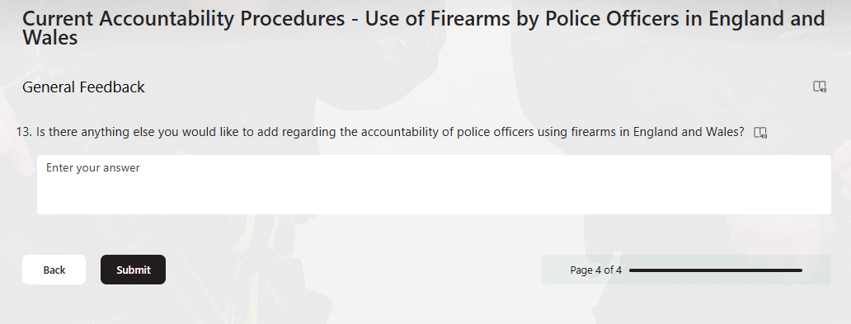

Appendix B - Research Survey Responses


