Revenue Management System
Presentation

Student name: Antonela Puiu
Student number: 2025260
Module: Contemporary Themes BMIH6001
Lecturer: Scott James

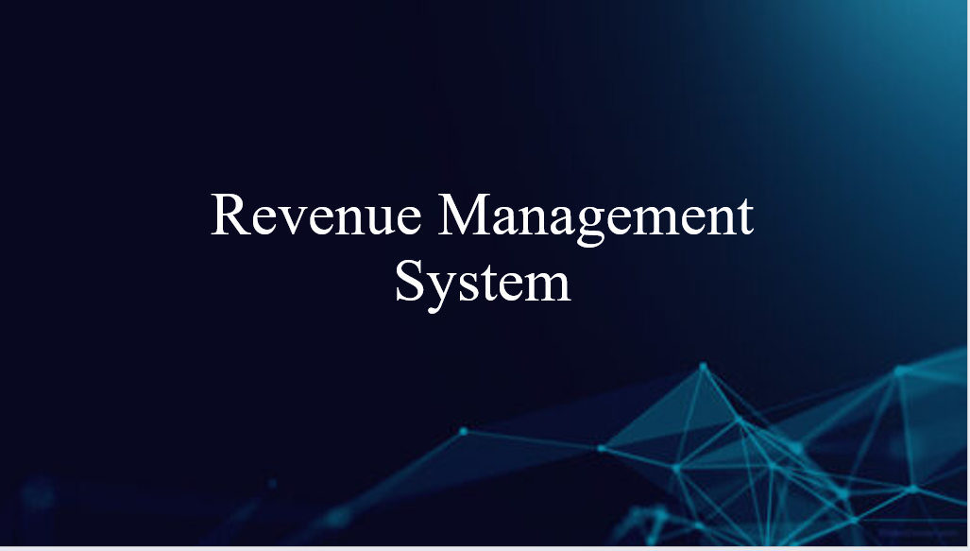

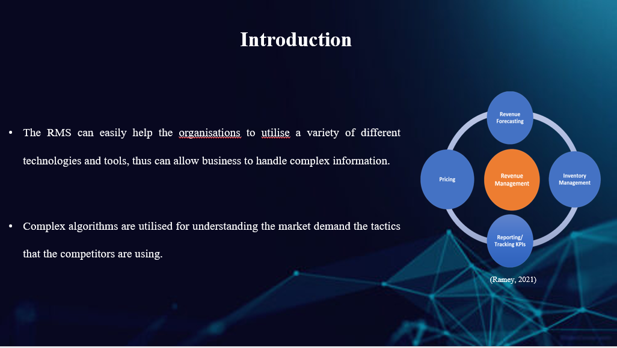

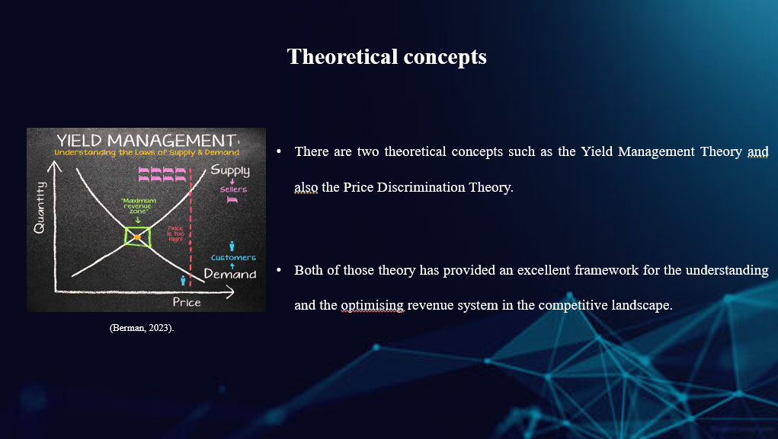

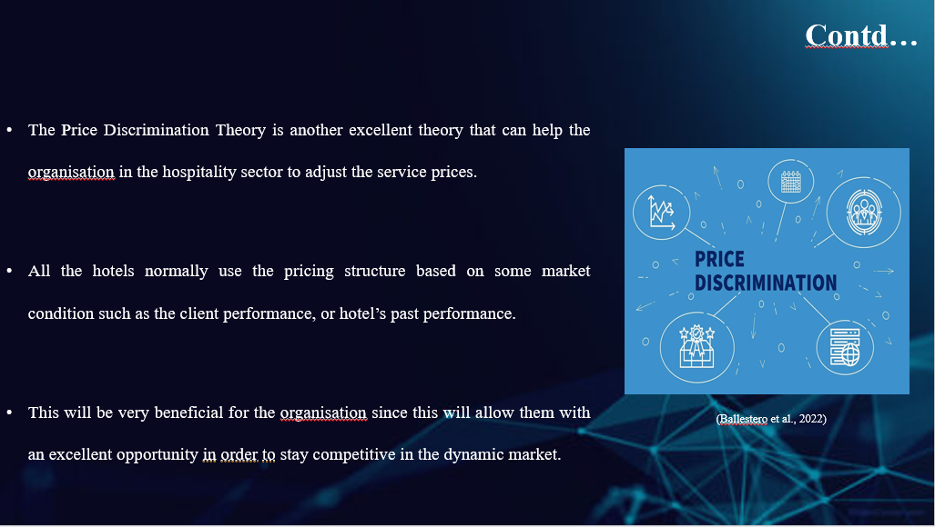

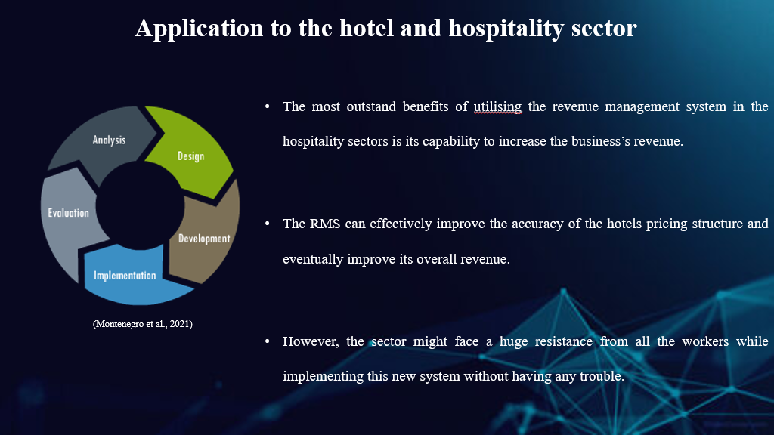

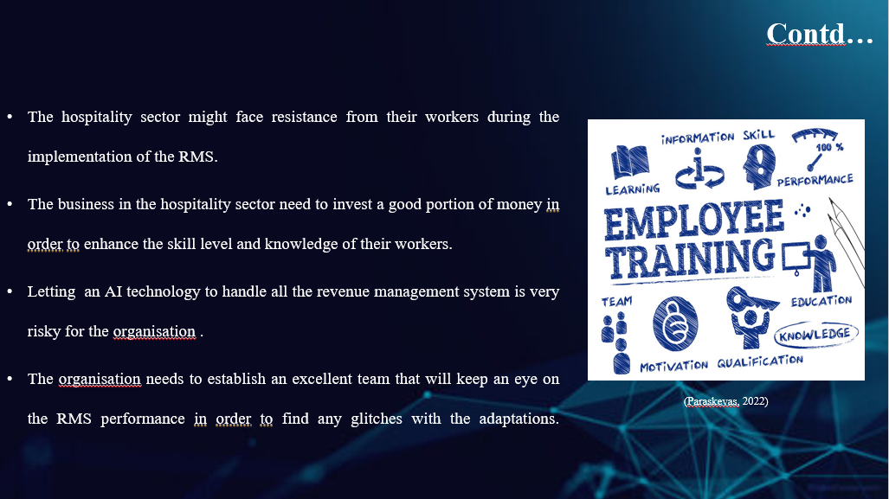

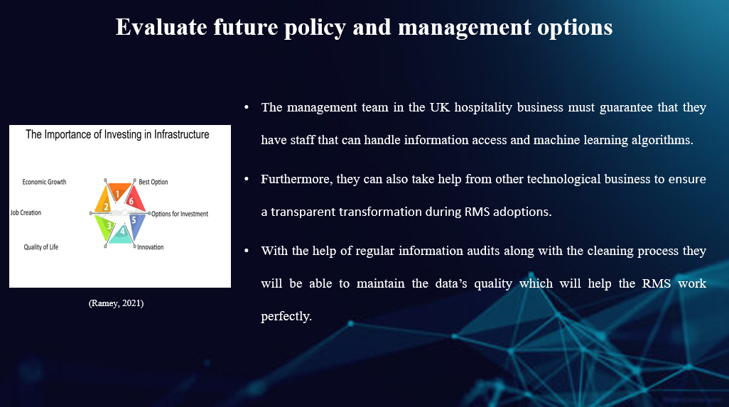

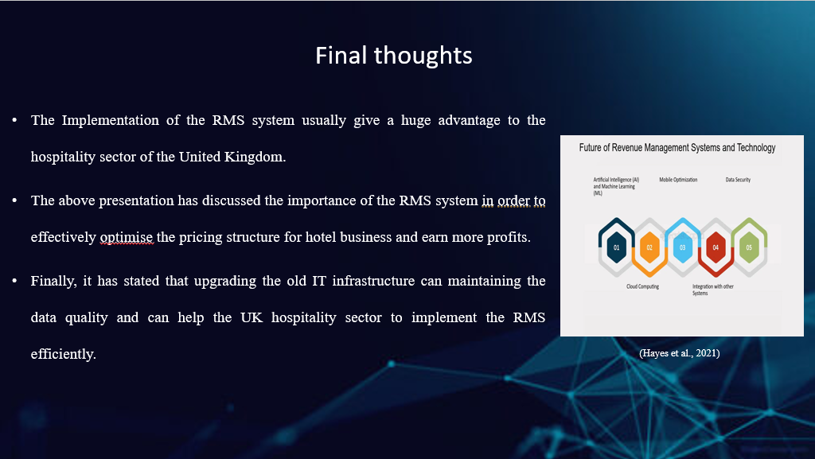

References
Barta, G. and Görcsi, G. (2021) ‘Risk management considerations for artificial intelligence business applications’, International Journal of Economics and Business Research, 21(1), pp.87-106.
Berman, D. (2023) Revolutionizing The Hospitality Industry With Artificial Intelligence. Available at: https://www.forbes.com/sites/forbesbusinesscouncil/2023/09/11/revolutionizing-the-hospitality-industry-with-artificial-intelligence/?sh=ad9518423d16 (Accessed: 16 January 2024).
Chi, O.H., Denton, G. and Gursoy, D. (2020) ‘Artificially intelligent device use in service delivery: A systematic review, synthesis, and research agenda’, Journal of Hospitality Marketing and Management, 29(7), pp.757-786.
De Bastos, B.P. (2023) ‘Contribution of hotels’ revenue management for supply chain sustainability’, Journal of revenue and pricing management, 22(4), pp.294-305.
Elbertouli, I. and Bahyaoui, S. (2023) Yield Management, Risks and Consequences for the Customer: Perspectives on the Moroccan Chain Hotel Industry.
Guerra-Montenegro, J. et al. (2021) Computational Intelligence in the hospitality industry: A systematic literature review and a prospect of challenges. Applied Soft Computing, 102, p.107082.
Guizzardi, A. et al. (2021) ‘Big data from dynamic pricing: A smart approach to tourism demand forecasting’, International Journal of Forecasting, 37(3), pp.1049-1060.
Hayes, D.K., Hayes, J.D. and Hayes, P.A. (2021) Revenue management for the hospitality industry. John Wiley & Sons.
Helmold, M. and Helmold, M. (2020) Total revenue management (trm) (pp. 1-12). Springer International Publishing.
McGilvray, D. (2021) Executing data quality projects: Ten steps to quality data and trusted information (TM). Academic Press.
Paraskevas, A. (2022) Cybersecurity in travel and tourism: a risk-based approach. In Handbook of e-Tourism (pp. 1605-1628). Cham: Springer International Publishing.
Pradina, N.L.G.V. (2023) ‘Yield Management Strategy in Increasing Room Occupancy in The New Normal Era’, International Journal of Travel, Hospitality and Events, 2(1), pp.79-90.
Ramey, V.A. (2021) The macroeconomic consequences of infrastructure investment (Vol. 28215, p. 219), Chicago: University of Chicago Press.
Sołtysik, M. (2024) Artificial Intelligence, Management, and Trust. Routledge.
Talón-Ballestero, P., Nieto-García, M. and González-Serrano, L. (2022) ‘The wheel of dynamic pricing: Towards open pricing and one to one pricing in hotel revenue management’, International journal of hospitality management, 102, p.103184.

