Name: WANG Yi (1904436)
Course: English Language Teacher Education (HPEN7005)
Assignment 2: Project Proposal (4,200 words)
_______________________________________________________
1. Title
The title of the provisional mini-research proposal is: An examination of the use of “Multiple Intelligences Theory” as a basis for developing the English language proficiency of undergraduates and its implications for the innovations of teaching strategies in comprehensive English course.
Multiple Intelligences Theory (Gardner, 1983, 1993) is an interesting theory I have learnt in the course HPEN 7005, which is not completely brand-new but can be applied to many contexts in education, especially in the foreign language teaching. In this mini-research, based on the Multiple Intelligences Theory, as an English teacher in a Chinese university, I would like to examine its functions and applications, including its advantages and disadvantages, in cultivating and improving the undergraduates’ English language proficiency based on their study in comprehensive English course. At the same time, I, as the researcher, will manage to dig out its implications for the changes and reforms of teaching strategies which aim to realize the goal of assisting students’ English language learning as well as stimulate students’ interests and motivations in English language learning.
2. The aims of the investigation
The aims and research questions of this investigation are as the following:
(1) What are the distributions of these undergraduates’ or subjects’ multiple intelligences?
Before teacher A design her teaching syllabus, instructions, assessment and the class activities, she need learn and understand the distributions of undergraduates’ varied intelligences to provide her a good overall picture of their strong and weak intelligences respectively, which will help her apply Multiple Intelligences Theory to the course better, offer more potential approaches to diverse undergraduates’ needs and build up the foundation for the subsequent experimental teaching process.
(2) What are the effects and impacts of Multiple Intelligences Theory on undergraduates’ English language proficiency after its application of in comprehensive English course?
Some researchers hold that Multiple Intelligences Theory is beneficial for learning in many aspects (Simeone,1995; Richards and Rodgers, 2001; Savas, 2012; Ahmadian, 2017), whereas others think the theory is too broad and inapplicable (Levin, 1994; White, 1998, Waterhouse, 2006a). Therefore, how and to what extent it enhances or weakens the students’ English language learning attainment and proficiency in a new teaching context is still to be verified in this proposal.
(3) Is the teaching activities and effectiveness of comprehensive English course based on Multiple Intelligences Theory gladly received by undergraduates?
Nearly all reforms and innovations in English class aim to increase the interests of students, accelerate the English language learning effectiveness, and raise the students’ English language proficiency. Therefore, when the theory is applied to the comprehensive English course, it is important for us to know whether it is feasible or acceptable to the lecturees.
(4) How does Multiple Intelligences Theory implicate and influence the College English teaching and teachers’ strategies?
After its application to comprehensive English course, Multiple Intelligences Theory will influence teachers to change and adjust their teaching strategies in class. Based on this empirical research, the researcher will manage to find out the novel strategies teachers can utilize and resort to.
3. The rationale and main conceptual themes for the investigation
The rationale in this proposal is that it will improve the English language proficiency and attainment of undergraduates with varied intelligences as well as illustrate more easily and feasibly English teaching approaches for teachers based on the application of Multiple Intelligences Theory. Although many reforms in comprehensive English course have been carried out in China, there still many students who can not achieve their good performance and lose interests in learning English at the university level. It is proposed that Multiple Intelligences Theory has a positive effect on facilitating the college English teaching, creating a preferred English learning context, leading to the effective interactions between teachers and students, and making comprehensive English course more attractive and interesting. Therefore, as a result of Multiple Intelligences-based English teaching, teachers can change the traditional teaching methods and adjust the innovated strategies in order to cater the indispensable needs of undergraduates’ attainment and proficiency. Moreover, undergraduates will be likely to improve their English proficiency as well as their oral and literal skills when they raise their interests and motivation in English learning accordingly.
With the development of international communication and commercial activities, English as a global language, plays a crucial role in the world as well as in Chinese education. Children begin to learn English when they are in kindergarten, and continue the learning until the postgraduate level. In 2005, Chinese Educational Department launched English education reforms in differently educational levels from kindergarten to university, in order to improve students’ English language proficiency, especially their listening and speaking abilities. Until now, some progresses have been made and students’ English language proficiency has been enhanced to some extent.
However, as far as English teaching in universities is concerned, it is worth noting that both teachers and students may meet some difficulties and challenges in teaching and learning English respectively during the process, even though English has a unique position as a compulsory course at the university level. On the one hand, it is the lagging teaching design and methods that mostly restrict to improve English teaching efficiency and undergraduates’ learning proficiency in universities. There still exist many problems which cannot be ignored in English class. For example, tedious teaching pattern, lacking open and flexible class activities, paying too much attention to the teaching contents without developing the English ability of integrative exertion, more teacher-centered and less student-centered, deficiency of peer communication in class and so on. On the other hand, teachers need to cater students’ needs, rather than teach them with the same material and without caring about their necessities in studying English, which is very important when teachers design the syllabus and activities in comprehensive English course. Accordingly, English teachers need to think about students’ attitude and motivation, managing to answer the following questions: What are their purposes to study English? What are they interested in? Which topic can arouse their interest and promote their communication with others as well as improving their writing and reading?
Multiple Intelligences focuses on the learners, attaches importance to the learning process, and pays attention to cultivate multiple abilities of learners according to abundant teaching activities, which is the main reason why I choose it as the main conceptual theory to solve the difficulties and challenges mentioned above. For one thing, Multiple Intelligences theory helps to reconceptualize values of teaching and learning in English as a foreign language classroom. Learners’ cognitive styles are reflected in every aspect of their foreign language learning process. As a result, it can make up many disadvantages of the current teaching methods and become an important theory in college English teaching. For another, Multiple Intelligences Theory focuses on the integration of learners, that is, the linguistic, logical, spatial, musical, kinesthetic, interpersonal, intrapersonal and naturalist intelligence are equal. Moreover, Multiple Intelligences Theory emphasizes the diversity and unique intelligences of learners, and leads teachers to teach the learners according to their own aptitude. It also teaches everyone to solve the practical problems, especially the ability to study the new knowledge. In addition, it can tap intellectual resources of learners and inherent potential; gradually increase learners’ level of multiple intelligences and language learning ability.
This proposal will widen the scope of investigations in the application of Multiple intelligences in the practical perspective, and derive the linkages between the innovation of teachers’ pedagogies and undergraduates’ comprehensive evaluation and proficiency improvement in English learning based on undergraduates’ differentia and diverse intelligences, managing to fill the gap between them in the academic field. In fact, many experts and scholars have made great contributions to college English teaching with the application of Multiple Intelligences and made certain achievements. But in China, most teachers connect Multiple Intelligences with the education of kindergarten, elementary and middle school learners, aiming at developing the multiple intelligences or increasing the interests of learners. Therefore, it is much less that relevant theoretical studies apply to the college English teaching field in contrast to the prosperous application in the kindergarten, elementary and middle school fields. However, though applying it to the college English teaching field, they just evaluate the learners from several separated aspects, such as the motivation, learners’ needs or preferences and testing scores. Therefore, another significance of this proposal is to explore the new teaching methods which combine the principles of interest, knowledge and practicality, mobilize the initiative of both teachers and students, and attach importance to the central role of students in teaching and learning process as well as undergraduates’ learning methods, English performance and proficiency.
4. A description of the evidence the researcher intends to collect
(1) Responses to questionnaires
Before the empirical class teaching, teachers A and undergraduates in Class 1 will do the questionnaires. All participants will be told that there are not exactly correct or incorrect answers and there is no maximum number of points. Therefore, they need not worry about the results and can provide rather reliable information about themselves. And only the questionnaires with complete responses or answers are computed and seen as valid.
Firstly, these undergraduates in Class 1 are given the “Class Activities” questionnaire (QA), which is designed on the basis of Roger Hawkey’s version (2001). QA has 20 items, and each item is with five choices, such as A. Never., B. rarely., C. sometimes., D. often., E. always. QA can help teacher A better acquaint with the activities which students enjoy or participate in when they are in senior middle school, and facilitate her to build a solid foundation of class activities design in comprehensive English course.
Then, “Multiple Intelligences Distribution” questionnaire (QB) (Walter McKenzie, 1999) will be delivered to these undergraduates in Class 1 to elicit some information about their strengths and weakness in the Multiple Intelligences profiles, help teacher A learn about students’ varied intelligences as well as manage to use the better approaches to arouse students’ interests, motivate and improve their English proficiency.
Finally, teacher A who will teach Class 1 will use the “Multiple Intelligences Inventory for ESL Teachers” questionnaire (QC) (Christison, 1998) to understand her intelligences in order to facilitate the teaching strategies applied later.
(2) Responses to interviews
In order to leave much space of subjects to freely express themselves, Richards and Lockhart’ model for learners (1994) is adopted and changed to satisfy the needs of Chinese students. The main questions focus on but are not limited to these: (a) Did you like English study in senior school? (b) Do you know about Multiple Intelligences Theory? (c) What do you think of the use of Multiple Intelligences Theory when you understand it? (d) Do you prefer to the way your teacher teaching according to your intelligence profile? And please tell the reasons.
At the end of the empirical study, ten students selected randomly in Class 1 will be involved in the interview. The researcher will talk with the students and interview them after classes in order to get familiar with or to know their attitudes and opinions about the English teaching.
This semi-structured interview is guided conversations but not constrained conversations, and new questions are allowed to arise as a result of the discussion. Also, it is a relatively informal, relaxed discussion based on a predetermined topic. The subjects should try to be as honest and open as they can, and the subjects will be told that there are not exactly correct or incorrect answers to these questions. These interviews are good complement of the items in questionnaires and other approaches.
(3) Observation notes
According to QB, clues to various intelligences are provided. The single best tool for assessing students’ multiple intelligences, however, is probably one readily available to the teacher—simple observation (Armstrong, 2000). During the study, the researcher will observe the performances of the participants for 6 times totally. To be specific, Class 1 and Class 2 will be observed for 3 times respectively, the first in the beginning of the study, the second in the middle and the third in the end. After the transcription of the observation, based on observation of the Class 1 and Class 2, the researcher will assess the comparison and contrast between them and center on the most different perspectives in class teaching influenced by Multiple Intelligences Theory. That is to say, the researcher will analyze the typical and universal significance out of students’ behavior and performances; thereby get a better understanding of Multiple Intelligences Theory, teaching peodagogies and the students’ feedback in class.
(4) Texts of English tests
At the beginning and at the end of this study, two English tests will be held to every undergraduate both in the Class 1 and Class 2 respectively. The first test (pre-test) adopts the English standardized test in Chinese College Entrance Examination, aiming to record their English language proficiency at the beginning of the empirical study, help teachers understand their students’ proficiency and attainment fully and facilitate teachers to design the class activities and adjust their teaching strategies. On the other hand, because the undergraduates are the freshmen and they should arrive at the level of College English Test Band 1 (Chinese English Proficiency Standard in Higher Education) at the end of the semester, the second test (post-test) is designed according to the College English Test Band 1 which has high validity and reliability.
Based on the comparison and contrast between the 2 tests, the researcher can analyze the results of tests and achieve the proficiency of students, which can reflect the impacts of the application of Multiple Intelligences Theory from the students’ language proficiency level.
5. The methods the researcher plans to use to collect the evidence
Mixed research methods are adopted according to the four research questions and purposes of this proposal. Compared with quantitative method in the exploration of the pre-test and post-test, qualitative method is widely applied to the analysis of QA, QB, QC, interviews and class observations. One of the unique features of qualitative research is that it centers on provoking meanings and understandings by means of the rich descriptions of the collected data. As a result, it can be a helpful approach to investigating some research questions in my proposal. For one thing, qualitative method can develop the interpretation of sophisticated English language teaching and learning as well as classroom activities and settings. For another, it also can deepen the indications that both teachers and students propose based on their experiences within the contexts.
Firstly, based on the qualitative analysis of QA, teacher A who teaches Class 1 can survey what kind of class activities are familiar and popular to the subjects. This will provide references and instructions for the teacher when she designs her class activities.
Secondly, the qualitative study of QB will answer the first research question and give teacher A a clear picture about the distribution of students’ intelligences. Based on the intelligence distribution of students, she can formulate some unique strategies and activities in order to activate their interests and involvement in comprehensive English course.
Thirdly, the qualitative illustration of QC aims to make teacher A understood herself better and answers the fourth research questions from the angle of the teacher’s preparing stage. Therefore, teacher A have more options. For instance, Teacher A has advantages in interpersonal intelligence, then she can design more English oral communications with students in class based on her interpersonally communicative skills. On the other hand, teacher A can avoid their disadvantages in intelligences on purpose in order not to fail in the teaching strategies or class activities.
Fourthly, the qualitative summary of interviews will answer the third research question and help the researcher better understand the evaluation of both the adaptation of Multiple Intelligences Theory and the innovation of teaching strategies in comprehensive English course from the students’ perspective.
Fifthly, based on the qualitative investigation of class observations which will partly give the answers to the second and the fourth research questions, the researcher can follow and record the changes and adjustments of the class procedures, providing more materials to think about the implication Multiple Intelligences Theory brings to the comprehensive English course.
Lastly, the scores of the pre-test and post-test will be data presented in numerical form in order to do the quantitative research. The comparison and contrast of the two tests will be analyzed by the quantitative method, contributing to the students’ proficiency changes (improving or declining tendency) and answering the second research question from the proficiency point.
Therefore, based on the mixed methods in this proposal, the researcher can successfully decipher the four research questions respectively.
6. A description of the settings in which the researcher plans to collect the evidence.
(1) Empirical study context
This empirical study is carried out among the undergraduates in Changchun University of Technology, China. Students who are chosen to be the subjects in the study are all freshmen. Just like most students in many other universities and colleges, they are mainly involved in the teacher-centered English classes. These subjects take English courses of intensive reading and listening comprehension by following the same English teacher. Moreover, they follow their teacher to take their intensive reading without multimedia equipment and take their listening courses in language laboratory. They own four hours together to have English classes every week. In detail, they have four hours of intensive reading in the odd week; two hours of intensive reading and two hours of listening in even week.
(2) Students
110 subjects are involved in this study. They are randomly chosen from the School of Business Administration in Changchun University of Technology. Class 1 (the experimental class) consists of 52 students, including 32 girls and 20 boys and Class 2 (the controlled class) consists of 58 students, including 30 girls and 28 boys. According to the investigation, students of the two classes have some common features. They have the same periods of exposure to English, sharing the similar cultural and social background and no one having been to an English-speaking country. The age of the subjects ranges from 18 to 21. Basically, they are almost in the same level prior to the introduction of intervention.
(3) Teachers
Teacher A and teacher B are involved in this research. Both of them are female and have fourteen years of teaching English experiences, major in applied linguistics and are adept at teaching comprehensive English course to the non-English majors. Teacher A teaches the experimental class A, while teacher B teaches the controlled class B. However, the experimental Class 1 will be taught and trained by teacher A who designs the syllabus, class activities and teaching strategies directed by the application of Multiple Intelligences Theory, while the controlled Class 2 will be taught in the traditional and normal approaches as what teacher B did in the past.
(4) Teaching materials
During this study, the textbooks College English (Third Edition) are used, including Intensive Reading Book 1, Focus Listening and Speaking Book 1, and Fast Reading Book 1 which are published by Shanghai Foreign Language Education Press. The teachers use the purposes and objectives in Teacher’s Book for College English Book 1 as a reference to prepare the contents of English classes.
7. The ethical issues the researcher need consider
The proposal will be conducted in agreement with the policies and principles of Changchun University of Technology as well as what is written in BERA Ethical Guidelines for Educational Research (4th edition, 2018). Before the application of this research, the researcher will take everything into consideration, minimizing any risk and harm to participants. At first, as the researcher in this research, I will show my respect for every participant with an ethic of social educational research when manipulating it. Second, prior to the empirical research and data collection, I will obtain the permission and approval for inviting the participants (teachers and students) to take part in the research from the University. Third, the presumptive participants will receive a printed invitation letter. In this letter, it will introduce the purposes, the research process and the outcomes of the research, issuing the assurances of anonymity and confidentiality, for example, all the details of participants will be masked by the numbers or English letters, and all information related to the research will have non-traceability to any participant in order to protect the privacy of participants. Also, they will be told that they have the right to withdraw at any time from the research if they want to. Fourth, students will be informed that the research itself will have no influences on their assessment in the comprehensive English course. In answering QA and QB, students will be told that there are not exactly correct or incorrect answers and there is no maximum number of points, just as it is when teacher A does QC. Fifth, as for teachers, participating in this research will not affect the results of their teaching inspection by the head staffs of Foreign Languages School in the University. Conversely, they will be supported by some other staffs in the school who are interested in the research. Sixth, prospective participants will voluntarily sign their names on the consent forms attached to the invitation letter and put the consent forms in a locked box with a slot on the top. Only the researcher has the key and can check the forms. Seventh, during the interview, the researcher will accompany with another two professors in order to do the safeguarding. At last, in terms of General Data Protection Regulation (2016), the records of all the data will be kept safe in a unique USB flash Disk with security codes which is only known by the researcher.
8. The methods the researcher expects to use to analyses the evidence collected.
First and foremost, three questionnaires QA, QB and QC will be issued and collected according to an online crowdsourcing platform “Wenjuan Xing” (This is the name of Chinese pinyin, which means “the star of questionnaire” in English) powered by “www.wjx.cn” in China, which offers the equivalent functions as “Amazon Mechanical Turk”, such as online questionnaire or surveys, online tests and online votes. The qualitative analyses of these questionnaires can be carried out by means of the data collection in this platform.
In the second place, interview will be recorded and transcribed. In order to ensure the validity and reliability of originally transcribed data, I will invite the two professors who accompany with me in the interview and another two professors who know little about the research to help me double check the inter-code consistency of the interview transcriptions. Also, thematic analysis will be adopted when I do the qualitative analysis of the interview.
Moreover, both the pre-test and the post-test contain the objective items, such as multiple choices items to test their vocabulary, grammar, listening and reading comprehension, and the subjective work to test their oral speaking, writing and translation skills. For the objective part, the test papers will be scored by using the scoring machine, which can give out the marks of every student within 10 seconds. For the subjective part, it can be divided into 2 sub-parts. In the oral test, 2 examiners who do not teach them will score the 110 students respectively and the mean score will be the final score of each student. Then, the writing and translation part will be scored in the same way. All the data in these two tests will be collected and analyzed by SPSS 25.0 for the sake of comprehending the frequencies and correlative coefficients. The researcher will adopt the t-test in this research in order to ensure the validity and reliability as well as verify the statistical accuracy.
9 The timetable for the proposed project
The research will be conducted in 3 phases and last for 10 months. The first phase is the research preparation period from 1, Jan. to 15, Mar. During this period, the researcher will design and refine QA, QB, QC, Interview Questions, the pre-test and the post-test. Then, the preparation for the ethical issues will be carried out. After attaining the confirmation of participants, QA, QB, and the pre-test will be distributed to the students in Class 1 and QC will be given to teacher A. Based on the data collection and analysis of these above data, teacher A can design and refine the syllabus, class activities and teaching strategies in comprehensive English course. The second phase from 16, Mar. to 15, Sep. is the application and practice phase. In this phase, teacher A and B will teach Class 1 and Class 2 respectively. The only difference between them is teacher A will adopt the innovated teaching strategies adapting to the intelligences’ distribution of students. There will be 3 class observations for each class during the teaching period, a post-test and an interview for 10 students in the end of the teaching. In the third phase which is from 16, Sep. to the end of October, based on the data analysis of post-test, interview and class observations, the researcher will solve the 4 research questions step by step and achieve some findings and implications of this research. Finally, the researcher will finish the thesis writing in accordance with the data analysis.
The timetable in detail is in the following Gantt chart.
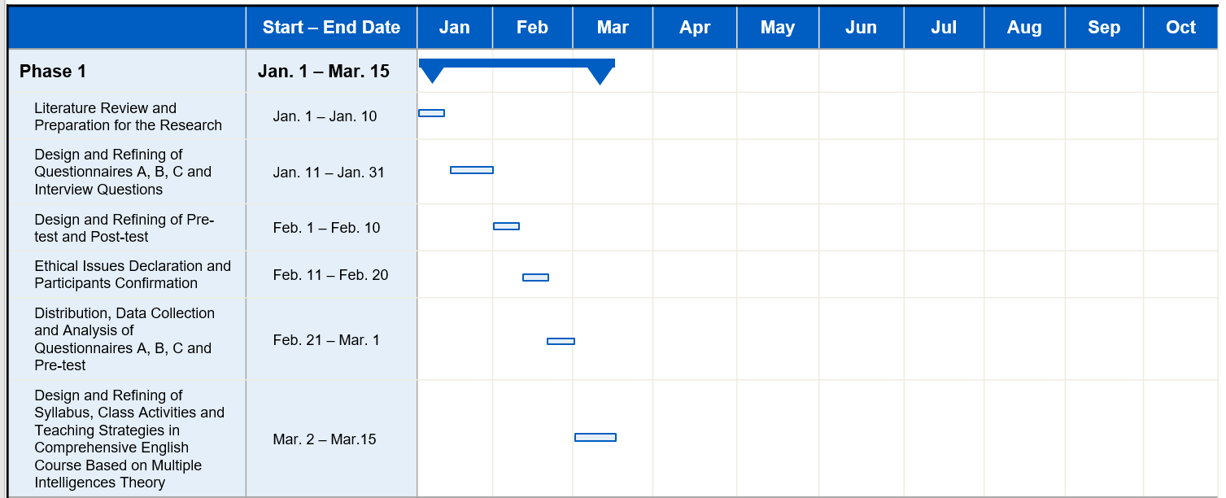
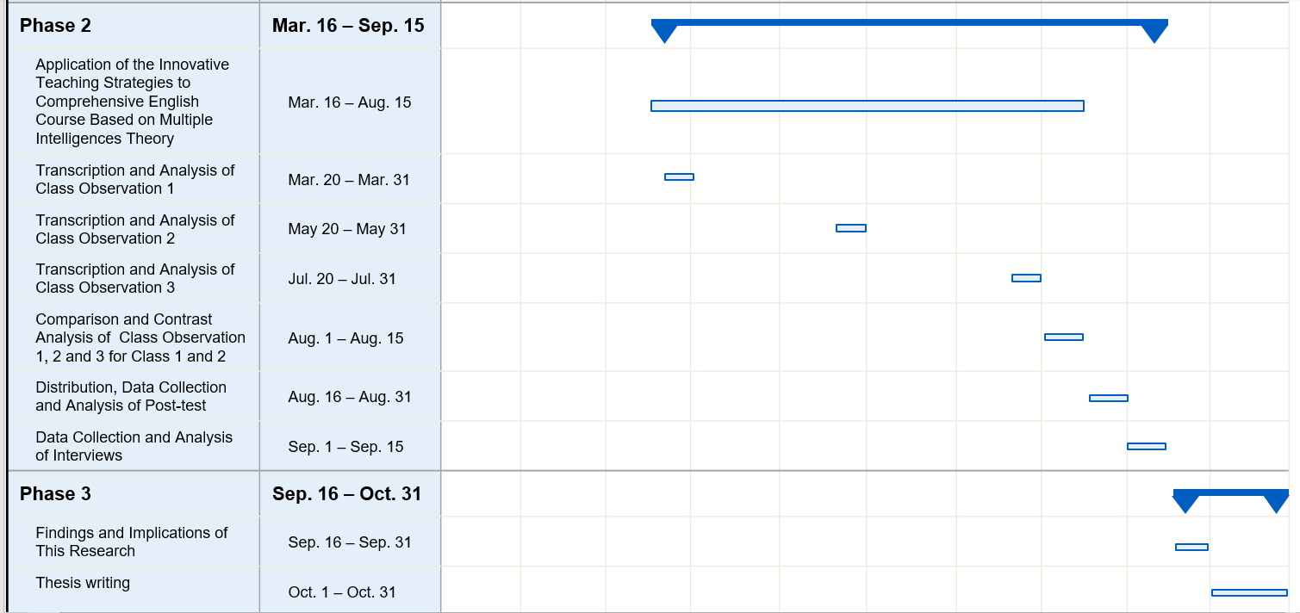
.

Bibliography
- Ahmadian, Moussa. (2017). Language Learning Strategies, Multiple Intelligences and Self-Efficacy: Exploring the Links. Journal of Asia TEFL 14.4: 755-72.
- Armstrong, Michael. (2000). Performance Management: Key Strategies and Practical Guidelines. 2nd ed. London: Kogan Page.
- British Educational Research Association [BERA] (2018) Ethical Guidelines for Educational Research, fourth edition, London. https://www.bera.ac.uk/researchers-resources/publications/ ethicalguidelines-for-educational-research-2018
- Christison, M. A. (1998). An introduction to multiple intelligence theory and second language learning. Understanding learning styles in the second language classroom, 1-14.
- Gardner, H. (1983). Frames of Mind: The Theory of Multiple Intelligences. New. York: Basic Books.
- Gardner, H. (1993). The Theory of Multiple Intelligences: The Theory into Practice. New York: Basic Books.
- General Data Protection Regulation [GDPR] (2016). https://gdpr-info.eu/
- Hawkey, Roger. (2001). A Progetto Lingue 2000 impact study, with special reference to language testing and certification. ed. by Michael Milanovic, Studies in Language Testing 18: European Language Testing in a Global Context.
- Levin, H. M. (1994). Commentary: Multiple Intelligences Theory and Everyday Practices, Teachers’ College Record, 95, 4, 570-583.
- McKenzie, Walter. (1999). http://surfaquarium.com/MI/inventory.htm
- Richards, Lockhart, and Lockhart, C. (1994). Reflective Teaching in Second Language Classrooms. Cambridge: Cambridge UP.
- Richards, Rodgers, and Rodgers, Theodore S. (2001). Approaches and Methods in Language Teaching. 2nd ed. Cambridge: Cambridge UP.
- Savas, Perihan. (2012). Pre-service English as a Foreign Language Teachers' Perceptions of the Relationship between Multiple Intelligences and Foreign Language Learning. Learning and Individual Differences 22.6: 850-55.
- Simeone, Wendy. (1995). Accommodating Multiple Intelligences in the English Classroom. English Journal 84.8: 60.
- Waterhouse, L. (2006a). Multiple Intelligences, the Mozart Effect, and Emotional Intelligence: A Critical Review, Educational Psychologist, 41, 4, 207-225 http://dx.doi.org/10.1207/s15326985ep 4104_5
- White, John (1998). Do Howard Gardner’s multiple intelligences add up? London: Institute of Education University of London.

