
Module Assignment Submission
Student Name: | Martine Kennedy
Student Number: | 2010990
Module Code: | Developing workplace – Critical Thinking
Module Title: | BMSK5001

Statement of Confirmation of Authenticity
By the act of making this submission, the student declares that this is the work of the student named above. The work has not, in whole or in part, been knowingly presented elsewhere for assessment, or where assessment has been built on a previous assessment, this has been identified. Where materials have been used from other sources it has been properly acknowledged. If this statement is untrue, the student acknowledges that an assessment offence has been committed.
Attention is drawn to the plagiarism and unfair practice policies of the University.

Table of Contents
Introduction 3
Critical thinking 3
Values, beliefs, attitude and behaviour……………………………………………………………………………………………….4
Management theories………………………………………………………………………………………………………………………..5
Conclusion……………………………………………………………………………………………………………………………11
Bibliography……………………………………………………………………………………………………………………………………..13
Reference………………………………………………………………………………………………………………………………………..13
Appendix A………………………………………………………………………………………………………………………..16
Appendix B…………………………………………………………………………………………………………………………17
Appendix C………………………………………………………………………………………………………..………………18

Introduction
For this assignment, the student is to identify the relationships between our values, beliefs, attitudes and behaviours and how, if applicable, they contribute to the workplace. They review management theorist and discuss models most relevant within their own place of work.
There are two areas in which the author is to critically analyse.
- Identify a management theory relevant to your role and critically assess its impact on your own beliefs, attitudes and values​.
- Critically assess the impact of beliefs, attitudes, and values on your own workplace behaviour.

Critical thinking
The author recognises critical thinking as not taking the information presented at face value and challenging alternative opinions, actions, thought processes etc. We critically analyse in our day to day lives on a regular basis without a second thought from the most basic, to more complexed situations. As in any situation there is no fixed way of applying yourself, therefore by being open minded to alternative solutions can be a huge benefit.
Chatfield (2018) summarises “when we think critically, we are searching for the best account we can currently offer of the way things actually are, and this means being obliged to change our minds when facts and reason demand that we do”. The student acknowledges that by applying such measures is positive.
There are various models available, however the student particularly found the RED module useful to think out the box – see appendix A. She felt it was a simple tool to use, as effectively broken down into three segments, which are as follows, recognising the assumptions, evaluating the argument and drawing a conclusion.

Values, beliefs, attitudes and behaviour
“Values are basic and fundamental beliefs that guide or motivate attitudes or actions. They help us to determine what is important to us. Values describe the personal qualities we choose to embody to guide our actions; the sort of person we want to be, the manner in which we treat ourselves and others, and our interaction with the world around us. They provide the general guidelines for conduct.” (Ethics Sage 2018).
“Beliefs and values are two important concepts that govern our behaviour and attitudes. Although values and beliefs are interrelated since they collectively affect our attitudes, perceptions, personality, character and behaviour, there is a distinctive difference between them. The main difference between values and beliefs is that values are principles, ideals or standards of behaviour while beliefs are convictions that we generally accept to be true. It is these ingrained beliefs that influence our values, attitudes, and behaviour.” (Hasa 2016).
“In psychology, an attitude refers to a set of emotions, beliefs, and behaviours toward a particular object, person, thing, or event. Attitudes are often the result of experience or upbringing, and they can have a powerful influence over behaviour. While attitudes are enduring, they can also change.” (Psichology 2022).
“The meaning a psychologist derives from behaviour is largely determined by his or her theoretical framework. Behaviourists, such as John B. Watson, are famous for seeing behaviour as the 'be all and end all' of psychology. Behaviourism considers behaviour to be the only objective phenomenon of psychology and thus the only reliable information on which to base predictions of future behaviours. Behaviourism developed in the late 19th century as a response to the theories of introspection and psychoanalysis, which relied on the observation of internal states of mind and emotions to understand one's conscious experience”. (Behaviour: Definition & Explanation, 2018).
In summary, whilst our behaviour and attitude is visual at times, whether this be positive or negatively, it is our values and beliefs that trigger such emotions. Prior to completing this assignment, the student did not analyse this in great depth, however it makes perfect sense and explains why/how we conduct ourselves on a daily basis. They feel our values and beliefs originate from religion and our experiences, which we are taught at an early age. Dependant on circumstance, our views are compromised sometimes. For example, the author feels providing for her family is a high priority in her life. However, recently made the decision to reduce her hours of work to ensure a healthy work/life balance with her daughter.
The student evaluated her main core values at the start of the assignment to be, family, respect, equality, good manners, financial stability, loyalty and empathy which she notes is passed onto her daughter, who is 12 years old. They have already noticed the conflict in values and beliefs between the pupils and often finds herself questioning “what are these children taught at home.” Whilst she accepts the lack of maturity due their age, they have regular conversations with her daughter to stand true to herself and not conform to those around them. This raises the debate, in the authors opinion, of how much our experiences dictate our values and beliefs.
After completing the Rokeach survey, the author was surprised as to how her opinion changed when a list of values were presented to her and how she ranked them. To highlight the top five in numerical order. Firstly, Loyalty, being polite, responsible, self-controlled and loving. Whilst she does hold these attributes, they were not all her first thought.

Management theories
Management theories, (school of management) is categorised into four core areas. Scientific, Classical, Behavioural and modern. Frederick Taylor was the first theorist to implement his perception of modern management of its time. Naturally, other theorist went on to develop theories to maximise productivity within a company with a view to increase sales. This would include Elton Mayo, the Human Relations movement, Max Webber, Bureaucracy, Henri Fayol, Administrative Management, Peter Drucker, Stephen Covey, The 7 habits of Highly Effective People and Douglas McGregor.
To summarise, “Frederick Taylor’s theory is a theory of management. It synthesises and analyses workflows. Its major purpose is improving, especially labour productivity, economic efficiency. It was an old effort to apply science to the engineering of the procedure and management.” (Higher Study 2022).
“Scientific Management approach is an art of knowing exactly what you want your men to do and seeing that they do it in the best and cheapest way.” (Frederick W. Taylor).
Studies suggest that adequate training and correct equipment would improve efficiency and industrial workers were viewed as machines. Given the period of which this theory was introduced, the author understands the lack of understanding and importance of the social aspects required to improve efficiency within a business.
(Villanova University 2021) research indicates that “classical management theory is based on the belief that workers only have physical and economic needs. Unlike more modern workplace management theories, it does not consider social needs or job satisfaction. Instead, classical management theory advocates a specialisation of labour, centralised leadership and decision-making, and profit maximization.
Designed solely to streamline operations, increase productivity and enhance the bottom line, this management theory arose in the late 19th century and gained prominence through the first half of the 20th century. While not as widely subscribed to in modern times, the classical management theory offers some principles that remain valid, to an extent, in small business settings in regard to manufacturing.”
Elton Mayo produced the human relations theory whereby he undertook various experiments, which are known of today as the Hawthorne experiments. Mayo saw the opportunity to expand on Taylor’s scientific approach with the focus on the social aspect of the working environment and understood that there were many factors in which increased productivity of employees.
(Harappa 2021), highlights key areas of Mayo’s theory.
“Humans are complex and different factors influence their behaviour.
Group dynamics (team relations) influence job performance and output.
Managers should understand that employees have unique needs, and one size doesn’t fit all; communication is essential between managers and employees.
People aren’t solely motivated by compensation; finding meaning in their work is important as well.
Employees are more open to change when given the opportunity to participate.”
It is the author’s opinion that by acknowledging the importance of the social aspect within the workplace. It is recognised in today’s time and beneficial within the workplace.
“Long before theorists started writing about employee satisfaction and good working conditions, management considered classical leadership with its sole interest in high production and efficiency, to be the most important to an organization's success. Later, it was concern for worker satisfaction and good working conditions that formed the foundation for behavioural management theory.
Behavioural management theory relies on the notion that managers will better understand the human aspect to workers and treat employees as important assets to achieve goals. Management taking a special interest in workers makes them feel like part of a special group.” (Behavioural Management Theory: Understanding Employee Behaviour & Motivation, 2013)
The student feels, Taylor’s theory does not consider employee’s or the fact that each individual is different. However, theorist such as Mayo, Weber and Fayol perceptions on the workplace introduce a more well balanced viewpoint.
“The modern day management theories can include, systems, contingency, quantitative or a mathematical approach” (Smriti Chand 2021)
The author currently works in the catering industry, in a shop environment that involves face to face customer service. It is a very faced paced environment preparing various dishes which are freshly cooked. Morale is exceptionally low at present, as it is the general consensus amongst the team that there is a lack of appreciation from the owner with an increased expectation of day to day functions. Post covid, staff resources have been reduced to an all-time low, putting additional pressure on personnel.
After reviewing the management theories that best describes her own workplace, it is felt that the McGregor’s X theory is applicable – see appendix C.
(Robert A Cunningham 2011). Summarises, “McGregor believed that managers' basic beliefs have a dominant influence on the way that organisations are run. Managers' assumptions about the behaviour of people are central to this. McGregor argued that these assumptions fall into two broad categories - Theory X and Theory Y. These findings were detailed in The Human Side of Enterprise, first published in 1960. Theory X and Theory Y describe two views of people at work and may be used to describe two opposing management styles. Theory X: the traditional view of direction and control Theory X is based on the assumptions that:
1. The average human being has an inherent dislike of work and will avoid it if possible.
2. Because of this human dislike of work, most people must be coerced, controlled, directed, and threatened with punishment to get them to put forth adequate effort toward the achievement of organisational objectives.
3. The average human being prefers to be directed, wishes to avoid responsibility, has relatively little ambition, and wants security above all”.
Whilst the owner works exceptionally hard, running two businesses he is very much driven by money and defines success with financial stability, nice house, car and other materialistic things. The student questioned his values and beliefs which his response was “it is all a load of rubbish, when you are in different situations you will respond accordingly, irrespective of your values. At first the author thought this to be a very shallow response, however on reflection, although she is not in full agreement with him, they do understand that experiences can prompt a response that perhaps is against your core values. After further discussions, it was highlighted that he, the owner, does not have a relationship with his mother and has had to become independent from an incredibly young age. By his own admission, his fear of losing his business’s and not being financially stable to provide for his family, outweighs everything. His focus at present is minimising outgoings of his companies and making money where possible, as the pandemic has affected his generation in sales. This however has impacted on the teams morale greatly, as outlined above. Working in a small team, the student has noticed the behaviour with each personnel hugely. Individuals are reluctant to cover shifts or additional hours, as the workload has become increasingly challenging for the pay. The appeal to this role is that it is flexible, and having families and children, is a huge benefit. However, all are feeling undervalued, and questioning do the pros outweigh the cons. Whilst team members are very dependable and sickness is not an issue, people are demotivated every day, extremely tired at the end of the shift which impacts on personal/family time. This does have a negative impact on productivity, as individuals are no longer willing to go the extra mile, as regularly done so in the past. This is still expected from the owner, where he continuously highlights areas of development without any acknowledgement of what is causing the issues.
There is a clear conflict with values and beliefs and what each individual deems as important to them. The student feels that each person’s behaviour in this instance, is driving by their values and beliefs of family. Although from different perspectives, it is triggered by what is important to their family setting.
(Robert A Cunningham 2011). suggests “A Theory X management style therefore requires close, firm supervision with clearly specified tasks and the threat of punishment or the promise of greater pay as motivating factors. A manager working under these assumptions will employ autocratic controls which can lead to mistrust and resentment from those they manage. McGregor acknowledges that the `carrot and stick' approach can have a place but will not work when the needs of people are predominantly social and egoistic.”
The student finds (D H Cook 2020) research interesting and one in which she would agree. McGregor’s X theory is somewhat old school and one in which she herself does not respond well to. “The overall character of motivation is explained by two theories that operate as a managed view of narcissism, Theory X and Theory Y (McGregor, 1960) in tandem with an alternative healthy view Theory Z (Maslow, 1968). Theories X and Y are opposing views. Theory X covers the “Traditional View of Direction and Control” (McGregor, 1960, pp. 33-44) with narcissism implied in the negative. Theory Y covers the “Integration of Individual and Organizational Goals” (Ibid, pp. 45-58) with narcissism implied in the positive. Theory Z (Maslow, 1968) added the transpersonal (humanism) dimension, the individual’s impulse to reach for the highest of abstract values with narcissism implied to hold self confidence in line with reality”. Having a strong opinion on equality, and the right to express yourself, the idea of somewhat dictatorship within the workplace is not positive for both the employer and employee.
In summary, the student feels that the McGregor X model is a not productive tool in the modern workplace, as people expect to be treated as equals, irrespective of their role. Its is demotivating and offensive to be led in such a dictatorship way.
In a previous role within a call centre, the management theory used was one of classical/modern. It could be argued that in organisations certain parts of different theories are applied. This was a larger organisation with various departments, Sales, Customer Service and Accounts.
Villanova University (2021) highlights the pros and cons “the classical management theory does have some strong points. They include:
- A clear structure for management, its functions and operations
- The division of labour that can make tasks easier and more efficient to accomplish, which can enhance productivity
- Clear definition of employee roles and tasks with little left to guesswork
When the classical theory is put into action, companies can see their production numbers increase. There are, however, some flaws that make this particular management model less than attractive in workplaces. These pitfalls include:
- By attempting to predict and control human behaviour, this management theory overlooks the importance of human relations and creativity.
- In essence, the classical model views workers almost as machines but fails to consider what job satisfaction, employee input and morale can bring to the workplace.
- The reliance on prior experience and the ability to apply the classical model almost solely to manufacturing settings is another drawback of this management theory.”
The CEO of the company very much focused on customer satisfaction and believed happy, motivated employees increase productivity, whereas the Sales Director was money driven. Incentives for all departments were continuously distributed, which also involved weekends away. This generally maintained a happy workforce, however there were conflicts between Sales and Customer Service on a regular basis. Sales were understandably driven by money and the call centre took pride in maintaining great customer service. Conflicts arose when Sales would set unrealistic goals with their clients, which then put pressure on fulfilling the request. Although working for the same company, Sales priority was making commission, whereas the service centre found reaching their target in customer satisfaction of high importance. This would indicate a clear conflict of values and beliefs amongst personnel which often generated heated debates between departments. Senior management meetings were conducted on a regular basis to help ease the gap between departments, as the objective of the business was being seriously compromised at times. The company recognised and encouraged ideas from personnel, which showed employees they were valued. In the same way departments felt they had a conflict in interest in their duties, the CEO and Sales director also showed their values and beliefs to be somewhat different in terms of importance. It would suggest that perhaps from the service perspective, loyalty and helping people is preferable to the individuals, whereas financial stability for those in a Sales role.
Modern management theories were also used across the business. “When implementing this theory, managers use technology and mathematical techniques to analyse their workforce and make decisions. This theory serves as a response to classical management theory, which believes workers solely work for monetary gain. The modern management theory believes that employees work for numerous reasons, including to achieve satisfaction, happiness and desired lifestyles. With this theory, managers understand employees' behaviours and needs and can implement strategies to meet those needs and support their skill development over time.” (Indeed Editorial Team 2021).

With technology continuously evolving, the author recognises a natural progression with modern management theories. Whilst working in this corporate setting, the focus was very much on figures, targets set by compiling reports, monitoring certain aspects of employees duties, but not all. In her opinion this is not always a true reflection of the situation, as this may fail to record all aspects of tasks completed. This was the basis of the debate between service personnel and the Sales force. At times when they were put under immense pressure to comply with requests from other departments, figures and data only showed their failings of reaching their personal/departmental targets, as opposed to the background surrounding the situation. Sales however would reach their targets purely on the monetary aspect.

Conclusion

In summary after researching and analysing management theories and if our values, beliefs, attitudes, and behaviours play any bearing in how we conduct ourselves within the workplace. I totally underestimated how much this plays a big part in our day to day lives. I feel we, as society, do not always take the time to really explore why we responded in a certain way or for those around us.
With regard to all management theories, I see pros and cons to all. As with anything in life, things progress therefore older theories would not be effective within our modern day world, but at the time I recognise how they would have their benefits. Ultimately any business strives to be a productive and profitable as possible.
I strongly feel that although we are taught core values from our parents, carers, our experiences have a huge influence in how we approach certain situations. As outlined above, I have already noticed conflicts with my daughter and her peers and at times need to address areas with her, as it is total opposite to what we as parents have taught her. Whilst there is an element she is maturing and learning life lessons my concern is that she may adopt behaviours with which she is surrounded.
Living in London for approximately twenty-three years, I returned to Cardiff three years ago. It was exceptionally challenging in first instance, as I felt like I had stepped back in time in terms of people’s mindsets etc. I clashed with various people and questioned my thought process on many occasions, as in my opinion a lot of individuals were closed minded which was a big surprise. Being a vocal person I would respond but really had to take a step back and accept the difference in opinions. I had many a conversation with family members of living in a big city to one that is smaller. Whilst this is not directly relevant to the workplace, it is my opinion that our experiences definitely impact on how we carry ourselves, which is naturally going to filter into the workplace.

Bibliography
Stokes, Baker, C., & Lichy, J. (2016). The Role of Embedded Individual Values, Belief and Attitudes and Spiritual Capital in Shaping Everyday Postsecular Organizational Culture. European Management Review, 13(1), 37–51. https://doi.org/10.1111/emre.12065
Wilkinson, Armstrong, S. J., & Lounsbury, M. (2017). The Oxford handbook of management. Oxford University Press.
Morris, D. (2014). Know your management theory.
Frederick Taylor. (2019). Lancaster Eagle - Gazette.
George F. Will. (1988). Spend 8 months of your life reading columns? Argh: FIVE STAR SPORTS FINAL Edition. Chicago Sun-Times (Chicago, Ill. : 1985).

References

Chatfield. (2018). Critical thinking : your guide to effective argument, successful analysis & independent study (Tom Chatfield 1980- author, Ed.; First Edition.). Sage.
Harappa (2021). Elton Mayo’s Humans Relations Theory for Management
http://www.Elton Mayo’s Human Relations Theory - Harappa

Wulandari, Baedhowi, & Hindrayani, A. (2021). Measuring Critical Thinking Skills with the RED Model. Journal of Physics. Conference Series, 1808(1), 12030–. https://doi.org/10.1088/1742-6596/1808/1/012030
Higher Study (2022). Scientific Management Theory by Taylor (5 Principles & More)
http://www.Scientific Management Theory by Taylor (5 Principles & More) (higherstudy.org)

Villanova University (2021). What is Classical Management theory?
http://www.Classical Management Theory Explained (villanovau.com)

Behavioural Management Theory: Understanding Employee Behaviour & Motivation. (2013,
February 12). https://study.com/academy/lesson/behavioral-management-theory-understanding-employee-behavior-motivation.html.

Psichology (2022): What is attitude in psychology.
https://www.What is attitude in psychology? (psichologyanswers.com)

Your article library: Modern Management Theory: Quantitative, System and Contingency Approaches to
Management. https://www.Modern Management Theory: Quantitative, System and Contingency Approaches to Management (yourarticlelibrary.com)

Ethics Sage (2018): What are values?
https://www.What are Values? - Ethics Sage

Hasa (2016): Difference Between Values and Beliefs.
https://www.Difference Between Values and Beliefs | Definition, Examples, Effect (pediaa.com)

Behaviour: Definition & Explanation. (2018, February 9). https://study.com/academy/lesson/behavior-definition-lesson-quiz.html.

Villanova University (2021). What is Classical Management theory?
http://www.Classical Management Theory Explained (villanovau.com)

Studocu.com (2013): CMI Henri Fayol – Business Administration
https://www. CMI Henri Fayol - Business Administration - HU0S017 - SouthWales - StuDocu

Cuofano G (2022).What is Theory Z?
https://www.What Is Theory Z? Theory Z In A Nutshell - FourWeekMBA

Harappa (2021). Max Weber’s theory of Bureaucratic Management
https://www. MAX WEBER’S THEORY OF BUREAUCRATIC MANAGEMENT - Harappa

Douglas McGregor-a lasting impression, Robert A Cunningham Ivey Business Journal, Sep/Oct vol 75 issue 5, 2011, pp5-7

Studocu.com (2022): Peter Drucker’s Concept – In Defense of Japanese Bureaucracy
https://www.Peter Drucker's Concept - In Defense of Japanese Bureaucracy - In Defense of Japanese Bureaucracy - StuDocu

Franklin Covey (2022): The 7 habits of Highly Effective People
https://www.The 7 Habits of Highly Effective People® - FranklinCovey

Deming, W. Edwards. Out of The Crisis (MIT Press) (pp. 23-24)
https://www.Dr. Deming's 14 Points for Management - The W. Edwards Deming Institute

Cook, D. H. Narcissism’s desensitizer: McGregor’s Theories X & Y in tandem with Maslow’s Theory Z (Trust).

Indeed (2021) Modern Theory of Management: Definition, Benefits and Types
https://www. Modern Theory of Management: Definition, Benefits and Types | Indeed.com

Appendix A

Critical thinking – RED model:

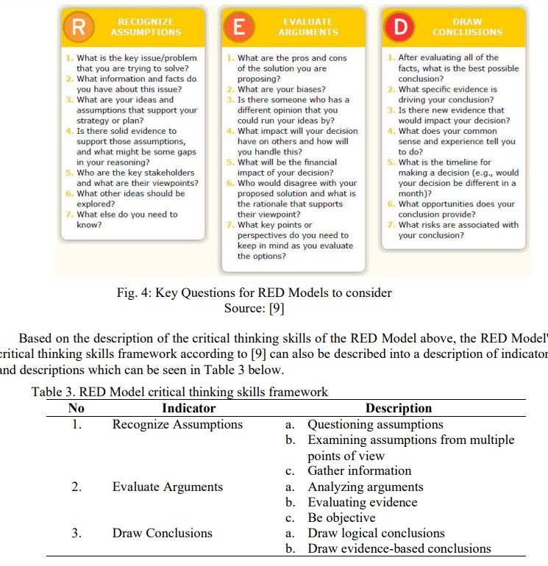

Appendix B

Relationships between values, beliefs, attitudes and behaviours

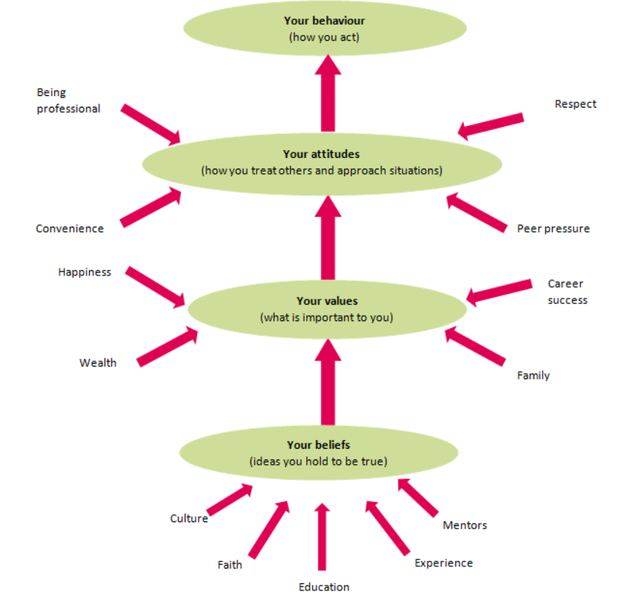

Appendix C

Mc Gregor’s theory



