Professional career development
univesity of wales trinity saint david
nasi alexe
1914432
2020
Table of Contents

Executive summary ……………………………………………….. 1
Introduction ……………………………………………………….. 2
Findings …………………………………………………………… 3
Conclusion ……………………………………………………….... 8
References …………………………………………………………. 9
Appendices ………………………………………………………… 10

Introduction

The purpose of my personal and professional development is to learn all the time new things and to evolve my career. There are a lots of learning activities that I can join like courses, volunteering, learning while I’m working or doing computer work to help me growing up continuously in my career. For me, personal development career is very important as I’m a very serious person who likes achieving goals being prepared to assimilate new information, enjoy working in teams and following my dreams.
At the moment, I’m working like a carer assistant in a care home and at the same time I’m study at University of Wales Trinity Saint David. This in helping me to improve my skills, my communication while interacting with other people and learning useful things that will help me when I will open my own business.

‘’ Self-awareness is someone’s ability to take an honest look at our life and identify what in right or wrong ‘’ (Debbie Ford 1998).

If I have an honest look at myself, I can notice that I have sometimes barriers language as English is not my first language and when I write something or when I am speak with another person, I do grammar mistakes and I confuse words. The best thing I can do to improve my English is to attend all classes on the university, interact with people who know very good English and can let me know when I do a mistake. I can also read books, watch movies, read newspapers, use the internet.

‘’ When we focus our attention on ourselves, we evaluate and compare our current behaviour to our internal standards and values. We became self-conscious as objective evaluators of ourselves’’ (Shelley Duval, Robert Wick Lund’s 1972).

Self-development is present throughout all our life. Since I was very little, I was very curious and was interested in learning new things. Every time when I wanted something, I tried to do my best to make my dream come true. Like now, I will finish my studies ,I will ask for a financial support if in necessary to open my own business and I hope it will be a profitable business with good feedbacks.

Findings

Before opening by business, I must implement SMART objectives. First of all, I have to be specific (know exactly what I want to achieve), after I need to be measurable (what I am going to do to help me get my plan to the end), be achievable (to do my best and make sure that my dream is on the right way), realistic (to have enough skills in the field) and finally to have a time limit set up from the beginning.
In order to open my own business, which is a bakery, I will do my best to attend all the classes to reach my goal. I will measure my progress by being present every week, Monday and Tuesday for a period of minimum one year, being sure I understand what my lecturer is teaching us, doing my homework’s and be always in time with the assessment, assignments and presentations. Working in a bakery for three years, I believe that I have enough experience to be on my own. Hopefully, this will be a successful business in three years.
SWOT is a very important instrument when I want to open your business. I must know before I start, which are my strengths, weaknesses (depends of me and my family), opportunities and threats (depends of external factors that I can’t control).
Strengths | Weaknesses
-three years of experience  -knowing secret recipes  -confident and responsible  -new ideas about new products that will make a big difference between me and the other bakery’s  -quality of products | -being scared about new beginnings  -my communication skills  -management skills  - a new bakery on the market which people are not used with
Opportunities | Threats
-in the town you can’t find a bakery of this type  -offering people new products | -people are used with different types of bakery  -spending a lot of money at the begging with no guarantee  -financial and economic reasons  -afraid to have so many competitors  -Brexit

After deciding which are my SWOT, I must analyse and check if my strengths and opportunities are strong and good enough and I must think, if it is possible in time to eliminate all my weaknesses and threats one by one.

Weakness-threats | Conversion strategy | Strength or opportunity created
Communication and management skills | Attending the university regularly, interacting with new people, read books | Develop my communication skills and be more proactive.
Scared from new beginnings and financial resources | Apply for a loan and looking for a good area on market | Possibility to offer people new products.

Abraham Maslow (1954) argues that individuals are motivated by lower-ranking needs until they are satisfied, after they stop being motivate and the tendency toward higher-ranking needs, begins to manifest. Motivation is a psychological process that make us be excited and they are directing us to reach our goals.

My motivation is to be my own manager and to increase my wages. I would like to reduce my stress level because I’m a serious and discipline person and is hard for me not being appreciate sometimes. I’m sure that this stress will disappear when I will have my business. Is true, that another stress factors will appear, but I’m prepared for everything.
According to Abraham Maslow (1943) Theory of Needs, my self-actualisation position is to open my own business. This was my first reason when I started this course, being sure that can this help me to develop my professional career. My actual position is on level three which is love and belonging needs.
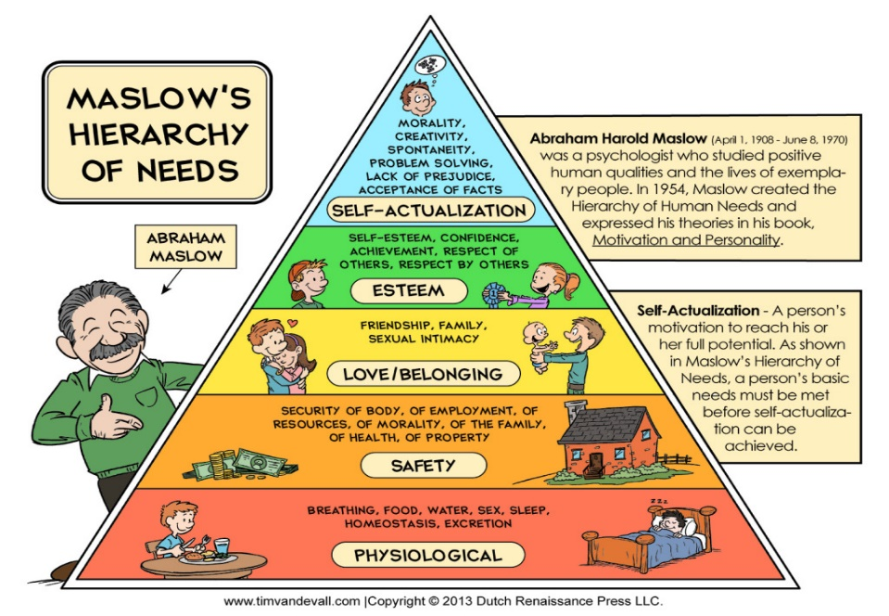

As Steven Covey the author of 7 habits of Highly Effective People until I will finish this course, I will keep the end in mind, continuing with seek first to understand and then to be understood, think win-win, synergize and once I finish the course I will start to be proactive, first things first and sharpen the saw.

Negative or positive opinions received from others are a very important elements in the process of personal knowledge. Through verbal or nonverbal communication, people can express their opinion sincerely. Not always a negative opinion of someone has a positive impact on us. In order to achieve a successful feedback, we must trust each other, accept each other, be as honest as possible and be interested in the needs of others. One of the most efficient ways of offering and receiving feedback is Johari Window (1950).
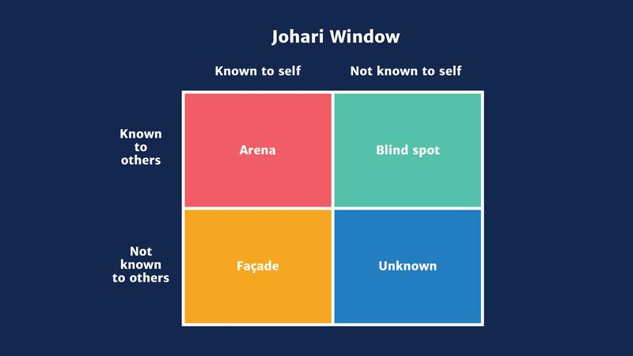

With the help of Johari's window, I will identify known and unknown information that I have about me or not, as well the same type of information that a group of people know about me.
Implementing to Johari window I will develop my business based on the feedback received from my customers.

According to Kolb’s learning cycle I started building my experience 10 years ago when I was working as a bakery salesman. At beginning, I start learning to work as a team, to have superiors, to memorize recipes and to prepare them. After a period of one year of work and a great effort, the superiors considered that I deserved to be promoted and I was placed in the position of assistant manager. Even, I haven’t got enough experience, at first, I was supported, trained and sent to special trainings to help me with my personal development. The responsibilities and obligations on this new post were much bigger, and I became the team leader at the same time. After another seven months when I was assistant manager, feedbacks from customers, the quality of products and the positive opinions classified me in the position of manager of the restaurant.
All these experiences help me to develop professionally and have quite a lot of experience in this field and after three years I decided to come in UK and find a stable job that would enhance my life and start studying again to obtain a degree and to open my own business.

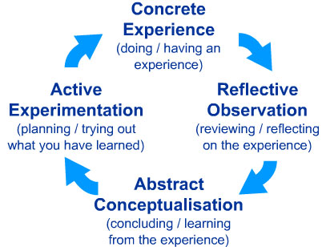

‘’ Learning is the process whereby knowledge is created through the transformation of experience ‘’ (Kolb 1984)

I start studying to University of Wales Trinity Saint David in January this year, on level 4 Certificate in Higher Education. During the courses and according VARK questionnaire, I discovered that my preferred learning style is Aural (appendix 1).
Even before, I knew that it was easier for me to assimilate information’s by hearing and not necessarily to take enough notes. I am a good listener, often very sociable with new people around me and sometimes I get distract quiet easily from the lessons by something else that happens around me. I prefer to absorb the information using audio or video clips or discussing topics.
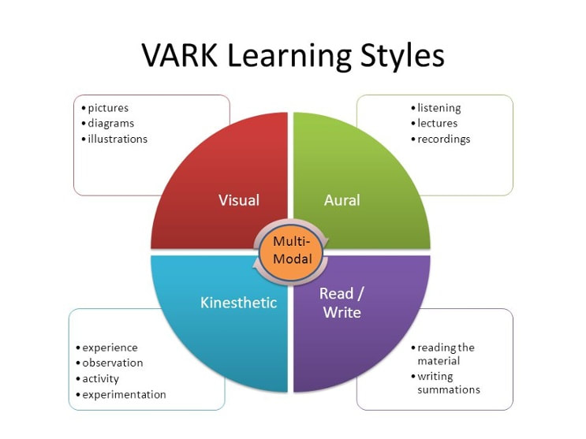

Described by Peter Honey and Alan Mumford reflectors are good listeners, cautious and want to adopt an unobserved profile.
After completing leaning styles questionnaire by Peter Honey and Alan Mumford, results classified me on reflectors category (appendix2).
Before reaching a conclusion, I want to weigh and observe the experiences from several perspectives. The collection and thorough analysis of data on experiences and events is what matters most and I am tempted to postpone a conclusion as much as possible. I am a cautious person who thinks a lot and likes to check all points of view before making any steps forwards. At meetings and in discussions, I prefer to see others in action, as I stand aside. I listen to others as they speak and then express my own opinion in the end.
During the course I completed another questionnaire that helped me discover my personality. The Keirsey questionnaire helped me to discover my personality type and I found out that I am a quiet and friendly person who is very devoted to the work, offers stability in any project or group, very patient, loyal and caring towards other people (appendix3)

PERSONAL DEVELOPMENT PLAN

Development objective | Specific actions | Blockers and how they will be removed | Support required | How I will know when I achieved the objective
Finish my studies | I will attend this course regularly, I will do all the homework’s, I will present all the assessments and presentations in time. | The blockers can be my family life, my actual job by doing extra shifts to earn extra money and a very busy schedule. | I will ask my manager to have a flexible rota and shifts, that will help me attend the university classes and I will need moral support from my family. | In three years’, when I will finish my studies and I will obtain my degree I will know that I achieved my objective.
Open my own business | After finishing the university, I will attend specific bakery trainings, I will look for good and busy area on the market and I will improve my secrets recipes. | The blockers that can be an impediment are financial and economic reasons. For removing financial barriers, I will ask my bank for support. | Asking the bank for support and applying for a loan which will help me to create my business. | When I will obtain my degree, and everything will be in place, I will have got the right area for my business, and the customer will recommend my products, I will receive positive feedbacks and the number of customers will increase
Buy my own house | Finish the university, create and develop my business, earn enough money to pay a deposit for a new house. | One of the reasons can be the financial one and my business is not working how I was expecting. If there are any financial barriers, I will ask my bank for a mortgage. | Asking the bank for support and apply for mortgage, moral family support. | In five years’ time when my business will be performing and I will buy my own house.

Conclusion

As a result of this report I understood that I must have a very well-established plan for what I want to achieve and numerous solutions to succeed. Knowing my personality, applying numerous theories to help knowing me better, by going to classes, improving my weaknesses and being very motivated I will be able to carry my dream to the end.
In order to reach my goal, there must be my own desire to continue whatever happens along the way, about self-discipline and the ability to do great things. All of us wants to reach high levels throughout our life, whether it is about the professional or personal sphere we have different perspectives on achieving success.
I am determined to continue my studies, to overcome my limitations step by step, to learn and to keep myself informed continuously. I want to evolve and implement a successful business plan. I am not lacking in motivation and self-confidence and I know that I will finish what I have proposed, being sure that will have my family support too.

References:

Cherry, K. (2019, Nov 27), Overview of VARK Learning Styles. Available at: https://www.verywellmind.com/vark-learning-styles-2795156 , (Accessed: 17th February 2020)
Duval, T. M. et al. (2012), Self-awareness and Causal Attribution
Fleming, G. (2020), ‘’The Auditory Learning Style’’. Available at: https://www.thoughtco.com/auditory-learning-style-p3-3212038 , (Accessed 15th February 2020)
Honey, P. & Mumford, A. (1982) Manual of Learning Styles, London: P Honey
Kolb, D. A. (1984), Experiential Learning: Experience as the Source of Learning and Development (vol.1), Englewood Cliffs, NJ: Prentice-Hall
Maslow, A. (1954), Motivation and Personality, Harper
Maund, A., Schriek, M., & Tinkler, P.K. (2017), Certificate in Higher Education: Skills for the Workplace Student Yearbook, SAGE Publication Ltd
Morgan, P. (2017), The Business Student’s Guide to Study and Employability, SAGE Publication Ltd
Mulder, P. (2017), Johari Window Model. Available at: https://www.toolshero.com/communication-skills/johari-window-model/ , (Accessed 16th February 2020)

Appendices:

Appendix 1
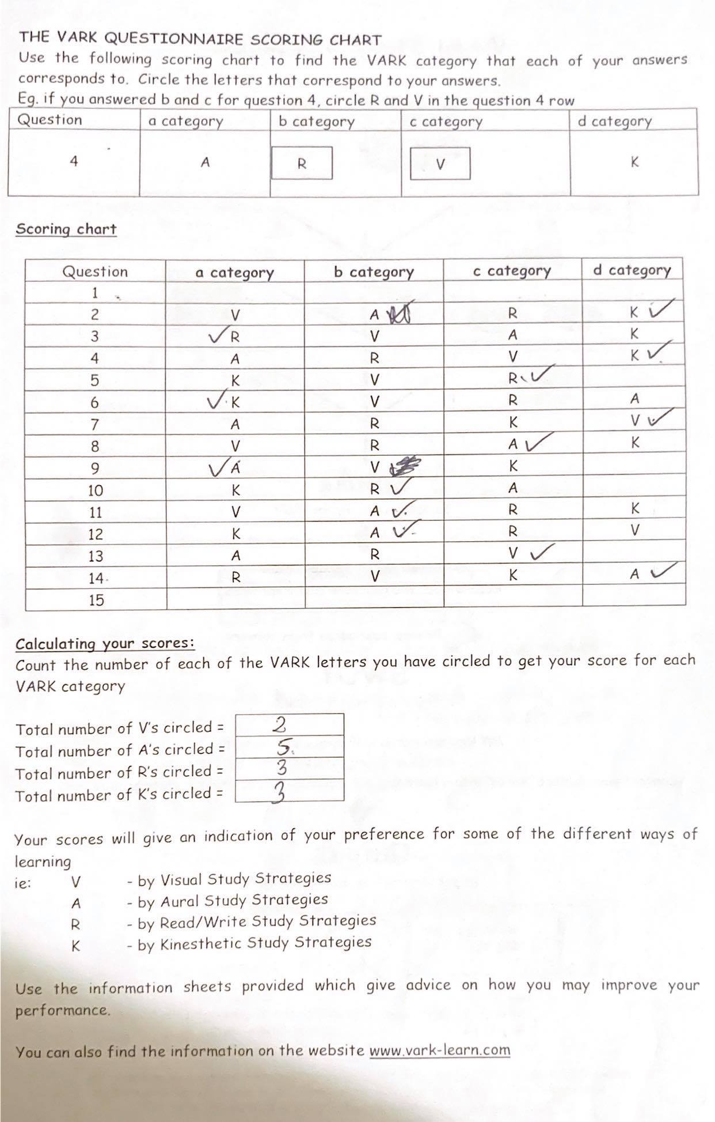
Appendix 2
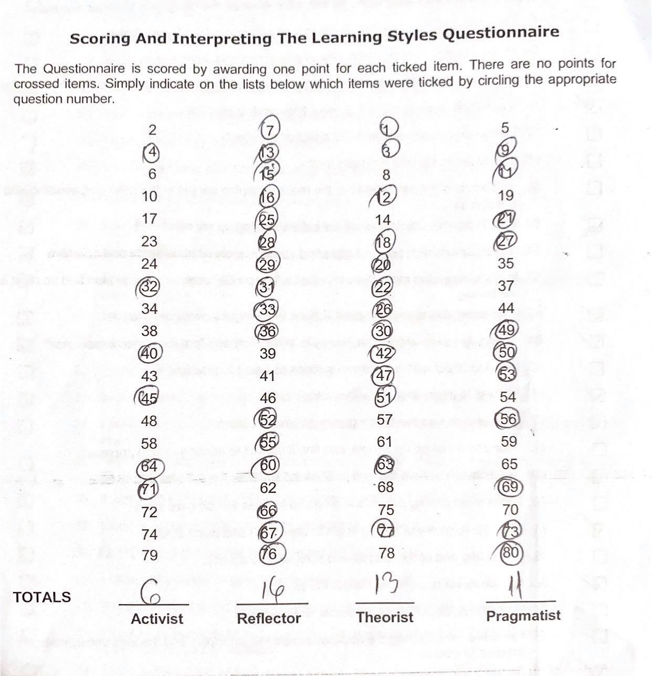

Appendix 3


