Portfolio of Writing

Student Name: Kaitlin Richards-Tang

Student Number: 2100327

Programme of Study: BA Hons Illustration

Module: ADAD4018 Ways of Thinking

Total Word Count: 1,499 words.
- [Task 1] Manifesto > 481 words.
- [Task 2] Semiotic Analysis > 487 words.
- [Task 3] Practice-Based Writing > 531 words.

Task 1: Manifesto.
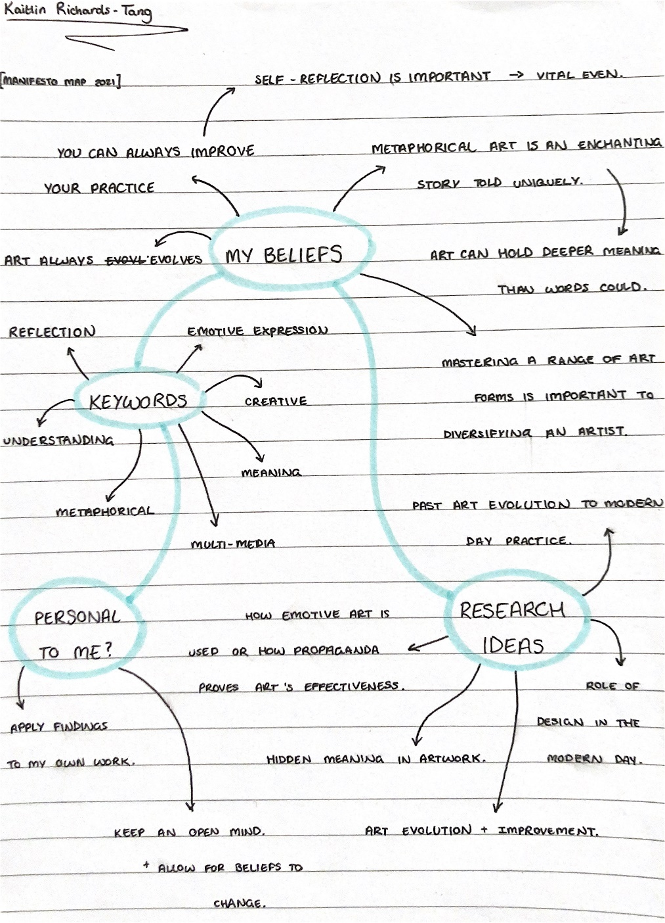

Fig 1: Map by Kaitlin Richards-Tang (2021).

8 statements:
- Art can speak to a soul louder than words.
- The embracement of creativity can set you free.
- We must reflect on that which we create to unlock a higher stage of innovation. Settling for an unsatisfactory middle ground is not an option.
- The role of art and design in modern society is more vital than ever before. Social media and art go hand in hand to shape a modern, enlightened future.
- Artists must always map and reflect how the practice of the past has influenced the present and will continue to shape the future.
- Do not take credit for laying a path made from others’ cement if all you contributed was a stir of the pot.
- We must recognise that progressing ideas is not always easy and accept that fact when committing ourselves, as artists, to a project.
- Passion should always drive art.

3 chosen statements:
5. Artists must always map and reflect how the practice of the past has influenced the present and will continue to shape the future.
1. Art can speak to a soul louder than words.
4. The role of art and design in modern society is more vital than ever before.

Keyword: Reflection.
- ‘Artists must always map and reflect how the practice of the past has influenced the present and will continue to shape the future.’

Although sometimes unknowingly obvious, it is imperative that we, as members of a cognitive society, reflect on the past, in order to inform a proper future. The same can be said for the visual world, since futurity does not simply mean development (Black, 2020) and art practice is a prime example of such a concept. At its core, reflection is an assessment of how or why we have perceived, thought or felt (Mezirow, 1990) at a given time, which is reflected in our work at its time of conception. The existence of art movements, from the Renaissance to modernism, insists that change is a natural direction for the art world and that it is my duty, as an artist, to look back at my previous works and utilise mistakes as fuel for driving my practice forward. “By producing artworks, the painter learns [both] the rules of art and to build his own artistic theory.” (Weststeijn, 2013.) Progress is dependent on reflection.

Keyword: Understanding.
- ‘Art can speak to a soul louder than words.’

Similar to how words carry meaning and translate ideas, visual expression is a portal into new perspectives for its observers. It can speak a message in a different way to people and, sometimes, convey emotions better than linguistics ever could. People tend to experience things by how we define them (Siler, 2012) and emotional responses are personal to the individual. Emotive pieces can trigger a greater response from someone than a simple spoken synonym could.
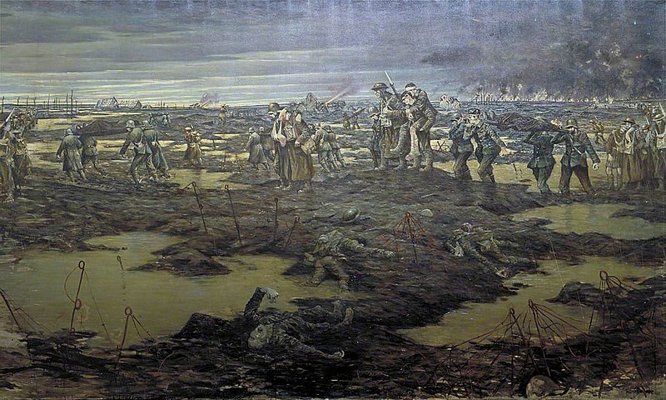
Fig 2: Harvest Of Battle by Christopher Nevinson (1918).
In this painting, Nevinson has captured the horrific nature of war better than the written/spoken signifier of ‘war’ would. This emotive concept expands upon Veit’s theory that metaphors inform the receiver about something they represent and transform the way they think about it (Veit, 2021). As an artist, I love the ambiguity of art; it speaks to me.

Keyword: Technology.
- ‘The role of art and design in modern society is more vital than ever before.’

In our society, the ways that art is used and interpreted are always evolving. With technological advancements taking centre-stage, social media can be used as a ‘communicative tool’ (Plume, 2016) for artists globally. Linking back to point 2, effective design can be tailored to help a cause online, such as raising awareness for movements like the Black Lives Matter cause.

Fig 3: The Black Lives Matter movement design (2020).
Ease of sharing and online trend systems can allow information/design to spread like wildfires online quicker than ever before, with platforms offering continued involvement and [vital] reflection (Mundt, 2018) using art/design as a universally-understood medium. I believe that this ability comes with great potential to inform our future by sharing our artwork online.

Bibliography:
Mundt, M., Ross, K. and Burnett, C., 2018. Scaling Social Movements Through Social Media: The Case of Black Lives Matter. Social Media + Society, [online] 4(4). Available at: <https://journals.sagepub.com/doi/full/10.1177/2056305118807911> [Accessed 27 November 2021].
Siler, T., 2012. Neuro-impressions: interpreting the nature of human creativity. Frontiers in Human Neuroscience, [online] 6. Available at: <https://www.proquest.com/docview/2293065674?accountid=130472&pq-origsite=primo> [Accessed 27 November 2021].
Veit, W. and Ney, M., 2021. Metaphors in arts and science. European Journal for Philosophy of Science, [online] 11(2). Available at: <https://link-springer-com.ezproxy.uwtsd.ac.uk/article/10.1007/s13194-021-00351-y> [Accessed 27 November 2021].
Weststeijn, T., 2013. The Universal Art of Samuel van Hoogstraten (1627-1678): Painter, Writer, and Courtier. 1st ed. Amsterdam: Amsterdam University Press.
Álvarez, M. and Black, C., 2020. Renaissance futurities. 1st ed. Oakland, California: University of California Press.
Plume, CJ, Dwivedi, YK & Slade, EL 2016, Social Media in the Marketing Context: A State of the Art Analysis and Future Directions. Elsevier Inc.

List of Figures:
Figure 1: Manifesto Map by Kaitlin Richards-Tang (2021).
Figure 2: Harvest Of Battle by Christopher Nevinson (1918). Available at: https://www.iwm.org.uk/collections/item/object/20223 (Accessed 27th November, 2021)
Figure 3: Black Lives Matter movement raised fist logo. Available at: https://www.bing.com/images/search?view=detailV2&ccid=S4b3vDWp&id=B7AE0D3B6A1477D8AFD74EEA3FB2324BBA9C8470&thid=OIP.S4b3vDWp5DDY-KThoN1IVgAAAA&mediaurl=https%3a%2f%2fi.ebayimg.com%2fimages%2fg%2fLMMAAOSwpLle1WWZ%2fs-l400.png&cdnurl=https%3a%2f%2fth.bing.com%2fth%2fid%2fR.4b86f7bc35a9e430d8f8a4e1a0dd4856%3frik%3dcIScuksysj%252fqTg%26pid%3dImgRaw%26r%3d0%26sres%3d1%26sresct%3d1%26srh%3d800%26srw%3d800&exph=400&expw=400&q=black+lives+matter+&simid=608006054620176942&FORM=IRPRST&ck=9724ADAD478B5A73DAEE2EF85C4B8896&selectedIndex=0&ajaxhist=0&ajaxserp=0 (Accessed 27th November, 2021)

Task 2: Semiotic Analysis.
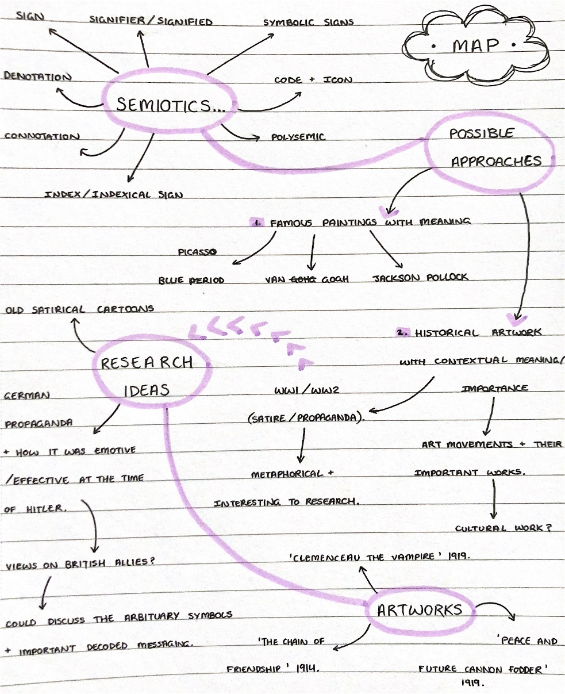

Fig 1: Map by Kaitlin Richards-Tang (2021).
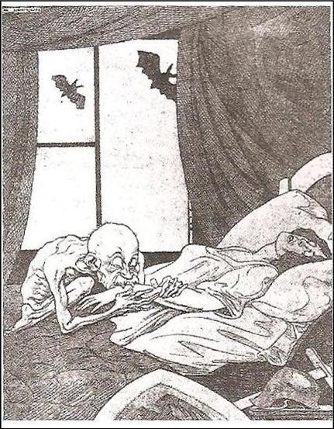
Figure 1: “Clemenceau the Vampire.’ by an unknown German newspaper-cartoonist (July 1919).

Observing the image above, it is clear that its depictions are of a sinister nature, calling out the vampire symbolising ‘Clemenceau’ in its title using ugly visuals. His hunched back, near-skeletal body and the fact that his teeth are sunk into a defenceless woman have clearly been illustrated to signify a cunning evil and portrays his intent to drain her living essence. Vampires, in modern society, are defined as being undead creatures that ‘prey ruthlessly on others’ (Oxford Languages, 2021), which is already an indexical (Saussure, 1916) sign of villainy and creates negative connotations of ‘Clemenceau’ on an extreme, satirical level. Immediately, it is clear that the German cartoonist that created this piece clearly had a strong opinion on the figure known as ‘Clemenceau,’ who happened to be the prime minister of France (Germany’s main opposition during World War I), which aids greatly in decoding the message they set out to spread using semiotics (Pierce, 1867-1871).
In June 1919, after Germany was forced to sign the Treaty of Versailles, created, in-part, by Clemenceau, the German people were outraged and had ‘forceful objections’ (Slavicek, 2010) to its conditions, blaming the Ally powers for their humiliation. Slavicek’s book, titled ‘The Treaty of Versailles’ has given me a new insight into what this image is trying to communicate. The arbitrary symbol (Saussure, 1916) of evil in this piece is ‘Clemenceau,’ who is culturally specific to the German people of this time era to understand without context. The fact that vampires are known to symbolise and ‘[personify] the evil of temptation’ (Lohnes, 2018) in modern mythology suggests a tone of mockery and that the artist wants to evoke negative feelings towards Clemenceau in the observers with the illustration.
Furthermore, the artist adds another layer of sharp bias to this piece, by symbolising Germany’s innocence using the woman, who is often, stereotypically, seen as an ‘innocent and vulnerable,’ (Carpenter, 2016), signifying that their country’s life was being drained by France. Furthermore, the palette of this illustration is monochrome and greyscale, which are common connotations of sadness/despair, as concluded by Sandrine Gil’s findings that grey is ‘the most negative [colour]’ in a 2014 study (Gil, 2014). This could also symbolise Germany’s situational unhappiness. However, the colour here could be polysemic, as it could also be aiming to signify an older aesthetic, similar to the 1800s when ‘modern’ vampires were first conceptualised: representing the iconic colour scheme of dated print-work.
After analysing the image in context, it has become apparent just how strongly the semiotic values of this image convey meaning. Admittedly, this image first presented itself as an uninteresting piece of dull art. However, it is now clear to me that the colours, satirical symbolism and the rich historical background all combine to produce an interesting illustration that is enriched with clever visual coding.

Bibliography:
Carpenter., R., (2016). Innocent Women and Children: Gender Norms and the Protection of Civilians. 1st ed. Taylor & Francis, p.2.
Gil, S. and Le Bigot, L., (2014). Seeing Life through Positive-Tinted Glasses: Color–Meaning Associations. PLoS ONE, [online] 9(8), p.e104291. Available at: <https://web-p-ebscohost-com.ezproxy.uwtsd.ac.uk/ehost/results?vid=0&sid=fcf29052-f06d-4e95-a261-6cf35cb5b615%40redis&bquery=%28SO%2B%28PloS%2Bone.%29%29AND%28DT%2B2014%29AND%28TI%2Bseeing%2Blife%2Bthrough%2Bpositive-tinted%2Bglasses%29&bdata=JmRiPWFwaCZ0eXBlPTEmc2VhcmNoTW9kZT1TdGFuZGFyZCZzaXRlPWVob3N0LWxpdmU%3d> [Accessed 29th November 2021].
Lohnes, K., (2018). Dracula | Summary, Characters, & Facts. [online] Encyclopedia Britannica. Available at: <https://www.britannica.com/topic/Dracula-novel> [Accessed 29th November 2021].
Languages.oup.com. (2021). Oxford Languages | The Home of Language Data. [online] Available at: <https://languages.oup.com/> and <https://www.bing.com/search?q=vampire+definition&cvid=abf5aefb70504a53819fd7b86dbd3f08&aqs=edge.1.69i57j0l8.4271j0j1&pglt=299&FORM=ANNTA1&PC=HCTS> [Accessed 29th November 2021].
Peirce, C., Kloesel, C., Fisch, M., Roberts, D. and Ziegler, L., (1984). Writings of Charles S. Peirce Volume 2 1867-1871. Bloomington, IN: Indiana University Press.
Saussure, F., Bally, C., Sechehaye, A. and Baskin, W., (1916). Course in general linguistics. 1st ed. London: Peter Owen.
Slavicek, L., (2010). The Treaty of Versailles. 1st ed. Chelsea House Publications.

List of Figures:
Figure 1: Semiotics Map by Kaitlin Richards-Tang (2021).
Figure 2: ‘Clemenceau the Vampire’ (1919) by an unknown German cartoonist. Available at: https://www.reddit.com/r/PropagandaPosters/comments/8bkuxq/clemenceau_the_vampire_antiversailles_treaty/ (Accessed 29th November, 2021.)

Task 3: Practice Based Writing
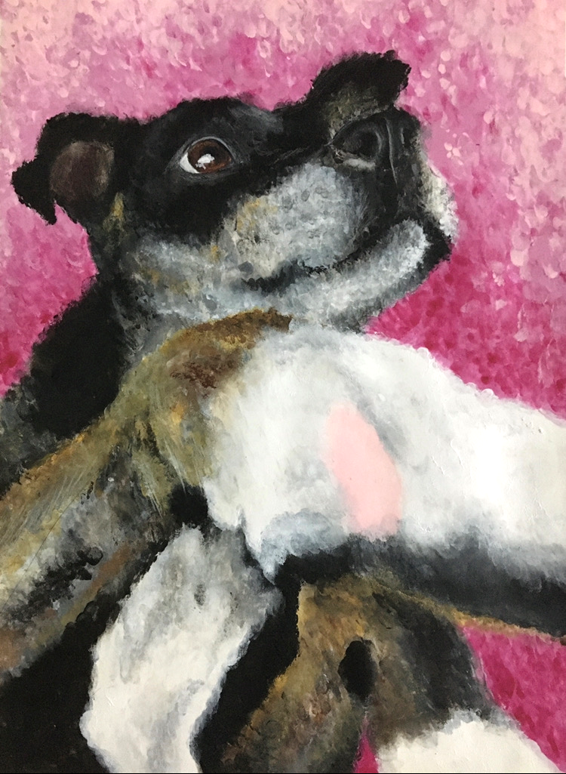
Fig 1: Beau (2020) by Kaitlin Richards-Tang [Acrylic on Canvas]

The painting of mine that I have chosen to explore here is an acrylic finger-painting that focuses on two key elements of art in particular: colour and contrasted realism. The statement that ‘colour is a universal gift of beauty’ (Mollica (2013) ring especially true to me as an artist and I love to explore this concept by adding assets of vibrant colour to contrast with an, otherwise, realist painting. The pink gradient background in the image above allows the dog to stand out as the key focal point and draws attention to the colour-harmonization occurring amidst the fur texturing. Mottled browns mixed amongst the other greyscale-hues on the fur allow for an interesting combination and the energetic colour (Sukhraj, 2020) of pink gifts the image a positive tonal-boost, ensuring that the duller colours of greys and browns don’t make the image appear too monotonous/boring.

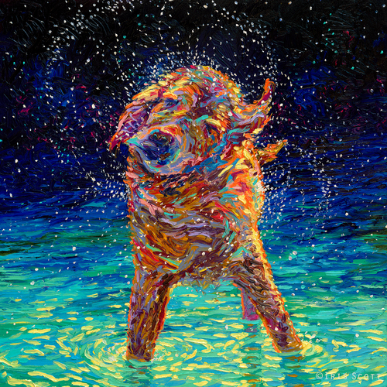
Fig 2: Moonlight Swim (2017) by Iris Scott [Oil on canvas]

Iris Scott, an artist that creates beautiful oil finger-paintings, was a key inspiration for the creation of Beau (2020). Her mix of vibrant colouring with imaginative realism masterfully contrasts with one another and allows the striking image to stand out immediately. Similar to Beau (2020), the fluorescent colour assets work incredibly well in giving the piece a sense of uplifting emotion in its tone, as ‘colour is, perhaps, the first element that we register when we view something’ according to Ambrose (2005). Both paintings allow for the dog to stand out as the ‘dominant’ colour focal point (Ambrose, 2005). Scott has utilized the warm undertones of brown and orange on the fur amongst the cooler-toned rippling background and Beau (2020) takes a similar approach, where the mottled spots of dull browns and greys amidst energetic pinks contrast nicely with each other. It is evident that both pieces respect the virtues of colour theory by their shared love of vibrant contrast on top of, otherwise, realist paintings.
Furthermore, these paintings are linked by the sense of wonder that they create through their dynamic compositions. Moonlight swim (2017) utilizes a central composition on the canvas, which position the dog in the centre and features every little swish of colour stem out from it in a growing spiral motion. This creates a perfectly ‘balanced’ image under the theory of Poore (1976), where balance in art is noted as being a vital necessity to a visually effective work. The spirals emitting from the centre of the artwork invoke uplifting tones, working together with the bright colours to give the piece a sense of wonder. Beau (2020) uses its sense of depth to create balance, with the paw in the right-foreground leading the viewer through the image and to the rest of the dog below. The way the dog is looking off at something unknown in the distance captures the same sense of wonder that Moonlight Swim (2017) achieves with its different approach to composition.
Overall, both finger-painted pieces take similar approaches to capturing the beauty of an animal by contrasting colour palettes and compositional techniques. They combine a traditional style of realism with intriguing hues, achieving a striking finish effectively.

Bibliography
Ambrose, G. and Harris, P. (2005). Basics Design 05: Colour. Lausanne: AVA Publishing.
Mollica, P., (2013). Color Theory: An Essential Guide to Color-from Basic Principles to Practical Applications. 1st ed. Walter Foster Publishing.
Poore, H. (1976). Composition in art. 1st ed. New York: Dover Publications.
Sukhraj, R. (2021). The psychology of design: pink in marketing and branding. [Blog] IMPACT, Available at: <https://www.impactplus.com/blog/the-psychology-of-design-pink-in-branding-design#:~:text=Connotations%20and%20emotions%20of%20the%20color%20pink%20Pink,after%20prolonged%20exposure%2C%20but%20that%E2%80%99s%20an%20extreme%20situation.> [Accessed 29 December 2021].

List of Figures:
Figure 1: Beau (2020) by Kaitlin Richards-Tang [Acrylic on Canvas].
Figure 2: Moonlight Swim (2017) by Iris Scott [Oil on canvas].

