The Role of Employee Training in Enhancing Guest Satisfaction: A Case Study of Novotel Paddington

Student name: Lavinia Curtean

Student ID: 2232073

Module name: Hotel Placement Research Project (BMIH6008)

Project supervisor: Kathryn Flynn

Date: 06/11/2025
Acknowledgement Statement format for AI Tool(s) usage.

I acknowledge the use of OpenAI on 06/11/2025 to support the rafinement of language, academic tone and structure in my dissertation.
I used the prompts:
1. Assist in rephrasing sentences to achieve academic clarity and conciseness.
2. Check grammar and consistency in academic writing.
3. Provide suggestions for improving the logical flow of the introduction and discussion sections.

I confirm that I have not presented any AI generated text as my own work. I confirm I have copies of my drafts, notes, and other resources I used before, and after the use of AI tools which I may be asked to provide in evidence.

Signed: ___________________Lavinia Curtean________________

Abstract
This dissertation discussed how employee training can contribute to guest satisfaction in the Novotel Paddington. In the hospitality sector, the aspect of quality services in terms of guest expectations depends upon the motivation and skills of the employees. This research has been set out to evaluate the employee training program that helps to assess the service delivery and guest satisfaction and provide valuable recommendations for the overall hotel performance. The secondary qualitative thematic analysis was adopted as a research method, which includes the case studies, journal articles and related industry reports. The results identified that the Novotel Paddington had extensive training and a well-structured system. Induction training was used to inform the subject of organisational policies, service standards and operational procedures, making sure that the operational modes were the same throughout. The employees were endowed with practical skills to work in the housekeeping, front office and food and beverage operations through the departmental training. It was also found that soft skills training, which included communication, problem-solving, and conflict resolution, was essential in improving the interactions of the employees with the guests, which led to positive experiences and satisfaction.
The issue of employee engagement and motivation became important in determining the effectiveness of training. Through the study, staff confidence, participation and initiative-taking behaviour were found to improve after opportunities to be open to mentoring and feedback, as well as cross-departmental exposure. Employees who believed training to be pertinent and valuable utilised acquired skills better, which resulted in better interaction with guests. The operational flexibility and teamwork, especially in times of high demand, were also supported through cross-training.
The study established that training had a direct impact on the quality of services in accordance with the SERVQUAL dimensions, reliability, responsiveness, assurance, empathy, and tangibles. The theoretical knowledge was reinforced and skills improved using the methodology of experiential learning, such as role-playing and on-the-job practice. It also ensured that employees were competent, flexible, and up to date with changes in the demands and expectations of the guests and operational standards through constant training, such as refresher courses and e-learning modules. The strengths and weaknesses were also established. The use of secondary qualitative information limited the perceptions of the employees in real-time and the ability to directly measure the results of guest satisfaction. Also, the effectiveness of training was reliant upon personal motivation and engagement of the employees. However, the study offered a context-based understanding of the contribution of employee training strategy to service quality and satisfaction of guests in Novotel Paddington.
Several recommendations were offered in accordance with the results. The training programmes must be updated regularly to consider technological changes, the trend in the industry, as well as guest expectations. Personalised service delivery was proposed to be enhanced with the help of enhancing the development of soft skills and training in emotional intelligence. Mentoring and coaching programmes were suggested to facilitate learning and support it with the use of individual support. Opportunities to train cross-departmentally and multi-skilling were offered to enhance the flexibility and effectiveness of operations. Along with the performance monitoring and feedback systems, the application of both experiential and technology-based learning approaches was suggested to keep the performance at the proper level of improvement. Lastly, the outline of the culture of continuous learning and training practices against industry standards was recommended to maintain a competitive advantage.

Declaration
I declare that this dissertation research titled "The Role of Employee Training in Enhancing Guest Satisfaction: A Case Study of Novotel Paddington" is entirely my own work. All information sources, like journal articles, case studies and online web materials, have been appropriately referenced and acknowledged. I have conducted this dissertation solely to fulfil all the required aspects of my course. I also confirm that this research has not been submitted in any academic sector.

Signature: Lavinia Curtean

Table of Contents
Chapter 1: Introduction 8
1.1 Background to the Research Project 8
1.2 Overview of the Case Study 8
1.3 Research Aim, Objectives and Questions 8
Chapter 2: Literature Review 10
2.1 Introduction 10
2.2 Concept of employee training in enhancing guest satisfaction 10
2.3 Training programmes provided to employees at Novotel Paddington 10
2.4 Evaluation of the impact of employee training on guest satisfaction 11
2.5 Recommendations for training practices for enhancing service quality 11
2.6 Theoretical or Conceptual Framework 12
2.6.1 Human Capital Theory 12
2.6.2 Service Quality (SERVQUAL) Model 12
2.6.3 Experiential Learning Theory 13
2.7 Literature Gap 13
2.8 Summary 13
Chapter 3: Methodology 14
3.1 Overview of the Case Study Methodological Approach 14
3.1.1 Advantages, Limitations, and Associated Techniques 14
3.2 Research Method Employed 14
3.3 Comprehensive Discussion of Their Relevance and Application 15
Chapter 4: Findings and Discussion 16
4.1 Introduction of the Findings 16
4.2 Comprehensive and Detailed Presentation of Results 16
4.2.1 Theme 1: Training Structure and Content 17
4.2.2 Theme 2: Employee Engagement and Motivation 17
4.2.3 Theme 3: Impact on Service Quality 18
4.2.4 Theme 4: Continuous Development and Improvement 18
4.3 Introduction of the Discussion 19
4.3.1 Interpretation of the Research Findings in Relation to the Existing Literature 19
4.3.2 Exploring Implications, Limitations, and Pointing Out Valuable Areas 20
4.3.3 Critical Evaluation 21
4.5 Summary 22
Chapter 5: Conclusion and Recommendations 23
5.1 Conclusion 23
5.2 Recommendations 25
References 28

Acknowledgements
I would like to express my heartfelt gratitude to my dissertation lecturer for their constant support and guidance in the construction of my feedback throughout my research. I also want to express my appreciation to my family and friends for their patience and encouragement shown during my research. Their immense support has been truly priceless to me.

Signature: Lavinia Curtean

Chapter 1: Introduction

Background to the Research Project
The hospitality industry depends on employee training as a determinant, and it has a direct effect on the quality of services, employee performance, and guest satisfaction. The hotels are extremely competitive, and in this, the brand reputation and success in the long term can be influenced by the experience of the guests. Professionally designed training provides employees with skills and knowledge to provide regular and quality service, which leads to an increase in operational efficiency and customer loyalty (Wilson, 2025). Employee training is also one of the primary factors leading to good service quality and guest satisfaction in the hospitality industry. Since training provides employees with technical skills, people skills, and critical thinking skills, these combined skills will help them improve customer experiences (Abdulrab and Hezam, 2024). The study aims at the detection of the way the training programmes translate into service provision and the general satisfaction of the guests. Through the exploration of the connection between employee development and customer experience, this paper aims to share information related to positive training methods in hotels.

Overview of the Case Study
Novotel Paddington is a branch of the global brand Novotel, which is situated in one of the central parts of London, and caters to both business and leisure travellers (Novotel Paddington.uk, 2025). The hotel includes various departments such as front office, housekeeping, food and beverage, and guest services, among others, which require the services of well-trained personnel to ensure the services are of quality. The Novotel Paddington hotel has a number of training programmes designed to improve the skills of the employees and guarantee high satisfaction among the guests (Novotel Paddington.uk, 2025). This research gives a chance to analyse these programmes, determine their effectiveness and define the possibilities to improve them. The results will be used to determine feasible guidelines, which can improve services and enhance the experiences of the guests within the hotel.

1.3 Research Aim, Objectives and Questions
Aim
The main aim is to investigate how employee training at Novotel Paddington directly influences guest satisfaction.
Objectives
- To analyse the training programmes provided to employees at Novotel Paddington.
- To evaluate the impact of employee training on guest satisfaction.
- To recommend improvements to training practices for enhancing service quality.
Questions
- What are the training programmes provided to employees at Novotel Paddington?
- What are the impacts of employee training on guest satisfaction at Novotel Paddington?
- What are the valuable recommendations or improvements to training practices for enhancing service quality at Novotel Paddington?

Chapter 2: Literature Review

2.1 Introduction
This chapter summarises the existing literature on employee training and its effect on guest satisfaction, especially in the hotel industry. It examines theoretical insights, training in Novotel Paddington and the findings that support the relationship between employee training and service delivery. It also detects the gaps in existing literature and provides a conceptual framework to conduct the study. The review sets the stage for how training programmes would result in guest satisfaction and operational performance.

2.2 Concept of employee training in enhancing guest satisfaction.
The employee training in the hospitality industry entails programmed employee training with the aim of enhancing skills, knowledge and performance. It encompasses customer service, communication, problem-solving and hotel-related technical competencies. Besides boosting the staff confidence, training also makes sure that service delivery is beyond the expectations of the guests. Wilson (2025) indicates that guest satisfaction, loyalty and positive reviews are always reported to be high in the hotels where they have invested in employee development. According to Darvishmotevali et al. (2025), training in relation to service errors minimises staff engagement, and this has a direct impact on customer experiences. Another benefit of effective training is a culture of continuous improvement, where the employees have the need to follow best practices and change in response to the changing needs of the guests (Calinaud et al., 2021). The offering of well-trained employees in extremely competitive markets is a way of separating hotels through the enhancement of consistency and responsiveness by the employees in service delivery. In addition, people skills can be improved with the help of the training and staff can better predict the needs of the guests and personalise services (Sofi et al., 2025).

2.3 Training programmes provided to employees at Novotel Paddington
Novotel Paddington has an exhaustive list of training programmes that have been implemented to advance the hotel departments. These entail the induction of new employees, departmental skills training, customer care training and continuous professional development training. The induction programmes introduce the employees to the policies of the company, the company's standard operating procedures, and the company culture so that service delivery methodology remains the same (Hatidja et al., 2025). Departmental training offers technical skills that are needed in housekeeping, front office, food and beverage and the guest services departments. Moreover, the hotel uses the training of soft skills, such as the ability to communicate and solve problems, to resolve conflicts that are vital to ensuring sustainable communication with guests. These are held together with performance reviews and mentor programmes that enable the employees to get feedback and areas to work on to ensure continual training programmes (Park et al., 2025). Cross-departmental training is also promoted in the hotel to facilitate flexibility and collaboration. Integrating formal with the on-the-job learning, Novotel will make sure that employees are well-equipped to manage the requirements of service. The programmes would be specifically aimed at not only improving the operational efficiency, but also increasing employee motivation, engagement, and confidence, and these qualities lead to increased guest satisfaction and an overall positive guest experience (Al-Gasawneh et al., 2024).

2.4 Evaluation of the impact of employee training on guest satisfaction
Training requirements of employees directly affect guest satisfaction in the hospitality industry (Ntounis et al., 2022). Research has shown that highly skilled employees offer quicker, more precise and personalised services which positively impact general guest satisfaction. Training programmes in Novotel Paddington have been associated with the improvement of the service quality indicator, which is the guest feedback score, the number of repeat bookings, and online reviews. Abdulrab and Hezam (2024) note that systematic training enhances the staff's competency, confidence, and initiative-taking behaviour, minimising the number of service errors and enhancing problem-solving abilities. The SERVQUAL model also introduces the key dimensions that are affected by training, such as reliability, responsiveness, assurance, empathy, and tangibles. The difference in the perceptions of guests is produced by employees who are trained in customer service techniques, are more empathetic, able to communicate effectively and give uniform service delivery (Arhin and Cobblah, 2024). Also, experiential learning enables employees to use theoretical learning in real-life scenarios that boost skills and service delivery. In general, the data support the idea that the investment in employee training assists in optimising the organisation of operations and employee engagement (Lepistö et al., 2024). Finally, the satisfaction of guests also proves the strategic value of the continuous development of the staff in the work of any hotel.

2.5 Recommendations for training practices for enhancing service quality.
The research and the practice in the industry propose various measures to improve the training practices to increase the satisfaction of the guests.
To begin with, regular refresher courses should be introduced in the hotels to strengthen the skills and to meet the service expectations as they change (Sardesai et al., 2024). The training must be conducted in a combination of both theory and practical learning that assists employees in applying the knowledge.
Second, the personalised coaching and mentoring will enable the employees to work on personal performance shortcomings and enhance confidence in dealing with guests (Alabi et al., 2024).
Third, cross-department training stimulates cooperation, flexibility, and improved knowledge of the hotel operations that will increase the overall quality of the provided services (Tan and Despotis, 2021).
Fourth, technology (e-learning platforms) should be used, which allows staff to access training material at their convenience and at their own pace, facilitating continuous learning.
Lastly, the management needs to keep track of the performance of training programmes by collecting feedback, performance reviews and key service measures of guests, and making changes accordingly (Guo et al., 2024). The use of the following strategies will make training relevant, comprehensive, and organisationally objective, which in the end leads to the achievement of better performance of the staff, consistency in services, and increased satisfaction of the guests.

2.6 Theoretical or Conceptual Framework

2.6.1 Human Capital Theory
The Human Capital Theory proposes that investment in the skills and knowledge of the employees will positively impact the performance of the organisation. Training enhances the competence of employees, efficiency and problem-solving among employees in the context of hospitality (Saxena et al., 2024). Trained employees can provide better quality services, minimise mistakes and effectively respond to the needs of the guests. Considering employees as assets, the hotels have understood the necessity of continuous improvement as the ability to remain competitive. The training programmes at Novotel Paddington can be analysed from this perspective and indicate how investment in human capital is converted into the enhancement of the level of guest satisfaction and operational efficiency (Hamadziripi, 2023).
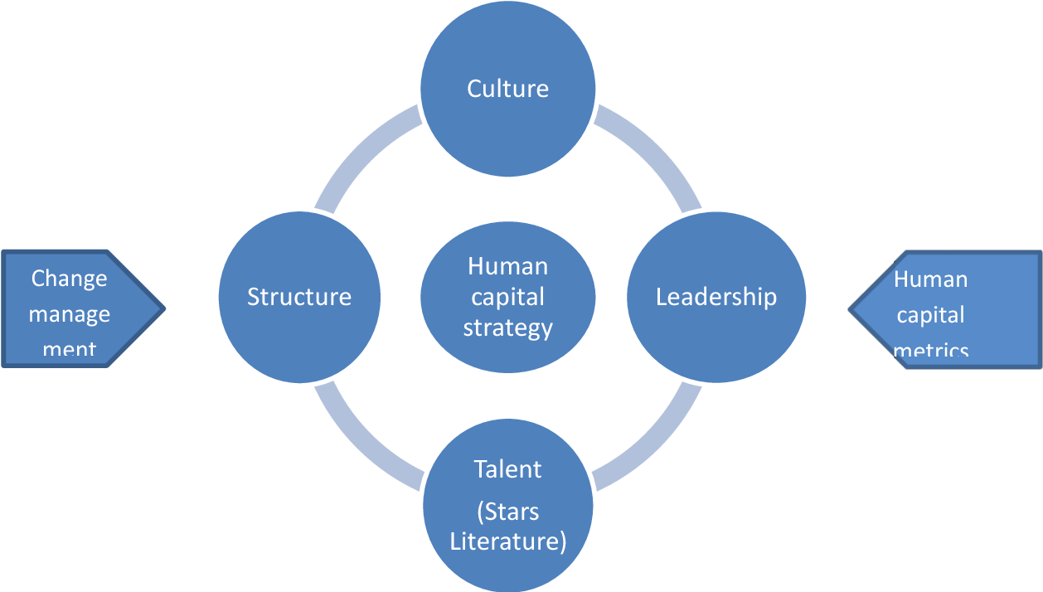
Figure 1: Human Capital Theory Framework
Source: (Budur and Poturak, 2021)

2.6.2 Service Quality (SERVQUAL) Model
The SERVQUAL model measures the quality of service on the aspects of reliability, responsiveness, assurance, empathy, and tangibles (Glaveli et al., 2023). Employee training in hotels has a direct impact on these dimensions because the employees are provided with skills to offer consistent and dependable service. As an example, communication training can make them more responsive and more assured, whereas the development of soft skills will help them prove to be more empathetic towards guests (Budur and Poturak, 2021). Training programmes should be aligned with SERVQUAL requirements to help hotels such as Novotel Paddington improve the quality of the provided services in a systematic manner, leading to an increase in guest satisfaction and loyalty.
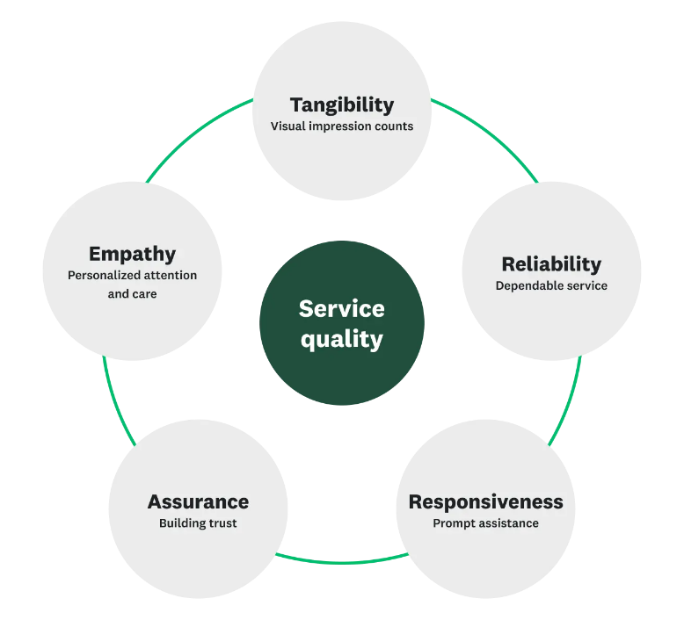
Figure 2: Service Quality (SERVQUAL) Model Framework
(Source: Jordan et al., 2024)

2.6.3 Experiential Learning Theory
Experience, reflection and application in learning are required in Experiential Learning Theory (Ghani et al., 2022). The employees in hospitality practise the theoretical learning in practical engagement with the guests. The techniques employed in Novotel Paddington include on-the-job training, simulations, and role-playing exercises, thus giving the staff the capacity to acquire problem-solving, decision-making, and customer service skills (Tai et al., 2021). Experience learning will be beneficial in ensuring that the employees remember better and adjust to the changing requirements of guests. Through experiential training programmes, hotels can enhance service delivery and increase the general satisfaction of guests (Jordan et al., 2024).
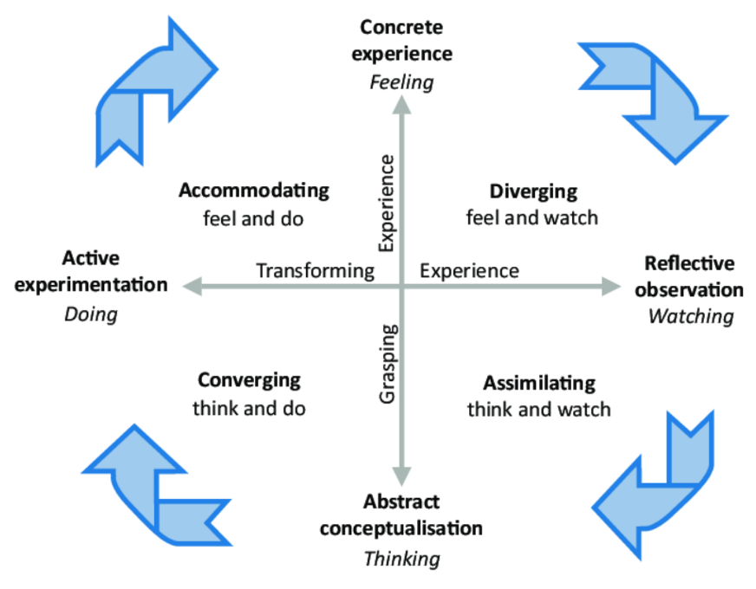
Figure 3: Experiential Learning Theory Framework
(Source: Glaveli et al., 2023)

2.7 Literature Gap
Although there is a lot of research on training and guest satisfaction, most studies are done on a large hotel setting or on a global scale, unlike in the case of Novotel Paddington. Most of the literature contains findings which are generalised across various hotels or regions and ignore the practices that are peculiar to an organisation. Empirical data as to the connection between certain training programmes and quantifiable guest satisfaction results is scarce. The proposed research fills this gap by analysing the training programmes of Novotel Paddington, gauging their effectiveness, and giving specific recommendations on how appropriate training will enhance the quality of services provided, employee performance, and customer experiences.

2.8 Summary
This section has served as an excellent literature discussion on the importance of training employees to improve the level of guest satisfaction. It examined the idea of staff development, training programmes in Novotel Paddington and how the training programmes have worked using theoretical concepts of Human Capital Theory, SERVQUAL and Experiential Learning Theory. The most important observations include the significance of systematic, ongoing, and real training to enhance the quality of the services. The gaps in the current studies were identified, so a narrow-scale case study is justified. The review provides a ground on which the further analysis chapters of this dissertation were to be based.

Chapter 3: Methodology

3.1 Overview of the Case Study Methodological Approach
The case study approach is specifically appropriate to analyse complex phenomena in a real-life situation, like the training of the employees in a hotel environment. This study holds a sole case study design in which Novotel Paddington will be the centre of the research to investigate the importance of staff training towards improving the levels of guest satisfaction. The use of case studies can enable the researcher to examine the process, behaviours, and organisational practices in greater detail, and this offers a wealth of qualitative data that quantitative methods may not be able to capture (Collis and Hussey, 2014). This research focuses on a single organisation and hence determines the training initiatives implemented, evaluates their success and produces practical recommendations to help them improve their service quality. The strategy also allows using theoretical views, such as the Human Capital Theory, SERVQUAL, and Experiential Learning Theory, to examine the connection between training and guest satisfaction in an organised manner (Ghanad, 2023).

3.1.1 Advantages, Limitations, and Associated Techniques
There are a number of benefits of the case study approach. One can study contextual variables in finer detail, the complexity of real-world settings is realised, and evidence may be built that may inform the theory and practice (Saunders et al., 2012). It also allows gathering a variety of types of data, such as documents and reports, as well as secondary research, which increases the level of informational support on training programmes and their effect. Limitations include that generalisability is reduced because what is discovered in one organisation cannot be applicable to the whole hospitality industry (Cottrell, 2014). Also, case studies may be time-consuming, and the quality and availability of data may be limited. Thematic analysis is associated with interpreting qualitative data systematically to determine the patterns pertaining to staff training and guests’ satisfaction (Silverman, 2011).

3.2 Research Method Employed
The research uses the secondary research method, which is a qualitative research method, as it involves the use of literature, reports of organisations and those of the cases that are published online. Secondary research can also be used to analyse recorded training programmes, observations of service quality, and best practice in the industry without necessarily collecting data from the hotel employees or their customers (Grbich, 2006). The method used is a thematic analysis approach, which identifies, codes and categorises recurring patterns regarding training effectiveness and guest satisfaction. Themes are created around the content of the training, strategies of implementation, and the outcomes reported, giving a structure through which evaluation can be conducted. The emphasis on qualitative data allows for a comprehensive insight into the organisational practice, personnel development and the improvement of service quality (Learned et al., 2022).

3.3 Comprehensive Discussion of Their Relevance and Application
The research objective, which focuses on the study of the effect of employee training on the guest satisfaction of Novotel Paddington, is appropriate to the methodological approach of the proposed study. The proposed study is useful in that it uses both case study and secondary qualitative research. This allows expanding on training initiatives in detail without sacrificing the viability of the project within the project timeline (Petropoulos et al., 2024). Through this thematic analysis approach, it may be possible to compare the training programmes of Novotel with known theoretical frameworks. This includes Human Capital Theory, which focuses on investment in the skills of employees and the SERVQUAL model, which evaluates service quality dimensions (Ma et al., 2024).
The Experiential Learning Theory provides additional evidence of the success of the practical training based on on-the-job training. Although it will be based on secondary data, the methodology will provide a strong platform upon which it is possible to consider the relationship between employee training and guest satisfaction, strengths and weaknesses of current practices, and develop evidence-based recommendations (Walliman, 2021). The use of the case study method together with the thematic analysis of qualitative analysis guarantees that the findings are contextual, scholarly, and can be applied in the hotel industry.

Chapter 4: Findings and Discussion

4.1 Introduction of the Findings
This chapter gives the results of the research on employee training and how it influences the level of guest satisfaction at Novotel Paddington. The analysis of thematic data was done based on secondary qualitative data such as scholarly literature, industry reports and organisational case studies to determine major patterns. The results are classified into four themes, including training structure and content, employee engagement and motivation, influencing service quality, and ongoing development and improvement. These themes can inform one about the impact of training programmes on the staff work and guest satisfaction.

4.2 Comprehensive and Detailed Presentation of Results
As opined by Thakur et al. (2025), the current training practices of Novotel Paddington may be analysed to outline some important insights. Induction training is first because the employees will be conversant with organisational procedures, culture, and policies. This induction period minimises mistakes at the outset and harmonises the delivery of services in the departments. Departmental training also enables the staff to have technical knowledge in the field of housekeeping, front office, food and beverage, and guest services. This will make sure that employees are able to work efficiently while following the standards of the hotel (Frankel et al., 2021). The other important aspect was the development of soft skills. Communication training, problem-solving and conflict resolution will prepare the staff to deal with complicated interactions with guests. According to the secondary sources, employees who have excellent skills in interpersonal communication would lead to an increase in their satisfaction rates and positive feedback from the guests (Sofi et al., 2025). The cross-departmental exposure of employees also allows them to learn how various operations associate with each other. Thus, it encourages teamwork and greater flexibility to deploy employees where most needed (Hamadziripi, 2023).
Employees can use theoretical information in practice using such learning techniques as role-playing or on-the-job training, and they receive the chance to use the acquired information in realistic situations. This increases problem-solving abilities, confidence creation and the guest experience (Pitakaso et al., 2025). It has also been found that the experiential methods tend to supplement the formal training process, making the learning process more effective and sustainable. Continuous professional growth, like refresher programmes, feedback on performance and mentoring, has been recurrent in the literature. These programmes fill the gaps in skills, support previous training, and keep employees in touch with their company changes or its new operations or service requirements (Manoharan and Ashtikar, 2025). There is also the learning culture, which is promoted by continuous training, and employees are motivated to enhance performance and be involved with organisational goals. Lastly, it can be concluded that training has positive effects on guest satisfaction indirectly because of the increase in employee confidence, competence, and motivation. The trained employees are dependable, responsive, assured and empathetic, which are some important dimensions of the SERVQUAL. There is secondary qualitative data that training minimises the inconsistencies in services and promotes the efficiency of operations, therefore, leading to improved guest experiences (Clark et al., 2021).

4.2.1 Theme 1: Training Structure and Content
Novotel Paddington has a systematic employee training strategy that includes inductions, department training, and development of soft skills. New employees are introduced to organisational policies, standards of services and procedures used in operations through induction training, which enables them to perform uniformly (Ali et al., 2025). The technical skills are offered at departmental workshops, focused on the front office, the housekeeping, the food and beverage and the guest services. The soft skills training, such as communication, conflict management, and problem solving, will empower the employees to deal with various guests with the aim of minimising conflicts. The availability of secondary literature proves that the reliability of the services provided by the establishment improved with the help of the structured training, and the operational mistakes decreased (Zhao et al., 2025). Secondly, the learning is supported by incorporating the elements of experience, which can be role-playing and on-the-job exercises. Alongside all the merits, research indicates that the contents of the training must be updated on a regular basis to accommodate changing expectations of the guests and technological changes. The systematic training system will give the employees the knowledge and self-confidence they require to offer uniform, quality service, creating a key basis in ensuring guest satisfaction (Park et al., 2025).

4.2.2 Theme 2: Employee Engagement and Motivation
The training programmes of Novotel Paddington have a strong influence on the level of employee engagement and motivation. Continuous learning opportunities, mentoring, and constant feedback promote a favourable workplace that promotes the involvement of staff and their development (Das et al., 2024). Nagirikandalage et al. (2025) indicate that motivated employees have a higher level of enthusiasm, proactiveness in behaviour, and a sense of empathy with the guests. The ability to train cross-departmentally would lead to effective teamwork and higher effectiveness of its operations due to greater knowledge of hotel operations and collaboration. Secondary data show that employees who believe that training is pertinent and useful tend to put learned skills into practice, thus have better application in dealing with the guests (Olawuyi and Kleynhans, 2025).

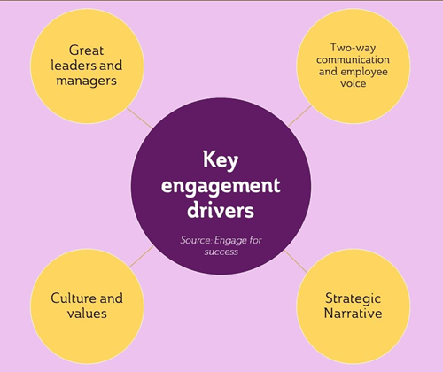
Figure 4: Employee Engagement and Motivation Framework
Source: (Guo et al., 2024)
Tying the results of training to performance reviews, Novotel strengthens the skills acquisition based on training and offers the actual reward for the employee's performance. This active style of engagement improves morale, decreases turnover and provides high-quality and constant service reflecting the immediate relationship between staff motivation and the satisfaction of the guests (Guo et al., 2024).

4.2.3 Theme 3: Impact on Service Quality
The training at Novotel Paddington has a direct relationship with service quality on five SERVQUAL dimensions - reliability, responsiveness, assurance, empathy, and tangibles (Hu, 2025). The level of communication and customer service employees are trained so that they provide more efficient, polite and personalised interaction with the guests, which enhances overall satisfaction. Through experiential learning methods like simulations and role-play, which allow the staff to deal with intricate requests by the guest and complainants successfully, the operational efficiency can be enhanced (Noorani, 2024). There is literature that backs up the connection between training and quality of service, which proves that a well-trained employee minimises error rates, enhances consistency and enhances how consumers perceive the services.
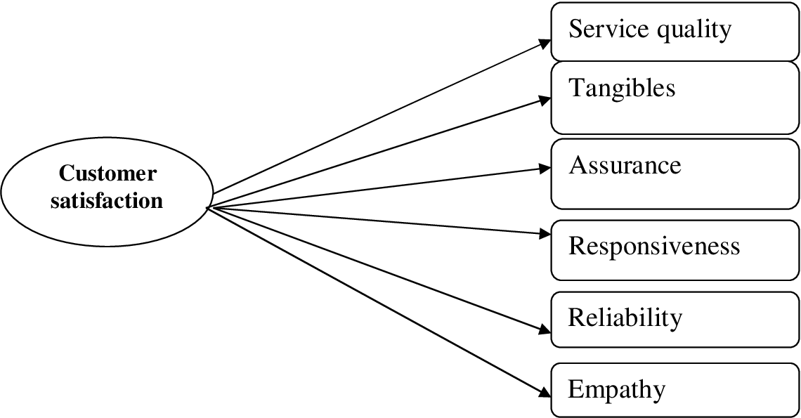
Figure 5: Impact on Service Quality
Source: (Jogarao, 2024)
The examples can be seen in attracting elevated levels using trained housekeeping personnel and attending to inquiries and complaints in a professional manner by the front office employees (Fatma and Kumar, 2024). Taken together, these results demonstrate that proper training is critical to improving the service delivery, building customer loyalty, and the competitive positioning of the hotel.

4.2.4 Theme 4: Continuous Development and Improvement
Training is a component of the strategy of Novotel Paddington, and it should be improved continuously. In addition to this, the hotel provides continuous professional development, refresher training and e-learning modules on top of the first induction and departmental programmes (Jogarao, 2024). Periodic performance evaluation of employees pinpoints the current skill deficiencies and guides a change in training materials, which should allow customers to meet the rising level of service quality. Literature highlights the inability to maintain the quality of services continuously when the mind is not engaged in a continuous learning process, and coaching will further increase staff competence and confidence and will result in retention and engagement (Moreno-Perdigon et al., 2021). Employees with the capability to be deployed flexibly during peak periods are facilitated by cross-departmental exposure and rotation opportunities, which the employees must have due to multi-skilled aspects. The dedication to continuous improvement makes the employees competent, confident, and motivated, which keeps their levels of guest satisfaction high, as well as the organisational efficiency and reputation (Olorunsola et al., 2024).

4.3 Introduction of the Discussion
This section discusses the analysis of the findings against the existing literature and theoretical concepts, which are Human Capital Theory, SERVQUAL, and Experiential Learning Theory. It elaborates on ways through which the findings apply to Novotel Paddington and the importance of employee training in enhancing service quality and the satisfaction of the guests. Limitation of the study, such as the use of secondary data, is also discussed in the discussion, and some areas where future research may offer more insight are also identified. This section reviews the effectiveness of training practices and their role towards operational success and competitive advantage in the hospitality industry.

4.3.1 Interpretation of the Research Findings in Relation to the Existing Literature
The results indicate that the training practices in Novotel Paddington are in line with the available literature on employee development and guest satisfaction. Formalised training programmes reinforce Human Capital Theory because they demonstrate how investing in employee expertise will result in better performance of the organisation (Grobelna and Tokarz-Kocik, 2025). The staff is given technical knowledge on how to operate in the departments, and soft skills training helps in person-to-person competence, with a direct impact on service quality. This is in par with Rahimi et al. (2022), who highlight that hotels that have well-established training programmes realise greater satisfaction for the guests and efficiency in the operations.
The SERVQUAL model is also proven by findings. Training also affects reliability since it guarantees consistency in service provision, responsiveness due to efficient problem-solving, assurance by having confidence within the staff, empathy by enhancing relationships with the guests and tangibles by attaining standards (Böhme, 2023). The Experiential Learning Theory can be traced in the role-playing and exercises in the field of work, supported by theoretical knowledge and introducing practical skills. It has been pointed out that such learning promotes skill retention, flexibility, and confidence, thus helping staff to satisfy the needs of the various guests (Al-Hyari et al., 2023).
Motivation and engagement of the employees were found to be essential intermediaries of training and guest satisfaction. The study shows that employees who find training to be relevant and worthy tend to apply the acquired skills, thus enhancing better experiences among guests (Schwepker Jr and Dimitriou, 2024). It has been established in the literature that engaged employees who are motivated have initiative-taking behaviour, effective communication, and responsiveness, which are critical to in-service excellence. There is also an ongoing process of development, which also supports the connection between training and guest satisfaction (Ali et al., 2021). The performance-based feedback, refresher courses and online learning make sure that the employee develop and keep their abilities. The exposure of the mentoring, operational resilience and interdepartmental resonation points out the value of flexible personnel and multi-skilled service quality management.

4.3.2 Exploring Implications, Limitations, and Pointing Out Valuable Areas
This research has several practical and theoretical implication which draws the deliberate importance of employee training in hotel operations. Intelligently designed training programmes will lead to quality services, the use of resources efficiently, and be able to satisfy the guest, hence be able to maintain their competitive edge (Vo et al., 2022). The Hotel can also follow the same structures with the integration of induction, departmental training, development of soft skills and experiential learning to enhance employee competence and performance.
Second, training can only be translated into better service delivery by means of employee engagement and motivation (Neupane and Khanal, 2022). Encouraging employees to put their skills to effective use through the provision of opportunities to develop professionally, mentoring, and feedback can secure learning and thus the successful implementation of a good practice. Interdepartmental training also increases flexibility, teamwork and operational efficiency, which is especially useful during high demand or multi-functional roles (Barreto and Mayya, 2023).
Thirdly, ongoing improvement is a guarantee that training will always be up to date and in response to the changing needs of the guests and industry trends. The inclusion of e-learning with a technological base and refresher courses facilitates lifelong learning, retention of skills and flexibility and eventually increases guest satisfaction and service quality (Abdulrab and Hezam, 2024).
The limitations of the study are since secondary qualitative information was used, and it might not reflect real-time employee perceptions or guest experience. The emphasis on one hotel restricts the ability to generalise, but it can be used to examine contextual training practices in a more detailed manner (Yılmaz and Özgener, 2022). Subsequent studies would involve primary information gathering by conducting interviews or surveys to understand the thoughts of the employees and the responses of the guests, as this would be a more sympathetic view of the effectiveness of training. The direction of further research should be beneficial in terms of the role of digital training platforms, the cost-efficiency of training programmes, and the effect the training has on staff retention and long-term operational performance (Piso, 2022). Also, the research could address the implications of cultural diversity and the role of multilingual training in deterring the satisfaction of the guests in the foreign hotel environment.

4.3.3 Critical Evaluation
The critical analysis of the results shows the strong and weak sides of the training strategy of Novotel Paddington. The combination of Induction training, departmental training and the soft skills training is one of the strengths (Zahidi et al., 2024). This 5-level strategy tackles both technical and people skills, hence it is the best practice in hospitality training (Tan and Despotis, 2021). The experiential learning methods also result in the enhancement of the approach, as employees will train skills in a realistic environment and learn to retain and be confident. Continuous training, mentoring and performance feedback were always used to boost employee engagement and motivation (Jain et al., 2024). This is correlated with the literature that indicates that motivated employees have higher chances of providing better guest experiences. The cross-departmental training proved to be one of the strategic benefits influencing the creation of flexibility and collaboration, which is especially helpful when occupancy is high (Tan et al., 2025).
Nevertheless, there are constraints that are apparent. Employee participation and motivation are critical to the training, and they might differ among employees. Although formal training is useful, it might not meet the learning needs of the individuals, as they keep up with the changing expectations of the guests. The use of secondary qualitative materials also restricts the level of understanding of how employees think of training effectiveness or whether it is directly correlated with the results of guest satisfaction (Giousmpasoglou, 2024). A more subtle sense of the matter would be gained by primary data of either interviews, surveys or observation. Moreover, even though the training of Novotel Paddington fosters the important dimensions of SERVQUAL, the literature indicates the necessity to keep the training material constantly updated with technological changes, cultural diversity, and the growing expectations of customers (Minor et al., 2025). Training programmes without periodic review will end up becoming obsolete or less effective.
Theoretically, the results affirm the theories of Human Capital that focus on the need to invest in employee skills to ensure that organisational performance is enhanced. The Experiential Learning Theory is also justified to show that practice makes knowledge retention and competency even more practical. However, the existing knowledge about how to relate training investment to quantifiable guest satisfaction indicators, like repeat guestroom, or Internet ratings, still has loopholes. Overall, the analysis has identified the training programme of Novotel Paddington as strong, multi-faceted, and geared towards service quality objectives. The strengths are well-organised delivery, interaction systems, and the learning methods. The weaknesses include fluctuating employee engagement, the absence of first-hand data, and the inability to update the programme regularly (Singh and Hassan, 2024). These gaps may also be filled, which will further improve in terms of training, service delivery, and guest satisfaction.

4.5 Summary
The chapter provided a specific analysis of the training of the employees and the influence of the training on guest satisfaction in Novotel Paddington. There were four themes, namely training structure and content, employee engagement and motivation, effect on service quality, and continual development. The results have shown that structured, experience and ongoing training lead to better staff competence, interest and performance that directly creates a better experience for the guests. These findings were related to Human Capital Theory, SERVQUAL, and Experiential Learning Theory through the discussion with practical and theoretical implications. Restrictions were not ignored, and the directions of research in the future were established. Overall, the chapter shows that strategic employee training is key to the attainment of operational excellence and guest satisfaction levels.

Chapter 5: Conclusion and Recommendations

5.1 Conclusion
This study was intended to examine how the training of its employees at Novotel Paddington has improved guest satisfaction. Training employees within the hospitality industry is considered an important aspect that contributes to the quality of services, efficiency, and customer satisfaction. The present research is based on the thematic analysis of secondary qualitative information. This included industry reports, case studies and scholarly articles, which have pointed out several interesting findings in terms of training programmes, staff engagement, service delivery and lifelong professional development at Novotel Paddington.
Among the most significant is connected to the organisation and content of training programmes. Novotel Paddington has adopted a multi-based model that includes induction, departmental modules, soft skills and continuous professional development. Induction programmes also ensure that the new employees are aware of the operational standards, organisational policies, and service culture of the hotel that form the basis of delivering consistency in service delivery to the different departments. The technical training offered departmentally furnishes one with the skills required in front office/ housekeeping and food and beverage services. The training prevents any complexities in dealing with diverse and multifaceted guests by providing soft skills training, such as communication, problem-solving, and conflict management skills. This organisational strategy also ensures that employees are equipped with technical skills and people skills that can make them deliver high-quality services, which has been demonstrated by Wilson (2025) and Abdulrab and Hezam (2024) regarding the significance of structured and comprehensive training in the hospitality industry.
The second important finding is how training has an influence on employee motivation and engagement. There is a fact that employees who feel that training is significant and can benefit them tend to be more engaged, initiative-taking and devoted to the idea of providing superb service. The culture of learning at Novotel Paddington has been practised through mentoring programmes, feedback and exposing the staff to cross-departmental exposure. This strategy will make staff more confident, collaborate on work and be more flexible to deliver services during high seasons or how to deal with a difficult guest experience. This is supported in the literature, where motivated employees have been noted to have a better level of empathy, responsiveness, and assurance, which are some of the dimensions of the SERVQUAL model that have a direct impact on guest satisfaction.

Another contribution made by the researcher is the direct effect of training on the quality of the services provided and the satisfaction of the guests. When employees are trained on the technical skills as well as people skills, they will be in a better position to provide dependable, responsive, and empathetic services to the customers. On-the-job practice and role-playing are the methods of experiential learning. Employees will put their knowledge into application in a real-life scenario and will reinforce their skills and increase their confidence. Consequently, training not only leads to an increase in the consistency of operations but also positively influences the experience of the guest, which creates trust and loyalty. Competent and confident staff are more likely to predict the needs of the guests, address the complaints in an efficient way, and remain at elevated levels of service. Such results are in line with the Human Capital Theory of the importance of investing in employee skills to achieve organisational success, and the Experiential Learning Theory, which prioritises the practical application in retaining skills.
The other valuable lesson is the value of one engaging in the process of continuous professional growth and improvement. Novotel Paddington focuses on refresher training, performance feedback and e-learning to keep the competencies of the employees current. Constant improvement keeps employees flexible to new guest demands and emerging technologies, as well as business needs. This learning culture is enhanced by cross-departmental rotation and mentoring that enhances cross-departmental flexibility, motivation and retention. Novotel Paddington maintains a continuous learning atmosphere to make sure that the workforce is ready to continuously satisfy or even surpass the expectations of the guests, which enhances the performance of the whole organisation and its functionality in the hospitality industry.
There are gaps and limitations that are also identified in the research. Although training programmes are well-organised and all-embracing in nature, the success of such plans depends on the engagement and motivation of the employees, and these may differ. Also, the secondary qualitative data cannot capture the real-time perception of the staff and the exact relationship between training and the actual outcome of the measurable guest satisfaction. The study, however, offers good knowledge on the impacts of training strategies on service delivery and organisational performance.
Overall, the study establishes that training employees at Novotel Paddington is a key procedure that improves the satisfaction of the guests. Organised and practice-based training programmes enhance competency, interest, and output of the staff, and ongoing professional development makes the services offered viable and consistent. This training has positive influences on the major service quality aspects such as reliability, responsiveness, assurance, empathy, and tangibles, which support organisational goals and competitive advantage. The paper has identified the strategic relevance of investing in human capital and the development of a culture of learning in the hospitality organisations to realise long-term gains in the level of customer satisfaction and overall organisational efficiency.

5.2 Recommendations
1. Periodical Assessment and Revision of Training Material: Training programmes must be reviewed frequently to make sure they are in line with the changing guest demands, contemporary trends in the hospitality industry and technology (Nazarian et al., 2024). New service protocols, digital tools, sustainability practices, and innovation of guest experience should be presented in the updates. This will retain employees who possess the relevant skills, enhance efficiency in operation, and provide a high-quality service to guests. The constant updates are also a reinforcement of the willingness to develop the staff by the hotel, which will increase both motivation and engagement (Nagirikandalage et al., 2025).
2. Development of Improved Soft Skills and Emotional Intelligence: Technical competence is important, but soft skills, such as communication, empathy, active listening and critical thinking skills, are important to guest satisfaction. Special workshops and training modules are to be implemented to enhance emotional intelligence and people skills (Limna, 2023). Such sessions will help employees to predict the needs of the guests, respond to complaints, and provide personalised services, which are the main motives of guest loyalty and positive reviews.
3. Mentoring and Coaching Programmes: The formal mentoring and coaching programmes are to be implemented to help in practising the skills in actual working conditions. The benefits of casing the experienced with the new employee are faster learning, confidence and knowledge transfer (Dogru et al., 2023). Individual performance gaps can also be managed by coaching and specialised assistance, which is convenient to deliver a uniform service delivery in all departments.
4. Multiple-Skilling and Multi-Departmental Chances: Allowing the employees to get experience working in different departments will boost teamwork, operational flexibility and knowledge of process relations. Employees who are multi-skilled can be assigned during the peak time, and in cases of a shortage of employees, service delivery will go on (Chen et al., 2023). Cross-training can also enhance employee participation and retention since it provides an internship and diversity in the workplace.
5. Combination of Experiential and Technology-based Learning: Training ought to still be based on experiential learning techniques, including on-the-job practice and simulations. Moreover, the technology-based learning platforms, such as e-learning curricula and mobile applications, can also provide training opportunities that are flexible and self-paced (Bhandari and Sin, 2023). Integrating experiential with digital learning would guarantee enhanced knowledge retention, suitability of different learning orientations, and professional growth.
6. Performance Monitoring and Feedback Systems: An effective performance assessment system that is associated with training performance and guest satisfaction indicators is needed. Periodic assessment of supervisors and guests would be able to identify the weaknesses in the quality-of-service delivery and the effectiveness of training (Burton and Dickinger, 2025). The insights would be provided by data to allow the management to optimise the content of training, use resources effectively, and see the improvement in service delivery over time.
7. Promoting the Culture of Lifelong Learning: A culture of lifelong learning is a strengthened way of strategic value of staff development. Rewarding employees who undergo training, use new skills in practice, or innovate service processes will also encourage them and will increase their involvement (Rather, 2025). Knowledge sharing sessions, peer learning, and recognition programmes enhance team cohesion and stability in operations.
8. Differentiated Guest-Centric Service Programmes: The modules in the training programmes must be on improving the experience of guests, which includes the ability to forecast the needs of guests, providing personalised services, and responding to situations that cause high pressure (Barth and Barber, 2025). Connecting the training purposes to the quantifiable results of the guest satisfaction will help Novotel reinforce its image of service quality and loyalty of customers.
9. Benchmarking and Industry Best Practices: To keep its competitive advantage, Novotel Paddington is expected to compare its training practices with the best of the hotels and develop innovative methods (Velaoras et al., 2025). The training is effective and relevant, and in accordance with the trends in the hospitality industry, it is conducted through regular audits and comparisons with industry standards.
Summary of Recommendations
The adoption of the recommendations will empower Novotel Paddington to enhance the competence, engagement, and motivation of the staff, which will eventually influence the quality of the services and customer satisfaction. Through integrated training, life-long learning, mentoring, cross-departmental exposure, learning through experience and monitoring their performance, the hotel can attain operational excellence and the ability to ensure that it maintains operational competitive advantage in the hospitality industry (Minazzi and Grechi, 2025). The strategies are also consistent with Human Capital Theory, principles of SERVQUAL, and Experiential Learning Theory, so that the development of employees is converted into the actual performance related to enhancing the services offered and experiences of the guests.

References
Abdulrab, M. and Hezam, N. (2024) Service Quality and Customer Satisfaction in the Hospitality Sector: A paper review and future research directions. Library of Progress-Library Science, Information Technology & Computer, 44(3).
Alabi, O.A., Ajayi, F.A., Udeh, C.A. and Efunniyi, C.P. (2024) Data-driven employee engagement: A pathway to superior customer service. World Journal of Advanced Research and Reviews, 23(3), pp.923-933.
Al-Gasawneh, J., Alsoud, M., Alhawamdeh, Z.M., Bani-Ata, T.J., Alghizzawi, M. and Daoud, M.K. (2024) February. Exploring the influence of digital marketing strategies on enhancing customer satisfaction in contemporary business environments. In 2024 2nd international conference on cyber resilience (ICCR) (pp. 1-7).
Al-Hyari, H.S.A., Al-Smadi, H.M. and Weshah, S.R. (2023) The impact of artificial intelligence (AI) on guest satisfaction in hotel management: An empirical study of luxury hotels. Geo Journal of Tourism and Geosites, 48, pp.810-819.
Ali, B.J., Gardi, B., Othman, B.J., Ahmed, S.A., Ismael, N.B., Hamza, P.A., Aziz, H.M., Sabir, B.Y., Sorguli, S. and Anwar, G. (2021) Hotel service quality: The impact of service quality on customer satisfaction in hospitality. International Journal of Engineering, Business and Management, 5(3), pp.14-28.
Ali, M., Khan, T.I. and Şener, İ. (2025) Transforming hospitality: the dynamics of AI integration, customer satisfaction, and organizational readiness in enhancing firm performance. Journal of Hospitality and Tourism Technology.
Arhin, E.P. and Cobblah, C. (2024) Total quality management implementation practices and customer satisfaction: the role of innovative employee behavior and employee empowerment. Management Research Quarterly, 1(1), pp.26-41.
Barreto, N. and Mayya, S. (2023) A systematic review on training and development in the hotel industry. International Journal of Management, Technology, and Social Sciences (IJMTS), 8(2), pp.22-52.
Barth, S.C. and Barber, D.S. (2025) Hospitality law: managing legal issues in the hospitality industry. John Wiley & Sons.
Bhandari, R. and Sin, M.V.A. (2023) Optimizing digital marketing in hospitality industries. Startupreneur Bisnis Digital (SABDA Journal), 2(1).
Böhme, C. (2023) Shaping the guest experience: How personalized services improve customer satisfaction in luxury hotels and create a competitive advantage. Signature.
Budur, T. and Poturak, M. (2021) Employee performance and customer loyalty: Mediation effect of customer satisfaction. Middle East Journal of Management, 8(5), pp.453-474.
Burton, A.M. and Dickinger, A. (2025) Innovation in Crisis. The role of leadership and dynamic capabilities for a more innovative hospitality industry. International Journal of Hospitality Management, 124, p.103946.
Calinaud, V., Kokkranikal, J. and Gebbels, M. (2021) Career advancement for women in the British hospitality industry: The enabling factors. Work, Employment and Society, 35(4), pp.677-695.
Chen, Y., Hu, Y., Zhou, S. and Yang, S. (2023) Investigating the determinants of performance of artificial intelligence adoption in hospitality industry during COVID-19. International Journal of Contemporary Hospitality Management, 35(8), pp.2868-2889.
Clark, T., Foster, L., Bryman, A. and Sloan, L. (2021) Bryman's social research methods. Oxford university press.
Collis, J., and Hussey, R. (2014) Business Research, A Practical Guide for Undergraduate and Post Graduate Students, Palgrave, London.
Cottrell, S. (2014) Dissertations and project reports: a step-by-step guide. New York: Palgrave.
Darvishmotevali, M., Arici, H.E. and Koseoglu, M.A. (2025). Customer satisfaction antecedents in uncertain hospitality conditions: an exploratory data mining approach. Journal of Hospitality and Tourism Insights, 8(1), pp.263-284.
Das, I.R., Islam, A.S. and Talukder, M.B. (2024) Customer satisfaction in hospitality marketing from a technological perspective. In Impact of AI and Tech-Driven Solutions in Hospitality and Tourism (pp. 383-407). IGI Global.
Dogru, T., McGinley, S., Sharma, A., Isık, C. and Hanks, L. (2023) Employee turnover dynamics in the hospitality industry vs. the overall economy. Tourism Management, 99, p.104783.
Fatma, M.A. and Kumar, M. (2024) Exploring the correlation between service quality and customer satisfaction in the hospitality industry. International Journal of Indian Psychȯlogy, 12(1).
Frankel, K.K., Deanna Brooks, M. and Learned, J.E. (2021) A meta-synthesis of qualitative research on reading intervention classes in secondary schools. Teachers College Record, 123(8), pp.31-58.
Ghanad, A. (2023) An overview of quantitative research methods. International journal of multidisciplinary research and analysis, 6(08), pp.3794-3803.
Ghani, B., Zada, M., Memon, K.R., Ullah, R., Khattak, A., Han, H., Ariza-Montes, A. and Araya-Castillo, L. (2022) Challenges and strategies for employee retention in the hospitality industry: A review. Sustainability, 14(5), p.2885.
Giousmpasoglou, C. (2024) Working conditions in the hospitality industry: the case for a fair and decent work agenda. Sustainability, 16(19), p.8428.
Glaveli, N., Papadimitriou, D., Karagiorgos, T. and Alexandris, K. (2023) Exploring the role of fitness instructors’ interaction quality skills in building customer trust in the service provider and customer satisfaction. European Sport Management Quarterly, 23(3), pp.767-788.
Grbich C. (2006) Qualitative Data Analysis, Sage Publications Ltd.
Grobelna, A. and Tokarz-Kocik, A. (2025) Work engagement and staff turnover in the hospitality industry: An analysis of selected job characteristics. International Entrepreneurship Review, 11(1), pp.125-141.
Guo, L., Gong, L., Xu, Z., Wang, W. and Chen, M.H. (2024) The role of service robots in enhancing customer satisfaction in embarrassing contexts. Journal of Hospitality and Tourism Management, 59, pp.116-126.
Hamadziripi, G. (2023) Guest satisfaction levels at commercial hospitality training facilities.
Hatidja, S., Mariana, L. and Quach, T.M. (2025) employee excellence and workplace diversity: Key drivers of satisfaction, retention, and brand success in ethnic restaurants. Global Review of Tourism and Social Sciences, 1(2), pp.158-171.
Hu, M. (2025) Internet of Things and big data in the hospitality industry: current state and prospects. Handbook on Big Data Marketing and Management in Tourism and Hospitality, pp.194-212.
Jain, A., Singh, K. and Jain, P. (2024) Understanding the impact of artificial intelligence and robotics in the tourism and hospitality industry through customer experience: A systematic literature review. Impact of AI and Tech-Driven Solutions in Hospitality and Tourism, pp.329-350.
Jogarao, M. (2024) AI in the hospitality industry: Revolutionizing guest experience. In Technology and luxury hospitality (pp. 199-210). Routledge.
Jordan, S., Matusovich, H., Case, J., Benson, L., Delaine, D., Kajfez, R., Lord, S., Paretti, M., Young, E. and Zastavker, Y.V. (2024) Share: A framework for secondary qualitative data analysis. Studies in Engineering Education, 5(1), p.125.
Learned, J.E., Frankel, K.K. and Brooks, M.D. (2022) Disrupting Secondary Reading Intervention: A Review of Qualitative Research and a Call to Action. Journal of Adolescent & Adult Literacy, 65(6).
Lepistö, K., Saunila, M. and Ukko, J. (2024) Enhancing customer satisfaction, personnel satisfaction and company reputation with total quality management: combining traditional and new views. Benchmarking: An International Journal, 31(1), pp.75-97.
Limna, P. (2023) Artificial Intelligence (AI) in the hospitality industry: A review article. International Journal of Computing Sciences Research, 7, pp.1306-1317.
Ma, Y.M., Li, M.Y. and Cao, P.P. (2024) Improving customer satisfaction in the hotel industry by fusing multi-source user-generated content: An integration method based on the heuristic-systematic model and evidence theory. Applied Intelligence, 54(17), pp.8719-8744.
Manoharan, G. and Ashtikar, S.P. (2025) AI Era in Hospitality: The New Frontier in Guest Satisfaction and Operations. In Digital Disruption in Hospitality, AI, and Emerging Technologies: A Roadmap to Personalized Experiences, Enhanced Operations, and Revenue Growth (pp. 59-77). Emerald Publishing Limited.
Minazzi, R. and Grechi, D. (2025) Exploring gen Z sustainable behavior in the hospitality industry. Administrative Sciences, 15(7), p.266.
Minor, K., McLoughlin, E. and Carlisle, S. (2025) The digital skills gap–is it time to rethink the needs of tourism and hospitality organizations in the UK? Journal of Hospitality & Tourism Education, 37(3), pp.301-312.
Moreno-Perdigon, M.C., Guzman-Perez, B. and Mesa, T.R. (2021) Guest satisfaction in independent and affiliated to chain hotels. International Journal of Hospitality Management, 94, p.102812.
Nagirikandalage, P., Lakhoua, C., BInsardi, A., Tzempelikos, N. and Kerry, C. (2025) Expert perspectives on factors shaping metaverse adoption for cultural heritage experiences in hospitality industry within an emerging economy. International Journal of Contemporary Hospitality Management, 37(4), pp.1332-1349.
Nazarian, A., Shabankareh, M., Ranjbaran, A., Sadeghilar, N. and Atkinson, P. (2024) Determinants of intention to revisit in hospitality industry: a cross-cultural study based on globe project. Journal of International Consumer Marketing, 36(1), pp.62-79.
Neupane, R. and Khanal, T.R. (2022) EVALUATION OF THE IMPACTS OF TRAINING ON EMPLOYEE PERFORMANCE IN THE UK HOTEL INDUSTRY: AN ANALYSIS OF EMPLOYEES’PERSPECTIVES AT MARRIOTT INTERNATIONAL. International Journal of Research-GRANTHAALAYAH, 10(3), pp.57-85.
Noorani, A. (2024) The role of Politeness Strategies in enhancing guest satisfaction in the hospitality industry. Journal of Policy Research, 10(2), pp.66-74.
Novotel Paddington.uk. (2025) Novotel London Paddington | London | Greater London | England. Available at: https://novotelpaddington.uk-london.website/ [Accessed on: 14 October 2025].
Ntounis, N., Parker, C., Skinner, H., Steadman, C. and Warnaby, G. (2022) Tourism and Hospitality industry resilience during the Covid-19 pandemic: Evidence from England. Current Issues in Tourism, 25(1), pp.46-59.
Olawuyi, O.S. and Kleynhans, C. (2025) A Bibliometric Analysis of Service Quality in the Hospitality Industry (2014–2024). Administrative Sciences, 15(6), p.215.
Olorunsola, V.O., Saydam, M.B., Arasli, H. and Sulu, D. (2024) Guest service experience in eco-centric hotels: a content analysis. International Hospitality Review, 38(1), pp.81-100.
Park, H., Lee, M., Back, K.J., DeFranco, A. and Suh, J. (2025) Dynamic roles of hotel mobile application in customer satisfaction and dissatisfaction: integrating text analytics and impact asymmetry analysis. International Journal of Contemporary Hospitality Management, 37(5), pp.1622-1640.
Petropoulos, F., Laporte, G., Aktas, E., Alumur, S.A., Archetti, C., Ayhan, H., Battarra, M., Bennell, J.A., Bourjolly, J.M., Boylan, J.E. and Breton, M. (2024) Operational Research: methods and applications. Journal of the Operational Research Society, 75(3), pp.423-617.
Piso, A. (2022). Controlling the clock: Working hours in the UK hotel sector. Research in Hospitality Management, 12(1), pp.1-11.
Pitakaso, R., Golinska-Dawson, P., Luesak, P., Srichok, T. and Khonjun, S. (2025) Embracing open innovation in hospitality management: Leveraging AI-driven dynamic scheduling systems for complex resource optimization and enhanced guest satisfaction. Journal of Open Innovation: Technology, Market, and Complexity, 11(1), p.100487.
Rahimi, R., Thelwall, M., Okumus, F. and Bilgihan, A. (2022) Know your guests’ preferences before they arrive at your hotel: evidence from TripAdvisor. Consumer Behavior in Tourism and Hospitality, 17(1), pp.89-106.
Rather, R.A. (2025) Metaverse marketing and consumer research: Theoretical framework and future research agenda in tourism and hospitality industry. Tourism recreation research, 50(1), pp.189-197.
Sardesai, S., D’Souza, E. and Govekar, S. (2024) Analysing the impacts of artificial intelligence service quality and human service quality on customer satisfaction and customer loyalty in the hospitality sector. Turizam, 28(1), pp.37-48.
Saunders, M., Lewis, P. and Thornhill, A. (2012) Research Methods for Business Students, FT/Prentice Hall: Harlow.
Saxena, D.K., Ghai, R.K. and Verma, S.M. (2024) The role of HR policies in training programs is instrumental in enhancing guest feedback in hotels.
Schwepker Jr, C.H. and Dimitriou, C.K. (2024) Employee-customer identification and service quality in the hospitality industry. American Journal of Business, 39(4), pp.211-227.
Silverman, D. (2011) Qualitative Research Methods, 2nd Ed, Sage: London.
Singh, A. and Hassan, S.C. (2024) Identifying the skill gap in the workplace and their challenges in hospitality and tourism organisations. In Contemporary challenges in social science management: Skills gaps and shortages in the labour market (pp. 101-114). Emerald Publishing Limited.
Sofi, M.R., Bashir, I., Alshiha, A., Alnasser, E. and Alkhozaim, S. (2025) Creating exceptional guest experiences: the role of engagement and relationship building in hospitality. Journal of Hospitality and Tourism Insights, 8(3), pp.891-914.
Tai, Y.F., Wang, Y.C. and Luo, C.C. (2021) Technology-or human-related service innovation? Enhancing customer satisfaction, delight, and loyalty in the hospitality industry. Service Business, 15(4), pp.667-694.
Tan, Y. and Despotis, D. (2021) Investigation of efficiency in the UK hotel industry: A network data envelopment analysis approach. International Journal of Contemporary Hospitality Management, 33(3), pp.1080-1104.
Tan, Y., Park, S., de Medeiros, A.M.A. and Wanke, P. (2025) Cost-benefit analysis in UK hotels: A hybrid SOCP-MCDM approach. Tourism Management, 106, p.105034.
Thakur, K., Singh, A. and Srimannarayana, M. (2025) May AI come in? Generative AI shaping gender diverse recruitment in the hospitality industry. International Journal of Hospitality Management, 126, p.104061.
Velaoras, K., Menegaki, A.N., Polyzos, S. and Gotzamani, K. (2025) The role of environmental certification in the hospitality industry: Assessing sustainability, consumer preferences, and the economic impact. Sustainability, 17(2), p.650.
Vo, N.T., Hung, V.V., Tuckova, Z., Pham, N.T. and Nguyen, L.H. (2022) Guest online review: an extraordinary focus on hotel users’ satisfaction, engagement, and loyalty. Journal of Quality Assurance in Hospitality & Tourism, 23(4), pp.913-944.
Walliman, N. (2021) Research methods: The basics. Routledge.
Wilson, O. (2025) Enhancing Operational Efficiency and Guest Satisfaction in Hotel Management: A Strategic Approach. OTS Canadian Journal, 4(5), pp.72-81.
Yılmaz, C. and Özgener, Ş. (2022) Competitive intelligence and competitiveness in accommodation businesses: the role of employee training effectiveness. Current Issues in Tourism, 25(18), pp.2905-2921.
Zahidi, F., Kaluvilla, B.B. and Mulla, T. (2024) Embracing the new era: Artificial intelligence and its multifaceted impact on the hospitality industry. Journal of Open Innovation: Technology, Market, and Complexity, 10(4), p.100390.
Zhao, Z., Cheng, M., Lv, K. and Huang, L. (2025) What matters most? A sustainable or a conventional hotel experience? The interaction effect on guest satisfaction: A mixed-methods approach. International Journal of Hospitality Management, 124, p.103988.

